Preparation and Investigations of Some New Metal Acetate Complexes Involving OO Donor Atoms Ligands: Di-Atomic Oxygen Bridged Dimers

Akram A.Mohammed
Dept. of Chemistry, College of Education, University of Mosul
Najla H.Taher
Dept. of Chemistry, College of Education for Girls, University of Mosul

(NJC)

(Recevied on 9/10 /2011 ) (Accepted for publication 4/12/2012)

الخلاصة
تم تحضير معقدات الكوبلت, النيكل, النحاس والخارصين الثنائيةالتكافوء الموجبة حيث اقترحت الصيغة [(M)₂L₁L₂(μ-CH₃COO)₂(H₂O)₄](Mتمثل ايون الكوبلت(II), النيكل(II), النحاس(II) او الخارصين(II) وL₁=بنزل، L₂=اثيلين كلايكول المزال منه بروتونين). حضرت هذة المعقدات بنسبة مولاريه 1:1:2(فلز: ليكاند: ليكاند). كذلك تم تحضير المعقدات[(M)₂L₁L₃(μ-CH₃COO)₂(H₂O)₄](M تمثل ايون الكوبلت(II), النيكل(II) النحاس(II) او الخارصين(II), L₁= بنزل، =L₃ كاتيكول المزال منه بروتونين). شخصت المعقدات من خلال التحليل الدقيق, قياسات التوصيلية المولارية للعناصر, مطيافية الاشعة تحت الحمراء, الطيف الالكتروني و القياسات المغناطيسية. دلت القيم الواطئة للتوصيلية الكهربائية للمعقدات بانها ذي طبيعة متعادلة. اوضحت اطياف الاشعة تحت الحمراء بان جميع الليكاندات تعمل بشكل ثنائي السن مخلبي. واتصال جزيئات الماء بالفلز وكذلك وجود مجموعتي كاربوكسيل ثنائية السن جسرية. اعتمادا على هذه الدراسات المختلفة, دلت القياسات بان هذه المعقدات ثنائية النوى وان كل فلز في المعقد يكون سداسي التناسق وذي بنية ثماني السطوح.

Abstract
Cobalt(II), nickel(II), copper(II) and zinc(II) complexes of the type [(M)₂L₁L₂(μ-CH₃COO)₂(H₂O)₄ ](where M=Co(II), Ni(II), Cu(II), or Zn(II); L₁= benzil while, L₂= deprotonated ethylene glycol) have been synthesized by 2:1:1molar ratio for metal: benzil and ethylene glycol.Also[(M)₂L₁L₃(μ-CH₃COO)₂(H₂O)₄] complexes (where M= Co(II), Ni(II), Cu(II) or Zn(II); L₁= benzil while L₃= deprotonated catechol) have been synthesized by 2: 1: 1molar reactions of metal acetate with benzil and catechol. The resulting complexes have been characterized by the metal content measurements, molar conductance measurements, infrared, electronic spectra and magnetic moment measurements. The complexes are non-electrolytes as is evident from low values of their molar conductance. The infrared spectral studies of all the complexes indicate that the ligands behave as bidentate chelating ligands.Also, the Infrared studies show that the water molecules are coordinated in the complexes and the metal centres are bridged by bidentate CH₃COO groups. The different studies reveal dinuclear nature of the complexes and the two metal atoms are hexacoordinated with octahedral geometry.

Introduction
Mixed ligand complexes play an important role in biological processes, as examplified by many instances in which enzymes are known to be activated by metal ions ^{(1,2)}. Such complexes have been implicated in the storage and transport of active substances through membranes⁽³⁾.Many mixed ligand complexes are finding applications in the microelectronic industry, chemical vapour deposition of metals and as drugs^{(4,5)}. Mixed ligand complexes have been used in the analysis of semi-conductor materials⁽⁶⁾. There is growing awareness associated with electrochemical, magnetic and spectroscopic studies of homobinuclear mixed ligand complexes^{(7,8)} due to their biological interest. The synthesis of bimetallic complexes is interesting because they exhibit magnetic exchange between the two metal ions⁽⁹⁾ or tendency to undergo multielectron redox reactions⁽¹⁰⁾. Polynuclear complexes containing bridging groups are of current interest due to their versatile molecular topologies and wide applications such as catalytic and electrochemical applications⁽¹¹⁾ also antibacterial⁽¹²⁾ and antityrosinase activities⁽¹³⁾.The carboxylate groupis one of the most widely used bridging ligands for designing polynuclear metal complexes with interesting magnetic properties. Normally, each of the two oxygen atoms of a carboxylate group are bonded to a different metal atom to form a M-O-C-O-M bridge⁽¹⁴⁾. Finally, binuclear complexes have been found to be better catalysts than the mononuclear complexes⁽¹⁵⁾.
The purpose of the present study is to synthesize complexes using OO donor atoms ligands, benzil(L₁) and ethylene glycol(L₂) or catechol(L₃), with these ligands, we have obtained pure di-atomic acetate oxygen bridged dinuclear complexes and have characterized them both structurally and magnetically.

(L₁)
(L₂)
(L₃)

Experimental
1.Chemicals:
All chemicals used in the present work including Co(CH₃COO)₂. 4H₂O,Ni(CH₃COO)₂.4H₂O,Cu(CH₃COO)₂.H₂O,Zn(CH₃COO)₂.2H₂O, benzil, ethylene glycol, catechol and solvents are Analytical Reagent (A.R) grade used without further purification.
2. Analytical and physical measurements:
Metal contents have been determined by applying gravimetric method⁽¹⁶⁾ after the decomposition of the complexes with concentrated nitric acid. Melting points were determined by using electrothermal 9300 digital apparatus. Molar conductivities of the complexes have been measured in an electrolytic conductivity measuring set LF-42 using 0.001Mof the complexes dimethylformamide (DMF) solutions at room temperature. IR spectra were recorded on a Bruker tensor 27 spectrophotometer in the 400-4000 cm⁻¹ range using KBr disc. Electronic spectra were recorded on a Shimadzu 1601 spectrophotometer in DMF at 25C° for 0.001M solution of the compounds using a 1 cm quartz cell. Magnetic susceptibilities of the complexes have been measured by Brucker B.M.6, using Faraday method.
3.a. Preparation of the homobinuclear mixed ligand complexes[(M)₂ L₁L₂ (μ-CH₃COO)₂(H₂O)₄]
The complexes were synthesized by the reactions of a hot ethanolic solution of (0.02 mol) of metal acetate hydrate with a hot solution of (0.01 mol) of ethylene glycol. The pH has been adjusted to 6-8 with NaOH solution (1.25M). using of a pH paper. The mixture was refluxed for four hours, then (0.01 mol) of benzil in the same solvent was added to the mixture and the pH readjusted again. Refluxing was continued for extra three hours. The complexes thus formed were collected and washed with distilled water and ethanol to remove the unreacted starting material and then were dried in air.
3.b. Preparation of the
homobinuclear mixed ligand complexes[(M)₂ L₁L₃ (μ-CH₃COO)₂(H₂O)₄]
The complexes were prepared by the same general method as described above except using 0.01 mol catechol instead of ethylene glycol.

Results and Discussion
All the prepared complexes were as powders, stable in air at room temperature.Their analytical data together with some physical properties are summarized in table 1.The reaction of metal acetate hydrate with benzil (L₁) and ethylene glycol (L₂) or catechol (L₃) in ethanol (molar ratio 2:1:1) yields complexes of the general formula [(M)₂ L₁L_{y}(μ-CH₃COO)₂(H₂O)₄].
(M=Co(II), Ni(II), Cu(II) or Zn(II); while y= 2 or 3).
Based on the metal content measurements have been supported the general formula: [(M)₂L₁L_{y}(μ-CH₃COO)₂(H₂O)₄], which shows that in each complex the ratio of metal: ligand: ligand is 2:1:1.The molar conductance of the complexes (Λ_{M}) in DMF is in the range (25-7)ohm⁻¹ cm² mol⁻¹ (table 1), indicating a non-electrolytic in nature and that no inorganic anions such as CH₃COO⁻ ions are present in outer sphere coordination⁽¹⁷⁾.The non-conducting character reveals the presence of (CH₃COO) groups and metal ions in the coordination sphere.

Table(1): The physical and analytical properties of the compounds
Compound | Colour | m.p  C° | Yield % | % Metal | Λ_{M}
 |  |  |  | Calc.(found) | Λ_{M}
Benzil | Lemon | 94-95 | ------ | ---------------- | ------
Ethylene glycol | Colourless | 198(bp) | ------ | ---------------- | ------
Catechol | Cream | 104-106 | ------ | ----------------- | ------
[(Co)₂L₁L₂(μ-CH₃COO)₂(H₂O)₄] | Dark gray | 344d | 51 | 20.39 (21.22) | 20
[(Ni)₂L₁ L₂(μ-CH3COO)₂(H₂O)₄] | Light green | 331d | 62 | 20.33 (19.83) | #
[(Cu)₂L₁L₂(μ-CH₃COO)₂(H₂O)₄] | Pale black | 312 | 47 | 21.64 (22.07) | 24
[(Zn)₂L₁L₂(μ-CH₃COO)₂(H₂O)₄] | Nacre | 302 | 62 | 22.13 (23.04) | 7
[(Co)₂L₁L₃(μ-CH₃COO)₂(H₂O)₄] | Black | 324d | 70 | 18.83 (19.251) | 12
[(Ni)₂L₁L₃(μ-CH₃COO)₂(H₂O)₄] | Black | 303 | 68 | 18.77 (18.63) | 14
[(Cu)₂L₁L₃(μ-CH₃COO)₂(H₂O)₄] | Khaki | 287d | 71 | 20.01 (20.75) | 25
[(Zn)₂L₁L₃(μ-CH₃COO)₂(H₂O)₄] | Icy gray | 291 | 59 | 20.46 (21.24) | 22
bp= boiling point; d= decomposition; calc. = calculated; # = very poor soluble.

IR spectra:
The IR spectra provide valuable information regarding the nature of functional group attached to the metal atom (table 2).The IR spectra of ethylene glycol and catechol show bands at 3384 and 3329 cm⁻¹ respectively, assignable to ν(OH).The absence of these bands,noted in the spectra of the complexes, indicates the deprotonation of the OH group on complexation.Instead, a band characteristic to v(OH) of coordinated water was observed in the region (3474-3404) cm⁻¹⁽¹⁸⁾. Also, the IR spectra of complexes show peaks in the regions (876-865) and (795-787)cm⁻¹,this was agood confirmation for the presence of coordinated water, assignable to the rocking and wagging modes, respectively. The IR spectrum of benzil (L₁) shows a band at 1677 cm⁻¹, assignable to v(C=O) (carbonyl group). In the IR spectra of the complexes, this band is shifted to lower frequencies (1660-1614)cm⁻¹, indicating the involvement of C=O oxygen in coordination with the metal ion⁽¹⁹⁾ and forming five membered chelate ring. The C-O stretching vibrations appeared at 1254 and 1281 cm⁻¹ in the spectra of ethylene glycol and catechol respectively. These bands are shifted to lower frequencies in the spectra of complexes (table 2).This shift confirms the participation of oxygen of ethylene glycol and catechol in the C-O-M bond⁽²⁰⁾ and forming five membered chelate ring.In the IR spectra of the complexes, the absorption bands in the regions (1593-1578) and (1449-1399)cm⁻¹, which are associated with the asymmetric and the symmetric stretching modes in carboxylates, respectively.The ∆v value (v_{as}-v_{s}) of the carboxylate is (179-131) cm⁻¹ and provides good evidence that the carboxylate group acts as bidentate bridging units to metal (II) ions ⁽²¹⁻²³⁾.
Finally, assignment of the proposed coordination sites is further supported by the appearance of new bands in the region (599-459)cm⁻¹, which could be attributed to the formation of M-O bond⁽²⁴⁾.

Table (2): Important IR spectral bands (cm⁻¹)
Compound | υ  (OH) | υ  (H₂O) | υ  (C = O) | υ_{as}  (COO) | υ_{s}  (COO) | υ  (C-O-M) | Rocking (H₂O) | Wagging (H₂O) | υ  (M – O)
L₁ | - | - | 1677 | - | - | - | - | - | -
L₂ | 3384 | - | - | - | - | 1254 | - | - | -
L₃ | 3329 | - | - | - | - | 1281 | - | - | -
[(Co)₂L₁L₂(µ-CH₃COO)₂ (H₂O)₄] | - | 3444 | 1660 | 1578 | 1409 | 1211 | 876 | 795 | 517
[(Ni)₂L₁L₂(µ-CH₃COO)₂(H₂O)₄] | - | 3442 | 1614 | 1593 | 1449 | 1211 | 875 | 794 | 514
[(Cu)₂L₁L₂(µ-CH₃COO)₂(H₂O)₄] | - | 3450 | 1614 | 1579 | 1410 | 1211 | 875 | 794 | 518
[(Zn)₂L₁L₂(µ-CH₃COO)₂(H₂O)₄] | - | 3444 | 1660 | 1578 | 1399 | 1211 | 876 | 795 | 468
[(Co)₂L₁L₃(µ-CH₃COO)₂(H₂O)₄] | - | 3418 | 1660 | 1579 | 1448 | 1251 | 865 | 787 | 599
[(Ni)₂L₁L₃(µ-CH₃COO)₂(H₂O)₄] | - | 3424 | 1660 | 1578 | 1419 | 1245 | 874 | 793 | 467
[(Cu)₂L₁L₃(µ-CH₃COO)₂(H₂O)₄] | - | 3474 | 1616 | 1579 | 1409 | 1245 | 876 | 795 | 459
[(Zn)₂L₁L₃(µ-CH₃COO)₂(H₂O)₄] | - | 3404 | 1631 | 1590 | 1413 | 1245 | 876 | 794 | 465

Electronic absorption spectra and magneticmoments:
Electronic absorption spectra of the complexes were recorded in DMF solution (table 3).The measured magnetic moments of these complexes are shown in table 3.
a.The electronic spectra and the magnetic moments of [(M)₂L₁L₂ (μ-CH₃COO)₂(H₂O)₄]
The cobalt complex spectrum shows two bands observed at 10914 and 17482 cm⁻¹, which may be assigned to ⁴T₁g (F)→⁴T₂g (F) (v₁) and ⁴T₁g (F) →⁴T₁g (P) (v₃) transitions, respectively.The UV-Vis. spectrum of Co(II) complex is consistent with the formation of an octahedral geometry⁽²⁵⁾.The magnetic moment of 3.3 B.M. per Co atom, indicates that, as expected, magnetic exchange occurs between the two cobalt sites. On the basis of the magnetic data, the cobalt (II) complex has a binuclear structure ⁽²⁶⁾. The electronic spectral study of the nickel (II) complex was unsuccessful due to its poor solubility in common organic solvents such as DMF and actually it shows a band at 26316 cm⁻¹, assigned to ³A₂g(F) →³T₁g(p) transition ⁽²⁵⁾. The magnetic moment of 2.41 B.M per Ni atom, is below the calculated value, 2.83 B.M., indicating spin-exchange interaction between the nickel (II) ions⁽²⁶⁾. The electronic spectrum of the copper (II) complex shows a band at 15674 cm⁻¹ due to the ²Eg → ²T₂g transitions, suggesting a distorted octahedral structure⁽²⁷⁾.The magnetic moment per Cu (II) ion, 1.42 B.M., is well below the calculated value, 1.73 B.M., indicating spin-exchange interaction between the copper (II) ions⁽²⁸⁾.Since the zinc ion has d¹⁰ configuration, the absorption at 27173 cm⁻¹could be assigned to a charge transfer transition⁽²⁹⁾.Zn(II) complex is diamagnetic as expected for the d¹⁰ configuration.However, taking into account the spectra and other physiochemical evidences, hexa-coordinated octahedral geometry is suggested for Zn(II) complex⁽²⁸⁾.
b. The electronic spectra and the magnetic moments of[(M)₂L₁L₃(μ-CH₃COO)₂(H₂O)₄]:
The cobalt complex spectrum shows three absorption bands in the visible region at 10080, 14970 and 17301 cm⁻¹assigned to ⁴T₁g(F) → ⁴T₂g(F) (ν₁), ⁴T₁g(F) → ⁴A₂g(F) (ν₂) and ⁴T₁g(F) → ⁴T₁g(P) (ν₃) transitions, respectively.This is typical of octahedral environment around the cobalt ion ⁽²⁵⁾. Themagnetic moment of 3.44 B.M. per Co atom, indicates the magnetic exchange occurs between the two cobalt sites, supporting a binuclear structure for the cobalt ion(II)⁽²⁶⁾.For nickel (II) complex, three bands were observed at 9803, 19762, and 23041 cm⁻¹, assigned to ³A₂g(F) →³T₂g(F) (ν₁), ³A₂g(F) → ³T₁g(F) (ν₂) and ³A₂g(F) →³T₁g(P) (ν₃) transitions, respectively, which supported an octahedral arrangement around d⁸ Ni(II) ion⁽²⁵⁾.The magnetic moment of 2.57 B.M per Ni atom, indicates that magnetic exchange occurs between the two nickel sites.On the basis of the magnetic data, the nickel(II) complex has suggested to have a binuclear structure⁽²⁶⁾.The Cu(II) complex shows a d-d absorption band at 14534 cm⁻¹ corresponding to ²Eg → ²T₂g transition, supporting a distorted octahedral configuration⁽²⁷⁾.The Cu(II) complex has a low μ_{eff} value (1.56 B.M. per copper).This may be caused by a strong copper-copper interaction⁽²⁸⁾.Finally, the absorption spectrum of Zn(II) complex shows no bands due to d-d transition, since it has d¹⁰ configuration, while the absorption at 26315 cm⁻¹, is assigned to the charge transfer transition⁽²⁹⁾.Taking into account the spectral and other physiochemical evidences, hexa-coordinated octahedral geometry is suggested for the Zn(II) complex⁽²⁸⁾.

Table (3): The electronic spectra and magnetic moments of the complexes
Complexes | Band  (nm) | Absorption  region(cm⁻¹) | Possible  assignments | μ_{eff}  (B.M.)
[(Co)₂L₁L₂(μ-CH₃COO)₂(H₂O)₄] | 914 | 10940 | ⁴T₁g(F) → ⁴T₂g(F) | 3.34
[(Co)₂L₁L₂(μ-CH₃COO)₂(H₂O)₄] | 572 | 17482 | ⁴T₁g(F) → ⁴T₁g(P) | 3.34
[(Ni)₂L₁L₂(μ-CH3COO)₂(H₂O)₄] | 380 | 26315 | ³A₂g(F) → ³T₁g(P) | 2.41
[(Cu)₂L₁L₂(μ-CH₃COO)₂(H₂O)₄] | 638 | 15674 | ²Eg →²T₂g | 1.42
[(Zn)₂L₁L₂(μ-CH₃COO)₂(H₂O)₄] | 368 | 27173 | Charge transfer | Dia*
[(Co)₂L₁L₃(μ-CH₃COO)₂(H₂O)₄] | 992 | 10080 | ⁴T₁g(F) → ⁴T₂g(F) | 3.44
[(Co)₂L₁L₃(μ-CH₃COO)₂(H₂O)₄] | 668 | 14970 | ⁴T₁g(F) → ⁴A₂g(F) | 3.44
[(Co)₂L₁L₃(μ-CH₃COO)₂(H₂O)₄] | 578 | 17301 | ⁴T₁g(F) → ⁴T₁g(P) | 3.44
[(Ni)₂L₁L₃(μ-CH₃COO)₂(H₂O)₄] | 1020 | 9803 | ³A₂g(F) → ³T₂g(F) | 2.57
[(Ni)₂L₁L₃(μ-CH₃COO)₂(H₂O)₄] | 506 | 19762 | ³A₂g(F) → ³T₁g(F) | 2.57
[(Ni)₂L₁L₃(μ-CH₃COO)₂(H₂O)₄] | 434 | 23041 | ³A₂g(F) → ³T₁g(P) | 2.57
[(Cu)₂L₁L₃(μ-CH₃COO)₂(H₂O)₄] | 688 | 14534 | ²Eg → ²T₂g | 1.56
[(Zn)₂L₁L₃(μ-CH₃COO)₂(H₂O)₄] | 380 | 26315 | Charge transfer | Dia*
*Dia= Diamagnetic

Conclusions
From the above discussion and data given in tables 1, 2 and 3, it is concluded that both ligands in the general formula [(M)₂ L₁ L_{y} (μ-CH₃COO)₂(H₂O)₄] coordinated as bidentate chelating ligands.Further coordination at the metal ion was occurred by two molecules of water on the Z axis (axial ligand) to each metal.And additional coordination by two carboxylic groups to the central atoms, also can be observed giving hexa coordinated metal ions. Thus an octahedral molecular geometries are suggested for these types of complexes as shown below: (Figures 1 and 2).

Figure (1): Suggested structure of the octahedral binuclear [(M)₂L₁L₂(µ-CH₃COO)₂ (H₂O)₄]complexes

Figure (2): Suggested structure of the octahedral binuclear [(M)₂L₁L₃(µ-CH₃COO)₂ (H₂O)₄]complexes

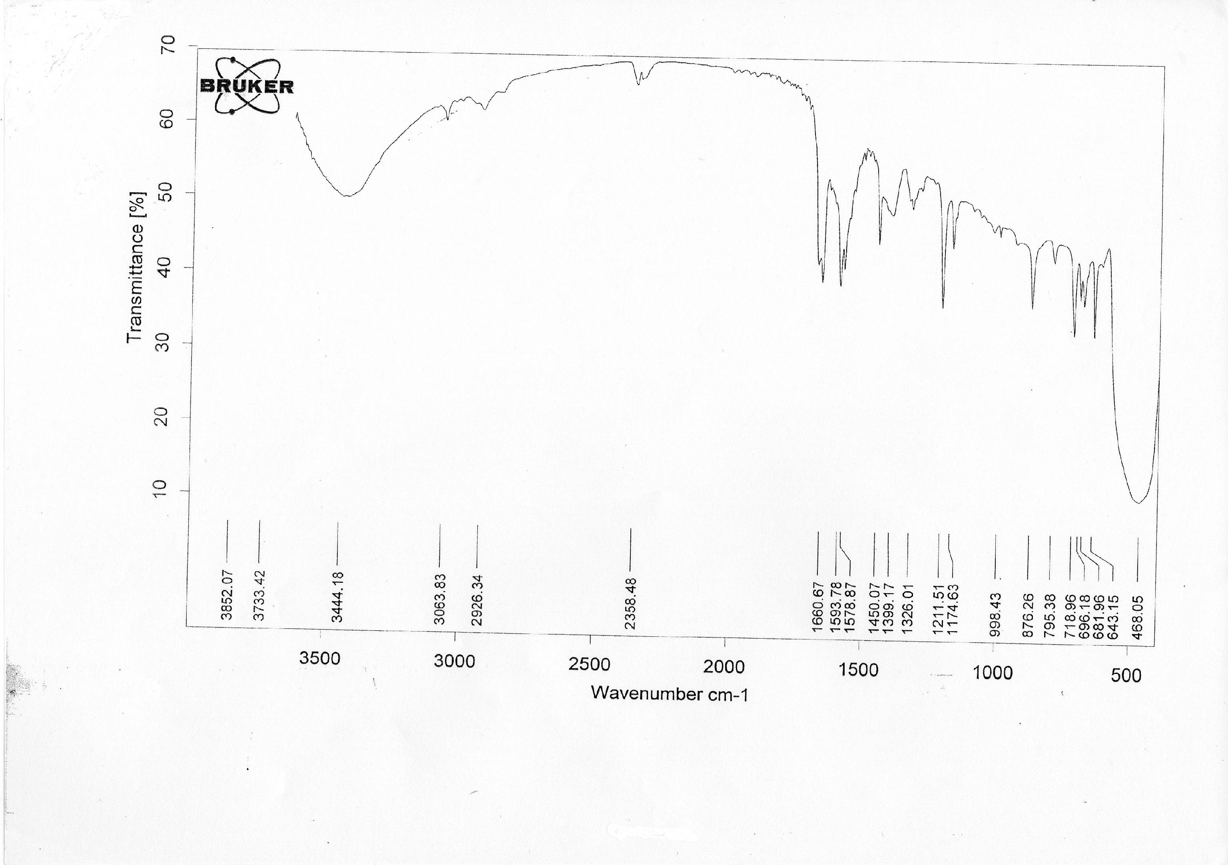

Figure (3): The IR. Spectrum of the [(Zn)₂L₁L₂(μ-CH₃COO)₂(H₂O)₄]complex.

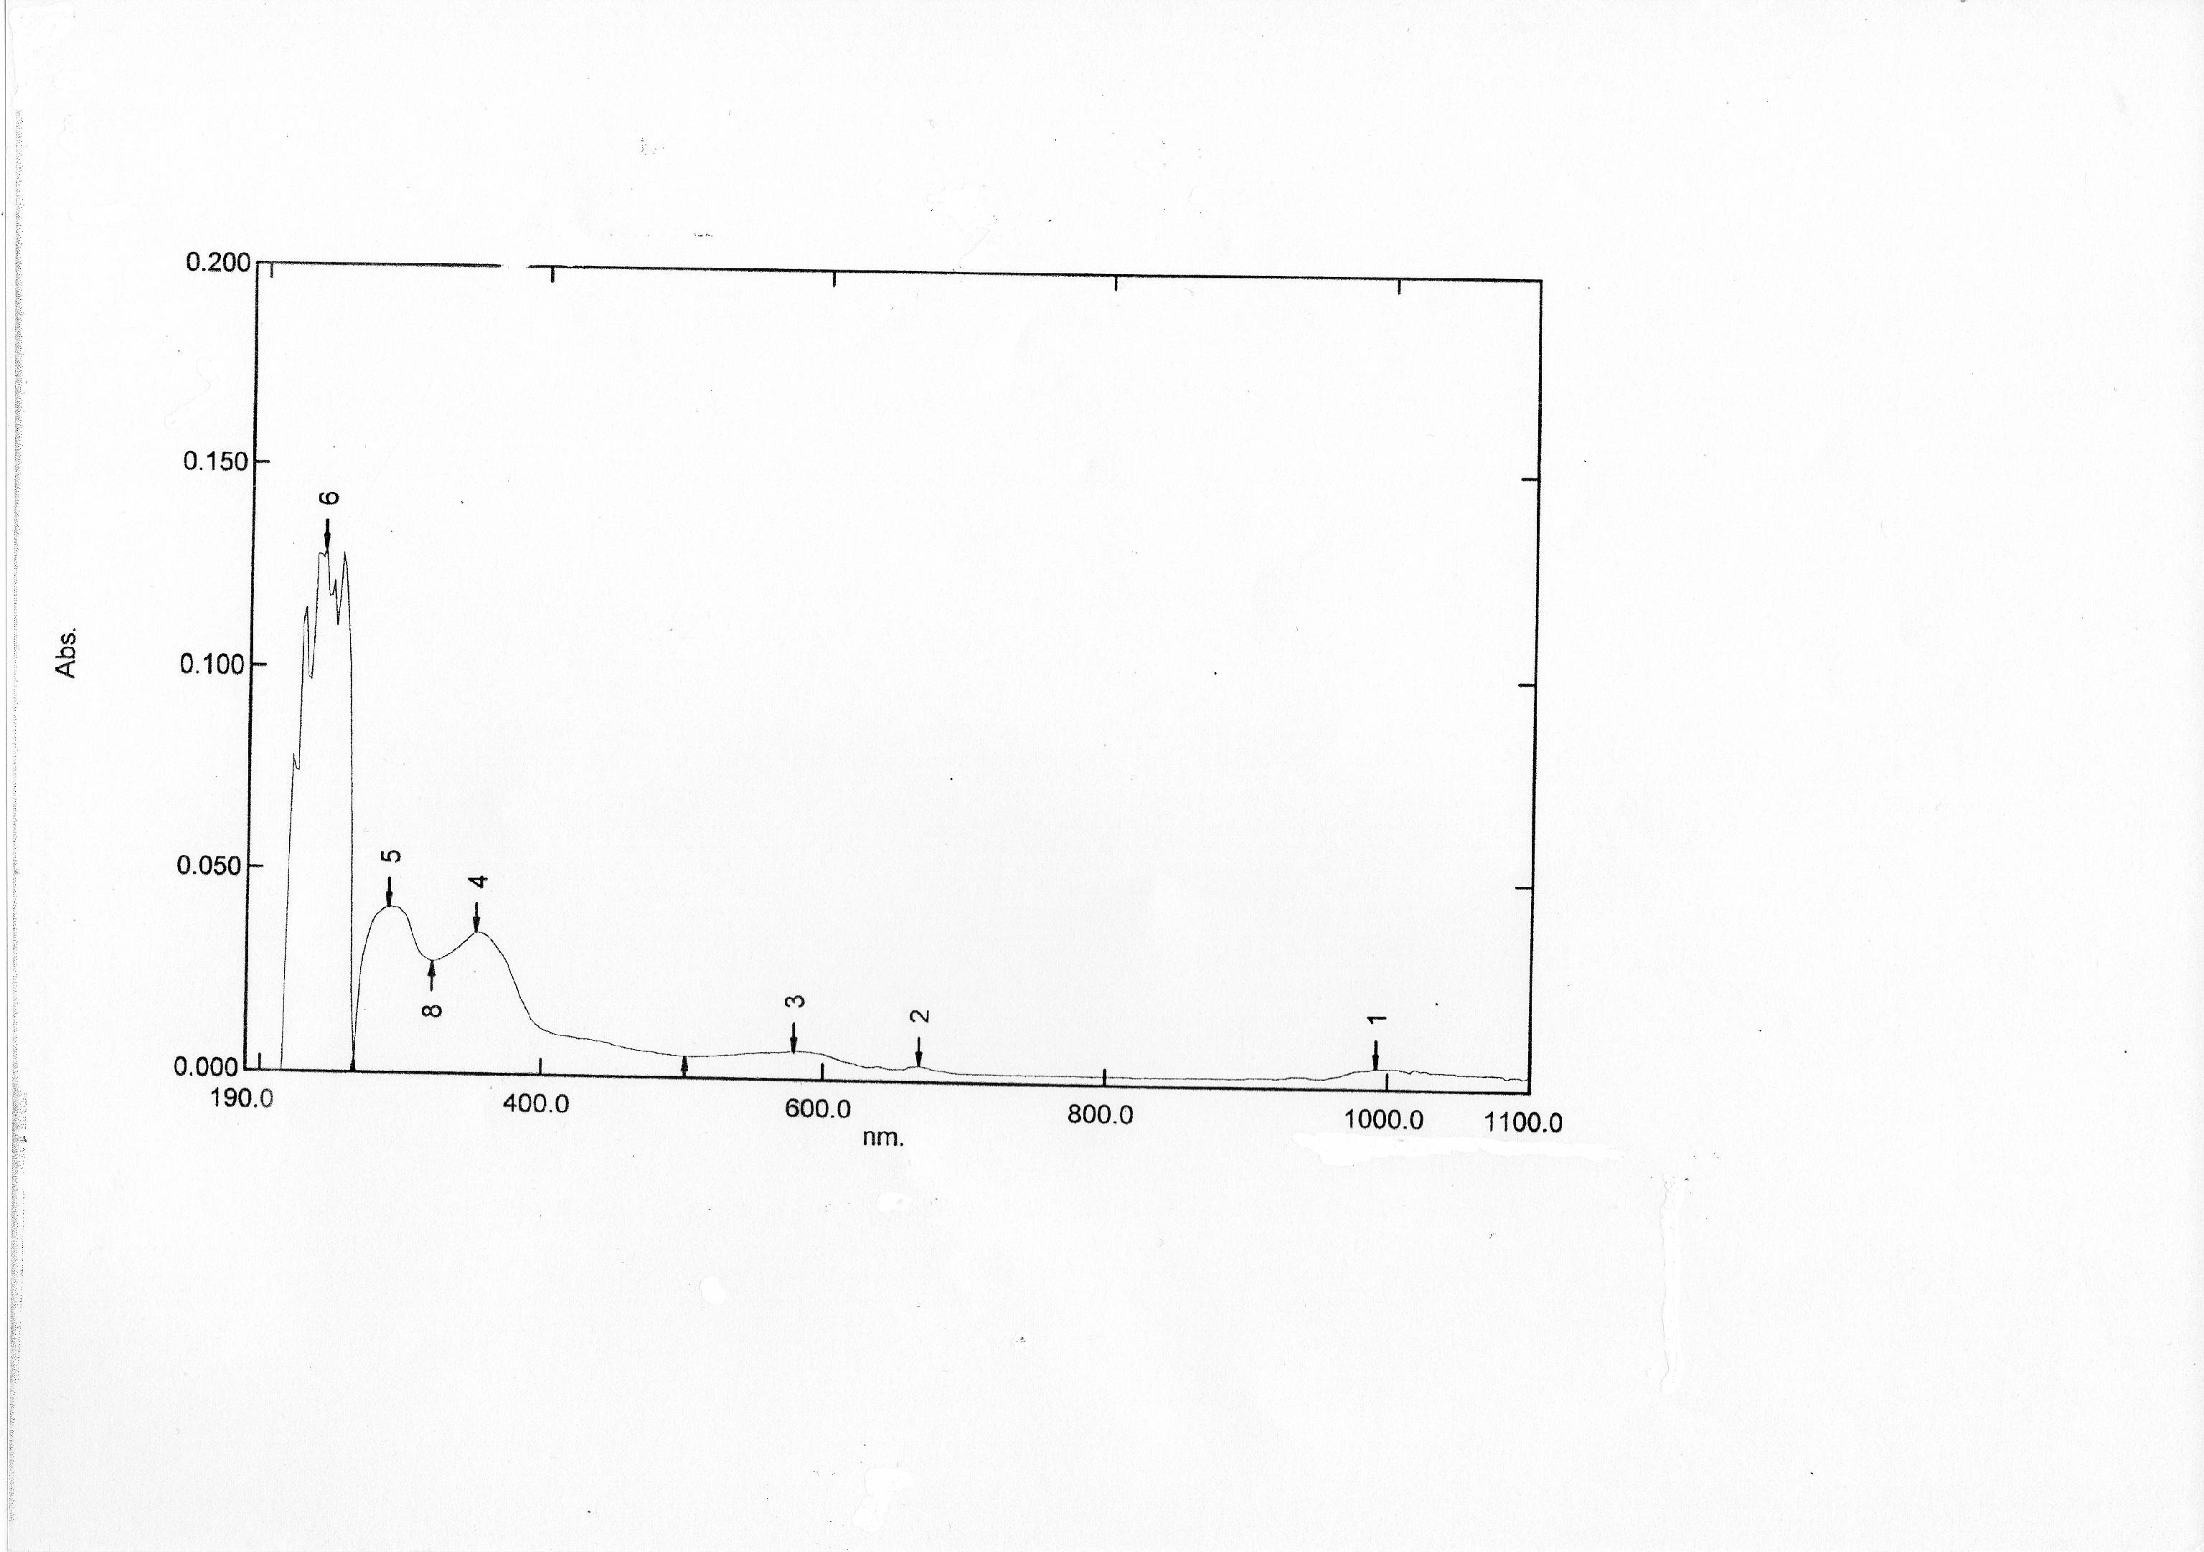

Figure (4): The U.V-Vis. Spectrum of the[(Co)₂L₁L₃(μ-CH₃COO)₂(H₂O)₄]complex.

References
1. Baran, E.j., Biochemistry, 2001, 65: 789.
2. Warad, D.U.; Satish, C.D. and Chandrasekhar S.B., Proc. Indian Acad. Sci., 2000, 112:400.
3. Dugas, H., “Bio-organic Chemistry”, Springer, New York(1995).
4. Shin, H.K.; Chi, K.M.; Farkas, J.; Smith, M.J.H.; Kodas, T.T. and Duesler, E.N.; Inorg.Chem., 1992, 31:424.
5. Price, S.J.B. and Sadler, P.J., Coord.Chem.Rev., 1996, 151:1 .
6. Murali, M. and Palaniandavar, M., Polyhedron, 2007, 26:3980 .
7. Mondal, B.; Drew, M.G.B.; Banerjee, R. and Ghosh, T.; Polyhedron, 2008, 27:3197 .
8. El-Tabl, A.S.; Trans.Met.Chem., 1997, 22:400 .
9. Costes, J.P.; Dahan, F. and Laurent, J.P.; Inorg.Chem.; 1985, 24:1018 and references cited therein.
10. Fenton, D.E.; Casellato, V.; Vigato, P.A. and Vidali, M.; Inorg. Chim.Acta., 1982, 62:57.
11. Kannappan R., Mahalakshmy R., Rajendiran T.M., Venkatesan R. and Rao P.S., Proc. Ind. Acad. Sci., 2003, 115:1.
12. Hui R.H., Zhou P. and You Z.L., Ind J. Chem., 2009, 48:1102 .
13. Bendre R., Murugkar A., Padhye S., Kulkarni P. and Karve M., Met. Based Drugs, 1998, 5:59.
14. Gosh, A.K.; Ghoshal, D.; Zangrando, E.;Ribas, J. and Chaudhuri, N.R.; Inorg.Chem., 2007, 46:3057 .
15. Singh, B. and Srivastav, A.k.; Proc.Indian, Acad.Sci. (Chem.Sci.), 1992, 104 (4): 457.
16. Vogel, A.I., “A text-Book of Quantitative Inorganic Analysis”, 3rd Ed.; Longman, New York (1972)pp:493, 397, 526, 529, 533.
17. Geary, W.J.; Coord.Chem.Rev., 1971, 7:81 .
18. El-Bindary, Trans. Met. Chem., 1996, 22:381 .
19. Faniran, J.A.; Patel, K.S. and Nelson, L.O.; J., Inorg.Nucl.Chem., 1976, 38:77.
20. Wang, G. and Chang, J.C.; Synth., Inorg.Met.-Org.Chem., 1994, 24:1091.
21. Nakamoto, K., "Infrared and Raman Spectra of Inorganic and Coordination Compounds", 4th Ed. Wiley, New York (1986) pp: 231-233.
22. Mehrotra, R.C. and Bohra, R., “Metal Carboxylates”, Academic Press, London (1983).
23. Ye, H.B.; Williams, I.D. and Li, X.Y.; J., Inorg.Biochem., 2002, 92:128.
24. El-Sonbati, A.Z.; Synth.React., Inorg.Met.-Org.Chem., 1991, 21:977 .
25. Liehr, A.D., J.Phys.Chem., 1967, 67:1314.
26. Sonmez, M. and Sekeric, M.; Synth.React., Inorg.Met.-Org.Chem., 2004, 34:489 .
27. Lever, A.B.P., “Inorganic ElectronicSpectroscopy”, 2nd Ed., Elsevier, New York (1984).
28. Carlin, R.N. and Van Dryneveldt, A.J., “Magnetic properties of Transition Metal Compound”, Springe-Berlag, New York (1997).
29. Radovanovic, B.C.S. and Andjelkovic, S.S., “Analytical Laboratory” (1997).

