Synthesis and spectral studies of new Schiff base pyrimidine-2-ylimino-acetic acid and its complexes with Cobalt(II), Nickel(II), Copper(II), Cadmium(II), Mercucry(II) and Lead(II) ions

Jasim Shihab Sultan and. Falih Hassen Mousa**
Department of Chemistry, College of Education, Ibn-AL-Haitham, University of Baghdad.
* Email: ja.sultan@yahoo.com.
** Email: dr.falihhassan@yahoo.com

(NJC)

(Recevied on 4/9 /2012 ) (Accepted for publication 2/12/2012)

Abstract
Pyrimidine-2-ylamine condens with glyoxylic acid gave pyrimidine-2-ylimino-acetic acid (L) and characterized by elemental analysis (C.H.N), FT-IR and ¹H, ¹³C-NMR. The ligand (L) reacted with metal ions (II); Co, Ni, Cu, Cd, Hg and Pb forming complexes. These complexes were identified by metal analysis (A.A.), FT-IR spectral, conductivity, magnetic susceptibility measurements and UV-visible spectral. The Co(II), Cd(II), Hg(II) and Pb(II) ions in each complexes are tetra coordinated in a tetrahedral geometry. The Ni(II), and Cu(II) ions are hexa coordinated in a octahedral geometry.
Keywords: Pyrimidine derivatives, spectral study, complexes.
الخلاصة
مفاعلة بريميدين-2-يل أمين مع حامض الكلايكوسيلك في وسط الايثانول معطياً ليكاند شيف جديد بريميدين-2-يل ايمينو حامض الخليك (L) تم تشخيصه بتحليل الكاربون، النتروجين، الهيدروجين، طيف تحت الحمراء، طيف بروتون- كاربون-13 الرنين النووي المغناطيسي مفاعلة الليكاند مع ايونات الفلزات الثنائية التكافؤ (الكوبلت، النيكل، النحاس، الكادميوم، الزئبق والرصاص) تنتج معقدات تلك الايونات، شخصت تلك المعقدات نسبة الفلز بوساطة طيف الامتصاص الذري، طيف تحت الحمراء، التوصيلية، الخاصية المغناطيسية والبنفسجية-المرئية.
تكون ايونات الكوبلت، الكادميوم، الزئبق والرصاص الثنائية التكافؤ في كل معقداتها رباعية التناسق في شكل هرم رباعي السطوح. أما ايونات النيكل والنحاس الثنائية التكافؤ في معقداتها فهي سداسية التناسق على شكل ثماني السطوح.
الكلمات المفتاحية: مشتقات البريميدين، دراسة طيفية، معقدات.

Introduction
Azomethines are generally known as Schiff bases to Honour Hugo, who synthesized such compounds. These compounds are containing characteristic (–\C=N–) group^{[1]}.
Kalpesh S. et.al., have reported some novel Schiff base derived from 4,6-dimethoxy pyrimidin-2-amine with various aromatic aldehyde^{[2]}. Sawsan S. et.al. have reported physico chemical studies of some mercury pyrimidine complexes^{[3]}. Jassim Sh. S. reported some metal ions of (2-aminophenylimino)-aceticacid^{[4]} and [2-(carboxymethylene-amino)-phenyl imino] acetic acid^{[5]}. In this paper, the synthesis of new Schiff base pyrimidine-2-ylimino-acetic acid (L) and its some complexes, with Co⁺², Ni⁺², Cu⁺², Cd⁺², Hg⁺² and Pb⁺² are reported.

Experimental
All chemicals were purchased from BDH, and used without further purifications.
Instrumentation
1. FTIR spectra were recorded in KBr on Shimadzu- 8300 Spectrophotometer in the range of (4000-400 cm^{–1}).
2. The electronic spectra in H₂O were recorded using the UV-Visible spectrophotometer type (spectra 190-900 nm) CECIL, England, with quartz cell of (1 cm) path length.
3. The melting point was recorded on "Gallen kamp Melting point Apparatus".
4. The Conductance Measurements were recorded on W. T. W. conductivity Meter.
5. Metal analysis. The metal contents of the complexes were determined by atomic absorption (A. A.) technique. Using a shimadzu PR-5. ORAPHIC PRINTER atomic obsorption spectrophotometer.
6. Balance Magnetic Susceptibility model MSB-MLI Al-Nahrain University
7. The characterize of new ligand (L) is achieved by:
A: ¹H and ¹³C-NMR spectra were recorded by using a Bruker 300 MHZ (Switzerland). Chemical Shift of all ¹H and ¹³C-NMR spectra were recorded in δ(ppm) unit downfield from internal reference tetramethylsilane (TMS), using D₂O as a solvent.
B: Elemental analysis for carbon, hydrogen and nitrogen was using a Euro Vector EA 3000 A Elemental Analysis (Italy), analysis (A and B) were done at AL-al-Bayt University, Al- Mafrag, Jordan.
Synthesis
1. Synthesis of pyrimidine-2ylimino-acetic acid (L)
To a hot solution of pyrimidine-2ylamine (0.95g. 1m mole) in (5ml) ethanol, a hot solution of glyoxylic acid (0.108 g. 1 m mole) in (5ml) ethanol was added. The solution was refluxed for 3.5 hrs. Upon cooling a pale brown precipitate formed, was filtered off and recrystallized from a hot mixture of (5:5:2) methanol, acetone and distilled water. A pale brown precipitate, yield 86%, melting point 170C°.
2. Synthesis of complexes
The complex [LCo.2H₂O]Cl has been synthesized as follows:
To a hot solution of ligand (L) (0.151g. 1m mole) in (5ml) ethanol, a hot solution of cobalt(II) Chloride hexa hydrate (0.238g. 1m mole) in (5 ml) of ethanol was added.
The precipitate immediately formed, the mixture was boiled and stirred for 10-15min., filtered off and recrystallized from a hot methanol (10ml), a blue precipitate was obtained, yield 82%, decomposed at 200 D°. A similar method was used to prepare other complexes: [LNi.4H₂O]Cl, L(0.151g 1m mole), NiCl₂.6H₂O (0.238g, 1m mole), (10ml) ethanol, (10ml) methanol, yield 80% decomposed at 135 D°, [LCu.4H₂O]Cl, L(0.151g, lm mole), CuCl₂.2H₂O (0.170g, 1m mole), (10ml) ethanol, (10ml) methanol, yield 78% melting point 220 C°, [LCd.2H₂O]Cl, L(0.151g, l m mole), CdCl₂.H₂O (0.202g, 1m mole), (10ml) ethanol, (10ml) methanol, yield 92%, decomposed at 210 D°, [LHg.2H₂O]Cl, L(0.151g, lm mole), HgCl₂ (0.271g, 1m mole), (10ml) ethanol, (10ml) methanol, yield 88%, melting point 175 C°, [LPb.2H₂O]NO₃, L(0.151g, lm mole), Pb(NO₃)₂ (0.331g, 1m mole), (10ml) ethanol, (10ml) methanol, yield 85%, melting point 150 C°.
The physical properties for synthesized ligand (L) and its complexes are shown in Table (1).

Table (1): The physical properties for synthesized lignad (L) and its complexes
Empirical  Formula | Yield % | M.P. C° | Colour | μ_{effect} | Found  (Calc.) % |  |  |  | Solubility
 |  |  |  |  | C | H | N | metal | Solubility
L=C₆H₅N₃O₂ | 86 | 170 | Pale brown | - | 48.00 (47.68) | 3.61 (3.31) | 28.29 (27.81) | - | Water, methanol, ethanol, acetone, ether, DMF, DMSO
[LCo.2H₂O]Cl | 82 | 200 D° | Blue | 4.80 | - | - | - | 21.28  (21.07) | Water, methanol, ethanol, acetone, DMF, DMSO
[LNi.4H₂O]Cl | 80 | 135 D° | Pale green | 3.10 | - | - | - | 19.10  (18.61) | =
[LCu.4H₂O]Cl | 78 | 220 | Green | 1.85 | - | - | - | 20.01  (19.62) | =
[LCd.2H₂O]Cl | 92 | 210 D° | Brown | - | - | - | - | 33.80  (33.63) | =
[LHg.2H₂O]Cl | 88 | 175 | Brown | - | - | - | - | 47.10  (47.50) | =
[LPb.2H₂O]NO₃ | 85 | 150 | Pale brown | - | - | - | - | 45.50  (45.39) | =

Results and Discussions
The characterization of the new ligand (L) has been achieved by:
a) The ¹H-NMR is spectrum of the ligand (L) in D₂O Fig. (1) Table (2a) is characterized by the appearance of chemical shift related to; the (8.5) ppm. (S, 1H, N = CH)^{[6-7]}, (6.03- 7.88) ppm. (M, 3H) aromatic protons, (12.5) ppm. (b, OH) carboxylic acid.
b) The ¹³C–NMR D₂O Fig. (2) Table (2b) showed the azomethine carbon peak at (160.28) ppm.^{[8]}. The carboxylic C=O peak showed at (173) ppm., the aromatic carbon peak of pyrimidine are observed at (114.20) ppm.
c) IR spectrum of the ligand (L) Fig. (3) shows bands, υ(OH), υ(C=O) stretching vibration of the carboxylic group (3246- 3423 cm⁻¹, 1728 cm⁻¹) respectively^{[9-10]}. Band appeared at 1581 cm⁻¹ due to the azomethine υ(HC=N)^{[11-12]}. Disappearace of υ(NH₂) (3329- 3169) cm⁻¹ (pyrimidine) and υ(C=O) (aldehyde) at 1745 cm⁻¹ (glyoxal) (starting materials) suggested that the new Schif base was formed.
d) The electronic spectrum of the ligand (L) Fig. (4) under study in water solution was characterized mainly by absorptions in the region (216) nm (46296) cm⁻¹ (ε_{max}=2164 molar^{–1} cm^{–1}) assigned to π–π* transition and (289) nm (34602) cm⁻¹ (ε_{max}=1396 molar^{–1} cm^{–1}) due to the n–π* transition^{[13]}.
e) The microanalysis (C.H.N) was performed and gave write formula C₆H₅N₃O₂, from above results the structure of prepared ligand (L) is shown in equation below;

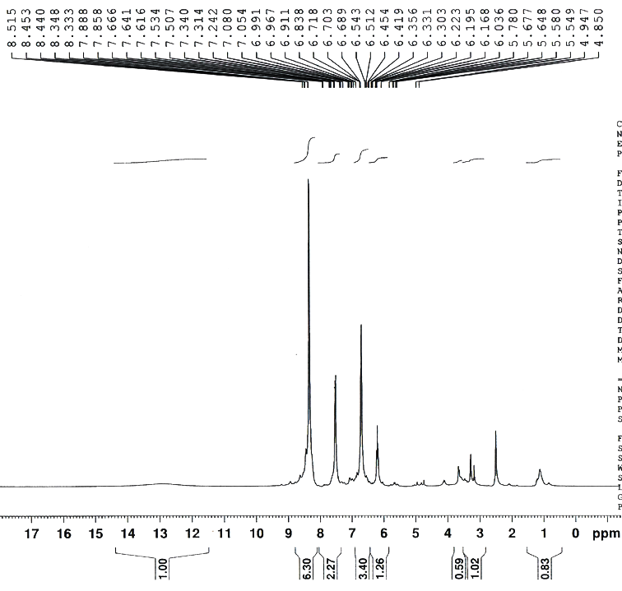

Fig. (1): The ¹H-NMR spectrum of ligand (L)

Table (2a): ¹H-NMR Chemical Shifts for Ligand (L) (ppm in D₂O)
H–C=N | 3H Aromatic protons | COOH
(8.5) ppm. | (6.30 – 7.88) ppm. | 12.5 ppm.
Table (2b): ¹³C-NMR Chemical Shifts for Ligand (L) ( ppm in D₂O)
H–C=N | COOH | Aromatic carbons of pyrimidine
(160.28) ppm. | (173) ppm. | 114.20

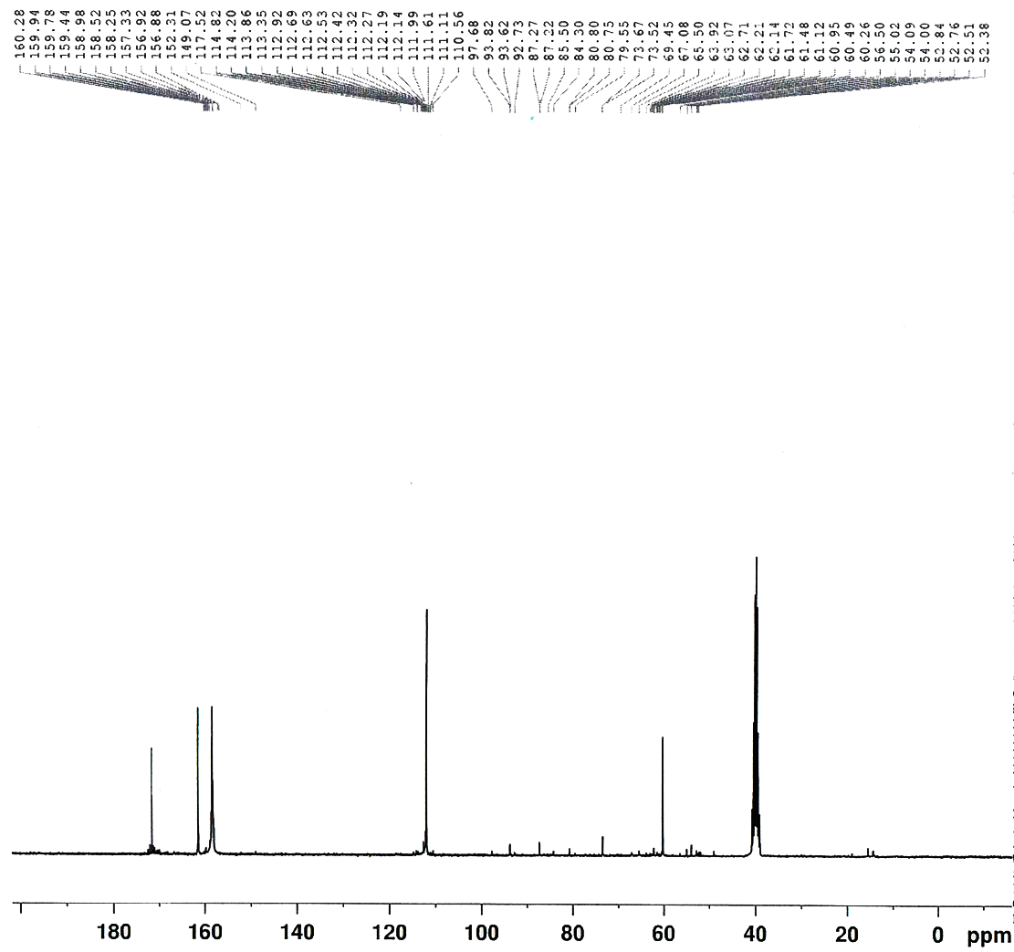

Fig. (2): The ¹³C-NMR spectrum of ligand (L)

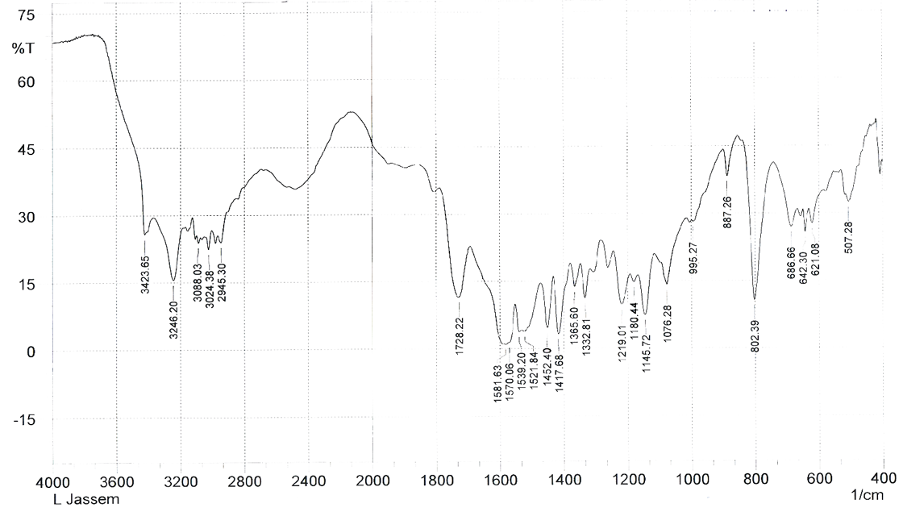

Fig. (3): The IR spectrum of ligand (L)
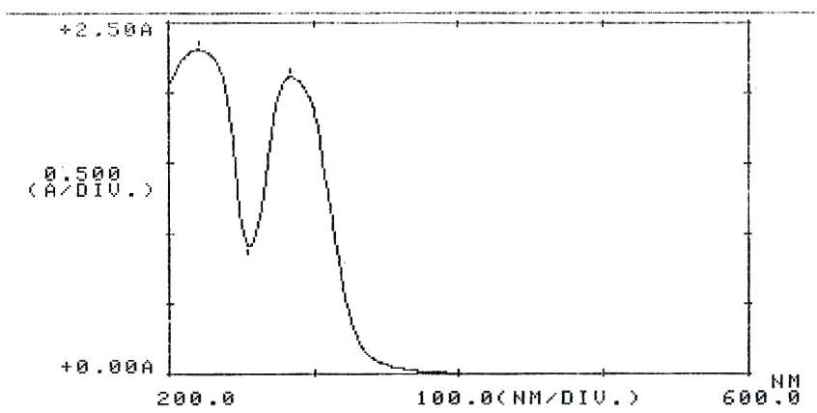

Fig. (4): Electronic spectrum of the ligand (L)

The IR, UV spectral and magnetic moments of complexes
The isolated ligand was subjected to elemental analysis (C,H,N). The metal analysis in the isolated complexes were done by A.A., giving L.Mx.nH₂O.
The data of the IR spectra of the ligand (L) and its complexes are listed in Table (3).
The IR spectra of the complexes for example Fig. (5) are compared with those of the free ligand (L) in order to determine the coordination sites that may involved in chelation. The spectrum of the ligand (L) contained a band at 1581 cm^{–1}, υ(HC=N), which shifted to lower values by (6-42) cm^{–1} in the complexes suggesting that the ligand (L) coordinate to the metal ion through azomethine^{[14-16]}. The spectra of these complexes exhibited a broad band around (3442- 3200) cm⁻¹ assigned to water, υ(OH), associated with the complexes in addition to these modes, coordinated water exhibited (H₂O) rocking at (790-777) cm^{-1[17]}. The free ligand (L) exhibits strong absorption band at 1219 cm^{–1} is due to the stretching vibration of carboxyl group. This band is disappeared and two new bands appeared in all complexes, in the range (1494–1450), (1363- 1354) cm^{–1} with Δυ = (134- 91) cm⁻¹ are due to the υ_{asymm}. (COO–) and υ_{symm} (COO–) and the value of Δ υ indicates the carboxylate group is coordinated to metal ions as a monodentate fashion^{[14-15]}.
New absorption bands υ(M–N), υ(M–O) appeared at (520- 505), (472- 418) cm⁻¹ in the spectra of the complexes^{[13,6]}, which support the coordination of the ligand (L) through the nitrogen of azometheine and the oxygen of carboxylato ion. In case of Pb(II) nitrato complex, the presence of band at 1270 cm^{–1} is due to the monodentate-ONO₂-group^{[18]}.

Table (3): Infrared spectral data (wave number –) cm^{–1} for the ligand, precursors and its complexes
Compound | υ(OH) | υ(NH₂) | υ(C=N) | υ(C-H)  Aromatic | υ(C=O) | υ_{assmm.} COO– | υ_{symm.} COO– | Δυ  cm^{–1} | Coordinate water | M-N | M-O
Glyoxylic acid | (3361)b | - | - | - | (1745)s | - | - | - | - | - | -
Pyrimidine-2-ylamine | - | (3329)s  (3169)s | - | (3050)w | - |  | - | - | - | - | -
L=C₆H₅N₃O₂ | (3246)s  3423 | - | (1581)m | (3088)w | 1728 | 1219 | - | - | - | - | -
[LCo.2H₂O]Cl | (3323)b | - | 1539 | 3097 | - | 1458 | 1354 | 104 | 777 | 505 | 418
[LNi.4H₂O]Cl | (3332)b | - | 1541 | 3093 | - | 1462 | 1357 | 105 | 788 | 516 | 439
[LCu.4H₂O]Cl | 3300 | - | 1540 | 3060 | - | (1494)w | (1360)w | 134 | 750 | 510 | 420
[LCd.2H₂O]Cl | 3396 | - | 1564 | 3097 | - | 1450 | 1359 | 91 | 790 | 513 | 472
[LHg.2H₂O]Cl | 3342 | - | 1568 | 3093 | - | 1456 | 1355 | 101 | 790 | 520 | 455
[LPb.2H₂O]NO₃ | (3320)m | - | 1575 | 3097 | - | 1466 | 1363 | 103 | 779 | 505 | 457
Where: w = weak, b = broad, s = strong, m = medium,.

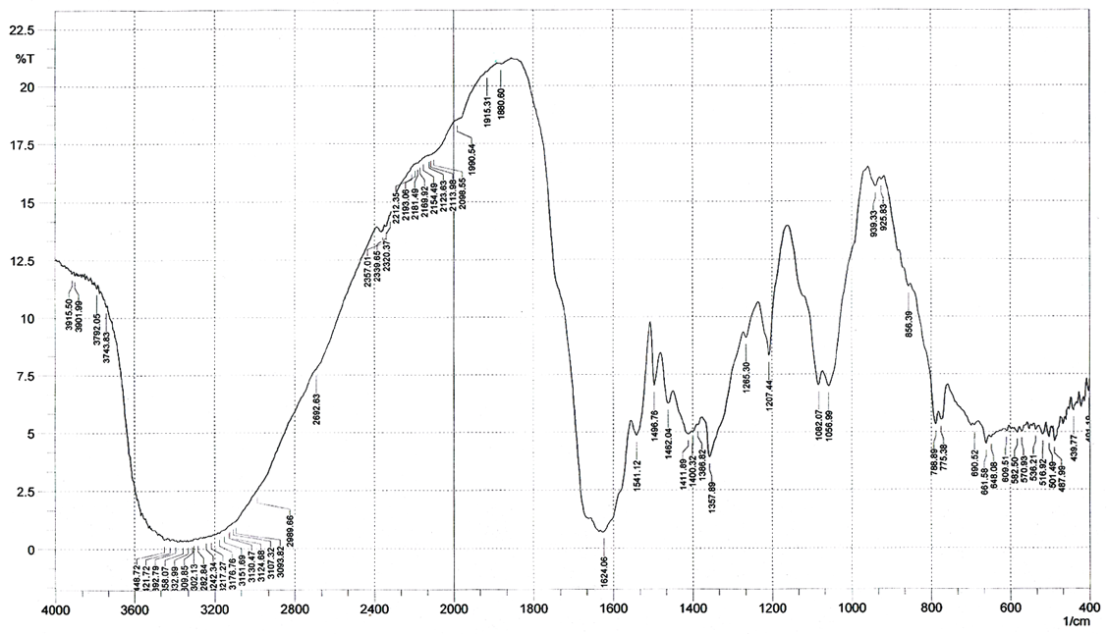

Fig. (5): The IR spectrum of [LNi.4H₂O]Cl complex

The electronic absorption of Co(II) complex (blue colour) in DMSO solution Table (4), resolved multiple bands at (614) nm and (680) nm centered at (647) nm (15455) cm⁻¹ (ε_{max}=800 molar^{–1} cm^{–1}) which assigned to ⁴T_{1(P)}←⁴A₂ (υ₃) for tetrahedral geometry.

Table (4): Electronic spectral data of the Ligand (L) and its complexes
Compound | λnm | υ– wave number cm^{–1} | (ε_{max} molar^{–1} cm^{–1}) | Assignments | Proposed structure
L=C₆H₅N₃O₂ | 216  289 | 46296  34602 | 2164  1396 | π→π*  n→π* | -
[LCo.2H₂O]Cl | 647 | 15455 | 800 | ⁴T_{1(P)}←⁴A₂ | Tetrahedral
[LNi.4H₂O]Cl | 416  747 | 24038  13386 | 1300  200 | ³T₁g_{(P)}←³A₂g  ³T₁g←³A₂g | Octahedral
[LCu.4H₂O]Cl | 884 | 11312 | 2700 | ²Eg←²T₂g | Octahedral
[LCd.2H₂O]Cl | 300 | 33333 | 1396 | C. T. | Tetrahedral
[LHg.2H₂O]Cl | 320 | 31250 | 1121 | C. T. | =
[LPb.2H₂O]NO₃ | 350 | 28571 | 564 | C. T. | =
Where C.T. = Charge Transfer

The υ₂ (⁴T_{1(F)}←⁴A₂) is usually appeared in the near infrared. The blue colour and magnetic susceptibility measurement (4.80) BM for the solid Co(II) complex is also indicative of three unpaired electrons per Co(II) ions consistent with its tetrahedral environment^{[19]}.
The electronic absorption of Ni(II) complex (pale green) in DMSO is shown in Fig. (6) gave one peak at (416) nm (24038) cm⁻¹ (ε_{max}=1300 molar^{–1} cm^{–1}) is assigned to ³T₁g_{(P)}←³A₂g, (υ₃) and doublet peaks at (707 and 786) nm centered at (747) nm (13386) cm^{–1} (ε_{max}=200 molar^{–1} cm^{–1}) is assigned to the ³T₁g←³A₂g (υ₂) for octahedral geometry.
The value of (υ₁), B complex and β can calculated as below:

$\frac{υ_{3}}{υ_{2}}=\frac{\text{24038}}{\text{13386}}=1\text{.}\text{79}$
Form appendix Fig. (7).
$$\begin{aligned}E=\frac{υ_{3}}{B_{\text{complex}}}=\text{25}\text{and} \frac{Δ_{0}}{B_{\text{complex}}}=\text{10} \\ ∴\frac{\text{24038}}{B}=\text{25}\end{aligned}$$
$$B_{\text{complex}}=\frac{\text{24038}}{\text{25}}=\text{961}$$
$$β=\frac{B_{\text{comp}\text{.}}}{B_{\text{free metal}}}=\frac{\text{961}}{\text{1030}}=0\text{.}\text{93}$$
$\begin{aligned}\frac{Δ_{0}}{B_{\text{complex}}}=\text{10}; \\ \frac{Δ_{0}}{\text{961}}=\text{10}\end{aligned}$
Δ₀ (υ₁) = 9610 cm^{–1}

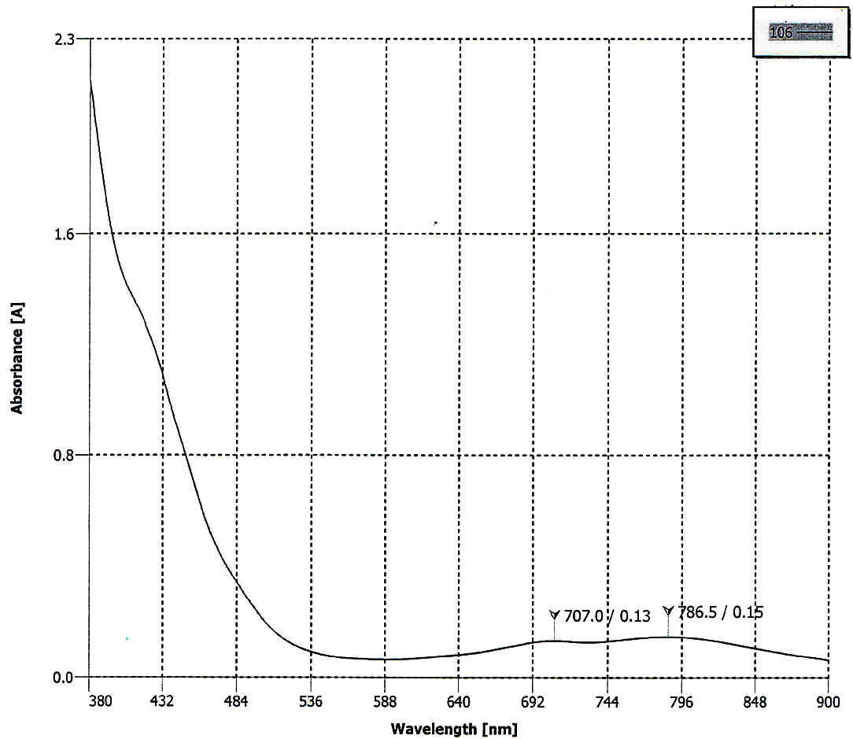

Fig. (6): Electronic spectrum of [LNi.4H₂O]Cl complex

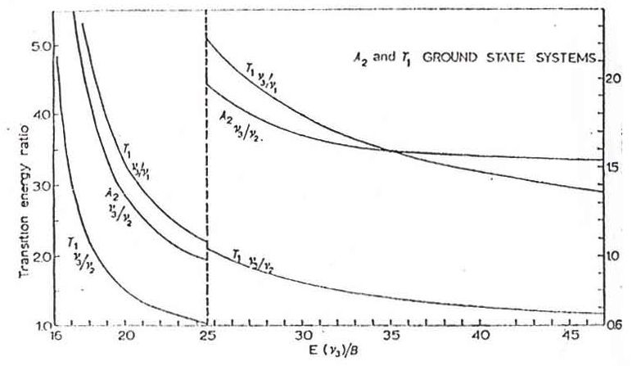

Fig. (7): A₂ and T1 ground states, transition energy ratios versus E(v3)/B (range 16-47). Note that the left-hand ordinate refers to E(v3)/B (16-24.6) and the right-hand ordinate to E(v3)/B (24.6-47) Co and Ni complexes

The value of μ_{eff} for the solid Ni(II) complex is (3.10) B.M. is also indicative of two unpaired electrons per Ni(II) ion consistent with its octahedral geometry^{[20]}. The electronic absorption of Cu(II) complex (green colour) gave broad band centered at (884) nm (11312) cm^{–1} (ε_{max}=2700 molar^{–1} cm^{–1}) the ion in fact, is tetragonaly distorted, presumably of the operation of the Jan Taller effect which assigned to ²Eg→²T₂g transition. The magnetic susceptibility measurement is (1.85) BM is supported of one unipair electron of per Cu(II) ion is quite fit with octahedral geometry^{[21]}. The electronic spectra of the metal complexes M^{II}= Cd, Pb, Hg Table (4) showed shift in n–π* absorption and tail (300-350) nm consistent metal ions with coordination ligand from their elemental analysis Table (1) and UV- visible spectral tetrahedral structures were proposed for them^{[22-23]}.

Solutions chemistry
Molar ratio
The complexes of the ligand (L) with selected ions (Co⁺², Cd⁺²) were studied in solution using water as solvents, in order to determine (M:L) ratio in the prepared complexes, following molar ratio method^{[24]}.
A series of solutions were prepared having a constant concentration (C) 10^{–3} M of the hydrated metal salts and the ligand (L). The (M:L) ratio was determined from the relationship between the absorption of the observed light and mole ratio (M:L) found to be (1:1). The result of complexes formation in solution are show in Table (5–6), Fig. (8).
To determined ΔG^{[25]}:
k = ML/[M][L] (1)
α = (Am – As)/ Am (2)
k = The equation (1) is written to mole ratio (1:1) as the following
k_{f} = (1 – α)/ α²C (3)
Λ = ε_{max}.b.c. (4)
k_{f} = stability constant
α = decomposition Degree
M = metal ion
L = The ligand
[ ] = concentration
As = The absorption of the equivalent point of mole ratio
Am = The maximum absorption of the mole ratio
C = The complex concentration (mole. L^{–1}).
Δ G = - 2.303 RT Log K.
R = 8.303
T = 273 + 25 = 298
The values of As, Am, α, k, log k and ΔG are presented in Table (6).
Molar conductivity for the complexes
The molar conductance of the complexes in (water), Table (7) lie in the (135-162) S. cm² molar⁻¹ range, indicating their electrolytic nature with (1:1) ratio^{[26]}.

Table (5): VM, VL and absorption of ligand (L). VM= volume of metal in ml, vl= Volume of ligand in ml
[LCo.2H₂O]Cl at (291)nm |  |  | [LCd.2H₂O]Cl at (291)nm
VM | VL | Abs | VM | VL | Abs
1ml | 0.25 | 0.500 | 1ml | 0.25 | 0.507
1 | 0.50 | 0.804 | 1 | 0.50 | 0.801
1 | 0.75 | 1.102 | 1 | 0.75 | 1.102
1 | 1.00 | 1.301 | 1 | 1.00 | 1.405
1 | 1.25 | 1.402 | 1 | 1.25 | 1.431
1 | 1.50 | 1.502 | 1 | 1.50 | 1.526
1 | 1.75 | 1.604 | 1 | 1.75 | 1.602
1 | 2.00 | 1.701 | 1 | 2.00 | 1.701
1 | 2.25 | 1.803 | 1 | 2.25 | 1.780
1 | 2.50 | 1.902 | 1 | 2.50 | 1.830

Table (6): stability constant and G for the Ligand (L) complexes
Compounds | As | Am | α | K | Log K | ΔG
[LCo.2H₂O]Cl | 1.301 | 1.701 | 0.235 | 13×10⁸ | 9.11 | –51.9
[LCd.2H₂O]Cl | 1.405 | 1.701 | 0.296 | 8×10⁸ | 8.90 | –50.7
[LCo.2H₂O]Cl > [LCd.2H₂O]Cl
Table (7): The molar conductance of the complexes
Compound fragmentations | Λm S.cm² molar^{–1} | ratio
[LCo.2H₂O]Cl | 150 | 1:1
[LNi.4H₂O]Cl | 162 | 1:1
[LCu.4H₂O]Cl | 140 | 1:1
[LCd.2H₂O]Cl | 155 | 1:1
[LHg.2H₂O]Cl | 140 | 1:1
[LPb.2H₂O]NO₃ | 135 | 1:1
Recorded in (water) solvent, where L= C₆H₅N₃O₂

Fig. (8): The mole ratio curves of complexes [LCo.2H₂O]Cl and [LCd.2H₂O]Cl in solution
(1×10⁻³ mole. l⁻¹) at (λ=291 nm)

Conclusion
In conclusion, we have prepared new Schiff base ligand (L). The elemental analysis (C,H,N) gave formula C₆H₅N₃O₂. Spectroscpic (FT-IR, ¹H, ¹³C-NMR) data showed the structure of the ligand contain azomethine and carboxylic groups. The metal complexes [ML.nH₂O]Cl [M^{II}=Co, Ni, Cu, Cd, Hg and Pb] are confirmed by elemental analysis (C,H,N) and metal content (A.A.). Spectroscopic, structural, conductivity and magnetic data show the metal ions are coordinated by azomethine–N and mono carboxylate–O.
The [ML.nH₂O]Cl, [M^{II}= Co, Cd, Hg and Pb] have tetrahedral structure, while [ML.nH₂O]Cl, [M^{II}=Ni or Cu] are octahedral structural as below:

M^{II}=Co, Cd, Hg and Pb
X=Cl– for all metal ions except Pb
where X = NO–₃
M^{II}=Cu or Ni
Structures of the complexes
(Octahedral)
(Tetrahedral)

References
- Markandan, U. and Rangappan R., J. Chem. Bio. Phy. Sci. Sec. A., 2012, 2 (2), 677-682.
- Kalpesh, S. Parikh and Sandip P. Vyas., Synthesis and spectral studies of some novel Schiff base derived with pyrimidines, derpharmacia letter, 2012, 4(2), 638-640.
- Mamdouh, S. Masoud, Sawsan S. Haggag, Zenat M. Zeki and Mohamed El- Shabasy, An International Journal for Rapid Communication, 1994, 27 (6), 775-786.
- Jasim, Sh. S., (2012), Synthesis, Characterization Of New Schiff Base And Some Metal Complexes Derived From Glyoxylic Acid and O-Phenylenediamine, (to be published), Ibn-Al-Haitham, University of Baghdad.
قبل للنشر في مجلة ابن الهيثم للعلوم الصرفة والتطبيقية 2/1737 في 7/8/2012
- Falih, H. M. and Jasim, Sh. S. (2012), Synthesis and Characterization of [2-(carboxy methylene-amino)-phenyl imino] acetic acid (L) and its some metal complexes, (to be published).
- Silverstein, M. R. G. C. Bassler and Morrill T. C. (1981), "Spectrometric Identification of Organic Compounds", 4th ed., John Wiley and Sons, New York.
- Tajmir, R. , J. Inorg. Biochem, 1990, 40, 181-188.
- Tajmir, R., Int. J. Inorg. Biochem, 1991, 42, 47-55.
- Sajjad, M.; Shokoh, B. and Asad, Sh., transition met Chem., 2011, 36, 425-431.
- Raj, K. D. and Sharad, K. M., Journal of Coordination Chemistry, 2011, 64 (13), 2292-2301.
- Mishchenco, A. V.; Lukov, V. V. and Popov, L. D., Joural of Coordination Chemistry, 2011, 64 (11), 1963- 1976.
- Arif, M.; Qurashi, M. M. R. and Shad, M. A., Journal of Coordination Chemistry, 2011, 64 (11), 1914-1930.
- Fleming and Williams D. H., (1966), "Spectroscopic methods in organic chemistry", Ed. McGraw Hill publishing company ltd, London.
- Cemal, S.; Zeliha, H. and Hakan, D., Journal of Molecular structure, 2011, 977, 53- 59.
- Geeta, B. and Ravinder, V., Chem.., pharm. Bull., 2011, 95 (2), 166-171.
- Bahel, S. C., Dubby B. L., Nath N., Tripatihi A. and Srivastava J. K., J. Indian Chem. Soc., 1982, 1127-1129.
- Hana, F. and Mohamed M. O., European J. of Chem., 2011, 2 (2), 178-188.
- Shaymaa, H. Naji, Majid S. Jabir and Falih. H. Musa, Journal of Al- Nahrain Univeristy, 2011, 14, 25-37.
- Lever, P. A. B. (1968), "In organic electronic spectroscopy", Elsevier publishing company, New York, 6, 121.
- Orgel, L. (1966), "An Introduction to Transition Metal Chemistry", 2nd ed, Wiley, New York.
- Kamellia, N. and Razie, S., Journal of Coordination Chemistry, 2011, 64(11), 1859-1870.
- Choi, K. Y.; Jeon, Y. M.; Lee, K. C.; Ryu, H.; Suh, M.; Park, H. S.; Kim, M. J. and Song, Y. H., Journal of Chemical Crystollography, 2004, 34 (9).
- Rakesh, K. Sh.; Munirathnam, N. and Ashoka, G. S., Tetrahedron; Asymmetry, 2008, 19, 555–663.
- Skoog, D. A. and Donald, M. (1974), Fundamentals of Analytical chemistry Altoit London Edition.
- Farrington, D. and Robert A. (1975), "Physical Chemistry", 4th ed.
- Kettle, S.F. (1975), "Coordination Compounds", Thomas Nelson and Sons, London, P. 165.

