Study of the sorption kinetic of Fe (III) by poly(Hydroxamic acid) chelating exchanger prepared from poly (Styrene-Co-Ethylacrylate)
Sadda Abed Abedullah Jamal
Chem.Dept, Education Collage For Women, Al-Anbar Univ.
E-Mail: sadda_ab@yahoo.com

(NJC)

(Recevied on 12/4 /2012 ) (Accepted for publication 17/6/2012)

Abstract
The aim of this research is showing the preparation of poly(Styrene-Co-Ethyl acrylate) which obtained by a free radical initiation process for co-polymerization between Ethlyacrylate and styrene with a mixing ratio (1:1) using benzoyl peroxide as an initiator at (70°c) and (10% ) ratio of conversion. Conversion of the ester group of the (CPS-EA) in to hydroxamic acid was carried out by treatment of (CPS-EA) with hydroxyl amine hydrochloride in alkaline medium at (pH=13) using sodium hydroxide. The poly hydroxamic acid was identified by (FT-IR) spectroscopy: Sorption capacity (q_{e}) of the metal ion (Fe³⁺) was determined This study also shows the effect of initial (pH), temperature and time on the sorption capacity of (Fe³⁺ ) by (PHA).The sorption capacity of (Fe³⁺) on to (PHA) resin which decrease as temperature increases indicates that the sorption was exothermic process . The values of (∆G°) was negative, showing that the sorption of (Fe³⁺) on to (PHA) resin is spontaneous .
Key words: Poly Hydroxamic acid ,Hydroxamic acid.
الخلاصة
يتضمن البحث تحضير البوليمر المشترك (ستايرين - أثيل أكريلات) وذلك باستخدام ميكانيكية الجذور الحرة للبلمرة المشتركة بين الستايرين و أثيل اكريلات وبنسبة خلط مولية (1:1) وبواسطة بيروكسيد البنزويل كبادئ وبدرجة حرارية (70°c) وبنسبة تحول (10%). ثم تم تحويل البوليمر المشترك الناتج الى بولي حامض الهيدروكساميك وذلك بمفاعلة البوليمر المشترك (ستايرين- أثيل اكريليت) مع هيدروكسيل أمين هيدروكلورايد في وسط قاعدي قوي(pH 13 ) باستخدام هيدروكسيد الصوديوم مع اجراء تصعيد حراري بدرجة (70°c) ولمدة (18) ساعة . تم تشيخص المركب الناتج باستخدام طيف الأشعة تحت الحمراء (FT-IR). تم تعيين سعة الأحتجاز (sorption Capacity ) لأيون الحديديك بوساطة بولي حامض الهدروكساميك . وكذلك تم دراسة تأثير الدالة الحامضية (pH ) وتركيز( Fe³⁺) ودرجة الحرارة على سعة الأحتجاز( q_{e} ) بوساطة بولي حامض الهيدروكساميك .وقد تبين أن سعة الأحتجاز لأيون ( Fe³⁺) بوساطة بولي حامض الهيدروكساميك تقل بارتفاع درجة الحرارة , ويستدل من ذلك أن عملية الأحتجاز هي عملية باعثة للحرارة . ومن قيم G°)∆) السالبة , تين ان عملية الأحتجازلأيون (Fe³⁺) بوساطة بولي حامض الهيدروكساميك هي عملية تلقائية .

Introduction
The hydroxamic acid group is well-known for its ability to form a stable chelates with various heavy metal ions, particularly iron ^{(1,2)}.The hydroxamic acid is regarded as derivatives of the nitrogone- bound hydrogen in the hydroxylamine molecules, and has a general formula R-CO-NHOH (R=alkyl or aryl) having a tautomerism of keto and enol forms⁽³⁾.
The stability is due in part to the geometry, where three hydroxamic acid units are spaced in such a way that can easily orientation a single iron (III) to satisfy the octahedral requirement of (3:1) iron (III) complex⁽⁴⁾.A number of poly (hydroxamic acid) resins have been synthesized by various methods and for various purposes ⁽⁵⁾.Synthesized the resins from poly methacrylate and studied the sorption of Fe⁺³,Cu⁺²,Ag⁺, Zn⁺², Hg⁺²,Al⁺³,Pb⁺² and TiO⁺² Petrie et al.⁽⁶⁾. Poly (hydroxamic acid) resins synthesized from Amberlite IRC-50 Wan Yanus⁽⁷⁾ studied the separation of Fe⁺³and Al⁺³ from Ca⁺² and Mg⁺² using poly (hydroxamic acid) resins. Katoh and Coworkers ⁽⁸⁾ synthesized resin from acrylonitrile and divinyl benzene and studied the structure of resin and the recovery of UO₂²⁺ from sea water. The newer chelating ionexchange resin,the preparation of this chelating Poly(Hydroxamic acid) resin from Copoly(Acrylamid Divinyl Benzen) and acryl Hydroxamic acid and with divinyl Bezene grafted sag starch is anew starting polymer to obtanin this resine ⁽⁹⁾. The chelating resins containing Hydroxamic acid group can also play avital role in environmental monitoring of toxic trace metals . There is also apossibility of using poly (Hydroxamic acid )resin to extract rare from sea water ⁽¹⁰⁾. The poly (Hydroxamic acid ) can be used to measure many elements quantitativdy in chromatography and for separation of various ions such as iron (III) Copper(II) Cobalt(II) and Lead(II) in biological and sensitive solutions ⁽¹¹⁾ .
Experimental Preparation of poly (styrene-Co-Ethyl acrylate):
The Co-poly (St-EA) was prepared by free radical solution polymerization.For the preparation of 18% styrene – cross linked polymer Ethylacrylate (13.27 gm) and styrene (7g). Benzoyl peroxide (200mg) was added, and the mixture was heated with stirring at (70°c) under N₂ atmosphere for 4hr. The polymer was collected by filtration, washed several times with water, ethanol, benzene and dried at 60°c^{(12,13) .}
Preparation Of Poly (hydroxamic acid):
The preparation of chelating resin was carried out by the reaction between poly (St-Co-EA) with hydroxylamine. Hydroxylamine was prepared by dissolving (21g) of hydroxylaminehydrochloride(NH₂OH.HCl) in (150 ml) aqueous ethanol solution (ethanol water 5:1). The HCl was neutralized by NaOH solution and the precipitate of NaCl was removed by filtration. The pH of the mixture was adjusted to pH 13 by addition of 1M sodium hydroxide solution about (10g) of poly (S-Co-EA) was placed in a two-neck round bottom flask ,which was equipped with a mechanical stirrer and condenser. Then, 150 ml hydroxylamine solution (prepared earlier) was added into the flask. The reaction was carried out at 75°c for 2hr. The product was separated by filtration and washed several times with ethanolic solution (ethanol: water; 4:1) It was then treated with100ml of methanolic solution of 0.2m HCl for 5minutes. Finally, the fiber product was filtered and washed several times ethanolic solution and dried at 50°c to constant weight ^{(13, 14, 15)}.
Studying characterization of poly(hydroxamic acid):
Determined of sorption capacity for Fe³⁺ by (PHA).
About (1g) of poly (St-Co-EAHA) mixing with (50ml) of (100ppm) Fe³⁺ solution. The mixture of Fe³⁺ solution and poly (St-Co-EAHA) was shaken for about (10)hours, after equilibration, the mixture was filtered was analyzed for Fe³⁺ concentration. The initial and the equilibrium concentrations of Fe³⁺ mg/g resin (PHA) were determined by using(UV.Vis) Spectrophotometer Model Bioteh Engineering Management Co.LTD.(UK) . Sorption capacity was calculated as mg of metal ion sorbed per gram sorbent by using the following equation: ^{(16,17 )}.
Sorption capacity ,q= (C_{o}-_{e})V/M…..(1)
Where q(mg.g⁻¹) is the amount of metal ion sorbed; C_{o} and C_{e} are initial and equilibrium concentration of the metal ion in solution (mg/L) respectively; V(L) is the solution volume and M (g) is weight of the sorbent poly(St-Co-EAHA).
The sorption was obtained by shaking about 1g of poly(St-Co-EAHA) in 50ml of Fe³⁺ solution of different concentrations (10,20,30,40 ,50,60,70,80,90,100ppm) for 5h at pH 6 and at 25°c . The initial and the equilibrium of Fe³⁺ concentration were measured and sorption capacity was calculated as above. The effect of pH on the Fe³⁺ sorption was studied by equilibrating 1g of poly (hydroxamic acid) in 50ml of 100ppm Fe³⁺solution at ( pH 1-8 ) by using sodium acetate buffer solution⁽¹⁸⁾. The kinetic study was carried out by shaking about 1g of poly(St-Co-EAHA) sorbent into 50ml of (100ppm) of Fe³⁺ at various time periods ,(10 – 300 min) at 25 °c. The effect of temperature on the Fe³⁺ sorption was studied by equilibrating 1g of poly (hydroxamic acid) in 50ml of 100ppm Fe³ solutions at (10,25, 50,70 °c).
Results and Discussion
Characterization of poly (hydroxamic acid).
The poly(styrene–Co-Ethylacrylate) which obtained by a free radical initiating process for Co-polymerization between styrene and ethylacrylare with a mixing ratio(1:1), using benzoyl peroxide as an initiator at (70°c) under N₂ atmosphere by ratio of conversion (10%). The poly (St-Co-EA) was identified by (FTIR) spectroscopy. (FTIR) spectra Fig(1) of poly (St-Co-EA) graphed shows a new absorption bonds at (1714cm⁻¹) of C=O (2954 cm⁻¹) of (C-H),and (1389 cm⁻¹) of (C-O). Poly (hydroxamic acid) prepared via a conversion of the ester group of the poly (St-Co-EA) into hydroxamic acid was carried out by treatment of poly (St-Co-EA) with hydroxyl amine hydrochloride in alkaline medium at (pH13) using sodium hydroxide. Poly (hydroxamic acid) was synthesized by the general techniques previously employed⁽¹⁶⁾.
The poly (hydroxamic acid) was identified by (FTIR) spectroscopy. The infrared spectrum Fig(2) of (PHA) resin showed the characteristic absorption bands of hydroxamic (O-H), amide (N-H),carbonyl (C=O) and (N-O) groups at (3200,3444, 1670 and 930 cm⁻¹).
This means that the formation of chelating complex weakens the double bonding character of carbonyl group in the hydroxamic acid owing to the Co-ordinate bond between oxygen atom of carbonyl groups and metal ions. The weakening of double bonding is more pronounced in chelating with Fe³⁺ complex in (1:3) because Fe³⁺ is a hard acid which Co-ordinates strongly to ligands made up of small nonpolarizable, Highly negative oxygen donor atoms (hard bases)^{(14,17)}. The coordinate between metal ions and poly(hydroxamic acid) now in this structure^{(20,21,27)}.

Sorption of Fe³⁺ by poly (St-Co-EA) hydraxmic acid:
Table (1) shows The initial and the equilibrium metalion concentrations (C_{o},C_{e}) and sorption capacity(q) of Fe³⁺ after treatment with poly (St-Co-EA) hydraxmic acid were determined using standard carve wich is shown in fig(3). The values of C_{o},C_{e} and q were 100 mg/liter ,68 mg/ liter and 1600 mg/g respectively ⁽²²⁾.
Effect of pH on Fe³⁺ Sorption :
Figure (4) shows the effect of pH on sorption capacity of the Fe³⁺ by poly (St-Co-EA) Hdroxamic acid. The sorption capacity was low at pH(1.0) and increased as the pH increased to a maximum at about pH=(6-7) .But sorption capacity will decreased when pH was increase further. The findings indicates that capacity of sorption decreased in alkaline medium . The low sorption capacity of Fe³⁺ by poly(St-co-EA) Hdroxamic acid at pH 1.0 could be due the fact there are more protons at lower pH availabel to protonate ,the active groups of the poly(St-co-EA) Hdroxamic acid surface and compete with Iron ions in the solution . At higher pH values , a greater number of deprotonated Hydroxamic acid fuctionl groups resulted in greater Fe³⁺ ion sorption^{(23,24)} .
Effect of Initial Concentration on Fe³⁺ Sorption:
Fig (5) shows The effect of initial Cocentration on the sorption Fe3+ by poly (St-Co-EA) hydroxamic acid condition 100mg/ liter.It can be seen that q_{e} increases initially with an increase of C_{e} until equilibrium is reached , after q_{e} remains constant. We can conclude that the sorption capacity does not depend on Fe³⁺ concentration , but on the quantity of Poly Hdroxamic acid , that is , Poly Hdroxamic acid ,which bound with Fe³⁺ ion by two oxygen atoms of hydroxamic acid group^{(25).}
Effect of Temperature on Fe³⁺ sorption:
Fig(6) shows the effect contact temperature on sorption capacity of Fe³⁺ by poly(St-Co-EA) hydroxamic acid. The sorption capacity was increased at low temperature and decreased when temperature was increased. The sorption capacity of Fe³⁺ with poly(St-Co-EA) hydroxamic acid increased to a maximum at about temperature 10°c.
Sorption Kinetics :
The kinetics of sorption of Fe³⁺ by poly (St-Co-EA) hydroxamic acid resin was studied at various temperatures . Table (3) shows the effect of contact time on sorption of 100mg/liter Fe³⁺ at 25°c ,50◦c and 70◦c. The sorption is rapid during initial stage and decreases when approaching equilibrium . The pseudo second-order kinetic models (Ho and Mckay 1998) rate constant ,K₂ for the sorption was detrmined using the following equation can be be written as^{(22,23,26)}:
t/q_{t}= 1/k₂ qe² + t/qe ….(2)
where k₂(g.mg⁻¹.min⁻¹) is the second-order rate constant, and q_{t} =(mg g⁻¹) and q_{e}=(mg.g⁻¹) are the amounts of sorption at time (min) and equilibrium, respectively. A polt of t/q_{t} versus time (min) gave a straight line in fig(7) and the values of q_{e} and k₂ were determined from the slope and intercept of the plot, respectively.The values of k₂ and q_{e} were found to be ( 6.75*10⁻⁶ , 8.8*10⁻⁶ ,1,47*10⁻⁵ (g/mg.min) ) , q_{e}=( 2469 ,1874 , 1316.63 ) mg/g, at (25, 50 ,75 ) °c, respectively.
Thermodyamics of the sorption process :
Activation energy:
The activation energy is related to be the rate constant by the Arrhenius equation as shown below ^{(18,22).}
lnk₂= lnA- E_{a}/RT ….(3)
Where A is the Arrhenius factor and E_{a} the activation energy of sorption (kJ.mol⁻¹). From the plot lnk₂ as a function of (1/T) showing in fig (8) the value of activation energy was determined from the slope of straight line and found to be 9.9768 (kJ.mol⁻¹). It is known that when activation energy is low the rate is controlled by intra-particle diffusion mechanism and hence it can be concluded the process is governed by interaction of physical nature.
Thermodyamic Parameters:
The amount of Fe³⁺ sorption at equilibrium was measured at 293, 323, and 348 °K. The equilibrium partition constant K_{d} is calculated as follows^{(17,26 )}:
K_{d}= q_{e}/C_{e} ……(4)
The values of K_{d} where (5.303 ,3.571 and 2.439 ml .g⁻¹) at 25,50 and 70 °c) respectively for sorption of Fe³⁺ by poly(St-Co-EA) hydroxamic acid. The values of K_{d} at initial concentration of 100 mg/liter decreased as temperature increased from (25 to 75 °c),indicating that the sorption is an exothermic process .The relationship between K_{d} and T is given by the vant- Hoff equation ^{(27, 28)}:
lnK_{d}=∆Sº/ R - ∆Hº/ RT ….(5)
Where ∆Sº= standard entropy, ∆Hº = standard enthalpy, T= absolute temperature (K), and R= gas constant. The values of ∆Hº and ∆Sº were calculated from the slopes and intercepts of liner regression of plot of lnK_{d} versus 1/T fig (8 ) respectively . The standard Gibbs free energy ∆Gº ,value was calculated from the equation⁽²²⁾:
∆Gº = ∆Hº - T ∆Sº ….(6)
The values of ∆Hº and ∆Sº were( -6.6512 kJ. mole⁻¹ ) and (-32.279 J.mole.K⁻¹) respectively. Through the negative value of the ∆Hº confimed that the sorption reaction of Fe³⁺ by poly(St-co-EA) Hydroxamic acid was exothermic. The poly (St-co- EA) Hydroxamic acid was more irregular and less randomized . The values of standard Gibbs free energy ∆Gº where(0.2859 , 0.867917and 1.44984 kj.mole⁻¹ ) at 25,50,75 °c)respectively , The values of ∆Gº at initial concentration of 100 mg/liter decreased as temperature increased from (25 to 75 °c)showing that the sorption was spontaneous at all temperatures .
Conclusions
1-The polymers of Hydroxamic acid can be prepared from polymers containe Ester such as poly –acrylate
2-Characterized polymers of hydroxamic acid containg of Hydroxamic acids groups are the selective chelating compounds with most ions of metallic elements such as Iron,Copper ,Lead …∆Gº …….
3-Increase the capacity of sorption of Fe³⁺ on poly (St-co-EA) Hydroxamic acid when pH=(6-7) , and less than high temperature. 4- Sorption of Fe³⁺ on poly (St-co-EMA) Hydroxamic acid followed the second order kinetics ,and the process of sorption of the exothermic, and decline negativity of enthalpy. 5-The value of free energy(∆Gº) for the sorption of Fe³⁺) on poly (St-co-EA) Hydroxamic acid, showing that the sorption process is spontaneous ,

Table (1): The values of C_{o} ,C_{e} and Sorption Capacity (q) of Fe³⁺ by poly (St-Co-EA) Hydroxamic acid condition: Temperature 25cº, concentration of Fe³⁺ 100ppm and time( 10 h)
Metal ion | C_{o} ppm | C_{e} ppm | C_{o} mg/liter *10² | C_{e} mg/liter *10² | Q_{e} (mg/g) *10²
Fe³⁺ | 100 | 88 | 1 | 0.88 | 3

Table (2): Effect time and Temperature on the sorption kinetics of Fe³⁺ by poly (St-Co-EA) Hydroxamic acid condition: pH=7, concentration 100 mg/50ml.
T(◦K) | q_{t} mg/g *10² of Fe³⁺ by PHA at time (min)
T(◦K) | 60(min) | 120(min) | 180(min) | 240(min) | 300(min)
298 | 1.65 | 1.98 | 2.43 | 2.79 | 3
323 | 1.23 | 1.56 | 1.74 | 1.93 | 2,25
348 | 0.84 | 1.24 | 1.57 | 1.86 | 2.13

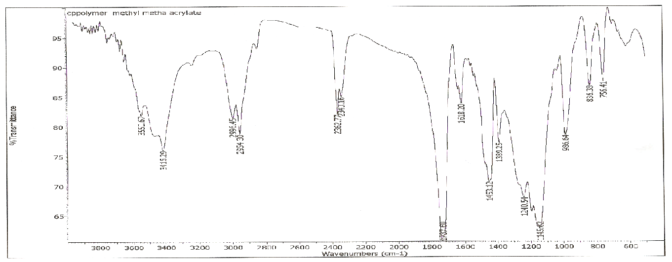
Fig.(1): FT-IR spectra of Pol ( St –co-EA) .
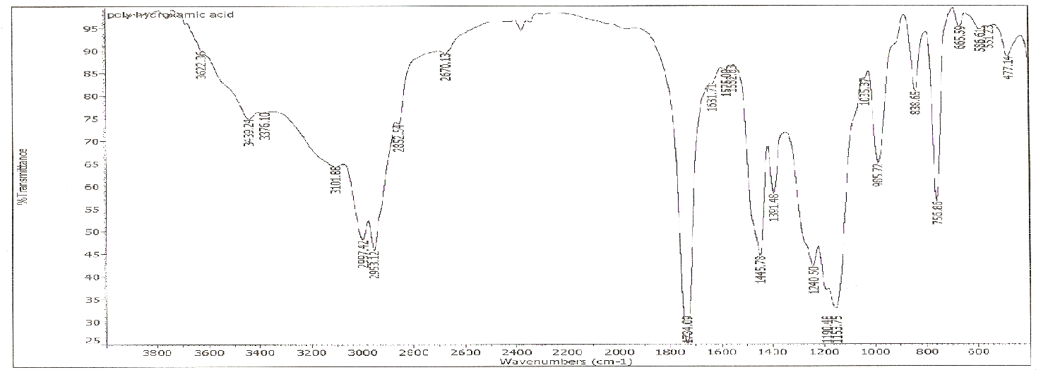
Fig.(2): FT-IR spectra of Pol ( St –co-EA) Hydroxamic acid .

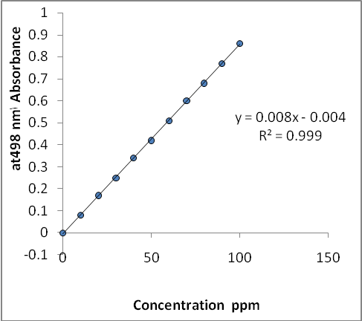  Fig (3):The standard carve for determination equilibriumco Cocentration and capacity sorption for Fe³²⁺ by poly (St-Co-EA) hydroxamic acid condition:  0.1M KCN=5 cm ³,Total volume=25cm³ and Wave Length =498 nm |  | 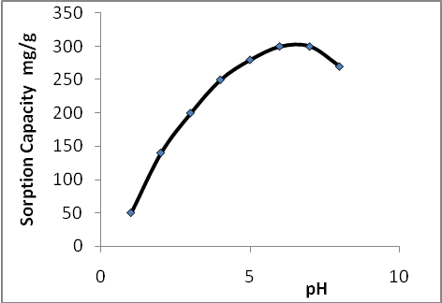  Fig (4): The effect of initial pH on the sorption Fe³⁺ by poly (St-Co-EA) hydroxamic acid condition 500mg/l; contact time 15h; temperature 25°c.
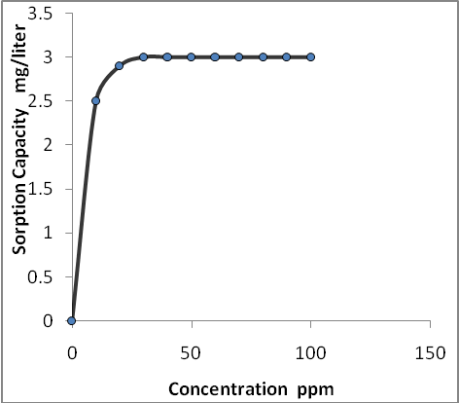  Fig (5): The effect of initial Cocentration on the sorptionFe³⁺ by poly (St-Co-EA) hydroxamic acid condition 100mg/ l: contact time 5h; temperature 25°c.  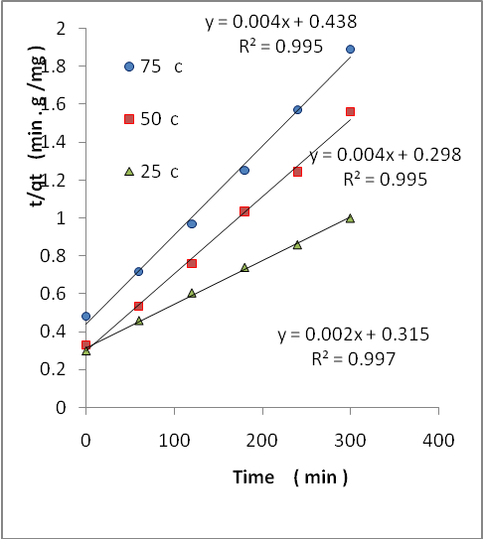  Fig(7): Second order kinetic plots for sorption of Fe³⁺ by poly (St-Co-EA) hydroxamic acid resin at various temperatures . | 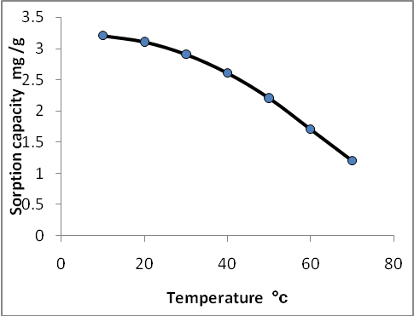  Fig (6): The effect of initial temperature on the sorption capacities of Fe³⁺ by poly (St-Co-EA) hydroxamic acid condition: Conc. 100mg/Liter,  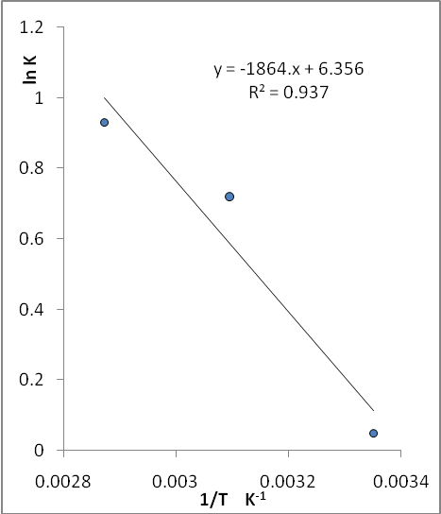  Fig (8): Arrhenius plot for second order react constant, k₂ contact time 5h,

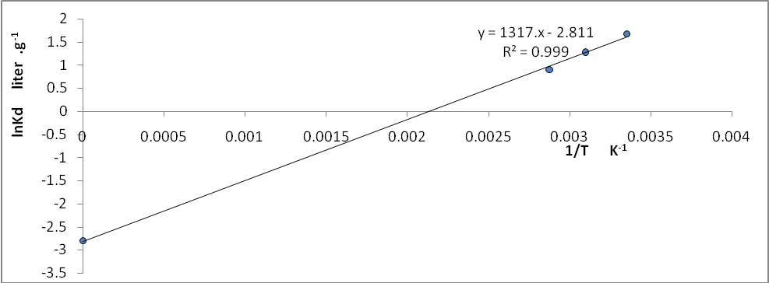
Figure (9 ): Vant Hoff plot for the sorption of Fe³⁺ by poly (St-Co-EA) hydroxamic acid resin at various temperatures.

References
1-Crumbiss,A.L., "Handbook of Microbial Iron Chelate"; Ed.G. CRC Press, New York, (1991)
2- Manisha, A.A., Jeena, H., and Rama, P., J. Phys. Org. Chem., 1999, 12, 103.
3- Shigeke, H., and Yushin, N., J. Chem. Soc. Perkin Trans., 1996, I.
4- Hoffman, R.V., Naygar, N.K., and Wenting, C., J.Am. Chem. Soc., 1993, 115, 5031.
5- Lipezynska, K.E., and Iwamura, H., J. Org. Chem., 1982, 47, 5277.
6- Petrie,G., Lockc,D.,and Meloan,C,E., Anal Chem, 1995, 37,919.
7- Wan Yun., Ph.D .Thesis Salford,(1980).
8- Ji, G.J.; Xue, C.B., Zeng, J.N.; Li, L.P., Chai, W.G., and Zhao, Y.F., Synthesis, 1988, 444.
9-Omara,H.A., Hassan ,K.F., Kandil, S.A., Hegazy,F.E., and Saleh,Z.A., Radionuclide Acta, 2009, 97(9), 467-471.
10-Sophiamma,P.N.,and Sreekunar,K., J.Appl.polm.Sci., 1996, 62, 1753.
11- Baya,C.A. and, Simunic,J., JInorg. Chem., 1990, 29, 1090-1092.
12- Shen, G., and Huan,G., J. Biochem pharmacol, 2007, 73(12), 1901-1909. Epub.
13- Suzuku,M., Endo,M., and Shinhara,F., Cancer Chemother Pharmacal, 2009, 64(6), 1115-1122, Epub.
14- Pyriadi, Thanun, M. A.; Pratical Polymer Chemistry, 1985, 99.
15- Ferruti, P.; and Bettelli, A., J. Polymer.,1972, 13, 462.
16- Khodada, R.; Fakhri, S. A.; and Entezami, A. A.; Iranian Polymer Journal,1995, 4, 242 – 274.
17- Rikiishi ,H., Shionohara ,F., Satto , Y., and Suzuku,M., Int. Joncol , 30 (5) : p( 1181-1188) , (2007).
18- Haron ,M,J., Shah,I.I., and Wan,W.Z.,m., The Malaysian Journal of Analytical Sciences ,Vol 10,No 2 p :261-268 ,(2006) .
19- Dursun ,s., and Yasemin ,C.I., J Polymer- Plastics Technology and Engineerig ,45:p: 729-734 .(2006) .
20 – Hossein, H., and Ali,K.E., Iranian Jornal of polymer Sciences and Technology ,Vol 4 No 2 (1995).
21- Taek ,S.L., and Suny, H., Jornal of polymer Builletin .32 ,p: 273-279 ,(1994).
22- - Haron ,M,J., Maiati,T.,Nor, A.I., Anuar,K., and Wan, Y.m., BioResources,4(4),p: 1305-1318.(2009).
23- Wan Ngah ,W.S., and Hanafiah, M.A., Journal of Environmental Sciences ,20 ,p:1168-1176, (2008).
24- Raju,G., Ratnam,C.T., Ibrahim, N.A., Rahman, M.Z.A., and Wan Yunus,W.M.Z., Technology and Engineerig ,46 (10),p : 949-955 ,(2007).
25- Ucun ,H., Aksakal,O., and Yildz,E., Journal of Hazardous Materials 161, p: 1040-1045 .(2009).
26 – Taek, S.L., Dong ,W.J., Jai ,K.K., and Sung ,H., Fibers and Polymers ,Vol ,2,No,1 p:13-17.( 2001).
27- Khalde,F.H., Shaban,A.K., Hossam,.M., A.,and Tharwat,S.,Chromatography Research International ,Volume 6,Articale ID 638090,p:doi;10.406 ,(2011).
28-Mohamad,Z.A,Md,L.R.,Md,J.H.,
sidik,s.,wan,M.Z.,W,Y.and Mansor, B.A., Mataysian Journal of Analyticalciences,Vol.7,No.2p.(453-456)(2001).

