Spectrophotometric determination of Chloranil via charge transfer complex formation

Dawood Habboo Mohammed Al -Habboo
Chemistry Department, Education College for Girls
Hiba Abid AlsallamMohamad
Chemistry Department , College of Sciences, Mosul University

(NJC)

(Recevied on 14/4 /2012 ) (Accepted for publication 17/6/2012)

Abstract
A sensitive and economical spectrophotometric method has been developed for the determination of chloranil in pure form. The method is based on the reaction of chloranil as π-acceptor with resorcinol as π-donor to give highly coloured complex species in aqueous solution which absorbs maximally at 495nm. Beer's law is obeyed in the concentration range 2-24 µg ml⁻¹ with high apparent molar absorptivity of 10.03×10³ l.mol⁻¹ cm⁻¹.

Keywords: Chloranil ; charge-transfer complex; resorcinol; aqueous solution

الخلاصة
تم تطوير طريقة طيفية تميزت بالبساطة والحساسية في تقدير الكلورانيل. اعتمدت الطريقة على تفاعل الكلورانيل بوصفه مستقبلا للإلكترونات نوع π مع الريسورسينول بوصفه مانحا للإلكترونات نوع n لإعطاء معقد ملون في المحلول المائي يمتلك أقصى امتصاص عند الأطوال الموجية 495نانوميتر. أمكن تطبيق قانون بير للتراكي 2 - 24 مايكروغرام/مللتر وبامتصاصية مولارية 59,2 × 10³ لتر.مول⁻¹سم⁻¹ .

Introduction
Quinones are compounds of wide occurrence in nature. Their importance in biochemistry is seen as bacteriostatic materials in antifungicidal action in the inhibitory influence on certain enzymes like carboxylase and urease and in the antitumor activity, which makes some quinones useful in cancer chemotheraphy ⁽¹⁾.
Chloranil (tetra chloro–1,4–benzoquinone) forms yellow crystals, which sublime when heated, insoluble in water, prepared by oxidizing phenol with an acid and potassium chlorate. The fungicidal properties of chloranil were discovered in 1937, it is mainly used as a seed protectant. It irritates the eyes, the skin and the respiratory tract and may cause effects on the central nervous system. Exposure at high level may result in unconsciousness. This substance may be hazardous to the environment; special attention should be given to fish. Avoid release to the environment in circumstances different to normal use ⁽²⁾.
Chloranil is used as an oxidizing agent in the organic synthesis especially for dye intermediates and as vulcanization agent. chloranil as a π – acceptor has been used by several workers for spectrophotometric micro determination of amino acids ⁽³⁾ ,proteins⁽⁴⁾, amines⁽⁵⁾,aromatic aldoximes⁽⁶⁾, ampicillin⁽⁷⁾, amoxicillin and neomycin⁽⁸⁾, vitamine B1⁽⁹⁾, paracetamol⁽¹⁰⁾, adrenaline⁽¹¹⁾, chlorpromazin⁽¹²⁾, and related organonitrogen compounds ^{(13 ,14)}, .Few spectophotometric methods have been reported for determination of chloranil^{(1,15,16)}.
This work describes a rapid and simple spectrophotometric method for the determination of chloranil, The method is based on charge transfer complexation reaction of chloranil with resorcinol.

Experimental

Apparatus
All spectral measurements were performed on Shimadzu U.V-visible recording spectrophotometer (U.V-160), pH measurements are carried out using a Philips PW 9420 pH meter.

Reagents
Chemicals used are of the highest purity available.
Chloranil(100µg/ml)solution: A saturated (1×10⁻³M) in ethanol solution was used.
Borate Buffer solution: borate buffer solution of pH 9 is obtained by preparation of (5×10⁻²M) sodiumtetraborate in aqueous solution.

Ethanol: Absolute (99-100 %) is used.

Resorcinol(0.18M):Prepared by dissolving 2g of pure resorcinol in distilled water and diluted to 100ml in volumetric flask.

Recommended procedure

To a series of 25ml volumetric flask , aliquots covering the range of 2-24 µg chloranil are transferred , 1 ml of borate buffer solution and 2 ml recorcinol solution

. The solutions were diluted to the mark with distilled water. The absorbance of each solution was measured at 495 nm versus blank.

Results and Discussion
Absorption spectra
chloranil reacted with recorcinol reagent in the presence of a base and produced a purple color having maximum absorption at 495 nm and against the respective reagent blank .

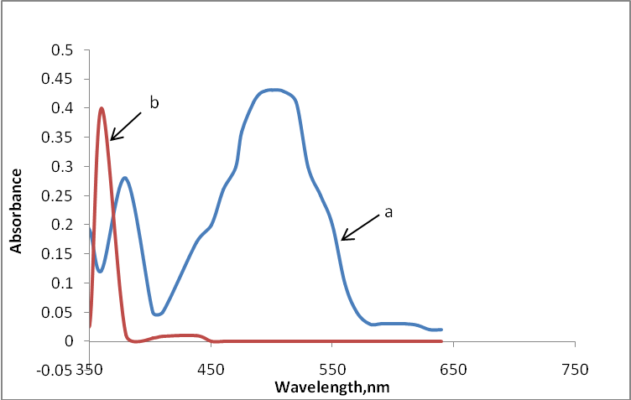

Figure 1. (a)Absorption spectra of chloranil (10 µg/ml) complex with resorcinol reagent
(0.18M) against reagent blank and (b) reagent blank against distilled water.

Study of the optimum reaction conditions
The effect of various parameters on the absorption of the coloured CT complexes formed with chloranil and the reactions conditions have been optimized for chloranil.

1. Effect of pH and buffer solutions on the absorbance
The effect of pH on the absorption of chloranil- resorcinol product using different concentrations of HCl and NaOH of pH ranging from 5-10. It was found that the product chloranil- resorcinol formed in the final pH9 in the presence of sodium hydroxide. Different buffers of pH9 namely bicarbonate, borate, phosphate buffers were prepared to examine the sensitivity of chloranil- resorcinol product. (Table 1) shows that maximum absorption is obtained by using a borate buffer solution. However, the optimum amount of this buffer has been investigated and it was found that 1ml of aliquots gave maximum absorbance and selected in subsequent experiments.

Table 1: Effect of different buffers of pH 9.
Borate | Bicarbonate | Phosphate | Buffer
0.447 | 0.429 | 0.436 | Absorbance

2.Effect of reagent concentration
The effect of changing the reagent concentration on the absorbance of solution containing a fixed amount of chloranil was studied, It was found, as shown in (Table 2), that absorbance increases with increasing resorcinol concentration and reached the maximum value on using 2ml of resorcinol which was used in subsequent experiments.

Resorcinol (0.18M )Ml | 1 | 1.5 | 2 | 2.5 | 3
Absorbance | 0.449 | 0.454 | 0.465 | 0.451 | 0.432

Table 2: Effect of the reagent concentration on absorbance

3. Effect of surfactant

Effect of various anionic, cationic and neutral surfactants including sodium dodecyl sulphate (SDS), cetavlon (CTAB), and triton X-100 were tested for the investigation of the sensitivity of method. The results reveal that the presence of the surfactants has no remarkable effect on the intensity of the colour. Therefore ,the methods have been carried out without using surfactants.

5. Effect of order of addition

In order to obtain the high colour intensity, the order of addition of reagents should be followed as given in the recommended procedures, otherwise a loss in colour intensity was observed.

Quantification and Analytical Data

The results for the determination of chloranil by method is summarized in Table 3, which show the sensitivity, recovery and reproducibility of the proposed methods. These are reasonably precise and accurate. The calibration graph is linear in the range of 1.0 - 36 µgml⁻¹ for method. The apparent molar absorptivities calculated for method 9.94 × 10³l mol⁻¹ cm⁻¹, Table 3 illustrates regression equations, and correlation coefficients (R²) for the proposed methods. The reproducibility of the proposed methods was checked by estimating three different concentration levels within the Beer's law limit in five replicates. The average recovery was 100.49 % reveal good accuracy. The relative standard deviation can be considered to be very satisfactory.

Table 3. Quantitative parameters of the proposed method.

Parameter Values
495 λ _{max} (nm)
Beer's law limits (µg/ml) 2-24
Molar absorptivity (l.mol⁻¹ cm⁻¹) 10.03×10³
Slope, a 0.041
Intercept, b 0.028
Correlation coefficient (R²) 0.9930
RSD# # ≤0.81
Average recovery % 100.49

# Y = aX+ b, where X is the concentration of chloranil in μg ml⁻¹.
# # Average of five determinations.

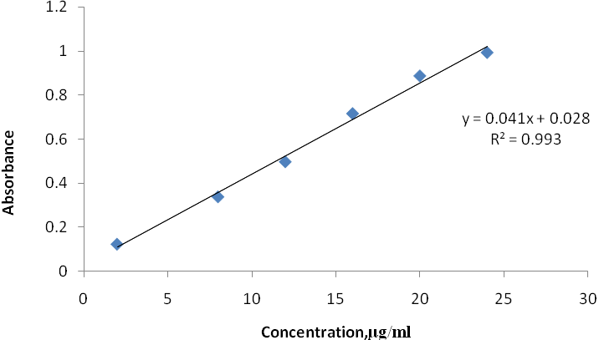 Figure 2: Calibration graphs for chloranil

Stoichiometric Relationship

The stoichiometry of the reaction between chloranil and resorcinol was investigated by Job’s method of continuous variation .The results obtained in figure (3) showed the existence of a 1:1. chloranil: resorcinol

Figure 3. Continuous variation plots of chloranil with
with resorcinol reagent

Precision and accuracy

The accuracy and precision of the proposed methods were estimated by measuring the content of chloranil in pure form at three different concentration levels (low, medium and high) within the Beer's law limit in five replicates , (Table 4 ). The relative standard deviation (representing precision) and mean percent recovery (representing accuracy) obtained by the proposed methods can be considered to be satisfactory.

Table 4 : Test of precision and accuracy of the proposed methods
Proposed method | Amount  added  (µg/ml) | Recovery*  (%) | Average recovery  (%) | RSD*
 | 8 | 101.5 | 100.49 | 1.62
 | 12 | 99.90 | 100.49 | 0.81
 | 20 | 100.09 | 100.49 | 1.43
* Average of five determinations.

Conclusion

The proposed methods are simple, , sensitive and economical and does not require any pretreatment of chloranil or extraction procedure and has good accuracy and precision.

References
- H. Abdollahi and L. Bagheri, "http://www.Analytical sciences.com, (2000), 20.
- L.M. Miall, and D.W.A. Sharp, "A New dictionary of chemistry", 4th Edn., Longman Green &Co. Ltd., (1968), P.133.
- F. Al–Sulaimany and A.Townsend, Anal. Chim. Acta, 1973, 66, 195-198.
- T.S. Al–Ghabsha, and S.A. Rahim, Egypt J. Chem., 1977, 20.
- T.S. Al–Ghabsha, S.A. Rahim, and A. Townsend, Anal. Chim. Acta, 1976, 85, 189.
- T.S. Al–Ghabsha, A. S. Azzouz, and Y. I. Hassan, Anal. Chim. Acta, 1982, 143, 289–292.
- T.S. Al–Ghabsha, T.N. Al–Sabha, and G. A. Al–Iraqi, Micochem. J., 1987, 35, 239–295.
- T.S. Al–Ghabsha, T. N. Al–Sabha, and G. A., Al–Iraqi, Microchem. J., 1987, 35, 323–325.
- T.S. Al–Ghabsha, S.A. Rahim, T. N. Al–Sabha, Microchem. J., 1986, 33, 89–91.
- T.S. Al–Ghabsha, M.Q. Al–Abachi, and A. Kh. Ahmad, Microchem. J., 1987, 35, 66.
- T.S. Al–Ghabsha, M.Q. Al–Abachi, and N.A. Al–Shahbaz, Microchem. J., 1985, 31, 272–274.
- T.S. Al–Ghabsha, S. K. Ibrahim, and M.Q. Al–Abachi, Microchem. J., 1981, 28, 501.
- B.Y. Lin, and K.L. Cheng, " Anal. Chim. Acta., 1980, 120, 335.
- Y. Tashima, H. Hasegawa, H. Yak, and K. Takiura, Japan, Anal., 1970, 43, 19.
- David Cybulski, Keith B. Male, Jeno M. Scharer, Murray Moo-Young,and John H. T. Luong , Environ. Sci. Technol., 1999, 33 (5), pp 796–800.
- Madlene L. Iskander, H. A. A. Medien and Lelly H. Khalil, Anal. Lett., 1995, 28(8).

