**Synthesis and Spectrophotometric Study of 4-(6- Bromobenzothiazolylazo)Orcinol as an Analytical Reagent for Determination of Copper**

Shaima Mouhsen

***College of Education, University of Al-Qadisiya***

Kasim Hassan

***College of Science, University of Babylon***

**(NJC)**

**(Recevied on 10/6 /2012 ) (Accepted for publication 12/8/2012)**

**Abstract**

The new azo reagent 4-[ (6-Bromo-2-benzothiazolyl ) azo] orcinol (6-BrBTAO) was prepared by coupling reaction between (6-bromo-2-benzothiazolyl diazonium ) chloride with orcinol in alkaline solution. The reagent was examined by using elemental analysis, UV-Vis, and infrared spectra. A sensitive and selective spectrophotometric method is proposed for the rapid determination of copper (II) using (6-BrBTAO), as anew spectrophotometeric reagent. The reaction between this reagent and copper (II) is instantaneous at 497 *nm* (λmax) and pH=4 to form red complex having a mole ratio 1 : 2 (metal : ligand) and the absorbance remains stable for over 24 hr. Beer's law is obeyed in the range of (5-30) μg.ml-1 with molar absorptivity (Є) = 149×103 L.mol-1.cm-1and a detection limit of 0.355μg.ml-1 The precision and accuracy were obtained to be R.S.D%=0.59%,Re%=99.94% and Erel%= -0.006%.The method is successfully employed for the determination of copper(II) in Amalgum dental filling Sampels .The most important interference were due to Ni2+, Zn2+, Co2+, Cd2+, Pb2+, Ag1+, and Cr3+ and suitable masking agents were used.

**Key words:-Thiazolylazo , Spectrophotomitric determination of Cupper.**

**الخلاصة**

تم تحضير الكاشف العضوي الجديد4-(6-برومو -2-بنزو ثيازوليل ازو) اورسينول من ازدواج (2-امينو 6-برومو بنزوثيازول) مع الاورسينول. وقد تم تشخيص الكاشف بوساطة التحليل الدقيق للعناصر وطيف الاسشعة فوق البنفسجية -المرئية وطيف الاشعة تحت الحمراءواشعة الرنين النووي المغناطيسي .كما تضمن البحث تقدير النحاس **(∏)** بطريقة طيفيه حساسة وإنتقائية وسريعة بإستخدام كاشف (6-BrBTAO) . أن التفاعل بين الكاشف المذكور وأيون النحاس**(∏)** يكون سريع وحساس عند الطول الموجي للأمتصاص الاعظم (λmax=497nm) و pH=4 ليعطي معقد احمر اللون وبنسبة مولية 2:1 (فلز : ليكاند) وإن الامتصاص يكون مستقر من (1-24) ساعة حيث كانت التراكيز التي تطاوع قانون بير مساوية الى (5-30) مايكروغرام /مل وقيمة معامل الامتصاص المولاري (Є)هي 49103 × 1 لتر.مول-1 . سم-1 .وحد الكشف 0.355 مايكروغرام/ مل كما تم تحديد دقة وضبط الطريقة التحليلية حيث وجد إن قيمة الانحراف القياسي (R.S.D% ) والاستعادية(Re%) والخطأ النسبي (Erel) هي0.59 و 99.94 و -0.006 على التوالي . تم دراسة تأثير أيونات Cd2+,Co2+,Zn2+ Ni2+,Cr3+,Pb2+,Ag1+ وأستخدام عوامل حجب قياسية. طبقت هذه الطريقة لتقدير النحاس **(∏)** في نموذج من حشوة الاسنان

**Introduction**

Copper is an essential element for human body it was important to establish its fuction in the body ,Oxygen and electrons transport constituent of enzymes to redox reactions involvement in the mobilization to hemoglobin synthesis(1). Copper levels in serum is used as marker for many diseases (2). Several methods for the determination of copper are used,such as differential pulse adsorption stripping voltammetry(3). ,electrothermal atomic absorption spectroscopy(ETAAS) (4), Flame atomic absorption spectrometry(FAAS) (5), ion selective electrodes (6). and reverse phase in HPLC (7). The thiazolyl azo compounds and derivatives as organic molecules highly conjugated with ahigh chromophore(8-10).Benzothiazole is aprivileged bicyclic ring system. (11). Though thiazolylazo and benzothiazolylazo compound and derivatives form avery interesting class of reagents for spectrometric determination of several metal ion(12). Some of these dyes are very sensitive chromogenic reagents for the determination of copper (13). Hetro cyclic thiazolylazo compounds and its derivatives have been prepared and investigated for many purposes(14-15).

It have been widely used as reagents for the spectrophotometric and extraction-determenations for many elements and use as metallo chromic indicators for the compelxometric determination of many metal ions(16-19). and as an organic reagent in analytical chemistry(20).

**Experimental Apparatus**

(FTIR)Spectra(4000-400cm-1)in KBr disk were recorded on aSHIMADZU FTIR-8400S fourier.transform. infrared. Spectrophotometer.\(Japan) , elemental analyses were carried out on aEURO EA3000 single elemental analyzer(Europe),absorption spectra were measured on aT80 UV-Vis spectrophotometer and absorbance were measured on Apel PD -303UV-visible spectrophotometer using 1 cm quartz cells,atomic content were measured on aSHIMADZU AA-6300 Atomic absorption spectrophotometer , A model WTW multi 720 pH – meter was used to adjusted and measure the pH of the solution , melting point were measured using SMP30 Stuart, UK.

**Reagents**

All chemicals used were of analytical grade – reagent unless other wise stated .All solution were prepared using de-ionized.water.

**Synthesis of 2-Amino6-Bromo Benzothiazol (2-ABrBT)**

2-ABrBT is prerared by a typical procedure(21). (direct Thiocyanogenation), it is described as follows:-p-Bromo aniline (4,3gm,0.025 mol) and ammonium thiocyanate (3.8 gm,0.05 mol)were dissolved in(70ml) glacial acetic acid, cooled in ice and stirred mechanically while a solution of bromine (4 gm) in (10ml) glacial acetic acid was slowly added drop by drop , external cooling was applied throughout the reaction to keep

The temperature below 10◦C and the stirring was continued for thirty minutes. After all the bromine had been added ,the crude product was obtained by pouring in distilled water (D.W) , an amount of cold NaOH solution was added to separate the precipitate and filtering . Apurified gilt yellow solid was obtained by filtering, washing with D.W , and recrystallization with ethanol.



˚

˚

**Synthesis of the reagent4-(6-Bromo 2-benzothiazolylazo)Orcinol**

**[6-BrBTAO]**

A (1.145gm ,0,005mol) of (2-ABrBT) was dissolved in 5 ml of HCl(37%)and (20ml)

glacial acetic acid and cooled to 0C◦ in ice-bath . A 5 ml of NaNO2

solution containing (0.3450gm,0,005 mol)was added dropwise and stirred Asprig orange diazo-salt solution was prepared after further stirring a (0-5◦C),separately(0.6207gm,0.005mol) of 3,5dihydroxytoulouine(Orcinol)and ( 1 gm )of NaOH were dissolved in (10ml) D.W and cooled to (0-5 ◦C), the diazo-salt solution was added dropwise to this solution with stirring , after mechanically stirring for a further 2 hours , the mixture was allowed to stand overnight, purple solution was get from which the crude product was obtained by pouring in D.W and filteration . Apurified dark red solid was obtained by filteration& recrystallization with ethanol(22).



**Standard solution of copper**

A solution of 100 ppm copper, was prepared by dissolving 0.0251 gm of CuCl2.2H2O in 100 ml of distilled water, working solutions were prepared freshly by appropriate dilution of the stock solution.

**(6-BrBTAO) solution**

A solution of 3.3×10-4 M was prepared by dissolving 0.0131 gm of pure reagent (6-Br-BTAO) in 250 ml of absolute ethanol.

**General procedure**

Three ml of solution containing less than 100 μg.ml-1 of copper (II) was transferred to a 10 ml calibrated flask and adjust the pH = 4 with ammonium acetate buffer solution, added 2 ml 3.3×10-4 M ethanolic (6-Br-BTAO) solution and diluted to the mark with distilled water. The absorbance of the resultant solution was measured after 5 min at 497 *nm* at 25ºC against a reagent blank prepared in a similar way but without copper(II)

**Results and Discussion**

**FTIR Spectrum of the Reagent(6-BrBTAO)**

The infrared spectroscopic data of reagent (6-Br-BTAO) fig(1) and 6-Br-BTAO-Cu(II) complex fig(2) have been studied. The comparison between spectra of reagent with the coordination Cu(II) – complex have revealed certain characteristic differences some of these main shifts along with conclusions are given below:-

1. The spectrum of free reagent shows a broad and weak absorption band around3346.61cm-1 due to (O-H) . This suggests astrong inter-molecular hydrogen bonding(23,24). In the spectrum of Cu(II)-Complex the very broad and weak absorption band around 3306.10 cm-1 is due to meta hydroxyl group (O-H).
2. Two weak bands had been observed at 2924.18 cm-1 and 2852.81 cm-1 in the spectrum of the free reagent are due to (C-H) aromatic and aliphatic respectively. These bands are stable in position as well as in intensity for both reagent and Cu(II)-Complex .
3. The (C=N) of thiazole ring(25)appear at 1624.12 cm-1 in the spectrum of the reagent .This band shifts to lower frequency at 1616.4 cm-1 with alittle change in shape . These differences suggest alinkage of copper ion with nitrogen of hetero cyclic thiazole ring(26).
4. The spectrum of reagent shows two absorption bands at 1487.17 cm-1 and 1471.74cm-1 due to azo group (N=N).The position of these bands in the spectrum of Cu(II)-complex is shifted to alower frequencies at 1454.38 cm-1 and 1386.86 cm-1 with decreased in intensity. This may indicates that it has been effected on coordination with copper ion(26,27).
5. Two bands at 1273.06 cm-1 and 1215.19 cm-1 in the spectrum of reagent , these bands are due to (C-S) of thiazole ring(28).The unchanged of these band in copper complex means that the sulphur atom of the heterocyclic ring does not participate in coordination. 6-The weak absorption band in spectrum of reagent at 572 cm-1 is due to (C-Br)

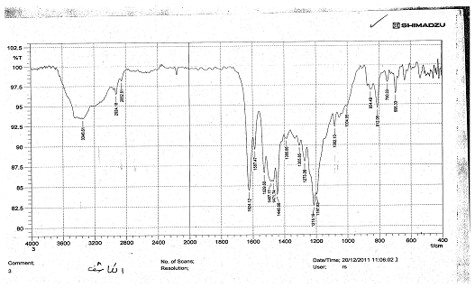

**Fig (1):-FTIR Spectrum of the reagent**

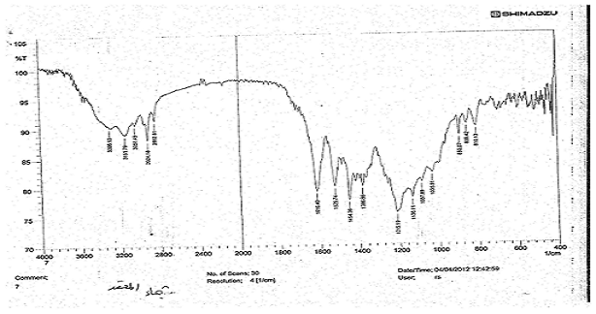

**Fig(2):-FTIR Spectrum of the complex**

**Physical and chemical properties of 6-BrBTAO**

6-BrBTAO is dark- red powder which is slightly soluble in water , it is soluble in organic solvents , such as:- ethanol , methanol , DMS , acetone , figure(3)show the UV-Vis spectrum of reagent in absolute ethanol solution

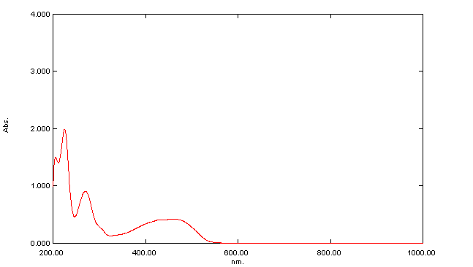

**Fig(3):-Absorption spectra of the reagent(6-BrBTAO) in absolute ethanol solution**

The reagent appears as yellow color in acidic medium and orange in basic medium , absorption spectra of the reagent at different PH value is shown in fig(4):-

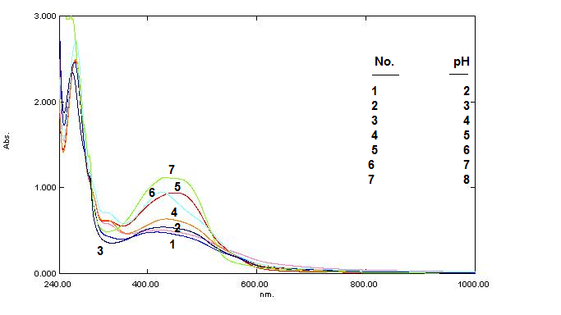

**Fig(4):-Absorption spectra of the eragent(6-BrBTAO) in different pH values**

This figure shows two isospestic point the first at (320) nm and the second at(588) nm The equilibria of the dissociation be written as follows:-



Pink solution pH˃10.7

**Absorption spectra and characteristics of the complex**

The absorption spectra UV-Vis of the reagent (6-Br-BTAO) and( 6-Br-BTAO)-Cu(II) complex are shown in fig.(5).The maximum absorbance (λmax) of the reagent occurs at 461 *nm* and copper complex maximum absorbance (λmax) at 497*nm*,. The reagent reacts immediately with copper (II) forming an red complex in aqueous medium at pH ═ 4 and the absorbance reached its maximum with 5 min, and remained stable, for at least, 24 hr, at room temperature.

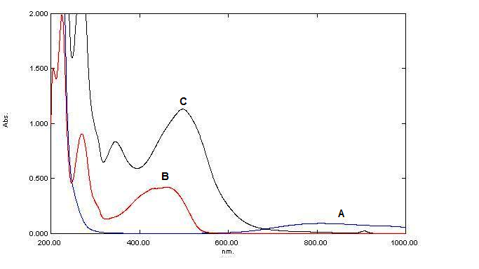

**Fig(5):-Absoption spectra of A:Copper ion 30ppm ,B:6-BrBTAO reagent3.3×10-3 M ,C:-Cu-6-BrBTAO Complex at pH=4**

The electronic spectrum of the reagent shows three characteristics bands, the two bands are (225,270 ) nm is due to the (π→π*) transition of the phenolic ring ,while the third band at (461 )nm is due to the (n→π*) transition of the non bonding electron pairs of the nitrogen atom .The complex of Cu(II) with this reagent shows a peak at (497) nm , this indicate that the reaction happen between Cu(II) and the reagent (6-BrBTAO).

**Effect of reagent concentration**

In avolumetric flask of (10 ml) volume (3 ml) of Cu(II) solution of constant concentration (30μg.ml-1) is put , the effect of reagent concentration (3.3x 10-3M) on absorbance of the complex was studied by varying the amount of the volume of reagent (0,5-4.0)ml , it was obtained that the formation was complete giving maximum absorbance with 2 ml of the reagent.

**Effect of pH**

The absorbance of Cu-(6-MBTAR) complex depends on the pH of the solution , the influence of pH was studied over the range (2-6)adjusted by means of dil by buffer solution (NH3+ CH3COOH) the optimum pH rang was obtained between( 3.5-5) of complex .fig(6) shows the relationship between absorbance of complex and pH. At pH ˂3 adecrease in absorbance may be due to the form at ion of azolium cation result from the reaction between hydrogen ion and the ione of pair electrons on the nitrogen atom of the thiazol ring , and also when pH is 4.5 the decrease in absorbance may be due to the hydrolysis of copper .



**Fig(6):-Effect of pH on the absorbance of Copper complex ,[Cu**2+**=30ppm]**

**Stability of the chromogenic system for complex at different time and different temperature**

It was found that the absorbance of the complex chromogenic system reaches a maximum value within 5 min and remain stable for 24 hrs .

The effect of temperature on the absorbance of the complex was studied at the range between ( 20-70 )◦C, the maximum and constant absorbance was obtained when the temperature is in the range(20-40)◦C , and at a higher temperature of 45 ◦C the absorbance was decrease which may be due to dissociation or evaporization of the complex (fig 7 )



**Fig.7 Effect of temperature on the absorbance of copper complex**

**Composition of the complex**

The composition and the stability constant were evaluated by both of the continuous variation and the mol ratio methods (fig.8 , fig.9).Both methods were showed that the molar ratio of Cu-6-BrBTAO complex is 1:2, ( metal : ligand ) and the stability constant was found to be 147x103  L.mol-1



**Fig(8):-Cotinuous variation method for copper complex with (6-BrBTAO)at pH=4**



**Fig (9):- Mole ratio method for copper complex with (6-Br-BTAO) at pH=4**

**Analytical characteristics**

The calibration curve was made giving astraightline with a good correlation coefficient (0.9981) .fig(10) ,and the analytical prameters get from the caliberation curveare put in table(1).



**Fig( 10 ):-Calibration curve of Cu(II) complex**

**Table (1): Analytical characteristics of the proposed procedure**

**(N=no. of determination )**

|  |  |
| --- | --- |
| **Analytical Parameter** | **Value** |
| Molar absorptivity | 149×103 L.mol-1.cm-1 |
| Sandell Sensitivity | 0.1136 L-1.gm.cm |
| Correlation coefficient(r) | 0.9981 |
| Detection Limit(D.L) | 0.355 ppm |
| Linear dynamic range | (5-40)ppm |
| Standerd deviation | 0.001 |
| Relative . Standard . Deviation% | 0.59%(N=7) |
| Percent Relative error | 0.006% |
| Percent Recovery | 99.94% |

These results indicating that this method is highly precise and suitable for the determination of Cu(II) spectrophotometrically

**Interference studies**

The effect of the ions Ni(II), Zn(II), Co(II), Cd(II), Pb(II), Ag(I) and Cr(III) which form complexes with the reagent (6-Br-BTAO) during its reaction with Copper (10)ppm was studied. The selectivity of various masking agents are examined for eliminating the effect of the interfering seven ions. These are KI, NaNO2, NaF and NH4SCN. The result are shown in table (2).

**Table(2) : Effect of foreign ions on the determination of Cu(II)and suitable masking agents .**

|  |  |  |  |  |
| --- | --- | --- | --- | --- |
| Cu (II) / ppm | | Foreign ion 100 ppm | Masking agent(1.0)ml ٫[0.01]M | Error% |
| 10 | | Ni (II) | 1-KI ,2-NH4SCN | 1-(-0.004),2- (-0.003) |
| 10 | | Zn (II) | NH4SCN | 0.00 |
| 10 | | Co (II) | 1-KI,2-NaNO2,3-NH4SCN | 1-(0.00),2-(-0.007),3-(0.004) |
| 10 | | Cd (II) | NH4SCN | 0.00 |
| 10 | | Cr (II) | 1-NaF,2-NaNO2 | 1-(-0.009),2-(0.008) |
| 10 | | Ag (I) | 1-NaF | -0.005 |
| 10 | Pb (II) | | 1-NaF,2-NH4SCN | 1-(0.004),2-(0.001) |

**References**

1-M.A.Korn,A.F.Santos ,H.V.Jaeger and C.S.Costa. ***J.Braz .Chem.Soc***., 2004, **15**, 2.

2-R.B.Passey,K.C.Mouf,and R.Fuller, ***Anal.Biochem***, 1985, **151**, 462.

3-A.A.Ensafi,S.Abbasi, H.R.Mansour,and I.M.Baltork, ***Anal.Sci***, 2001, **17**, 609.

4-E.Ivanova,K.Benkedda,and F.Adams, ***J.Anal.At.Spectrum.***, 1998, **13**, 527.

5-V.A.Lemos,M.S.Santo,G.T.David and M.Vasconcelos. ***Journal of Hazardous Matrials***, 2008, **159**, 245-251.

6-M.R.Ganjal.etal, ***Anal.Sci***, 2003, **19**, 223.

7-Q.Hu,G.Yang,J.Yang and Jan Yin, ***J.Environ.Monit***., 2002, **4**, 956-959.

8-K.Singh,A.Mahajan,andW.T.Robinson, ***Dyes and Pigments***, 2006, **1**, XX.

9-S.J.Naik, and U.P.Halkar, ***ARKIVOC***, 2006, **4**, xiii.

10-L.Qin,Y.Shen,J.Zual,F.Zn,and T.Zhang. ***J.Mter.Sci***, 2004, **39**, 2335.

11-A.Gupta,S.Rawat,G.Divakar and M.K.Jangid . ***Journal of current pharmaceutical Research***, 2010, **3(1)**, 13-23.

12-M.S.AbuBakr,A.S.El.Shahawy and S.MAhmed,  ***Journal of Solution Chemistry,*** 1993***,* 663**, 7-22.

13-K.Shanthal Kshmi,S.L.Belagali.Cuniversity of Mysore Karnataka,India(2009)

14-Barlink,R.Strzyzewsk and W.pol, ***J.Appl.Chem***, 1992, **2**, 207.

15-A.Pencher and N.Gajiv. ***J.Dyes and pigments***, 1992, **19**, 113.

16-M.L.Perezpont,M.J.Sanchez,A.Francisco,and F.Gareia, ***Montelongo***, 1986, 183-190.

17-M.M.Heravi and F.F.Bamoharram, ***Molecular Catalysis Chem.,*** 2005, **242**, 173-175.

18-A.Andreani,M.Granaiola and A.Leonic, ***ARIVOC***, 2004, 76-84.

19-P.X.Baliza,S.L.C.Ferreira,L.S.G.Teixcira, ***Talanta***, 2009, **79**, 2-9.

20-Y.Zhu,J.Lin,P.Lin,and X.Zbou, ***Mikrochimical***, 1993, **112**, 127-133.

21-J.K.Malik,F.V.Manvi,B.K.Nanjwade,ands.Singh Drug., ***Inven.Today,*** 2009, **1**, 32.

22-B.C.Dixit,H.M.Patel,R.B.Dixit ,D.J.Desai, ***J.Serb.Chem.Soc***., 2010, **75**, 607.

23-F.A.snavely,and C.H.Yodeer, ***J.Org.Chem,*** 1968, **33**, 513.

24-A.G.Catchpok,W.B.Foster,and S.Holder, ***Spectro Chim,Acta***, 1968, **18**, 1363.

25-S.I.Gusev,M.V.Zhvakina,and I.A.Kozhevikov,ZH. ***Analit.Khim***., 1974, **26**, 859.

26-L.Mangsup, S.Siripaisarnpipat and N.Chaichit, ***Anal.Sc.***, 2003, **19**, 1345.

27-M.W.Bes,S.F.Kettle,and D.B.Powell. ***SPectrochem Acta.***, 1974, **30A**, 139.

28- N.B.Colthup,L.H.Daly,and S.E.Wiberely;"Introduction to infrared and raman spectroscopy" 2nd Ed.Academic press .Inc.J.R.Dyer;(1975)