Synthesis and Characterization some of Pyridine Derivatives

Abdullah jawad kadhim
Chemistry Department, College of Education, University of Al-Qadissiyah
Iraq 2012
abdullah_m1975@yahoo.com Email:

(NJC)

(Recevied on 27/5 /2012 ) (Accepted for publication 17/9/2012)

Abstract

Starting compound (2,6-dimethyl-4-phenyl-3,5-diethoxy carbonyl -1,4-dihydropyridine)(1) has been prepared by treating (2mole) from ethylacetoacetate with benzaldehyde, which reacted with (2mole) hydrazine hydrate and ethanol to give hydrazide derivative(2), then converted hydrazide group to oxadiazole and triazole rings by reacted with (2mole) from carbon disulphide and potassium hydroxide to give compound(3) and with (2mole) from carbon disulphide and potassium hydroxide then (2mole) from hydrazine hydrate to give compound (4). hydrazide derivative (2) also reacted with P-nitrobenzaldehyde and P-chlorobenzaldehyde to give (5) and (6) respectively.
Keywords: Pyridine, 1,4-dihydropyridine, benzaldehyde, synthesis compounds
الخلاصة
المركب الاساسي (2 ,6- ثنائي مثيل-4-فنيل-3 ,5-ثنائي ايثوكسي كربونيل -1 ،4-ثنائي هيدرو بيريدين) (1) حضر بمعاملة (2مول) من المركب اثيل اسيتو اسيتيت مع البنز الديهايد، والذي تفاعل مع (2مول) من الهيدرازين المائي بوجود الايثانول ليعطي مشتق الهيدرازيد (2)، ثم حولت مجموعة الهيدرازيد الى حلقات الاوكسادايازول والترايازول بمفاعلة المشتق مع (2مول) من المركب ثنائي كبريتيد الكربون وهيدروكسيد البوتاسيوم ليعطي المركب (3) ومع (2مول) من ثنائي كبريتيد الكربون وهيدروكسيد البوتاسيوم ثم (2مول) من الهيدرازين المائي ليعطي المركب (4). مشتق الهيدرازين (2) تفاعل ايضا مع الالديهايدات ليعطي المركبات (5) و (6).

Introduction

1, 4-Dihydropyridines (1, 4-DHPs) are one of the most important classes of heterocyclic compounds due to their pharmacological activity as calcium antagonists or agonists⁽¹⁾. The 1, 4-DHPs cause vasorelaxation by blocking voltage operated calcium channel in smooth muscle cells and also by increasing NO release from the intact endothelium. Recently, some other pharmacological activities have been reported such as: antitumor,⁽²⁾ bronchodilating,⁽³⁾ antidiabetic,⁽⁴⁾ antiviral⁽⁵⁾ and antianginal⁽⁶⁾ also many natural products and bioactive agents such as nifedipine,⁽⁷⁾ nitrendipine⁽⁸⁾ and felodipine⁽⁹⁾ are 1,4-dihydropyridine derivatives (1,4-DHPs).The 1,4-DHPs have also been extensively utilized as analogs of NAD(P)H coenzymes to study the mechanism and synthetic potential of various redox processes⁽¹⁰⁾.1,4-dihydro pyridine (DHP) structural subunit is contained in a growing number of both natural products and synthetic compounds with wide range of biological properties⁽¹¹⁾. For example, the 1,4-DHP derived drugs such as nefidine, and nimodipine are frequently used as cardiovascular agents (Ca²⁺channel blockers) for the treatment of hypertension and angina pectoris diseases.
Experimental Part
Instruments
1-Melting points were determined by using Melting Point SMP3 apparatus
2- F.T.I.R. spectra were recorded by using Fourier Transform Infrared Spectrophotometer (F.T.I.R) 8400 S Shimadzu apparatus.
3- U.V. spectra were recorded by using U.V-Visible Spectrophotometer 1650 PC Shimadzu
apparatus
Synthesis Methods
Note : All the methods are general methods.
Synthesis of starting material(3,5-diethylcarboxylate -2,6-dimethyl-4-phenyl-1,4-dihydropyridine(1)
A mixture of benzaldehyde (0.1mole), ethylacetoacetate (28ml) (0.2mole) and concentrated ammonium hydroxide (8ml) (0.2mole) in ethanol (60ml) under reflux for 3hr. to resulting mixture then allow cooling. filter off separated product and wash with 60% aqueous ethanol (10ml) to yield yellow prisms⁽¹²⁾. The purity of compounds prepared was examined by using the thin layer chromotogravea. R_{f} values of these compounds were measured using eluent (acetic acid: ethanol: water)2:4:4 respectively by using silica gel on glass plates . R_{f} for this compound is 0.84
2,6-Dimethyl-3,5-dicarbohydrazide-4-phenyl-1,4 dihydro pyridine (2)
A mixture of starting material (0.03mol) and hydrazine hydrate (0.06mole) in ethanol (30ml) then refluxed the mixture for 3hr. cooled and filtered then recrystallized from ethanol ⁽¹³⁾. R_{f} for this compound is 0.687 .
5,5'-(2,6-dimethyl-4-phenyl-1,4-dihydropyridine-3,5-diyl)bis (1,3, 4-oxadiazole-2-thiol)(3)
Solution of carbohydrazide (2) (0.01mol) was added to ethanol which is contain potassium hydroxide (0.02mol) and carbondisuphide (0.02mole) the mixture was refluxed even out hydrogen sulphide. Cooled and filtered then recrystallized from ethanol. R_{f} for this compound is 0.743 .
5,5'-(2,6-dimethyl-4-phenyl-1,4-dihydropyridine-3,5-diyl)bis(4-amino-4H-1,2,4-triazole-3-thiol)(4)
Solution of carbohydrazide (2) (0.01mol) was added to ethanol which is contain potassium hydroxide (0.02mol) and carbondisulphide (0.02mole) the mixture was refluxed on water bath for 1hr., then remove the solvent and melt remaining with (10ml) water,then add hydrazine hydrate (0.02mole) and refluxed for 4hr.,cold and softened with water and acidified by hydrochloric acid, then filtered and recrystallized from ethanol. R_{f} for this compound is 0.881 .
(2,6-dimethyl-4-phenyl-1,4-dihydropyridine-3,5-diyl)bis(N'-(2-nitro-benzylidene)formic hydrazide(5)
A mixture of compound (2) (0.01mole) and(2-nitrobenzaldehyde) (0.02mole) in ethanol was refluxed for 3hr.,the mixture was cold and filtered then recrystllized from ethanol. R_{f} for this compound is 0.853 .
(2,6-dimethyl-4-phenyl-1,4-dihydropyridine-3,5-diyl)bis(N'-(4-chloro-benzylidene)formic hydrazide(6)
A mixture of compound (2) (0.01mole) and (4-chlorobenzaldehyde) (0.02mole) in ethanol was refluxed for 3hr.,the mixture was cold and filtered then recrystllized from ethanol. R_{f} for this compound is 0.778 .
Note: All chromatographic methods were used (0.001 mol) of compounds prepared with volumetric ratios 2:4:4 of eluent (solvents) as a general way to bring models to measure the R_{f} values. R_{f} % values ​​shown in the table (3-1).

Discussion
3,5-diethylcarboxylate -2,6-dimethyl-4-phenyl-1,4 dihydro pyridine(1)
This compound was diagnosed by using infrared spectroscopy (F.T.I.R), which showed a sharp absorption at the pack (3348-3448 cm⁻¹) back to the bond (N-H), as well as the emergence of a package when the sharp absorption (1635 cm⁻¹) back to the bond (C = O) of the ester group. This frequency is less than the frequency in the carbonyl bond aldehydes and ketones, due to the phenomenon of resonance between the two atoms of oxygen in the ester group, as well as the emergence of absorption when the pack (732 cm⁻¹) back to the benzene ring unilateral compensation and pack at (3016 cm⁻¹) back to (C-H) aromatic. Table (3-2) shows the other packets absorption of compound.
3,5-dicarbohydrazide-2,6-dimethyl-4-phenyl-1,4-dihydro pyridine(2)
Spectroscopy showed infrared absorption package at (3178-3278 cm⁻¹) bake to a group (NH₂) primary amine , while the group emerged (N-H) secondary amide at (3399 cm⁻¹), either bond (C = O) has remained at (1630 cm⁻¹) because it is in the case of resonance with a group (N-H) , as well as the package absorption appeared at (1420 cm⁻¹) due to (C-N) bond. Table (3-2) shows the other packets absorption of compound.
5,5'-(2,6-dimethyl-4-phenyl-1,4-dihydropyridine-3,5-diyl)bis(1,3,4-oxadi azole-2-thiol)(3)
Showed spectral measurements of the infrared absorption of the disappearance of a package bond (C=O) and a new absorption appeared pack at (1655-1685 cm⁻¹) back to (C=N), as well as the measurements showed the disappearance of a package bond NH₂ absorption due to the formation oxadiazole ring, in addition to that ,the appearance of weak absorption package at (2265 cm⁻¹) back to bond (S-H), and the package of absorption at (702 cm⁻¹) back to (C-S), either bond (C-O-C) has emerged strong at (1210 cm⁻¹).Table (3-2) shows the other packets absorption of compound.
5,5'-(2,6-dimethyl-4-phenyl-1,4-dihydropyridine-3,5-diyl)bis (4-amino-4H-1,2,4-triazole-3-thiol)(4)
The infrared measurements of the compound observed the disappearance of bond absorption (C = O) and the emergence of a new package absorption at (1658-1689 cm⁻¹) back to the bond (C = N), and survival a bond (NH₂) due to the formation triazole ring. As well as the emergence of weak absorption package at (2414 cm⁻¹) back to the bond (S-H) either the bond (C-S) has emerged at the frequency (717 cm⁻¹). Table (3-2) shows the other packets absorption of compound.
3, 5-di (2-nitrobenzilidine) form amide-2, 6-dimethyl-4-phenyl -1, 4-dihydropyridine(5)
Spectroscopy showed the compound similar to compound (2) in the frequencies of bonds (N-H) and (C=O), but appeared the package at (1500m⁻¹) bake to a group (NO₂) and the package of absorption at 700cm⁻¹ back to the benzene ring bilateral compensation. Table (3-2) shows the other packets absorption of compound.

2,6-dimethyl-4-phenyl-1,4-dihydropyridine-3,5-diyl)bis(N'-(4-chloro-benzylidene)formic hydrazide(6)
The spectral measurements of the infrared of this compound similar to compound (5), but was noted the emergence of absorption when the packet (780 cm⁻¹) back to the bond (C-Cl), as noted the survival of other packages as they are in the above compound

Table (3-1) physical properties of compounds
Compound | Molecular formula | Solvent | Yield % | R_{f} % | m.p. Cº | Color
Starting material (1) | C₁₉H₂₃NO₄ | Ethanol | 71 | 84 | 150-151 | Yellow
2 | C₁₅H₁₉N₅O₂ | Ethanol | 94 | 68.7 | 129-130 | Yellow
3 | C₁₇H₁₅N₅O₂ | Ethanol | 44 | 74.3 | 160-161 | Yellow light
4 | C₁₇H₁₉N₉ | Ethanol | 52 | 88.1 | 173-174 | Dark gray
5 | C₂₉H₂₅N₇O₆ | Ethanol | 78 | 85.3 | 144-145 | Yellow
6 | C₂₉H₂₅N₅O₂ Cl₂ | Ethanol | 93 | 77.8 | 192-193 | Dark brown
Table (3-2) (F.T.I.R) spectra of compounds
Comp. | C-H aromat cm⁻¹ | C-H aliphatic cm⁻¹ | (C=C) cm⁻¹  (C=N) cm⁻¹ | Other cm⁻¹
Starting material (1) | ------- | ------ | 1473-1515 | (COOEt)  (1238-1338)  (C=O) 1650
2 | 3101 | 2908 | 1420-1473 | (C=O) 1630 cm⁻¹  (C-N)1420 cm⁻¹
3 | 3093 | 2970 | 1500-1655 | (N-H)  3340-3440
4 | 3089 | 2981 | 1658-1689 | --------
5 | 3100 | 2980 | 1580-1650 | C-N(1300)  No₂ (1500)
6 | 3100 | 2980 | 1500-1650 | C-N(1300)  C-Cl (780)

Fig. (1) (F.T.I.R) spectrum of starting material(1)

Fig.(2) (F.T.I.R) spectrum of compound (2)

Fig.(3) (F.T.I.R) spectrum of compound (3)

Fig.(4) (F.T.I.R) spectrum of compound (4)

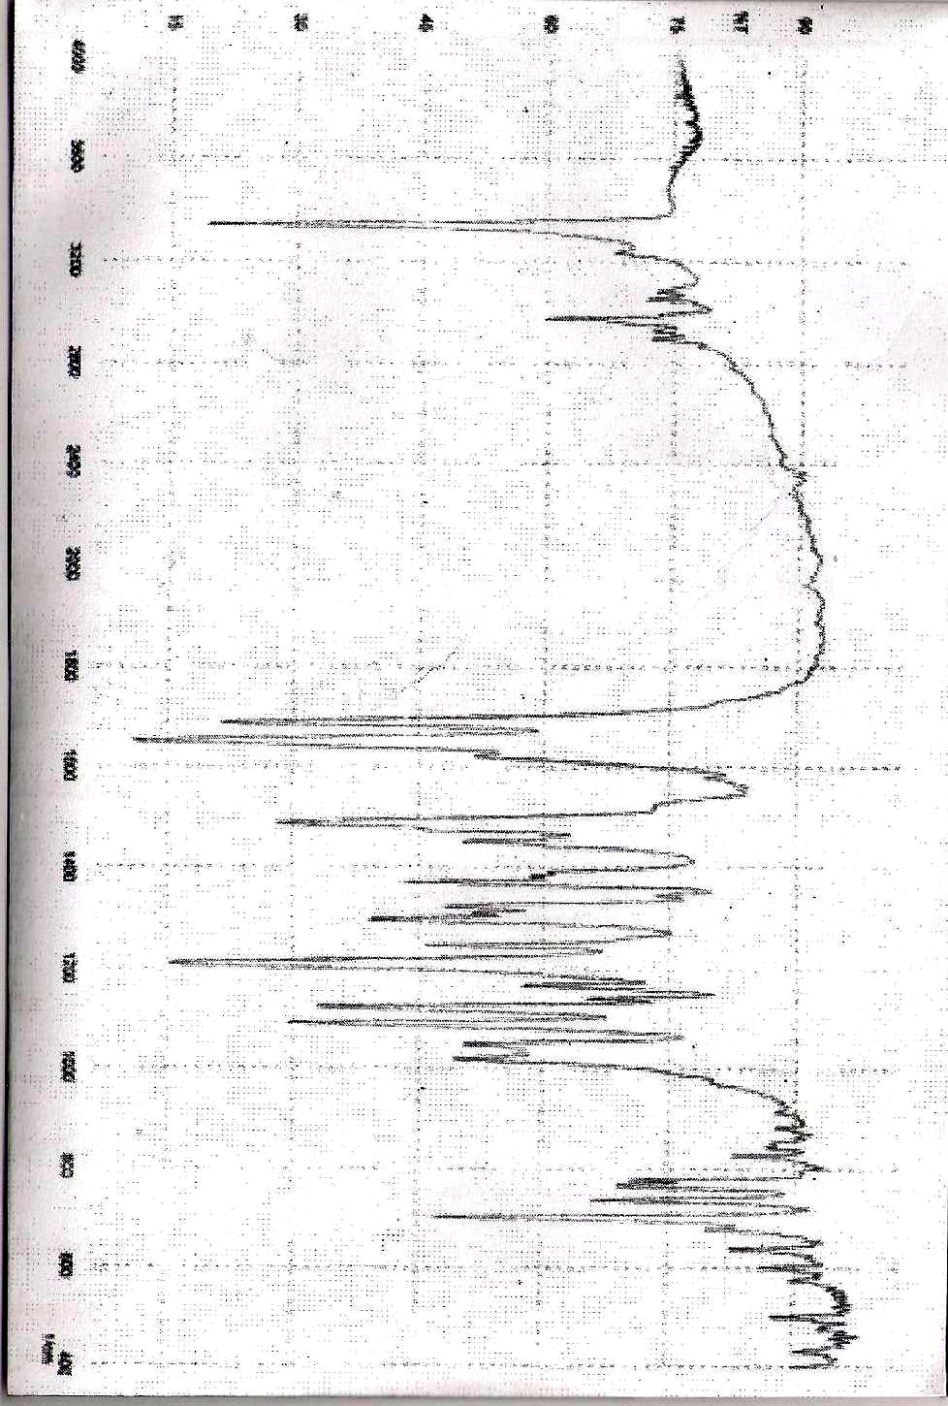
Fig.(5) (F.T.I.R) spectrum of compound (5)

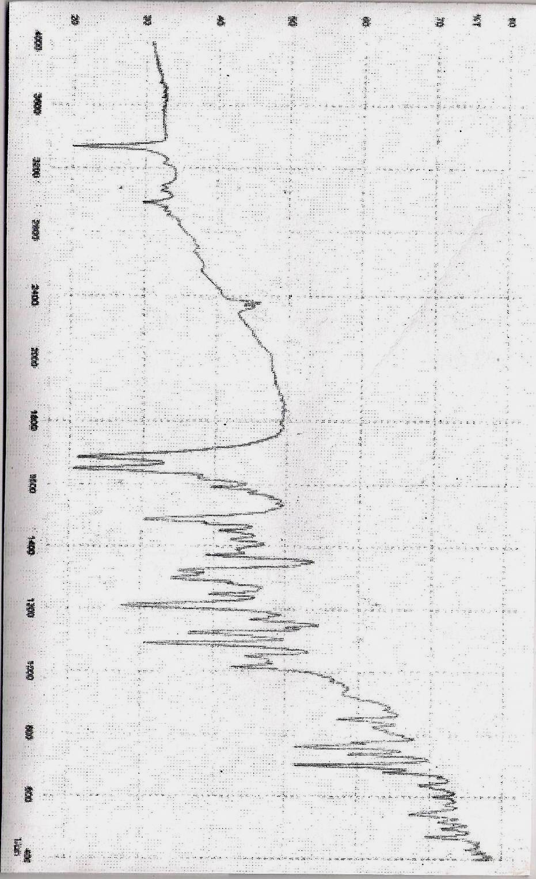

Fig.(6) (F.T.I.R) spectrum of compound (6)

References
1- Bagley, M. C.; Lubinu, M. C. Synthesis 2006, 1283.
2- Tsuruo, T.; Iida, H.; Nojiri, M.; Tsukagoshi, Cancer Research, 1983, 43,2905.
3- Chapman, R. W.; Danko,G.; Siegels, M. I. Pharmacology, 1984,29, 282.
4- Malaise, W. J.; Mathias, P. C. F. Diabetologia 1985, 28, 153.
5- Krauze,A.;Germane, S.; Eberlins, O.; Sturms, I.;Klusa, V. J.Med Chem.1999,34,301.
6- Peri, R.; Padmanabhan, S.; Rutledge, A.; Singh, S. J. Med.Chem. 2000, 43,2906
7- Messerli, F. H.; Staessen, J. A. Am. J. Med. 2005, 118, 1418.
8- Siddiqui, M. Asif, A.; Plosker, Greg L. Drugs 2004, 64, 1135.
9- Sevanian, A.; Shen, L. J.; Ursini, F. Pharm. Res. 2000, 17, 999.
10- Stout, D. M.; Meyers, A. I. Chem. Rev. 1982, 82, 223.
11- Nandkishor N. Karade, and Sumeet V.Gampawar, Arkivoc journal (xii) 9-16(2008).
12- Arthur I. Vogel"Atext book of practical organic chemistry"Fourth edition,London
(1978).
13- El-sayed . El-Tamaty and I. M.El-Deen ,Ind. J. Chemistry, 1996, 35B, 1067-1072.

