Radiolysis of Purines and Pyrimidines Aqueous Solutions.

Faris D. Hassan
Chemistry Department, College of Science, Almustansryah University

(NJC)

(Received on 20/2/2005) (Accepted for publication on 4/ 9 /2005)

Abstract
The γ- radiolysis of purines and pyrimidines N2O- saturated aqueous solutions in the presence of either tetranitromethane (TNM) or N,N,N",N"- tetramethyl -P- phenylenediamine (TMPD) has provided information on the yield of both reducing and oxidizing radicals and followed by measurements of G(-chromophore) under various experimental conditions.
The observed yields are attributed to the hydrolysis of intermediate products which can be both base- and acid- catalysed. G(-chromophore) has also been measured. The addition of Cu+ or Cu+ / H2O2 enhances the yields, in the later case by a chain mechanism.
الخلاصة
التحليل الاشعاعي للمحاليل المائية للبيورين والبريميدين بواسطة اشعة كاما (γ) للمحاليل المشبعة بغاز (N2O) بوجود رباعي نيترو ميثان (TNM) و (ن- ن- ن"- ن")– رباعي مثيل –p- فنيلين داي امين (TMPD) تعطى معلومات عن الناتج لكل من الجذورالمؤكسدة والمختزلة ويتبعها قياس قيمة (-chromophore) G تحت ظروف التجربة المختلفة. ان الناتج الملاحظ يعزى الى كل النواتج الوسطية التي يمكن ان تكون محفزة حامضيا او قاعديا. (-chromophore) G كذلك يقاس. ان اظافة Cu⁺ او Cu+/ H₂O₂ يسرع الناتج في الحالة الاخيرة بواسطة الميكانيكية المتسلسلة.

Introduction
Radiation chemistry can be defined as a study of chemical effect produced by the absorption of ionization radiations by matter.
Ionizations radiation can be electromagnetic such as x-ray and γ-ray or particulate such as high energy electrons (β-rays), helium nuclei (α-rays), protons, deuterons and neutrons.
Thus in dilute aqueous systems most of radiation energy will be absorbed by water, which as a result of ionization and excitation decomposes according to the over all equation.
H2O H ., .OH, e⁻ _{aq} ., H3O⁺ , H2O₂, H₂…(1)

Radiation – chemical yields are expressed by G-values, which refer to the number of species which are produced or disappear per 100 ev of energy absorbed.
A unit of radiation dose which is frequently used is the rad;
1 rad = 6.24 x 1013 ev/g.

A general formula for purine compound is shown:
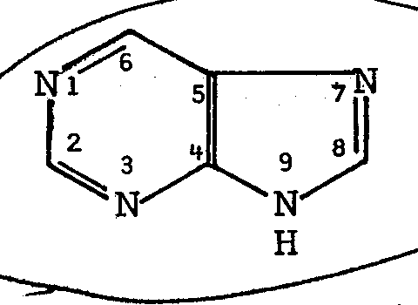

A general formula for pyrimidines is shown below:
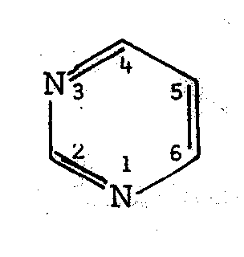

The mechanism of formation of the radical intermediates has been investigated using DNA and aqueous solutions of free bases (purines and pyrimidines), nucleotides and uncleosides.
Site of attack of the OH radical on the purines is at the 4:5 double bond, and on the pyrimidines at the 5:6 double bond.
The effect of various additives and the presence of secondary solutes such as oxidant Cu2+, TNM and the reductant TMPD in the deaerated, N2O-saturated pyrimidine and purine solutions have been studied.
It has been shown that in neutral aqueous oxygenated solutions the site of attack of the OH radical on the purines is at the 4:5 double bond, and the pyrimidines at 5:6 double bound (1.2.3).

Table 1 shows the reported yield of the 6-OH and 5-OH adducts (5,6). Additional slow TMPD± component which they attributed to the conversion of the reducing radicals to oxidizing ones.
Table 1*.

pyrimidine | (py-6-OH)  =G (TMPD^{.+}) initial | (py-5-OH)  =G(NF⁻)
Uracil  Thymine  6-Methy1 uracil  1so-orotic acid  Orotic acid  cytosine | 1.1  1.7  0.6  1.9  0.5  1.2 | 4.9  3.6  5.3  3.8  5.2  5.1
Radical yields in irradiated N₂O/ pyrimidine solutions (5,6)

Experimental
Materials
The reagents used were "ANALAR" or the highest purity grade available and were directly used without further purification. The pyrimidines used were uracil, thymine, cytosine, 6-methyluracil, 1,3-dimethyluracil, 3-methyluracil, uridine, uridylic acid, thymidine and thymidylic acid.
The purines used were hypoxanthine, adenine and guanosine.
All acids, hydrochloric acid, sulphuric acid, perchloric acid were Analar, Tetranitromethane (TNM) and N,N,N",N", -tetramethyl –p- phenylenediamine (TMPD) were obtained from sigma chemicals, England, nitrous oxide (N₂O)and oxygen were obtained from B.O.C. medical grade.
Irradiation Vessels
The irradiation vessels used were made of pyrex, cylindrical in shape (~50 ml capacity) and fitted with a B-10 joint and stopper.
Prior to irradiation the solutions were saturated by bubbling with the appropriate gas for 10-20 minutes for the N2O/O2 mixture (3:1) monitoring the flow rate of the individual gas using a ratemeter placed in each gas line.
Radiation Source
The cobalt-60 γ-ray source (nominally 1180 Curie) in the form of several pellets contained in steel capsule could be raised or lowered mechanically through an aluminium tube, by means of a worm gear into a concrete shielded chamber.
Preparation of Solutions
All solutions were made up with triply-distilled water freshly collected within 24 hours prior to use.
Ordinary distilled water was redistilled first from a dilute alkaline potassium permanganate solution and then from a dilute phosphoric acid solution.
Chemical Dosimetry
In γ-radiolysis, the amount of energy absorbed by solution was determined by the Fricke dosimeter (11) modified by miller (12). The dosimeter solution consisted of ferrous ammonium sulphate (1mM), sodium chloride (1mM) and sulphuric acid 0.4M in triply-distilled water.
Results & Diseusion
Results
Purine and pyrimidine solutions containing TNM (0.1- 0.85mM) were prepared by injection (using a microsyringe) of liquid TNM into the stock solution after saturation with N2O. A Sonicor vibrator (model SC-211-22TH) was used to dissolve the TNM. The concentration of TNM was determined by making the solution alkaline (pH ~12) and measuring the NF - so formed at 350 nm taking ξ350 = 13250M⁻¹ cm⁻¹ (5).
Purine and pyrimidine solutions containing TMPD (0.1 mM) were prepared using a freshly-prepared TMPD solution; the yields of TMPD.+ Were measured at 565 nm ξ 565 = 12500M⁻¹ cm⁻¹ (5).
Yield-dose plots for the formation of NF - and TMPD.+. were linear (c. f. Figs. 1,2) and the observed yields are given in Table (2).
Some pulse-radiolysis experiments with hypoxanthine solutions were carried out using electron pulses from the Cookridge van de Graaff machine with doses of ~1.5 krad.
Using 1 mM hypoxanthine solutions saturated with N2O the second-order decay of the transient hypoxanthine radicals were monitored at λ > 300nm. The rate constants (2k) at 325, 350 and 375 nm were found to be 3.3, 3.6 and 6.6 x 108 dm mo1-1 s-1 in reasonable agreement with those already found by M. Ali (14 viz. 1.7,1.4 and 3.0 x 10⁸ dm3 mo1-1s-1.
Transient absorption spectra from a pulsed N2O-saturated hypoxanthine (1 mM) solution containing TNM (0.5 mM) at pH 5.5 are shown in Fig. (3).
An initial absorption peaking around 340 nm decays by first-order kinetics (t½ = 1µs) to form NF-; G(NF-) was found to be around 6.0 in agreement with the γ-radiolysis results.
On pulse radiolysis of N2O-saturated solutions of hypoxanthine (2mM) + TMPD (0.05 mM) the yield of TMPD.+., measured at 565 nm, was found to be quite small (G = 0.3).

Table (2). γ-Radiolysis of aqueous N₂O-saturated solutions of purines and pyrimidines containing either TNM or TMPD.

Purine / pyrimidine | Observed G(NF⁻)^{b} | Calculated G(NF⁻)from H+TNM | Observed G(TMPD⁺.)ª | Calculated G(TMPD⁺.) formed from OH + TMPD | % Reducing radicals | % Oxidizing radicals | Minimum % of reducing radicals converted to oxidizing radicals
Thymine  Uracil  6-Methyl Uracil  Adenine  Guanosine  Hypoxanthine | 3.6 (3.6)^{d}  4.8 (4.9)^{d}  5.4 (5.3)^{d}  5.3  2.8 (3.0)^{e}  6.1 | 0.07  0.05  0.04  0.11  0.11  0.45 | 4.2 (1.7, 4.1)^{f}  4.4 (1.1, 4.5)^{f}  3.8 (0.6, 3.7)^{f}  1.8  5.0 (3.3)^{e}  *^{c} | 0.47  0.4  0.5  0.55  0.32  0.76 | 60  80  90  88  46  100 | 40  20  10  12  54  0 | 45  65  55  15  60  0

- [Purines], [pyrimidines] = 2mM; [TMPD] = 0.1mM, pH = 5.5.
- [Purines], [pyrimidines] = 1mM; [TNM] = 0.26 x 10⁻³m, 0.11 x 10⁻³m, 0.2 x 10⁻³m, 0.07 x 10⁻³m, 0.107 x 10⁻³M and 0.85 x 10⁻³M, for thymine, uracil, 6-methyl uracil, adenine, guanosine and hypoxanthine respectively; pH 7.3.
- A slight colouration due to TMPD^{.+} disappeared with in a few minutes after irradiation.
- Pulse-radiolysis data of Fujita and Steenken (6).
- Pulse-radiolysis data of O,Neill (7).
- Yield of first component and final yield of TMPD^{.+} obtained by Pulse-radiolysis (Fujita and steenken)(6).

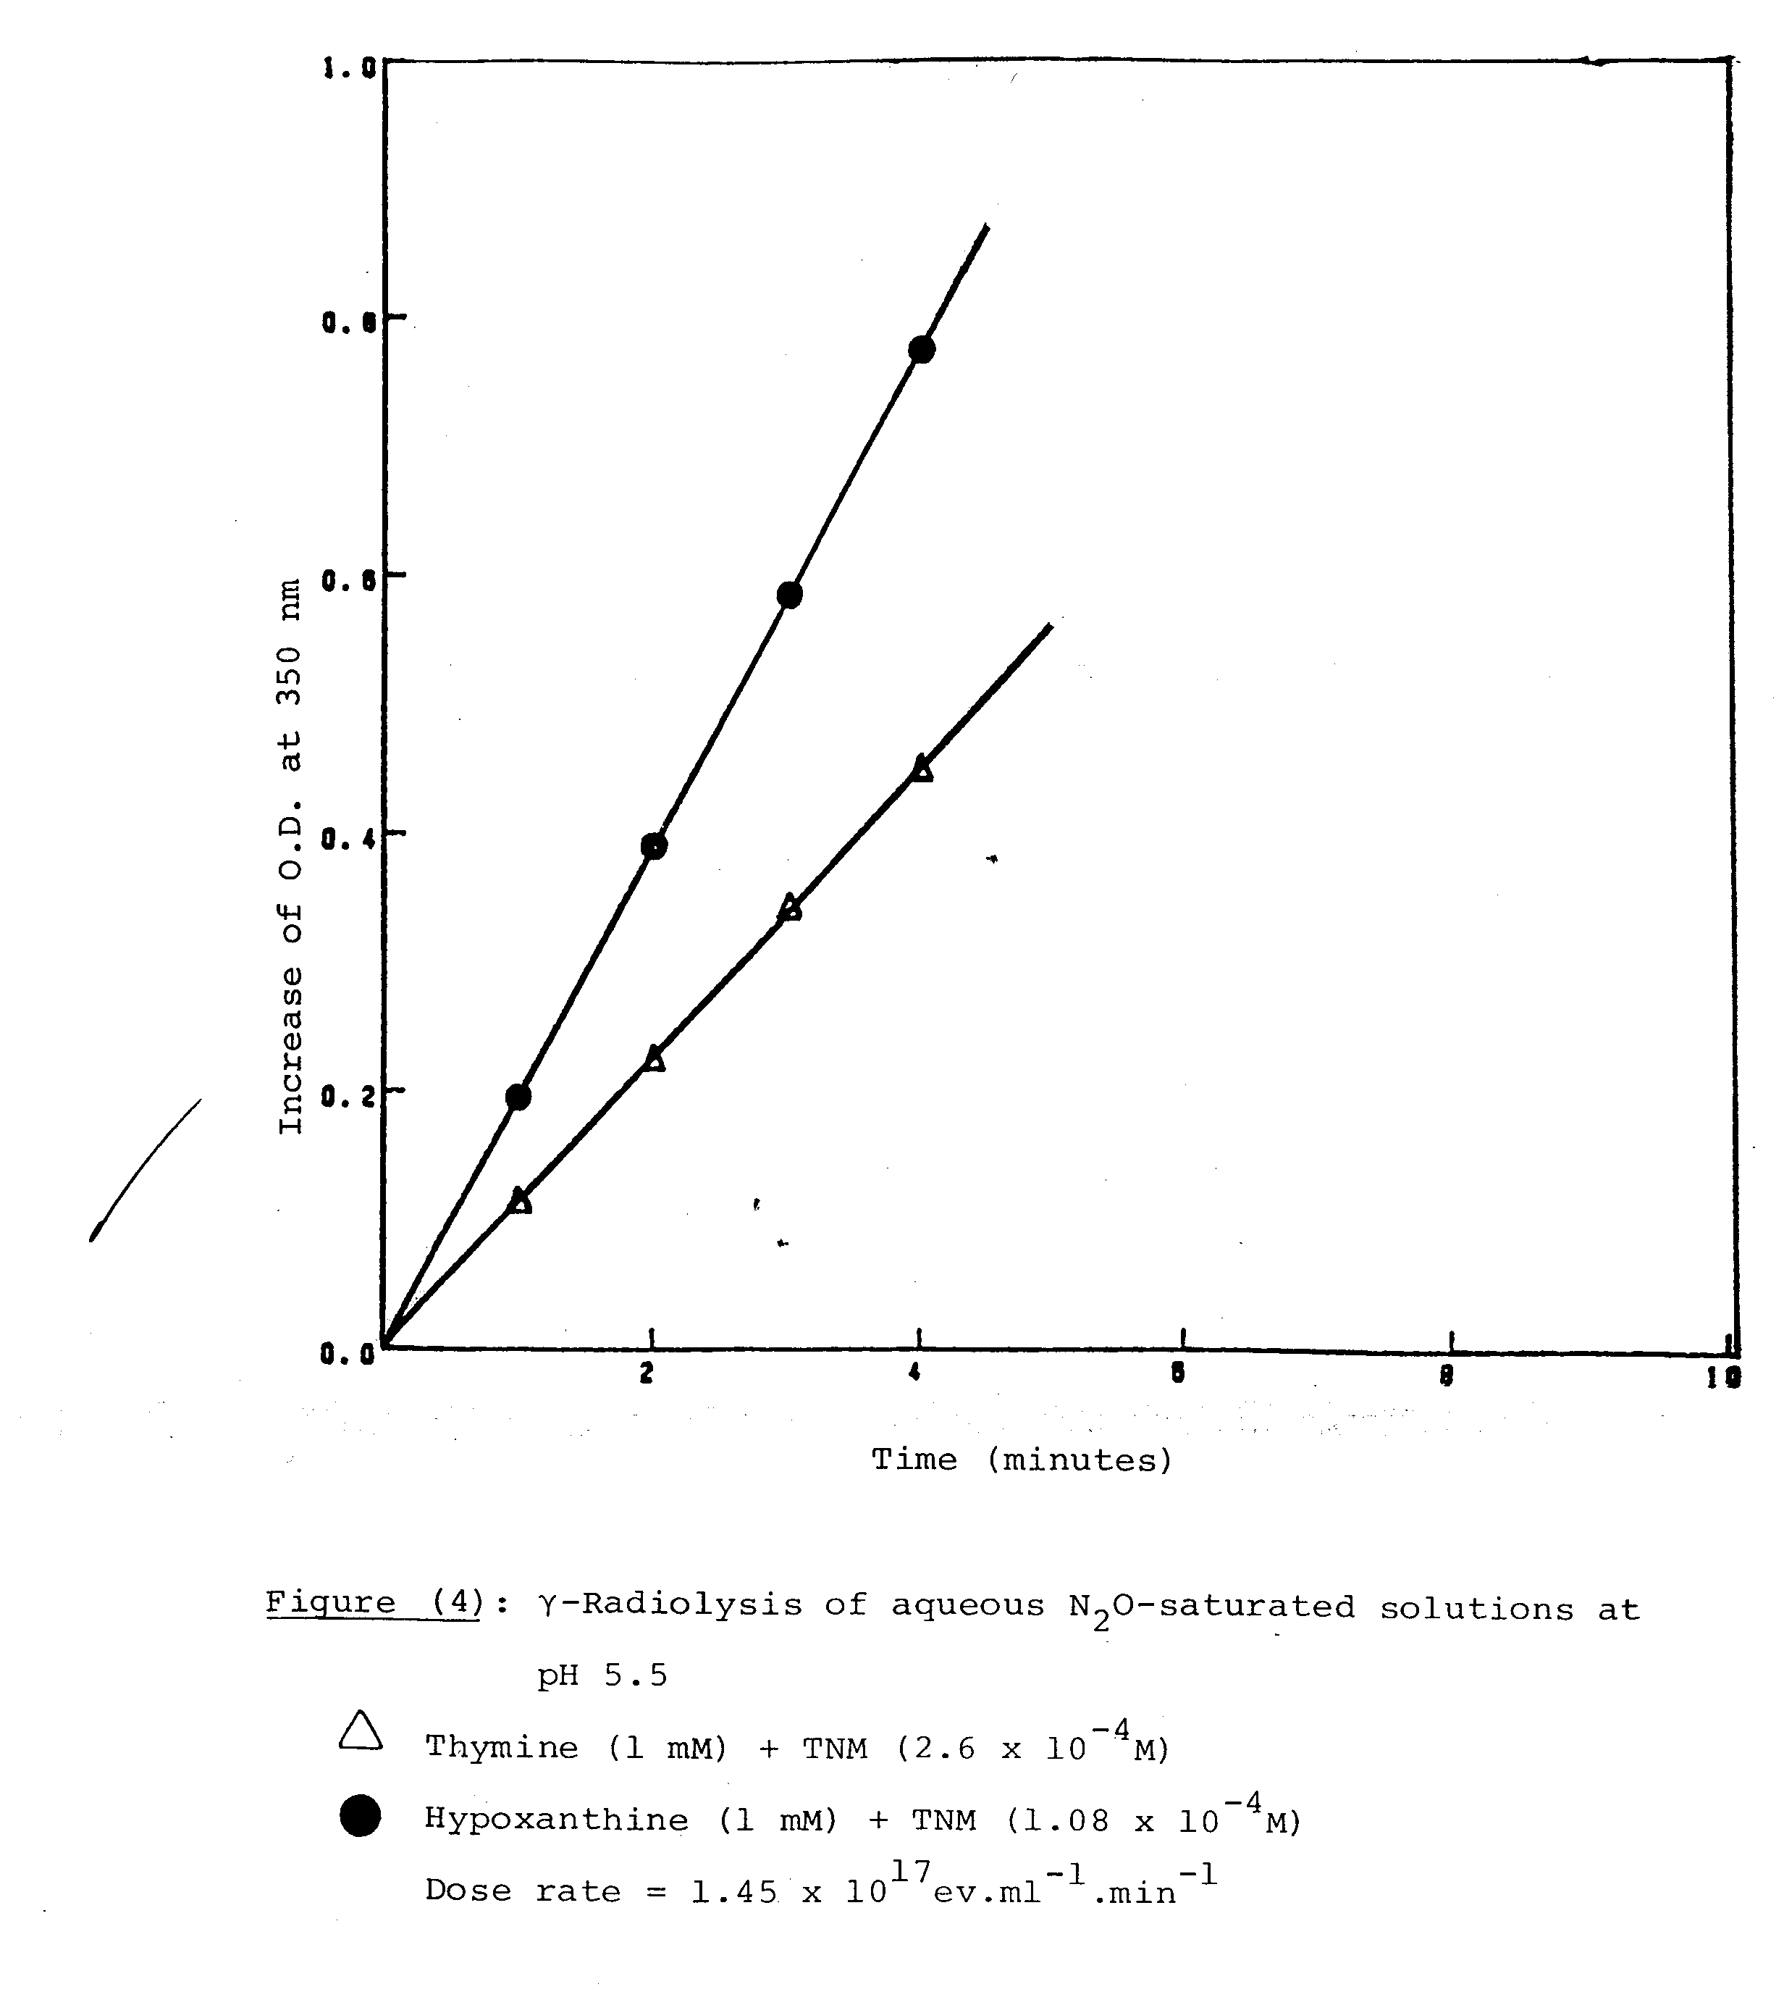
(1)

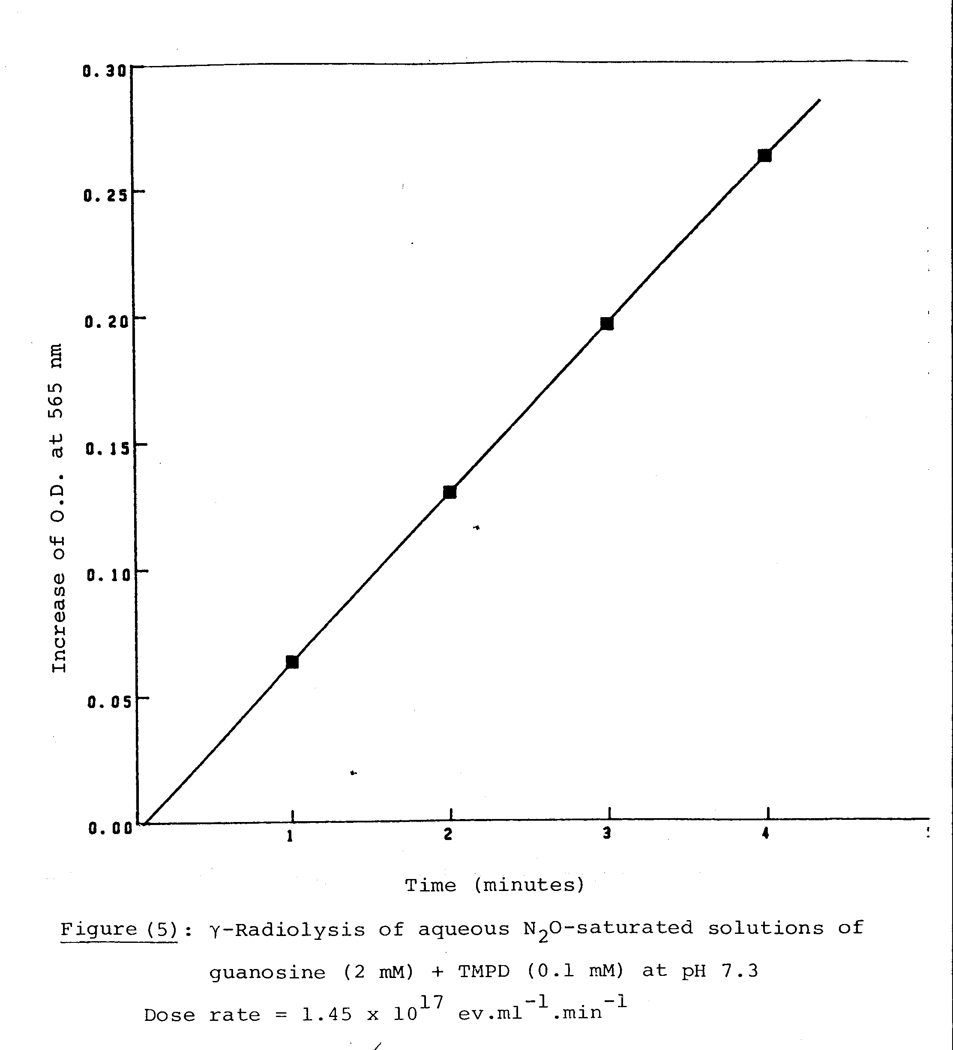
(2)
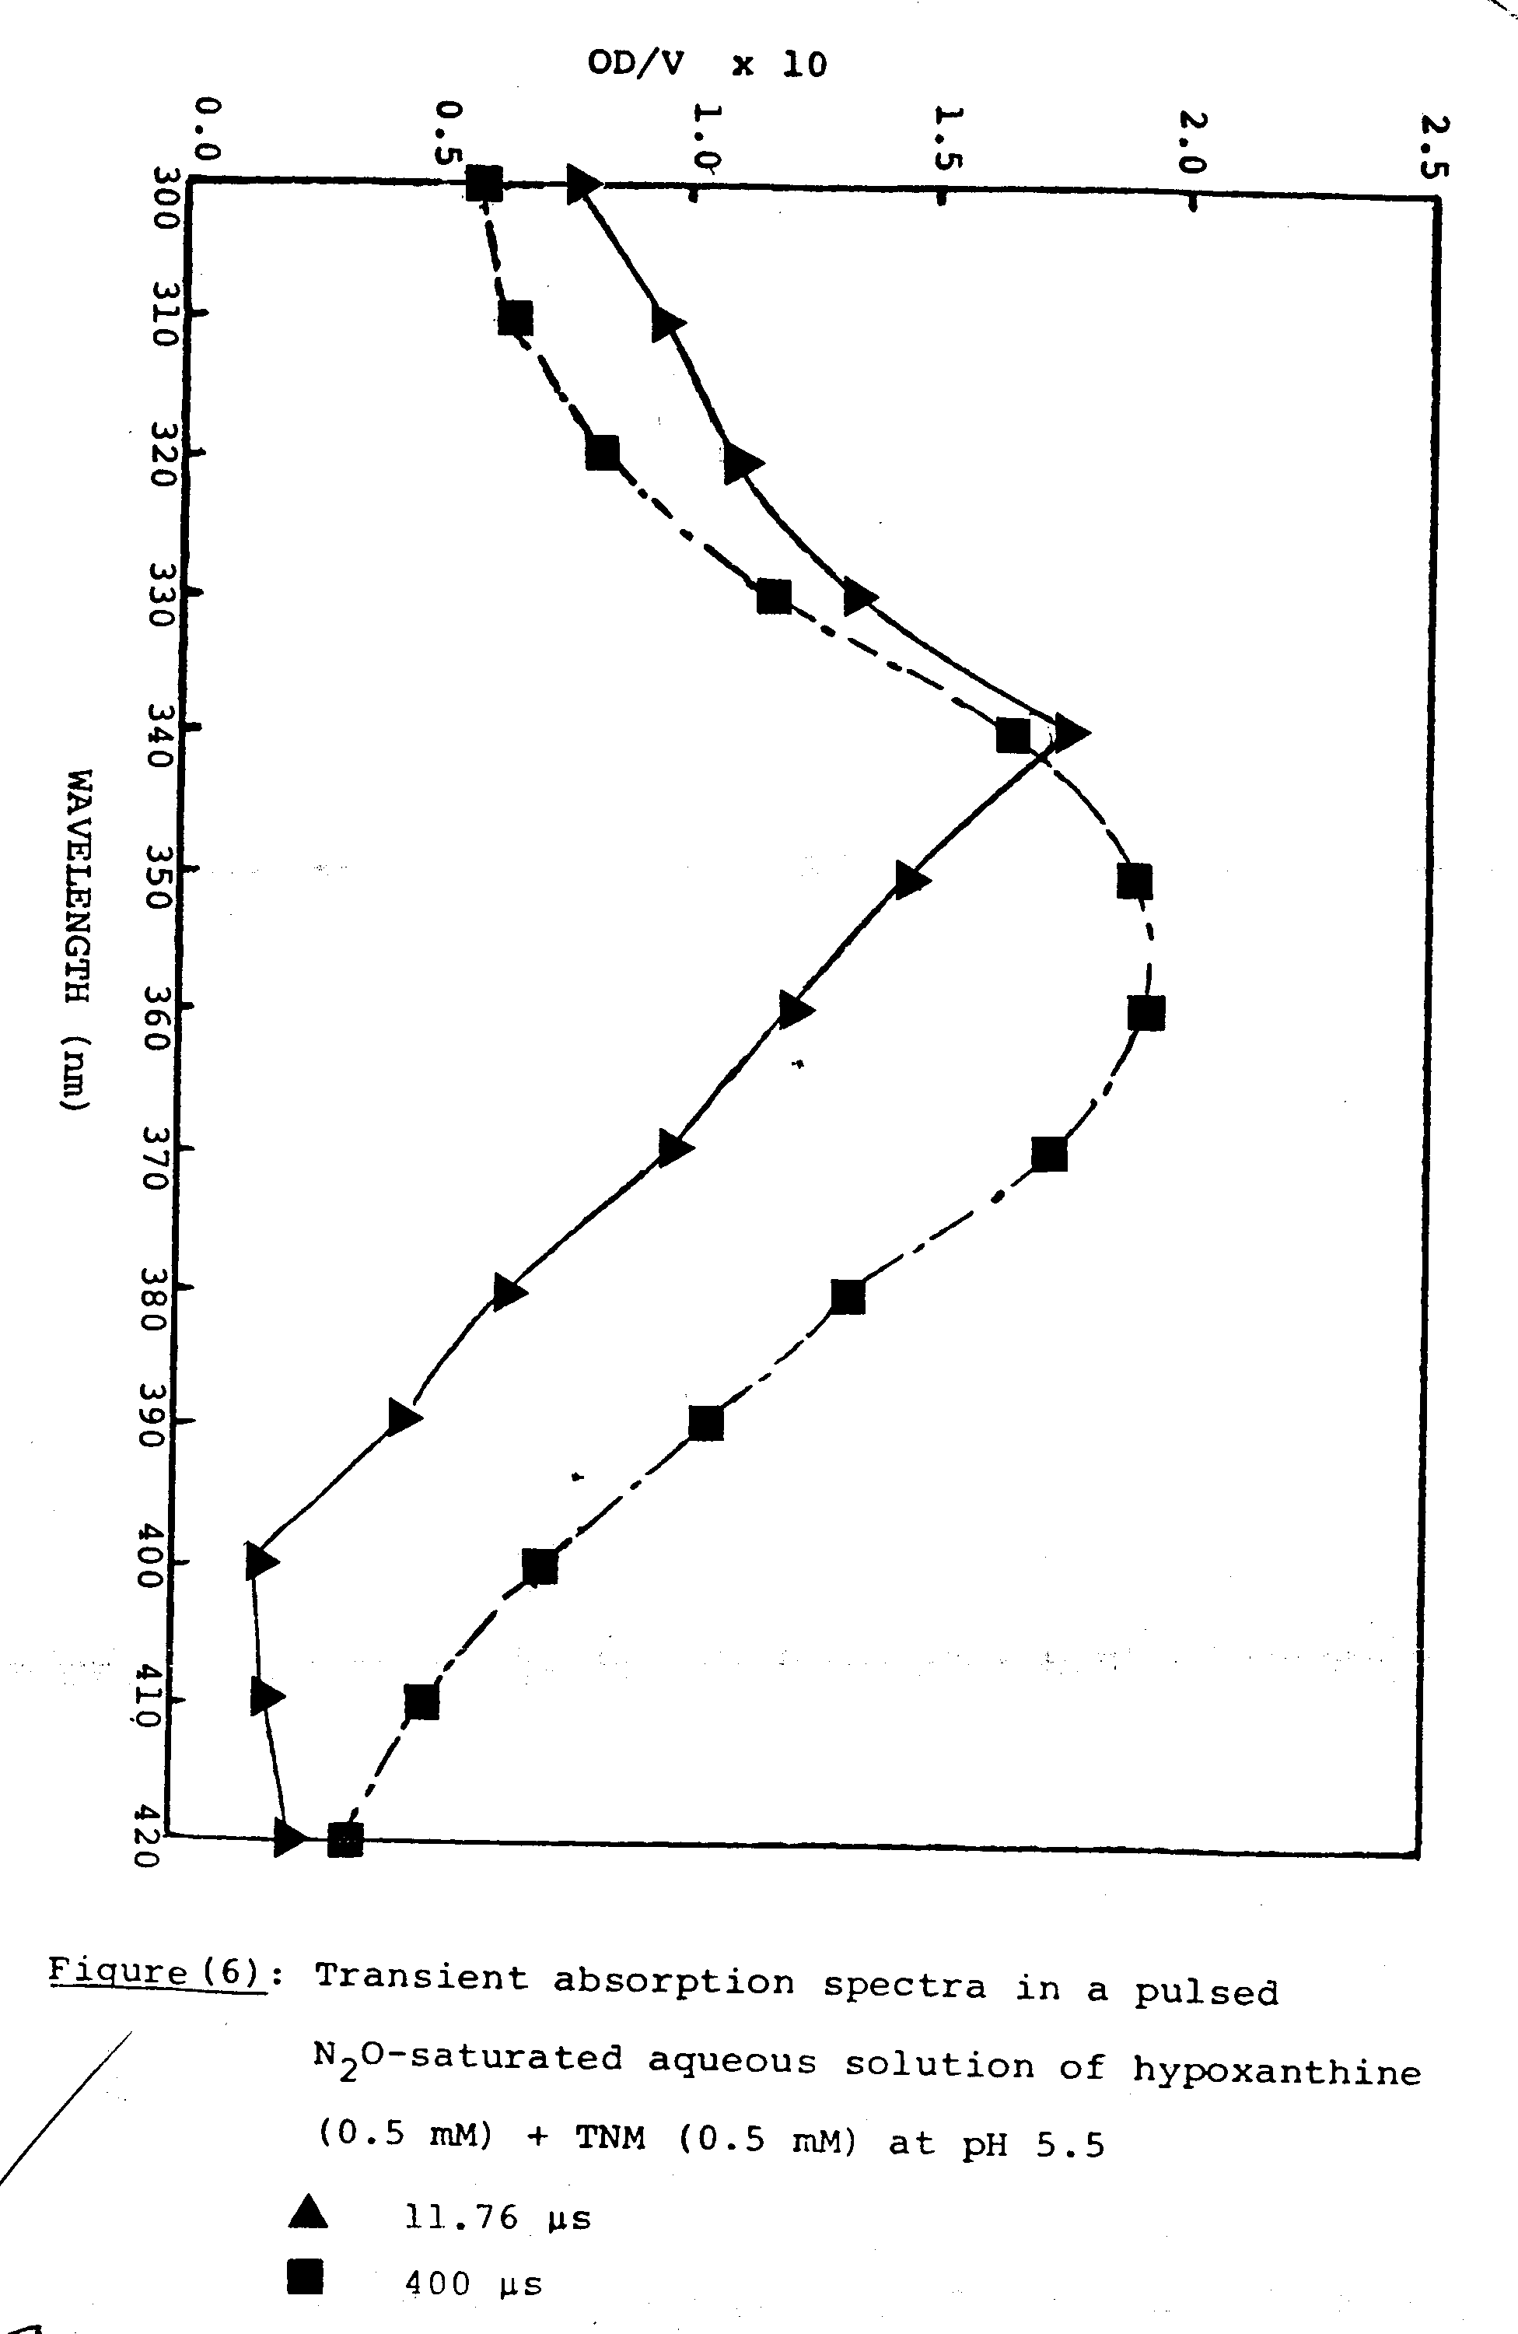
(3)
Discussion
For the purpose of the following discussion it is assumed that, as a consequence of the reaction;

H₂O + e⁻_{aq} N₂ + .OH + OH⁻………..(2)
H₂O

The G-value of scavengeable radicals (.OH and .H) is 6, where G(H) = 0.55. Some competition for e⁻aq by the bases occurs but the extent of this is relatively small; in 1mM and 2mM base solutions reaction with e⁻aq amounts to a G-value of 0.15 and 0.3, respectively.
From the results with TNM, which agree very well with some reported pulse-radiolysis data, the percentage of reducing radicals and hence, by difference, the percentage of oxidizing radicals can be arrived at; these are given in Table (2).
In most experiments the extent of reaction of the H atoms with TNM is very small; G-values for this reaction given in Table (2) were calculated from the rate constant data given in Table (3). Of particular interest is the observation that the radicals formed from hypoxanthine (both by .OH and H attack) are essentially all reducing ones.
Under the conditions of the base + TMPD experiments there is some direct oxidation of TMPD by OH radicals; the values for direct oxidation given in Table (2) were calculated from the rate constant data of Table (3). The observed yields of TMPD^{.+} from γ-irradiated pyrimiding solutions agree very well with the total yields of TMPD± observed by Fujita and steenken (5 by pulse-radiolysis of the same systems. These authors have

proposed that of the two OH-adducts, the py-5-OH adduct is reducing and the py-6-OH adduct is oxidizing.
It was found that there were two components of the TMPD^{.+} yield, the second, slower one, being attributed to the oxidizing radical formed from py-5-OH or its anion via keto-enol tautomerism followed by water or OH⁻ elimination.
The conversion was found to be base-catalysed. The higher TMPD^{.+} yields were then attributed to the following sequence of reactions:

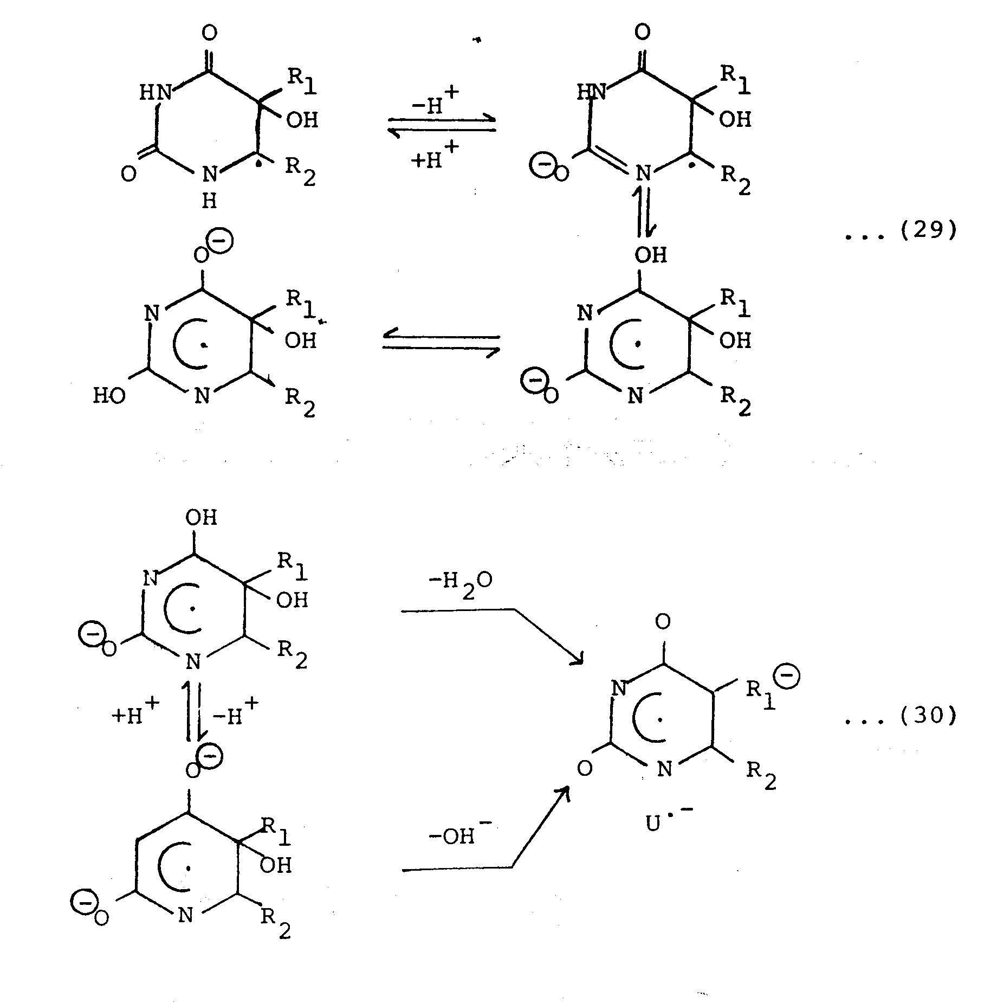
…..(3)
…..(4)

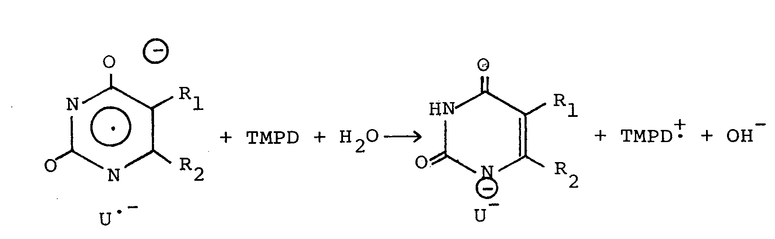
…..(5)

Since the sum, G(NF⁻) + G(TMPD^{.+}), for both adenine and guanosine solutions is >6 then the same conversion of reducing to oxidizing radicals is also taking place in these purines.
O,Neill (10) reported that the yield of TMPD^{.+} in pulsed guanosine solutions was the same at pH 11 as at pH 7 and therefore no such base-catalysed conversion takes place.
The conversion rate of course, be too slow and therefore only observable under stationary conditions. O Neill has reported that of the OH-adducts, I,II, and III are formed by reaction at C(4), C(5) and C(8).

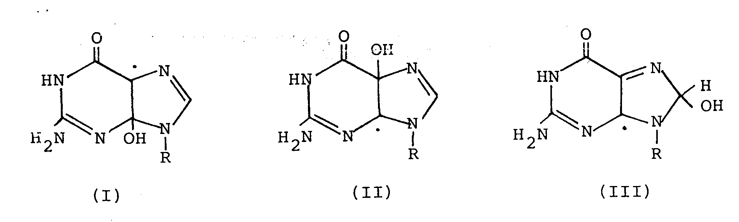
Adduct I is oxidizing whilst adducts II and III are reducing; the nature of the conversion of a reducing to an oxidizing species is unknown. In the case of hypoxanthine the present results with TNM would favour .OH addition at either C(4) or C(8) of the purine molecule.
In the γ-radiolysis of hypoxanthin + TMPD solutions there was a rapid disappearance of the small yield of TMPD.+ expected to be formed by reaction of. OH with TMPD. This is presumably due to reaction of TMPD.+ with a permanent radiation product acting as a reductant. This could, of course, be occurring in other purine systems and for this reason the approximate values of the percentage of reducing radicals converted to oxidizing radicals given in the last column of Table (2), are to be regarded as minimum ones.
In pulsed hypoxanthine + TNM solutions an intermediate is formed which then decays by a first-order mechanism to form NF-. Examples of such complex formation are already known. For example, Eibenberger and steenken (13) observed transient adduct formation in the pulse radiolysis of solutions of 1,4-dioxane + TNM. The following reaction sequence was proposed:

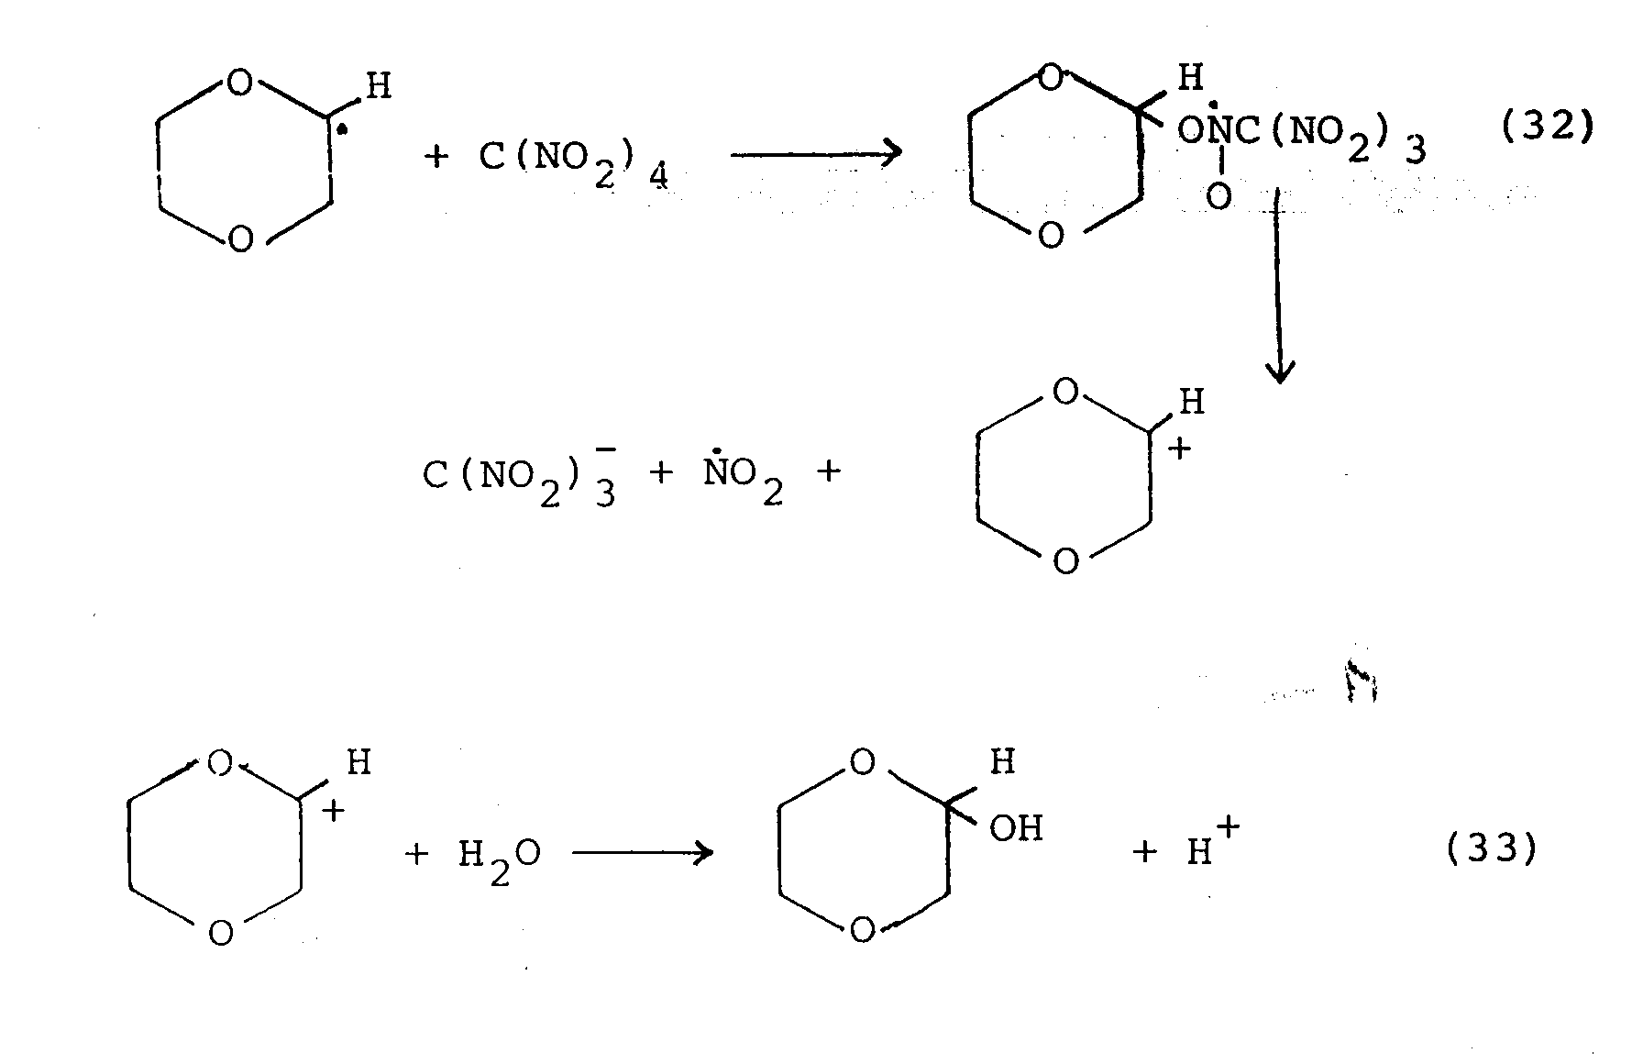
…..(6)
…..(7)

in which the first-order decay of the complex has a half life of 4 µs.
Addition of TNM to the radical centre at C(4) of the hypoxanthine molecule would be an obvious possibility. The same reaction may be expected to occur with the comparable guanosine radical. It should be noted here that O,Neill (10) did not observe simple first-order kinetics of NF⁻ formation in pulsed guanosine +TNM solutions, it has being estimated that ~10-15% of NF⁻ is formed in a slower reaction; this particular system probably requires a more detailed investigation. The yield of NF⁻ from pulsed hypoxanthine + TNM solutions is consistent with the formation of reducing radicals only; the yield of TMPD^{.+} in the pulsed hypoxanthine + TMPD solution (G = 0.3) is near to that expected (G = 0.5) from reaction of OH radicals with TMPD.

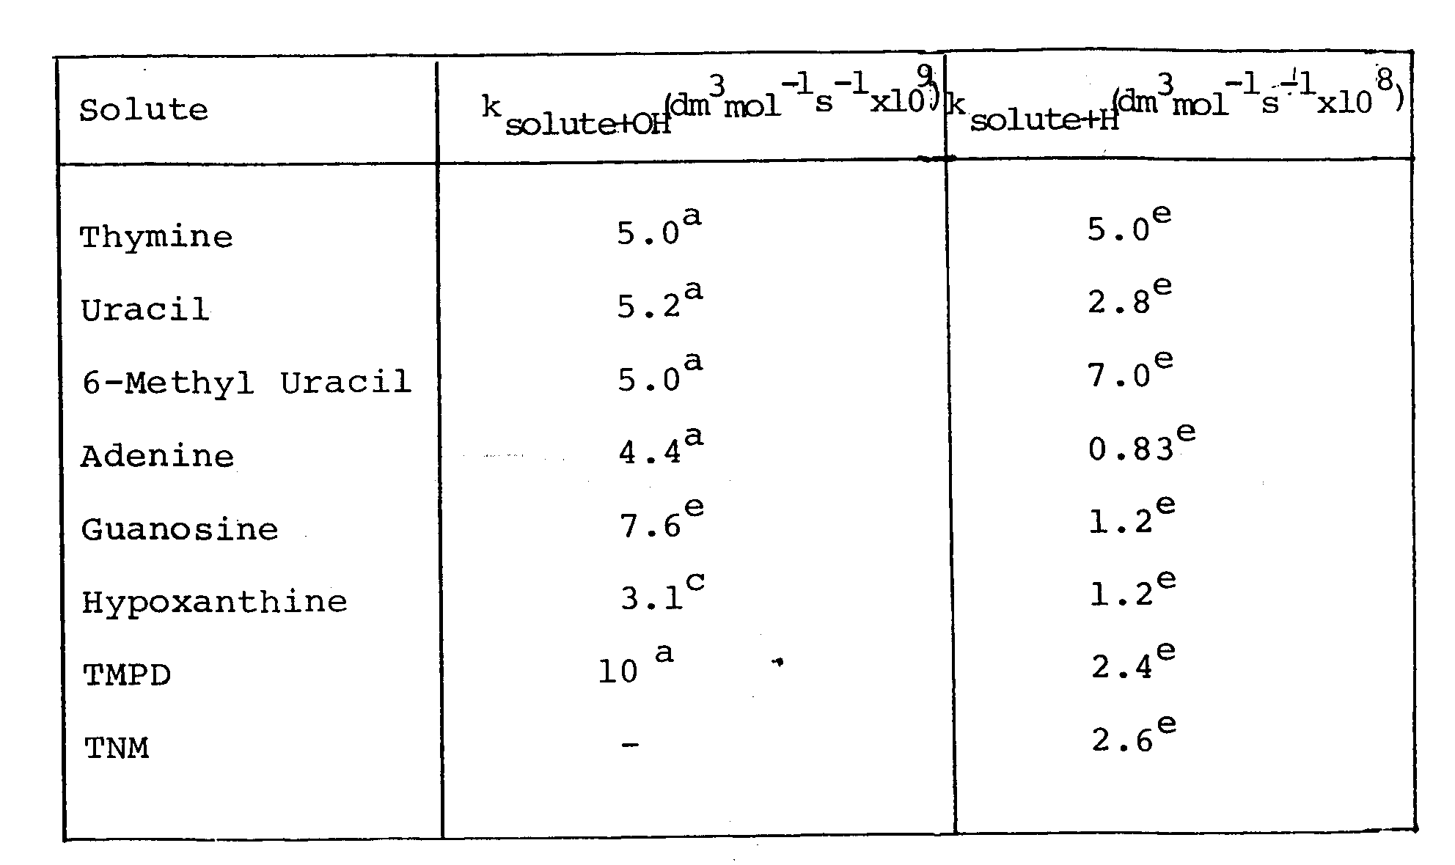
Table (3): Rate constants used for the data of Table (2):
- Reference 3
- Reference5
- Reference14
- Reference15

References
- H. Fricke and E.J. Hart, J. Chem. Phys., 1935, 3,60.
- J. Weiss, Nature, 1944, 153, 748.
- G. Scholes "The Radiation Chemistry of Pyrimidines, Purines and Related Substances" Photochemistry and Photobiology of Nucleic Acids, Vol. 1 Chemistry (1976) Academic Press, INC.
- J. Holian and W.M. Garrison, Nature, 1966, 212, 394.
- S. Fujita and S. Steenken, J. Am. Chem. Soc., 1981, 103, 2540.
- D.K. Hazra and S. Steenken, J. Am. Chem. Soc., 1981, 105, 4380.
- B. Pullman and A. Pullman, Nature, 1961, 189, 725.
- Y. Le Roux, J.P. Boulanger and R. Arnaud, C.R. Acad. Sci. Ser., 1971, C272, 1757.
- J.J Van Hemmen and J.F. Bleichrodt, Rad. Res., 1971, 46, 444.
- P. O,Neill, Rad. Res., 1983, 96, 198.
- H.Fricke et al., Am.j. Roentgenol, 1927, 18, 430.
- N. Miller, J. Chem. Phys., 1950, 18, 79.
- J. Eibenberger, D. Schulte-Frohlinde and S. Steenken, J. Phys., Chem., 1980, 84, 704.
- M. A. A. M. Ali (ph. D. Thesis, University of Newcastle upon Tyne, 1982).
- Selected Specific Rates of Reactions of Transients from Water in Aqueous Solution, II. Hydrogen Atom, NSRDS-NBS 51 (1975).

