Qualitative and Quantitative Evaluation of some Organic
Compounds in Iraqi Thyme

Ikbal S. Al-Sheibany
Chemistry Dep., College of Education, Baghdad University
Kasim H. Kadhim and Amal S. Abdullah
Chemistry Dep.,Ccollege of Science, Babylon University

(NJC)

(Received on 8/5/2005) (Accepted for publication on 4 / 9 /2005)

Abstract
The study was based on extraction of volatile oil which obtained from Iraqi Thyme ( Thymbra spicata), qualitative identification and quantitative evaluation of some organic active compounds in the extract oil. The active organic chemical compounds in the oil extract by Clavenger method, were identified by using Gas chromatography (GC) The oil were found to contains carvacrol, thymol, p- cymene and camphor in 29.5%, 0.38%, 5.75% and 0.46% respectively. The compounds were isolated and identified by Thin Layer Chromatography (TLC), Infrared spectroscopy (IR) respectively.
الخلاصة
تضمن البحث استخلاص الزيت الطيار الموجود في نبات الزعتر العراقي والتقدير الكمي والنوعي لبعض المركبات العضوية الفعالة الموجودة في الزيت المستخلص بطريقة كلافينجر باستخدام كروموتوغرافيا الغاز , حيث ان الزيت المستخلص يحتوي على الكارفكرول والثايمول والباراسايمين والكافور وبنسبة29.5% و 0.38% و 5.75% و 0.47% على التوالي. حيث تم عزل وتشخيص هذه المركبات بواسطة استخدام كروموتوغرافيا الطبقة الرقيقة ودراسة اطياف الاشعة تحت الحمراء لهذه المركبات.

Introduction
Thyme was a multi-purpose herb that was often used for its fragrance, flavor, or medicinal properties in mouthwashes, decongestants, potpourris and sachets, and other products. Thyme remains a popular remedy for sore throats, laryngitis, and dry coughs. Herbalists also recommend it for other respiratory ailments such as pertussis (whooping cough) and bronchitis⁽¹⁾.
In the law of Avicenna about thyme ((it is softening solution beneficial in pelvic pain and toothache and cure redundant gum, its oil is beneficial for liver and stomach and cidal for intestinal worms))⁽²⁾.
The life force of a plant was called the volatile oil or essential oil. Volatile oils are highly concentrated substances extracted from various parts of aromatic plants and trees. These aromatic plants and oils have been used for thousands of years dating back to ancient civilizations that used them to heal^{(3).} Volatile oils are colourless liquids consisting of mixtures of saturated or unsaturated cyclic hydrocarbons. The mixtures compounds of volatile oils may be separated in various ways, such as: low temperatures, fractional distillation, fractional crystallization, different forms of chromatography.
Volatile oils were used for their therapeutic action, for flavouring like the oil of lemon, in perfumery like the oil of rose or as starting materials for the synthesis of other compound like the oil of turpentine. For therapeutic purposes they are administered as inhalation like the oil of eucalyptus, orally like the oil of peppermint, as gargles and mouthwashes like thymol ⁽⁴⁾.
Oil of thyme was the important commercial product obtained by distillation of the fresh leaves and flowering tops of Thymbra spicata. Its chief constituents are from 20-25% of the phenols thymol(1) and carvacrol(2), rising in rare cases to 42%⁽⁶⁾. The phenols are the principal constituents of thyme oil, thymol being the most valuable for medicinal purposes, but carvacrol, on isomeric phenol, preponderate in some oils. Cymene(3) and pinene(4) are present in the oil, as well as a little camphor(5) ⁽⁵⁾.

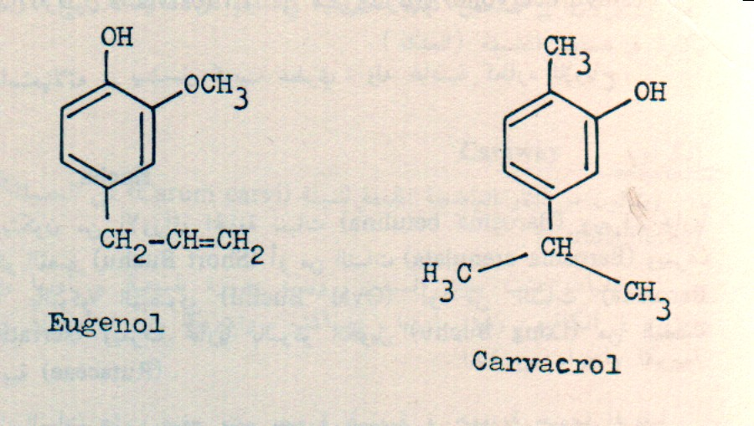  OH  Thymol(17) | Carvacrol(18) | 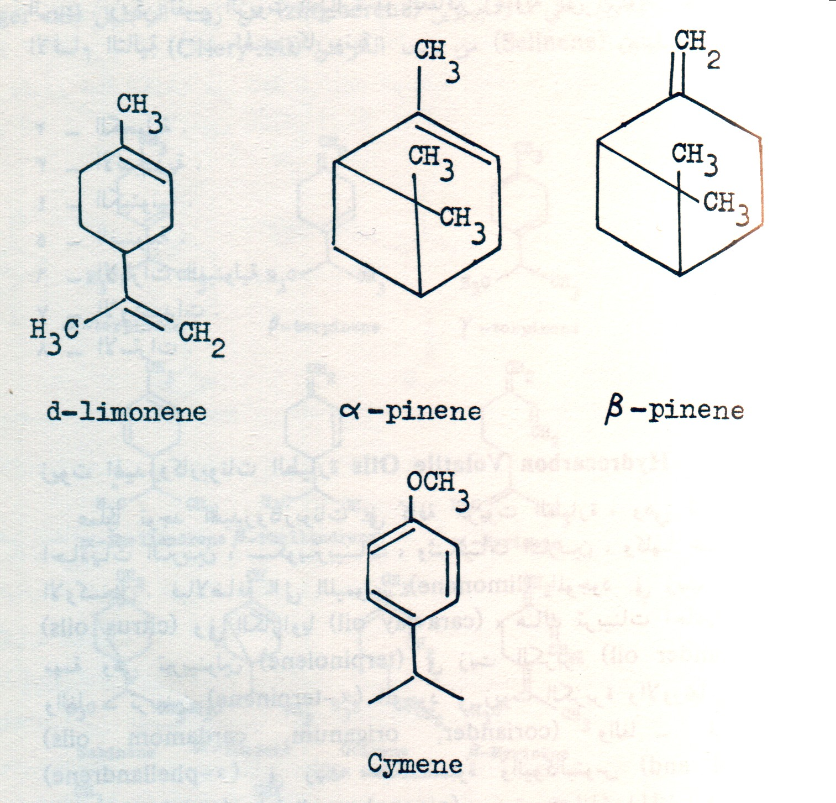  CH₃  p-Cymene(3)
α-pinene(4) |  | 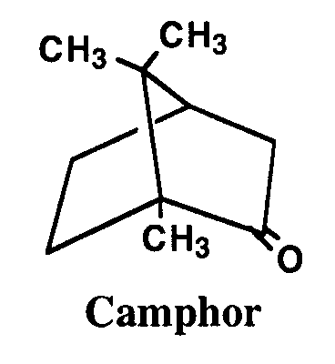  Camphor(5)

Experimental
- Collection of plant
The dry plant Thyme was obtained from the Ministry of health /center of herbal medicine. The plant was identified by "herbelium college of science" Baghdad University. It was air-dried, and packed in plastic containers until used. Thyme species Thymbra spicata Figure (1) widely grown in north of Iraq ⁽⁶⁾ .

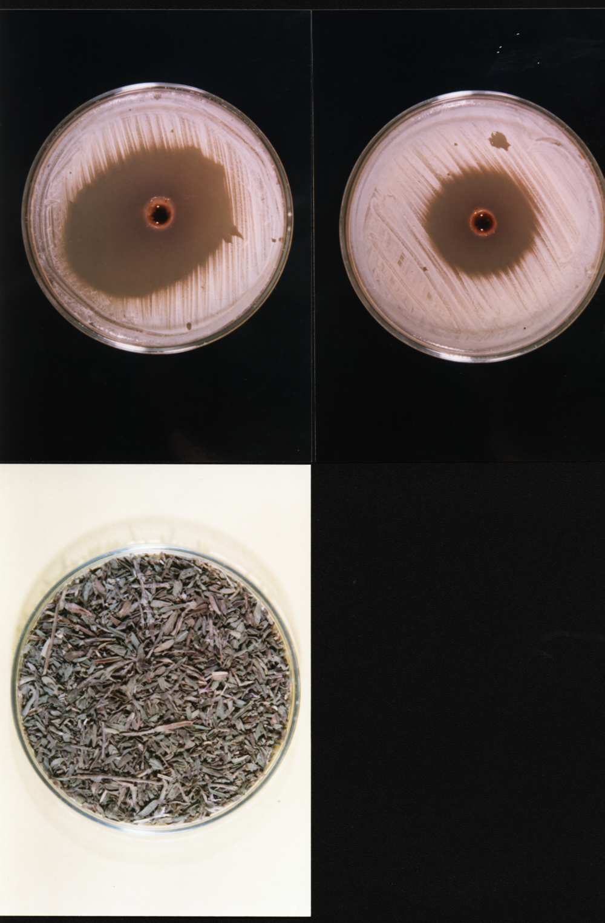
Figure (1) leaves and flowers of ( Thymbra Spicata)

- Extraction of Volatile Oils
One hundred grams of plant were placed in a 1000 ml round-bottomed flask, and distilled water was added in a ratio of (5:1) (water: plant). The distillation process was carried out for 3h; by using Clavenger apparatus⁽⁷⁾. The yield of volatile oils was separated from the aqueous phase with diethyl ether and then dried with anhydrous sodium sulphate, filterate, evaporate in water bath at 40°C. The oils obtained were stored in dark vials at 4°C.
- Isolation and Identification Study
3.1 Thin-layer chromatography
For testing the essential component of volatile oil, the following solvent ^{(8,9)} have been used as mobile phase:
- EtOAC:C₂H₄Cl₂ | (1.0:9.0)
- EtOAC:Toluene | (0.5:9.5)
- EtOAC:Toluene | (0.7:9.3)
- EtOAC:C₆H₆ | (1.0:9.0)

Using a suitable silica gel as the coating substance at width 0.25mm and dimension (2cm X 8cm). The best separation of active compounds of volatile oil is the mixture of ethyl acetate and toluene (0.5:9.5), the chromatogram shows five zones, which p-cymene, thymol, carvacrol, and camphor has been fully identified, and one another still unknown. Each zone has been scratched, isolated and dissolved in ether, which on filtration and removal of the solvent gave the desired compounds. The identification process depend on corresponding R_{f} value with standard compound under the same conditions.
3.2 Gas Chromatography (GC)
Gas chromatography analysis was carried out using a GC apparatus, using GC14A from Shimadzu equipped with a flame ionization detector. A thermon-600T fused silica (50m X 0.25 mmID: film thickness o.25µm) capillary column 25m to 60m long and about 0.3mm in internal diameter coated with macrogol 20,000 was used. The carrier gas was nitrogen at flow rate of 2ml/min; both the injection and detector temperatures fixed at 250°C. The oven temperature was kept at 70°C for 10 min., programmed to rise up to 180°C at a rate of 2°C/min., and then kept constant at 180°C for 30 min. The essential oil components were identified by comparing their relation times with those of authentic samples has been found superimposed ⁽¹⁰⁾ .
3.3 IR Spectra
IR spectra were recorded using Fourier Transform Infrared spectrophotometer on a Schimadzu 8300 over the range 4000-200 cm⁻¹ to analyses the compounds that has been isolated in this study from the preparative (TLC).
Results and Discussion
It is now possible to draw the following conclusions:-
Steam is forced through the fresh plant droplets to the condensing chamber. The advantage of extraction over distillation; is due to uniform temperature (50ºC) so the oil will preserve natural odors. Using high temperature not only affects on the volatile oil content of the plant, but also affect on the other constituents⁽¹¹⁾.
Of the many chromatographic methods presently available, thin-layer chromatography has become widely adopted for the rapid and positive analysis of essential oil. The results of the tests showed in Tabel (1), the volatile oil contain p-cymene at value (R_{f} =0.96), thymol at value (R_{f} =0.88), carvacrol at value (R_{f} =0.68), camphor at value (R_{f} =0.25) and unknown compound at (R_{f} =0.28).
The best separation of active compounds of volatile oil is mixture of 5 volumes of ethyl acetate and 95 volumes of toluene, the chromatogram shows five zones, and this system is suitable for the analysis.
During GC measurement we prepared separately the chromatogram of thyme oil Figure (2). The retention time of thymol is (3.91) minutes at 0.38%, p-cymene is (8.98) minutes at 5.75% camphor is (22.25) minutes at 0.46% and the retention time of carvacrol is (46.08) minutes at 29.50% in the volatile oil (Table (2)).
The volatile oil components were identified by comparing their relative retention times with those of authentic samples⁽¹¹⁾. Table (3) shows the results of GC analysis, a total of 4 components have been identified; this result is in a good agreement with the finding of other authors⁽¹²⁾. Beside it many other peaks appeared, these other substances certainly have a role in the effect of the volatile oil but we did not identify them.

Tabel (1) Retention factor (R_{f}) of identification compound for volatile oil used EtOAc:Toluene (0.5:9.5) as a mobile phase.
Compound | R_{f}
P-Cymene | 0.96
Thymol | 0.88
Carvacrol | 0.68
Unknown | 0.28
Camphor | 0.25

Table (2) Quantitative and qualitative composition (w/w%) of the Thymbra essential oils studied.
Components | Retention time(min.) | w/w%
Thymol | 3.91 | 0.38
P-Cymene | 8.98 | 5.75
Camphor | 22.25 | 0.46
Carvacrol | 46.08 | 29.5

IR spectrum for thymol shown in Figure (3), exhibits a broad band appearing at 3250-3300 cm⁻¹ assigned to the stretching vibration of (OH) group, 2962-2867 cm⁻¹due to stretching of CH₃ group, 1458-1419 cm⁻¹due to the C-C ring stretching. In the region 1380-1340 cm⁻¹due to O-H in-plane bending vibration, 1286 cm⁻¹due to isopropyl group region, a strong band 1244 cm⁻¹ due to C-O stretching in phenol produce region, 800 cm⁻¹ out-of-plane due to the aromatic C-H bending.
The IR spectrum of carvacrol Figure (4) revealed a clear broud strong band in the region 3382cm⁻¹ due to stretching vibration of phenolic O-H group. The absence of (OH) absorption band was a clear proof and a good indication for the success of preparation reaction. 3020 cm⁻¹ due to aromatic C-H stretching, 2960-2868 cm⁻¹ due to C-H stretching branched alkane, 1585-1458 cm⁻¹ due to C-C ring stretching band, 1458-1421 cm⁻¹ due to the OH bending vibration, show a peak at 1359 cm⁻¹ due to the isopropyl group, a strong band in 1251 cm⁻¹ due to C-O stretching, 800 cm⁻¹ due to aromatic C-H bending .
In the compound camphor ( bicyclo [2,2,1]1,7,7-trimethyl-2-one) heptane Figure (5), 2950 cm⁻¹due to band stretching CH_{3.} The band 1750 cm⁻¹ related to C=O stretching, the region 1390-1375 cm⁻¹ due to C-(CH₃)₂ band, and 750 cm⁻¹due to aromatic C-H bending.
The most prominent and most informative bands in the spectrum of aromatic hydrocarbon in p-cymene[ 1-isopropyl-4- methylbenzene] that shown in Figure (6), 3049-3018 cm⁻¹due to aromatic C-H stretching band, 2965-2869 cm⁻¹ stretching due to C-H methyl group, 1514 cm⁻¹ due to C-C stretching of the ring, 1390-1370 cm⁻¹ due to -CH₃ symmetrical banding. 1056 cm⁻¹ in-plane bending C-H band, 813 cm⁻¹ at low frequency rang due to out-of-plane bending of C-H band ⁽¹²⁾.
The difference in the results of type and percentage of chemical components of thyme in our country comparing with countries is probably due to the season of collection and to the nature of the plant In addition to that there is another factors such as genotype, chemotype, geographical origin and environmental and agronomic conditions can all influence the composition of the final natural product of the plant ⁽¹³⁻¹⁵⁾.

Table (3) The major IR absorptions
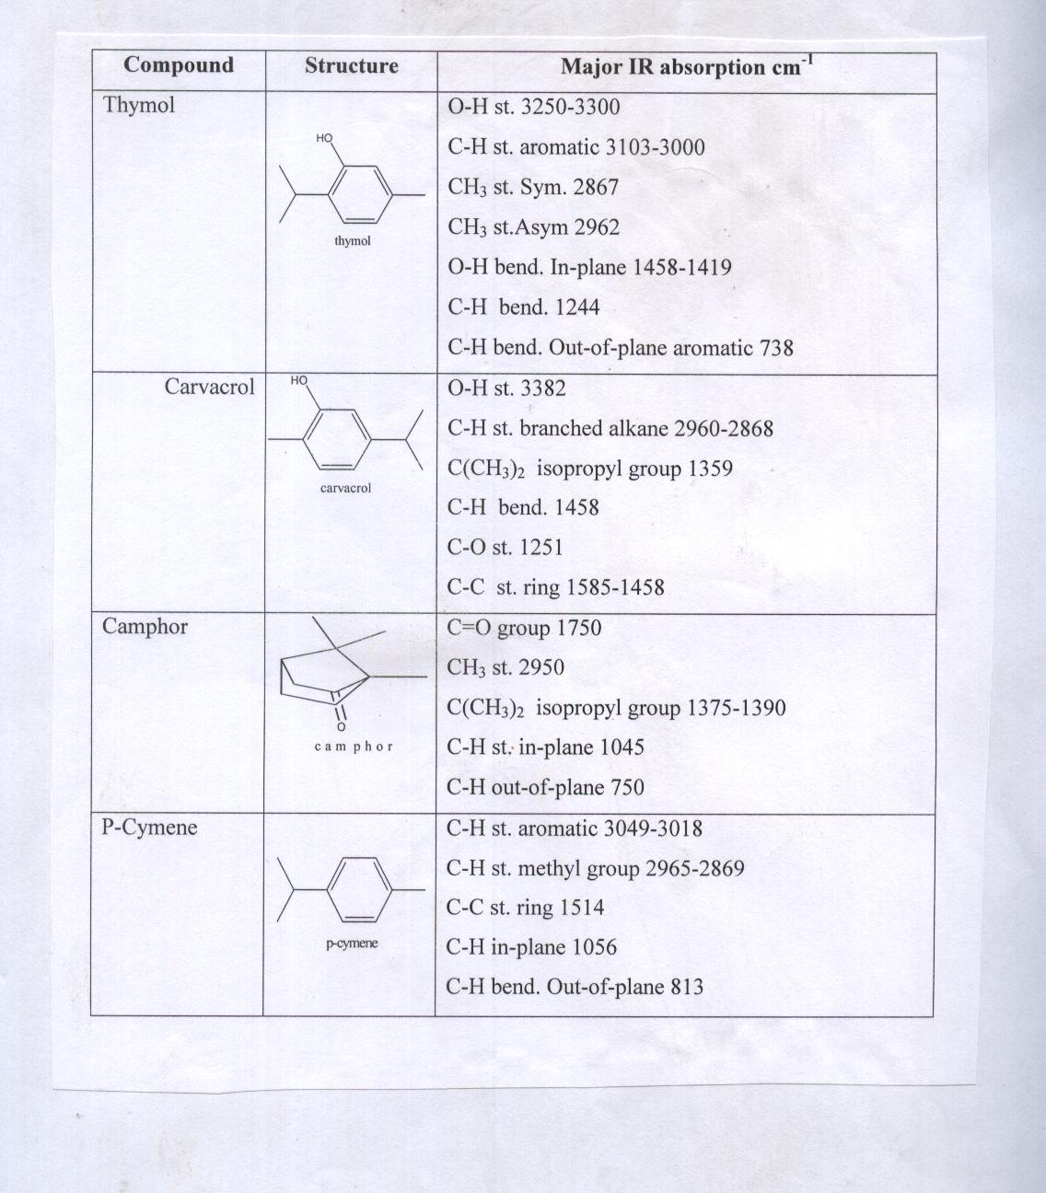
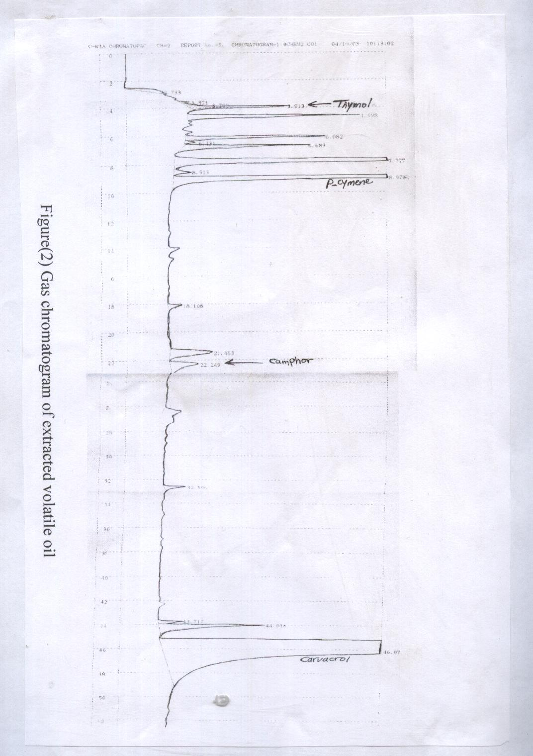
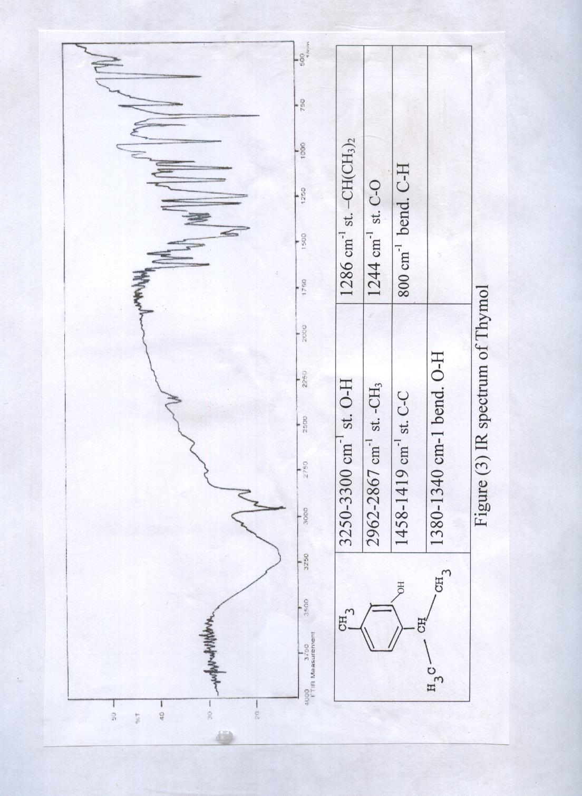
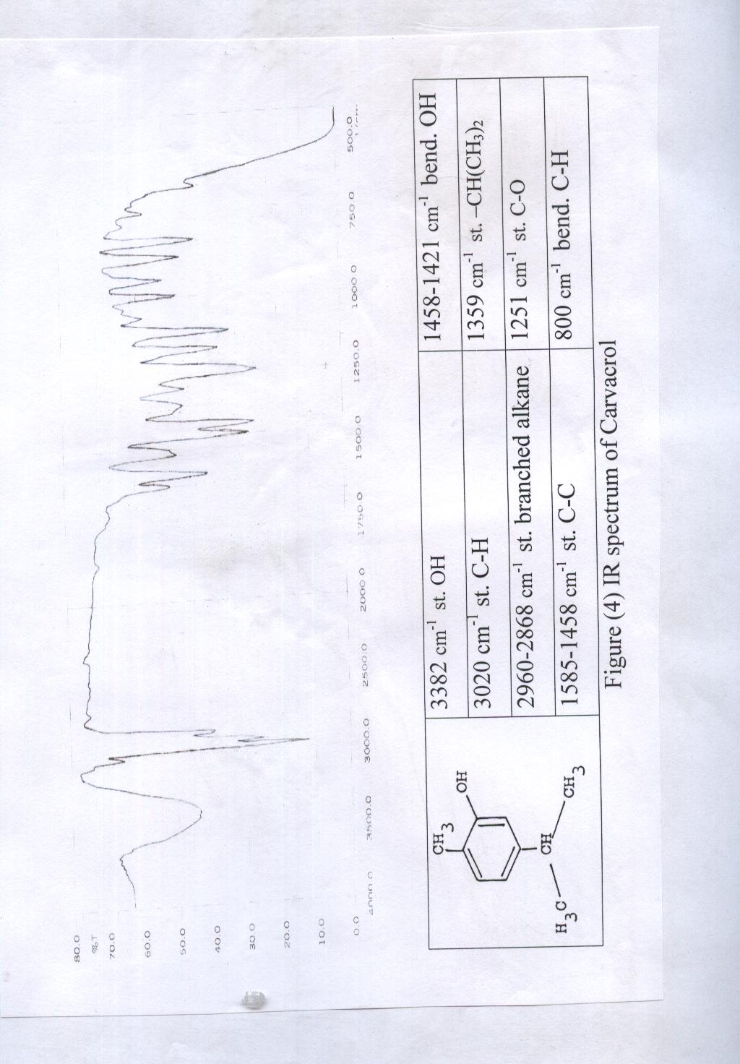
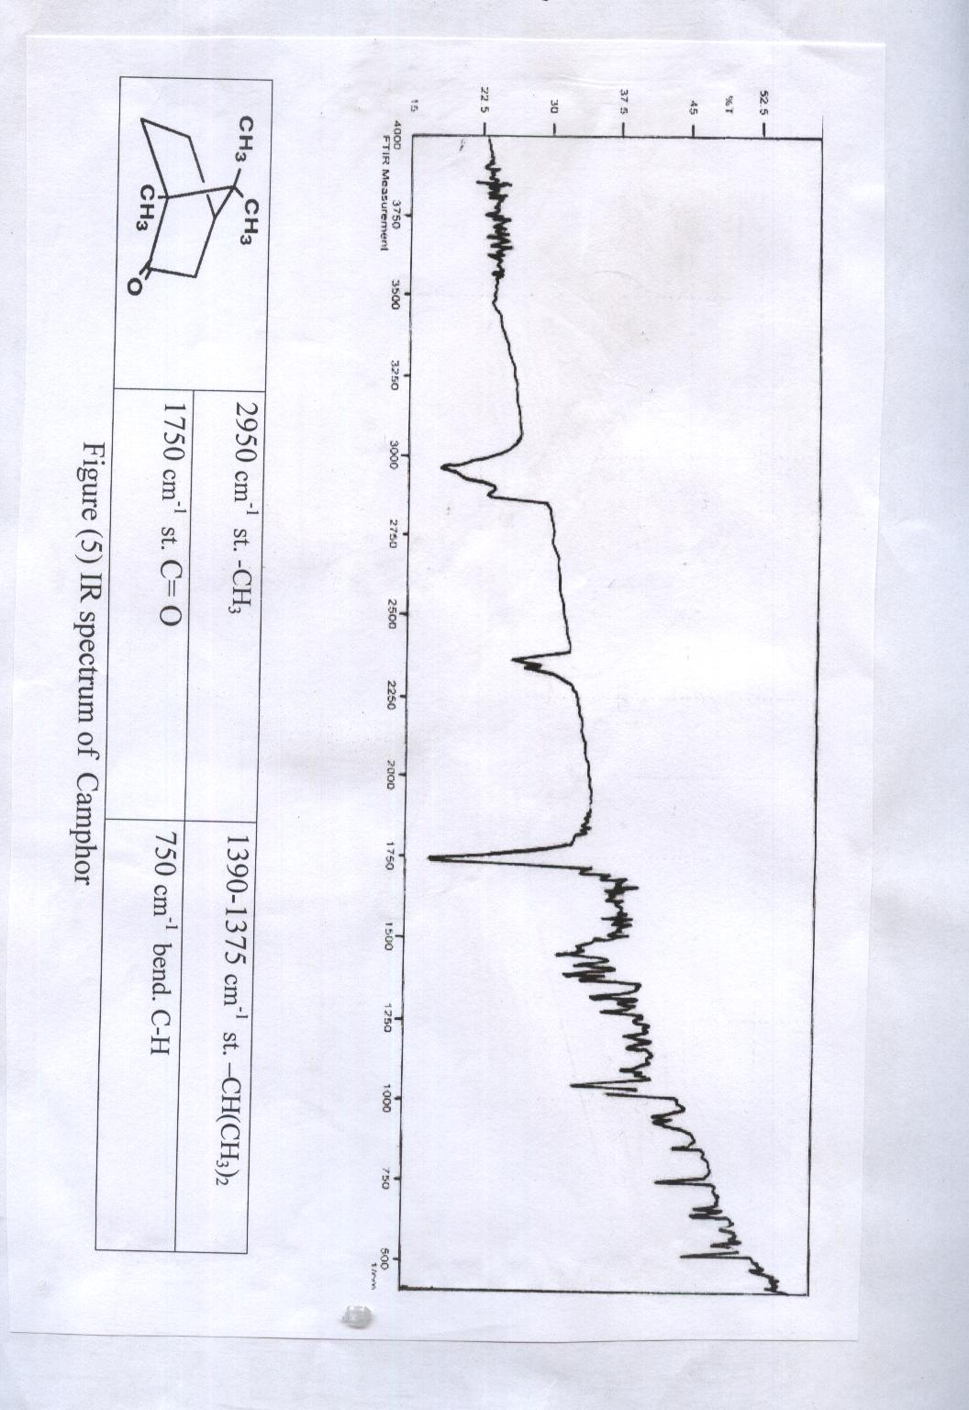
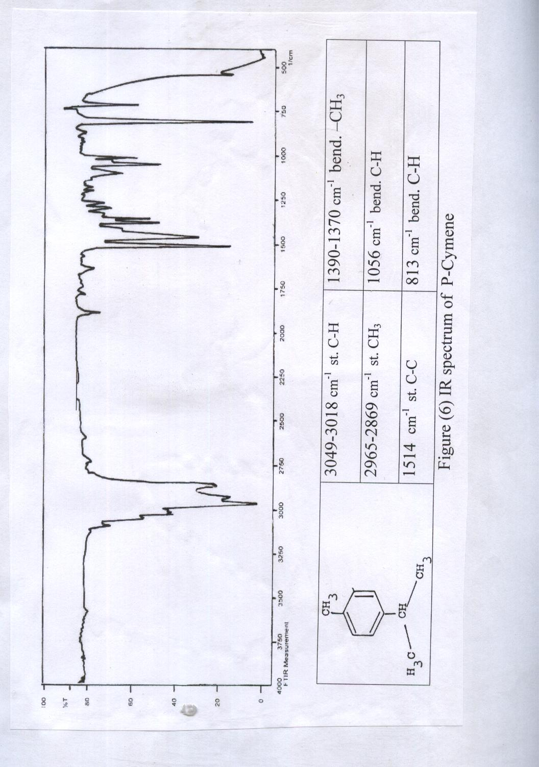
References
- D. Hoffmann, Herbal Materia Medica. Health World Online. 2003.
- R.Ayash, Avicenna pharamacy, Dar alSorour , Lebanon, p.467,1999 (Arapic).
- K.Svoboda, S.Deans. J.Acta Hortic. 390,203,1995
- W.Ch.Evans, Trease and Evans pharmacognocy, 15th ed. W.B.Saunders, p.253.2002.
- A.Akgul, and M.Ozcan. J. Essential Oil Research, 1999, 11,2,209.
- Al-Bayati,M.A. Ph.D. Thesis. Baghdad University. 2001.
- Indian Herbal Pharmacopoeia. Vol.II. Ajoint publication of Regional Research Laboratory and Indian Drug Manufacturer`s Association. P. 1999.
- H.Wagner, S.Bladt, and E. Zgainski. Plant Drug Analysis A thin layer chromatography. Spring-Verlag Berlin Heidelberg. P.18. 1984.
- British Pharmacopoeia. vol.II, British herbal medicine association,1993,p 670.
- S.Serap, S. Sahin, and L.Yilmaz. J. NahrungFood., 2003, 47(4)252.
- S.Sonsuzer, S.Sahin and L. Yilmaz. J. Supercriticalfilids., 2004, 30(2)189.
- H.Baydar, S. Osman, G.Ozkan and K.Tahsin.J. Food Control, 2004, 15(3)169.
- A.Rustaiyan, S.Masoudi, A.Monfared. J. Planta Medica., 2000, 66,197.
- R.Baranauskiene, P.R Venskutonis, P.Viskelis, and E.Dambrauskiene. J. Agric Food Chem., 2003, 17,51,26,7751.
- M.J. Jordan, R.Martinez, M.A Cases, and J.Sotomayor. J. Agric Food Chem., 2003, 27,51,18,5420.

