Photocatalytic Degradation of Arsenazo as a Model Compound

Nada Y . Fairooz Fatima J . Jassim Hassam A . Habeeb
College of Science Dentist College College of Education
Babylon University Babylon University University of Al Qadissia

(NJC)

(Received on 13/3/2005) (Accepted for publication on 4 / 9 /2005)

Abstract
Titanium dioxide (TiO₂)Was used as photocatalyst for the detoxification of water containing arsenazo dye(AD) which was degraded under UV radiation source. No, degradation It was found that for the arsenazo dye in the dark place in the presence of TiO₂.Saveral experiments were performed to optimize the experimental parameters by employing medium pressure mercury lamp (MPML 125W).Firstly ,it has been found that best TiO₂ mass was 60 mg which gave the highest rate of degradation. The temperature in the range (283-303) K was studied to evaluate the activation energy of degradation which was 21.0612 KJ/mole .The effect of PH has been studied over the range (4,6,8,and 9) . It has been found that the highest degradation rate was at PH=4.
الخلاصة
تم خلال البحث الحالي دراسة الأكسدة الضوئية لتفكك صبغة الازو فنيل باعتبارها مادة ملوثة وقد وجد إن ليس هنالك تفكك للصبغة بالظلام وبوجود TiO₂ كعامل مساعد, أجريت مجموعة من التجارب باستخدام الأشعة الفوق البنفسجـية وباستخـدام مصباح الزئبـق المتوسط الضغط وبقدرة (125 واط نوع (كما أجريت مجموعة من التجارب لتحديد الظروف المثلى للتفاعل منها تحديد كمية العامل المساعد TiO₂ المثلى حيث وجد إن استخدام 60 mg من العامل الساعد يعطي أعلى قيمة لثابت سرعة التفاعل .تم دراسة تأثير درجة الحرارة على التفاعــل الضوئي وإيجاد طاقـة التنشيط وقد وجد أنها تساوي 21.062 كيلو جول /مول , كما تم دراسة القيمة المثلى للـPH لوسط التفاعل وكانت ضمن PH=4.

Introdoction
Water resources are limitted in developing countries and there is great need to recycle water and to reuse it in agriculture and industry⁽¹⁾. Solar energy is aboundaut in most developing countries. Solar energy intensity is quite suitable and can be used as a source for the photocatalytic detoxification of polluted water⁽²⁾. This process may prove to be economically and technologically feasible⁽¹⁻³⁾ for water treatment and detoxification of water.Photocatalysis has received growing interest over the last few years⁽⁴⁾ .
Titanium dioxide (TiO₂) is generally considered to be the best photocatalyst and has the ability to detoxification water from a number of organic pollutant⁽⁵⁾ . Anatase (TiO₂) has a wide band gap, Eg=3.2 eV ^{(6) ,}thus only light below 400 nm is absorbed and capable to forming (e⁻ /h⁺ ) pair⁽⁷⁾ which recombine in competition with separation to yield a conduction band electron and valance band hole in less then 30 ps⁽⁸⁾ . The presence of oxygen is very essential for the trapping of photo electrons to reduce recombination pocess, which occurs between (e⁻_{cb} /h⁺_{vb} ) pair⁽⁹⁾, TiO₂ acts as short circuited photoelectrochemical cells and directly oxidize absorbed electron donors or reduce adsorbed electron excerptors by electron and hole transfer at two positions on TiO₂ surface.
Photo catalysis is potential technology for the destruction of organic contaminants in water such as aromatic compounds, which present a potential hazard to the environment. Oxidation of organic compounds in aqueous solution is achieved by the reactive hydroxyl radical (OH). Using photocatalysis has mineralized different compounds, among them hydrocarbons⁽⁸⁾ ,phenols⁽¹⁰⁾ , chlorophenols⁽¹¹⁻¹²⁾ .
The aim of the present work is to explore the possibility of using solar radiation for the detoxification of different pollutant. Arsenazo dye (AD) (Figure 1) was used as a model compound because it was possible to use UV- visible spectroscopy to monitor the degradation under different conditions such as (TiO₂) concentration, different temperature, and PH of the solution.

Figure (1) : Structural Formula of arsenazo I .

Experimental
Chemicals:
All chemicals were used without further purification. Arsenazo dye was supplied by BDH , Titanium dioxide (P-25) was supplied by Degussa . Double distilled water was used in all experiments.

Instruments:
Medium pressure mercury lamp (MPML) type OSRAM (125 W) was used as source of irradiation.
photo cell with quartz window was used as vessel and medium pressure mercury lamp (type Osram 125 watt) was used and fit controlling the temperature was adjusted by circulating thermo state was used. Cintra-5 UV Visible spectrophotometer was used to determination the undegarded dye in the λ max (497 nm). The temperature was adjusted dye regulator thermostat (Desaga Frigostat) . The PH of suspension was controlled by using PH meter (Radiometer Copenhagen).

Photodegradation Experiments:
All photodegradation experiments were carried out by irradiating the aqueous suspension of dye by visible light emitted from LPML in the reaction vessel (25 cm³) fitted with quartz window (2 cm²) with continuous stirring of suspension and bubbling of oxygen by using a compressor . The suspensions were irradiated for 75 min. A small quantity (0.5 ml) of suspension was taken and centrefuged and filtrated to remove TiO₂ .

To detect the optimum conditions of photodegradation process , the effect of TiO₂ quantity (10-90 mg/25 cm³), dye concentration (2 x 10⁻² -2 x 10⁻⁵ M ) , Temperature (283-303 K) , and PH(4,6,8,9) were performed.

Some of experiments were done in the dark in presence of TiO₂ for comparison with photodegradation process.

Result and Discussion
Arsenazo (AD) was chosen as a model compound. This is red in the aqueous solution. The UV-visible spectrum show two maxima wave length.
The UV-Visible for (AD) in distilled water show two absorption maxima (Figure 2). The first band observed at 361 nm while the second band at 497nm. The second band at 497nm was used to monitor the photo catalysis on the degradation of (AD) to study the optimum condition and the effect of different parameters on the degradation of (AD) under the UV radiation the following experiments were used degradation decay follow a first order kinetics from the slops of 1m(concentration vs. time).

Effect of solar Radiation without TiO2 :
The reaction vessel was exposed to the UV radiation without TiO₂ for 3hr . It was noticed that AD is quite stable under solar condition. This means that light ,O₂,and TiO₂ are very essential for photocatalytic degradation of arsenazo dye⁽¹³⁾ .

TiO₂ Concentration Optimization:
As expected for photocatalytic reaction , the rate of photocatalytic degradation of Arsenazo dye has been increased with the amount of catalyst due to complete absorption of the incident light potentially absorbable by TiO₂.

Figure (3) shows such behavior, maximum value of rate has been obtained at 60 mg of TiO₂ for 25cm ³ of the solution so that this quantity was chosen to study the effect of other parameters. Using low weight of TiO₂produce direct proportional between weight of TiO₂ and photocatalytic degradation and this observation can be explained that the number of TiO₂ particles are a few as compared with the number of incident photons, so that the rate of degradation has been increased with increasing TiO₂ particles, but when the weight of TiO₂ more than 60 mg /25 ml , particles form inner filter ⁽¹⁴⁾ which absorb high portion of incident light as well as scatters parts of light.

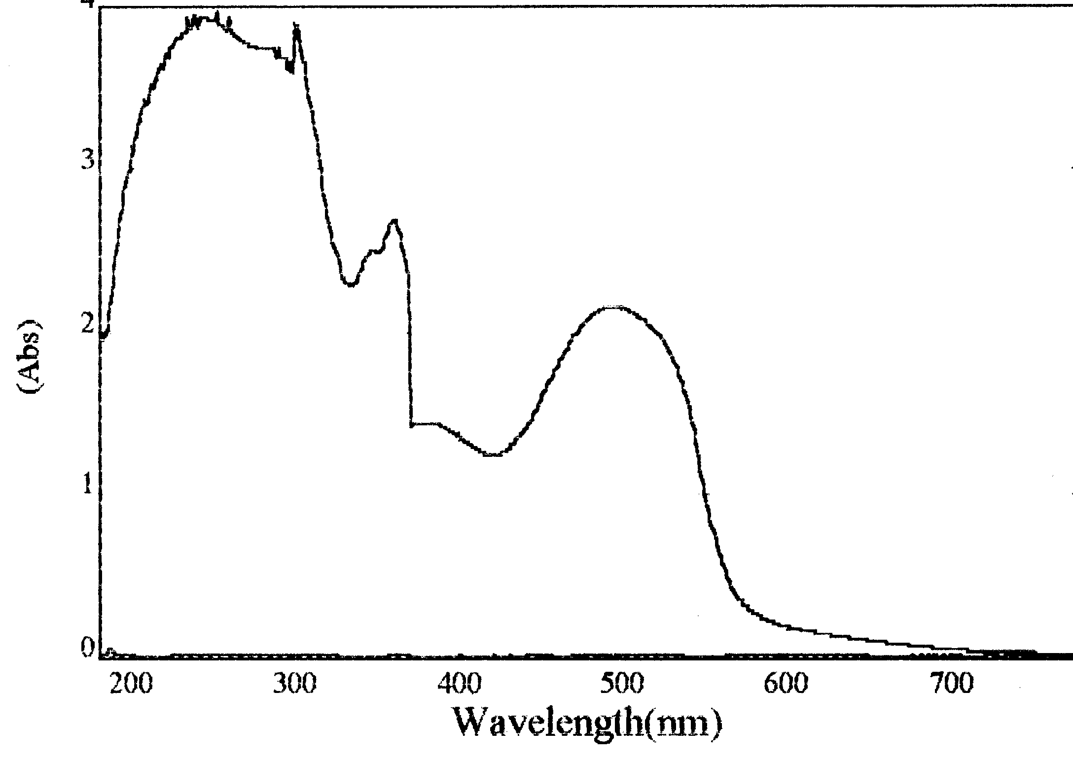
361.0 nm.

497.0 nm

Figure (2) : Spectroscopic absorption spectrum of arsenazo dye dissolved in distilled water

Table (1): Rates of arsenazo dye degradation over different weights of
TiO₂ at 283 K .

Rat of degradation x 10⁶\ mol.L⁻¹S⁻¹ | Weight of TiO₂\mg
3.6 | 10
3.9 | 30
4.2 | 60
3.8 | 90
IrradationTime/min

Conc. X 10⁴ M

Figure (3): photocatalytic degradation of (AD) with different weight of TiO₂

Effect of PH:
The PH of the solutions which include 60mg TiO₂ and affixed concentration of (AD) were varied. The experiments were performed at the same time, the best degradation was obtained with PH=4.

Most of photocatalytic reactions are perfomed in aqueous solution. The PH of the solution effects on the particle size, the surface charge , and the band edge positions of the TiO2 due to it,s amphoteric character . When the PH solution is around 7 the surface of TiO₂ is uncharged. While in acidic media .The particle surface is positively charged , in alkaline media , the surface charge is negative⁽¹⁵⁾ according to the following equations:-

TiOH₂⁺ TiOH + H⁺
TiOH TiO⁻ + H⁺

Positive charge of TiO₂ surface enhanced adsorption of an ionic and polar substrates so that the initial photocatalytic rate was increased with increasing PH solution.
Figure(4) shows that the effect of PH on the degradation of the pollutants is variable and controversial . Where the photocatalytic degradation rate has been decreased with increasing PH . This means that the acidic medium was more suitable for the photocatalytic degradation of (AD) .

Effect of Temperature and Determination of Activation Energy:
A series of experiment have been done over range of temperatures (283-303) K. Their experiments were carried out under illumination with light of 366 radiations from mercury lamp. The results are show in Table (3) and plotted in Figure (5) .The linear dependence of rate reaction on temperature variations was found in this work .The increased rate of reaction with increasing in the temperature may be attributed to the effect of temperature on the adsorption and desorption processes on the surface of TiO₂⁽¹⁶⁾ .

Arrhenius plots shown in Figure (6). The Activation energy has been calculated from the effect of different temperature on the rate of reaction. The manner in which activation energy for (AD) degradation over TiO2 is 21.062 kJ.mol⁻¹, so that this energy was independent on the reaction condition led to suggest that , it was the energy required to promote photoelectrons from the photo catalyst to be trapped at surface by adsorbed oxygen molecules⁽¹⁷⁾ .

Table (2): Rates of arsenazo dye degradation in the rang of PH (4-9) by using 60 mg TiO₂ at 283 K .

Rat of degradation x 10⁶ \mol.L⁻¹S⁻¹ | PH
3.15 | 4
2.81 | 7
2.62 | 8
2.34 | 9

Conc. X 10⁴ M

IrradationTime/min

IrradiationTime/min

Figure(4) : photocatalytic degradation of (AD) under different PH by using 60 mg TiO₂ at 298 K .

Table (3): Rates of arsenazo degradation by using 60 mg TiO₂ in the rang of temperature (283-303)K.

Rat of degradation x 10⁶\ mol.L⁻¹Sec⁻¹ | _{T/K}
4.1 | 283
4.3 | 288
4.9 | 293
5.2 | 298
5.5 | 303
IrradationTime/min
Conc. X 10⁴ M

Figure(5) : photocatalytic degradation of (AD) by using 60 mg TiO₂ under different temperature.

Slope=-1.1x 10³
Slope= -E_{a/} 19.1475
E_{a}= 21.062 x 10³ J. mol⁻¹
E_{a} =21.062 kJ.mol⁻¹

Log rate( mol . L⁻¹.s¹)⁻

1/T x 10³ K⁻¹

Figure (6) : Temperature dependence for the photocatalytic degradation of arsenazo over 60 mg TiO₂

Conclusions
TiO₂ was used as photocatalyst for the detoxification of (AD) which was used as a model compound one can conclude the following.The presence of light and TiO₂were very necessary in photocatalytic degradation of (AD) .The ideal weight of The presence of light and TiO₂, which gave an optimum efficiency for (AD)degradation is 60 mg/25 ml. The photo degradation has been increased with the amount of catalyst due to complete absorption of the incident light potentially absorbable by TiO₂, while using more than 60 mg of TiO₂ reduces the rate of photodegradation, due to the formation of inner filter which absorbs high portions of incident light and scatters other part .

The PH of the solution effect on the rate degradation. the rate of photocatalytic degradation was increased with decreased PH solution because the surface of TiO₂become positive charge in acidic media and this positive charge was enhanced adsorption of ionic and polar substrates.

The rate of photocatalytic degradation of (AD) has been increased with increasing temperature, because increase in temperature leads to enhance adsorption and desorption processes which occur on the surface of TiO₂.

References
1- M.J.Kim,.H.S.Na,C.H.Kwon,W.S.Coi,and J.Park,The Iternational Conference on TiO₂ Photocatalytic Purifications and Treatment of Water and Air , 2001, 100,149.

2- C.Y..Wang , and C.Y. Liu, J. Photochem. Photobiol. A: Chem.,1997, 109, 65.

3- V. Augugliaro , B. Galvez . G. Lopez , V. Loddo, and J . Munoz , Catalysis Today , 1999, 54(2-3), 245.

4- K. Sayama , K. Muasa , R.Yuab , Y. Abe, and H.Arakawa , J. Photochem. Photobiol. A: Chem.,1994, 77, 83.

5- S .Das , M.Muneer , and K. Gopidas, , J. Photochem. Photobiol. A: hem..1994, 77, 83.

6- B. K. Kraeutter , and A.J. Bard, J. Amer. Chem. Soc., 1978, 100, 2239.

7- L . R. Skubal, N.K.Meshkov, and M.C. Vogt , , J. Photochem. Photobiol. A: Chem., 2002, 148, 103.

8- M.Ehrarhardt , and G, Peterick,Mar, Chem.Soc.,1985, 16, 227, 238.

9- D. Dounghong , E.Borgare, and M. Gratzel , J. Amer. Chem. Soc., 1981, 104, 2977.

10- U.Stafford ,K.A.Gray ,and P.V.Kamat, J.Phys.Chem.,1994, 98(25), 63453.

11- N.Serpone, P.Moruthamtha , P.Pichat , E.Petizzeti , and Hidaka , J. Photochem. Photobiol. A: Chem.,1995, 247.

12- N.L. Pruden , and D.F.Oills , Ournal of Catalysis , 1983 , 82 , 404.

13- F.H.Hussin , and , H.A.Habbeb , J.AL.Qadisia , 2000,1 ,3.

14- F.T.Weiss , Determination of Organic Compound Method and Procedures , 1955, P 91.

15- S.P. Parra , Ph . D.Thesis , Chemst. Universided OCL Valle , Coli Colomble , 2001,6.

16- A.J.Attia , and F.H.Hussein , National . J . Chem., 2001, 2, 230.
17- F.H.Hussein,A.H.Ibrahim, and S.A. Shakir, Zanco, 1988, 2(4), 83.

