FI-Spectrophotometric Determination of Catechol amine Drugs in Pharmaceutical Preparations Via Oxidative Coupling Reaction with 4-amino antipyrine and sodium hydroxide

Mouayed Q. Al-Abachi and Muneer A. Al-Da'amy
Department of Chemistry, College of Science, University of Baghdad
Baghdad, Iraq

(NJC)

(Received on 28/2/2005) (Accepted for publication on 4/ 9 /2005)

Abstract:
A new Spectrophotometric flow injection method has been established for the determination of Catechol amine drugs (Methyl dopa (I), Adrenaline (II) and Dopamine.HCl (III)). The method is based on the oxidative coupling reaction of Catechol amine drugs with 4-amino antipyrine and sodium hydroxide to form a red-water-soluble stable product, that has a maximum absorbance at 500, 509 and 498 nm for Methyl dopa (I), Adrenaline (II), and Dopamine (III) respectively. Beer's law is obeyed in the range of 5-200, 10-100 and 5-50 μg.ml⁻¹ a limit of detection (signal/noise=3) of 0.75, 0.86 and 0.57 μg.ml⁻¹ for (I), (II) and (III) respectively. The method was applied successfully for the determination of (I), (II) and (III) in pharmaceutical preparation with a good precision and accuracy.
الخلاصة:
يتضمن البحث تطوير طريقة طيفية باستخدام أسلوب الحقن ألجرياني لتقدير أدوية الكاتيكول أمين في المستحضرات الصيدلانية. تعتمد الطريقة على تفاعل الازدواج التاكسدي بين هذه الأدوية والكاشف العضوي 4-امينو انتي بايرين بوجود هيدروكسيد الصوديوم حيث يعطي ناتج احمر ذائب في الماء وله أعلى امتصاص عند طول موجي 500, 509 و 498 نانوميتر نسبة إلى المثيل دوبا (I) , الادرينالين (II) و الدوبامين (III) على التوالي. طبق قانون بير في مدى التراكيز 5-200, 10-100 و 5-50 مايكروغرام .مل¹⁻ وقيمة حد الكشف (S/n=3) مساوياً إلى 0.75 , 0.86 و 0.57 مايكروغرام .مل¹⁻ نسبة إلى الدواء (I) , (II) و (III) على التوالي. تم تطبيق الطريقة بنجاح في تقدير الأدوية في المستحضرات الصيدلانية وبدقة وضبط جيدين.

Introduction
In recent years more and more strict regulations related to the quality control for pharmaceutical led to increasing demands on the automation of analytical assays carried out in appreciation control laboratories. At the same time, during twenty-five years of the existence, the FIA technique ⁽¹⁾ become aversatile instrument tool that contribute substantially to the development of the automation in pharmaceutical analysis. This can be documented by a number of reviews on the use of FIA in the analysis of drugs ⁽²⁻⁴⁾ oxidative coupling organic reactions seem to be one of the most suitable FIA spectrophotometric determination of drugs such as Sulphonamide ^{(5,6)} Paracetamol ⁽⁷⁾ Methyl dopa ⁽⁸⁾, Folic acid ⁽⁹⁾ and phenylephrine.HCl ⁽¹⁰⁾. Catechol amines have been detemined by visible spectrophotometry after reaction with Meta periodate ⁽¹¹⁾, Chloranil ⁽¹²⁾, Fe(III) and o-Phenathroline ⁽¹³⁾, Palladium Chloride ⁽¹⁴⁾, Ammonium Meta Fandate ⁽¹⁵⁾ and Isoniazid in the presence of N-Bromosuccinimide ⁽¹⁶⁾. The purpose of the present investigation is to develop a simple and sensitive method for the determination of some Catechol amine drugs (Methyl dopa (I), Adrenaline (II) and Dopamine.HCl (III)) in pharmaceutical prepartations using oxidative coupling reaction and FIA spectrophotometer. The proposed method is based on the reaction of Catechol amine drugs with 4-amino antipyrine in the presence of sodium hydroxide to form an intense red colored which shows an absorption maximum at 500, 509 and 498 nm for (I), (II) and (III) respectively.
Experimental
Apparatus
A shimadzau 260 uv-visible digital double beam spectrophotometer supplied with a (cecil) 50 μl flow cell was used.
Manifold
The flow manifold is show in Fig. 1 a two channel manifold were used for the (FI) Spectrophotometric determination of Catechol amine drugs. Four channel peristaltic pump [Ismatec, labortechnik-Analytic CH-8152 Glatbrugg-Zurich, Switzerland] minipuls (2) peristaltic pump was employed to transport the carrier stream. (Rheodyne-USA) injector valve was used for injection of the drug sample. Flexible vinyl tubing of 0.8 mm internal diameter was used for the peristaltic pump. The reaction coil (RC) was made from Teflon with an internal diameter of 0.5 mm. In Fig. 1, the channel 1 was used to transport 4-amino antipyrine and channel 2 to introduce sodium hydroxide. The drug sample was injected through the injection valve into the resulting stream of the mixture of 4-amino antipyrine with sodium hydroxide solution and were propelled by the peristaltic pump with an individual flow rate of (1.2,1.5, 1.5) ml.min⁻¹ and the absorbance was measured at λ max 500, 509 and 498 nm for (I),(II)and (III) respectively.

P

D
SX
IV
F.C
W
4-amino antipyrine
sodium hydroxide
R.C

Fig. 1 manifold employed for FI-Spectrophotometric determination of Catechol amine drugs with 4-amino antipyrine and sodium hydroxide.
Where:
IV: injection valve.
R.C: reaction coil.
SX: drugs sample (Catechol amine drugs).
P: peristaltic pump.
D: detector.
W: waste.

Reagents
The pure Methyl dopa was obtained from SDI-Iraq.
Aldomate tablets were provided from SDI and ASIA (jourdianian drug company).
The pure Adrenaline was obtained from Rhone pulence company/ France. Where as the injections (1 mg/ml) were from life pharma-Italy.
The pure Dopamine.HCl and the injection sample (200 mg/5ml) were obtained from biological-Italia LAB.
Methyl dopa stock solution (1000 μg.ml⁻¹):
0.1000 gm of Methyl dopa was dissolved in 100 ml of distilled water in a volumetric flask of 100 ml.
Adrenaline stock solution (1000 μg.ml⁻¹):
0.1000 gm was dissolved in 10 ml of ethanol and completed the volume to 100 ml with distilled water in a volumetric flask of 100 ml.
Dopamine.HCl stock solution (1000 μg.ml⁻¹):
2.5 ml of (200 mg/ 5ml) solution was diluted with distilled water in a volumetric flask of 100 ml.
4-amino antipyrine (3*10⁻² M):
0.6097 gm of 4-amino antipyrine was dissolved in 100 ml of distilled water in a volumetric flask of 100 ml.
Sodium hydroxide (1 M):
10.0000 gm of sodium hydroxide was dissolved in 250 ml distilled water in a volumetric flask of 250 ml.
General procedure for the determination of Catechol amine drugs:
The mixture of (0.025, 0.010 and 0.010 M) of 4-amino antipyrine and (0.1 M)of sodium hydroxide for Methyl dopa (I), Adrenaline (II), and Dopamine (III) respectively were passed through a coil and allowed to react with (100 μl) of Catechol amine drugs. The reaction was carried out by passing the solution through a (50,60 and 50 cm) reaction coil for Methyl dopa (I), Adrenaline (II), and Dopamine (III) respectively. The absorbance of the resulting dye product was measured at λ max of 500, 509 and 498 nm for (I), (II) and (III) respectively. All streams were pumped at an individual flow rate of (1.2, 1.5 and 1.5 ml.min⁻¹) for (I), (II) and (III) respectively. For optimization of conditions 100, 50 and 20 μg.ml⁻¹ from Methyl dopa, Adrenaline and Dopamine were used respectively.

Results and discussion
The Catechol amine drugs reacted with 4-amino antipyrine in the presence of sodium hydroxide to form an intense red colour product that can be measured at 500, 509 and 498 nm for (I), (II) and (III) respectively. Fig.2,3 and 4 showed the spectrum of the dye product. The absorbance of the red dye is directly related with the concentration of the Catechol amine drugs and can be used for its spectrophotometric determination. It was found that the sensitivity of the colour products depends on the reaction conditions and were optimized as follow.

Effect of the 4-amino antipyrine concentration:
The effect of various concentration of 4-amino antipyrine was investigated. A concentration of (0.025, 0.010 and 0.010 M) gave the highest absorbance for Methyl dopa, Adrenaline and Dopamine respectively and were used for further experiments. The results obtained are shown in Fig.5

Effect of sodium hydroxide concentration:
It was observed that the reaction between Catechol amine drugs and 4-amino antipyrine depend on the presence of sodium hydroxide. The effect of various concentration of sodium hydroxide were studied. A concentration of 0.1 M gave the best results for Catechol amine drugs as shown in Fig.6 and were considered as optimum.
Effect of flow rate:
The effect of flow rate on the sensitivity of the colour reaction product was investigated. The results obtained showed that a flow rate of (1.2,1.5and 1.5 ml.min⁻1) gave the highest absorbance for Methyl dopa, Adrenaline and Dopamine respectively as shown in Fig.7 and was used in all subsequent experiments.
Effect of reaction coil length:
The coil length is an essential parameter that affected on the sensitivity of the colour reaction product and was investigated in the range of 25-100 cm. The results obtained showed that a coil length of (50, 60 and 50 cm) gave the highest absorbance for Methyl dopa, Adrenaline and Dopamine respectively as shown in Fig.8 and were used in all subsequent experiments.

Effect of injected sample volume:
The effect of sample volume was investigated by injection of a volume of difference length of sample loop. The results obtained showed that an injection sample of 100 µl) gave the best absorbance for Catechol amine drugs as shown in Fig.9 and were used in the general recommended procedure.
Calibration graph for the determination of Catechol amine drugs:
Under the optimum condition a linear calibration graph. Fig.10 was obtained over the concentration range of (5-200,10-100 and 5-50 μg.ml⁻¹) for Methyl dopa, Adrenaline and Dopamine respectively. The limit of detections (signal/noise=3) were (0.75, 0.86 and 0.57 μg.ml⁻¹) for Methyl dopa, Adrenaline and Dopamine respectively. The correlation coefficients were 0.9996, 0.9997 and 0.9998 for Methyl dopa, Adrenaline and Dopamine respectively. The relative standard deviation of the method was better than 1.47% (Table 1).
Nature of the dye product:
The stoichiometry of the reaction between Catechol amine and 4-amino antipyrine was investigated using the molar ratio method(17) under the optimized conditions. The results obtained (Fig.11), show a 1:1 drugs to reagent product was formed. The formation of the dye may probably be occur as follows.

R
OH
OH +
drugs
4-amino antipyrine
H₂N
N
NaOH
N
R
OH
O
Red colour product
CH₃
CH₃
N
ph
O
H₃C
N
H₃C
N
ph
O

Where:
R= -CH₂CCH₃NH₂COOH for Methyl dopa.
R= -CHOHCH₂NHCH₃ for Adrenaline.
R= -CH₂CH₂NH₂ for Dopamine.

Analytical applications:
The proposed method was applied for the determination of Catechol amine drugs (Methyl dopa, Adrenaline and Dopamine) in pharmaceutical preparations. Good accuracy and precision were obtained for the studied drugs. The results obtained were given in Table 1 which confirms the applicability of the method. Finally, the proposed method was compared successfully with the standard method (Table 1).

Table 1: the application of the proposed method for the determination of Catechol amine drugs in pharmaceutical preparations.
Sample | Amount of drugs  taken µg.ml⁻¹ | RSD % * | Recover %
Sample | Amount of drugs  taken µg.ml⁻¹ | RSD % * | Proposed  method | Standard  method*
Pure Methyl dopa | 50 | 0.40 | 100.54 | 101.17
Aldomate-SDI | 50 | 1.12 | 99.10 | 101.17
Aldomate-ASIA | 50 | 0.90 | 99.08 | 101.17
Pure Adrenaline | 50 | 0.39 | 100.30 | 100.00
Ampoules Adrenaline | 50 | 0.88 | 99.12 | 100.00
Ampoules Adrenaline | 100 | 0.17 | 100.20 | 100.00
Pure Dopamine | 20 | 0.60 | 99.58 | 102.50
Ampoules Dopamine.HCl | 20 | 0.68 | 100.60 | 102.50
Ampoules Dopamine.HCl | 50 | 0.25 | 99.83 | 102.50
* average of three determination.
* U.S.P standard method.

Conclusions
A simple accurate and sensitive FI-Spectrophotometric method for the determination of Catechol amine drugs in pharmaceutical preparation has been developed. The method needs neither temperature nor pH control. The method was applied successfully to different pharmaceutical samples.

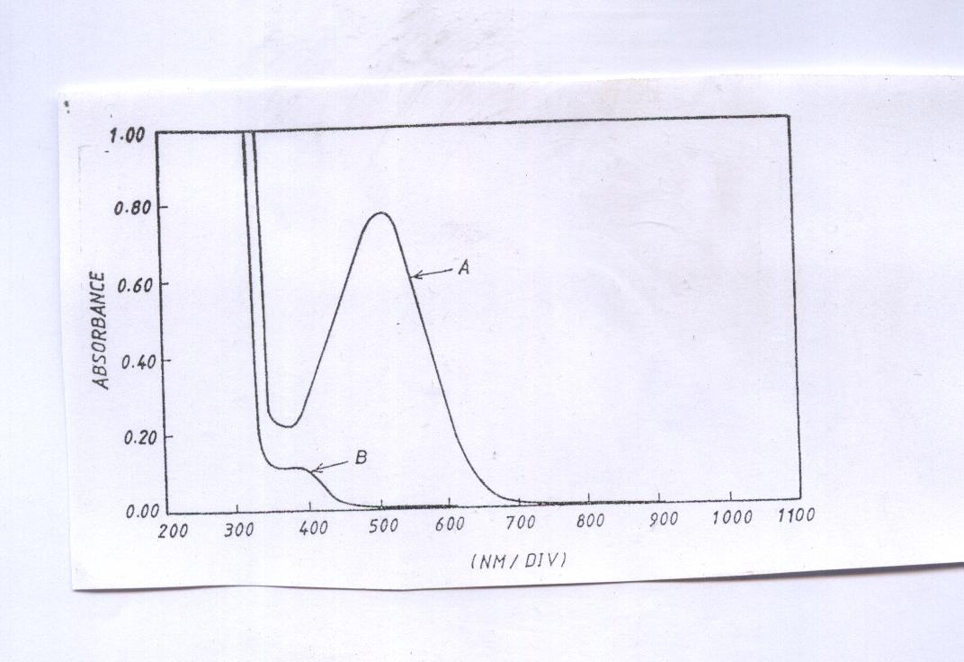
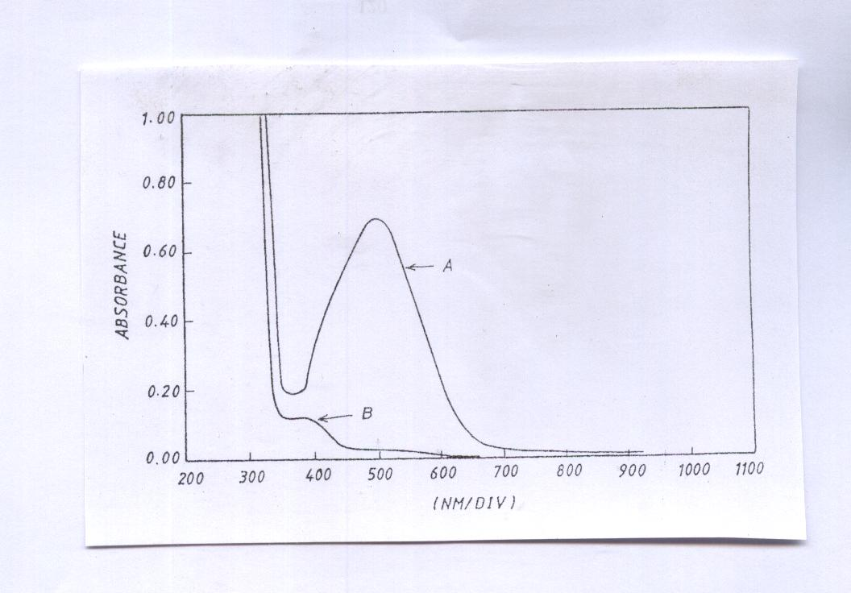
Fig.2 Absorption spectra of A (1700g/25ml) of Methyl Dopa trated as described under procedure and measured against reagent blank of B the reagent blank measured aginst distelled water.

Fig.3 Absorption spectra of A (1700g/25ml) of Adrenaline trated as described under procedure and measured against reagent blank of B the reagent blank measured aginst distelled water.
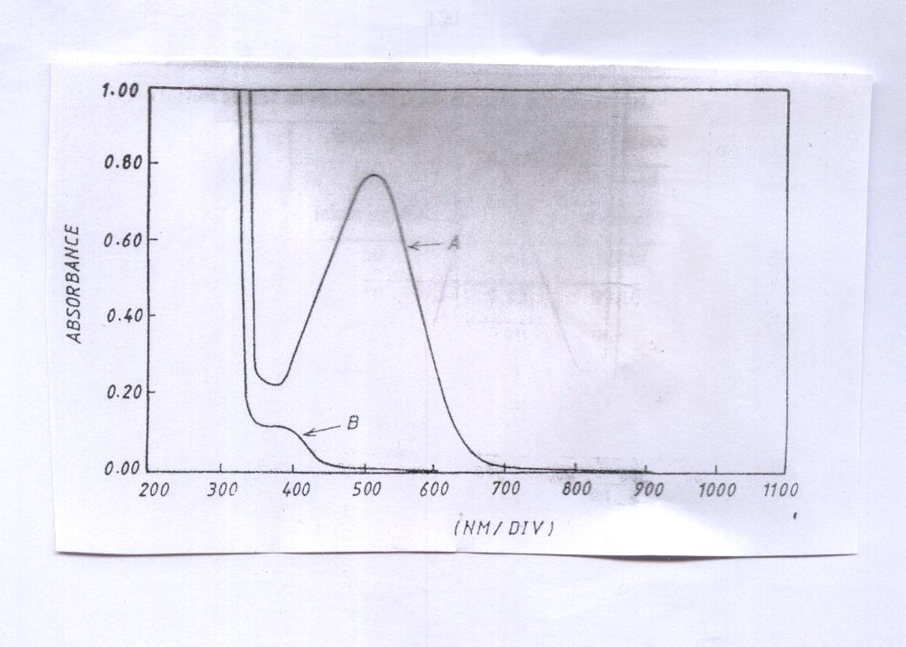
Fig.4 Absorption spectra of A (1700g/25ml) of Dopamine trated as described under procedure and measured against reagent blank of B the reagent blank measured aginst

Fig.5 Effect of reagent concentration on the Coloured reaction product.

Fig.6 Effect of base concentration on the coloured reaction product.

Fig.7 Effect of flow rate on the sensitivity of the coloured product.

Fig.8 Effect of reaction coil length on the absorbance of coloured product.

Fig.9 Effect of injection volume on the absorbance of coloured product.

Y=0.0018*X+0.0183
R²=0.9993

Y=0.0036*X-0.00056
R²=0.9998
Y = 0.00118182 * X + -0.0048
R²=0.99957
.

Fig.10 Calibration graph of Adrenaline and Dopamine.

Fig.11 Molar ratio of drug to reagent

References
- Ruzicka J. and Hasen E. H., Flow injection Analysis, Wiley, New-Yourk (1988).
- Karlicek R. , Solich P., Polasek M., J. Flow injection Anal., 1994, 11, 45.
- Catyud J. M. And Mateo J. V. G., Pharm. Technol. Internet, 1992, 4, 17.
- Catayud J. M. , Flow injection Analysis of pharmaceutical. Automation in the laboratory, Taylar and Francis, London (1996).
- Al-Abachi, M. Q., E. S. Salih, and Salem M. S., Fresenius J. Anal. Chem., 1991, 337, 408.
- Al-Abachi, M. Q., Salih E. S., Al-Ghabsha, T. S., Microchemical Journal, 1990, 41, 64.
- Al-Abachi, M. Q., Al-Ward, H. S., National Journal of Chemistry, 2001, 4, 548.
- Al-Abachi, M. Q., Farid, Y. Y., and Hamza, M. J., National Journal of Chemistry, 2002, 8, 520.
- Al-Abachi, M. Q., and Al-abudi, R. S., National Journal of Chemistry, 2002, 8, 527.
- Al-Abachi, M. Q., Hassan, M. J., and Mustafa, M. A., National Journal of Chemistry, 2003, 9, 79.
- EI-Kommos, E.M., Mohamed, F.A., and Khedr, S.A., J. Assoc. of F. Anal-Chem., 1990, 73, 516.
- Al-Ghabsha, T.S., Al-Sabah, T.N., and Saleem, M.S., J. Techn. Res., 1994, 19, 49.
- Issopoulos, P.B., Fresenius, J. Anal. Chem., 1990, 336, 124.
- Zivanovic, L., Vasilijevic, M. and Kustrin, J. Pharm. Biomed. Anal., 1991, 9, 1157.
- San, R. T., Bhousule, G. I., and Sawant, S. V., Indian drugs, 1987, 24, 107.
- Nagaraja, P., Srinivasa Murthy, K. C., Rangappa, K. S. and Mode Growda, N. M., Talanta, 1998, 46, 39.
- B. G. Gowad, M. B. Melwanki and J. Seetharmappa, Analytical Sciences, 2001, 17(4), 533.

