Synthesis and Spectrophotometric Study of 2-(6-Bromo-2-
benzothiazolylazo)-4-chloro phenol as an Analytical
Reagent for Determination of Copper.

Aymen A. R. Jewad, Kasim H. Kadhim, and Abbas N. Al-Sharefy
Dept. of chemistry, college of science, University of Babylon
Babylon-Iraq

(NJC)

(Received on 20/2/2005) (Accepted for publication on 4/ 9 /2005)

Abstract
2-( 6-Bromo-2-benzothiazolylazo )-4-chloro phenol (6-Br-BTACl) has been synthesized , and used for the spectrophotometric determination of microgram amounts of copper. This method sensitive, selective and rapid for reaction between Cu⁺² and (6-Br-BTACl), to form a green complex having a molar ratio of 1:2 (Cu-6-Br-BTACl) at pH 3.7. The molar absorptivity of the complex is (0.38x10⁴ L.mol⁻¹.cm⁻¹) at λ_{max} 636 nm. Beer’s law is obeyed in the range of 0.05 –1.2 µg.ml⁻¹ and the stability constant was found to be 3.8x10⁶ L². mol⁻².
The relative standard deviation, recovery and relative error values of method were found to be R.S.D% = 2.4 , R_{e} % = 96.5 and E_{rel} % = -3.5 . The most important interference were due to Zn²⁺ ، Cd²⁺ ، Hg²⁺ ، Mg²⁺ ، Co²⁺ ، Ag⁺ ، Pb²⁺ ، Ca²⁺ ، CrO₄²⁻ ، Bi³⁺، Ba²⁺ , WO₄²⁻ ,and Ni²⁺, and suitable masking agents were used. The method was applied successfully for determination of copper in the serum of human blood.

الخلاصة
حضر الكاشف العضوي2-(6- برومو-2- بنزوثيازوليل ازو)-4- كلورو فينول واستخدم في تقدير كميات مايكروغرامية من ايون النحاس الثنائي بطريقة تحليلية طيفية سهلة وسريعة وحساسة. المعقد المتكون ( الأخضر اللون) من تفاعل الكاشف مع ايون Cu²⁺ عند pH =3.7 يمتلك نسبة مولية 2:1 من الايون الفلزي إلى الكاشف. معامل الامتصاص المولاري للمعقد 0.38x10⁴ لتر.مول^{–1}.سم⁻¹ عند الطول الموجي للامتصاص الاعظم 636 نانومتر حيث كانت التراكيز التي تطاوع قانون بير مساوية إلى (0.05-1.2) مايكروغرام نحاس\مليلتر, وبلغت قيمة ثابت الاستقرارية 3.8x10⁶ لتر² .مول⁻² , وحدد دقة وضبط الطريقة التحليلية المتبعة باستخدام محلول قياسي من ايون النحاس ذي تركيز 0.4 مايكروغرام\مليلتر فكانت قيمة R.S.D % , R_{e} % , E_{rel} % هي-3.5، 96.5 ، 2.4على التوالي ، كذلك تم دراسة تأثير ايونات Zn²⁺ ، Cd²⁺ ، Hg²⁺ ، Mg²⁺ ، Co²⁺ ، Ag⁺ ، Pb²⁺ ، Ca²⁺ ، CrO₄²⁻ ، Bi³⁺، Ba²⁺ , WO₄²⁻ , Ni²⁺ والتي تتداخل عند تفاعل الكاشف (6-Br-BTACl) مع ايون النحاس II وتم حجب تأثيرها باستخدام عوامل حجب قياسية , طبقت الطريقة التحليلية لتقدير النحاس في مصل الدم للإنسان.

Introduction
Copper is important as an essential trace element in biological systems having a complex role in many body functions, in addition, copper are toxic and the concentration levels between essential and toxic being narrow. ⁽¹⁾ Therefore sensitive, simple, and accurate methods for the determination of copper are required.
Several methods for the determination of copper are available, such as differential pulse adsorption stripping voltammetry⁽²⁾, electrothermal atomic absorption spectrometry⁽³⁾, ion selective electrodes⁽⁴⁾ reverse phase-HPLC ⁽⁵⁾. Spectrophotometry is essentially a trace-analysis technique and is one of the most powerful tools in chemical analysis.The determination of elements by Uv-Vis spectrophotometry requires a selective chromogenic reagent. Different chelating agents have been proposed, such as 1-(2-pyridilazo)-2-naphthol (PAN) and benzildithiosemicarbazone.^{(6,7)}
Thiazolylazo compounds have attracted much attention as analytical reagents owing to the high sensitivity and selectivity^{(8,9)}. Many thiazolylazo reagents have been reported for spectrohotometric determination of copper such as 2-{2-(6-methylbenzothiazolyl)azo}-5-(dimethylamino) benzoic acid ⁽¹⁰⁾. In this work, a new heterocyclic azo dye reagent (6-Br-BTACl) has been synthesized, and used for spectrophotometric determination of micrograms quantities of copper(II). This method sensitive, and rapid.

Experimental
Apparatus
Absorption spectra were recorded with cintra5-GBC scientific Equipment, while absorption measurements were obtained with pye unicam uv-Visible sp8-100 double-wave length spectrophotometer both with matched 1 cm quartz cells. pH of the solution was measured using a philips Pw 9421 pH meter (pH + 0.001), FT-IR spectra were recorded with FT-IR-8000 shimadzu, single beam , path laser by KBr discs. atomic absorption spectrophotometer 5000 , perkin-Elmer , U.S.A was used.
Reagents
All chemicals were used of analytical – reagent grade unless other wise stated. All solution were prepared using de-ionized water.

Perperation of Reagent
(6-Br-BTACl) has been synthesized by the diazotisation-coupling reaction using (Huseyinli) et. al.⁽¹¹⁾ method (with some modifications) for synthesis this kinds of compound. 2-Amino-6-Bromobenzothiazole (1.14 gm) was dissolved in 20 ml of acetic acid and 5 ml of concentrated hydrochloric acid, then 25 ml of water were added. To this solution was added dropwise a solution of 0.34 gm of sodium nitrite in 5 ml of water at 0–5 °C and the mixture was stirred at 0–5 °C. Separately, 4-chloro phenol (0.64 gm) was dissolved in 50ml of water with addition of 2 gm sodium hydroxide and the solution was cooled to 0–5 °C. This solution was then added dropwise to the above diazotized solution with vigorous stirring. The mixture was stirred in an ice-bath and allowed to stand overnight. The precipitate formed was filtered off and first purified by the ethanol recrystallization and further purified by acetone.

Standard copper Solution
A solution of copper 100 ppm was prepared by dissolving (0.0392) gm of CuSO₄.5H₂O in 100 ml of distilled water, working solutions were prepared freshly by appropriate dilution of the stock solution.
(6-Br-BTACl) Solution
A solution of 1×10⁻³M was prepared by dissolving (0.0921)gm of pure reagent in 250ml of absolute ethanol.

General procedure
Into a 10 ml calibrated flask, transfer 1 ml of sample solution containing not more than 3 µg.ml⁻¹ of copper and 4 ml of 1x10⁻³M ethanolic (6-Br-BTACl) solution. Dilute to volume with distilled water, mix well and after 10 min measure the absorbance of solution at 636 nm at 25°C in a 1 cm cell against a reagent blank prepared in a similar way but without copper.

Results and Discussion
Physical properties of (6-Br-BTACl)
The reagent is a deep red powder decomposes at 181°C, which is not soluble in water. It is soluble in ethanol, acetone, ether, benzene, carbon tetra chloride, chloroform, and DMF. It is red in alkaline solution, but yellow in weakly and strongly acidic solution.

FT-IR Spectra of Reagent⁽¹²⁻¹⁴⁾
selected FT-IR absorption bands of reagent are shown in (Table 1)

Table 1 FT-IR bands of the reagent

ν/cm⁻¹ | Group
3450 | O-H
2922 | C-H al
3087 | C-H ar
1627 | C=N
1438 | C=C
1274 | C-S
1529 | N=N
600-800 | C-Cl
500-750 | C-Br

Chromogenic reaction of 6-Br-BTACl with metal ions
6-Br-BTACl was tested in reaction with 22 cations. It was found to react mainly with Cu²⁺, Zn²⁺ ، Cd²⁺ ، Hg²⁺ ، Mg²⁺ ، Co²⁺ ، Ag⁺ ، Pb²⁺ ، Ca²⁺ ، CrO₄²⁻ ، Bi³⁺، Ba²⁺ , WO₄²⁻ ,and Ni²⁺.

Absorption spectra
The absorption spectra of (6-Br-BTACl) and its copper complex under the optimum conditions are shown in Fig. 1. The wavelength for the maximum absorption (λ_{max}) of the reagent was found at 428 nm ,and the λ_{max} of the complex was found at 636 nm, hence the wavelength difference (∆λ) is 208 nm.

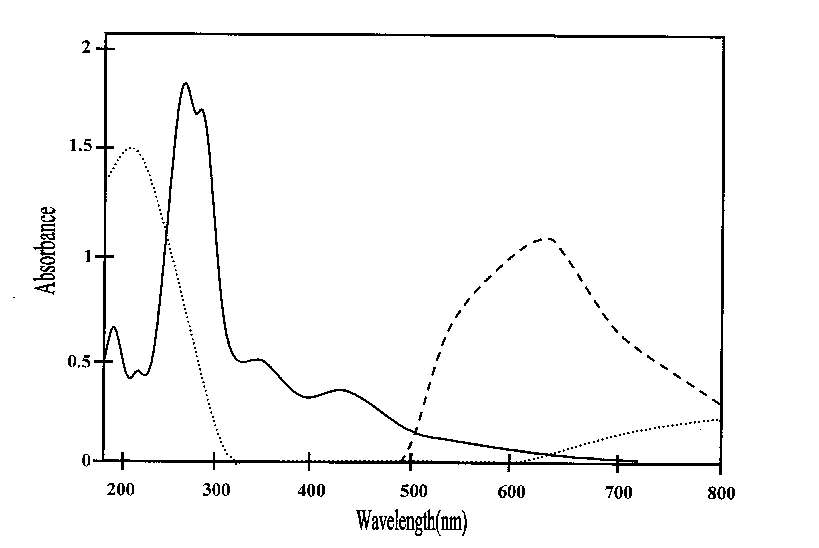
Fig. 1 Absorbtion spectra of A: copper ion , B: 6-Br-BTACl reagent , C: Cu-6- Br-BTACl complex
C
B
A

Effect of (6-Br-BTACl) concentration
For solution containing up to 1 µg.ml⁻¹ of copper (ii), the addition of more than 4 ml of 1x10⁻³M (6-Br-BTACl) solution sufficed to complete the reaction. Therefore, 4 ml of (6-Br-BTACl) was subsequently used.
Effect of pH:
The experimental results demonstrated that the absorbance of the (Cu-6-Br-BTACl) system is maximum and constant in the pH range 3-4.5 and a pH of 3.7 was adopted. Fig.(2) shows the relationship between absorbance of complex and pH. At pH > 5 a decreases in absorbance may be due to the hydrolysis of copper, and also when pH < 2.7 a decrease in absorbance occur due to form azolium cation result from the reaction between hydrogen ion and the ion pair of electron which found in the nitrogen atom for thiazole ring.

pH control

Fig. 2 Effect of pH on the absorbance of copper complex, Cu²⁺ = 1 µg. ml⁻¹.

Stability of the chromogenic system
It was found that the absorbance of the complex Cu-6-Br-BTACl chromogenic system reaches a maximum value within 10 min at room temperature and remains stable for at least 24 h (Fig. 3).

Fig.3: Effect of time on the absorbance of copper complex Cu²⁺ = 1 µg. ml⁻¹.

Effect of temperature
The effect of temperature on the absorbance of the Cu-6-Br-BTACl complex was studied. The study was performed at temperature between 10ºc and 60ºc (Fig.4). The maximum absorption was obtained when the temperature was varied between 20ºC and 30ºc, at temperature higher than 30ºc the absorbance gradually decreased with increasing temperature until it reaches 60cº, which may be due to dissociation of the complex.

º

Fig.4 Effect of temperature on the absorbance of copper complex

Composition of the complex
The composition and apparent stability constant were evaluated by the both of continuous variation and the mole ratio methods (Fig.5 , Fig.6). Both methods were showed that the molar ratio of Cu-6-Br-BTACl complex is 1:2, and the stability constant was found to be 3.8x10⁶ L². mol⁻². The general equation of the reaction between copper and the reagent (6-Br-BTACl) is shown as follow:-

Fig.5 continuous variation method for Fig.6 mole ratio method for copper
copper complex with (6-Br-BTACl) at pH =3.7 complex with (6-Br-BTACl) at pH =3.7

Calibration graph and sensitivity
The calibration graph was constructed following the general procedure. Beer’s law was obeyed in the concentration range of 0.05-1.2 µg Cu(ii).ml⁻¹, with a correlation coefficient r = 0.9976. The molar absorptivity of the Cu-6-Br-BTACl complex was found to be 0.38x10⁴ L.mol⁻¹.cm⁻¹ at 636 nm and the Sandell sensitivity was 0.0166 µg.cm⁻².

Precision and accuracy
The precision and accuracy of the analytical procedure used showed that the R.S.D% was 2.4% to 0.4 μg.ml⁻¹ of Cu(II). The recovery and E_{rel}% for the complex solution containing (0.4) μg.ml⁻¹ of Cu(II) were found to be 96.5, and -3.5% respectively. The detection limit was found to be 0.028 μg.ml⁻¹ of copper. These results indicating that this method is highly precise and suitable for the determination of copper (II) spectrophotometrically.
Interferences
The selectivity of Cu-6-Br-BTACl system is tested by carrying out of determination of 10 µg.ml⁻¹ in the presence of foreign ions. These ions (Zn²⁺ ، Cd²⁺ ، Hg²⁺ ، Mg²⁺ ، Co²⁺ ، Ag⁺ ، Pb²⁺ ، Ca²⁺ ، CrO₄²⁻ ، Bi³⁺، Ba²⁺ , WO₄²⁻ ,and Ni²⁺) which also reacts with the reagent 6-Br-BTACl during its reaction with Cu²⁺. Above cations were masked by using suitable masking agent. The results obtained are summarized in Table 2

Table 2 Study of interference
Interference | Amount added / μg | Form added | Foreign ion
-11.3 | 5 | NiCl₂.6H₂O | Ni²⁺
+8.4 | 5 | ZnSO₄.7H₂O | Zn²⁺
+5.6 | 5 | Cd(NO₃)₂.4H₂O | Cd²⁺
+1.4 | 5 | HgCl₂ | Hg²⁺
-0.9 | 5 | Mg(NO₃)₂.6H₂O | Mg²⁺
+4.7 | 5 | Co(NO₃)₂.6H₂O | Co²⁺
+0.9 | 5 | AgNO₃ | Ag⁺
-6.6 | 5 | Pb(NO₃)₂ | Pb²⁺
+1.8 | 5 | Ca(NO₃)₂.4H₂O | Ca²⁺
+0.9 | 5 | K₂CrO₄ | CrO₄²⁻
+0.9 | 5 | Bi(NO₃)₃.5H₂O | Bi³⁺
-2.8 | 5 | Ba(NO₃)₂ | Ba²⁺
-11.3 | 5 | Na₂WO₄.2H₂O | WO₄²⁻

In order to enhance the selectivity various masking agents are examined. These are citric acid, tartaric acid, ascorbic acid, oxalic acid, 5-sulphosalicylic acid, and sodium fluoride. The result are shown in Table 3
Table 3 Effect masking agents
Cu²⁺ μg.ml⁻¹ | Masking agent (2) ml,[0.01]M | Abs.
10 | Complex without any addition | 0.127
10 | Citric acid | 0.038
10 | Tartaric acid | 0.078
10 | Ascorbic acid | 0.126
10 | Oxalic acid | 0.027
10 | 5-sulphosalicylic acid | 0.118
10 | NaF | 0.122

The results indicate that citric acid, tartaric acid, and oxalic acid cased masking for copper, while other masking agents have no or little effects on the absorbance.

Analytical Application
The proposed method has been successfully applied to the determination of copper in human serum.The result obtained from the proposed method was compared with those given by atomic absorption spectroscopy (AAS) (Standard additions method).The concentration of Cu⁺² analyzed by proposed method was found be 0.952 μg.ml⁻¹ and that AAS was found to be 1.003 μg.ml⁻¹. The results show a good agreement of the results obtained by the two methods.

Conclusion
The synthesis of 6-Br-BTACl is very simple. The proposed method is more simple and sensitive compare with some organic reagents for the determination of copper (Table 4). Thus, the proposed method can be used for the determination of copper(II) in samples of different matrixes.

Table 4 Comparison of reagents for the spectrophotometric
determination of copper
Ref. | εx10⁴ | Range μg.ml⁻¹ | λ_{max}  _{(nm)} | Reagent
15 | 0.184 | 0.03 | 406 | 2,7-dichloroquinoline-3-carbaldehyde thiosemicarbazone
16 | 0.034 | - | 400 | 7-methyl-2-chloroquinoline-3-carbaldehyde thiosemicarbazone
17 | 0.16 | 0.2-22.5 | 570 | 3-(2-{2-(-hydroxyimino-1-methyl-propylideneamino)-ethyl amino}-butan-2-one oxime
18 | 0.25 | 0.2-20 | 400 | 4-chloroisonitroso-acetophenone thiosemicarbozone
19 | 0.14 | 1-12.7 | 420 | 3,4-dihydroxy-5-bromo acetophenone thiosemicarbozone
20 | 0.074 | 0.5-7.62 | 325 | Benzaldehyde-4-(2-hydroxy-5-sulfophenyl)-3- thiosemicarbozone
This work | 0.38 | 0.05-0.12 | 636 | 2-(6-Bromo-2-benzothiazolylazo) -4-Chloro phenol

References
- N. B. Li, H. Q. Luo, and G. N. Chen, Anal. Sci.,2004,20.825.
- A. A. Ensafi, S. Abbasi, H. R. Mansour, and I. M. Baltork, Anal. Sci., 2001,17, 609.
- E. Ivanova, K. Benkhedda, and F. Adams, J. Anal. At. Spectrom.1998, 13, 527.
- M. R. Ganjali, et al, Anal. Sci., 2003,19,223.
- Y. Zhao, and C. Fu, Analyst, 1991,116, 621.
- M. Thakur, and M. K. Deb, Talanta, 1999,49,561.
- B.K. Reddy, J.R. Kumar, K.J. Reddy, L.S. Sarma, and A.V. Reddy, Anal. Sci.,2003,19, 423.
- H. R. Havoind, Analyst, 1975,100,769.
- S. Oszwaldowski, and M. Jarosz, Chem. Anal.(Warsaw), 1997,42,740.
- Y. Zhu, J. Liu, P. Liu, and X. Zhou, Mikrochim. Acta, 1993, 112, 127.
- A. A. Huseyinli, F. Koseoglu, and U. D. Uysal, Anal. Sci., 2001,17, 793.
- P. Crews, J. Rodriguez, and Jaspars, Organic Structure Analysis, Oxford University Press, New York, p.332(1998).
- H. R. Maradiya, and V. S. Patel, J. Braz. Chem. Soc., 2001,12,710.
- M. S. Masoud, G. B. Mohamed, Y. H. Abdel-Razek, A. E. Ali, and F. N. Khairy, J. Korean Chem. Soc., 2002,46,99.
- V. A. Jadhav, and M. Vandre, J. Indian Chem. Soc., 1992, 69, 791.
- F. Cui, D. Xia, and Y. Wang, Anal. Lett., 2002,35,413.
- O. Dalman, et al, J. Pharmaceutical Biomedical Analysis, 2002, 27,183.
- R. S. Lokhande, S. V. Poman, and H. R. Kapadi, Asian J. Chem., 2001,13,1222.
- J. M. Desai, and K. K. Desai, Asian J. Chem., 1999,11,1313.
- A. L. Patel, and I. J. Patel, J. Inst. Chem. (Indian), 2000,72,8.

