Synthesis and antibacterial activity of bis-oxadiazole derivatives

Ali Hussein Raheemah. Al-Daraji
Department of Chemistry, College of Science, Al-Mustansiriya University

(NJC)

(Recevied on 18/12/2011 ) (Accepted for publication 7/5/2012)

Abstract
New compounds containing two heterocyclic rings (1,2,4 and 1,3,4-oxadiazole)in the same molecules have been synthesized through many reactions . Prepared of 1,2,4-oxadiazole derivatives (3) by refluxing the oxime compound (2) and ethyl p-methyl benzoate with sodium ethoxide for 48 hrs. Synthesized the 1,3,4-oxadiazole derivatives (7_{a-l}) by reaction prepared hydrazide and many acids with phosphorus oxychloride (POCl₃). All the Synthesized compounds were characterized by melting points, FTIR and ¹H-NMR data. All the final compounds have been screened in vitro for their antibacterial activities against five types of bacteria [Gram-positive(S. aureus, S. cerevisiae and C. diphtheria) and the Gram-negative(E. coli and P. aeruginosa)] in two concentration (100 and 200 )µg/mL. The result showed considerable antibacterial activities against Gram-positive (G+) , but did not show any antibacterial activities against Gram-negative (G-) .
الخلاصة
حضرت مركبات تحتوي على حلقتين غير متجانسة (4,2,1 و 4,3,1-اوكسادايازول ) في نفس الجزيئة من خلال عدة تفاعلات , حضر مشتق للمركب 4,2,1-اوكسادايازول(3) بواسطة التصعيد العكسي لمركب الاوكسيم (2) ومركب اثيل4-مثيل بنزويت وبوجود ايثوكسيد الصوديوم ولمدة 48 ساعة . حضرت مشتقات للمركب 4,3,1-اوكسادايازول (7_{a-l}) بواسطة تفاعل الهايدرازايد المحضر مسبقا مع عدة حوامض وبوجود ثلاثي كلوريد الفسفوريل . جميع المركبات المحضرة شخصت بواسطة درجات انصهارها وبواسطة طيف الاشعة تحت الحمراء FTIR وطيف الرنين النووي المغناطيسي ¹H-NMR . درست الفعالية البايولوجية لجميع المركبات النهائية المحضرة (7_{a-l}) خارج الجسم تجاه خمسة انواع من البكتريا[Gram-positive(S.aureus, S.cerevisiae and C.diphtheria)and Gram-negative(E.coli and P.aeruginosa)] في تركيزين 100 µg/mLو200 . أظهرت النتائج فعالية بايولوجية جيدة ضد البكتريل من النوع Gram-positive (G+) لكن لم تظهر اي فعالية تجاه النوع الآخر. Gram-negative (G-)

Introduction
Since their introduction, antimicrobials are one of most significant weapons in fighting bacterial infections. They have extremely benefited the health-related quality of human life. Over the past few decades, these health benefits are under threat as many commonly used antibiotics have become less effective against certain illnesses because of their toxic reactions and due to emergence of microbial resistance. Therefore, it is essential to investigate newer drugs with lower resistance.
There are four possible isomers of oxadiazole depending on the position of nitrogen atom in the ring out of these 1,3,4-oxadiazoles are found to be most potent biologically.
The development of new antimicrobial agents will remain an important challenging task for medicinal chemists. There are two basic approaches to develop a new drug: (a) synthesis of analogues, modifications or derivatives of existing compounds for shortening and improving treatment and (b) searching for novel structures, that the bacteria has never been presented before. To pursue this goal, our research efforts are directed to synthesize new pharmacophores. Substituted oxadiazoles are of considerable pharmaceutical importance, which is documented by several numbers of publications and patents. A large number of drugs used clinically have oxadiazole ring as a structural building block.
Literature survey reveals that particularly 1, 3, 4-oxadiazole derivatives exhibit wide range of biological activities including anticancer ^{[1]}, anti-inflammatory ^{[2]}, fungicidal^{[3]}, herbicidal^{[4]}, pesticidal, analgesic ^{[5]}, anticonvulsant ^{[6]}, anti-HIV ^{[7]}, antibacterial and plant growth regulator activities ^{[8]}.
According to these observations, in the design of new bioactive compounds, the development of hybrid molecules through the combination of different pharmacophores in one frame may lead to compounds with interesting biological profiles. In the present study, prompted by these observations, the synthesis and antimicrobial screening of new 1,2,4- and 1,3,4-oxadiazole derivatives in the same molecules incorporating different pharmacophores as hybrid molecules possessing antimicrobial activity were aimed.
Experimental
Materials and physical measurements
All starting materials and solvents were purchased from Aldrich and Fluka and used without further purification. Melting points were determined on Electrothermal capillary apparatus and are uncorrected, FT-IR measurements were recorded on Shimadzu model FT-IR-8400S in university of Al-Mustanseriya , department of chemistry, college of science, Baghdad, Iraq. ¹H-NMR spectra were obtained with Bruker spectrophotometer model ultra shield at 300 MHz. in university of Ahl-albait, Amman, Jordan. The compounds dissolved in DMSO-d₆ solution with TMS as internal standard. Note: in some ¹H-NMR spectra, the peaks at δ 2.5 and 3.35 are for the solvent (DMSO-d₆) and dissolved water in (DMSO-d₆) respectively.
Preparation methods and physical data of the synthesized compounds 1-7_{(a-l)}
All compounds (1 , 2 , 3 , 4 , 5 , 6 , and 7_{a-l}) were synthesized according to the procedures previously described by I. H. R. tomi ^{[9]} .
4-Butoxybenzonitrile (1)
A mixture of (10.36 g, 87 mmol) of 4-cyanophenol, (4.88 g, 87 mmol) potassium hydroxide and (50 ml) of absolute ethanol was heated at reflux for several minutes. Then (13.95 ml, 130 mmol) n-butyl bromide was added dropwise and the reaction mixture was refluxed for 72 hr. After cooling, the potassium bromide was precipitate then (50 ml) of water, (50 ml) of diethyl ether were added. The mixture was extracted and the organic layer washed with (25 ml) of water and (25 ml) of 10% sodium hydroxide solution then (25 ml) of water, dried the organic layer over anhydrous magnesium sulfate overnight. After filtration and evaporation the solvent, the oil residue was contained yield (95%); FT-IR (film, cm⁻¹) 2960, 2874 (C_{sp3}-H), 2224 (C≡N), 1606, 1508 (C_{sp2}-H), 1259, 1172 (C-O-C).
4-Butoxybenzamidoxime (2)
A mixture of (23.5 g, 134 mmol) of nitrile (1), (10.0 g, 144 mmol) of hydroxyl amine hydrochloride, ( 6g ) sodium hydroxide in (200 ml) ethanol with (50 ml) water was stirred for 24 hrs at refluxed, then concentrated the mixture in vacuum. The residue was placed in (500 ml) of cold water, filtered, washed with water and dried. The product was purified by washing it with n-hexane. Yield (85%); mp 100-102°C; FT-IR (KBr disk, cm⁻¹) 3441, 3350 (N-H), 3174 (O-H), 1647 (C=N); ¹H-NMR (DMSO-d₆, 300 MHz, δ) 0.92 (t, 3H, lateral CH₃), 1.44 (m, 2H, CH₃-CH₂-CH₂-), 1.69 (m, 2H, -CH₂-CH₂-CH₂O-), 3.95 (t, 2H, -CH₂O-), 5.70 (s, 2H, NH₂), 6.90 (d, 2H, 2 arom. H), 7.58 (d, 2H, 2 arom. H), 9.43 (s, 1H, OH of the amidoxime group).
3-(4-Butoxyphenyl)-5-(4-methylphenyl)-1,2,4-oxadiazole (3)
This compound was synthesized according to the procedure previously described by M. Parra, ^{[12]}. A mixture of (2.7 g, 13 mmol) amidoxime (2) and (4.1 g, 25 mmol) of ethyl 4-methylbenzoate dissolved in sodium ethoxide solution (prepared from dissolving 0.32 g, 14 mmol of sodium metal in (27 ml) of absolute ethanol), then the reaction mixture was heated under reflux for 48 hrs. After the mixture was cooled, off white crystals were collected by filtration and dried. The crystals were recrystallized from ethanol. Yield (68%); mp 112°C; FT-IR (KBr disk, cm⁻¹) 2943, 2852 (C_{sp3}-H), 1610 (C=N), 1591 (C=C), 1248, 1178 (C-O-C), 924 (N-O); ¹H NMR (DMSO-d₆, 300 MHz, δ) 0.95 (t, 3H, lateral CH₃), 1.46 (m, 2H, CH₃-CH₂-CH₂-), 1.73 (m, 2H, -CH₂-CH₂-CH₂O-), 2.42 (s, 3H, -C₆H₄-CH₃), 4.07 (t, 2H, -CH₂O-), 7.15 (d, 2H, 2 arom. H of –C₆H₄- linked to methyl group), 7.46 (d, 2H, 2 arom. H of –C₆H₄- linked to methyl group), 7.98 (d, 2H, 2 arom. H of –C₆H₄- linked to butoxy group), 8.09 (d, 2H, 2 arom. H of –C₆H₄- linked to butoxy group).
3-(4-Butoxyphenyl)-5-(4-carboxyphenyl)-1,2,4-oxadiazole (4)
To a stirred solution of (0.77 g, 2.5 mmol) of compound (3) in (16 ml) pyridine and (11 ml) water at 70°C, (3.33 g, 21 mmol)of potassium permanganate was added portionwise. Then the mixture was heated under reflux for 6 hrs. The solvents were evaporated in vacuum, then (35 ml) of water was added to the mixture and filtered. The acid (4) was precipitated by acidification the aqueous solution (2M HCl). It was filtered under vacuum, washed with water and dried at 100°C. Yield (82%); mp > 300°C; FT-IR (KBr disk, cm⁻¹) 3100 – 2544 (carboxylic O-H), 2960, 2874 (C_{sp3}-H), 1697 (C=O), 1608 (C=N), 1589 (C=C), 1249, 1176 (C-O-C), 931 (N-O); ¹H NMR (DMSO-d₆, 300 MHz, δ) 0.96 (t, 3H, lateral CH₃), 1.49 (m, 2H, CH₃-CH₂-CH₂-), 1.77 (m, 2H, -CH₂-CH₂-CH₂O-), 4.09 (t, 2H, -CH₂O-), 7.17 (d, 2H, 2 arom. H of –C₆H₄- linked to carboxy group), 8.05 (d, 2H, 2 arom. H of –C₆H₄- linked to carboxy group), 8.18 (d, 2H, 2 arom. H of –C₆H₄- linked to butoxy group), 8.28 (d, 2H, 2 arom. H of –C₆H₄- linked to butoxy group), 13.4 (s, 1H, very week and broad COOH).
3-(4-Butoxyphenyl)-5-(4-Ethoxycarbonylphenyl)-1,2,4-oxadiazole (5)
As a general method, a solution of (3.2 g, 9.47 mmol) of compound (4) and (0.11 ml) of H₂SO₄ in (50 ml) absolute ethanol were heating under reflux for 72 hrs. After hot solution was filtered and evaporated the solvent, the crude ester was precipitated. The white crystal of ester was washed with 10% of NaHCO₃ solution then with water. After dried, we purified it by recrystalization from ethyl acetate. Yield (80%); mp 242°C; FT-IR (KBr disk, cm⁻¹) 2962, 2872 (C_{sp3}-H), 1726 (C=O), 1610 (C=N), 1591 (C=C), 1249, 1172 (C-O-C), 904 (N-O); ¹H- NMR (DMSO-d₆, 300 MHz, δ) 0.94 (t, 3H, lateral CH₃), 1.35 (t, 3H, O-CO-CH₂-CH₃), 1.45 (m, 2H, CH₃-CH₂-CH₂-), 1.72 (m, 2H, -CH₂-CH₂-CH₂O-), 4.06 (t, 2H, -CH₂O-), 4.37 (q, 2H, -O-CO-CH₂CH₃), 7.14 (d, 2H, 2 arom. H of –C₆H₄- linked to ester group), 8.02 (d, 2H, 2 arom. H of –C₆H₄- linked to ester group), 8.19 (d, 2H, 2 arom. H of –C₆H₄- linked to butoxy group), 8.30 (d, 2H, 2 arom. H of –C₆H₄- linked to butoxy group).
3-(4-Butoxyphenyl)-5-(4-benzoylhydrazine)-1,2,4-oxadiazole (6)
Hydrazine hydrate (2.5 g, 50 mmol) was added to a solution of compound (5), (3.66 g, 10 mmol) in ethanol (25 ml). The reaction mixture was heated under reflux for 48 hrs, concentrated in vacuum, the precipitate obtained was filtered, washed with cold water, dried and recrystalized from ethanol. Yield (79%); mp 220°C (decom.); FT-IR (KBr disk, cm⁻¹) 3282 (N-H), 3205, 3160 (NH₂), 2955, 2872 (C_{sp3}-H), 1635 (C=O), 1612 (C=N), 1585 (C=C), 1247, 1172 (C-O-C), 902 (N-O); ¹H-NMR (DMSO-d₆, 300 MHz, δ) 0.91 (t, 3H, lateral CH₃); 1.43 (m, 2H, CH₃-CH₂-CH₂-); 1.74 (m, 2H, -CH₂-CH₂-CH₂O-); 4.05 (t, 2H, -CH₂O-); 4.62 (s, 2H, NH₂); 7.13 (d, 2H, 2 arom. H of –C₆H₄- linked to hydrazide group); 8.01 (d, 2H, 2 arom. H of –C₆H₄- linked to hydrazide group); 8.08 (d, 2H, 2 arom. H of –C₆H₄- linked to butoxy group); 8.25 (d, 2H, 2 arom. H of –C₆H₄- linked to butoxy group); 10.07 (s, 1H, N-H).
1-[3-(4-Butoxyphenyl)-1,2,4-oxadiazole-5-yl]-4-[5-(n-substitutedphenyl)-1,3,4-
oxadiazole-2-yl]-benzene 7_{(a-l)}
A mixture (0.7 g, 2 mmol) of compound (6) and (2 mmol) of appropriate n-substituted benzoic acid in (5 ml) of phosphorous oxychloride was heated gently under reflux for 24 hrs. The paste white residue was poured into ice water and made the mixture basic by adding (10 g) sodium bicarbonate in (50 ml) water. The resulting off white powder was filtered, dried and recrystalized from chloroform to give the desired product. Yield (60-65%).
Data for 1-[3-(4-Butoxyphenyl)-1,2,4-oxadiazole-5-yl]-4-[5-(4-nitrophenyl)-1,3,4-oxadiazole-2-yl]-benzene (7)_{c} . FT-IR (KBr disk, cm⁻¹) 2972, 2866 (C_{sp3}-H), 1618 (C=N of 1,2,4-oxadiazole ring), 1602 (C=N of 1,3,4-oxadiazole ring), 1581 (C=C), 1246, 1168 (C-O-C), 901 (N-O of 1,2,4-oxadiazole ring); ¹H-NMR (DMSO-d₆, 300 MHz, δ) 1.05 (t, 3H, lateral CH₃); 1.43 (m, 2H, CH₃-CH₂-CH₂-); 1.70 (m, 2H, -CH₂-CH₂-CH₂O-); 3.85 (s, 3H, lateral CH₃O); 4.05 (t, 2H, -CH₂O-); 7.11 (d, 2H, 2 arom. H of –C₆H₄- linked to methoxy group); 7.19 (d, 2H, 2 arom. H of –C₆H₄- linked to methoxy group); 8.04 (d, 2H, 2 arom. H of –C₆H₄- linked to butoxy group); 8.15 (d, 2H, 2 arom. H of –C₆H₄- linked to butoxy group); 8.39 (s, 4H, 4 arom H of –C₆H₄- between 1,2,4- and 1,3,4- oxadiazole rings).
Data for 1-[3-(4-Butoxyphenyl)-1,2,4-oxadiazole-5-yl]-4-[5-(4-methoxyphenyl)-1,3,4- oxadiazole-2-yl]-benzene (7)_{e}. FT-IR (KBr disk, cm⁻¹) 2960, 2872 (C_{sp3}-H), 1612 (C=N of 1,2,4-oxadiazole ring), 1595 (C=N of 1,3,4-oxadiazole ring), 1580 (C=C), 1251, 1174 (C-O-C), 906 (N-O); ¹H-NMR (DMSO-d₆, 300 MHz, δ) 0.94 (t, 3H, lateral CH₃); 1.45 (m, 2H, CH₃-CH₂-CH₂-); 1.68 (m, 2H, -CH₂-CH₂-CH₂O-); 4.02(t, 2H, -CH₂O-); 7.14 (d, 2H, 2 arom. H of –C₆H₄- linked to nitro group); 7.99 (d, 2H, 2 arom. H of –C₆H₄- linked to nitro group); 8.09 (d, 2H, 2 arom. H of –C₆H₄- linked to butoxy group); 8.33 (d, 2H, 2 arom. H of –C₆H₄- linked to butoxy group); 8.41 (s, 4H, 4 arom H of –C₆H₄- between 1,2,4- and 1,3,4- oxadiazole rings).
Results and Discussion

Synthesis
The synthesis of compounds 7_{(a-j)} is outlined in scheme 1.

Scheme 1 Synthetic route of compounds 1-7_{(a-l)}

All the newly synthesized compounds gave satisfactory analysis for the proposed structures, which were confirmed on the basis of their spectral (FT-IR and ¹H-NMR) data.
The bis-oxadiazoles compounds (7)_{a-l} were synthesized starting with an alkylation reaction of 4-hydroxybenzonitrile with 1-bromobutane in ethanolic solution of potassium hydroxide to give the 4-butyloxybenzonitrile (1). The reaction of compound (1) with hydroxylamine hydrochloride was yielded the corresponding amidoxime (2). This compound (2) was reacted with ethyl 4-methylbenzoate in sodium ethoxide solution leading to the formation of 1,2,4-oxadiazole compound (3)^{[12]}. The suggestion mechanism of this reaction may be outlined as follows in scheme 2.

Scheme 2 The mechanism steps of formation of compound 3.

The acid compound of 1,2,4-oxadiazole(4) was obtained by the standard procedures of oxidation reaction of compound (3) by potassium permanganate in pyridine and water. Then, esterification of the acid compound (4) by general method yielding the ester compound of 1,2,4-oxadiazole (5). The reaction between the ester (5) and hydrazine hydrate 80% in ethanol leading to formation the hydrazide of 1,2,4-oxadiazole (6). The condensation reaction of hydrazide (6) with appropriate 4-alkoxybenzoic acid in phosphorousoxy chloride leads to the bis-(1,2,4- and 1,3,4-( oxadiazole compounds (7)_{a-l}. The mechanism steps of the ring closer of 1,3,4-oxadiazole described by Tomi et al., ^{[9]}.
Figure 1, 2 and 3 showed the ¹H-NMR spectra of compounds 2-6, 7_{c} and 7_{e} respectively, Table 1 and Table 2 showed the physical properties and FT IR data of all compounds (7)_{a-l} respectively.

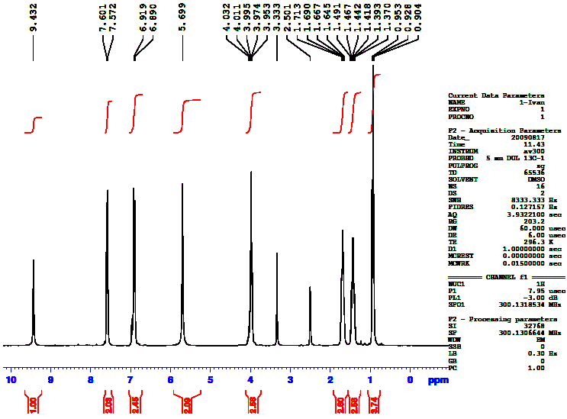

Compound 2
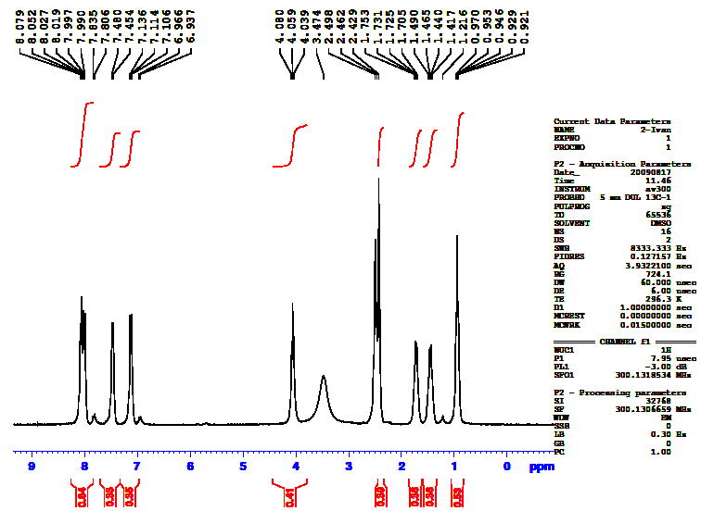

Compound 3

Figure 1 ¹H-NMR spectra of compounds 2 and 3
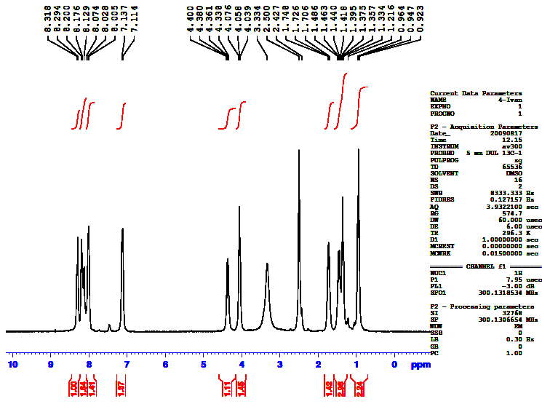
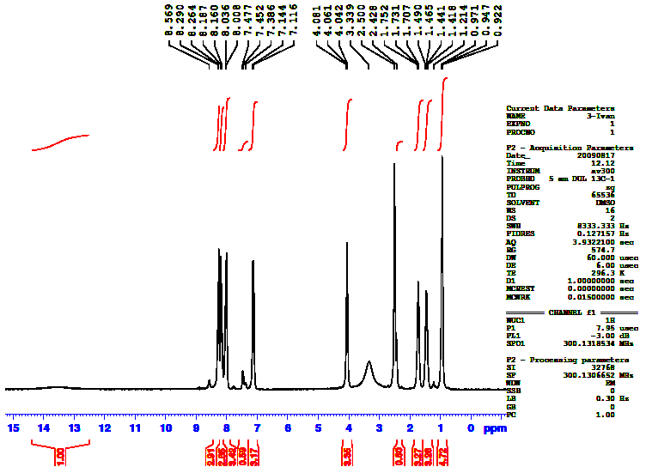
Compound 4 Compound 5

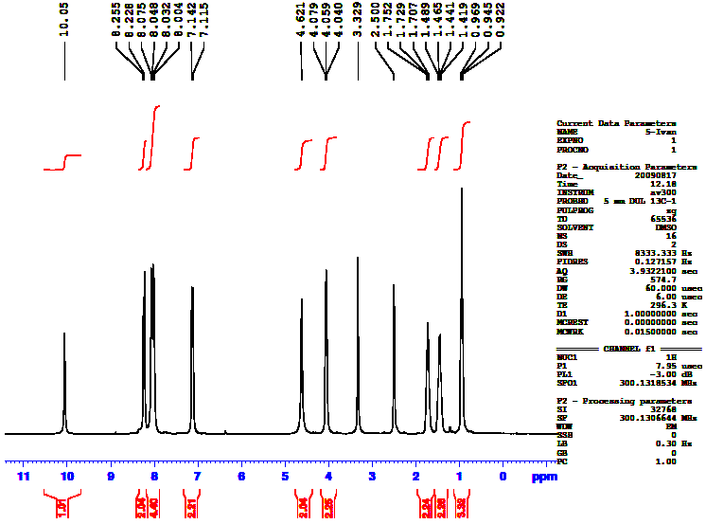

Compound 6
Figure 2 ¹H-NMR spectra of compounds 4 , 5 and 6

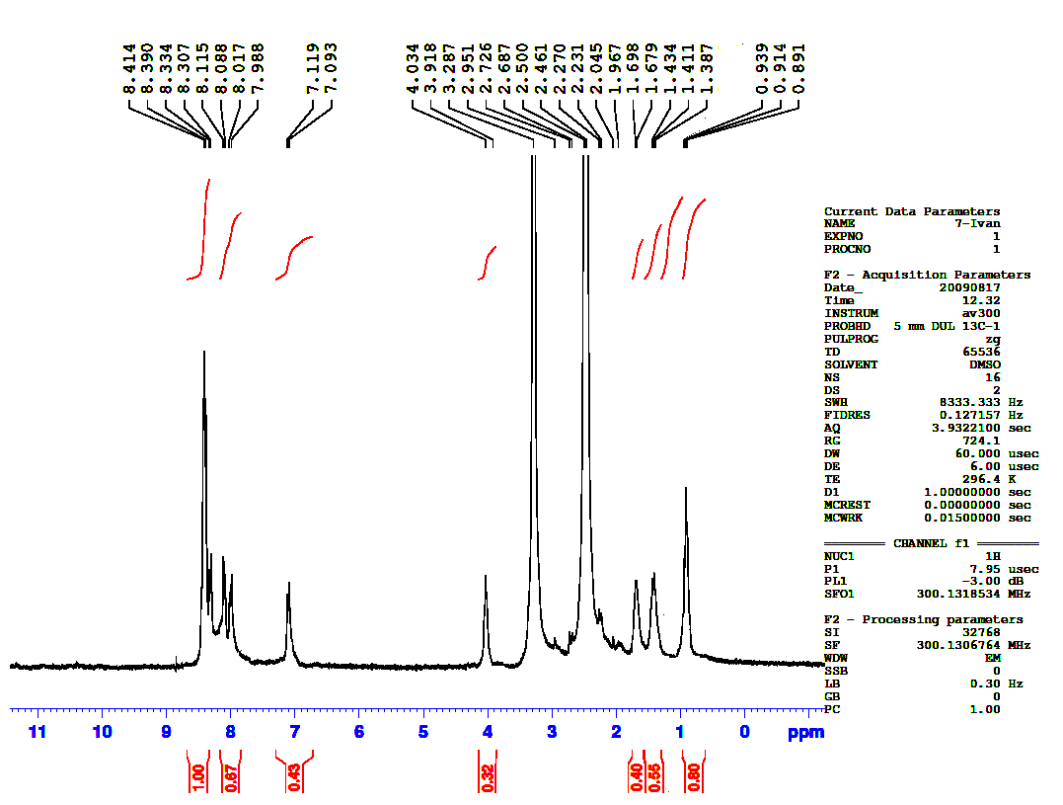
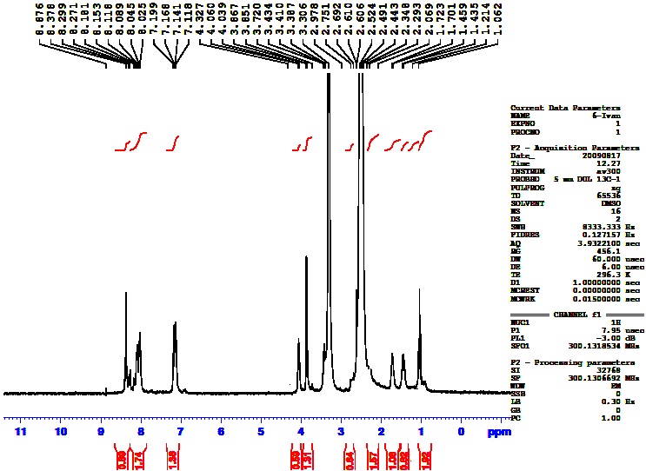

Compound 7_{c} Compound 7_{e}

Figure 3 ¹H-NMR spectra of compounds 7_{c} and 7_{e}

Table 1Some physical properties of compounds 7_{a-l}

Comp. | Substituents | Mol. Formula / | Yields% | Mp ºC
7a | X₁=X₂=X₃=X₄=X₅=H | C₂₆H₂₂N₄O₃ | 53 | 275-281
7b | X₁=X₂ =X₄=X₅=H, X₃=CH₃ | C₂₇H₂₄N₄O₃ | 55 | 300
7c | X₁=X₂ =X₄=X₅=H, X₃=NO₂ | C₂₆H₂₁N₅O₅ | 55 | ˃300
7d | X₁=X₂ =X₄=X₅=H, X₃=Cl | C₂₆H₂₁ClN₄O₃ | 62 | ˃300
7e | X₁=X₂ =X₄=X₅=H, X₃=OCH₃ | C₂₇H₂₅N₄O₄ | 40 | 298-300
7f | X₁= X₃=X₄=X₅=H, X₂=NO₂ | C₂₆H₂₁N₅O₅ | 65 | 290-297
7g | X₁= X₃=X₄=X₅=H, X₂=Cl | C₂₆H₂₁ClN₄O₃ | 65 | 285-290
7h | X₂=X₃=X₄=X₅=H, X₁=NO₂ | C₂₆H₂₁N₅O₅ | 45 | 290-294
7i | X₂=X₃=X₄=X₅=H, X₁=Cl | C₂₆H₂₁ClN₄O₃ | 65 | 297-306
7j | X₂= X₄=X₅=H, X₁=X₃=OCH₃ | C₂₈H₂₇N₄O₅ | 40 | 280-288
7k | X₂= X₃=X₅=H, X₁=X₄=OCH₃ | C₂₈H₂₇N₄O₅ | 55 | ˃300
7l | X₂= X₃=X₅=H, X₁=X₄=NO₂ | C₂₆H₂₀N₆O₇ | 60 | ˃300

Table 2 FT IR data of compounds 7_{a-l}

Comp | υ C=C-H  CH aromatic(sp2) | υ C-C-H  CH aliphatic(sp3) | υC=N oxadiazole | υC=C | υC-O-C asym.- sym. | υNO₂  asym.- sym.
7a | 3061 | 2954 , 2929 | 1602 | 1583 | 1258-1140 | -
7b | 3034 | 2924 , 2867 | 1608 | 1585 | 1266-1135 | -
7c | 3080 | 2972 , 2866 | 1618 | 1590 | 1246-1168 | 1525 , 1344
7d | 3077 | 2936 , 2890 | 1612 | 1588 | 1250-1152 | -
7e | 3085 | 2935 , 2875 | 1610 | 1586 | 1251-1174 | -
7f | 3070 | 2966 , 2881 | 1608 | 1590 | 1265-1126 | 1533 , 1350
7g | 3091 | 2926 , 2854 | 1600 | 1582 | 1253-1166 | -
7h | 3045 | 2958 , 2902 | 1605 | 1586 | 1244-1118 | 1520 , 1345
7i | 3092 | 2955 , 2928 | 1600 | 1580 | 1246-1177 | -
7j | 3065 | 2938 , 2880 | 1605 | 1580 | 1250-1150 | -
7k | 3075 | 2955 , 2870 | 1609 | 1586 | 1268-1145 | -
7l | 3062 | 2947 , 2868 | 1611 | 1588 | 1250-1161 | 1530 , 1352

Biological properties

To determine the antibacterial activity of these compounds, the filter paper disc technique ^{[13, 14]} at two concentrations (50 and 100 ppm) was carried out using ampicillin and streptomycin as the reference antibiotics. Dimethylsulphoxide (DMSO) was used as solvent control. The prepared compounds were screened for their antibacterial activity against Escherichia coli (Ec), Staphylococcus aureus (Sa), Klebsiella pneumoniae (Kp) and Bacillus substilis (Bs), the test results presented in Table 3.

Table 3 Effect of new bis-oxadiazole on the growth of tested bacteria

Compounds  No. | Concentration  (µg/ml) | Zone of inhibition ( in mm )*
Compounds  No. | Concentration  (µg/ml) | Gram-positive (G+) |  |  | Gram-negative (G-)
Compounds  No. | Concentration  (µg/ml) | S. aureus | S.cerevisiae | C.diphtheria | E. coli | P.aeruginosa
7_{a} | 100  -------------  200 | 16  ------------  18 | 22  ------------  23 | 20  ------------  21 | -  ------------  7 | -  ------------  7
7_{b} | 100  -------------  200 | 19  ------------  18 | 19  ------------  22 | 20  ------------  23 | -  ------------  8 | -  ------------  8
7_{c} | 100  -------------  200 | 20  ------------  19 | 22  ------------  23 | 20  ------------  22 | -  ------------  9 | -  ------------  8
7_{d} | 100  -------------  200 | 19  ------------  22 | 19  ------------  24 | 21  ------------  22 | -  ------------  9 | -  ------------  9
7_{e} | 100  -------------  200 | 22  ------------  21 | 21  ------------  24 | 21  ------------  23 | -  ------------  7 | -  ------------  9
7_{f} | 100  -------------  200 | 22  ------------  24 | 19  ------------  22 | 24  ------------  22 | -  ------------  7 | -  ------------  9
7_{g} | 100  -------------  200 | 19  ------------  20 | 20  ------------  22 | 21  ------------  22 | -  ------------  7 | -  ------------  8
7_{h} | 100  -------------  200 | 20  ------------  23 | 19  ------------  22 | 22  ------------  24 | -  ------------  9 | -  ------------  10
7_{i} | 100  -------------  200 | 24  ------------  22 | 23  ------------  21 | 24  ------------  22 | -  ------------  8 | -  ------------  9
7_{j} | 100  -------------  200 | 20  ------------  22 | 20  ------------  23 | 24  ------------  23 | -  ------------  9 | -  ------------  10
7_{k} | 100  -------------  200 | 23  ------------  22 | 20  ------------  21 | 18  ------------  20 | -  ------------  11 | -  ------------  10
7_{l} | 100  -------------  200 | 22  ------------  24 | 20  ------------  20 | 16  ------------  18 | -  ------------  11 | -  ------------  11
Ampicillin  Trihydrate | 50 | 26 | 23 | 38 | 38 | 21
DMSO | - | 0 | 0 | 0 | 0 | 0
*Diameter of the hole was 6mm
The compounds tested displayed good activity toward the Gram-positive bacteria, but were less active against Gram-negative.

References
- V. KR.Sahu, A. K. Singh, D. Yadav. International Journal of ChemTech Research, 2011, 3, (3), 1362-1372.
- D. Dewangan1, A. Pandey1, T.Sivakum, R.Rajavel, R. D. Dubey. International Journal of ChemTech Research, 2010, 2,(3), 1397-1412.
- J.Q. Weng, X. H. Liu, H. Huang, C.X. Tan, J. Chen. Molecules, 2012, 17, 989-1001.
- K. K. Oza, H. S. Patel. Bulgarian Chemical Communications, 2010, 42, (2), 103–106.
- A. Husain, M. ajmal. Acta Pharm, 2009, 59, 223–233.
- A. Almasirad, N. Vousooghi, S. A. Tabatabai, A. Kebriaeezadeh, A. Shafiee. Acta Chim. Slov, 2007, 54, 317–324.
- A.A. El-Emam, O.A. Al-Deeb, M.Al-Omar, J.Lehmann. Bioorganic & Medicinal Chemistry, 2004, 12, 5107–5113.
- M. A. Al-Omar. Molecules, 2010, 15, 502-514.
- I.H.R. Tomi. Synthesis, characterization and comparative study of mesomorphic properties of some new compounds containing both 1,2,4- and 1,3,4-oxadiazole moieties linked in the same molecule. Journal of Saudi Chemical Society, 2011, in press.
- H. Gallardo, I.M. Begnini. Mol. Cryst. Liq. Cryst, 1995, 258, 85.
- L.A. Karamysheva, S.I. Torgova, I.F. Agafonova, R.CH. Mol. Cryst. Liq. Cryst., 1994, 4, 289.
- M. Parra, J. Hidalgo, J. Alderete. Liq. Cryst., 2005, 32, 449.
- A. Singh,V. KR. Sahu, D. Yadav. International Journal of Pharma Sciences and Research, 2011, 2,(6), 135-147.
- A. N. Mayekar, H. S. Yathirajan, B. Narayana, B. K. Sarojini, N. S. Kumari. International Journal of Chemistry, 2011, 2(1), 38-54.
- A. W. Ricardo, F. Neves, A. V. Andre, S. Ricardo, M. S. Rajendra, G. Hugo. Synthesis of new light-emitting liquid crystals containing 1,2,4- and 1,3,4-oxadiazoles rings. 13th Brazilian meeting on organig Synthesis, 31 August-4, September, 2009.

