Polycondensation ofAcidanhydrides with Aspargenyl Imide Diamine and Curing with Styrene as Smart Polymers

Firyal M.Ali
Department of Chemistry, College of Science, University of Al-Mstansiriyah
Ahmed M.A
Department of Chemistry, College of Science, University of Misan
Assel Q. M
Department of Pharmaceutical Chemistry and Pharmacognosy, College of Pharmacy, University of Al-Mustansiriyah

(NJC)
(Recevied on 14/2 /2011 ) (Accepted for publication 16/5/2012)

Abstract
In this paper some new condensed polymers were synthesized from reacting of unsaturated acid anhydride such as maleic or methylnadicanhydrides, with N-aspargenyl imide diamine, which was prepared from reacting of aspargenyl chloride with ammonia. The new condensed polymers were cured with styrene and the cross linked polymers were obtained with high percent conversion. The physical properties of these polymer were measured . The monomers and the corresponding polymers were characterized by FT-IR and UV. spectroscopy. The intrinsic viscosity was calculated and swelling% was studied for the prepared cross linked polymers.
The inserted aspargen as amino acid could enhance the biodegradability properties, and the prepared polymers can be used as biomaterial in different applications, such as smart polymers due to their sensitivity to pH change.
الخلاصة
حضر في هذا البحث بعض البوليمرات التكاثفية الجديدة من تفاعل الحوامض اللامائية مثل حامض الماليئيك أو مثيل نادك اللامائي مع N-أسبارجنيل أيمايد داي أمين المحضر من تفاعل الأسبارجنيل كلورايد مع الأمونيا. إن نسبة التحويل المئوية للبوليمر التكاثفي المحضر كانت نسبة عالية.
قيست الصفات الفيزياوية وشخصت المونومرات والبوليمرات المحضرة بواسطة مطياف الأشعة فوق البنفسجية والأشعة تحت الحمراء وقيست اللزوجة الجوهرية وأجري التحليل الحراري للبوليمرات المحضرة.
إن إدخال الأسبارجين كحامض أميني في السلسلة البوليمرية ساعدت على صفة التحلل البايولوجي. وإن البوليمر المحضر الفعال بايولوجيا يمكن إستعماله لتطبيقات مختلفة، والذي يمكن إستعماله كبوليمر ذكي نتيجة تحسسه للدالة الحامضية في أوساط مختلفة.

Introduction
In the last two decades, the development of polymers, which change their structures and properties in response to environmental stimuli such as pH, temperature and light has attracted a great deal attention ⁽¹⁻³⁾.
Such polymers have been called "Smart Polymers", "Intelligent Polymers", "Stimulus-Sensitive Polymers" or "Responsive Polymers". They have been used in many applications ranging from bioactive delivery to separation ⁽⁴⁾.
The synthesis of a new family of bioacradableα-amino acid polymer with pendant benzyl ether groups and hydroxyl functional groups is reported ⁽⁵⁾. The synthetic strategy employs the ring opening reaction of O-benyl-serin-N-carboxy anhydride with di p-toluenesulfonic acid salt, of bis -1-valine butane-1,4-diester, followed by solution polycondensation reaction with di-p-nitro phenyl sebacate in N,N-dimethyl acetamide, catalytic hydrogenation benzyl ether protected resorbable poly (ester anhydride) networks based on caprolactam, L-lactide and D,L-lactide oligomers were synthesized. The ring opening polymerization of the monomer yielded hydroxyl oligomers, which were end-functionalized with succinic anhydride and reacted with methacrylic anhydride to yield dimethacrylatedoligomeric containing anhydride bonds. The crosslinking of the oligomers were carried out thermally with dibenzoyl peroxide leading to polymer network with high glass-transition temperature and high water absorption and complete mass loss in 4 days ⁽⁶⁾.
Hydroxyl-group functional polylactone were prepared and converted to acid terminated poly esters in a reaction with a series of alkenylsuccinic anhydrides containing 8, 12 or 18 carbons in their alkenyl chains moiety in their poly ester blocks. The hydrolysis behavior was found to depend on the thermal properties of the polymer precursors ⁽⁷⁾.
Many new condensed polymers were synthesized from reacting sulfonated amino acids such as histidine, D-alanine and aspurgen with benzidine as biomaterial polymers ⁽⁸⁾.
New poly(ester amide) of 1, 4-butane-diol acid, and caprolactam that appears to be completely biodegradable and shows both good performance and good processing behavior ⁽⁹⁾.
Poly maleimide is a type of polymer with high reactivity and excellent thermal stability ⁽¹⁰⁾.
Generally, polymaleimide is synthesized by homopolymerization by free radical or anionic polymerization^{(11, 12)}. The other is thermolysis or hydrolysis.
Experimental
Instrumentation :
Melting points were measured using Gallen Kamp M. F. B-600 melting point apparatus. Infrared spectra measurements were performed using pyeunican SP3-100 U.V-Visible double beam scanning spectrophotometer-260. Different scanning calorimentry (DSC) and Thermo gravimetric analysis (TGA) were recorded using (PL-STA 1500, RheometricSentific UK). The inherent viscosities were measured at 25ºC, DMSO. Swelling% of polymers were determined by using 0.2g of polymer in pH 1.1 for 5 days.
All chemicals were purchased from Fluka and BDH, all the available chemical reagents were used without further purification.
Controlled Released Study
100mg of the prepared aspargen polymer was kept in cylinder containing 50:50ml of buffer:dioxane and in water bath at 37ºC without stirring. A sample from the release medium was periodically withdrawn and analyzed by U.V at 300nm to determine the amount of the released asparagine. A calibration curve was constructed with a software built in the computerized U.V spectrophotometer, the amount 0.1mg of the released asparagine was determined directly from the software for many days, using the calibration curve in different pH values at 37ºC as shown in fig. (3) and fig. (4).Swelling% of the prepared polymer was found to 15-25%.Swelling% was calculated according to :
Δ_{m} = m₁ – m₀ / m₀ x 100
When m₀ is the weight of a dry polymer
m₁ is the swallowed polymer in pH 1.1 or 10.
The softening point of the crosslinked polymer was > 300ºC, which measured by using melting point apparatus.
Modified Aspargen to its acid chloride [M₁]
To a round bottomed two necks flask equipped with a magnetic stirrer, condenser and separator funnel was added with (5g, 0.01mole) of aspargen in 15ml of 1:10 of DMF:Dioxane. The thionyl chloride 0.01mole) was added drop wise about 15mints, the yellow product was isolated and washed with diethyl ether for several times and dried at 50ºC, the yield was 75%.
Synthesis of Imide AspargenDiamine [M₂]
(5g, 0.01mole) aspargenyl chloride [M₁] was dissolved in 10ml of dioxane with few drops of DMF, the mixture was placed in a round bottomed flask with continued stirring, the 0.5molar ratio of ammonia was added drop wise at room temperature. The imide diamine [M₂] was filtered and purified from ether, dried at 50ºC, the yield was 75%.
Melting point was 135ºC.
Polycondensation Polymerization [M₂] with Acid anhydrides [M₃-M₄]
In a round bottomed two necks flask equipped with a thermometer and reflux condenser was charged with (2.5g, 0.001mole) of [M₂] was dissolved in 15ml of dioxane with few drops of DMF, acid anhydride (0.001 mole) maleic or methyl nadic anhydride was added gradually, then the mixture was stirred and refluxed.
The stirring was continued for 1hr. the colored condensed polymers [M₃& M₄] was collected, filtered and washed with ether and dried at 50ºC, the conversion% was (75-80)%.

Table -1 : Physical Properties of Condensed Polymers [M₃& M₄]
Poly No. | R |  | Color | [η]_{in}d/g | Softening point ºC | Conversion %
M₃ |  |  | Yellow | 0.71 | 163.3-177.3 | 75
M₄ |  |  | Brown | 0.78 | 250-260 | 80

Crosslinking of Prepared Polymers [M₃& M₄] to [M₅& M₆] by Using Styrene
The condensed polymers [M₃& M₄] were crosslinked with styrene monomer by free radial polymerization using 1:1 molar ratio, in the presence of mixture solvents of DMF:dioxane with 1:10 volume, the dibenzoyl peroxide was used as initiator (0.05%) and the mixture was heated for about 1 hr. at 90ºC.
The crosslinked polymer was poured into petridishe, then the solvent was evaporated through air-dried at room temperature for 24hrs. followed by a vacuum drying cycle at 50ºC, washed with ether for several times. Table (2) shows the physical properties of cross linked polymers [M₅, M₆].

Table -2 : Physical Properties of the Cross linked Polymers [M₅, M₆]
Poly No. | Color | Conversion % | Softening Point ºC | Swelling% in pH 1.1
M₅ | Deep Yellow | 90 | >300 | 15
M₆ | Brown | 92 | >300 | 25

Results and Discussion
In this study new bioactive polymers were prepared through condensed polymerization of unsaturated acid anhydride such as maleic or methylnadic anhydrides, with aspargen imide-diamine, which prepared as shown in the following equations :

Then crosslinked polymers M₅ and M₆ were synthesized from M₃ and M₄ with styrene monomer by free radical polymerization as described below :

Fig. (1) shows the FTIR spectra of prepared aspargen imide-diamine with maleicanhydride polymer [M₄], the υC=O absorption at 1730 cm⁻¹ for imide and at 1658cm⁻¹ for amide. The υ(–NH₂) stretches absorption were showed at 3450-3350cm⁻¹and υ(-NH) at 3252cm⁻¹, and around 1220-1240cm⁻¹ because of C-N absorption.
Fig. (2) of prepared polymer M₃ shows absorption for υC=O amide at 1683cm⁻¹ and υ-NH imide at 3115cm⁻¹ while υ-NH₂ of υCONH₂ amide absorbed at 3452-3385cm⁻¹ and peak at 2955cm⁻¹ assigned to aliphatic C-H stretching, also the FTIR of M₃ and M₄ showed peaks at 1600cm⁻¹ due to C=C stretching of unsaturated acid anhydride.
The physical properties of prepared aspargen imide-amide polymers were studied such as intrinsic viscosity, which was measured at 25ºC with Ostwald viscometer.
Fig. (3) and fig. (4) showed the effect of pH values on the rate of controlled release of polymer [M₃] and [M₄] and profiles of mole fraction of aspargen ratio to total moles presented in the sample versus time at pH values 10 and 1.1 at 37ºC. Amides are fairly stable in water but the amide bond is cleaved on the heating in the presence of basic, normally this cleavage produces an amide and carboxylate ion .

The release of aspargen at suitable condition gradually with outside effect, this hydrolysis of amide group, which was shown in the following mechanism:

In basic medium the carboxylic acid is deprotonated giving a carboxylate ion:

Swelling% of crosslinked polymers M₅ or M₆ equal to 10-25% were studied at pH 1.1 solutions for five days as shown at fig. (5).
Fig. (6) shows the thermal analysis of polymer [M₃], which indicated the thermal stability in the range of melting temperature equal to 163.37-177.36ºC.
The intrinsic viscosities of the prepared polymers [M₃] and [M₄] ranged between (0.71, 0.78)dL/g respectively.
The aim of this study was to synthesize polymer based with a smart bioactive aspargen, and the main goal of this work is to investigate the effects of pH values at 37ºC as illustrated in fig. (3) and fig (4). The role of hydrolysis of amide bond in basic medium higher than the acidic medium.

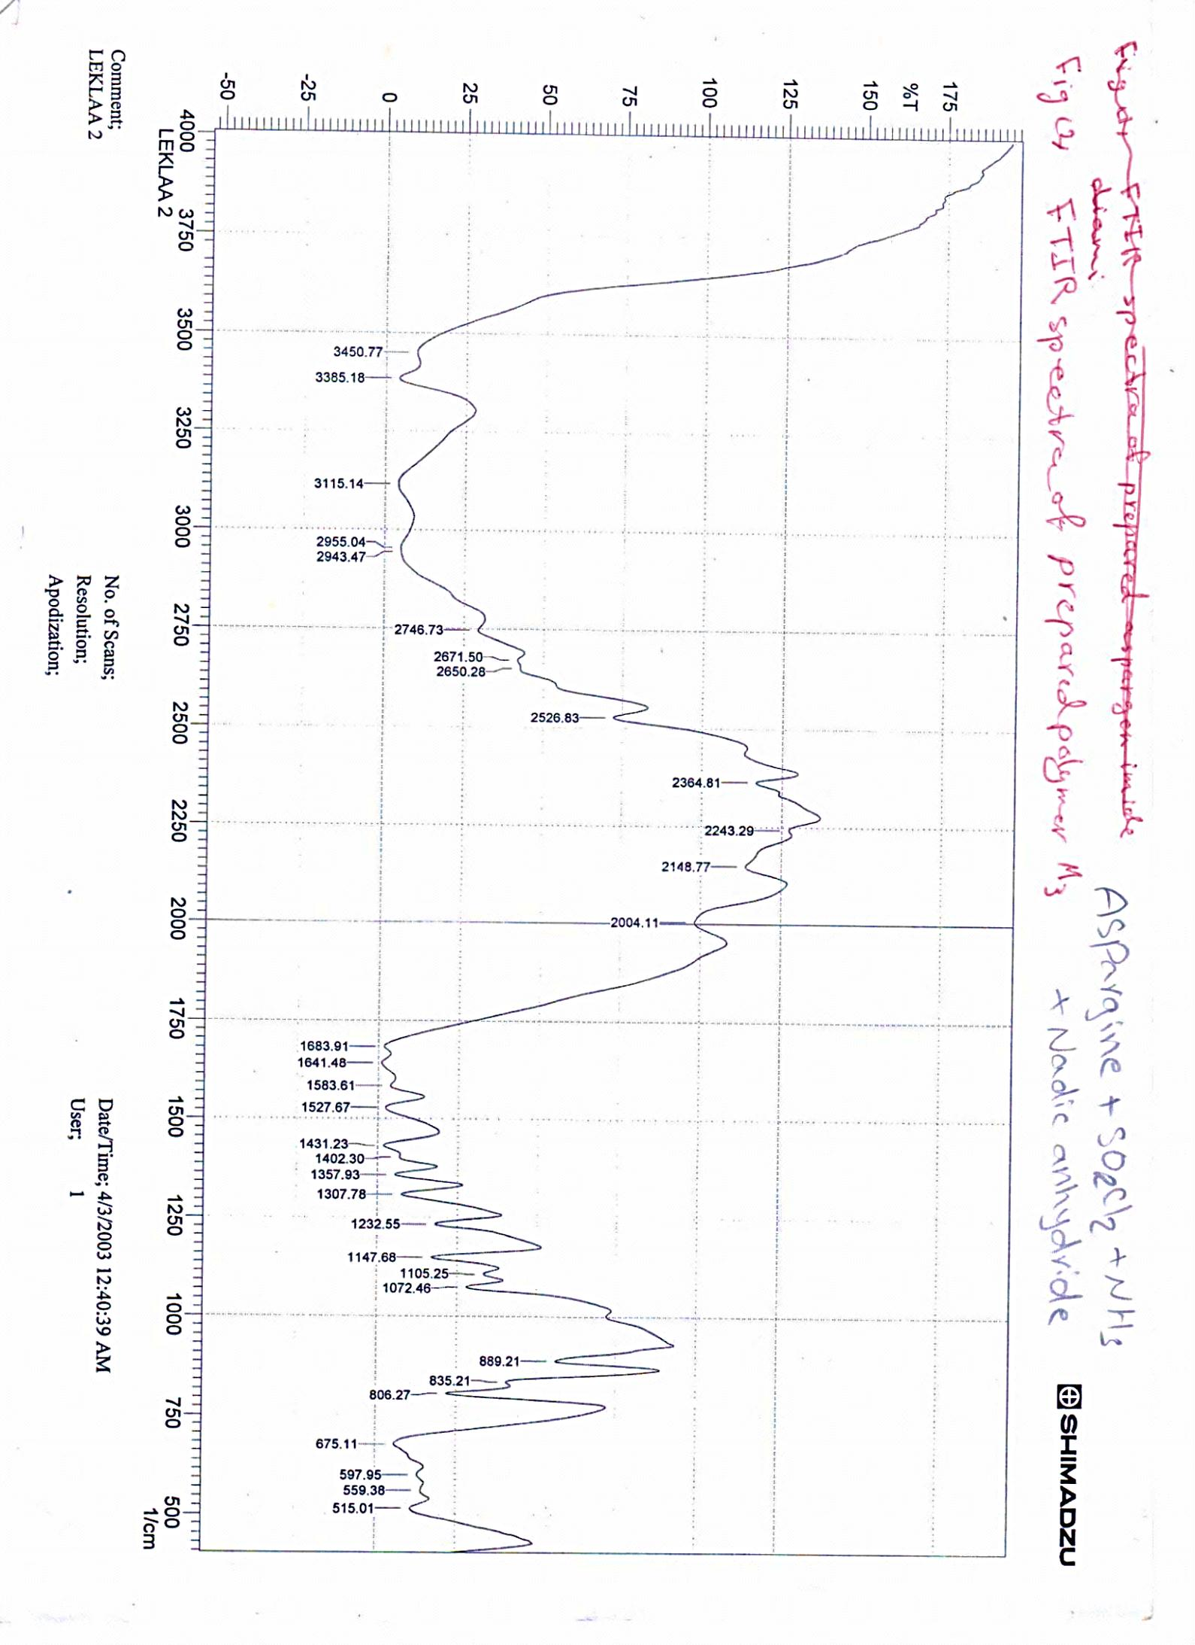
Fig(1) FTIR Spectra of aspargen Imide- Diamine with Maleic anhydride Polymer [M4]

Fig.(2) :FTIR Spectra of prepared polymer [M3]

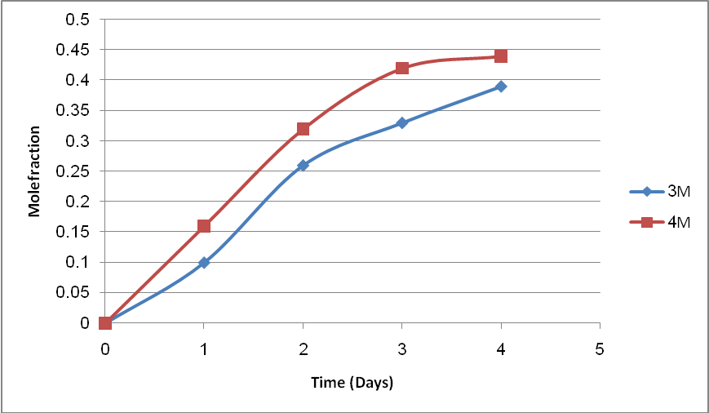Fig. (3) : Controlled Release of Prepared Polymers M₃ and M₄ in pH 1.1 at 37ºC
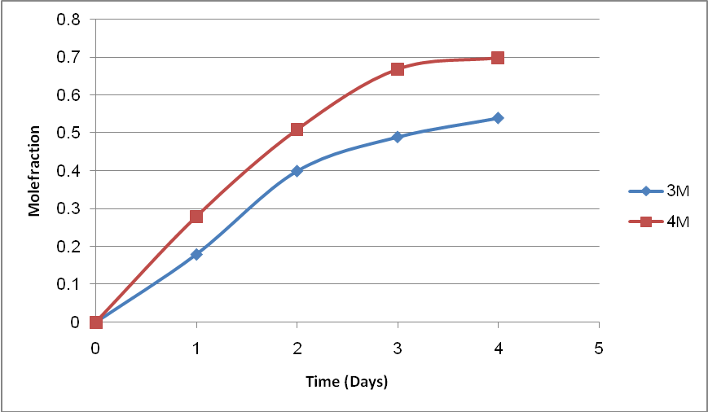
Fig. (4) : Controlled Release of Prepared Polymers M₃ and M₄ in pH 10 at 37ºC
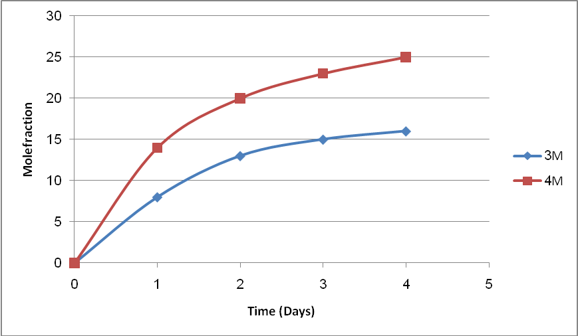
Fig. (5) :Swelling% of Polymers M₅ and M₆ in pH 1.1 at Room Temperature

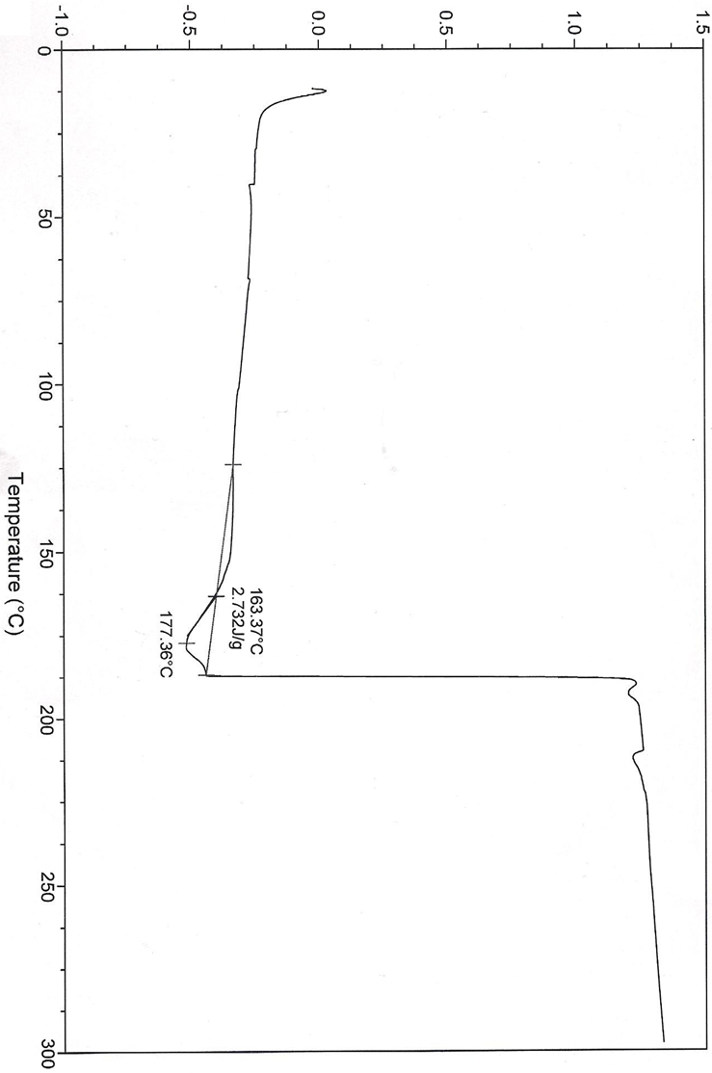
Fig.(6) Thermal Analysis of Polymer [M3]

References
1- | Brahim S., Narinesingh D. and Guisepps A., Biomaterials Cromdeules, 2003, (4), 1224-1231.
2- | Yu Y., Nakano M. and Ikeda T., Nature J., 2003, 425, 145.
3- | Malmstadt N., Yagek P., Hoffman A. and Styton P., J. Anal. Chem. , 2003, 175, 2943-2949.
4- | Base Y., Okano T. and Kin S., J. Coutrd Release, 1989, 271-278.
5- | Dena M., Wu J. and Reinhart G., J. Acta. Biomat., 2011, (4), 1504-1515.
6- | Antti O., Harri K. and Jukka V., J. Polym. Science, 2003, 41(23), 3788-3797.
7- | Hart K., Bisto A., Antti O. and Jukka V., Macromolecular Bioscience, 2006, 6 (7), 496-505.
8- | Firyal M., Amel A. and Khudheyer G., J. Education, 2011, 34.
9- | Mehavar R., J. Control Release, 2008, 69, 1-25.
10- | Gangadhara C and Thomas M., J. Polym. Sci. Part A Polym., 1998, 36, 2531-2546.
11- | Benjamin E., Hijji Y., J. Molecules, 2008, 13, 157-169.
12- | Agarwal P. and Yu Q., J. Ind. Eng. Chem. Res., 2003, 42, 2881-2884.
13- | Firyal M. A., Abbas N. M. and Khudheyer J. Kadem, "Modification of Poly Vinyl Pyrrolidinone with Amoxilline to Drug Polymer", 5th Scientific Conference College of Science University of Babylon, 2010, 5, 224-229.
14- | Bonartsev A., Bonartsera G., Makhiua T., J. App. Biochem. Microb., 2006, 42, 625-630.

