Effect of Thermal and Wet Chemical Treatments on The Electrical Conductivity of Active Carbon

Mohsin.Eerybi. Aldokheily, Saher Abdulredha Ali and Abeer Qias Abdulwahab
Chemistry Department,College of Science, University of Dhi-Qar
mohsinaldokheily@yahoo.com

(NJC)

(Recevied on 28/7 /2011) (Accepted for publication 7/5/2012)

Abstract
Activated carbon is a weak conductor 18x10⁻³ Sm⁻¹ , it's electrical conductivity could be enhanced either by heating the specimen in an open oven to a temperature of 100 to 600 ºC ,or by different wet chemical treatments including: acids, organic solvents, reducing agents, oxidizing agents, and finally consecutive chemical treatments .The electrical conductivities were increased compared to the untreated specimens as follow: Acids( HCl 60.3% , Nitric 55.2%. Sulfuric 48.7%,Phosphoric 41%. Acetic 15.4% ). Organic solvents( Chloroform 45.9%,Acetone 34.5%,Diethyl ether 3.1%.Cyclohexane26.3%).Reducing agents (Sodium borohydride 57.5%, Zinc chloride/ HCl 40.9%).Hummer's Reagent 42.2% . Bromine 27.2% . Consecutive treatments a)Solvent – Oxidizing agent –Reducing agent 70.9%.b) Solvent –Reducing agent –Oxidizing agent 69.2 %.Heat / Air (100 ºC: 9%,250 ºC : 18.1%, 350 ºC: 26.1%, 450 ºC 36.3% , 600 ºC: 45.4%Sample treated with sodium borohydride shows a highest pore area 222.87 g m⁻² compared to untreated specimen 153.76 g m⁻² and that treated with hydrochloric acid 171.27 g m⁻². XRD, ATR, FT-IR and TGA techniques were implemented to monitor structural changes induced by above mentioned treatments.

Key Words Activated carbon , surface modification , electrical conductivity ,acid treatment, electrical properties, FTIR, ATR , TGA, XRD, and particle size.

الخلاصة
الكاربون المنشط موصل ضعيف 1.8×10^{–3} Sm^{–1}غير ان توصيليته الكهربائية يمكن تحسينها اما بتسخين النموذج في فرن مفتوح بدرجة حرارة بين 100 الى600 درجة مئوية , او بواسطة المعالجات الكيميائية الرطبة والمتضمنة : الحوامض والمذيبات العضوية والعوامل المختزلة والعوامل المؤكسدة او سلسلة من المعالجات المتعاقبة . ازدادت التوصيلية الكهربائية مقارنة بالعينات غير المعالجة بالحوامض كما ياتي ( حامض الهيدروكلوريك 60.3%،والنتريك 55.2% , والكبريتيك 48.7% , والفسفوريك 41% ، والخليك 15.4 % ) وفي المذيبات العضوية كما ياتي ( الكلروفورم 45.9 % ، والاسيتون 34.5 % ، والاثيل ايثر 3.1 % ، والسايكلوهكسان 26.3 % ) وبالعوامل المختزلة كما ياتي ( هايدروبورات الصوديوم 57.5 % ، وكلوريد الزنك / حامض الهيدروكلوريك 40.9 % ، وكاشف همر 42.2 % ، والبروم 27.2 % ، والمعالجات المتعاقبة با لكواشف (ا) مذيب ، مؤكسد ، مختزل 70.9 % و(ب) مذيب مختزل مؤكسد 69.2 % . اما المعالجة بالهواء/ حرارة فكانت 100 م: 9 % ، 250 م : 18.1 % ، 350 م : 26.1 % ، 450 م : 36.3 % 600 م : 45.5 % .
اظهرت النماذج المعالجة ببوروهيدريد الصوديوم اعلى مساحة للمسامات (222.87 غم / م² ) مقارنة بالغير معالجة ( 153.76 غم / م² ( وبذلك المعالج بحامض الهيدروكلوريك 171.27 غم / م² .
تم توضيف حيود الاشعة السينية ، مطيافية الاشعة تحت الحمراء ، التحليل الحراري التفاضلي لمسح التغيرات التركيبية المحتثة بالمعالجات المذكورة.

Introduction
The surface functional groups anchored on carbons were considered to be responsible for a variety in thermal and electrical properties of the matter .The heteroatom of porous carbon surface mainly contained oxygen ,nitrogen, halogen…etc which is bonded to the edges of carbon layers ⁽¹⁾. The surface groups could be modified by different methods Edwin Vasu ⁽²⁾ used concentrated nitric acid , hydrogen peroxide and ammonium persulfate to modify active carbon for batch adsorption experiments. Frysz and Chung ⁽³⁾ conducted thermal oxidation by heating in air the carbon black specimens as well as chemical oxidation by immersing the carbon in an acid medium. Shen etal⁽¹⁾ reviewed different surface modification methods including acids treatment which contribute in mineral elements removal and improved hydrophilicity of the treated surface . The number of lactonic ,phenolic and hydroxyl groups increased with oxidizing chemicals strength . Other treatments including ammonia to yield basic surfaces through the introduction of nitrogen containing groups ⁽⁴⁾,thermal treatments⁽⁵⁾ either under inert atmosphere⁽⁶⁾ or microwave heating for efficient and rapid temperature control ⁽⁷⁾ . Heat treatments in the presence of oxygen will increase the oxygen containing groups or may convert the surface carbons to carbon monoxide, or carbon dioxide rendering more roughness to the surface. Modified carbons were used for electrochemical applications ⁽⁸⁾, Adsorbent^{(1,9)}, electronic materials⁽¹⁰⁾, catalyst industry⁽¹¹⁾and others.
In this paper the electrical resistance or inversely electrical conductivity was measured as a function of surface groups modification after thermal or chemical treatments.
Experimental
Fabrication of specimen -1
Activated carbon (Fluka product No 05110) was first grinded, sieved through 150 micron .To about 3.0 g of the sample,3 ml of distilled water was mixed thoroughly forming a thick slurry. The thick slurry placed in the mould, ( figure 1) which is equipped with a lower and upper thin, small sheets of copper. The mould and the slurry were pressed by 100 kN hydraulic press for one hour. The extruded disks of diameter 19 mm and thickness 100 mm (figure 2)were rubbed with few drops of diethyl ether for further smoothness , left overnight for dryness and subsequent measurements .

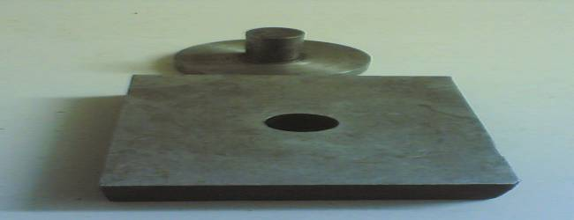
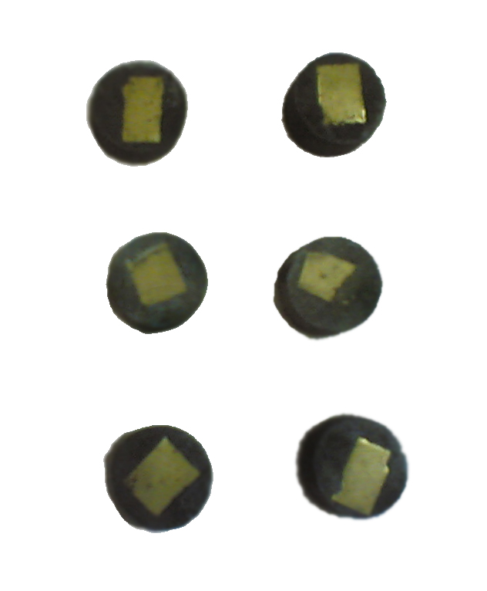
Figure 1: The mould Figure 2 : Active carbon specimens

2-Thermal treatment
A crucible containing 3.0 g of sieved active carbon placed in a muffle furnace fixed at 100 °C for 30 minutes and consequently other specimens at 250,350,450,and 600°C, then removed from the furnace prior to re- weighing and molding . Thermal treatment was also carried out after chemical treatment with HCl, NaBH₄, and CHCl₃
3- Chemical treatment
10 ml of 10% solution of each( reducing agents NaBH₄ , ZnCl₂/HCl) ,(acids HCl , HNO₃ , H₂SO₄, H₃PO₄, CH₃COOH),( Bromine water), ( solvents CH₃COCH₃, CHCl₃ , C₆H₁₂,CH₅OC₂H₅), and Hummer reagent (10 g NaNO₃+ 10 g KMnO₄ + 10 ml H₂SO₄ made up to 100 ml) were added separately to a 250 ml beaker containing 3.0 g each time of sieved active carbon .Stirred for 10 hours then filtered ,dried and moulded. Consecutive treatments were carried out for two samples according to the sequences 1): chloroform, nitric acid , sodiumborohydride and 2) chloroform,, sodiumborohydride, nitric acid.
4- Measurements
pH
To 1.5 g carbon placed in 25 ml beaker, 20 ml deionized water was added and further 2 drops of acetone ,stirred for 5 minutes at 10 °C . The pH recorded using Hana-MX645
Electrical resistance
To the lower and upper copper sheets attached to carbon specimen a ( L 10 cm O.D1mm) two pieces of wires soldered and connected to a multimeter type HP 9208A to measure the resistance. Particle size distribution and pore area
Measured by using US microTech.
Thermo gravimetric analysis
Measured by Schimadzu 50 H TGA.
X- Ray diffraction
Measured by Schimadzu xrd-6000
IR – spectra
Attenuated total reflectance and FTIR spectra measured by Schimadzu 8400 spectrophotometer .
Results and discussion
Untreated active carbon molded specimen has a pH value of 9.55 , and an electrical resistance of 55 Ω( conductivity 1/ Ω =18x10⁻³S) measured by two probe method . Atmospheric thermal treatment from 100 – 600 °C showed increased conductivities of carbon specimens from ≈ 9%(at 100°C )to about 45 % at 600 °C ( Table 1) .

Table1: Effect of atmospheric thermal oxidation on electrical resistance of active carbon

Conductivity /  S X 10⁻³ | Resistance/ Ω | Weight Loss % | Temperature ⁰C | Weight after  treatment /g | Weight before  treatment / g | No.
20 | 50 | 1 | 100 | 2.97 | 3 | 1
22 | 45 | 3.6 | 250 | 2.89 | 3 | 2
25 | 40 | 5 | 350 | 2.85 | 3 | 3
28.5 | 35 | 7.6 | 450 | 2.77 | 3 | 4
33 | 30 | 15 | 600 | 2.55 | 3 | 5

Thermal oxidation increases oxygen contents of the functional groups situated on the surface furnishing extra electrons capable of conducting electricity , however excessive heating will convert oxygenated groups like lactonic , phenolic , carbonyl , anhydrides and ethers to carbon monoxide and carbon dioxide leaving cavities on the surface . The cavities will not necessarily accompanied by an increased or decreased particle size distribution . Particle size distribution remained almost intact after wet chemical treatments (Table2) .

Table 2: Particle size distribution of treated and untreated active carbon samples
particle sizeµ | percent% | Treat- ment | Particle size µ | Percent% | Treat-  ment
46.61 | Less than 10 | Treated by ZnCl₂/HCl | 46.57 | Less than10 | Untreated
50.04 | Less than 30 |  | 50.00 | Less than 30
53.46 | Less than 50 |  | 53.43 | Less than 50
56.46 | Less than 70 |  | 56.78 | Less than 70
60.31 | Less than 90 |  | 60.30 | Less than 90
46.61 | Less than 10 | Treated by NaBH₄ | 46.31 | Less than 10 | Treated by HCl
50.04 | Less than 30 |  | 49.80 | Less than 30
53.46 | Less than 50 |  | 53.29 | Less than 50
56.88 | Less than 70 |  | 56.78 | Less than 70
60.31 | Less than 90 |  | 60.28 | Less than 90
46.61 | Less than 10 | Treated byCHCl₃ | 46.61 | Less than 10 | Treated by Hummer' sol
0.04 | Less than 30 |  | 50.04 | Less than 30
53.46 | Less than 50 |  | 53.46 | Less than 50
56.88 | Less than 70 |  | 56.88 | Less than 70
60.31 | Less than 90 |  | 60.31 | Less than 90

The pore area measurements revealed that chemical treatments have a variable positive
effects on pore area except for chloroform treatment which has a slight negative effect. The slight negative decrease of pore area of the specimens treated by chloroform may due to the removal of the two microns layer⁽³⁾ covering the particles which leads to the coagulation of some particles . Substantial increase of pore area was noticed for samples treated by sodium borohydide (Table3).

Table3 : Porosity of treated and untreated active carbon surface
Porosity increased % | Specific pore area/ g.m⁻² | Treatment | Sample
- | 153.76 | Untreated | 1
11 | 171.27 | HCl | 2
7 | 164.64 | Hummer solution | 3
2 | 156.77 | ZnCl₂\(HCl) | 4
44.9 | 222.87 | NaBH₄ | 5
-3.6 | 148.17 | CHCl₃ | 6

pH values as well as electrical resistance (or conductivities) for samples treated by acids were increased in accordance with pK_{a} values (Table 4 ) , however other electrical conductivities were : chloroform 33.3x10⁻³S, acetone 27.7x10⁻³S , cyclohexane24.6x10⁻³S , diethyl ether26.4x10⁻³S , bromine water 25.0x10⁻³S, zinc chloride/ HCl 32.5x10⁻³S, hummer solution 31.7x10⁻³S

Table 4 : Electrical conductivities of acid treated samples
Conductivity/S x 10⁻³ | Resistance/ Ω | pH | Treatment with 10% | No
45.8 | 21.8 | 3.5 | HCl | 1
40.6 | 24.6 | 3.7 | HNO₃ | 2
35.4 | 28.2 | 4 | H₂SO₄ | 3
30.8 | 32.4 | 5.1 | H₃PO₄ | 4
21.5 | 46.5 | 5.8 | CH₃COOH | 5

Attenuated total reflectance spectra of active carbon heated to 250 and even 350°C showed a very limited structural changes , while pronounced structural change a appeared in samples heated to 450°C and 600°C as can be traced easily in the peaks appearing1600- 1000 cm⁻¹. There is another decrease in the intensity of the peaks at 600°C indicating a migration of oxygenated groups (figure 3 ) . Above mentioned changes are relevant with weight losses presented in thermographs (figure5)

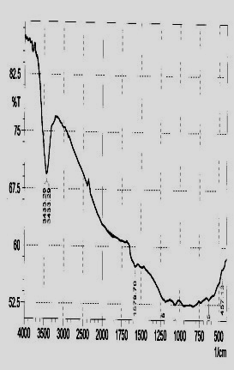 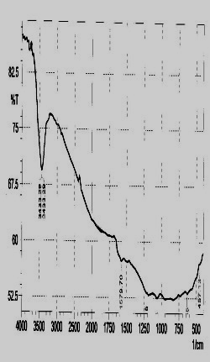 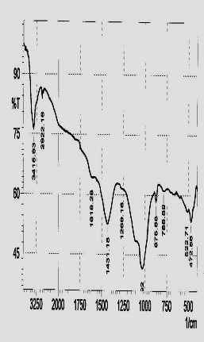 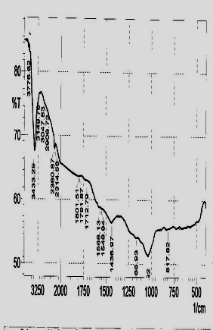 250°C 350°C 450°C 600°C

Figure 3: FTIR spectra of thermal treated samples a) 250°C b) 350°C c)450°C d)600°C

Infrared spectra(figure 4 ) of samples treated with nitric, sulphuric and hydrochloric acids as well as with sodiumborohydride and chloroform showed an extended broad band at 3450cm⁻¹ which due to OH-stretching from absorption of water vapor which is not evident in thermographs(figure 5 ) .Also another band of special importance is that at 3730- 3730 cm⁻¹ which may attributed to CO₂ adsorption and to the presence of some other volatile compounds, Thermographs showed a weight loss at 42.4 - 47°C.The lost weight for untreated carbon was – 7.32% compared with that of HCl - 10.14%, NaBH₄ -4.22,and - CHCl₃ only 1.38% at that range. Treated sample with acids may increased the ability to absorb gases . Different modes⁽¹⁴⁾ of OH, NH mix 3100- 3500 cm⁻¹, aromatic CH 3000-3100 cm⁻¹,aliphaticCH 2800-3000 cm⁻¹ phenolic and carboxylic or ketonic C=O 1640- 1750 cm⁻¹ and others all are evident in spectra .

a

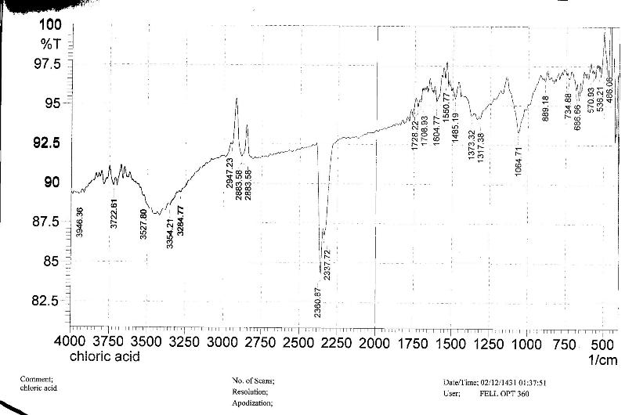

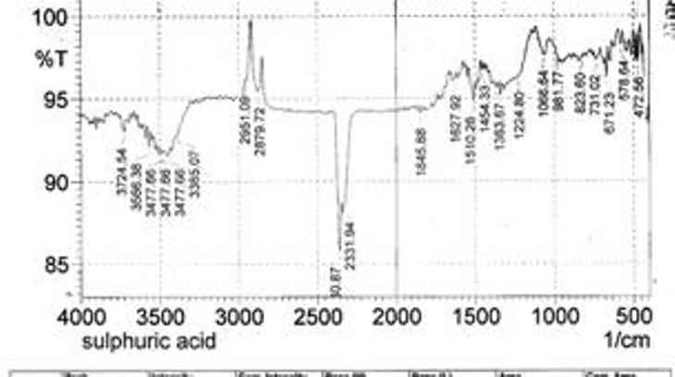
b

c
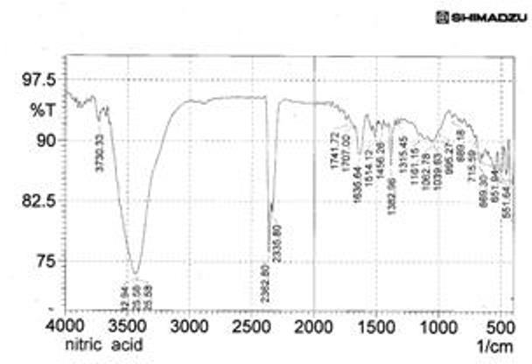
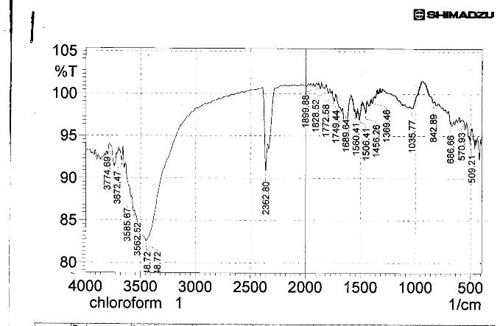
e

H₂SO₄ c) HNO₃ d ) CHCl₃ e) NaBH₄ b) HCl a) samples Figure 4: Infrared spectra

Measurements of electrical conductivities after re- thermal oxidation for preheated active carbon samples by HCl, CHCl₃ ,NaBH₄ were presented in tables 6,7, and 8 as well as comparison between the results in table 9 . Generally a small increase of electrical conductivities for samples treated by HCl and CHCl₃ after re-atmospheric thermal oxidation ,while the sample treated by NaBH₄ behaved differently at each temperature range indicating a formation of different surface groups after reduction.

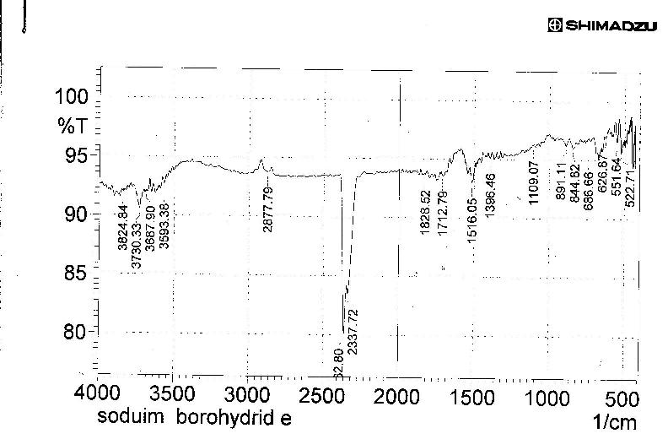

Table 5 : Effect of thermal oxidation on conductivity for samples treated by hydrochloric acid

Conductivity/Sx10⁻³ | Resistance /Ω | Loss% | Weight after heating/ g | Temperature/ ⁰C | Heating time/min | Weight/g
31 | 32 | 2.6 | 2.92 | 100 | 30 | 3
33 | 30 | 5.0 | 2.85 | 250 | 30 | 3
37 | 27 | 10.0 | 2.70 | 350 | 30 | 3
45 | 22 | 25.0 | 2.25 | 450 | 30 | 3
52 | 19 | 30.0 | 2.10 | 600 | 30 | 3

Table 6 : Effect of thermal oxidation on conductivity for samples treated by chloroform

Conductivity/S x 10⁻³ | Resistance /Ω | Loss% | Weight after heating/ g | Temperature/ ⁰C | Heating time/min | Weight/g
32 | 31 | 2 | 2.94 | 100 | 30 | 3
34 | 29 | 5 | 2.85 | 250 | 30 | 3
38 | 26 | 10 | 2.70 | 350 | 30 | 3
43 | 23 | 12.6 | 2.62 | 450 | 30 | 3
50 | 20 | 13.3 | 2.60 | 600 | 30 | 3

Table 7:Effect of thermal oxidation on conductivity for samples treated by sodiumborohydride
Conductivity/Sx10⁻³ | Resistance /Ω | Loss% | Weight after heating/ g | Temperature/ ⁰C | Heating tim/min | Weight/g
25 | 40 | 3 | 2.91 | 100 | 30 | 3
27 | 36 | 4.6 | 2.86 | 250 | 30 | 3
33 | 30 | 8 | 2.76 | 350 | 30 | 3
37 | 27 | 15 | 2.55 | 450 | 30 | 3
45 | 22 | 25 | 2.25 | 600 | 30 | 3
Table 8 : Comparison between electrical conductivities before and after wet chemical treatment
Temperature/ ⁰C
600 |  | 450 |  | 350 |  | 250 |  | 100 |  |  | Treatment
Conductivity/ S x 10⁻³ |  |  |  |  |  |  |  |  |  |  | Treatment
after | before | after | before | after | before | after | before | after | before |  | Treatment
52 | 38.32 | 45 | 28.5 | 37 | 25 | 33 | 22 | 31 | 20 |  | HCl
50 | 35.32 | 43 | 28.5 | 35 | 25 | 34 | 22 | 32 | 20 |  | CHCl₃
45 | 35.32 | 31 | 28.5 | 33 | 25 | 27 | 22 | 25 | 20 |  | NaBH₄

Neither wet oxidation/reduction or thermal heating up to 600°C have a clear effects on the amorphous nature of the active carbon as shown in xrd figure 5 .

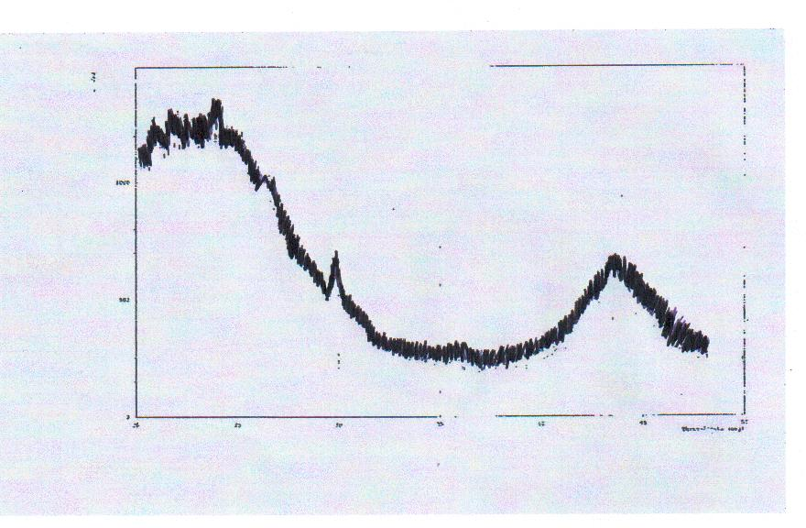
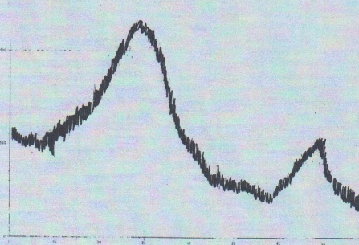

b
a) untreated b)NaBH₄
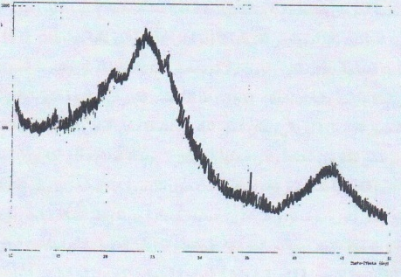
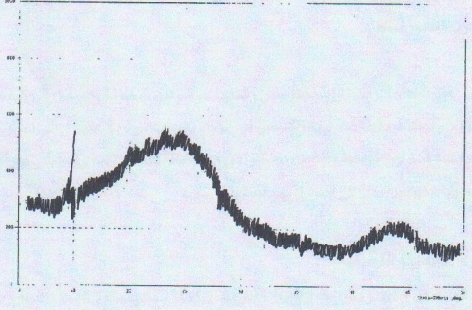

c) CHCl₃ d) HCl
Figure5: XRD pattern of active carbon a)untreated, b) NaBH_{4,} C)CHCl_{3,}d) HCl

Carbon treated at 900°C may has a partial graphitization as shown by thermal gravimetric analysis figure 6.

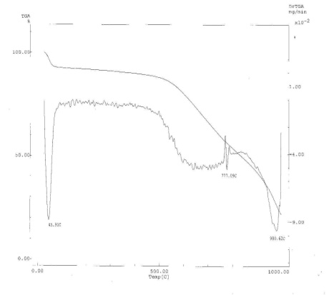
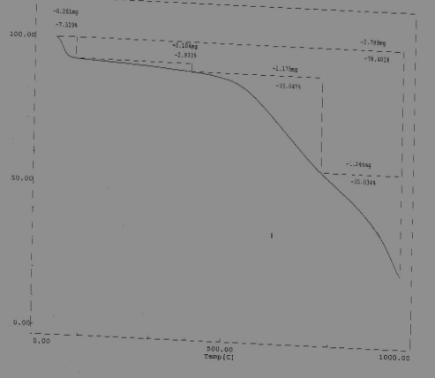
a)untreated
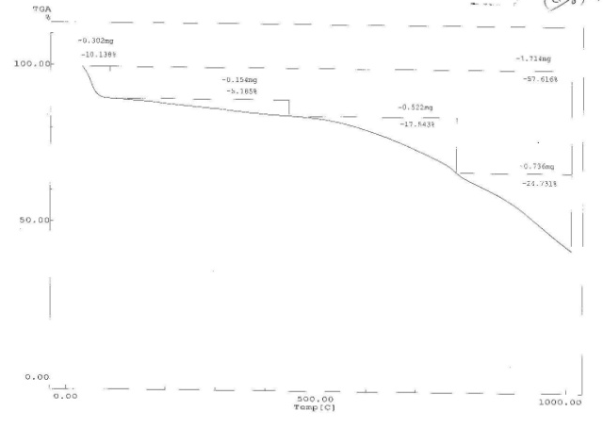 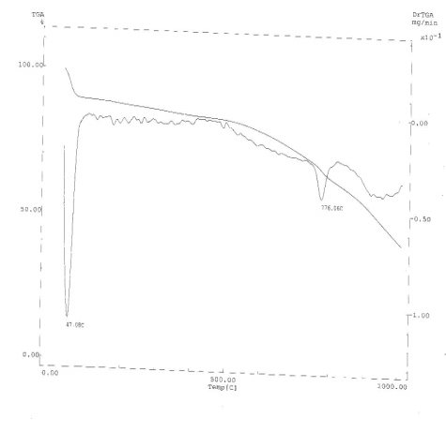 b) Treated by HCl
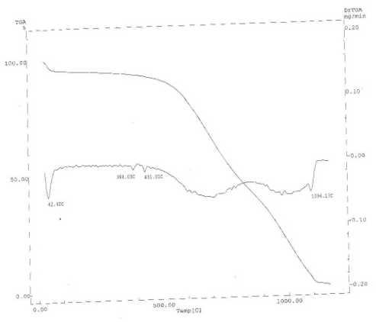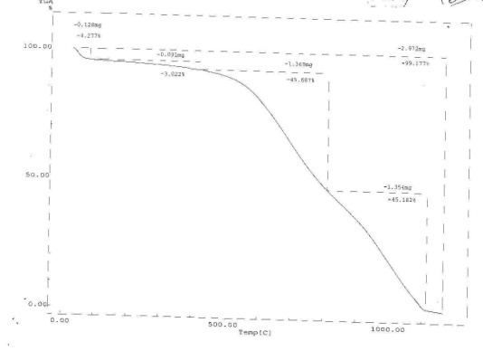
c) Treated by NaBH₄
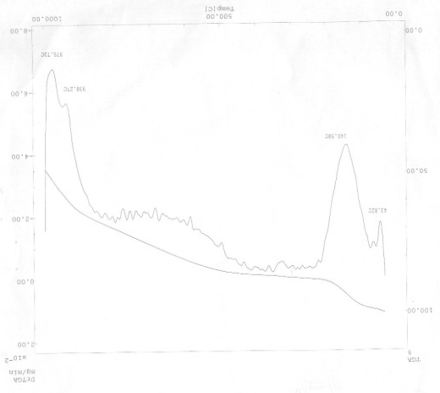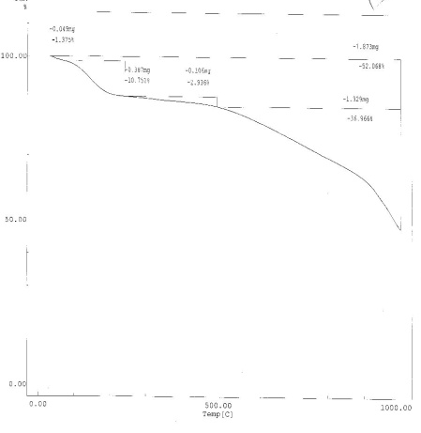
d) Treated by CHCl₃

Figure 6: Thermal gravimetric analysis( Right : TGA ,Left . DGA)

Although active carbon samples showed a similar TGA patterns , but some variations are exist due to the presence of different surface groups . Untreated sample lost up to 78.4% from its original weights °C .While samples treated with a reducing agent NaBH₄lost up to 99.177at the end of heating cycle which means that most surface and moiety groups retained their lost hydrogen and then burnt off to carbon dioxide and monoxide . Only 57.61 lost from samples treated by HCl and 52.68 % from samples treated by chloroform. Many workers employing TPD technique correlate different surface oxygen – containing groups decomposition on activated carbon with temperature by determination relevant CO,CO₂ and H₂O liberated during the process like anhydrides⁽¹²⁾ 828K, quinines⁽¹³⁾1050K, phenols ⁽¹⁴⁾113K, carbonyls and ethers⁽¹²⁾113 K. All samples in this work lost their weights in the following ranges ( 42-47, up to 500 , up to 777 , up to 1000°C . The consecutive treatment of the sequence (solvent- oxidizing agent- reducing agent and the sequence reducing agent-oxidizing gent ) gave even higher electrical conductivities 70.9% and 69.2 respectively which is the highest percentage compared to other types of treatments. In spite the fact that specimens treated with reducing agents only gained larger porosity but their electrical conductivities remained only around a half of that followed by oxidizing agent .

References
1.Shen W, Li Z ,Liu Y : Recent Patents on Chemical Engineering, 2008, 1, 27-40.
2. Edwin Vasu A , E- Journal of chemistry , 2008, 5(4) , 814-19.
3.Frysz C A, and Chung D D L : Carbon , 1997, 35(8) , 1111 – 27.
4. Mangun C I ,Benak K R , Economy J, Foster K I; Carbon, 2001, 39, 1809-20.
5.Kinoshita K; Carbon Electrochemical and Physiochemical Properties , John Wiley and Sons , New York, 1988, 287-88.
6. Mandez J A. Philips J, Xia P , Radovic I R : Langmuir, 1996, 12, 4405-10.
7. Nabias M V ,Carrott P T M, Carrott M M I , Mendez J A, : Carbon, 2004, 42, 1315-20.
8. Chung D D , J.of Material Science, 2004, 39, 2645-61.
9. ShimJ W , Park S J , Ryu S K , ; Carbon, 2001, 39,1635- 42.
10. Chen P W, and Chung D D ; ACI Mater, 2001, 30(11),1448.
11. Marta S, Frank S , August F, Azael F , Josep F; Carbon, 2005, 43, 2134-45.
12. LiH.Y.; LeeC.W.; GulletB.K.;Carbon, 2002, 40, 65-72.
13. Rajalakshmi N.;Dhathareyan K.S.; Gonvinderaj A.; Satishkumar B.C.; Electrochem Acta, 2000, 45, 4531-4555.
14.Cuhadaoglu D,Uygun A.; African J. Of Biotech., 2008, 7, 3703-3710.

