Synthesis and Spectrophotometric Study of 4-(6- Bromo -2-benzothiazolylazo)phloroglucinol as an Analytical Reagent for Determination of Bismuth.
Zainab Hashim Kasim Hassan*
College of Science, University of Babylon
(NJC)
(Recevied on 3/7 /2011 ) (Accepted for publication 27/9 /2011)
Abstract
A new chromogenic reagent, 4-(6-Bromo-2-benzothiazolylazo)phloroglucinol (6-BrBTAPG), was synthesized by diazo coupling of(2-amino-6-bromo benzothiazol) (2-ABrBT) with phloroglucinol, and used for the spectrophotometric determination of bismuth (III).This method was simple, sensitive, selective and rapid for reaction between Bi³⁺ and (6-BrBTAPG),to form a pink complex having a molar ratio of (1:1) (Bi-6-BrBTAPG) at pH 7.5. The molar absorptivity of the complex was 0.2654×10⁴ L.mol⁻¹ cm⁻¹ at λ _{max} 538 nm. Beer’s law is obeyed in the range of (0.5–30) ppm of bismuth ,and the stability constant was found to be 3 × 10⁴ L.mol⁻¹.
The relative standard deviation for seventh replicate measurements ,recovery ,and relative error values of this method were found to be 0.736% , 101.33%, and1.33% respectively . The interference of foreign ions was also investigated. All the other ions studied did not interfere with bismuth determination except for Mn²⁺ , Co²⁺,Fe³⁺,V⁵⁺,and pb²⁺. The interferences were eliminated approximately using suitable masking agent .

الخلاصة
تم تحضير الكاشف العضوي الجديد 4- (6- برومو- 2 – بنزو ثايوزوليل ازو ) فلوروكلوسينول من ازدواج (2- امينو 6- برومو بنزو ثايوزول ) مع الفلوروكلوسينول واستخدم في التقدير الطيفي لايون البزموث الثلاثي بطريقة تحليلية طيفية بسيطة وحساسة وانتقائية وسريعة . تم قياس المعقد المتكون (الوردي اللون ) من تفاعل الكاشف مع ايون ⁺³Bi عند pH =7.5 بنسبة (1:1) من الايون الفلزي الى الكاشف عند الطول الموجي 538 نانوميتر .وكان معامل الامتصاص المولاري للمعقد 0.2654x10⁴ لتر .مول⁻¹ .سم⁻¹ .حيث كانت التراكيز التي تطاوع قانون بير ضمن المدى (0.5-30) ppm /بزموث, وبلغت قيمة ثابت الاستقرارية 3 x 10⁴ لتر.مول⁻¹.
وحدد دقة وضبط الطريقة التحليلية المتبعة باستخدام محلول قياسي من ايون البزموث ذي تركيز 15 جزء بالمليون فكانت القيم لـ % R.S.D , % R_{e} , % R_{rel} هي % 0.736، % 101.33،% 1.33على التوالي .كذلك تم دراسة تاثير ايونات Mn²⁺ و Co²⁺ و Fe³⁺ و V⁵⁺و pb ²⁺التي تتداخل عند تفاعل الكاشف (6-BrBTAPG) مع أيون البزموث (III) وتم حجب تاثيرها باستخدام عوامل حجب مناسبة.
Keywords: spectrometry ,Azo for Phloroglucinol,Bismuth(III).

Introduction
Bismuth(Bi,at. mass 208.98)occurs in its compounds in the +III and +V oxidation states upon dissolution, only compounds of bismuth(III)are found, bismuth(III) hydrolyses at pH(1-2), and shows no amphoteric properties⁽¹⁾.Bismuth is found in the earths crust up to 0.0002% , it is the least toxic element among the heavy metals⁽²⁾. Therefore sensitive ,simple, and accurate methods for the determination of bismuth are required. The most important methods of bismuth determination are atomic absorption⁽³⁾,inductively coupled plasma-mass spectrometry(ICP-MS) ⁽⁴⁾,flow injection analysis (FIA)⁽⁵⁾, high-performance chelation ion hromatography(HPCIC)⁽⁶⁾,adsorptive stripping voltametry⁽⁷⁾,spectrophotometry is essentially a trace-analysis technique and its one of the most powerful tools in chemical analysis, there are a great number of spectrophotometric methods based on its ability to form complexes , mainly colored , with organic and inorganic compounds . Benzothiazoles are heterocyclic compounds with multiple applications. Thiazolylazo compounds have been used as a reagents for spectrophotometric determination of metal ions⁽⁸⁾.The most important thiazolylazo reagents for the spectrophotometric determination of bismuth are 4-(thiazolylazo)Resorcinol [TAR]⁽⁹⁾,N,N'-bis(2-hydroxyethyl)glycine⁽¹⁰⁾, O- hydroxy hydroquinonephthalein⁽¹¹⁾, Cyanex301 ⁽¹²⁾,1,2DiaminocyclohexaneN,N,N',N'-tetraaceticacid(DACT)⁽¹³⁾,4-(2-pyridylazo)Resorcinol[PAR]⁽¹⁴⁾.In this work, anew heterocyclic azo dye reagent(6-BrBTAPG)has been synthesized ,and used for the spectrophotometric determination of bismuth(III) ,this method is simple, sensitive ,selective , and rapid .

Experimental
Apparatus

(FTIR)Spectra(4000-400cm⁻¹ ) in KBr disk were recorded on a SHIMADZU FTIR – 8400 S fourier. transform. infrared. spectrophotometer. (Japan) , elemental analyses were carried out on a EURO EA3000 single elemental analyzer(Europe),absorption spectra were measured on a T80 UV- Vis spectrophotometer and absorbance were measured on Apel PD - 303UV- visible spectrophotometer using 1cm quartz cells , atomic content were measured on a SHIMADZU AA-6300 Atomic absorption spectrophotometer ,A model WTW multi 740 pH - meter were used to adjusted and measure the pH of the solution , melting point were measured using SMP30 Stuart,UK.
Reagents
All chemicals were used of analytical grade − reagent unless other wise stated .All solution were prepared using de-ionized.water .
Synthesis of 2-Amino 6- Bromo Benzothiazol (2-ABrBT)
2-ABrBT is prepared by a typical procedure ⁽¹⁵⁾ (direct thiocyanogenation) ,it is described as follows:-p-Bromo aniline (4.3 gm,0.025 mol) and ammonium thiocyanate (3.8 gm,0.05 mol ) were dissolved in (70ml) glacial acetic acid, cooled in ice and stirred mechanically while a solution of bromine (4 gm) in (10ml) glacial acetic acid was slowly added drop by drop , external cooling was applied throughout the reaction to keep the temperature below 10˚C and the stirring was continued for thirty minutes after all the bromine had been added ,the crude product was obtained by pouring in distilled water(D.W) , an amount of cold NaOH solution was added to separate the precipitate and filtering . A purified gilt yellow solid was obtained by filtering, washing with D.W , and recrystallization with ethanol .

˚
˚

Synthesis of the reagent
4-(6- Bromo 2- benzothiazolylazo) phloroglucinol [6-BrBTAPG]
A (1.145 gm,0.005 mol) of (2-ABrBT) was dissolved in 5 ml of HCl(37%) and (20ml) glacial acetic acid and cooled to 0˚C in ice-bath. A 5 ml of NaNO₂ solution (0.3450gm,0.005 mol) was added dropwise and stirred. Asprig orange diazo-salt solution was
prepared after further stirring for 20 min at( 0-5˚C) , separately A(0.6305 gm ,0.005 mol) of 1,3,5,- tri hydroxy benzene (phloroglucinol) and (0.5 gm) of NaOH was dissolved in (50ml) of D.W and cooled to (0-5˚C) , the above diazo-salt solution was added dropwise to this solution with vigorous stirring , after mechanically stirring for a further 2 hours ,the mixture was allowed to stand overnight , A red-purple solution was producted ,the crude product was obtained by pouring in D.W and filtering .Apurified riddish orange solid was obtained by filteration and recrystallization with ethanol⁽¹⁶⁾ .

˚
˚
˚
˚

Standard solution of Bismuth:

A solution of bismuth(III) 100ppm was prepared by dissolving 0.0232 gm of Bi(NO₃)₃.5H₂0 in (10ml) of distilled water containing(0.1ml) of conc.HNO₃ ,and dilute the solution to volume 100 ml with water, working solutions were prepared freshly by appropriate dilution of the stock solution.

(6-BrBTAPG) solution

1.5×10⁻⁴ M. 6-BrBTAPG (0.0055 gm) was dissolved with <5 ml of absolute ethanol, this was transferred into a100 ml calibrated flask and diluted up to the mark with absolute ethanol.

General procedure

Into a 10ml standard flask , transfer 1ml of sample solution containing 25ppm of bismuth(III) and 2ml of 1.5× 10⁻⁴ M (6-BrBTAPG) solution ,dilute to the mark with distilled water, adjust pH around 7.5 ,mix well and after 5 min measure the absorbance of solution at 538nm at 40˚C in a 1 cm quartz cells against a reagent blank prepared in the same condition .

Results and Discussion
FTIR Spectrum of the Reagent (6-BrBTAPG)

The FTIR spectrum of reagent fig(1) showed absorption band at 3282.62cm⁻¹ due to (O-H) group found in Para position of phloroglucinol ring ,it was shifted to lower vibrational due to the sharing (O-H) group through hydrogen bonding, absorption band at 3122.54cm⁻¹ and 2970.17cm⁻¹ which refers to(C-H) of aromatic and aliphatic ring respectively ,absorption band of (C=N) at 1643.24 cm⁻¹ ,absorption band of(N=N) at 1527.67cm⁻¹,absorption band of(C=C) of thiazol ring at 1467.73 cm⁻¹ ,absorption band at 1284.50cm⁻¹and 1226.64cm⁻¹which refers to (C-S) of asym. and sym.vibrational respectively, and absorption band at 542cm⁻¹of (C-Br)^{(17,18)}.

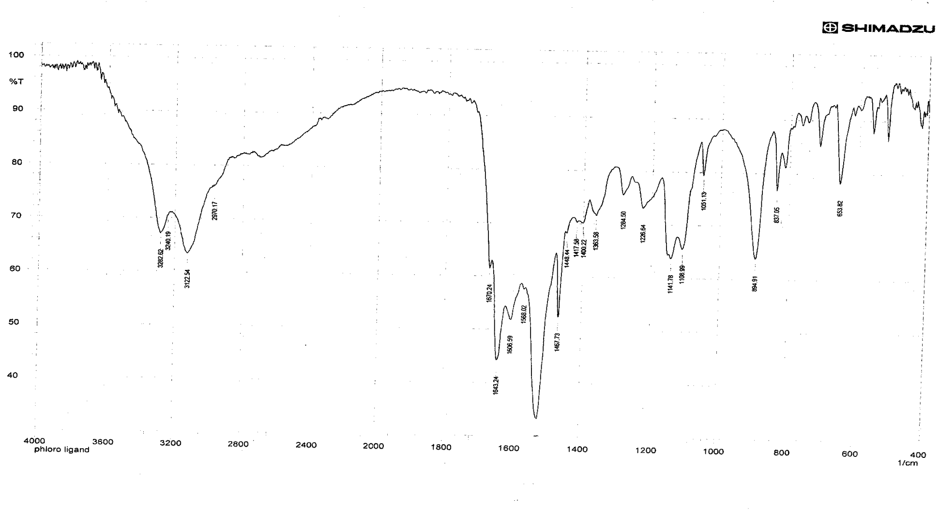
Fig(1):-FTIR Spectrum of the reagent

FTIR Spectrum of the complex
(6-BrBTAPG-Bi)

The FTIR spectrum of complex fig(2) showed absorption band at(3358.18−3138.29)cm⁻¹ which refers to (O-H) found in Para position of phloroglucinol ring or to the found of H₂O in the complex, absorption band appeared at1600.97cm⁻¹to(C=N) of thiazol ring which differ from this band in the reagent because it was shifted to lower vibration ,that mean a coordination of metal ion with nitrogen ring ,in addition to that absorption band at 1492.95cm⁻¹which refers to(N=N) ,and that means a coordination with metal from nitrogen azo group .
In this complex ,a new band696.33cm⁻¹ is appeared which refers to (M-O).

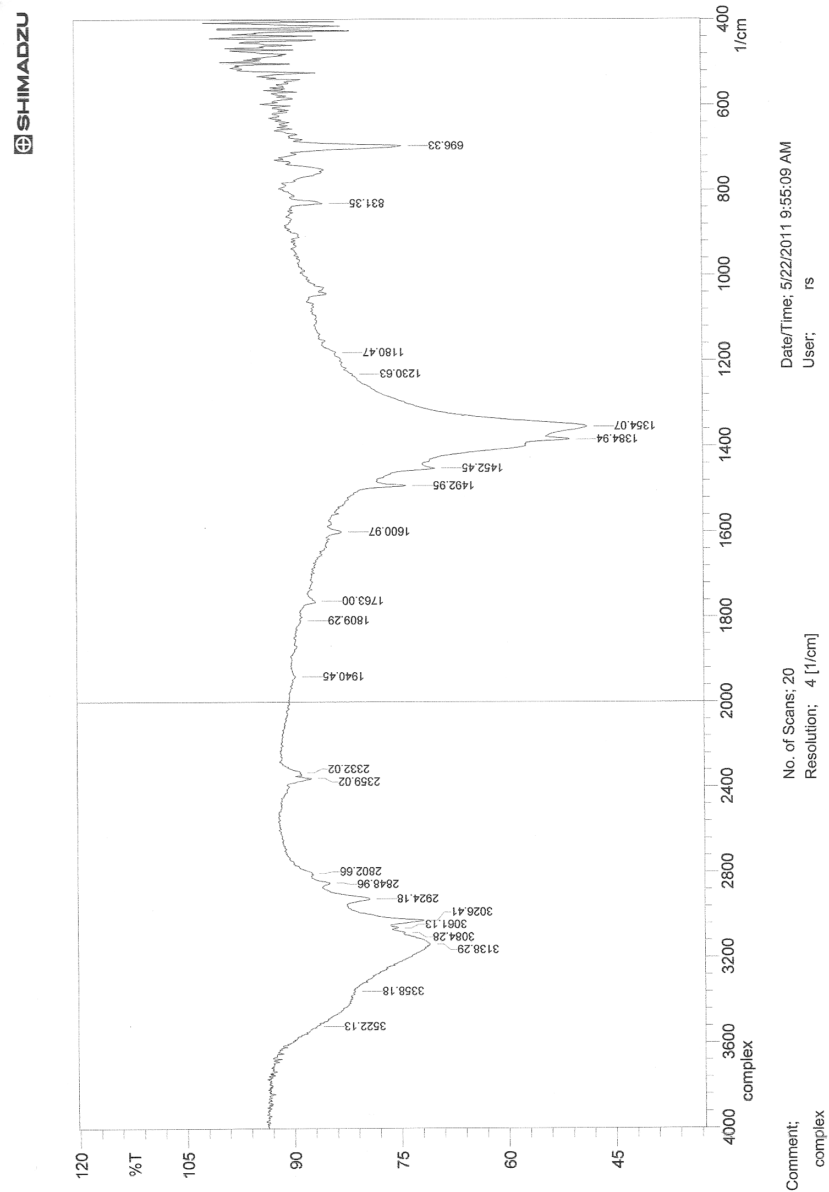

Fig(2):-FTIR Spectrum of the complex

Physical and chemical properties of 6-BrBTAPG

6-BrBTAPG is reddish-orange powder which is slightly soluble in water, it is

soluble in organic solvents ,such as , Dioxane, Chloroform ,ethanol, methanol as follows in fig(3):

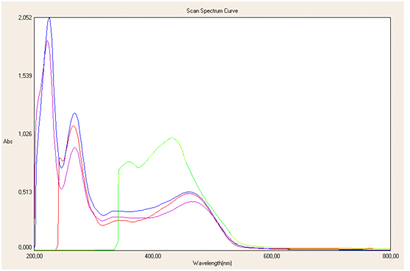
MeOH
EtOH
Dioxane
CHCl₃
1
2
3
4
1
2
3
4
No.
solvents
Fig(3):-Absorption spectra of the reagent(6-Br BTAPG)
in different Solvents.

The reagent appears as yellow color in acidic medium and orange in basic medium , absorption spectra of the reagent at different pH values as follows in fig(4):-

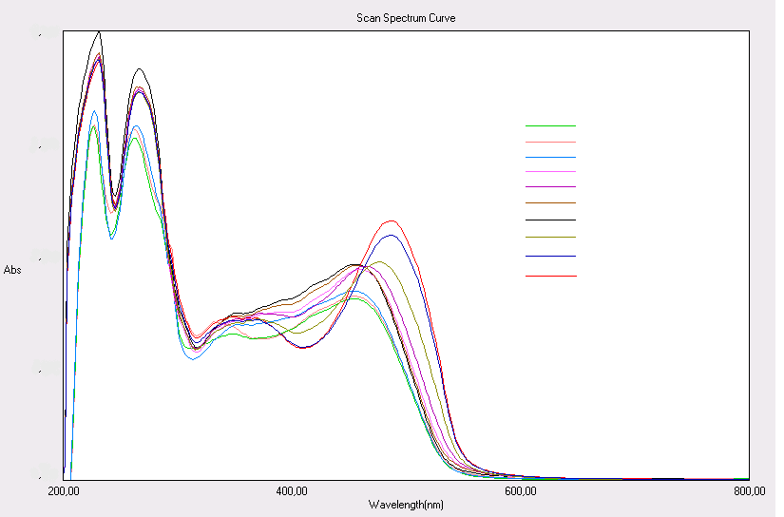
6.5
4.5
2.5
2.0
5.5
2 052
1 539
1 026
0 513
pH
9.5
7.5
3.0
3.5
7.0
0 000
1
2
3
4
5
6
7
8
9
10
1
2
3
4
5
6
7
8
9
10
No.
Fig(4):-Absorption spectra of the reagent at different pH values

This figure shows two isobestic point the first at 350nm and the second at 460nm. The equilibria of the dissociation can be written as follows:-

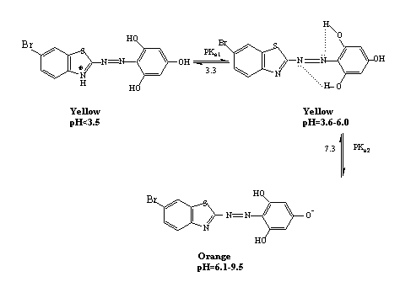

Absorption Spectra

The absorption spectra of [ 6- Br BTAPG] and its bismuth complex under the optimum condition are shown in fig (5):-

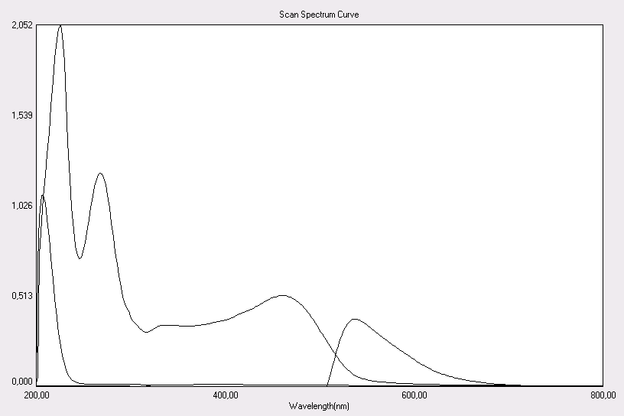
A
B
C

Fig.( 5 ):-Absorption spectra of A:Bismuth ion 25ppm, B:6-BrBTAPG reagent 1.5X 10⁻⁴ M ,C: Bi-6-BrBTAPG complex at pH=7.5

The electronic spectrum of the reagent shows three characteristics bands, the two band at (226,268) nm is due to the (π π*) transition of the phenolic ring , while the third band at (462)nm is due to the ( n π*) transition of the non bonding electron pairs of the nitrogen atom .
The complex of Bi(III) with this reagent appears the peak at 538nm, this indicate the reaction happen between Bi(III) and the reagent (6-BrBTAPG).

Effect of reagent concentration

Keeping a constant concentration (15μg.ml⁻¹) of Bi(III) solution ,the effect of reagent concentration (1.5 x 10⁻⁴ M) on absorbance of the complex was studied by varying the amount of the volume of reagent (0.5-4.0)ml ,it was obtained that the complex formation was complete and absorbance was maximum when the amount exceeds 1ml.

Effect of pH

The absorbance of the Bi-complex depends on the pH of the solution,the influence of pH was studied over the range (2-9.5) adjusted by means of dil NH₄OH(0.01M) and dil HCl(0.01M), the optimum pH range was obtained between (5-8) of complex. fig(6) shows the relationship between absorbance of complex and pH. At pH <5 a decrease in absorbance may be due to form azolium cation result from the reaction between hydrogen ion and the ion pair of electron on the nitrogen atom for thiazol ring ,and also when pH >8.5 a decrease in absorbance was observed due to formation of bismuth hydroxide .

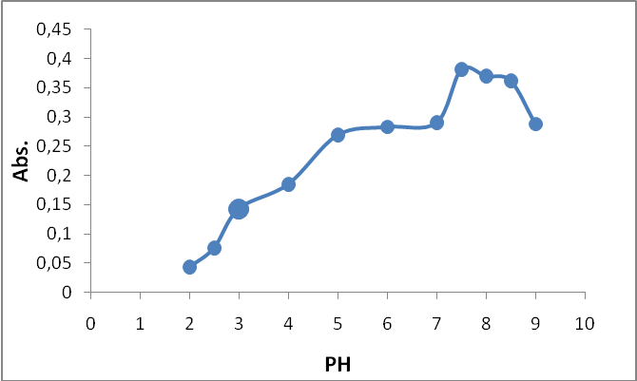
=pH control [Bi³⁺]=30ppm
Fig(6):-Effect of pH on the absorbance of bismuth complex ,[Bi⁺³]=30ppm

The stability of chromogenic system for the complex at different time and different temperature

It was found that the absorbance of the complex chromogenic system reaches a maximum value within 5min and remain stable for 24 hrs.
The effect of temperature on the absorbance of the complex was studied at the range between (10-70)˚C ,the maximum and constant absorbance was obtained when the temperature in the range (10-40)˚C ,and at ahigher temperature of 45˚C the absorbance was decrease which may be due to dissociation or evaporization of the complex .

Composition of complex and stability constant

The complex composition was determined by job's and mole-ratio methods [ fig (7 , 8) ] ,both methods indicated that the complex has a molar ratio of (1:1) (M:L) at pH 7.5, and the stability constant (K_{stab.}) and (α) of complex was found to be (3 x10⁴ L.mol⁻¹) and (0.3735) respectively by using the following equations ⁽¹⁹⁾ .
$$K_{\text{stab}\text{.}}=\frac{1}{K_{\text{inst}\text{.}}}$$
Where α=dissociation constant . c =total conc.of the complex=1.5x10⁻⁴., n =mole ratio = 1 . E_{m} = absorbance of a solution containing reagent two times excess than the amount of bismuth . E_{s}= absorbance of a solution containing a stoichiometric amounts [reagent] = [ bismuth] = 1.5x10 ⁻⁴ .

$K_{\text{inst}\text{.}}=\frac{(αc)\text{.}(nαc)^{n}}{c(1−α)}$
E_{m} – E_{s}
= α ,
E_{m}

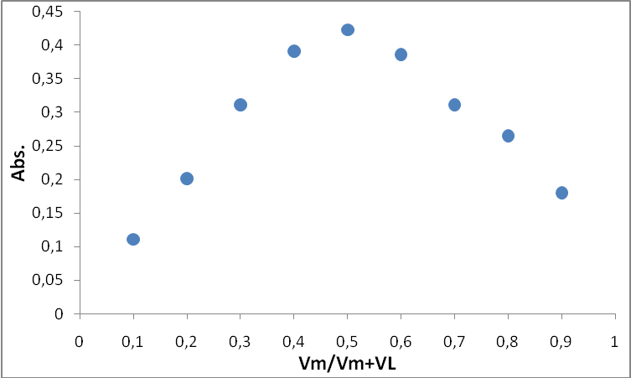
Fig(7):- Continous variation method for Bismuth complex with (6-BrBTAPG) at pH=7.5 .

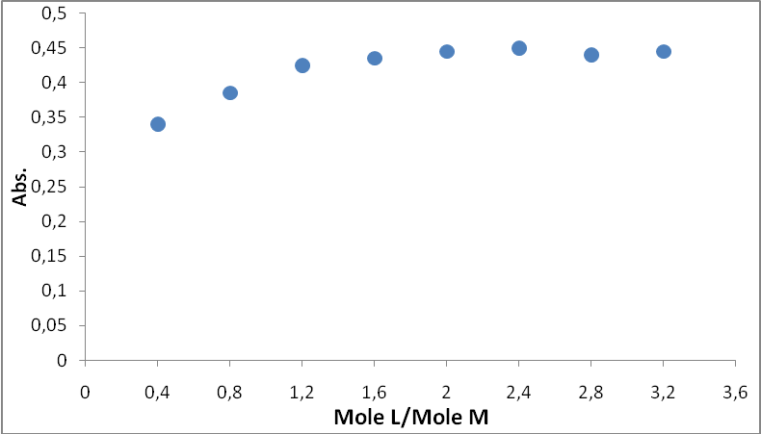
Fig(8):- Mole ratio method for Bismuth complex with (6-BrBTAPG) at pH=7.5 .

Analytical characteristics

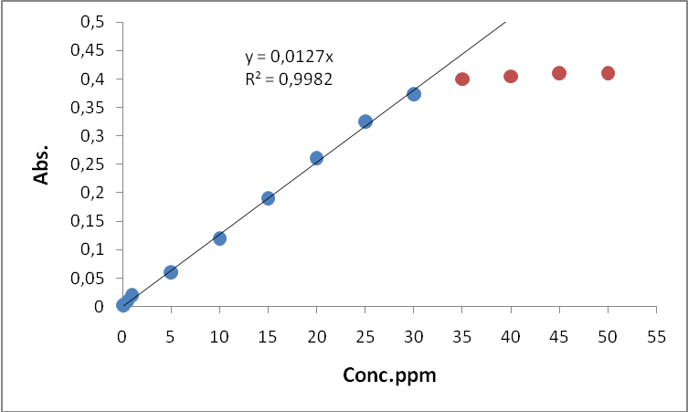
The calibration curve was made as described in the experimental procedure and good correlation coefficient was found .fig(9) , the some analytical parameters for this spectrophotometric determination of Bi(III) using this reagent are summarized in table (1)⁽²⁰⁻²²⁾.

Fig(9):-Calibration curve of Bi³⁺ Complex
Table (1) : Analytical characteristics of the proposed procedure ( N =no . of determination )
Value | Analytical parameter
L.mol⁻¹.cm⁻¹ ⁴10×0.2654 | Molar absorptivity
0.0787 L⁻¹.gm.cm | Sandell Sensitivity
0.9982 | r) )Correlation coefficient
0.3315 | Detection Limit(D.L)
(0.5 -30) ppm | Linear dynamic range
0.0014 | Standerd deviation
%(N=7) 0.736 | Relative .Standard .Deviation
%1.33 | Percent Relative error
%101.33 | Percent Recovery
These result indicating that this method is highly precise and suitable for the determination of Bi (III) spectrophotometrically.

Interferences

The effect of the ions (Mn²⁺,Co²⁺,Fe³⁺,V⁵⁺,pb²⁺) which form complex with the reagent during its reaction with bismuth(10ppm) were studied.on the other hand , suitable masking agent were examined for elimination the effect of the interferences of this ions as shown in table (2) .

Table (2) : Effect of foreign ions on the determination of Bi (III) and suitable masking agents.

Error% | Masking agent  ( )ml,[ ]M | Error% | Foreign ion  50ppm | Bi³⁺ ppm
1.3 | 5-Sulphosalicylic (1.0)[0.01] | 6.1 | Mn²⁺ | 10
0.7 | 5-Sulphosalicylic(0.75)[0.01] | -13.7 | Co²⁺ | 10
0.0 | NH₄OH at pH 4.5 | -22.1 | Fe³⁺ | 10
0.1 | Oxalic acid (2.0) [0.01] | 4.9 | VO₃⁻ | 10
0.9 | Sodium acetate (1.5)[0.01] | 2.2 | Pb²⁺ | 10

References

1-Z.Marczenko,and M. Balcerzak ,''Separation ,Preconcentration ,and Spectrophotometry in Inorganic Analysis'',1st ed.,Elsevier,P.113,Vol 10(2000).
2-S.H.Gaikwad,S.V.Mahamuni, and M.A.Anuse,Indian J.of Chem.Tech., 2005,12,365.
3-J.G.Crock,Anal.Lett., 1986,19,1367.
4-J.Shi,and et al., Asian J. of pharma. Sci., 2009,4,228.
5-D.G.Themelis,P.D.Tzanavaras, and J.K.Papadimitrion,Analyst, 2001,126,247.
6-R.M.C.Sutton,S.J.Hill,and P.Jones,J.of.Chrom., 1997,789,389.
7-S.S.Khaloo,A.A.Ensafi,and T.Khayamian,Talanta, 2007,71,324.
8-B.S.Garg,R.K.Sharma,and E.Kundra,trans. Metal.Chem., 2005,30,552.
9-M.Hnilickova,andL.Sommer, Talanta, 1969,16,681.
10-A.B.Lopez,A.G.Portal,and F.B.Martinez,Micro.Chem.J., 1988,37,200.
11-I.Mori,et al.,Talanta, 1988,35,879.
12-A.P.Argekar,A.K.Shetty,Analyst, 1995,120,1819.
13-J.Krzek,A.Apola,M.Stolarczyk,and W.Rzeszutko,Analyst, 2007,64,3.
14-.Dedkova,O.Shvoeva,andS.Savvin, J.of Anal.Chem., 2010,65,577.
15-J.K.Malik,F.V.Manvi,B.K. Nanjwade,andS,Singh, Drug.Inven.Today,2009,1,32.
16-B.C.Dixit,H.M.Patel,R.B.Dixit,and D.J.Desai,J.Serb.Chem.Soc., 2010,75,607.
17-M.S.Masoud, et al., J .Korean Chem. Soc., 2002,46,108.
18-R.D.Patel,M.P.Patel,and R.G. Patel, Indian J.of Chem., 2005,44B,1944.
19- W.C.Vosburgh,and G.R.Cooper, J.Am.Chem.Soc., 1941,63,437 .
20-D.A.Skoog,''Principle of Instrumental Analysis'',3rd ed.,Saunder Golden Publishing,P.22,(1985).
21-D.A.Skoog,F.J.Holler,and J .A . Nieman ,''Principle of Instrumental Analysis'',5thed.,Saunders College Publishing,P.13,(1998).
22-J.D.Ingle,J.Chem.Educ., 1970,42,100.

