High Performance Liquid Chromatographic Method for the determination of Diclofenac sodium in pharmaceutical preparations and in Environmental Samples

Nief Rahman Ahmed
Department of Environmental Technology,College of Environmental University of Mosul
Suhaib N.Lottfi
The State Company for Drug Industries and Medical Appliances, Mosul

(NJC)

(Recevied on 24/5/2011 ) (Accepted for publication 2/11/2011)

Abstract
Rverse phase high performance liquid chromatography (HPLC)method has been developed for the determination of diclofenac sodium in pharmaceutical preparations and environmental water samples.. Chromatography was carried out on supelco C18 column (25cm×4.6m.m), 5µm. Using methanol as mobile phase. The flow rate was 1.0 ml/min with Uv-detection at 283 nm. Separation was completed within 2.9 min. Calibration curve was linear coefficient correlation 0.998 over a concentration range of (5-80µg/ml). The relative standard deviation ( RSD) was found <1%.The proposed method was successfully applied to the determination of diclofenac sodium in pharmaceutical dosage forms and in environmental water samples.

الخلاصة
تم اختبار طريقة كروماتوغرافيا السائل عالي الاداء لتقدير صوديوم داي كلوفيناك في حالته النقية وفي بعض مستحضراته الصيدلانية حيث تم استخدام الفصل بكولوم نوع C_{18 وبالابعاد}(25cm×4.6m.m), واستخدم الميثانول كوسط ناقل وبسرعة جريان1 مل/ثانية وتم استخدام مكشاف الاشعة فوق البنفسجية عند الطول الموجي 283 نانو ميتر وامكن تقدير الكميات التي تتراوح بين(5- 80) مايكروغرام/مل. ووجد بأن الانحراف القياسي النسبي للطريقة اقل من 1% واستخدمت الطريقة بنجاح لتقدير صوديوم داي كلوفيناك في حالته النقية و بعض مستحضراته الدوائية وفي بعض النماذج البيئية

Introduction
Diclofenac sodium (2-[(2,6-dichlorophenyl)
amino]-benzene – acetic acid mono sodium
salt⁽¹⁾,( Fig.1).

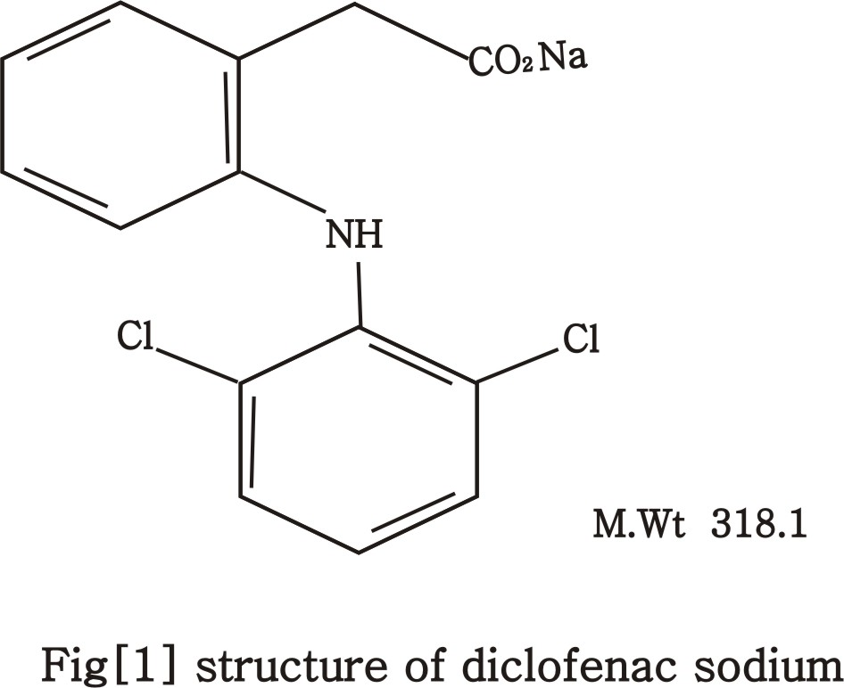

Is a synthetic non-steroidal anti-inflammatory agent with analgesic, anti-inflammatory and antipyretic activity . Its mechanism of action is associated principally with the inhibition of prostaglandin synthesis (specifically, inhibition of cyclooxygenase ^{(2). .} It has been determined by a variety of analytical techniques ,such as the official potantiometric titration^{(3),}UV spectrophotometry ^{(4-5),} UV spectrophotometry and partial least squares regression ^{(6),} ,visible spectrophotometry ^{(7-14),.}
high performance liquid chromatography (HPLC) ^{(15-18),} and high performance thin layer chromatographic method ^{(19).}
High performance liquid chromatography (HPLC) can be used for determination of drugs and for purposes of control throughout the entire manufacturing process of drugs.as well as quality control of the finished product .It has the advantages of being sensitive, selective, rapid, accurate and reproducible. The present paper reports the development of a new high performance liquid chromatography (HPLC) method for determination of dichofenac sodium in ampoule , suppositories and environmental water samples.

Experimental
Apparatus
Chromatographic system consisted of an shimadzu HPLC model LC-20AT with UV detector model SPD-20A and C18 supelco column (25cm ×4.6mm),5 µm particle size HPLC condition are given in( Table 1)

Table 1 : HPLC conditions

Supelco C18(25cm×4.6mm),5 µm | Column
283nm | Wavelength
Methanol | Mobile phase
2.9min | Retention time
1.0ml/min | Flow rate
ambient | Temperature
20 µl | Injection volume

Reagents
All chemical used were of analytical or pharmaceutical grade and HPLC grade methanol was used through out .
A standard stock solution of diclofenac sodium (100 µg/ml) was prepared in methanol, Working standard solutions in a range of (5-80 µg/ml) were prepared by dilution from this stock solution.

Determination of diclofenac sodium
A series of standard solution containing 5-80 µg/ml of diclofenac sodium and the sample solution of pharmaceutical preparation and water samples were applied respectively.A 20µl a liquot of each solution was injected in to the column in a duplicate and the chromatograms were recorded. Calibration graph was constructed by plotting the mean peak area versus concentration of diclofenamc sodium. The concentration of the unknown was read from the calibration graph or calculated from the regression equation derived from the concentration and peak area data.

Procedures for pharmaceutical preparations:
Ampoules:
The content of 5 ampoules were mixed well in 250ml dried beaker. A liquots equivalent to 10mg of diclofenac sodium was transferred into 100ml volumetric flask and diluted with methanol to the volume. The determination of diclofenac sodium proceeded as described under HPLC method for determining diclofenac sodium. Calculate the percentage recovery using a calibration graph previously prepared.

Suppository:
Five suppositories were weighed and, transfer to a porcelain dish, melt and allow to cool while stirring with a glass rod. Accurately weigh a portion of the melted suppository mass, equivalent to 10mg of diclofenac sodium, extract with 50ml methanol, filter, dilute the filtrate to 100ml with the same solvent and proceed as described under HPLC method for determining diclofenac sodium. Calculate the percentage recovery using a calibration graph previously prepared or calculated from the regression equation derived from the concentration and peak area data.

Procedure for environmental water samples:
The tap and river water samples were fortified with concentration in the range from 10-50 ppm of diclofenac sodium in methanol. The determination of diclofenac proceeded as described under HPLC method for determining diclofenac sodium. Calculate the percentage recovery using a calibration graph previously prepared

Results and Discussion
The development of HPLC methods for the determination of drugs has received considerable attention in recent years because of their importance in the quality control of drugs and pharmaceutical products. The aim of this study was to develop a rapid HPLC method for the determination of diclofenac sodium in pure from ,its pharmaceutical formulations and environmental water samples using the most commonly employed RP C18 column with UV detection.
The retention time (Rt) of diclofenac sodium was found to be 2.9 min. A typical chromatogram formulation of diclofenac sodium is shown in ( Fig.2).

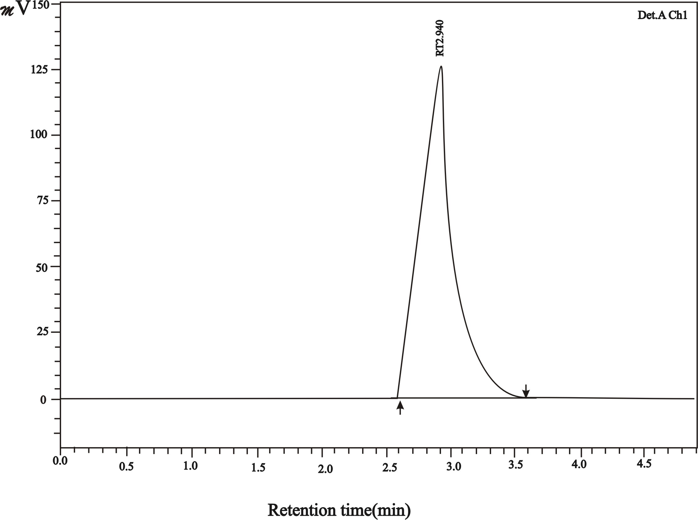

Figure 2: Typical chromatogram (diclofenac sodium (10 µg/ml))

sodium was constructed by plotting the peak area against concentration of diclofenac sodium .It was found to be linear with a correlation of 0.998, the representative linear regression equation being Y=2.23 + 23.11X were Y is the mean peak area and X is the concentration in µg/ml (fig 3). This method was validated for its intra and inter-day precision, the relative standard deviation based on the peak area for five triplicate injection were found to be between 0.48 and 0.91 . The inter-assay precision( 3days , n=5) was expressed as relative standard deviation and rang between 0.15% and 0.95% (Table 2)

Table[2] : Inter- and intra-day precision for diclofenac sodium assay by the proposed HPLC method.
Observed concentration of diclofenac sodium* |  | Concentration of diclofenac sodium µg/ml
Inter- day  Mean (n=5) RSD% | Intra – day  Mean(n=5) RSD% | Concentration of diclofenac sodium µg/ml
10.11 0.15  . 30.01 0.52  50.12 0.95 | 10.07 0.48  30.03 0.75  49.94 0.91 | 10  30  50
*Mean of five determinations

The percent recovery of diclofenac sodium from synthetic mixtures of suppositories and ampoules was found to be satisfactorily high, mean recoveries being 100.95±1.72(n=6) and 100.22±1.22(n=6) respectively, as shown in Tables [3] and[4]. Further- more, the results were precise at all concentration levels.

Table [3]: % Recovery of diclofenac sodium from synthetic mixture of diclofenac sodium suppositories
% Recovery | Amount found(mg)* | Amount added (mg)
101.60  101.57  99.23  101.00  100.99  101.33 | 2.54  2.58  2.61  5.05  5.1  7.6 | 2.5  2.54  2.63  5.00  5.05  7.5
100.95  0.884 | Mean value  RSD
*Mean of six determinations

Table [4]: % Recovery of diclofenac sodium from synthetic mixture of diclofenac sodium ampoules
%Recovery | Amount found(mg)* | Amount added(mg)
99.00  99.63  100.54  100.90  100.90  100.37 | 4.95  5.38  5.53  5.55  5.55  5.32 | 5.0  5.4  5.5  5.5  5.5  5.3
100.22  0.757 | Mean value  RSD
*Mean of six determinations

Analytical application

The proposed method was successfully applied to the assay of diclofenac sodium in ampoule,suppository and water samples. No interfering peaks were found in the chromatogram, indicating that the excipients did not interfere with the estimation of the drug by the proposed HPLC method. The results obtained are presented in tabls [5] and [6] wich reveals that there is close agreement between the results obtained by the proposed method and the lable claim for the determination of diclofenac sodium in pharmaceutical formulations and good agreement between results and known values indicated the successfully applicability of the proposed method for determination of diclofenac sodium in environmental samples.

Table [5]: Determination of diclofenac sodium formulations

Label amount | Proposed method found* | Pharmaceutical formulations
100 mg/Suppository  75 mg/Ampoule | 100.5 mg/Suppository  75.2 mg/Ampoule | Suppository  Ampoule
*Mean of five determinations

Table[6] : Determination of diclofenac sodium in environmental water samples

% Recovery(n=10) | Diclofenac sodium(mg/ml)* |  | Water samples
% Recovery(n=10) | found | taken | Water samples
99.4 | 9.94 | 10 | Tap water
100.06 | 30.02 | 30 | Tap water
99.84 | 49.92 | 50 | Tap water
99.66 | 9.96 | 10 | River water
99.83 | 29.95 | 30 | River water
100.06 | 50.03 | 50 | River water
*Mean of ten determinations

Conclusion In this study, a simple, fast, efficient and reliable HPLC method was developed and validated for the determination of diclofenac sodium in pharmaceutical formulations (ampoule and suppository) and environmental water samples .The method presented in this study was selective enough using a conventional RP C18 analytical column and applicable to pharmaceutical preparation after simple extraction with methanol. Thus the developed method is recommended for control through out the entire manufacturing process of drugs as well as quality control of the finshed product and environmental samples in view of its high recovery, precision and accuracy

References
- The united state pharmacopeia USP,2009, 32 , 2124
- Martindale,The Extrapharmacopeia The pharmaceutical press, London 34th
edition, , 2005, 32
- British pharmacopeia B.P, 2009, 1894
- R.Joshi and K.Gupta,,Der.Pharmacia,Sinica,., 2010,1, 44
- M.Szuitowaska and M.Stokrocka, Acta poloniae pharmaceutica-Drug Research., 2007, 63, 401
- M.M.Sena,Z.F. Chaudhry, C.H. Colling and R.J. Poppi”. J.Pharm. Biomed. Anal, 2004,36, 743.
- S.Mitic, G.Miletic, A. Pavlovic, S. Tosic and E.Pecev,” “,Chem..Pharm.Bull, 2007, 55, 1423
- J.C.Botello and G.P. Caballera, “,” Talanta, 1995, 42, 105
- S.Sultan,H.Mohamed,A.Jaber and N.Alarfaj, J.Flow Injection Anal, 2010, 27, 49.
- E.G. Ciapina, A.O.Santiui, P.L. Weinert, M.A. Gotardo, H.R. pezza and L.pezza;””; Ecletica Qumica, 2005, 30, 29.
- J.A.Rodriguez,M.E.Paez-Hernaudez, G.lslas and E.Barrado”,J.Flow Injection Anal., 2008, 25, 39.
- Z.O.Kormosh, I.P.Hunka and Y.R.Bazel,””,Journal of Chinese Chemical Society., 2008, 4, 356.
- O.S.Idowu, O.A.Adegoke, B.A.Oderin and A.A.Olaniyi”, Pak.J. Pharm. Sci., 2006,19, 1
- R.Souza and M.Tubion, “,J.Braz. Chem. Soc., 2005,16, 1068.
- D.Nayak,V.Kumar and A.Patnaik, International Journal of Pharm Tech Research., 2010,2, 1488..
- S.Dhaneshwar and V.Bhusari , Der.Chemica.Sinica,.2010,1,11
- S.Demircan, F.Sayin, N.Basci, S.Kir and H.Kocaoglan”, FABAD J.Pharm., Sci ., 2005,30, 33.
- R.Kasperk,”, Acta polonic pharmaceutica-Drug Research., 2008,65, 403.
- W.Thongchal, B.Liawruangrath, C.Thongpoon and T.Machan, “, Chiang Mai J.Sci., 2006,33 123.

