Comparison of the Vibration Frequencies of [6] Cyclacene (Zigzag, Armchair and Chiral) Monoring Molecules

Rehab M. Kubba
College of Science, University of Baghdad

Huda N. AL-Ani Muthana Shanshal

Author to whom correspondence to be mailed.

(NJC)

(Recevied on 13/1/2011 ) (Accepted for publication 27/9 /2011)

Abstract
The (3N-6) vibration frequencies and IR-absorption intensities of [6] Cyclacene (zig zag, armchair and chiral) monoring molecules were calculated applying Density Functional Theory (DFT) of the type (B3LYP) and a Gaussian basis (6-311G) method. Comparison of the results showed that, similar to the polyaromatic hydrocarbons, the following relations hold:
ν_{sym}. CH str. > ν _{asym.} CH str.
and,
ν_{sym}. CC str. > ν _{asym.} CC str. i. e.,
ν_{sym}. CC str.(axial.) > ν_{asym.} CC str.(axial) > ν_{asym}. CC str.(circumferential) in the zigzag molecule, where axial are the vertical C-C_{a} bonds (annular bonds) in the rings and circumferential C-C_{c} are the outer ring bonds. The relation for the C-C str. is reversed in the armchair and the chiral molecules, since the C-Ca bonds are converted to C-Cc bonds in the armchair and chiral cyclacenes. The results include the assignment of all puckering, breathing and clock-anticlockwise bending vibrations. They allow a comparative view of the charge density at the carbon atoms too.

الخلاصة
تمت مقارنة ترددات الاهتزاز وشدد امتصاص الاشعة تحت الحمراء, لجميع الاحداثيات الداخلية لجزيئة (سايكلاسين- 6 بأنواعها الثلاثة Zig-Zag و Chiral و Armchair) و بعددها 3N–6)) و مناقشتها تماثليا و تأصريا ، والتي تم حسابها باسلوب نظرية دوال الكثافة DFT (B3LYP/6-311G).
و عند مقارنة نتائج الحسابات للتراكيب الثلاثة، وجد بأن ترددات الاهتزاز للانماط المتماثلة لحركات المط التآصرية أعلى من تلك غير المتماثلة لاواصر (C-H) والعكس لاواصر (C-C)، و تكون ترددات الاهتزاز غير المتماثلة للحركات الانثنائية (δCH) و (δCC) أعلى من نظائرها المتماثلة وبصورة مماثلة لما هو عليه في الجزيئات العطرية متعددة الحلقات . ويمكن تلخيص هذه العلاقات بالاتي:
ν_{sym.}CH str. > ν_{asym.} CH str.
وأن

ν_{sym}. CC str. > ν _{asym.} CC str. i. e.,
ν_{sym}. CC str. (axial.) > ν_{asym.} CC str. (axial) > ν_{asym}. CC str. (circumferential)

و تمثل C-C_{a} في جزيئة zig zag الاواصر العمودية و C-C_{c} ثمثل الاواصر المحيطية عند الحواف الخارجية لحلقات الجزيئة، وتنعكس العلاقة أعلاه في جزيئتي Chiral و Armchair لتحول الاواصر العمودية الى الاواصر المحيطية.
كما تم و بدقة تعيين جميع ألانماط الاهتزازية العائدة للحركات الانبعاجية و التنفسية والانحنائية باتجاه وعكس اتجاه عقرب الساعة، و التي تعود اليها التشوهات الحاصلة من جراء الاهتزاز.
أيضا تم حساب و دراسة توزيع الكثافة الالكترونية على ذرات هذه الجزيئات، و كانت النتائج متوافقة مع الصفات الفيزياوية والتوصيلية للانابيب المبنية من امثال هذه الجزيئات.

Introduction
Single wall carbon nanotubes (SWCNTs) are formed from folded sheets of annulated six membered aromatic rings ^{[1]}. The hybridization of each carbon atom in the sheet is sp² ^{[2]}. They are of aromatic character, similar to graphite, and posses conjugated C-C bonds ^{[3]}. Their aromaticity is determined by the space distribution of the atoms, the nature of their molecular orbitals, their symmetry and chirality ^{[4]}. Various studies appeared in former years for the physical properties of the nanotubes ^{[5-10]}.
Cyclacenes are monoring segments of carbon nanotubes (CNT), Fig.1. Generally, attempts to synthesize them failed, with the exceptions of few cases ^{[11]}. An approach for their chemical stabilization was suggested ^{[12]}. It should faciliate their synthesis. For the cyclacene molecules with different ring size, numerous theoretical studies had been published ^{[11]}. However, no thorough treatment, including symmetry assignments for their vibration frequencies appeared. Comparison of their vibration frequency values with those of the nanotubes and the planar polyaromatic hydrocarbons should help to estimate the strength of their total force field strength. For this purpose a complete normal coordinate analysis is required. In this work the quantum mechanical Density Functional Theory (DFT) method ^{[13]}, is applied, in the form of the B3LYP approach ^{[14]} and the 6-311G Gaussian bases ^{[15]} is utilized.
Methods of calculation.
G03 program of Pople et al. ^{[17]} was applied throughout the present work.
Results and Discussion.
To study the vibration motions of such molecules, one has to define its geometric parameters, and has to distinguish between the axial CC (C-Caxial) and circumferential CC (C-Cc) bonds. Figure 1 shows the two types of bonds in the different cyclacene orings.

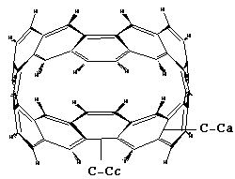
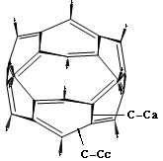
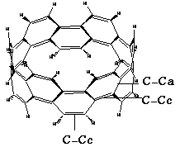

Zig-zag Armchair Chiral
Figure 1: Structure of [6] Cyclacene (zigzag, armchair and chiral) monoring molecules, indicating the two types of C-C bonds; C-Caxial (C-C_{a}) and C-C_{circumferential} (C-Cc).

Obviously, the vibration of a nanotube as well as cyclacenes, causes a deformation in its geometry Fig. 2. Structure deformation is expected to change their thermal and electronic properties ^{[18]} too.

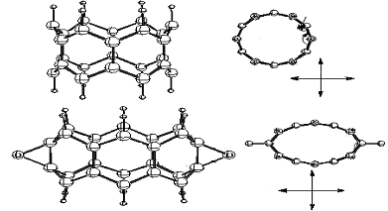
Figure 2: Structure deformation of a [6] Cyclacene (zigzag) monoring molecule as caused by its vibration motion.

Basic vibrations of CNTs were measured and assigned as breathing, puckering and clock-anti-clockwise deformation modes ^{[19]}. The frequencies of their IR active vibrations range between (873-1557 cm⁻¹) ^{[20]}. They are considered as finger print vibrations for the carbon nanotubes (CNTs) ^{[21]}. Measurements were done at 6ºK to study the impact of the puckering distortion on the electronic properties of CNTs ^{[22-23]}.
[6] cyclacene (zigzag, armchair, chiral) molecules are composed of annulated six membered aromatic rings. Their (DFT) calculated equilibrium geometry shows D_{6h}, D_{6d}, D_{3d} symmetry respectively ^{[24]}, Figure 3.

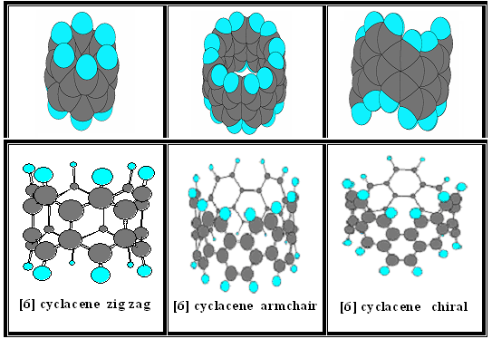
Figure 3: Equilibrium geometry for [6] Cyclacene (zigzag, armchair and chiral) monoring molecules.

Due to their symmetries D_{6h}, D_{6d} and D_{3d}, figure 4 shows repetitive sections of [6] Cyclacene monoring molecules, and Table 1 shows some of their calculated geometric parameters.

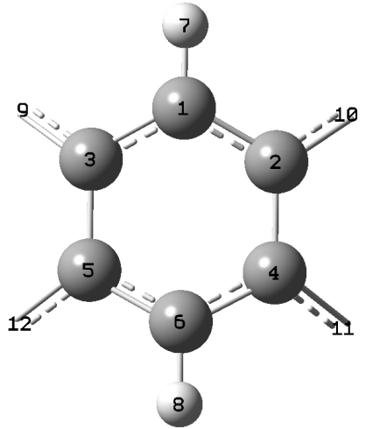
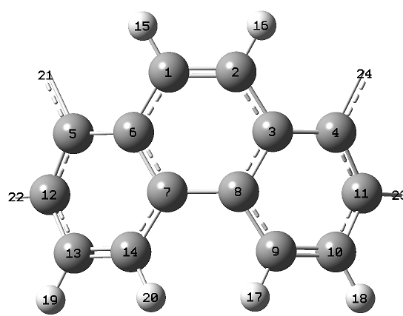
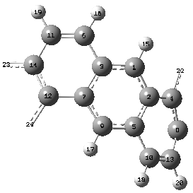

(a) (b) (c)
Figure 4: Repetitive sections of the bonds and angles of [6] Cyclacene ((a) zigzag, (b) armchair and (c) chiral) monoring molecules.

ÅTable 1: DFT calculated bond distances of [6] Cyclacene (zigzag, armchair and chiral) monoring molecules. .
Molecule | Diameter  (Å) | Length  (A⁰) | C---Ca (Å) | C---Ca (Å) | C---Cc (Å) | C=Cc (Å) | C-Cc (Å) | C-H  (Å)
[6] Cyclacene zig-zag (D_{6h}) | 5.183 | 4.972 | 1.446 | ------- | 1.413 | ------- | ------- | 1.094
[6] Cyclacene armchair (D_{6d}) | 8.760 | 5.532 | 1.435 | 1.417 | ------- | 1.366 | 1.452 | 1.080
[6] Cyclacene chiral (D_{3d}) | 8.758 | 6.758 | C--C 1.433  C-C 1.449 | 1.403 | 1.454 | 1.356 | 1.471 | =CH 1.082  --CH 1.081

As shown in (Table-1) the C-Ca bonds in the zigzag molecule are single bonds. They are longer than the C-Cc bonds connected to them. The C-Ca bonds in the armchair molecule are essential single bonds, and the C-Cc bonds are either double or single bonds. For the chiral molecule the C-Ca bonds are either single or conjugated and C-Cc bonds are of the three types; double, single and conjugated.

Vibration frequencies of [6] Cyclacene (zigzag, armchair and chiral).
-For zig-zag molecule:
The [6] Cyclacene (zigzag) molecule posses 102 fundamental vibrations. Inspection of its irreducible representations, as defined by the symmetry character table, results in the following modes of vibration;
Г_{vibration} = Г_{total} - (Γ_{rotation} + Γ_{translation}) = 3N – 6 = 108 – 6 = 102 = 6A_{1g}+ 2A_{2g}+ 4B_{1u}+ 5B_{2u} + 8E_{1u}+ 9E_{2g}+ 3A_{1u} + 5A_{2u} + 5B_{1g}+ 4B_{2g}+ 8E_{1g} + 9E_{2u}
Relative to the _{h}б reflection the vibration modes are classified as symmetric and antisymmetri modes;
a- symmetric modes with respect to _{h}б (б+_{h}).
Г_{hб+} = 6A_{1g}+ 2A_{2g}+ 5B_{1u}+ 4B_{2u}+ 8E_{1u}+ 9E_{2g} ( In-plane σ_{h} modes of vibrations)
b- antisymmetric modes with respect to _{h}б (б-_{h})..
Г_{–hб} = 3A_{1u}+ 5A_{2u}+ 4B_{1g}+ 5B_{2g}+ 8E_{1g}+ 9E_{2u} (Out of plane σ_{h} modes of vibrations)

These are 51 modes of vibration in number, of which 24 are Raman active (6A_{1g} (polarized) + 9E_{2g} (depolarized)), and 18 IR active (9E_{1u}).

-For armchair molecule:
Г_{vibration} = 210 = 9A₁+ 8A₂ +9B₁ +8B₂ +17E₁ +18E₂ +18E₃ + 18E₄+ 17E₅
These are 79 Raman active (9A₁ (polarized) + 17E₅ , 18E₁(depolarized)), and 44 IR active (8B₂, 18E_{1u}).

-For chiral molecule:
Г_{vib} = 210= 18A_{1g} + 35E_{g} + 17A_{2u} + 35E_{u} + 17A_{2g} + 18A_{1u}
These are 88 Raman active (18A_{1g} (polarized) + 35E_{g} (depolarized), 87 IR active (17A_{2u} + 35E_{u}) and 35 Raman and IR inactive (17A_{2g} , 18A_{1u}). Their assignments are as follows:

CH stretching vibrations
-For the zigzag molecule:
Their frequency values are in the range 3055-3067cm⁻¹, showing the following correlations:
ν _{sym} (CH str. (3067 cm⁻¹) > ν_{asym} (CH str.) )3055cm⁻¹)
-For armchair molecule:
Their frequency values are in the range 3083-3046 cm⁻¹. Indicating the following relation:

ν_{sym} (=CH str.) (3083 cm⁻¹) > ν_{asym} (=CH str.) (3046 cm⁻¹)
(A₁) (B₁)

-For chiral molecule:
Their frequency values are in the range 3032-3057 cm⁻¹, showing the following correlations:

ν_{sym} (CH str.) (3057 cm⁻¹) > ν_{asym} (CH str.) (3054 cm⁻¹)
(A_{1g}) (E_{g})

For the three molecules the relation ν_{sym} (CH str.) > ν_{asym} (CH str.) holds

Ring (CC stretching) vibrations
-For zig-zag molecule:
Calculated CC stretching vibration frequencies are in the range 1382-1565 cm⁻¹. Showing the following correlation;

ν_{sym.} (CC str.) (1531 cm⁻¹) (axial.) > ν_{asym.} (CC str.) (1457 cm⁻¹) (axial.)
(A_{1g}) (A_{1u})
ν_{sym.} (CC str.) (1531 cm⁻¹) (axial.) > ν_{asym.} (CC str.) (1411 cm⁻¹) (circum.)
(A_{1g}) (B_{1g})
In general ν_{sym.} (CC str.) > ν_{asym.} (CC str.)

-For armchair molecule:
Calculated vibration frequencies are in the range 1334-1635 cm⁻¹. They show the following relations;

ν_{sym} (C=C str.) (1634 cm⁻¹) < ν_{asym} (C=C str.) (1635 cm⁻¹) circum.
(A₁) (E₁)
ν_{sym} (C--C str.) (1406 cm⁻¹) < ν_{asym} (C--C str.) (1596 cm⁻¹) axial
(A₁) (B₁)
ν_{sym} (C-C str.) (1334 cm⁻¹) < ν_{asym} (C-C str.) (1379 cm⁻¹) circum.
(A₁) (E₂)
In general ν_{sym} (C-C str.) < ν_{asym} (C-C str.)

This relation is reverse to that in zig-zag molecule because the C-Ca bonds become as a C-Cc bonds in armchair molecules.

-For chiral molecule:
Calculated vibration frequencies are in the range 1342-1638 cm⁻¹. They show the following relations;

ν_{sym} (C=C str.) (1637 cm⁻¹) < ν_{asym} (C=C str.) (1642 cm⁻¹) (circum.)
(A_{1g}) (E_{g})
ν_{sym} (C--C str.) (1602 cm⁻¹) < ν_{asym} (C--C str.) (1642 cm⁻¹) (axial)
(A_{1g}) (A_{1u})
And generally:
ν (C-C str.) (circum.) < ν (C--C str.) (axial.) < ν (C=C str.) (circum.)

Ring (CCC stretching vibrations)
Unlike the C-C vibration modes, these are not located at definite C atoms as could be seen from the atomic displacement vectors. Their frequencies are lower than those of the C-C vibration modes.
According to the calculating results, the range of these frequencies are 1300-1347cm⁻¹ ,for zigzag molecule, 1359-1406 cm⁻¹ for armchair molecule, and 1358-1454 cm⁻¹ for chiral molecule.
Bending (CCC) vibrations (δCCC)
Of smaller values are the deformation (δCCC) vibrations. According to their assignment, they fall in the range 431-1228 cm⁻¹ for zigzag molecule. These modes include the expected clock and anticlockwise vibration motions.

-For armchair molecule:
Their calculated frequencies are in the range 448-1155 cm⁻¹.
-For chiral molecule:
Their calculated frequencies are in the range 833-1102 cm⁻¹.
Generally for the three molecules, the symmetric modes are of higher frequencies than the asymmetric.
Bending CH vibrations (δCH)
Their displacement vectors are mainly located at the corresponding H atoms.
-For zigzag molecule:
The calculated frequency values are in the range1107-1288 cm⁻¹.
-For armchair molecule:
Their calculated frequencies are in the range 1180-1474 cm⁻¹.

-For chiral molecule:
The calculated frequencies are in the range 1164-1484 cm⁻¹, with the following correlation:
ν_{sym.} δ(--CH) (rock.) > ν_{sym.} δ(--CH) (sciss.)
ν_{sym.} δ(--CH) (sciss.) > ν_{sym.} δ(=CH) (sciss.)
ν_{asym.} δ(=CH) (rock.) > ν_{asym.} δ(=CH) (sciss.)

Out of plane vibration frequencies (γCH)
-For the zigzag molecule:
The (γCH) out of plane vibration frequencies are in the range 817-956 cm⁻¹. The following relations hold too;

860 cm⁻¹) ) 956 cm⁻¹) > ν_{asym} (γCH) (twist.)) (wag.) (ν _{sym} (γCH
(A_{1g}) (B_{1g})
904 cm⁻¹) ) 936 cm⁻¹) > ν_{asym} (γCH) (twist.)) (wag.) (ν_{asym} (γCH
(E_{1g}) (E_{2g})

-For armchair molecule:
The (γCH) out of plane vibration frequencies are in the range 706-993 cm⁻¹.
-For chiral molecule:
The calculated frequencies are in the range 682-997cm⁻¹, with the following relations:
ν_{asym.} γ(=CH) (twist.) circum. > ν_{asym.} γ(--CH) (twist.) (axial.)
ν_{sym.} γ(=CH) (wag.) circum. < ν_{asym.} γ(--CH) (twist.) (axial.)
ν_{sym.} γ(=CH) (wag.) circum. < ν_{sym.} γ(--CH) (wag.) (axial.)
Ring out of plane vibrations (γCCC)
The ring out of plane vibrations (γCCC), show frequencies values of which the range is 133-768 cm⁻¹. The modes include puckering, deformations, as well as breathing vibrations of the whole ring. The relation of the sym. to the asym. modes for zigzag molecule is viewed in the following scheme;

ν _{sym.} (γCCC) (axial.) (537 cm⁻¹) > ν _{sym.} (γCCC) (circum.) (462 cm⁻¹)
(A_{1g}) (A_{1g})
ν _{asym.} (γCCC) (axial.) (768 cm⁻¹) > ν _{asym.} (γCCC) (circum.) (658 cm⁻¹)
(E_{1g}) (E_{1g})
ν _{sym.} (γCCC) (axial.) (537 cm⁻¹) > ν _{asym.} (γCCC) (axial.) (324 cm⁻¹)
(A_{1g}) (B_{1u})
ν _{sym.} (γCCC) (circum.) (462 cm⁻¹) > ν _{asym.} (γCCC) (circum.) (331 cm⁻¹)
(A_{1g}) (B_{1g})
-For armchair molecule:
The calculated frequencies range is (187-865 cm⁻¹).

-For chiral molecule:
The calculated frequencies range is (64-765 cm⁻¹), with the following relations:

ν _{sym.} (γCCC) (616 cm⁻¹) < ν _{asym.} (γCCC) (765 cm⁻¹)
(A_{1g}) (A_{1u})

Table 2 includes the calculated frequencies and IR absorption intensities of the vibration modes of the zigzag molecule as a sample of the calculation and assignment results. Commonly known, the vibrations with (intensity= 0.0) are IR forbidden, those with (intensity≠ 0.0) are IR allowed. The vibration modes in the table are classified according to the Herzberg scheme ^{[25]}.
Figure 5 shows the vibration pictures for some modes of the [6] Cyclacene (zig zag) molecule, as calculated applying the DFT method.

Table (2): Calculated vibration frequencies and IR absorption intensities for [6] Cyclacene (zig zag) molecule.
Symmetry & description |  | PM3 Freq. cm⁻¹ | (DFT) B3LYP/ 6-311G Freq. cm⁻¹ | Intensity km/mol
A_{1g}
ν₁ | CH str. | 3073 | 3067 | 0.000
ν₂ | ring (CC str.) (axial b.) | 1644 | 1531 | 0.000
ν₃ | γCH (wag.) | 950 | 956 | 0.000
ν₄ | δring (δCCC) (elongation) | 890 | 775 | 0.000
ν₅ | γring (γCCC) (axial b.) (breath.) | 538 | 537 | 0.000
ν₆ | γring (γCCC) (circum. b.) (breath.) | 452 | 462 | 0.000
B_{1g}
ν₇ | CH str. | 3072 | 3055 | 0.000
ν₈ | ring (CC str.) (cercum. b) | 1600 | 1411 | 0.000
ν₉ | γCH (twist.) | 867 | 860 | 0.000
ν₁₀ | γCH (twist.) + γring (γCCC) | 782 | 817 | 0.000
ν₁₁ | γring (γCCC) (cercum. b.) (puck.) | 330 | 331 | 0.000
A_{1u}
ν₁₂ | ring (CC str.) (cercum. b.) + δCH rock.) | 1717 | 1388 | 0.000
ν₁₃ | δCH (rock.)+δring(δCCC)(axial. b.) | 1119 | 1107 | 0.000
ν₁₄ | δring (δCCC)(clock & anticlock wise) | 453 | 431 | 0.000
B_{1u}
ν₁₅ | ring (CC str.) (axial b.)+ δCH (sciss.) | 1583 | 1457 | 0.000
ν₁₆ | ring (CCC str.) (axial b.) | 1377 | 1363 | 0.000
ν₁₇ | ring (δCCC) + δCH (sciss.) | 979 | 903 | 0.000
ν₁₈ | γring (γCCC) (axial b.) (puck.) | 358 | 324 | 0.000
E_{1g}
ν₁₉ | CH str. | 3071 | 3061 | 0.000
ν₂₀ | CH str. | 3071 | 3061 | 0.000
ν₂₁ | ring (CC str.) (cercum. b) | 1694 | 1565 | 0.000
ν₂₂ | ring (CC str.) (cercum. b) | 1694 | 1565 | 0.000
ν₂₃ | δCH + δring (δCCC) | 1384 | 1288 | 0.000
ν₂₄ | δCH + δring (δCCC) | 1384 | 1288 | 0.000
ν₂₅ | δCH + δring (δCCC) | 1145 | 1207 | 0.000
ν₂₆ | δCH + δring (δCCC) | 1145 | 1207 | 0.000
ν₂₇ | γCH (wag.) | 925 | 936 | 0.000
ν₂₈ | γCH (wag.) | 925 | 936 | 0.000
ν₂₉ | γring (γCCC) (axial. b.) (puck.) | 827 | 768 | 0.000
ν₃₀ | γring (γCCC) (axial. b.) (puck.) | 827 | 768 | 0.000
ν₃₁ | γring (γCCC) (cercum. b.) (puck.) | 638 | 658 | 0.000
ν₃₂ | γring (γCCC) (cercum. b.) (puck.) | 638 | 658 | 0.000
ν₃₃ | γring (γCCC) (puck.) | 329 | 333 | 0.000
ν₃₄ | γring (γCCC) (puck.) | 329 | 333 | 0.000
E_{1u}
ν₃₅ | CH str. | 3073 | 3062 | 20.066
ν₃₆ | CH str. | 3073 | 3062 | 20.066
ν₃₇ | ring (CC str.) (axial b.) + δCH (rock.) | 1632 | 1516 | 3.559
ν₃₈ | ring (CC str.) (axial b.) + δCH (rock.) | 1632 | 1516 | 3.559
ν₃₉ | ring (CCC str.) (axial b.) | 1479 | 1347 | 32.422
ν₄₀ | ring (CCC str.) (axial b.) | 1479 | 1347 | 32.422
ν₄₁ | δCH (rock.) + ring (CCC str.) | 1156 | 1201 | 0.117
ν₄₂ | δCH (rock.) + ring (CCC str.) | 1156 | 1201 | 0.117
ν₄₃ | γCH (twist.) | 927 | 910 | 557.652
ν₄₄ | γCH (twist.) | 927 | 910 | 557.652
ν₄₅ | δring (δCCC) (axial b.) (elongation) | 894 | 762 | 5.054
ν₄₆ | δring (δCCC) (axial b.) (elongation) | 894 | 762 | 5.054
ν₄₇ | δring (δCCC) (cercum. b.) | 594 | 585 | 19.554
ν₄₈ | δring (δCCC) (cercum. b.) | 594 | 585 | 19.554
ν₄₉ | γring (γCCC) (cercum. b.) (puck.) | 443 | 403 | 8.433
ν₅₀ | γring (γCCC) (cercum. b.) (puck.) | 443 | 403 | 8.433
A_{2g}
ν₅₁ | ring (CC str.) (circum. b., clock & anti clockwise) + δCH | 1248 | 1504 | 0.000
ν₅₂ | δCH (rock.) (clock & anticlockwise) | 1090 | 1227 | 0.000
A_{2u}
ν₅₃ | CH str. | 3072 | 3064 | 58.588
ν₅₄ | ring (CCC str.) (cercum. b.) + δCH | 1404 | 1300 | 90.410
ν₅₅ | γCH (wag.) | 928 | 922 | 378.955
ν₅₆ | γring (γCCC) (axial. b.) (puck.) | 809 | 735 | 131.157
ν₅₇ | γring (γCCC) (cercum. b.) (puck.) | 418 | 382 | 76.438
B_{2g}
ν₅₈ | ring (CC str.) (cercum. b) | 1556 | 1432 | 0.000
ν₅₉ | δCH (sciss.) + ring (δCCC) | 1207 | 1274 | 0.000
ν₆₀ | γring (γCCC) (axial. b.) (puck.) | 678 | 665 | 0.000
ν₆₁ | ring (δCCC) (cercum. b.) | 475 | 466 | 0.000
B_{2u}
ν₆₂ | CH str. | 3073 | 3056 | 0.000
ν₆₃ | ring (CCC str.) + δCH (sciss.) | 1573 | 1320 | 0.000
ν₆₄ | γCH (twist.) | 832 | 876 | 0.000
ν₆₅ | ring (δCCC) + δCH (sciss.) | 598 | 599 | 0.000
ν₆₆ | γring (γCCC) (axial b.) (puck.) | 281 | 255 | 0.000
E_{2g}
ν₆₇ | CH str. | 3073 | 3058 | 0.000
ν₆₈ | CH str. | 3073 | 3058 | 0.000
ν₆₉ | ring (CC str.)(axial b.) + δCH (sciss.) | 1608 | 1497 | 0.000
ν₇₀ | ring (CC str.)(axial b.) + δCH (sciss.) | 1608 | 1497 | 0.000
ν₇₁ | ring (CC str.) (axial b. + cercum. b.) | 1576 | 1382 | 0.000
ν₇₂ | ring (CC str.) (axial b.+ cercum. b.) | 1576 | 1382 | 0.000
ν₇₃ | δCH + (δCCC) | 1280 | 1271 | 0.000
ν₇₄ | δCH + (δCCC) | 1280 | 1271 | 0.000
ν₇₅ | γCH (twist.) | 961 | 904 | 0.000
ν₇₆ | γCH (twist.) | 961 | 904 | 0.000
ν₇₇ | γCH (twist.) + γring (γCCC) | 864 | 845 | 0.000
ν₇₈ | γCH (twist.) + γring (γCCC) | 864 | 845 | 0.000
ν₇₉ | δring (δCCC) (circum b.) (elongation) | 627 | 619 | 0.000
ν₈₀ | δring (δCCC) (circum b.) (elongation) | 627 | 619 | 0.000
ν₈₁ | γring (γCCC) (cercum. b.) (puck.) | 405 | 387 | 0.000
ν₈₂ | γring (γCCC) (cercum. b.) (puck.) | 405 | 387 | 0.000
ν₈₃ | γring (γCCC) (axial b.) (puck.) | 147 | 133 | 0.000
ν₈₄ | γring (γCCC) (axial b.) (puck.) | 147 | 133 | 0.000
E_{2u}
ν₈₅ | CH str. | 3072 | 3056 | 0.000
ν₈₆ | CH str. | 3072 | 3056 | 0.000
ν₈₇ | ring (CC str.) (cercum. b) | 1685 | 1547 | 0.000
ν₈₈ | ring (CC str.) (cercum. b) | 1685 | 1547 | 0.000
ν₈₉ | ring (CCC str.) + δCH (sciss.) | 1428 | 1308 | 0.000
ν₉₀ | ring (CCC str.) + δCH (sciss.) | 1428 | 1308 | 0.000
ν₉₁ | δring (δCCC) (cercum. b) | 1196 | 1228 | 0.000
ν₉₂ | δring (δCCC) (cercum. b) | 1196 | 1228 | 0.000
ν₉₃ | γCH (twist.) | 885 | 892 | 0.000
ν₉₄ | γCH (twist.) | 885 | 892 | 0.000
ν₉₅ | γCH (twist.) + γring (γCCC) | 846 | 839 | 0.000
ν₉₆ | γCH (twist.) + γring (γCCC) | 846 | 839 | 0.000
ν₉₇ | γring (γCCC) (axial. b.) (puck.) | 672 | 670 | 0.000
ν₉₈ | γring (γCCC) (axial. b.) (puck.) | 672 | 670 | 0.000
ν₉₉ | γring (γCCC) (cercum. b) (puck.) | 430 | 429 | 0.000
ν₁₀₀ | γring (γCCC) (cercum. b) (puck.) | 430 | 429 | 0.000
ν₁₀₁ | γring (γCCC) (cercum. b) (puck.) | 181 | 185 | 0.000
ν₁₀₂ | γring (γCCC) (cercum. b) (puck.) | 181 | 185 | 0.000
γ: Out of plane of the molecule., δ: In- plane of the molecule.
(breath.): ring breathing mode., (puck.): ring puckering mode. , (sciss.): CH scissoring mode.
(twist.): CH twisting mode., (wag.): CH wagging mode.

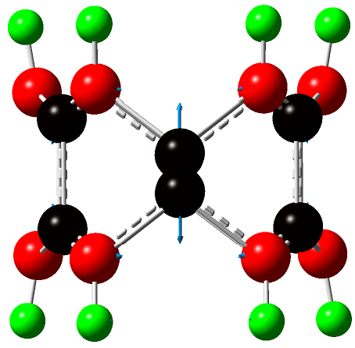
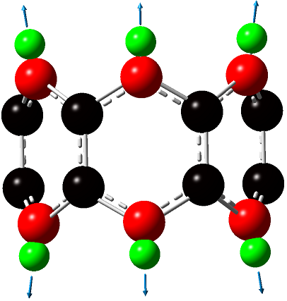
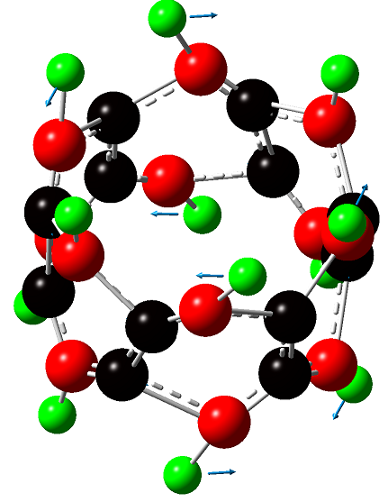

sym. CCstr. (axial b.)
(ν₇₁, E_{2g}, 1382)
sym.CC str.(cercum. b)
(ν₈₇, E_{2u}, 1547)
sym. CH str.
(ν₁, A_{1g}, 3067)

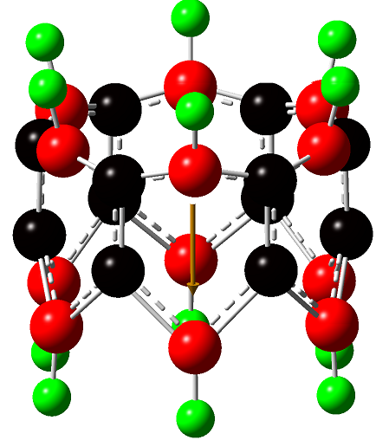
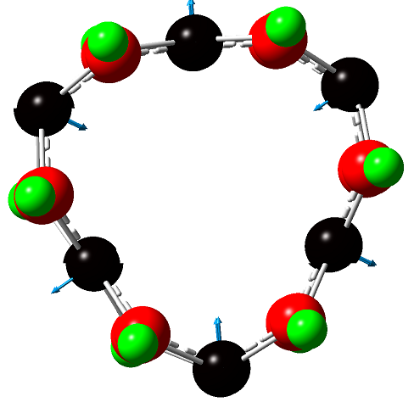
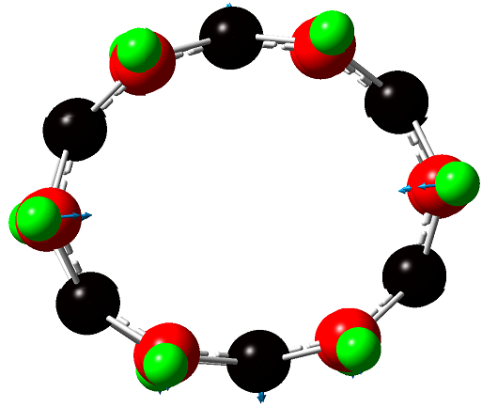

sym. γring (axial b.)
(ν₈₄, E_{2g}, 133)
sym. γring (cercum. b.)
(ν₈₁, B_{1u}, 324)
asym CCC str.(cercum. b.)
(ν₅₄, A_{2u}, 1300)

Figure 5. The graphical pictures of some vibration modes for [6] Cyclacene (zigzag) molecule as calculated applying the DFT method.

Table 3 shows comparison of the calculated vibration frequencies of [6] cyclacenes molecules with the frequencies of anthracene and phenanthrene molecules by using the same level of DFT theory, the frequency values of [6] cyclacenes are lower. The comparison shows that the force field for cyclacene is weaker than that of the coplanar polyaromatic molecule. It indicates the influence of folding in diminishing the C-C bond strength of the aromatic molecule too.

Table 3: Comparison of the calculated vibration frequencies of [6] cyclacene molecules with those of coplanar anthracene and phenanthrene molecules using B3LYP/6-311G .
Molecule | C-H sym. | C-H asym. | C-Ca sym. | C-Ca asym. | C-Cc sym. | C-Cc asym. | δCH sym. | δCH asym | γCH sym. | γCH asym.
Anthracene  (D_{2h}) | 3156  A_{g} | 3153  B_{1u} | 1592  A_{g} | 1582  B_{2u} | ------- | 1670  B_{1u} | 1302A_{g}ِ | 1320  B_{3g} | ------ | 992  B_{1g}
Phenanthrene  (C_{2v}) | 3209  A₁ | 3198  B₂ | 1644  A₁ | 1656  B₁ | 1662  A₁ | ------- | 1341  A₁ | 1328  B₂ | 1005  A₂ | 1021  B₁
[6] Cyclacene zig-zag (D_{6h})  H  H  H  H  H  H  H  H  H  H  H  H | 3067  A_{1g} | 3055  B_{1g} | 1531  A_{1g} | 1457  B_{1u} | ------- | 1411  B_{1g} | 1222  A_{1g} | 1274  B_{2g} | ------ | 992  B_{1g}
[6] Cyclacene armchair(D_{6d}) | 3083  A₁ | 3046B₁ | 1406  A₁ | 1496  B₁ | 1634  A₁ | 1635  E₁ | 1222  A₁ | 1214  E₁ | 810  A₁ | 963  B₁
[6] Cyclacene chiral (D_{3d}) | 3057  A_{1g} | 3042  A_{1u} | 1602  A_{1g} | 1642  A_{1u} | 1637  A_{1g} | 1641  E_{g} | 1224  A_{1g} | 1244  A_{1u} | 933  A_{1g} | 915  E_{g}

The result parallels that of Turker ^{[26]} who showed, on the basis of the Hückel treatment, that the electronic binding energy of the planar polyaromatic hydrocarbon are bigger in value than those of the cyclacene molecule with similar number of benzene rings.

References
1-M. Kaempgen, G. S. Duesberg and S. Roth, Appl. Surf. Sci.,2005, 252(2), 425-429.
2- I. Lukovitz, F. H. Karman, P. M. Nagy and E. Kalman, Croat. Chim. Acta, 2007,80, 233-237.
3- T. Yao, Hao Yu, R. J. Vermelj and G. J. Bodwell, Phys., 2008, Rev.Lett. 80, 1-3.
4- M. S. Dresselhaus, G. Dresselhaus and P. Avouris, Carbon Nanotubes, Synthesis, Structures, Properties and Applications, Springer- Verlag, New York, 1996.
5- N. Anderson, A. Hartschuh, S. Cronin and L. Novotny, J. Am. Chem. Soc. 2005, 127, 2533-2537.
6- S. Iijima, Nature, 1991, 354, 56–58 ; S. Iijima, T. Ichihashi, Nature, 1993, 363, 603–605.
7- N. Hamada, S. Sawada, A. Oshiyama, Phys. Rev. Lett., 1992, 68, 1579–1581.
8- Y. Wang and X. Jing, Polym. Adv.Technol., 2005, 16, 344.
9- T. Durkop, S.A. Getty, E. Cobas and M.S. Fuhrer, Nano Lett., 2004, 4, 35-39.
10- B.I. Yacobson and R.E. Smalley, American Scientist, 1997, 85, 324-337.
11-R. Gleiter, B. Esser and S. Kornmeyer, Acc. Chem. Res., 1983, 16, 328-334.
12- M. Shanshal, Turk. J. Chem., 2010, 34, 269–275.
13- W. Kohn, and L. J. Sham, Phys. Rev., 1965, 140, A1133-A1138, P. Hohenberg, and W. Kohn, Phys. Rev., 1964, 136, B864-B871.
14- R. G. Parr and W. Yang, “Density-Functional Theory of Atoms and Molecules,” Oxford, New York, p. 53, 1989; E. Wilson, Chem. Eng. News, 1998, October 19, 12; D. Malakoff, Science, 282, 610, 1998.
15- 6- 311G, See G03, Manual, Gaussian, Inc. Pittsburgh, PA, 2003.
16- J. J. P. Stewart, J. Comp. Chem., 1989, 10, 209; J. J. P. Stewart, J. Comp. Chem., 1989, 10, 221; J. J. P. Stewart, J. Comp. Chem., 1991, 12, 320; M. J. S. Dewar, E. F. Healy, A. J. Holder, and Y. C. Yuan, J. Comp. Chem., 1990, 11, 541.
17- M.J. Frish, Gaussian 03, RevisionB.03, Gaussian Pittsburgh, PA., 2003.
18- L. Vitali, M. Burghard, M.A. Schneider, Y.Wu, Lei Liu, C. Jayanthi and K. Kern, Phys. Rev. Lett., 2004, 93, 136103.
19- R. Saito, G. Dresselhaus, M. S. Dresselhaus, Phys. Rev, 2000, .B 61, 2981.
20- a- U. Kuhlman, H. Jantoljak, N. Pfander, P. Bernier, C. Journet and C. Thomsen, Chem. Phys. Lett., 198, 294, 237-240, b- U. Kuhlman, H. Jantoljak, N. Pfander, C. Journet, P. Bernier, and C. Thomsen, Synnth. Met. , 1999, 103, 2506-2507.
21- K.A. Ramani and H. Chadl, J. Phys. chem., 2006, B 110 (25), 12388-12393.
22- A.B. Dalton, J.N. Coleman, B. McCarthy, P.M. Ajayan, S. Lefrant, P. Bernier, W. Blau and H.J. Byme, J. Phys. Chem., 2000, B 104, 10012.
23- a- A. Rochefort, P. Avouris, J. Phys. Chem., 2000, A 104, 9807–9811; b- L. Chico, L.X. Benedict, S.G. Louie, M.L. Cohen, Phys. Rev., 1996, B 54, 2600–2606; c- P.E. Pehrsson, W. Zhao, J.W. Baldwin, C.H. Song, J. Liu, S. Kooi, B. Zheng, J. Phys. Chem., 2003, B 107, 5690–5695.
24- G. Davidson, “Introduction to group theory for Chemists”, Applied Science Publishers Ltd. London, Elsevier Publishing Comp. Ltd., 1990.
25- G. Herzberg, “Molecular Spectra and Molecular Structure, Infrared and Raman Spectra of Polyatomic Molecules”, van Nostrand Co. New York, 1971.
26- L. Turker, Turk. J. Chem., 2000, 24, 217-222.

