Cobalt(II), Nickel(II) and Copper(II) Complexes With Schiff Base Ligand Derived From Diacetylpyridine and Carbodihydrazide, SYNTHESIS AND SPECTRAL STUDIES
Ashour H. Dawood
College of Science, Kerbala University
(NJC)

(Recevied on 20/3 /2011 ) (Accepted for publication 27/9 /2011)

Abstract
The condensation reaction of two equivalent carbodihydrazide with one equivalent diacetylpyridine obtain the ligand type N₃O₂ as a donor set atoms, the prepared compound reacted with Co⁺², Ni⁺² and Cu⁺² ions to form their complexes , the ligand and its complexes were characterized by FT-IR, UV-Vis, ¹H, ¹³C NMR spectroscopy, conductivity and magnetic susceptibility. From the spectroscopy studies and the conductivity and magnetic measurements suggest the distorted octahedral geometry around the metal ions
الخلاصة
حضر الليكند بطريقة التكثيف من خلال مفاعلة مكافئين من الكاربو ثنائي هيدرازيد مع مكافئ واحد من ثنائي مثيل استيل بردين ليتكون اليكند الحاوي على ثلاث ذرات نايتروجين وذرتي اوكسجين كذرات واهبة ثم تمت مفاعلة الليكند مع ايونات الكوبلت والنيكل والنحاس الثنائية لتكوين معقدات هذه الايونات. تم تشخيص الليكند والمعقدات المحضرة بواسطة مطيافية الاشعة تحت الحمراء والاشعة فوق البنفسجية – المرئية و الرنين النووي المغناطيسي للبروتونات و كاربون -13 اضافة الى قياس التوصيلية المولارية والحساسية المغناطيسية. من دراسة اطياف المعقدات وقياسات التوصيلية المولارية اقترح الشكل ثماني السطوح المشوه للمعقدات

Introduction
The chemistry of mixed donor atom spatially nitrogen and oxygen atoms ligands classified as hard atom according to the Persen classification with complexing ability have been recorded in the last years ^{[1-2]}, the design and synthesis of N₃O₂ ligands containing more than one recognition sit for binding several spices is of considerable current interest in chemical literature^{[3-8]}. The coordination chemistry of mixed nitrogen and oxygen atoms preference towards the transition metal ions. The lower coordination number of (imino)pyridines vs 2,6-bis(imino)pyridines In an attempt of correlating structure and catalytic activity, a great deal of attention has been focused on the many structural variations exhibited by theses^{[9-14]}.

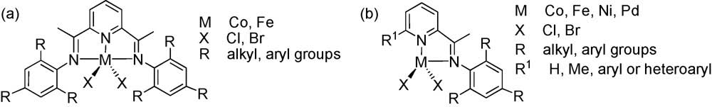

Experimental Section
All reagents were commercially available (Aldrich Chemical Company) and were used without further purification. The solvent used in the synthesis were distilled from the appropriate drying agent immediately prior to use all manipulations in the synthesis of precursor and template ligand complexes were performed under Nitrogen atmosphere.
Electronic spectra were measured in the region 200-800 nm for solution methanol at room temperature using a Perkin Elmer precisely UV-Vis spectrophotometer. Infrared spectra were recorded by using a Varian Resolutions – 300 FTIR spectrometer. HNMR spectra were recorded in DMSO-d6 using a JEOL – JNM-ESC400,(All measurements were done in New Castle University, School of Chemistry).
1-SYNTHESIS OF THE LIGAND N''-N-(hydrazinocarbonyl) ethanehydrazonoyl]pyridin-2-yl} ethylidene)carbonohydrazide
In 250 size shlink flask putted (1.00g, 6.128 mmol.) from diacetyl pyridine dissolved in 15 mL ethanol stirred until dissolve completely , added a solution of (1.10g, 12.256 mmol.) carbodihydrazide dissolved in sufficient amount ethanol slowly , the resulted mixture was refluxed to four hours under nitrogen blanket , observed a white precipitate was obtained, the solvent removed under vacuum, filtered the rest solution, washed with cold ethanol and ether twice times, recrystallized by hot ethanol, dried to gave a shine white crystal. m.p 124 ºC.
2- Synthesis Of Complexes
The Cobalt (II), Nickel (II) and Copper (II) complexes were carried out in the same method by using the shlink flask, dissolve 0.1 g from the prepared ligand in 20 mL absolute methanol with stirring, the added a salts of ions 0.094g, 0.094g and 0.078g dissolved in 10 mL methanol for Co(NO₃)₂.6H₂O, Ni(NO₃)₂.6H₂O and Cu(NO₃)₂.3H₂O respectively the mixtures were refluxed under nitrogen atmosphere two hours, cooled the mixture at room temperature, the solutions covered and kept overnight in the Lab. Observed the pale brown, green, and blue precipitates obtained from solution of Co, Ni and Cu salts respectively. Collected, recrystallized, filtered, washed and dried to form the titled complexes.
Results and Discussions
1-Synthesis of Ligand and their Complexes
The N₃O₂ donor atoms ligand was formed from reaction two equivalent carbodihydrazide with one equivalent of diacetylepyridine in ethanol as a solvent. While their complexes carried out by refluxed reaction the ligand with nitrates salts of cobalt(II), nickel(II) and copper(II) ions 1:1 ratio, the compounds were characterized by ¹H NMR, FT-IR and UV-Vis spectroscopy , conductivity and magnetic susceptibility measurements. The synthesis of ligand and their complexes summarized in the following Scheme

2- FT-IR SPECTRA:
The FT-IR spectrum of the ligand Fig. (1) Displayed the intense bands at (3356 cm⁻¹) and (3325 cm⁻¹) attributed to the v(N-H₂) stretching, the band at (3206 cm⁻¹) assigned to the v(N-H) stretching, the characteristic band at (1678 cm⁻¹) due to the iminic group v(C=N) stretching comparison with the carbonyl group of diacetylpyridine which that appeared at (1707 cm⁻¹), the other bands summarized in Table (1).
While the FT-IR spectra of Co⁺², Ni⁺² and Cu⁺² complexes ion Figs. (2,3,4) appears the shifting in the v(C=N) stretching which that shows in the free ligand at (1678 cm⁻¹) to the lower frequency and appeared at (1624 cm⁻¹, 1652 cm⁻¹, 1623 cm⁻¹) for Co⁺², Ni⁺² and Cu⁺² ions cmplex. This shifting can be attributed to the delocalisation of the electron density of the metal ion into the π-system of the ligand (HOMO → LUMO) [ where HOMO= Highest Occupied Molecular Orbital; LUMO= Lowest Unoccupied Molecular Orbital], the weak band at (1632,1566, 1606,1566 cm-1) assigned to ν(C=N) stretching aromatic pyridine ring comparison with the diacetylpyridine shows at (1661 cm⁻¹), and (1575, 1512, 1548, 1513 cm-1) assigned to ν(C=C) stretching aromatic pyridine ring. We can observe the shifting in the value of C=N and C=C stretching due to the coordination between the metals and ligand ^{[15,16]}.
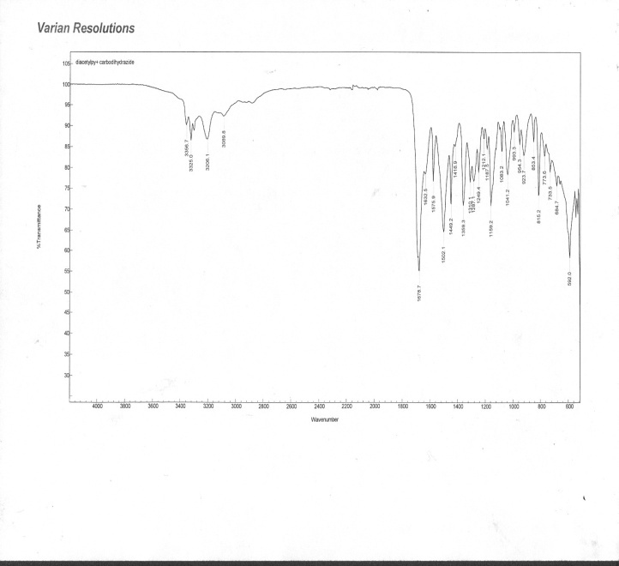

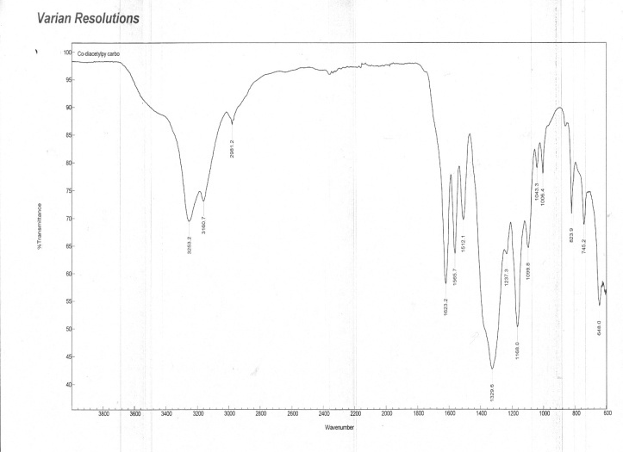

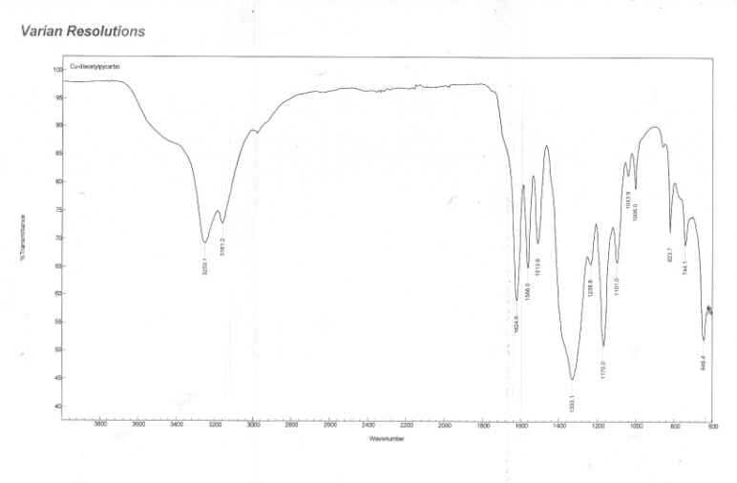
Fig. (1) FT-IR spectrum of the Ligand Fig.(2) FT-IR spectrum of he o⁺² complex
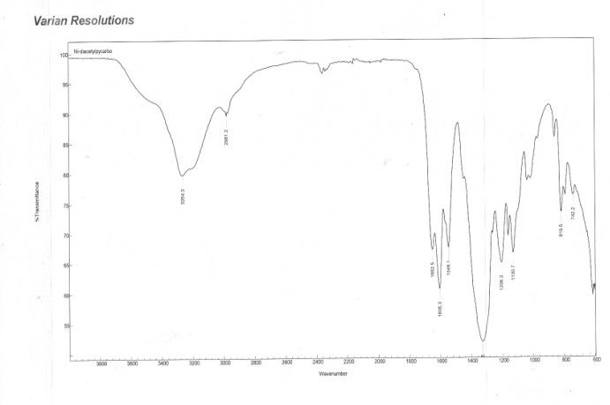
Fig.(3) FT-IR spectrum of the Ni⁺² complex Fig.(4) FT-IR spectrum of the Cu⁺² omplex

3-Ultraviolet- Visible spectra:
The electronic spectra of the complexes Fig. (5) shows the peaks in the UV region attributed to the π→π* and n→π* while the visible region show a weak peaks at (650 nm), (685 nm) and (710 nm) due to the d-d transitions type⁴ T₁g^{(F)} → ⁴T_{2g}^{(F)} , ³A₂g → ³T₂g and ²Eg→ ²B₁g for Co⁺², Ni⁺² and Cu⁺² complexes respectively as a good agreement with the octahedral geometry around the ions ^{[17]}.

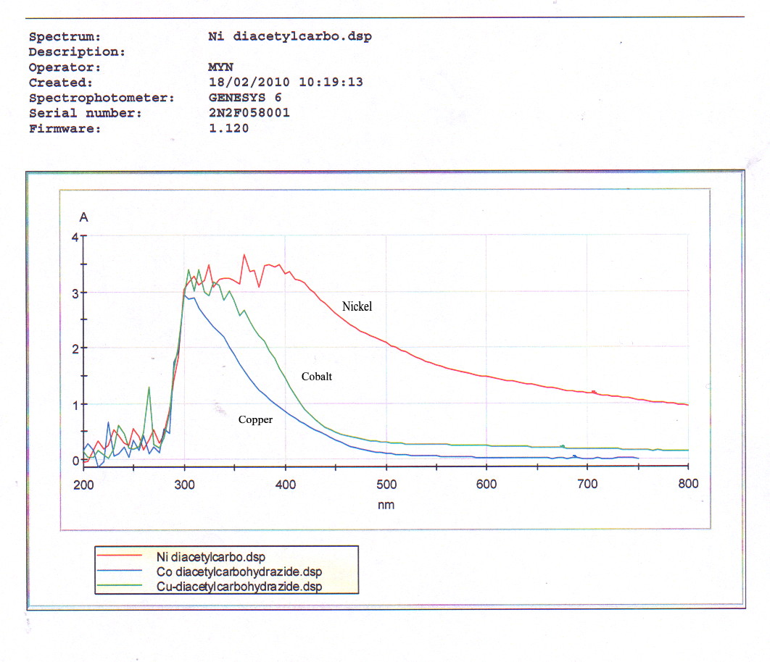

Fig. (5) UV-Vis spectrum of the complexes

4- ¹H & ¹³C NMR SECTA
The ¹HNMR spectrum in DMSO-d⁶ (δ= 2.75 ppm) of the ligand Fig. (6) displays the chemical shift at (δ= 10.40 ppm, 4H) assigned to protons (H-N), the signals at (δ= 7.95 ppm, 4H, δ= 7.85 ppm, 1H) attributed to (H₂-N) groups and (H-C) aromatic proton, while the rest two equivalent protons in the pyridine ring displays the chemical shift at (δ= 7.26 ppm, 2H), the two equivalent methyl groups shows the signal at (δ= 1.54 ppm, 6H). the ¹³C NMR spectrum in DMSO-d⁶ (δ= 41.13 ppm) of the ligand Fig. (7) shows the chemical shifts at (δ= 159 ppm) assigned to (C=O), (δ= 154 ppm) assigned to (C-N) which that

neighboring to the nitrogen atom of the pyridine ring, the signal at (δ= 151 ppm) attributed to (C=N) imine groups, the chemical shifts at (δ= 133 ppm) and (δ= 128 ppm) due to (C=C) and (C-C) in the ring respectively, while the two methyl groups carbon atoms appeared the chemical shift at (δ= 13 ppm).
The ¹HNMR spectra in chloroform CDCl₃ (δ= 7.26 ppm) of the complexes Figs. (8, 9, 10) for Co⁺², Ni⁺², Cu⁺² ion complexes respectively shows the weakness of the signals of the groups due to the coordination effect, while the two methyl groups appeared at (δ= 1.56 ppm, and δ= 1.52 ppm) for the three complexes can be attributed to the mutual phenomena of the two methyl groups [15,18].

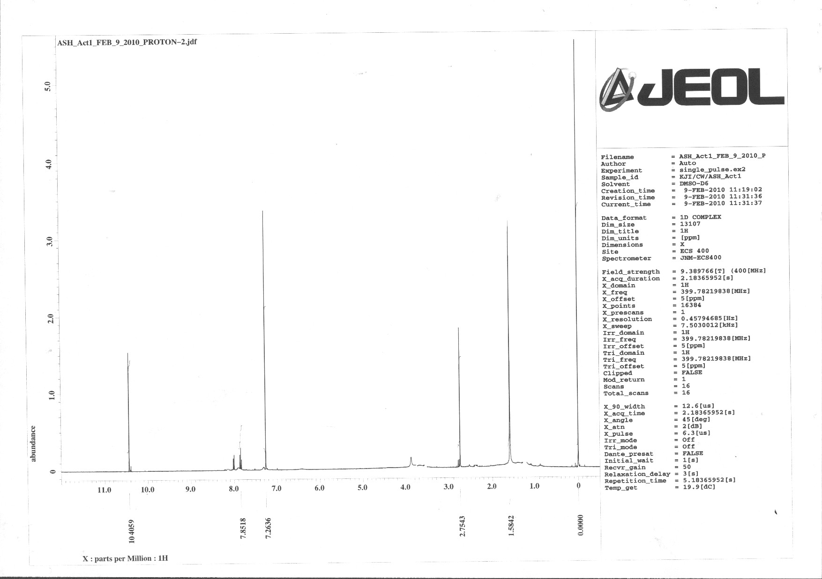
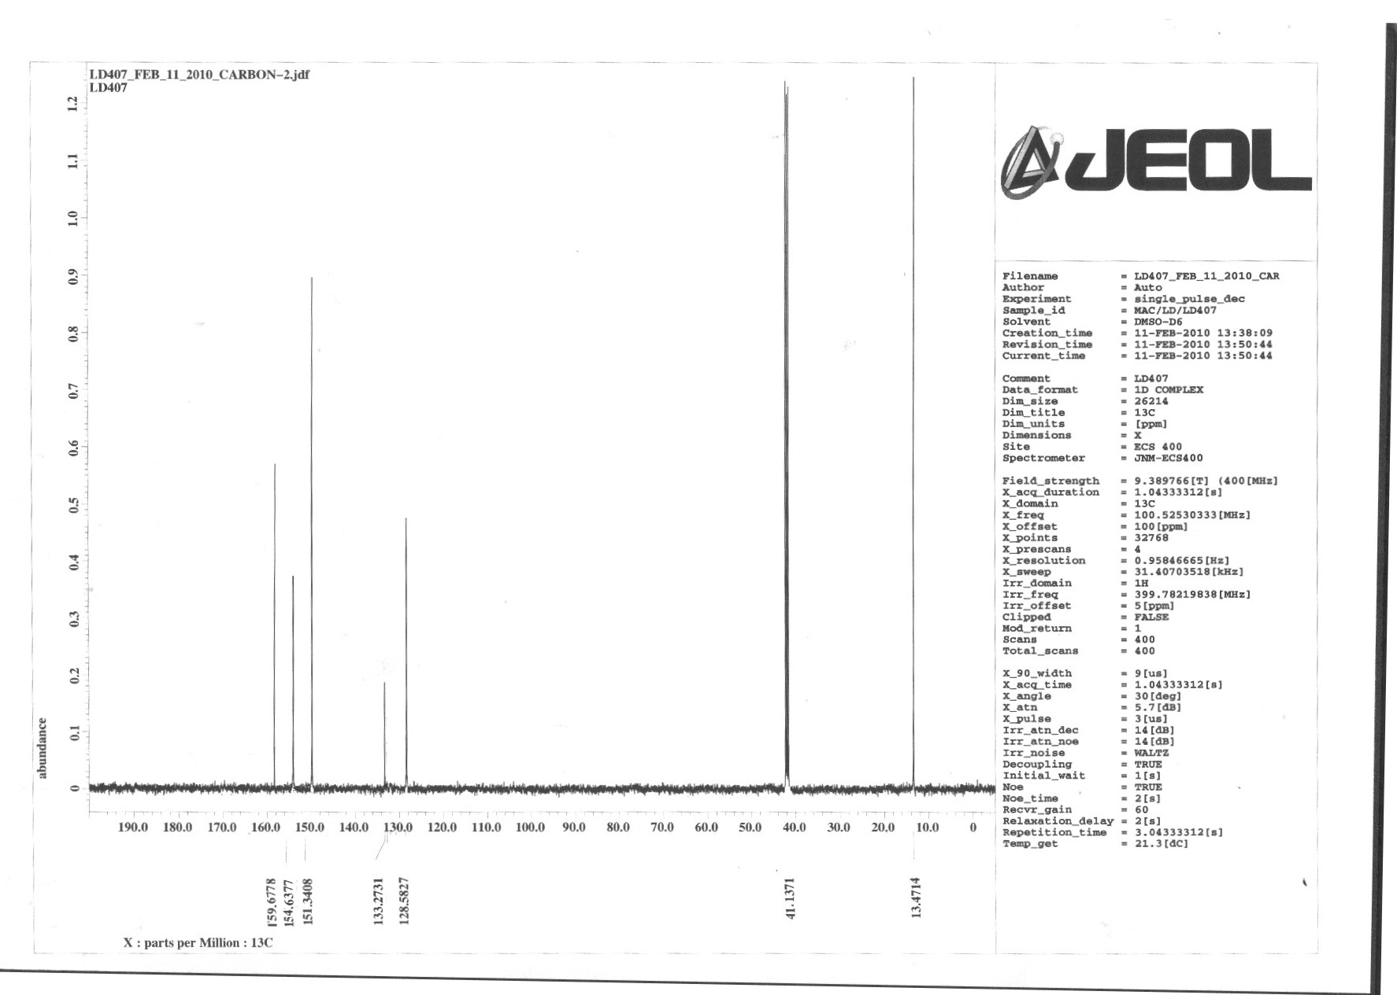

Fig.(6) HNMR spectrum of Ligand Fig.(7) CNMR spectrum of Ligand
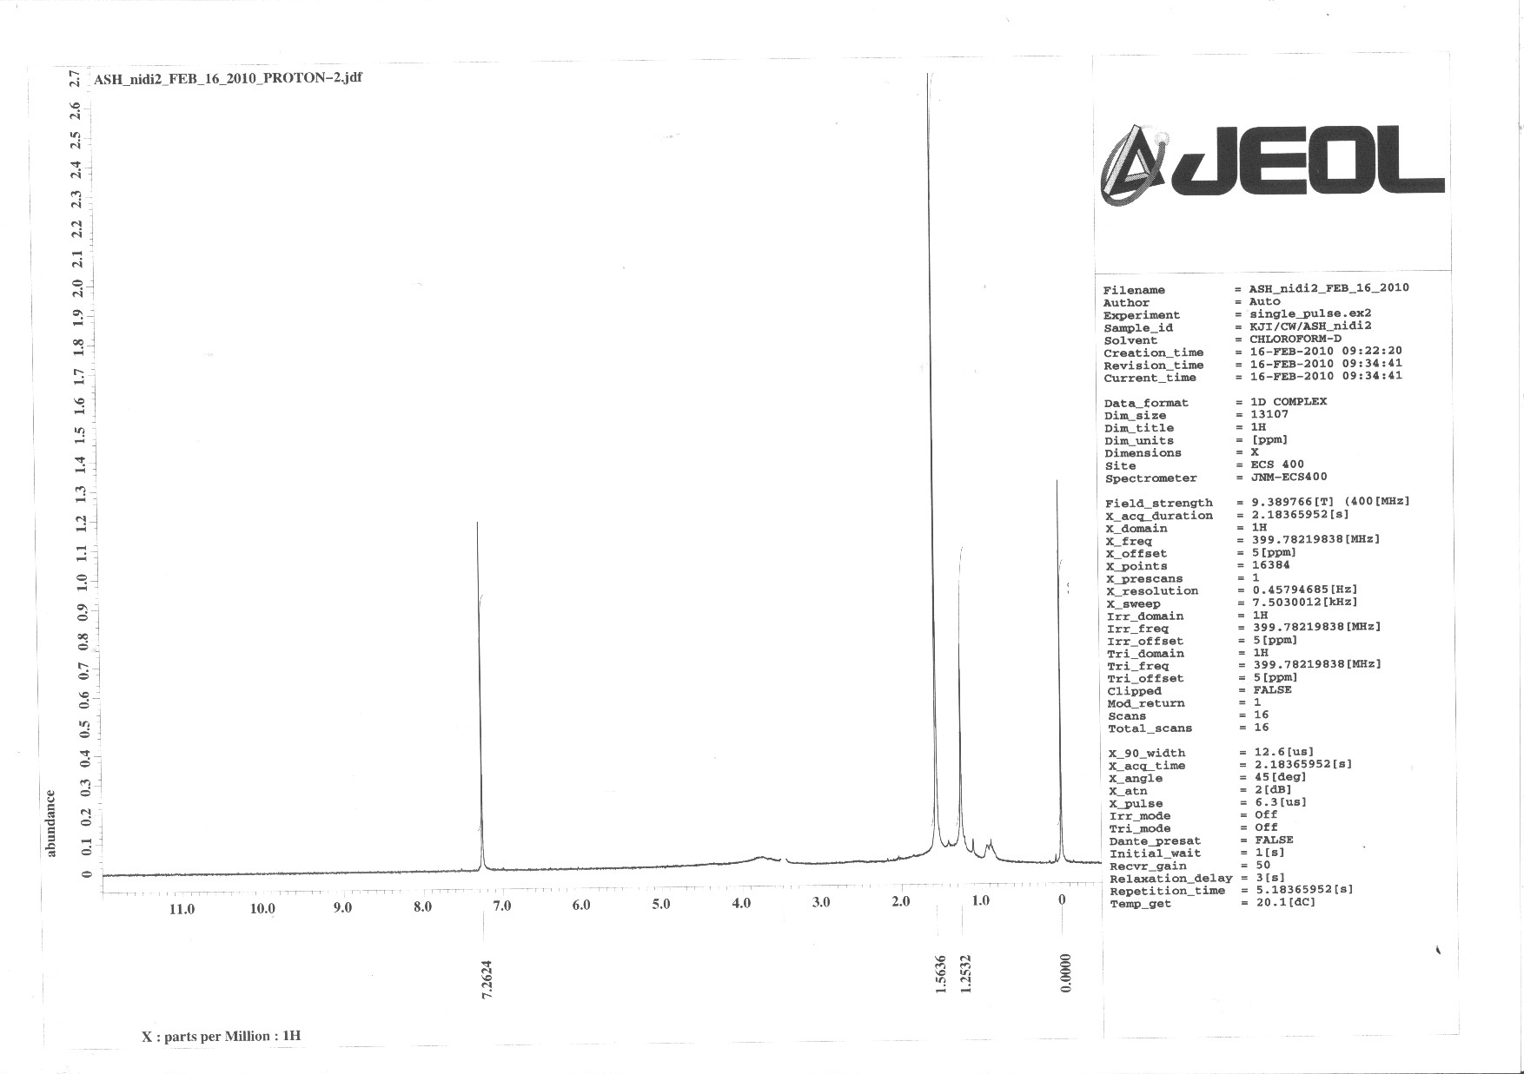
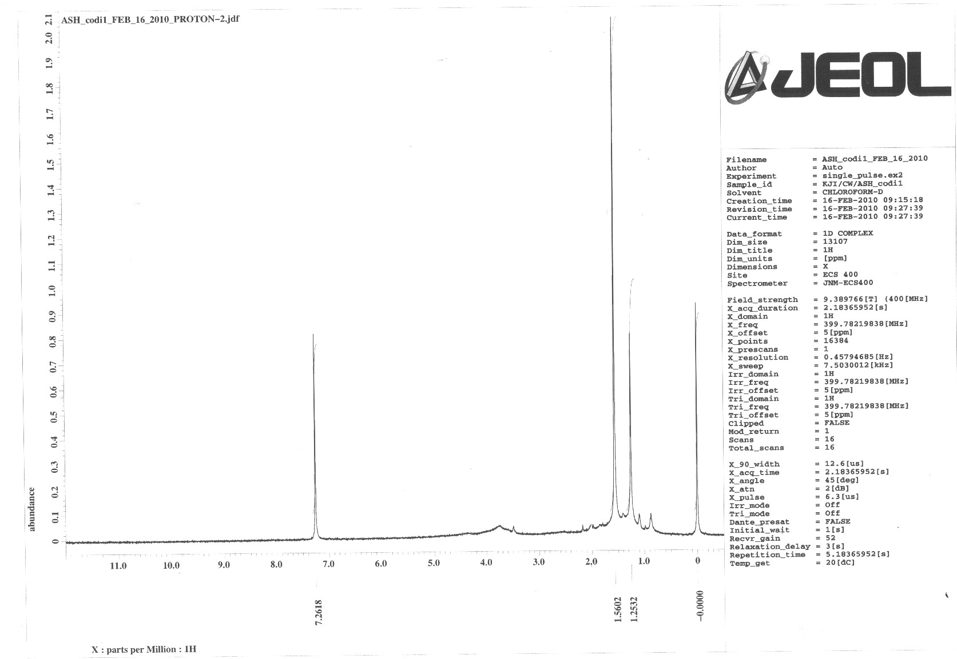

Fig.(8) HNMR spectrum of Co complex Fig.(9) HNMR spectrum of Ni complex

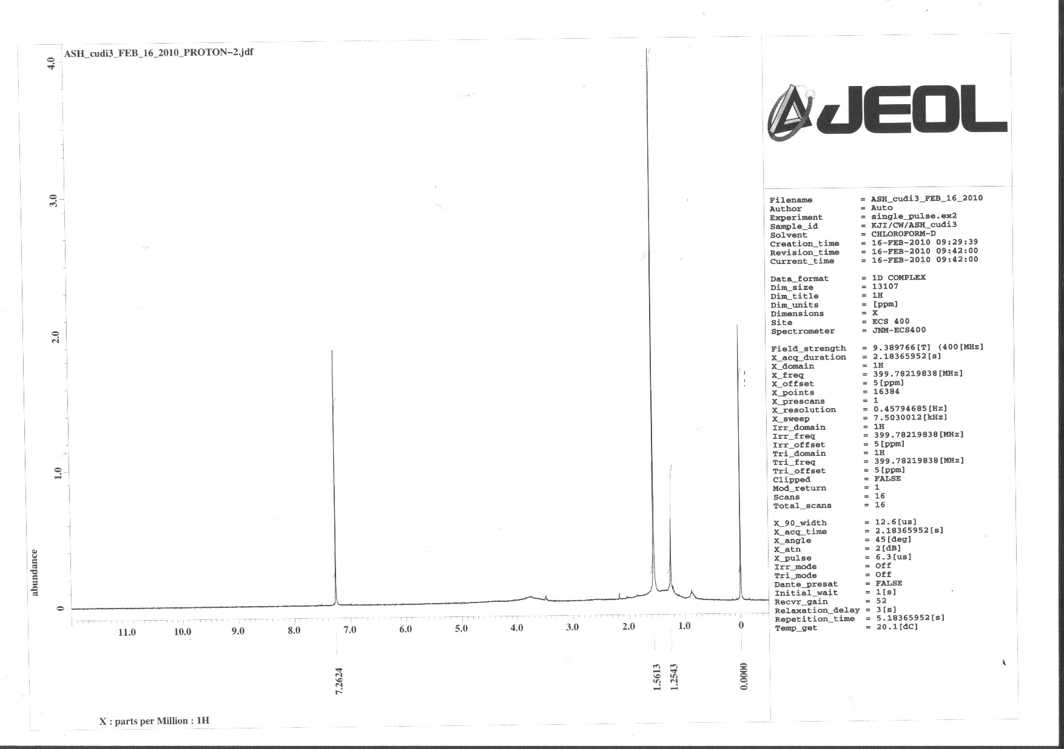

Fig.(10) HNMR spectrum of Cu complex

5- Magnetic susceptibility and molar conductivity
The magnetic properties of the prepared complexes were measured by Faradi method shows the complexes are paramagnetic with (3.73, 2.77, 1.81 BM) due to the existence of three, two and one unpaired electrons for Co⁺², Ni⁺² and Cu⁺² complexes respectively, and the molar conductivity of the complexes was recorded in DMF solvent appears the complexes were electrolyte with 1:1 ratio. Supported with octahedral geometry for complexes.
ACKNOWLEGMENTS
I would like to express of my grateful thanks and acknowledging the Ministry of Higher Education & Scientific Research/ Research and Development for this opportunity which that donate for me and the School of Chemistry, Newcastle University and Prof. Dr. Richard A. Henderson for your efforts and help to carried out this thesis and its measurements.

Table (1) FT-IR SPECTRAL DATA OF THE LIGAND AND THEIR COMPLEXES
COMPOUND | ν(N-H) | ν(N-H₂) | ν(C=N) | ν(C=N) ring | ν(C=C) ring | ν(C-H) aromatic | ν(C-H) aliphatic
Ligand | 3325 | 3206 | 1678 | 1632 | 1575 | 3089 | 2967
[Co L NO₃]NO₃ | 3353 | 3160 | 1623 | 1565 | 1512 | 3056 | 2981
[Ni L NO₃]NO₃ | 3345 | 3156 | 1652 | 1606 | 1548 | 3020 | 2981
[Cu L NO₃]NO₃ | 3256 | 3161 | 1624 | 1566 | 1513 | 3030 | 2976

References
- C. Bianchini, G. Giambastiani, L. Luconi, A. Meli, Coordination Chemistry Reviews,2010, 254, 431–455.
- D. M. Haddleton, C. Waterson, P. J. Derrick, C. B. Jasieczek, A. J. Shooter, Chem. Commun., 1997, 683.
- T. V. Laine, K. Lappalainen, J. Liimatta, E. Aitola, B. Löfgren, M. Leskelä, Macromol., Rapid. Commun., 1999, 20, 487.
- T. V. Laine, U. Piironen, K. Lappalainen, M. Klinga, E. Aitola, M. Leskelä, J. Organomet. Chem., 2000, 606, 112.
- F. A. Cotton, G. Wilkinson, C. A. Murillo, M. Bochmann , "Advanced Inorganic Chemistry", vol. 1, 6th ed., Wiley, New York, 814. 1999
- R. Morassi, L. Sacconi, J. Chem. Soc. A , 1971, 492.
- K. Dhara, K. Sarkar, P. Roy, M. Nandi, A. Bhaumik, P. Banerjee , Tetrahedron, 2008, 64, 3153-3159.
- E. Brunet, O. Juanes, J.C. Rodriguez-Ubis, Curr. Chem. Biol., 2007, 1, 11.
- E. G. Moore, A. P. S. Samuel, K. N. Raymond, Acc. Chem. Res., 2009, 42, 542.
- K. W. Y. Chan, W. T. Wong,, Coord. Chem. Rev., 2007, 251, 2428.
- S. K. Mittal, S. K Ashok Kumar, Indian Journal of Chemistry, 2008, 47A, 1676-1680.
- T. E. Kokina, R. F. Klevtsova, L. A. Glinskaya, E. G. Boguslavskii, and S. V. Larionov, Russian Journal of Coordination Chemistry, 2010, l.36(1), 53-50.

- Yu. G, Shtyrlin, A. R., Garifzyanov, and V. F., Toropova, "Zh. Obshch. Khim.," 1987, 57(9), 2008.
- I. A., Kakovskii, B. A., Stepanov, O. F., Ryazantsev, and N.V., Serebryakov, Zh. Fiz. Khim., vol. 33, No. 8, (1959)
- R. M. Silverstein, and G. C. Bassler “Spectrometric Identification of Organic Compounds”.6th. ed., John Wiley and Sons (1998).
- K.Nakamoto, "Infraredspectra of inorganic and coordination compounds" 4th edition. Wiley, intr., New York (1996).
- A. B. P. Lever, “Inorganic Electronic Spectroscopy 2nd Edition”, New York (1984).
- N. Sarikavakli, G. Ierz, Turk. J. Chem., 2005, 7-115 .

