Theoretical study for degradation of Captan in gas phase Using DFT

S. N. Naman B.R.J. Muhyedeen
College of Science, Dohuk University College of Science, Baghdad University
A.A.Drea
College of Science, Babylon University

(NJC)

(Recevied on 27/3 /2011 ) (Accepted for publication 27/9 /2011)

Abstract
Captan Photodegradation have been theoretically studied in gas phase through reacting with hydroxyl free radical simulating their degradation in aqueous solution using UV light and some oxidants. Quantum calculation likes Semi-empirical and ab initio and DFT have been carried out by using two reliable well-known programs Hyperchem7.5 and Gaussian03W. Chemical reactivity, activation energy and rate constant of cleavage reaction step are calculated for Captan . Total energy, heat of formation and vibration spectrum has been calculated for all reaction components that is probable to be formed during the complete degradation of Captan into essential minerals.
The activation energy of peroxide dissociation into its two moieties of hydroxyl radical is equal to 224.304 kJ mol-1.
The first degradation reaction step of Captan is endothermic reaction have been carried out through nitrogen-sulphur bond to give up three major component THID, SCCl₂ and OCl*. The activation energy of this reaction step is 406.852 kj.mol⁻¹. Rate constant of cleavage step reaction is 2.50 x 10⁸ s⁻¹. Enthalpy change value of overall reaction for Captan is -109089.432 kj.mol⁻¹. Forty one moles of hydroxyl radical are needed to convert Captan completely into simple moieties produced from this reaction like H₂CO₃, H₂O, H₂SO₄, HOCl, H₂, NH₃ and OCl*.
Keyword :
- pesticides
- DFT
- photodegrdation
- Captan
- theoretical calculations .
الخلاصة
تم دراسة التكسر الضوئي للكابتان نظريا في الطور الغازي بوساطة التفاعل مع جذر الهيدروكسيل الحر ,محاكاة لتفاعل التكسر الضوئي في المحلول المائي بوساطة الأشعة فوق البنفسجية وبعض المؤكسدات.
أجريت حسابات الكم ,مثل الحسابات الشبة التجريبية والحسابات الأولية الأساسية وحسابات نظرية الكثافة الوظيفية المحملة ضمن البرنامجين هايبركم 7.5 وكاوسين 03. تم احتساب الفعالية الكيميائية وطاقة التنشيط وثابت معدل سرعة تفاعل خطوة التجزيء الأولى. احتسبت الطاقة الكلية وحرارة التكوين والطيف الاهتزازي لجميع مكونات التفاعل التي ان تتكون خلال تفاعل التجزيء الكامل للكابتان إلى المواد الأساسية.
وجد من خلال الدراسة ان حاجز الجهد لتفكك البيروكسيد إلى جذري هيدروكسيل يساوي 224.304 كيلو جول لكل مول واحد. إن الخطوة الأولى لتجزيء الكابتان هو تفاعل ماص للحرارة ويتم من خلال الآصرة الرابطة بين ذرتي الكبريت والنيتروجين لتكون بذلك ثلاث مكونات رئيسية وهي THIDو SCCl₂ و OCl* . إن طاقة حاجز الجهد لهذه الخطوة تساوي 406.852 كيلو جول لكل مول واحد وبثابت سرعة تفاعل مقداره 2.50^{x}10⁸ ثانية⁻¹ .إن قيمة التغير في المحتوى الحراري للتجزيء التام للكابتان يساوي 109089.432 - كيلو جول لكل مول واحد. يلزم إحدى وأربعون مول من جذر الهيدروكسيل لتحول جزيئة كابتان واحدة الى مواد كيميائية ابسط تركيبا لتنتج من هذا التفاعل مثل H₂CO₃و H₂Oو H₂SO_{4و}, HOClو H₂و NH₃ و OCl*..
الكلمات المفتاحية:
- نظرية الكثافة الوظيفية
- التجزيء الضوئي
- الكابتان
- الحسابات النظرية
- طرق ميكانيك الكم

Introduction
Pesticides constitute major pollutants of aquatic environment, and their presence is of cretin concern because of their potential toxicity towards animals and human being. They are only partially eliminated by biological and chemical degradation⁽¹⁾. Presently, several hundred pesticides of various chemical natures are used all over the world for agricultural and non-agriculture purposes. Many of these pesticides are utilizing in amounts over 50 ton/year⁽²⁾. Relatively high pesticides contamination levels are found in ground waters and surface water: 0.1—0.3 µg/L in US ground waters, and 0.03-0.5 µg/L in European ground waters. To protect the quality of drinking and surfaces waters, priority lists of pesticides discharged in the aquatic environment have been established by the European community with very drastic tolerance limits⁽³⁾. Therefore, there is an increasing interest in the developments of simple cheap and rapid methods for the destruction of organic pesticides in water.
Photochemical reactions have been extenensively used directly and indirectly for pesticides degradation. Direct photodecomposition processes can be used whenever organic pesticides absorb light sufficiently in the UV region (250-300nm)⁽⁴⁻⁶⁾.
Captan is synthetic chemical fungicides. It belongs to the group's related chemicals called "Phthalimides"⁽⁷⁾. Half-life, assuming a quantum yield of 1 and using experimental extinction values, was estimated to be about 880 days⁽⁸⁾. Metabolism of Captan in goats and hens proceed by cleavage of the N-S bond to form THPI and a derivative of the -SCCl₃ side chain. THPI and -SCCl₃ undergo further metabolism through independent pathways. The carbon of the side chain becomes incorporated into Thio-Tri Chloro Methan TTCM and natural products. The cleavage partner THPI is oxidized to form THPI epoxide which is subsequently hydrolyzed to form 4,5-diOH THPI, or hydroxylated at the cyclohexene ring to form 3-OH and 5-OH THPI. The hydrolysis of THPI and its hydroxylated derivatives results in the formation of the corresponding THPAM derivatives. In apples, tomatoes and lettuce most of the residue was presence on the surface of the leaves and fruit, mainly as unchanged captan. Metabolism in the plants includes cleavage of the thio-indole bond to form THPI and derivatives of the -SCCl₃ side chain. Half-life of [trichloromethyl-¹⁴C] captan in Greenville sandy loam soil exposed to sunlight was 15 days while the half-life for the dark control soil was 20 days⁽⁹⁾. Photochemical half-life was estimated to be 54 days. Most of the radioactivity was accounted for as captan and carbon dioxide, with the remainder present as bound residues and unidentified compounds. In irradiated samples on day 21 captan accounted for 36-40%, ¹⁴CO₂ for 49-51%, bound residues for 7%, acid-released residues for 2-5% and unidentified residues for 1.4% of the applied radioactivity. In dark control soil samples captan accounted for 50-56% and ¹⁴CO₂ for 33-40% of the applied radioactivity. The natural sunlight photolysis of [cyclohexene-¹⁴C] captan at 25°C have been studied on the surface of Greenville sandy loam soil treated at 4.48 kg ai/ha ⁽¹⁰⁾. The half-life’s for photolysis were 130 and 236 hours for the light and dark conditions respectively, resulting in an estimated photochemical half-life of 287 hours. Products present at >3% were identified by HPLC and TLC. The major components formed under both light and dark conditions were THPI, THPI epoxide , THCY, THPAM and THPAL.
The aim of the present work tend to study the reaction of Captan with hydroxyl radical theoretically through the quantum calculation treatments of the electronic and geometrical structure of this pesticide with their reliable transition states , also to find out a reasonable mechanism of photodegradation reaction in gas phase.
Theoretical Part
DFT, ab initio and PM3 methods have been used for evaluation of electronic energies, heat of formation and electrostatic potential of Captan and OH*. The geometries of fifteen intermediates and final molecules have been optimized at /6-311++G(2df,2p) (5d,7f) and PM3 level. Polarized spilt valence 6-311++G(2df,p) and 6-311++G(d,p) basis functions were employed for HF calculation while B3-LYP was used for DFT calculation. Single point MP2 calculation were performed on the optimized structures using 6-31G(d), 6-311G(d), 6-311++G(d,p) and 6-311++G(2df,2p) for high accuracy. The Polak-Ribiere method was used for optimization algorithm. The initial guess of the molecular orbital coefficients was from a projected Hückel, INDO and Harris calculation ⁽¹¹⁾.
Theoretical vibrational frequencies of large molecules were carried on at PM3 method while the IR H₂O₂ have been calculated at MP2/6-311++G(2df,2p) (5d,7f) level in addition to calculation of zero point energy, ZPE, to compute the relative quantum mechanical energies. Theoretical ultraviolet and visible spectra are also calculated at configuration interaction, CI (10x10), level using 6-31G(d) basis sets. PM3 and ZINDO/S are also used for calculation of UV/VIS spectra of the copper and nickel complexes. HyperChem 7.52 was used for these calculations in addition to MOPAC2000 program ⁽¹²⁾ .
Rate constant calculation using RMP2/6-311++g(2d,2p)//RHF/6-31G(D) . Also PM3 method has been used for IR, UV, and Transition state calculation⁽¹³⁾.
Results and Discussion
Hydroxyl radical has single unpaired electron at oxygen atom, which involved from hemolytic of O—O bond in peroxide or O—H bond of water. Hypothetically, one may generate the hydroxyl radical by simulation of photochemical reaction of peroxides molecules in gas phase. Peroxide hemolytic products consisted from two OH* radical's moiety. The geometry parameters obtained from the calculation of O—O bond length is 1.4024 ^{ο}A. The angle of H-O-O bond is 101.264 ^{ο} and the torsion angle of atoms H-O-O-H is built to 90º but the equilibrium value became 112^{ο} which calculated by MP2 6-311++G(2d,2p). Other methods from G03W⁽¹⁴⁾ gave similar or higher values as shown in table 1. Of course the most reliable quantum method, CBS-Q, gave 123.777 A°.
Different calculation methods can be used to estimate the energetic properties of hydroxyl radical as shown in Table 2. The physical properties of peroxide calculated at MP2 6-311++G(2d,2p) level of theory has been shown below in Figure 1.

Table 1. estimate the bond torsion angle of peroxide molecule using different calculation methods of G03W program .
Method | torsion angle of O—O bond (A°)
CBS-Q | 126.777
G2 | 121.197
MP2(Full)/6-311++G(2df,2p) | 115.293
MP2(Full)/6-31++G(d,p) | 121.371

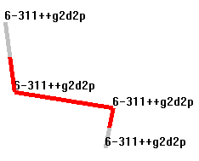 | 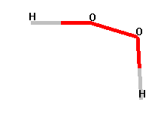
A-Basis set function of calculation | B-Bond Type
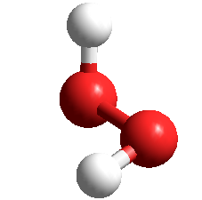 | 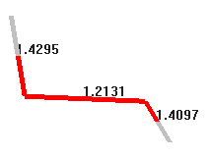
a-Ball and stick view | b-bond order
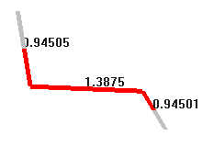 | 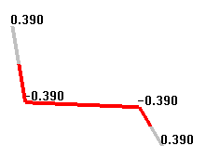
b-bond length( A°) | c-Atomic Charge (coulomb)

Figure 1. Physical properties of peroxide calculated at MP2-6-311++G(2d,2p) level of theory.

Table 2. Energy and IR frequencies calculations of H₂O₂ at different theoretical methods using G03W.
Method | Energy  kJ mol⁻¹ | *IR- wave No (cm⁻¹) | **IR-Intensity km mol⁻¹
CBS-Q | -633.340 | 371.2188 1144.7134 1492.5602  1671.5184 4103.3726 4106.4137 | 280.21 2.44 118.32  0.571 17.53 80.33
MP2/6-311++G(2df,2p) (5d,7f)* | -633.311 | 395.3719 936.6880 1345.5774  1457.0925 3824.1276 3824.7258 | 189.45 0.823 110.28  0.089 19.98 71.56
MP2/6-311++G(2d,2p)//UHF/6-1G(d,p) | -632.955 | - | -
G2MP2 | -633.281 | - | -
*Normal Mode Frequencies of Vibration in ( cm⁻¹). **Integrated Infrared Band Intensities in( km mol⁻¹).

The theoretical spectrum of vibrational frequencies of H₂O₂ calculated at MP2/6-311++G(2df,2p) (5d,7f)* can be displayed in Figure 2.

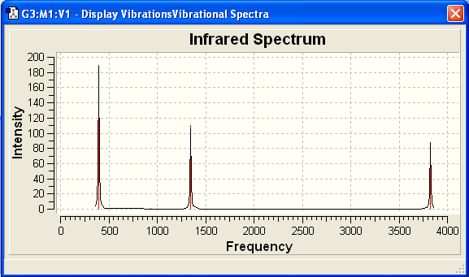
Figure 2. IR frequencies calculated at MP2/6-311++G(2df,2p) (5d,7f)*

The stability of O—O bond calculated from potential energy surface is approximately equal to -395931.92 kJ mol⁻¹ which can be broken down at 2^{ο}A . Figure 3. illustrates potential energy curve of this bond calculated at MP2/6-31++G**level of theory using HyperChem 7.52.

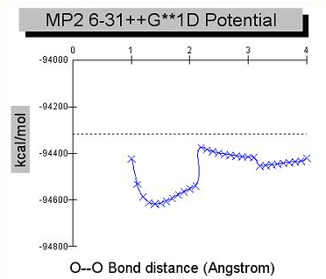
Figure 3. Potential energy of O—O bond in peroxide.
KJ mol⁻¹

The proposed reaction in gas phase is suggested as follow:
H₂O₂ 2 OH* (1)
The energy barrier of this reaction is equal to 224.304 kJ mol⁻¹, calculated at configuration interaction of four occupied with one unoccupied ⁽¹⁵⁾orbitals PM3/CI(4x1) level of theory. Also the energy barrier of this reaction equal to 258.295 kJ mol⁻¹ at HF/6-31G* level of theory according to transition state pathway. The corresponding wavelength for this energy barrier 224.304 kJ mol⁻¹ is equal to 533.84 nm. These results are in good agreement with experimental energy value 214.605 kJ mol⁻¹ in literature.
Of course, this value of wavelength from Tungsten lamp is very useful for this gas phase reaction. The oxygen atom and hydrogen atoms have equal opposite charges as shown in Figure 4. the oxygen and hydrogen atoms have charges of -0.336 and 0.336 C respectively. Hydroxyl radical can pass into free radicals reaction mechanism through an appositive electrostatic potential to form an transition state⁽¹⁶⁾ , that’s tend to be in minimum energy either by decomposition into fragments, or rearrangement side reactions.

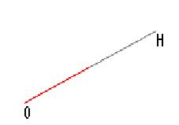 | 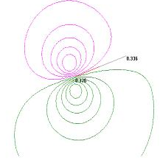
A-Atomic Symbol | B-Electrostatic potential various 2D
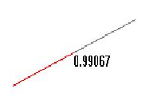 | 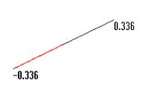
C-Bond Length (A°) | D-Atomic Charge(coulomb)
Figure 4. Physical properties of Hydroxyl radical.

Electronic Features of Captan
Energies and geometries of molecules have a clear relationship to chemical phenomena. Other quantities, such as atomic charge, electrostatic potential and bond length are less defined but provide useful qualitative results. The total energy in a molecular orbital calculation is the net result of electronic kinetic energies and the interactions between all electrons and atomic course in the system⁽¹⁷⁾. The geometry optimization of Captan molecules have been calculated at MP2/6-311++G** level of theory as shown in Figure 5. The atomic charge of the reactive atoms, which are possibly sharing in the reaction, that’s atoms of carbon, nitrogen, and oxygen have a negative charge and the atoms of sulphur, chlorine, and hydrogen have a positive charge. It could be expected that the negative charge of oxygen of hydroxyl radical can attached to the positive charge atoms in Captan molecule, and same opposing thing for positive hydrogen atoms at hydroxyl radical. The total surface potential energy of free Captan is -610749.053 kJ mol-1 calculated at MP2/6-311++G** Level of Theory.

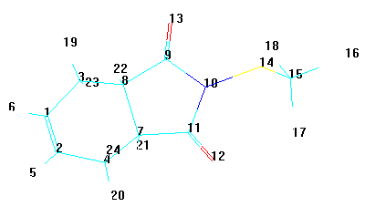 |  | 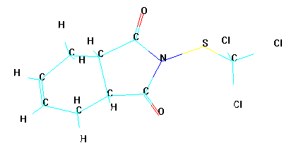
A-numbers of atoms |  | B- symbols of atoms
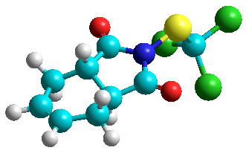 | 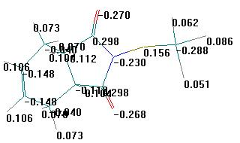
C-Ball and cylindrical view | D-Atomic charge C
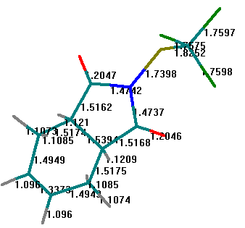 | 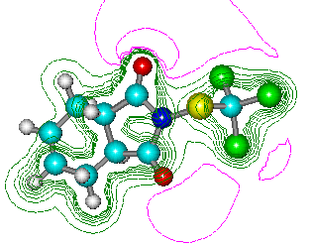
E-Bond length (A°) | F-Electrostatic Potential
Figure 5. Physical properties of Captan calculated at MP2/6-311++G** level of Theory.

Bond strength from PES (Potential Energy Stability) has been measured⁽¹⁸⁾ for the main important bonds. Figure 6. illustrates the stability of N₁₀—S₁₄ bond, and S₁₄—C₁₅ bond. The S₁₄—C₁₅ is more stable rather than N₁₀—S₁₄ bond, because the first bond can be broken down at longer length. It has needed more potential energy. The torsion of bond gives us a clear view⁽¹⁹⁾ about the stability of bond S₁₄-C₁₅ . They were the torsion value of N₁₀-S₁₄-C₁₅-Cl₁₇ angle is 61.2^{ο}, and torsion angle of C₁₁-N₁₀-S₁₄-C₁₅ is 97.2^{ο}. Another evidence for the cleavage reaction step begins from N₁₁-S₁₄ bond.

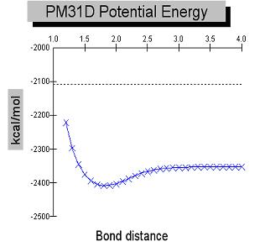  KJ mol⁻¹ | 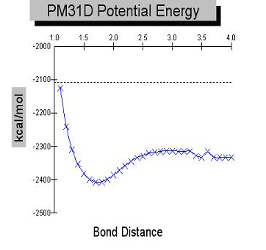  KJ mol⁻¹
A-N₁₀—S₁₄ Bond potential | B-S₁₄—C₁₅ Bond Potential
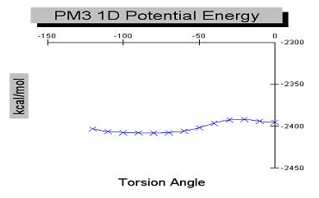  KJ mol⁻¹ | 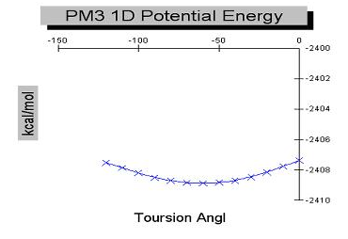  KJ mol⁻¹
C-Torsion Angle of N₁₀-S₁₄-C₁₅–Cl₁₇ is 61.2 ^{ο} | D-Torsion angle of C₁₁-N₁₀-S₁₄-C₁₅ is 97.2^{ο}.
Figure 6. Potential energy stability of main bonds in Captan .

Chemical Reactivity of Captan
Investigation of the chemical reactivity has been carried out through the studying interaction between charges favours reaction between sites (on the two species) that have extreme charge values⁽²⁰⁾ . The most positive charge interacts with the most negative charges, so that calculations of the atomic charge and molecular orbital have been carried out in order to predict the active site ⁽²¹⁾of reaction in the Captan molecules toward hydroxyl radical.
Thermodynamics force factors oriented the reaction to produce the most stable product, which usually take place in one-step⁽²²⁾. Negative atoms of hydroxyl radicals attached with opposite charges atoms in Captan. Figure 7. described the total change in electronic features of Captan through reaction with hydroxyl radical. The overlap interaction investigation of electrostatic potential for both reactant and also the most original electronic properties were changed. The net atomic charge of oxygen and hydrogen atom in hydroxyl radical is changed from-0.336, 0.336 into-0.714, 0.239 C respectively. The same thing occurred to Captan atoms, was atomic charge of N₁₀, S₁₄, C₁₅, and Cl₁₇, that’s which changed from -1.015, 0.599,-0.540, 0.073 into -0.657, 0.148,-0.375,-0.017 respectively and so on for the rest atoms. Bond length of N₁₀—S₁₅ bond, S₁₄—C₁₅ bond, and C₁₅—Cl₁₇ bond in Captan was also changed from 1.6727, 1.8228, 1.7863 into 7.8368, 1.6166, 4.3416 ^{ο}A respectively. Bond length of hydroxyl radical has the same behaviour were bond length of O—H bond was changed from 0.9907 to 2.0306 ^{ο}A. Initial assumption from the above data, those oxygen atoms of hydroxyl radical has preferred to attach to Cl_{17,} S₁₄ in large ratio than other active site in Captan. Hydrogen atom of hydroxyl radical has preferred to attach to N₁₀, C1₅ in large ratio than other active site in Captan molecule.

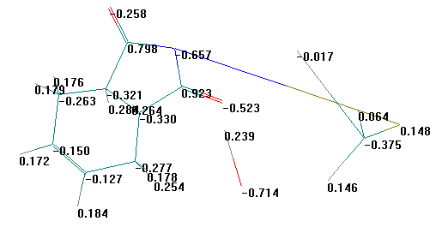
A- Interaction of atomic charge C.
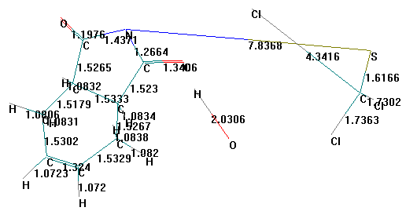
B-Bond length Interaction Bond length (^{ο}A).
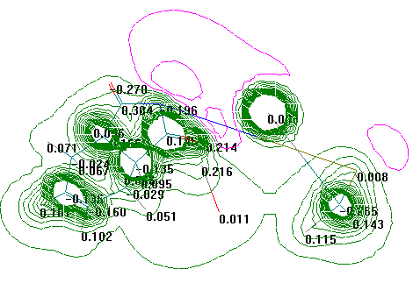
C-Interaction of Electrostatic Potential .
Figure 7. Electronic features interaction of Captan with hydroxyl radical through the transition state calculated at MP2/6-31+G** Level of Theory.

Reaction of Captan with Hydroxyl Radical
The reaction of Captan with hydroxyl radical may be complicated due to several factors. There are different possibilities for hydroxyl radical to attach at more than one active site in Captan. the conditions of reactions are like the influence of H₂O₂, semiconductor, sensitizer, temperature, and intensity of UV-light. All these factors may have an important rule in the transition state formation of reaction mechanism. Only one radical initiate the degradation reaction through cleavage rate determining step one. By taken into account the above results, one may derive some reasonable transition state, which will be responsible for First Degradation Step.
Proposed Transition States
Five different transition state have been proposed, that may be one of these which will give us the real path of degradation Figure 8. shows the geometries stick view of these states.
The prediction depends on different attachments to the possible sites in Captan for hydroxyl radical to interact with. These sites are N₁₀, S₁₄, C₁₅, Cl₁₇, and O₁₂, or O₁₃. All five proposed Transition state structures have been studied through optimization their geometries and calculation of their vibration spectra. Table 3. describes the features of these states with their imaginary frequencies. Bond length of N₁₀—S₁₄, and S₁₄—C₁₅ bond have the same ratio of length difference relatively to the interaction structure of Captan with radical, the others have abnormal bond length which are expected to yield cleavage through N₁₀—S₁₄ bond.
The investigation of these five transition states have been carried out through the theoretical calculation. Only TS₁ was real TS structures due it is the first negative frequencies. Potential energy surface of TS₁ has a minimum value -326471.746 kJ mol⁻¹ than other state. Zero point energy calculation estimation of both TS₁ has higher ZEP value than other states, which tends to be has low value of activation energy than others transition states⁽²³⁾. Theoretical vibration spectra have calculated for these structures to identify transition state structures. Structure with one negative frequency is transition state structure, the structure with more than negative one frequency is hilltop structure⁽²⁴⁾.

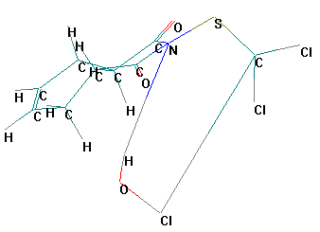 | 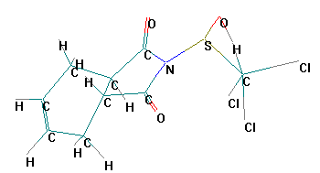
A-TS1 | B-TS2
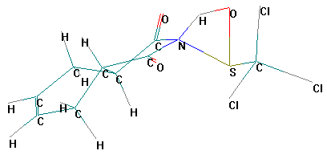 | 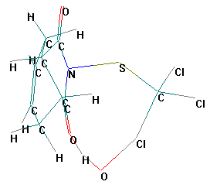
C-TS3 | D-TS4
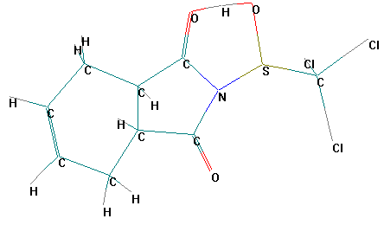
E-TS5
Figure 8.Geometries in wire form view of five proposed transition states for Captan cleavage through N₁₀—S₁₄ bond, Calculated at MP2/3-21G** level of theory.

Table 3. Optimized Geometry and Vibration spectrum of proposed Transition state for Captan reaction with Hydroxyl radical Calculate at 3-21G** level of theory.
TS | R(N₁₀-S₁₄)  A^{ο} | R(S₁₄ –C₁₅)  A^{ο} | PES  kJ mol⁻¹ | ZPE  kJ mol⁻¹ | Imaginary  Frequency
1 | 1.744 | 1.716 | -326471.746 | 450.939 | -
2 | 1.698 | 2.115 | -32621.099 | 437.950 | +
3 | 1.740 | 1.818 | -326020.961 | 447.450 | +
4 | 1.791 | 1.851 | -325804.314 | 429.199 | +
5 | 1.692 | 1.826 | -32619.117 | 436.057 | +

From the above evidence, the first degradation reaction step pass through TS1 structure ,scheme1. represent the suggestion reaction as follow:-

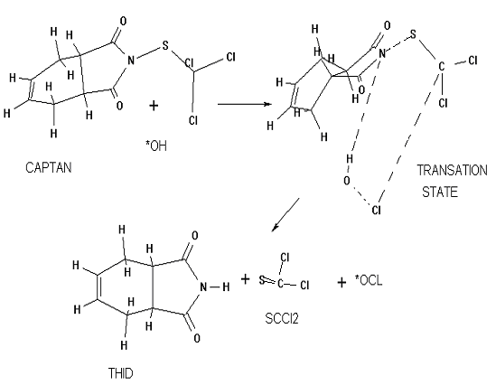

Scheme 1. Suggested first cleavage step of Captan .

The equation of this reaction can be written as in the following:
Captan + OH* → THID + SCCl₂ + OCl* (2)
∆H_{reaction} = 104.591 kJ mol⁻¹

The energy barrier (Activation Energy) of this reaction is 406.856 kJ mol⁻¹ (294.284 nm), and the enthalpy change formation of this reaction is 104.591 kJ mol⁻¹calculated by CI –PM3 methods.
Reaction rate of the cleavage step can be calculated according to Arrhenius equation by using G03W program, which is used to calculate the thermodynamic properties of reaction component. Table 4. represented the thermodynamics values of reaction component. The enthalpy change of reaction is equal to ∆H_{298.15K}= 78.102 kJ mol⁻¹. The Gibbs free energy of reaction is equal to ∆G_{298.15K}= 19.376 kJ mol⁻¹. reaction rate, K value is equal to 2.50 x 10⁸ s⁻¹.

Table 4. thermodynamics calculation of Captan cleavage reaction components, using G03W program.
Reaction components | Sum of electronic and thermal Enthalpies ∆H_{298.15K}( Hartree)* | Sum of electronic and thermal Free Energies ∆G_{298.15K} (Hartree)
Captan | -2325.377825 | -2325.436450
OH* | -75.369868 | -75.390067
THID | -512.205648 | -512.247980
SCCl₂ | -1354.285387 | -1354.319100
OCl* | -534.226911 | -534.252057
* 1Hartree = 627.5095 kJ mol-1

Reactions of THID with Hydroxyl Radical
Extensive calculations have been achieved on this pathway to discover the probable path for the reaction that may take place to complete the degradation of THID molecule. The suggestion of some structures based on chemical intuition as well as for the above data. A high level of ab initio calculation has been used for these reaction steps of THID with more than one hydroxyl radical.

The energy calculations of the relative stability and the equilibrium structures of these possible configurations will enable us to deduce the other reactions which are taking place to complete the cleavage reaction step.
Hydroxylation process may take place at different possible site of Captan molecule. All these subside reactions may face the same cleavage reaction step, to produce the hydroxylated products towards the complete degradation. The theoretical vibration spectra were used for the proposed structures to identify the nature of each structure whether it is a transition state, hilltop or intermediate structure.

Subside reactions have produced several compounds. These compounds may inter further reactions to produce other different products. Full optimized geometries of the structures obtained from the subside reaction are calculated. To estimate the reaction possibility to take place within the cleavage step, the calculations of the activation energy of reaction barrier and enthalpy changes for these reactions were carried out. There are some parallel reactions which differ in activation energy barrier. The lowest activation energy reaction will occur at high probability with high yielding percent. Other reactions will have small probability and so on for yield percentage. The over all mechanism of THID can be summarized into four main reactions as in following equations.

THID + 13*OH →TOHA + 2H₂CO₃ + NH₃ +4H₂O + H* (3)

∆H _{reaction} = -3540.895(kJ mol⁻¹)

TOHA + 7*OH + H* → 4H₂CO₃ + 2*CH₃ (4)
∆H _{reaction} = -1521.902(kJ mol⁻¹)

2 x {*CH₃ + 5*OH → 2H* + 2H₂O + H₂CO₃} (5)
2 x (∆H _{reaction} = -86.092(kJ mol⁻¹))

2 x {H* + H* → H₂} (6)
2 x (∆H _{reaction} = -492.042 (kJ mol⁻¹) )
THID + 30 *OH → 8H₂CO₃ + 8H₂O + 2H₂ + NH₃ (7)
∆H_{reaction}= -6219.06 kJ mol⁻¹
Equation 7 represents the over all degradation reaction of THID.

Reactions of SCCl₂ with Hydroxyl Radical
Several assumptions have been achieved on this pathway to discover, what probabilities for the reactions are, that may take place to complete degradation of SCCl₂. Some structures were suggested that’s based on chemical intuition as well as on the above data. A high level of ab-initio calculation has been used for these reaction steps of SCCl₂ with more hydroxyl radicals to produce simple chemical moieties. These moieties may inter further reactions to produce another different product. Full optimized geometries of the structures obtained from the subside reaction are calculated at MP2/6-31(2d,2p) level.
The over all mechanism of SCCl₂ can be summarized into four main reactions as in following equations:-

SCCl₂ + 3 *OH → (HO)₂-C-Cl₂ + HO-S * (8)
∆H _{rea} = -482.164 (kJ mol⁻¹)

(HO)₂-C-Cl₂ + 3*OH → 2HOCl + H₂CO₃ + H* (9)
∆H_{rea} = -101065.168 (kJ mol⁻¹)

HO-S * + 4*OH → H₂SO₄ + H₂O + H* (10)
∆H_{rea} = -664.377 (kJ mol⁻¹)

{H* + H* → H₂} (11)
∆H _{rea} = -492.042 (kJ mol⁻¹)

SCCl₂ + 10OH*→ H₂SO₄ + H₂CO₃ + 2HOCl + H₂O +H₂ (12)
∆H_{rea} = -102871.116(kJ mol⁻¹)

Equation 12 represents the over all degradation reaction of SCCl₂.

Overall reactions of Captan with hydroxyl radical
Degradation reactions of Captan in gas phase by hydroxyl radicals can be generalized into three main steps. First step is the cleavage step of Captan equation2, which is endothermic reaction to produced main degraded components. These components will be degraded as in equation 7, and equation 12 to represent the step two and step three respectively. By combination, the last two exothermic reaction steps with first step to produce general equation for Captan degradation as following:-

Captan + 41*OH →9H₂CO₃ +9H₂O +H₂SO₄ +2HOCl +3H₂ +NH₃ +*OCl -----(13)
∆H _{overall reaction}= -109090.176 kJ mol⁻¹

The enthalpy change value of overall reaction for Captan degradation indicates that reaction is exothermic reaction, although the first step is endothermic. Finally, simple moieties produced from this reaction like H₂CO₃, H₂O, H₂SO₄, HOCl, H₂, NH₃, and OCl* . The radical OCl* may inter further reactions with H* to produce another molecule of HOCl by energy barrier equal to 9.811kJ mol⁻¹.
CONCLUSIONS
Activation energy of peroxide dissociation into two moles of hydroxyl radical is equal to 224.283 kJ mol⁻¹ ( 533 nm). First degradation reaction step of Captan can be written as in the following equation:

Captan + OH* → THID + SCCl₂ + OCl*
∆H_{reaction} = 104.587 kJ mol⁻¹

The activation energy of this endothermic reaction step is 406.852 kJ mol-1 (294 nm). The calculated rate constant of cleavage step reaction is 2.50 x 10⁸ s⁻¹. The enthalpy change value of overall reaction for Captan is -109090.176 kJ mol⁻¹. Simple moieties are liberated from this degradation reaction according to the following equation:

Captan+ 41OH* → 9H₂CO₃ +9H₂O +H₂SO₄ +2HOCl +3H₂ +NH₃ +OCl*
Abbreviations

FULL NAME STRUCTURE | COde
1,2,3,6-tetrahydrophthalimide | THPI:
cis/trans-3-hydroxycyclohex-4-ene-1,2-dicarboximide | 3-OH THPI
cis/trans-5-hydroxycyclohex-3-ene-1,2-dicarboximide | 5-OH THPI
4,5-dihydroxycyclohexane-1,2-dicarboximide | 4,5diOHHHPI
(cis/trans-1,2,3,6-tetrahydrophthalamic acid)  epoxide7oxabicyclo[4.1.0]heptane3,4dicarboximide | THPAM
Dichloroviyl dimethyl phosphate | DDVP
Moller-Plesset Perturbation Second Version | MP2
Slater- type orbital | STO
Gaussian type function | G
Unrestricted Hartree-Fock | UHF
Restricted Hartree-Fock | RHF
Complete basis set –Quadratic method | CBS-Q
3a,4,7,7a-Tetrahydro-isondole-1,3-dione | THID
Thiophosgen | SCCl₂

References
- J.J.Aaron, and M. A. Oturan. Turk. J. Chem. 2001,25,509.
- D.Barcelo. J.cheromatogr., 1993, 643 , 117 .
- C.Tomlin. "ThepesticidesManual", 10thed.British crop protection Council , Brackwell ,UK (1994) .
- A.Coly ,and J.J.Aaron .Talanta , 1994, 1, 1475.
- A.Coly ,and J.J.Aaron . Anal.Chim .Acta ,1998, 360 ,129.
- L.Patria, N.Merlet, and M.Dore .Environ .Technol., 1995,
16,315 .
- W. L. Biehn . Chevron Chemical Company., 1989, IR-4 PR 3458.
- F.Moffatt. Zeneca Agrochemicals, (Company file: TMN-0363). (1994).
- P.A .Jones. Pan Agricultural Laboratories(TMN-0333).(1988).
- P.A.Jones . Pan-Agricultural(TMN-0330) (1988).
- J. Harris, Phys. Rev. B 31, 1770 (1985) .
- G.Gallais. Makhteshim Agan Report R-11136, R9066 (2000).
- David J. Griffiths . “Introduction to Quantum Mechanics “(2nd ed.). Prentice Hall (2004).
- P. Z. Schaefer,F. Henry ,and E. Kapuy. Chemical Physics Letters.,1993, 203, 195.
- H.E.Dorsett . A review of quantum chemical studies of energetic materials. DSTO Technical Report(1996).
- F. Jensen" Introduction to Computational Chemistry", Wiley ,New York (1999).
- K.I. Samawi,M.Sc.Thesis, AlNahreen Uinv,Iraq(2006) .
- A.Dearing.J.Computer-Aided Molecular Design ., 1988, 2, 179.
- HyperChem6.2usermanuals.HC50-00-03-00, Hypercube, Inc., FLOctober (1996). URL-http:// www. Hyper.com/
- J. B. Foresman , and A.E.. Frisch, "Exploring Chemistry with Electronic Structure Methods", 2/e, Gaussian, Inc., Pittsburgh, Florida(1993).
- A.E.. Frisch, and M. J. Frisch, "Gaussian 98 User's Reference", 2/e, Gaussian, Inc., Pittsburgh, Florida (1998).
- M. J. Frisch, A. B. Nielsen, and A.E. Frisch, "Gaussian 98 Programmer's Reference", 2/e, Gaussian, Inc., Pittsburgh, Florida (1998).
- R. A. Pascal, Jr., R.B. Grossman, and D. Van , J. Am. Chem. Soc.,1987, 109, 6878.
- H.L.Paige, R.J.Berry, R.F.Donald, and M.R.Nyden. Technical Working Conference, May 7-9, Albuquerque, NewMexico, (1996).

