Synthesis of [ N-Ampicilline Amic acids]as Drug Polymers

Firyal M.A.AL-Salami
College of Science, AL-Mustansiriyah University
Abbas N.M.AL-Sharify Khudheyer Jawad Kadem
College of Science, Babylon University

(NJC)

(Recevied on 20/7 /2011 ) (Accepted for publication 30/10 /2011)

Abstract
In this paper two monomers have been prepared such as [N-Ampicilline male amic acid M₁, and N-Ampicilline citraconic amic acid M₂] , from reaction of ampicillin with maleic anhydride or citraconic anhydride at room temperature using dioxane as a solvent.
The two new prepared monomers M₁andM₂ were polymerized by free radical with Azobisisobutyronitrile (AIBN) to their corresponding poly amic acids P1 and P2. Which were converted to their sodium salt polymers P3 and P4 to enhanced their solubility in water.
The physical and chemical properties were studied, the prepared monomers and polymers were characterized by FTIR and UV. spectroscopy, the intrinsic viscosity was measured Ostwald viscometer at 30 ⁰C with DMF as a solvent, the swelling % was calculated and the drug release rate was studied. Experimental results showed that the hydrolysis of ampicilline in alkaline medium was higher than acidic medium.
TG and DTA and DSC Analysis were studied for P1 and P2.
الخلاصة
حضر في هذا البحث المونومرات N- امبيسيلين حامض المالي اميك M₁و N- امبيسيلين حامض الستراكونيك M₂ . من تفاعل الامبيسيلين مع حامض الماليئك او الستراكونيك اللامائي وبدرجة حرارة الغرفة باستخدام الدايوكسان مذيبا.
بلمر المونيمران المحضران M₁ و M₂ بالجذور الحرة باستخدام ازوبيس ايسوبيتيرونايتريلAIBN بادئا, الى البوليمرات المقابلة P₁ وP₂ , ثم حولت الى املاح الصوديوم للبوليمرات المحضرة P₃ و P₄ لتسهيل قابلية الإذابة بالماء .
درست الصفات الفيزيائية للمونمرين المحضرين والبوليمرات المقابلة , شخصت بواسطة استخدام أطياف الأشعة تحت الحمراء والأشعة فوق البنفسجية وقيست اللزوجة الجوهرية باستخدام استوالد فسكوميتر بدرجة 30 مº واستخدام DMFمذيبا,وقيست كذلك درجة الانتفاخ , وقيست سرع التحرر الدوائي للامبيسيلين وكانت في الوسط القاعدي أعلى من الوسط ألحامضي ,درست التحاليل DSC ,DTA ,TG للبوليمرين P1, P2 .
Introduction

Ampicilline (Fig.1) is a semisynthetic antibiotic, a member of the pencilline family of antibiotics, it has been synthesized first in 1961, to extent the usefulness of the pencilline to the treatment of infection caused by gram-negative. Ampicilline is a white crystalline, sparingly soluble in water, acid stable, susceptible to β-Lactam, the half-life of it at pH 6.5 and 25 ⁰C is 39 day ₍₁₎. The ampicilline molecule consists of 6-aminopenicillanic acid (6-APA), connecting to a side chain. The basic structure of the ampicilline is shown below:

Ampicilline has a thiazolidine ring (A) attached to β-Lactam ring (B) that carries a secondary amino group. The 6-APA nucleous is biosynthesized from two amino acids, L-cysteine and D-valine twisted together biogenetically into a cyclic dipeptide. It is very hydrophilic and dose not easily diffuse across the gastrointestinal epithelium, following oral administration and is absorbed from the intestinal tract to produce peak blood level concentrations in about 2 hours. The possession of acyl amin side chain prevents hydrolysis of the β-Lactam ring which kills the bacteria ₍₂₎. It has been noticed that ampicilline exists as zwiter-ion over a wide range of pH range and this leads to significant improvement of its absorption and also affects both spectrum of activity and degree of resistance against pencillinase enzyme. Two successive steps are usually involved in the interaction of a cationic amphiphilic drug with bilayers, namely₍₃₎.
- An electrostatic interaction between the positively charged amino group of the drug and the negatively charged phosphor groups in the phospholipids.
- A hydrophobic interaction of the lipophilic moieties of the drug with the hydrocarbon chains of the fatty acids.
The enzymatic synthesis of semi-synthetic antibiotics is becoming an interesting industrial process, since it reduces the number of reaction steps and decreases the amount and toxicity of west products per kilogram of antibiotic ₍₄₎.
However, in the enzymatic production of amoxilline at 25 ⁰C and pH 6.5, when the maximum yield of antibiotic production is achieved the reaction media is composed of the desired product antibiotic, undesired products (resultant of hydrolysis) and un reacted substrates. The recovery of these biomolecules from bioreactors my involve several methods of extraction and purification performing an important function on the global economic productive analysis of the process. The adsorption of certain β-Lactam antibiotics such a amoxillin, ampicilline, cephalexin and cefadroxyl in aqueous media has been studied using several polymeric adsorbent to extraction and purification of these bioproducts₍₅₋₇₎.
It is well known that changing appropriately some physiochemical properties of polymeric nonaparticles, such as size and surface characteristics, it is possible to modulate their biodistribution parameters. ₍₇₎.
N-Procaine maleamic acid and citracon amic acid were synthesized and polymerized free radically using dibenzoyl peroxide as initiator ₍₈₎ .

Experimental

Materials
Ampicillin was obtained from Sammura Drug Company, Maleic anhydride and Citraconic anhydride were purchased from Merck.
All available chemical reagents were used without further purification.
Instrumental
FTIR spectra were taken on a Shimadizu spectrophotometer. Ultra violet spectra was recorded using Shimadizu UV-VIS recorder over the range500-4000cm⁻¹. Differential Scanning Calorimeter (DSC) study was carried out on a Shimadzu-60 instrument(Japan) at a heating rate of 10⁰C min⁻¹ under air (normal) , temperature range from room temperature up to 500⁰C . Thermogravimetric Differential Thermal Analyzer (DTG). Shimadzu instrument(Japan) at a heating rate of 10⁰C min⁻¹ under air (normal) .
Preparation of N-Ampicilline maleic acid M1 and N-Ampicilline citriconamic acid M2
( 0.051 mole) of maleic anhydride or citraconic anhydride was dissolved in 20ml of dry dioxane in ascrow-capped round bottom flask, the ( 3.35g, 0.01mole) of dissolved ampicillin powder was added gradually .
The mixture was left for 1hr. at room temperature, until the yellowish –white product of N-ampicillin amic acid was obtained, the yield was recrystillized from ethanol,

Table (1)shows the physical properties of M1 and M2 monomers.

Table (1) physical properties of prepared amic acid monomers

No. | R | m.p ⁰C | Color | Yield % | UV. absorption
M1 |  | 65-66 | Yellow | 85 | 200,300
M2 |  | 60-61 | Yellow | 78 | 210,330

Polymerization of M1&M2 freeradically to P1&P2
In a screw capped polymerization bottle, 3g. of N-ampicillin maleamic acid or citracon amic acid was dissolved in 15 ml of dioxane, 0.05% of the monomer weight of Azobisisobuteronitrile was added. The bottle was flushed with nitrogen for few minutes inside a glove and firmly stopped. The yellow solution was maintained at 70 ⁰C. using water bath for 1hr. the reprecipitation of the solution in 50ml of ethanol, The brown residue of polymer was obtained, washed three times with ether, dried in a vacuum oven.

Table (2) shows the physical properties of prepared poly amic acids P1&P2.

Table (2): Physical properties of prepared ampiciline amic acid P1 &P2

Conversion of P1&P2 to their corresponding sodium salts P3&P4.
No. | R | Softening point C⁰ | Color | Conversion  % | Swelling% in ether | Intrinsic viscosity [η]_{in}=dl/g
P1 | H | 190-200 | Brown-yellow | 80 | 6 | 0.80
P2 | CH₃ | 210-220 | Brown-yellow | 84 | 10 | 0.88
Two grams of new prepared polymers P1or P2 were dissolved in 10 ml of water with 5% of NaHCO₃ solution, the salt was formed with concentrated solution, washed the salt with ethanol several times, dried in a vacuum oven.

Studying of Controlled release of drug polymer [10]
A mixture of 50:50ml of dioxane and buffer solution was kept in a cylinder than 100mg. of P1 or P2 were added, kept at 37C⁰ without stirring, release sample was periodically drown with an analysis by UV spectra at 300nm to determine the amount of release ampicilline. A calibration curve was constructed with soft ware built in the computerized UV photometer and the drug controlled release was carried out in different pH values at 37 ⁰C .

Result and discussion
Ampicillin as antibiotic containing NH₂ group which reacts with maleic anhydride as in scheme 1, nucleophilic attack of amino group gave corresponding amic acids M1&M2.
Amic acids are organic compounds containing a carboxylic group and amide group. The new N-Ampicillin amic acids were prepared from reaction of maleic anhydride or citraconic anhydride with drug amine material. The following equation described as in scheme (1) .

The mechanism of ring opening of acid anhydride was illustrated as in scheme (2).

Scheme (2) shows the ring opening reaction of acid anhydride by nucleophilic reaction of NH2 groups of Ampicillin to N-Ampicillin maleic acid or citraconic amic acid.
Physical properties of Prepared amic acids M1 and M2 are listed in table (1). In fact their absorption of the amic acid due to υ(-OH) carboxylic group is appeared at 3500-3000 cm⁻¹, and υ(-NH)at 3250cm⁻¹in addition to the carbonyl group of anhydride peak was disappeared at 1790 cm⁻¹ and 1850 cm⁻¹as in Fig.( 1).
Polymerization of M1 and M2 freeradically by using dibenzoyl peroxide as initiator at 90-95C⁰ as described in equation:-

IR spectra Fig.(2) and Fig.(3) of P1 and P2 polymers were indicated the polymerization by disappearing of vinylic group of the monomer at 1629 cm⁻¹ .The υ(-C=O) at 1720 cm⁻¹ and 1770 cm⁻¹ and the absorption revealed at 3333,3246 cm⁻¹which attributed to υ(-OH) carboxylic group.
These prepared Ampicillin polymers were converted to their corresponding salts with 5% NaHCO₃ solution to enhanced the drug solubility in water, as in P3 and P4.

Polymers which substituted with drug materials are successful for long term drug delivery applications, and highly desirable in those situations because they degrade in the body to biologically inert and compatible molecules, by incorporating drugs in biodegradable polymers, dosage forms that release the drug over a prolong length of time can be prepared in variety of shapes and sizes, No surgical procedure are needed after completion of dosages regime since the remaining polymer wide degrade and get cleared by body. As a result , biodegradable polymers offer a novel approach for developing sustained released drug delivery systems that are simple and convenient to patient. Fig.(4a ) and (4b ) show the effects of pH values on rate of release and profiles of mole fraction of Ampicilline (ratio of the mole of Ampicillin to total moles present in the sample) versus time at pH values (4, 10) in (60:40,V/V) aqueous buffer/dioxane at 30 and 40C⁰.
Release of drug is due to rate of hydrolysis of amide bond, the following mechanism illustrated as follow₍₉₎:-

The UV absorptions for P1 and P2 gave λ_{max} at 200-300 nm and 210-330 respectively due to (n-π*) and (π- π*) electron transitions.
Thermogravimetric analysis TGA , DTA and DSC . indicated the high thermal stability for P2 was decomposed with one step which began at 208.09 ⁰C as shown in Fig(5), and the TG analysis of P1 began weight los 41.39% at 355 ⁰C and its full decomposed at above 765 ⁰C as shown in Fig.(6).

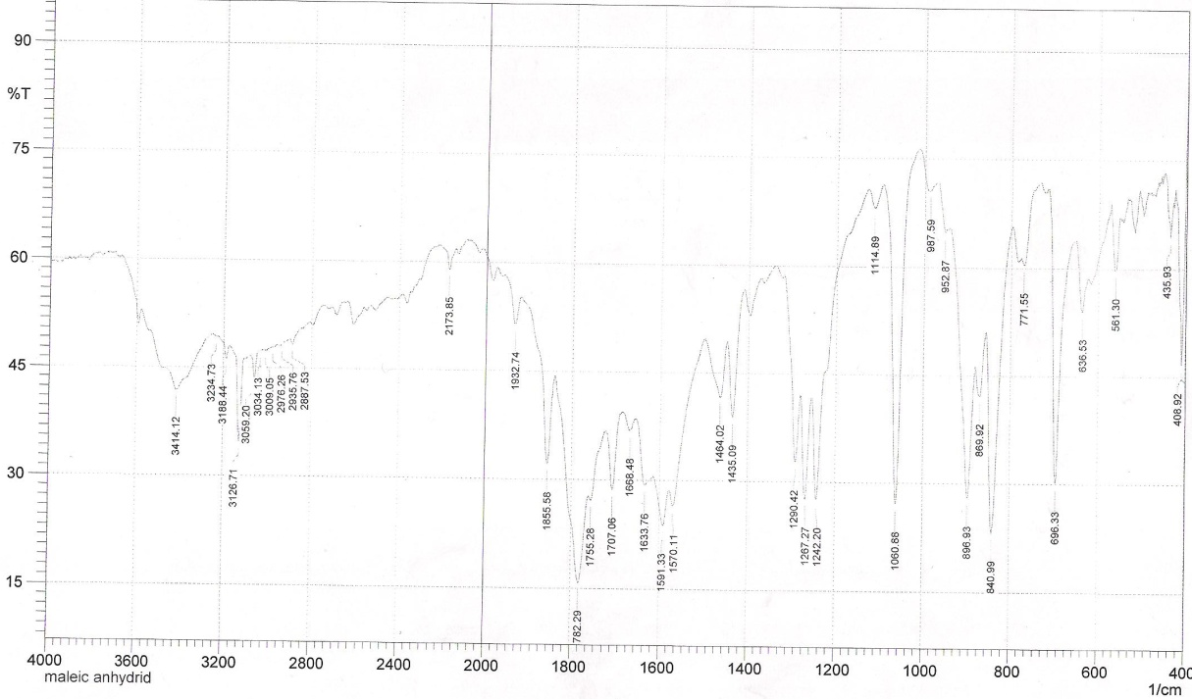
Fig.(1) FTIR spectra of maleic anhydride

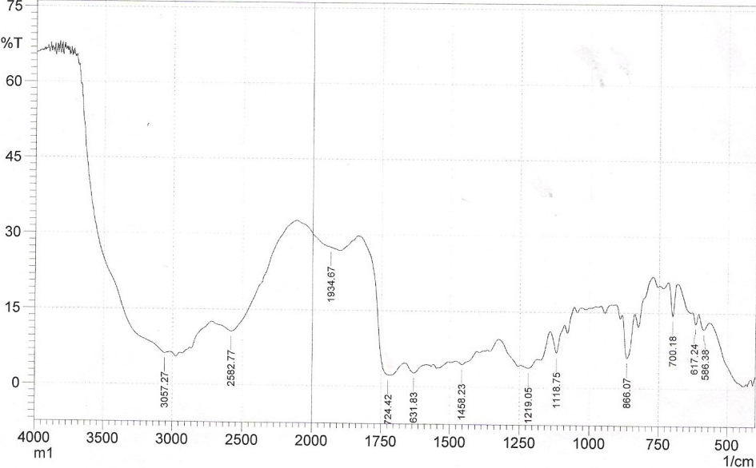

Fig.(2)FTIR spectra of poly( N-Ampicillin maleamic acid)

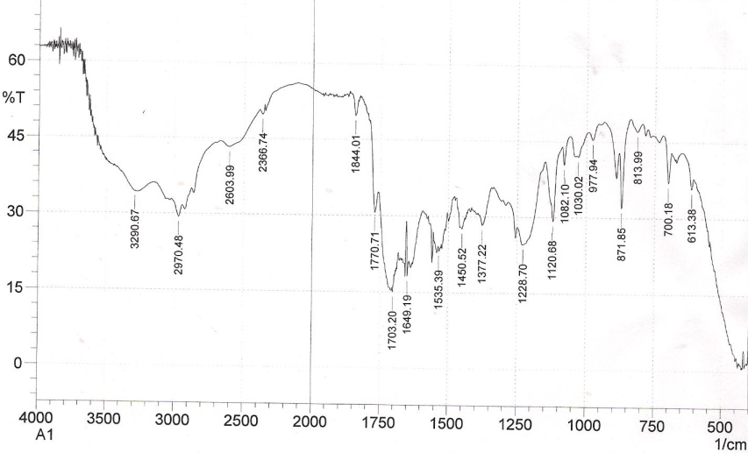
Fig.(3)FTIR spectra of poly( N-Ampicillin citraconic amic acid)
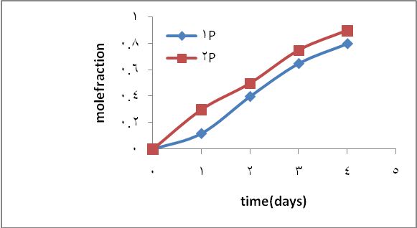

Fig.(4a) Controlled release of P1&P2 at pH10 at37 ⁰C.

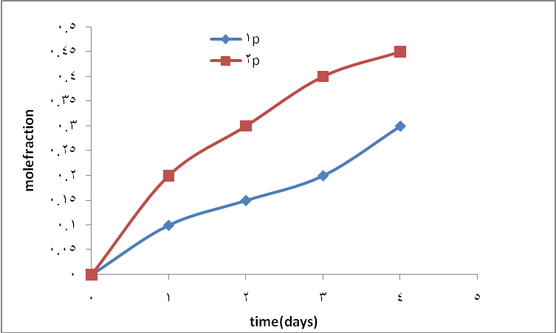
Fig.(4b) Controlled release of P1&P2 at pH4 at37 ⁰C.
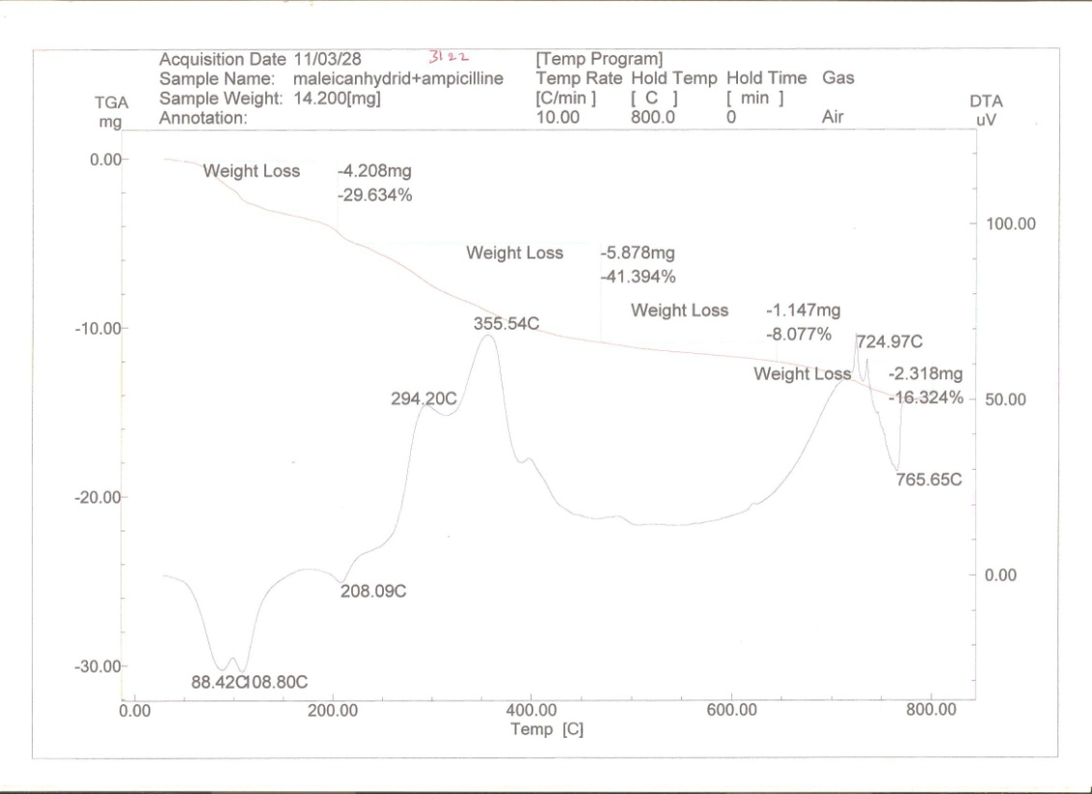
Fig.(5) Thermal analysis( TG and TDA) of P2 drug polymer
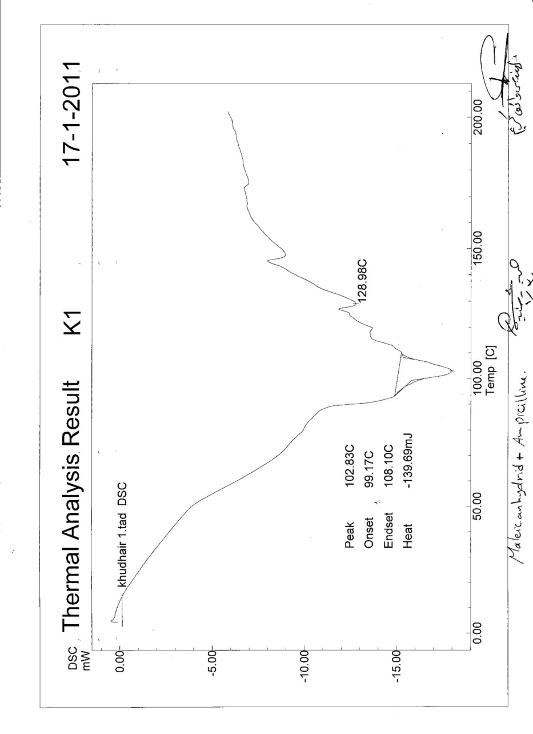
Fig.(6) Thermal analysis (DSC) of P1 drug polymer

References
- Patric G.L.(An Introduction To Medicinal Chemistry) 1^{ed} Oxford University press, chapter (2004) p.373.
- Aladwn A.S.,and Aboud A.Y.Z.( Iraq. Drug Guide), 1990, first addition 190, 100-104.
- Chanteux H., Paternotte I,, Paule M., eclercyM.L. R.Brasseur, Sonveaux E., and P.M.Tulkens, (Pharmaceutical Research), 2003, 20, 624-631.
- Wong Y.C., Szeto Y.S., Cheung W.H.(Adsorption of acid dyes on chitosan equilibrium isotherm analysis), Process Biochemical, 2004, 39(6), 695-704.
- Adriano W.S, Veredas V., Santana C.C.,and Goncalves L.R.(Adsorption of Amoxillin on chitosan beads, kinetics, equilibrium) Biomaterial Engineering Journal, 2005, 27, 133-137.
- Dharmendra S.,(Development and Characterization of chitosan nanoparticles loaded with Amoxillin )Ph.D Thesis , Rajasthan University,(2009).
- Poloma M., Torre D., Yewande E., Guillermo T.(Release of amoxilline from polyionic complexes of chitosan and poly(acrylic acid)), Biomaterial, 2003, 24 ,1499-1509.
- Firyal M.A., Abbas N.M. and Khudheyer J. Kadem (Preparation of poly(N- Procainyl Amic acids) as Drug Polymers) The Fourth Scientific Conference (2010) College of Science-University of Wassit .
- McMury J., ''Organic Chemistry'' 7^{ed} ,Cornell University,chapter 20,(2008).
- Firyal M. , Abbas N. and Khudheyer J. Kadem. (Preparation of (N-Procainyl amic acid) polymers. Fourth Scientific Conference University of Waist. Iraq,(2010).p402-410.

