An Indirect Spectrophotometric Determination of Mesna in Pharmaceuticals and Environmental Samples

Nief Rahman Ahmed
Department of Environmental Technology,Colleg of Environmental, University of Mosul

(NJC)

(Recevied on 24/5/2011 ) (Accepted for publication 31/10/2011)

Abstract
Two indirect spectrophotometric methods were proposed for the determination of mesna in pure and pharmaceutical preparations using sodium hypochlorite and two indicators, methyl orange and congo red. The methods involved addition of a known excess of sodium hypochlorite to mesna in acidic medium, followed by determination of residual sodium hypochlorite by reacting with a fixed amount of either methyl orange, measuring the absorbance at 505nm (method A) or congo red measuring the absorbance at 605nm (method B). In both methods the amount of sodium hypochlorite reacted correspond to the amount of mesna and the measured absorbance was found to increase linearly with the concentration of mesna, which is corroborated by the correlation coefficient of 0.9996 and 0.9998 for method A and B respectively. The two methods obey Beer’s law for 0.08-1.6 µg mL ⁻¹ and 0.2-2.0 µg mL⁻¹ for method A and B respectively. The apparent molar absorptivities were calculated to be 1.02×10⁴ and 1.5×10³ L mol⁻¹ cm⁻¹ for method A and method B respectively. The limit of detection (LOD) and quantification (LOQ) were calculated to be 0.016 and0.05µg mL⁻¹ for method A and 0.048 and 0.15 µg mL⁻¹ for method B. The intra-day and inter-day precision and accuracy of the two methods were evaluated according to the current ICH guidelines. Both methods of comparable accuracy(relative error) better than ± 1.8%. and precision of < 2%. The proposed method was proved to be selective and applied to the determination of mesna in pharmaceutical preparations and environmental water samples.

Keywords: Mesna, Spectrophotometry, Pharmaceutical preparations,Environmental samples.

الخلاصة
تم اختيار طريقتين طيفيتين غير مباشرتين لتقدير الدواء السرطاني مزنا بحالته النقية وفي بعض مستحضراته الصيدلانية باستخدام هايبوكلورات الصوديوم وكاشفين هما المثيل البرتقالي و الكونكو الاحمر تتضمن الطريقة اضافة زيادة معلومة من هايبوكلورات الصوديوم الى الدواء مزنا في الوسط الحامضي ثم قياس المتبقي من هايبوكلورات الصوديوم بمفاعلته مع كمية ثابتة من المثيل البرتقالي. حيث يقاس عند 505 نانوميتر ( الطريقة الاولى ) او الكونكو الأحمر حيث يقاس عند 605 نانوميتر ( الطريقة الثانية). وفي كلتا الطريقتين فإن كمية هايبوكلورات الصوديوم المتفاعلة تمثل كمية مزنا وان الامتصاص سوف يزداد مع زيادة تركيز مزنا والذي يمثل باستقامة الخط المستقيم ڊ 0.9996 و 0.9998 للطريقة الأولى والثانية على التوالي.
وفي كلتا الطريقتين فإن قانون بير يسري على الكميات التي تتراوح بين 0.08-1.6 جزء بالمليون و 0.2-2.0 جزء بالمليون لكلتا الطريقتين على التوالي وان معامل الامتصاص المولاري هو 1.2×10⁴ و 1.5×10³ لتر. مول-1. سم-1 لكلتا الطريقتين على التوالي. وان حد الكشف والحد الكمي تم ايجاده 0.016 و 0.05 مايكروغرام لكل مللتر للطريقة الاولى و 0.048 و 0.15 مايكرو غرام/مل للطريقة الثانية.
ان ضبط الطريقتين خلال اليوم الواحد او بين يوم وآخر و تقيمهما اعتماداً على دليل ICH فكلتا الطريقتين لهما دقة )خطأ نسبي) اقل من 1.6 % وضبطهما اقل من 2% . وقد تم دراسة المواد المتداخلة مع مزنا والتي عادة تتواجد معها ووجد بأنها لا تسبب أي تداخل وكلتا الطريقتين طبقت بنجاح لتقدير مزنا في مستحضراتة الصيدلانية و في النماذج البيئية.

Introduction
Mesna, (sodium 2-sulfanylethane sulfonate) with a molecular formula of C₂H₅NaO₃S₂ and molecular weight of (164.18 g mol⁻¹). Its structural formula is as follows:

HS-CH₂-CH₂-SO₃-Na⁺

A nucleophilic thiol doner often used for the prevention of urothelial toxicity in patients treated with the antineoplastics ifosfamide or cyclophosphamid. In the kidney, dimesna, the inactive metabolite of mesna is redused to free mesna which has thiol groups that react with the metabolitied of ifosfamide and cyclophophamide, including acrolein, considered to be responsible for the toxic effect on the bladder⁽¹⁻³⁾.
The aim of mesna therapy is to ensure adequate levels of mesna in the urine throughout the period during which these toxic metabolites, are present and the duration of mesna treatment should therefore equal that of the antineoplastic treatment. Plus the time taken for the concentration of antineoplastic metablites in the urine to fall to non-toxic levels. Urinary output should be maintained and the urine monitored for hoematuria and proteinuria throughout the treatment period. However, frequent emptying of the bladder should be avoided. recently mesna used as antioxidant agent against acetaminophen toxicity⁽⁴⁾ .Mesna is rapidly oxidized to dimesna, so in pharmaceutical formulation it must be stabilized using EDTA, sodium hydroxide and inert gas atmosphere. The reducing character of mesna should be taken into account in the design of any analytical methods⁽⁵⁾ The literatures revealed that mesna has been determined by means of a few analytical methods. These include: HPLC⁽⁵⁻⁸⁾.Chemiluminescence-flow injection analysis⁽⁹⁾ .B.P method described a titrimetric assay for pure drug only⁽¹⁰⁾. The present work is to provide a simple, sensitive spectrophotometric method for the determination of mesna in dosage forms and water samples, utilize sodium hypochlorite and two dyes methyl orange and congo red.

Experimental
1 Apparatus

Optima SP 3000 plus UV-Visible spectrophotometer (Optima .Japan) with 1.0 cm quartz cells was used for the absorbance measurements.

2 Reagents

All chemicals used were of analytical purity grade and all solutions were prepared with distilled water. A standard sodium hypochlorite solution (0.1%) was prepared by dilution of 1.25mL of 8% sodium hypochlorite to 100 mL with distilled water, store in a dark bottle and standardized iodometrically every 4-5 days. This solution stored in a dark bottle⁽¹¹⁾.
Congo red: 0.1 % was prepared by dissolving 0.1 g accurately weighed dye in water, and diluting to 100 mL in volumetric flask.
Methyl orange 0.1% was prepared by dissolving 0.1 g accurately weighed dye in water and diluting it to 100 mL in volumetric flask.
Standard material and pharmaceutical preparations (mesnan tablet 400 mg,and mesnan 100mg injection ) were provided from state company of drug industries and medical appliance (NDI) Ninavah- Iraq .
Standard solution of mesna (100µg ml⁻¹).
This solution was prepared by dissolving 0.1 g of pure drug in 1L distilled water. It was later diluted with water to get concentration of 10 µg ml⁻¹.

3 Analytical procedures

Method A:-

Different aliquots of standard mesna solution equivalent 2-40 µg were transferred into a series of 25mL volumetric flasks, 1mL of 1N HCL, and 5 ml of sodium hypochlorite
solution were added. The content was mixed and let stand for 5 min with occasional shaking. Finally, 1mL of 0.1% methyl orange solution was added and the volume was diluted to the mark with distilled water and mixed well. The absorbance of each solution was measured at 505 nm against a reagent blank .

Method B:-

Different aliquots of standard solution equivalent to 5-50 µg of mesna solution were transferred into a series of 25 mL volumetric flask, 1mL of HCL and 3 mL of sodium hypochlorite were added. The content was mixed well and the flasks were kept aside for 5 min with intermitten shaking. Finally, 3mL of 1% congo red solution was added to each flask, the volume was diluted to the mark with distilled water, mixed well and absorbance was measured against a reagent blank at 605nm.
4 Preparation of Mesna drugs

1 Tablets

To minimize a possible variation in the composition of the tablets, the mixed content of 20 tablets, were weighed and grounded, then the powder equivalent to 100 mg of mesna was stirred well with water for 15min and the volume was made to 1L with distilled water ,filtered through whatman No. 42 filter paper and 10 mL of this solution was diluted to 100 ml by distilled water and aliquot of this solution was treated as described above for analytical procedure.

2 Injection

1ml vail containing 100 mg of mesna was transferred into 1L volumetric flask and diluted up to the mark with distilled water, 10mL of this solution was diluted to 100mL with distilled water and a aliquot of this solution was treated as described above for analytical procedure.

3 Preparation of spiked water samples

To demonstrate the practical applicability of the proposed method, real water samples were analysed by this method. Drinking water from the mosul water-supply net work , industrial waste water from the state company for drug industries and medical appliances Mosul-Iraq, were spiked with the concentrations ranging from 0.1-1.5mg/ml of mesna and a liquot of this solution was treated as described above for analytical procedure.

Result and Discussion

The versatility of sodium hypochlorite as an analytical reagent can be gauged by its applications in the spectrophotometric determination of many organic compounds of therapeutic importance⁽¹²⁻¹⁶⁾.. The use depends mainly on its ability to effect the oxidation of diverse functional groups. Taking advantage of the rapid oxidation reaction of sodium hypochlorite with mesna.Mesna is a reducing agent owing to the presence of thiol group(-SH) in its structure. The proposed spectrophotometric methods are indirect and based on the determination of residual sodium hypochlorite after bringing the reaction between mesna and sodium hypochlorite to completion. The residual sodium hypochlorite was determined by methyl orange or congo red indicators.

2 HS-CH₂-CH₂-SO₃Na + NaOCL (Known excess) → NaO₃-CH₂-CH₂-S-CH₂-CH₂-SO₃Na
Di mesna
+ Un reacted NaOCL

Method A

Un reacted NaOCL +Methyl orange → Bleached methyl orange (measured at505nm)

Method B

Un reacted NaOCL + Congo red→ Bleached congo red (measured at 605nm)
When added in increasing concentration to a fixed concentration of sodium hypochlorite, mesna consumes the latter proporationally and there is a concomitant drop in the remaining concentration of sodium hypochlorite. When a fixed indicator concentration is added to decreasing concentration of sodium hypochlorite, a concomitant increase in the indicator concentration result a proportional increase in absorbance at the respective ג max is observed with increasing concentration of mesna.Fig (1and 2).
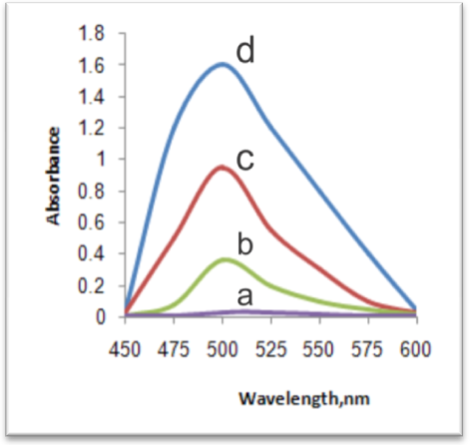

Fig[1]:Absorption spectra of method A; a ,reagent blank against water.,b,c and d after addition of 10,30 and 50µg of mesna.

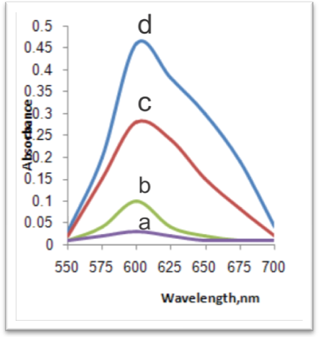

Fig[2]:Absorption spectra of methodB ; a ,reagent blank against water.,b,c and d after addition of 10,30 and 50µg of mesna.
Preliminary experiments were preformed to fix the upper concentration of the indicator that could be determined spectrophotometrically and this was found to be 1 and 3mL of 0.1% of methyl orange and congo red respectively. A sodium hypochlorite concentration 500 µg was found to bleach the red color due to 100 µg of methyl orange where as 300µg was required to destroy the blue color due to 300µg congo red. Hence, different concentration of mesna were reacted with hypochlorite solution 5 ml of 0.1% method A and 3mL of 0.1% sodium hypochlorite in method B, followed by determination of residual sodium hypochlorite under the recommended procedure for both methods. The reaction between mesna and sodium hypochlorite and the determination of the latter by reacting with the indicators. HCL medium (1mL of 1N) was found to be ideally suited. Reaction time of 5mint is not critical and any delay up to 6h did not affect the absorbance reading.
3-1 Method Validation
Under the optimized conditions,
A liner correlation was found between absorbance at ג max and mesna concentration.Fig (3 and 4).
A = 0.016 + 0.303 C R = 0.996 n = 6 (method A)
A = 0.0018 + 0.091C R = 0.998 n = 6 (method B)
Where A is the absorbance and C is concentration in µg.ml⁻¹, R is the regression coefficient and n is the number of concentration levels.

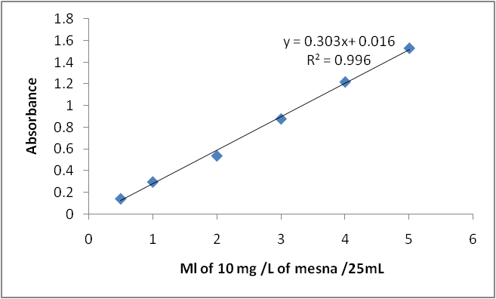

Fig[3]: Calibration curve of mesna with methyl orange.

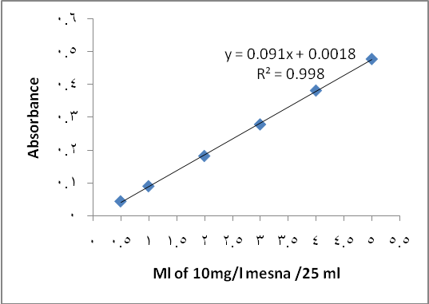

Fig[4]:Calibration curve of mesna with congo red

Table 1:Method validation of the spectrophotometric determination of mesna.
Parameter | Method A | Method B
ג _{max} (nm) | 505 | 605
Beer’s law limit (µg mL⁻¹) | 0.08-1.6 | 0.2-2
Molar absorptivity (L mol⁻¹ cm⁻¹) | 1.02×10⁴ | 1.5×10³
Limit of detection (µg mL⁻¹) | 0.016 | 0.05
Limit of quantification | 0.048 | 0.15
Intercept | 0.016 | 0.0018
Slope | 0.303 | 0.091
Correlation coefficients ,(r) | 0.996 | 0.998

The optical characteristics such as Beer’s Law, limits and molar absorptivity values is given in Table (1). The limit of detection (LOD) and quantication (LOQ) calculated according to ICH guidelines ⁽¹⁷⁾ as the ratio of 3.3 and 10 standard deviations of the blank (n = 6) and the slope of the calibration line.

3-2 Accuracy and Ruggedness of the proposed methods
To evaluate the accuracy and intra-day precision of the methods a pure drug solution was analysed at two different concentrations, each determination being repeated six times. The relative error (%) and relative standard deviation (%) values are summarized in table (2). From Table (II), it is clear that method A with a relative error of 1.3% is as accurate as method B with 1.6%. Moreover, both methods are found to be precise with RSD values < 2%. For a better picture of reproducibility on a day-to-day basis, a series of experiments were performed, in which the standard drug solution was determined at three different levels each day for six days, with all solutions being prepared a fresh each day. The day-to-day relative standard deviation values were in the range of 1.1-1.8 % and represent the best appraisal of repeatability of the proposed methods.

Table ( 2) Accuracy and precision of the proposed methods.
Method | Mesna conc. taken µg | Conc.found ( µg ) | Er (%)ª | RSD(%)
A | 20 | 20.22 | 1.1 | 1.3
A | 40 | 40.52 | 1.3 | 1.8
B | 10 | 10.12 | 1.2 | 1.5
B | 30 | 30.48 | 1.6 | 1.1
a: Mean of six determinations

3-3 Interference studies

In order to assess the possible applications of the two proposed methods, the effect of substances that often accompany with mesna in various pharmaceutical products (Tablets and injections) were studied by adding different amount of interferents to 20 µg of mesna. An attractive featuer of the

method is its relative freedom from interference by the usual diluents and excipients in amounts for in excess of their normal occurance in pharmaceutical preparations. The results are given in table (3)

Table (3) Determination of 20µg of mesna in the presence of excipients and other substancess

Interfering substances | Amount of interferents taken/mg | Amount found/µg |  | RSD %
Interfering substances | Amount of interferents taken/mg | Method A | Method B | Method A | method B
Na₂- EDTA | 1 | 19.8 | 18.9 | 0.78 | 0.68
Benzyl alcohol | 1 | 19.5 | 19.6 | 0.88 | 0.64
Chlorobutanol | 10 | 19.4 | 19.3 | 0.91 | 0.93
Lactose | 40 | 19.5 | 19.6 | 0.71 | 0.77
Microcrystalline cellulose | 20 | 18.9 | 19.5 | 0.64 | 0.79
Calcium phosphate | 10 | 19.4 | 19.5 | 0.81 | 0.77
Corn starch | 30 | 19.8 | 19.6 | 0.78 | 0.68
Povidone | 30 | 18.9 | 19.5 | 0.79 | 0.64
Magnesium stearate | 40 | 19.4 | 19.4 | 0.91 | 0.93
Hydroxylpropyl methyl cellulose | 40 | 19.5 | 19.3 | 0.93 | 0.91
Poly ethylene glycol | 20 | 19.8 | 19.5 | 0.91 | 0.64
Titanrium dioxide | 10 | 19.4 | 19.5 | 0.88 | 0.68
*Average of six determinations.

3-4 Analytical applications

Table(4),(5) gives the results of the assay and reveals that there is close agreement between the results obtained by the proposed methods and the lable

claim for pharmaceutical preparations and the recovery results of real water samples was higher than 98%,indicating that successfully applicability of the proposed methods.

Table (4): Determination of mesna in pharmaceutical formulations.
Pharmaceutical formulation | Label amount  (mg) | Found* (mg)
Pharmaceutical formulation | Label amount  (mg) | Method A | Method B
Mesnan tablet(NDI) | 400 | 402 | 401.3
Mesnan ampoule(NDI) | 100 | 99.7 | 99.9
*Mean value of six determinations.

Table(5): Determination of mesna in spikedwater samples
Water samples | Mesna(mg/ml)  Taken Found  Method Method  A B | % Recovery(n=6)  Method Method  A B
Drinking water | 0.1 0.101 0.101  1.0 0.98 0.99  1.5 1.48 1.47 | 101 101  98 99  98.66 98
Industrial waste water | 0.1 0.1 0.1  1.0 1.02 1.01  1.5 1.5 1.51 | 100 100  102 101  100 100.6

*Mean of ten determinations

4- Conclusions
An indirect spectrophotometric methods were established for the analysis of mesna in pure form ,pharmaceuticals and water samples .The proposed methods are simple ,rapid ,sensitive ,accurate ,selective, and no need of heating or solvent extraction. To the best of our knowledge, this is the first report of the reaction between mesna and excess of sodium hypochlorite(NaOH) and then indirectly determined the drug after the residual hypochlorite bleaches the dyes which absorb at different wavelength maxima.

References
- C.Krogh, et1, “compendium of pharmaceuticals and specialties”. 28th ed, Ottawa: Canadian pharmaceutical Association 1993: pp 1286-1287
2. K.Shaw and M.Graham, “Mesna ashort review. Cancer Treat Rev. 1987,14,67-86
3. Martindale: the complete drug reference, 43ed, volume 1, 2005 pharmaceutical press, London, P.1041
4. G.Sener, O.Schirili, S.Cetinel, etl, “Journal of applied Toxicology, 2005,25; 20-29
5. M.Verschragen,M.Bosma,T.Zwiers, Journal of chromatography B, ,2003,783; 33-42
6.M.Verschraagen,T.H.Ursula,E.Torun,M.G.Donker,N.J.Reinhoud,W.J.F. Vander Vijh. “ Journal of pharmaceutical sciences”, , 2003,92;1040-1050
7. R.Glowacki, K.wojcik and E.Bald, “Journal of chromatography A, ,2001,914; 29-35
8. R.Glowacki,D.Gryglik,K.Kusmierek and E.Bald, “Talanta, 2005 ,66; 534-539
9. L.F.Capitan-Vallvery,M.C.Valencia Miron and R.Acosta Acosta, Talanta, , 2000,51;1155-1161
10. British pharmacopoeia, 2009 volume l , p3796
11. .M.Kolthoff, R.Belcher, V.A.Stenger and G.Matsuyama, volumetric Analysis, Interscience publishers, New York,1957, III, 580
12. M.Walash, S.Toubar, S.Ahmed and N.Zakari, Analytical Letters, , 1994,27; 2513
13. J.Vilhez, R.Blance,R.Awidad and A.Nawalon, “, journal of pharmaceutical and Biomedical Analysis,”, 1995,13; 1119-1125
14.C.Sastary,T.Reka and A.Satyanaryane, “, Mikrochimica acta, 1998,128; 201-205
15.A.Clezio and F.Orlando, Quim.Nova, 2002,25; 387-391
16. N.Kunio and S.Shigetaka, “, Japan analyst, 1982,31; 724-726
17- ICH Harmonized tripartite guideline prepared within the international conference on the harmonization of technical requirements for the registration of pharmaceuticals for human use (ICH) Q2B, validation of analytical procedure: methodology. ICH, London 1996

