Spectrophotometric Determination of Micro Amount of Copper (II) in Different Enviromental and Vital Samples by New Organic Reagent
Shawket K. Jawad Senaa K. Ali Safa M. Hameed
College of Education for Girls - Kufa University

(NJC)

(Recevied on25 /4/2011 ) (Accepted for publication 11/7 /2011)

Abstract
2-[4-Chloro-2-methoxy phenyl azo]-4,5-diphenyl imidazole used as a new complexing organic reagent for extraction and determination of copper (II) in different samples include plants leaves, soil and water from different position in Al-Najaf governorate as well samples of human serum, cow liver and kidney, vitamins and spices. All these measurement carried out at the optimum condition for complexation reaction. Beer's law is obeyed over the concentration rang 0.5-30µg/mL with a detection limit 8×10⁻⁵ µg.mL⁻¹ and molar absorptivity 8459.79L.mole⁻¹.cm⁻¹. Sandell’s sensitivity 7.5×10⁻⁸µg.cm⁻².
Key words: Spectrophotometric determination, Copper, Solvent Extraction.
الخلاصة
2-[4-كلورو-2-ميثوكسي فنيل ازو]-4,5- ثنائي فنيل اميدازول استخدم ككاشف تعقيد عضوي جديد لاستخلاص وتقدير النحاس (II) في نماذج مختلفة تضمنت أوراق النباتات، التربة، المياه من مناطق مختلفة في محافظة النجف الأشرف وكذلك نماذج مصل دم الإنسان، كبد وكلية البقر فضلا عن بعض الفيتامينات والتوابل. وكل هذه القياسات تمت تحت الظروف المثلى لتفاعل التعقيد. المطاوعة لقانون بير كانت في حدود التراكيز 0.5-30µg/mL وكان حد الكشف 8×10⁻⁵ µg.mL⁻¹ وقيمة الامتصاصية المولية 8459.79L.mole⁻¹.cm⁻¹. حساسية ساندل 7.5×10⁻⁸µg.cm⁻².

Introduction

Copper is both vital and toxic for many biological systems depending on it’s contain. Thus, the determination of trace amount of Cu (II) in different samples it’s important for life and pollution. A cloud point extraction procedure was presented for the preconcentration of copper, Nickel , Zinc and Iron ions in various samples, after complexation by 2-(6-(1H-benzo[d] imidazole-2-yl)-1H-benzo[d]imidazole⁽¹⁾. An extraction and sensitive differential pulse anodic stripping voltammetric method at a hanging mercury drop electrode is described for the determination of Zn, Cu , Pb (µg g⁻¹) and Cd (ng g⁻¹) metal ions in water and 0.1M HCl extracted for kaked, anise, cumin, caraway and black pepper ⁽²⁾. The acid decomposition sequential extraction procedure for determination of heavy metals has been applied to a marine sediments collected from kagoshima bay, Cu, Zn, Cd and Pb in the sediments extracts were determined by FAAS ⁽³⁾. Cu is quantitatively retained with 1, 5-diphenyl carbazone on microcrystalline naphthalene in the pH range 6.5-8.0 from a large volume of aqueous solutions of various samples ⁽⁴⁾. Copper was determined by an adapted extraction–spectrophotometric method as a complex with sodium (I) diethyl dithiocabamate. The influence of the extraction solvent a masking agent and interfering elements (Fe (III), Cr (III)) was examined. The elimination of the extraction stage by using a protective colloid for spectrophotometric determination of Cu in soil was investigated ⁽⁵⁾. Spectrophotometric determination of Cu²⁺ by using meso-hexamethyl propylene amine oxime a stable 1:1 Cu²⁺:meso-HMPAO red pink complex, λ_{max}= 497nm, Sandell's sensitivity was 0.18µg cm⁻². This method applied for determination of Cu²⁺ in foodstuffs and pharmatical samples ⁽⁶⁾. Also spectrophotometric determination of Cu²⁺, it’s based on the reaction at pH=4-9 between the synthesized acetophenone-p-chlorophenyl thiosemicarbazone and Cu²⁺ forming a green complex, Cu²⁺:A-p-CIPT (1:2) that floats quantitively with oleic acid (HOL) surfactant, λ_{max}=600nm, detection limit 0.021mg.L⁻¹, Sandell's sensitivity was 0.244µg cm⁻², this procedure applied to the analysis of Cu²⁺ in natural water, certified scrap steel samples and vitamins samples ⁽⁷⁾.
Experimental
1.Apparatus
For absorbance measurements shimadzu UV-1700 spectrophotometer was used with 1cm quartz cells (Japan), pH- measurements were carried out using WTW, listed 8F93(Germany), Shimadzu, Atomic Absorption Spectroscopy AA-6300 used also to comparable the results.IR- spectra for the complex were recorded by using FTIR-8400 Shimadzu.

2.Reagents

All reagents were analytical reagent grade and were used without further purification. The standard stock solution of Cu (II) (1mg/100mL) was prepared by dissolving 0.392gm of CuSO₄.5H₂O (Merck) with distilled water in 100mL volumetric flask. (1×10⁻²M) solution of organic reagent (4-ClMePADPI) prepared by dissolving 0.0388gm of (4-ClMePADPI) with chloroform in 10mL volumetric flask. Other working solutions were prepared by appropriate dilution with chloroform. Although the organic reagent (4-ClMePADPI) prepared as in previous study ⁽⁸⁾.

3. General procedure
After limitation optimum condition for complexation reaction between organic reagent (4-ClMePADPI) and copper to form ion pain complex extracted to chloroform organic solvent, make experiment for determine copper in different samples which is include digested environmental and vital samples by wet digestion method^{(9,10)}. Take 5mL from digestion solution make it acidity at (pH=8), and added 2mL of (1×10⁻²M) sodium fluoride, afterward shaking with 5ml of (1×10⁻⁴M) organic reagent dissolved in chloroform for (10 minutes), at later separate organic phase form aqueous phase and taken absorbance of organic phase at λ_{max}=519nm against organic reagent as blank.
Results and Discussion
Copper forms a stable colored complex with 4-CIMePADPI, absorption spectrum of the complex formed has maximum absorbance at λ= 519nm. Whereas organic reagent show maximum absorbance at λ_{max}=426nm. By the way this deviation in absorbance wave length as a result of coordination organic reagent with copper cation^{(11,12,13)}.

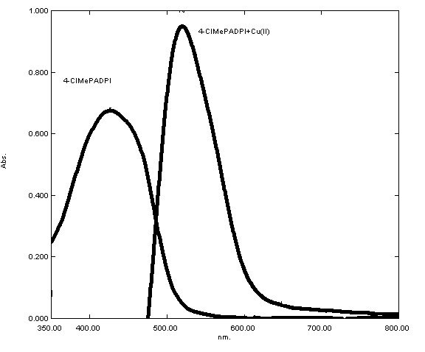
Figure (1): UV-Vis spectrum of the organic reagent 4-CIMePADPI and its complex with Cu⁺²
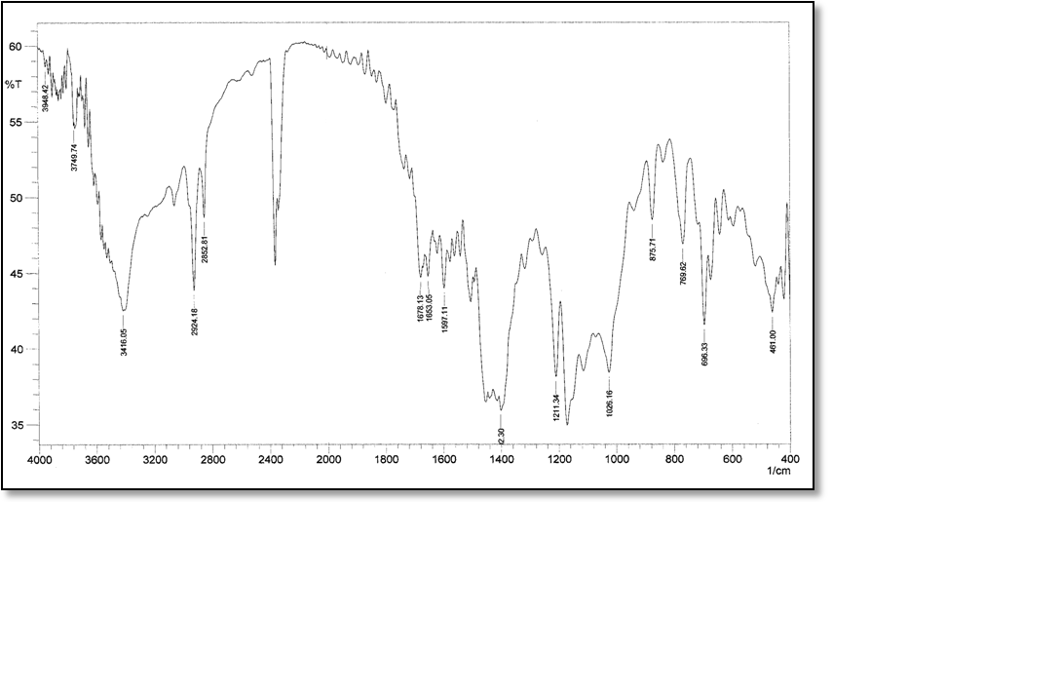
Figure (2): IR- spectrum of Cu⁺² complex with the organic reagent 4-CIMePADPI

About limitation of optimum condition for complexation reaction study the effect of pH on recovery of copper and the results show (pH=8) was the best for ion pair complex formation which is giving higher absorbance for complex in organic phase at λ_{max}=519nm in Figure (3).

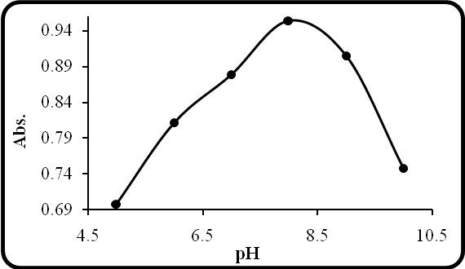
Figure (3): Effect of pH

Second optimum condition studied was shaking time of two phases, the results of this experiment in Figure (4) show (10 minutes) shaking time giving higher absorbance for complex extracted to organic phase and necessary to reached the equilibrium.

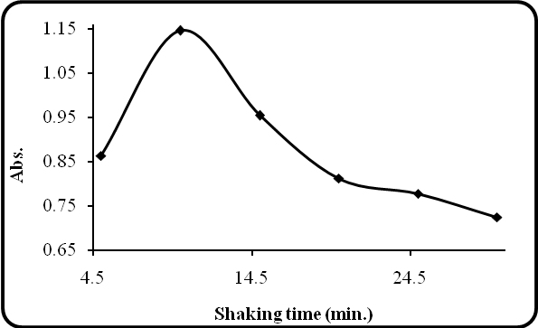
Figure (4): Effect of shaking time

To determine the stoichiometry of the extracted complex used continuous variation method and mole ratio method the results demonstrate extracted complex Cu²⁺: [4-ClMePADPI] was 1:1, as in Figures (5,6,7).

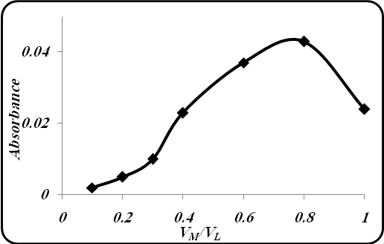 | 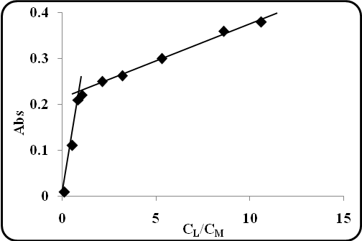
Figure (5): Determine the stoichiometry of the extracted complex; continuous variation method | Figure (6): Determine the stoichiometry of the extracted complex; mole ratio method

Figure (7): The probable structure of extracted complex

The study show the complexation reaction was exothermic reaction and chloroform organic solvent was the best for extraction method. Calibration curve of Cu⁺² complex prepared under optimum Conditions developed, above, as in Figure (7).

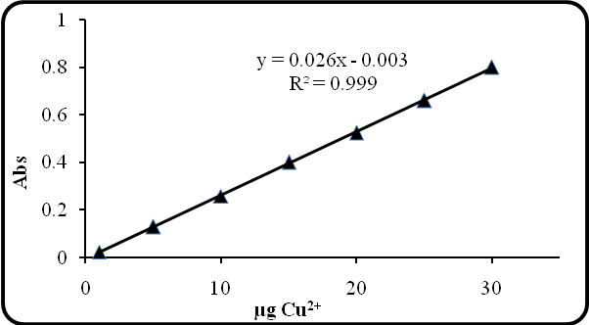
Figure (8): Calibration curve of Copper(II) with the organic reagent 4-CIMePADPI

Application of method in different samples
The proposed method was applied to determination copper (II) in enviromental and vital samples.
- Spectrophotometric determination of Copper(II) in plant leaves
The range of copper in plants according to WHO measurements is 5-30ppm^{(14,15)}.

- Al-Mishkhab
 | 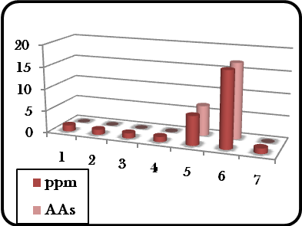
  No. of sample | Sample name | Copper quantity
  No. of sample | Sample name | ppm* | %RSD | AAs**
  1 | Spinacia oleraca | 1.40 | 3.57 | 1.5
  2 | Beta vulgaris v.cilca | 1.18 | 3.38 | 1.23
  3 | Aplum gravealens | 1.16 | 4.31 | 1.08
  4 | Raphanus sativus | 1.16 | 4.31 | 1.08
  5 | Hibiscus esaculuntus | 6.60 | 3.03 | 6.80
  6 | Foeniculum vulgare | 17.0 | 3.52 | 17.01
  7 | Visit | 1.20 | 8.30 | 1.3

- Al-Manadira
 | 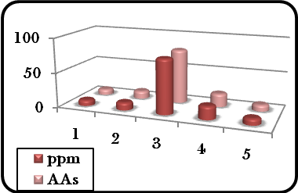
  No. of sample | Sample name | Copper quantity
  No. of sample | Sample name | ppm* | %RSD | AAs**
  8 | Helianthus annuus | 8.40 | 2.30 | 8.42
  9 | Raphnus sativus | 11.20 | 1.78 | 11.40
  10 | Lepidoum sativum | 28.85 | 0.30 | 28.80
  11 | Foeniculum vulgare | 19.20 | 0.52 | 19.30
  12 | Lactuca sativa | 9.20 | 1.08 | 9.30

- Al- Najaf
 | 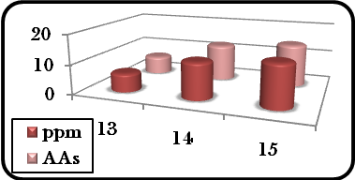
  No. of sample | Sample name | Copper quantity
  No. of sample | Sample name | ppm* | %RSD | AAs**
  13 | Lactuca sativa | 6.32 | 0.15 | 6.34
  14 | B. oleracea V.Capitata | 12.4 | 0.80 | 12.5
  15 | B. oleracea V.Botrytis | 14.4 | 0.69 | 14.5

- Al-Huria
 | 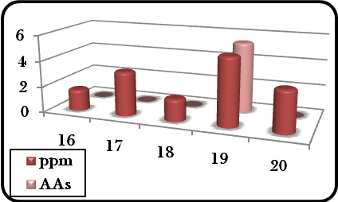
  No. of sample | Sample name | Copper quantity
  No. of sample | Sample name | ppm* | %RSD | AAs**
  16 | Lactuca sativa | 1.66 | 0.60 | 1.52
  17 | Allium Cepa | 3.4 | 2.94 | 3.2
  18 | Beta Vulgaris V.Cilca | 1.72 | 0.58 | 1.8
  19 | Aplum gravealens | 5.20 | 1.92 | 5.40
  20 | Spinacia oleraca | 3.20 | 3.12 | 3.3

- Al-Abasia
 | 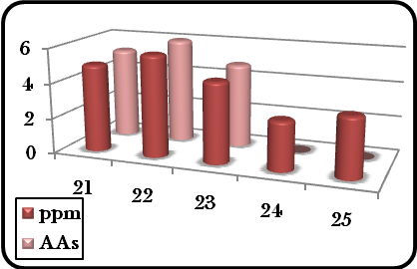
  No. of sample | Sample name | Copper quantity
  No. of sample | Sample name | ppm* | %RSD | AAs**
  21 | Lactuca sativa | 5.00 | 2.00 | 5.20
  22 | Allium Cepa | 5.80 | 1.72 | 6.00
  23 | Beta Vulgaris V.Cilca | 4.60 | 2.17 | 4.80
  24 | Aplum gravealens | 2.80 | 3.57 | 2.9
  25 | Spinacia oleraca | 3.40 | 2.94 | 3.3

- Spectrophotometric determination of Copper(II) in some nuts
 | 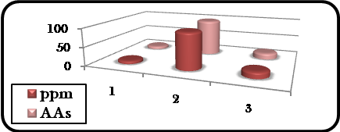
  No. of sample | Sample name | Copper quantity
  No. of sample | Sample name | ppm* | %RSD | AAs**
  1 | Juglans Sp | 8.40 | 1.19 | 8.50
  2 | Prunus amygdalus | 29.25 | 0.02 | 29.26
  3 | Pistacia Sp | 16.80 | 0.59 | 16.90

- Spectrophotometric determination of Copper(II) in some grain
 | 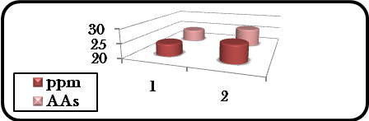
  No. of sample | Sample name | Copper quantity
  No. of sample | Sample name | ppm* | %RSD | AAs**
  1 | Phaseolus Sp | 24.36 | 0.16 | 24.38
  2 | Vicia Faba | 26.36 | 0.07 | 26.4

- Spectrophotometric determination of Copper(II) in some specis
 | 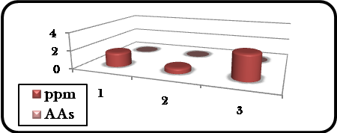
  No. of sample | Sample name | Copper quantity
  No. of sample | Sample name | ppm* | %RSD | AAs**
  1 | Sumac | 1.60 | 6.25 | 1.65
  2 | Curry Powder | 0.60 | 16.60 | 0.7
  3 | Maggi | 2.80 | 1.27 | 2.9

- Spectrophotometric determination of Copper(II) in soil:-
In general the soil contains copper at the range 10-200ppm and this different return to nature of soil according to WHO measurements^{(14,15)}.
The samples of soil was collection from different position, the result reported in table below

No. of sample | Sample name | Copper quantity
No. of sample | Sample name | ppm* | %RSD | AAs**
1 | Al-Manadira | 3.80 | 2.63 | 4.00
2 | Al-Mishkhab | 6.014 | 1.89 | 6.02
3 | Al-Kufa near the bridge | 5.50 | 1.81 | 5.70
4 | Al-Abasia the thoroughfare | 2.14 | 0.93 | 2.20
5 | Al-Zurfate region | 0.38 | 2.63 | 0.40
6 | Al-Abasia arable land | 1.50 | 6.66 | 1.45
7 | Al-Huria the thoroughfare | 1.38 | 0.72 | 1.40
8 | Al-Huria arable land | 9.20 | 1.08 | 9.40
9 | Al- Kufa street in front of Al-Mufeed secondary school | 8.20 | 1.21 | 8.40
10 | Al-Saad quarter far the thoroughfare | 11.2 | 0.89 | 11.50
11 | Al-Saad quarter the thoroughfare | 2.20 | 4.54 | 2.30
12 | Al-Kufa street in front of Al-Adala quarter | 1.00 | 10.00 | 1.10
13 | Al-Kufa street in front of the protection grid | 3.60 | 2.7 | 4.0
14 | Al-Jawahery street | 1.10 | 9.09 | 1.08
15 | Al-Ameer quarter far the thoroughfare | 0.66 | 9.09 | 0.68
16 | Near Thawret Al-Eshreen | 0.82 | 1.21 | 0.85
17 | Madhlum housing section | 1.00 | 10.00 | 0.98
18 | Madhlum arable land | 1.50 | 6.66 | 1.48
19 | Al-Ameer quarter near generated | 11.85 | 0.42 | 11.87
20 | Al-Ameer quarter near the garage | 15.25 | 0.32 | 15.28
21 | Al-Jamea quarter housing section | 16.00 | 0.62 | 16.20
22 | Al-Jamea quarter isolated section | 10.80 | 0.92 | 11.00
23 | The market of Al- Jamea quarter | 19.60 | 0.51 | 19.80

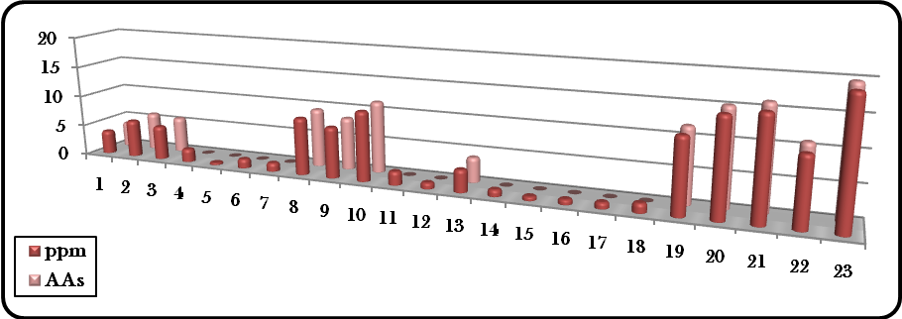

- Spectrophotometric determination of Copper(II) in different spring water:-
 | 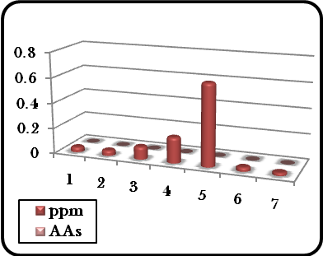
  No. of sample | Sample name | Copper quantity
  No. of sample | Sample name | ppm* | %RSD | AAs**
  1 | Al-Abasia river | 0.04 | 25.00 | 0.05
  2 | Al-Mishkhab river | 0.042 | 4.76 | 0.05
  3 | Al-Mishkhab drink water | 0.100 | 0.10 | 0.12
  4 | Al-Manadira drink water | 0.202 | 0.99 | 0.21
  5 | Al-Najaf drink water | 0.640 | 1.56 | 0.63
  6 | Madhlum drink water | 0.032 | 3.12 | 0.04
  7 | Madhlum normal well | 0.024 | 4.16 | 0.03

- Spectrophotometric determination of Copper(II) in Vital samples:-
 | 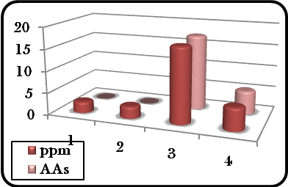
  No. of sample | Sample name | Copper quantity
  No. of sample | Sample name | ppm* | %RSD | AAs**
  1 | Imported cow kidney | 2.60 | 3.84 | 2.70
  2 | Local cow kidney | 2.80 | 3.57 | 2.85
  3 | Imported cow liver | 17.20 | 1.16 | 17.30
  4 | Local cow liver | 5.20 | 3.84 | 5.40

- Spectrophotometric determination of Copper(II) in human blood serum:-

This study includes the comparison between the serum of healthy women and the serums of women suffer from Toxoplasmosis disease. The range 1.1-1.5mg/L according to WHO measurements ^{(14,15)}.

The quantity of Copper(II) in the blood serum of healthy women | 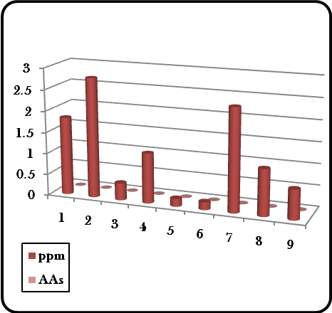
  No. of sample | Age | Copper quantity
  No. of sample | Age | ppm* | %RSD | AAs**
  1 | 24 | 1.83 | 0.54 | 1.90
  2 | 34 | 2.80 | 3.57 | 2.85
  3 | 36 | 0.40 | 25.00 | 0.46
  4 | 38 | 1.17 | 0.85 | 1.19
  5 | 40 | 0.18 | 0.05 | 0.19
  6 | 42 | 0.18 | 0.05 | 0.19
  7 | 46 | 2.40 | 4.16 | 2.50
  8 | 54 | 1.08 | 8.60 | 1.12
  9 | 58 | 0.70 | 14.28 | 0.72
The quantity of Copper(II) in the blood serum of patient women | 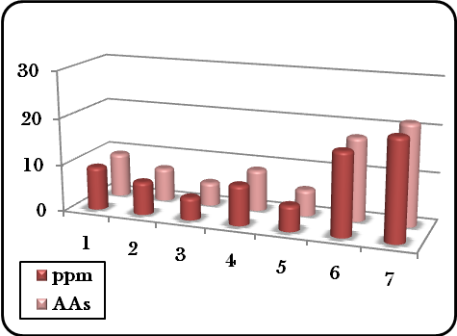
  No. of sample | Age | Copper quantity
  No. of sample | Age | ppm* | %RSD | AAs**
  10 | 21 | 9.20 | 1.08 | 9.40
  11 | 24 | 7.01 | 0.14 | 7.10
  12 | 29 | 4.80 | 2.08 | 5.00
  13 | 39 | 8.50 | 1.17 | 8.80
  14 | 42 | 5.43 | 0.55 | 5.60
  15 | 44 | 16.54 | 0.12 | 17.68
  16 | 47 | 21.30 | 0.93 | 21.50

*ppm: copper quantity determined by this Spectrophotometric determination method
**AAs: copper quantity determined by Atomic absorption method

- Spectrophotometric determination of Copper(II) in Vitamins:-
Vitamins is the drug which content of copper(II) and this study use two types of vitamins.

 | 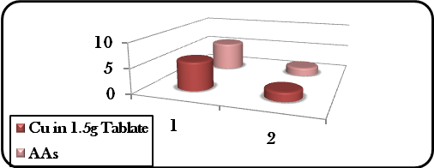
  No. of sample | Sample name | Cu in 1.5g  Tablate | %RSD | AAs  ppm
  1 | Vitiron | 58µg | 1.72 | 5.82
  2 | Cenvite | 1.8mg | 5.55 | 1.70

As a conclusion from this study we can use this organic reagent (4-ClMePADPI) for determination spectrophotometrically for other metal in different samples, and synthesis new azo derivatives for spectrophotometric determination of micro amount of metals.
References
- Mehrorang G., Khodabakhsh N., Ebrahim N. and Mustafa S., , Journal of the Chinese Chemical society, 2009, 56, 981-986.
- Komy Z.R., American Journal of Applied sciences, 2005, 2(5),961-968.
- Hayao S., Takashi T. and Norinobu Y., Rep. Fac. Sci., Kagoshima Univ., 1997, 10(30), 71-83.
- Shishehbore M.R., Nasirizadeh N., Hajishabani A.M.,Tabatabaee M., Canadian Journal of Analytical Sciences and spectroscopy, 2005, 50(3), 10-18.
- Jankiewicz B., Ptaszyński B., Turek A., Polish Journal of Enviromental studies, 1999, 8(1), 35-38.
- Thipyapong K. and Suksai C., Bull. Korean Chem. Soc., 2003, 24(12),1767-1770.
- Ghazy S.E., El-Shazly R.M., El-Shahawi M.S., Al-Hazmi G.A.A. and El-Asmy, Journal of the Iranian Chemical Society, 2006, 3(2), 140-150.
- Zainab.A. Hammoud “Studies in solvent extraction of Group IIB metal ions by new organic reagent 2-[(4-chloro-2-methoxy phenyl)azo]-4,5-diphenyl imidazole, MSc, Thesis, Kufa University-Collage of education for girls.
- Hslam E., Yang X., He Z. and Mahmood Q., J.Zhejiany Univ. Sci., 2007, 8(1), 1-13.
- Skurikhin,I. M., J. Assoc. Anal. Chem.,1989, 72(2), 286.
- Patel S., (1975) "The Chemistry of Hydrrazo, Azo and Azoxy group", John Wiley and Sons. London, New York, Part (1).
- Algucil F.J., Solvent Extraction and ion Exchange, 2003, 21, 841-852.
- Hussein S.A., (2008), MSc, Thesis, Kufa University-Collage of education for girls.
- “Canadian Soil Quality Guidelines for Copper Environmental and Human Health”, March (1997), Canadian Council of Ministers of the Environment.
- “Copper Development Association: Copper in plant, Animal and Human Nutration”, Prepared by V.M.Shorrocks and B.J.Alloway, TN35, (1988), Internet:WWW.Copper info.Co.uk.

