Preparation of Poly (N-4-Antipyrinyl Amic Acids) and Studying
Their Controlled Release Drug Polymers

Firyal M.A.AL-Salami
College of Science, AL-Mustansiriyah University
Abbas N.M.AL-Sharify, Khudheyer Gawad Kadhem
College of Science, Babylon University

(NJC)

(Recevied on 18/4/2011 ) (Accepted for publication 19/7 /2011)

Abstract
Two new monomers of N-4-antipyrinylmaleamic acid M1 and N-4-antipyrinyl citraconamic acid M2 were synthesized from reaction of 4-Aminoantipyrine with maleic anhydride or citraconic anhydride at room temperature with dioxane as a solvent.
The prepared monomers M1 and M2 were polymerized free radically with AIBN as initiator to corresponding polyamic acids P1 and P2. Which were converted to their sodium salt polymers P3 and P4 to enhanced their solubilities in water.
The physical and chemical properties were studied for monomers and polymers, also FT-IR ,¹H-NMR and UV. Spectroscopy were characterized. The intrinsic viscosity was measured by Ostwald viscometer at 30 ⁰C .The swelling %was measured and the controlled release rates of drug polymers were studied in different pH values at 37 ⁰C.
Keywords: Preparation; N-4-Antipyrinyl Amic Acids ;Drug Polymers

الخلاصة
حضر المونومران N-4-انتي بايرينيل حامض المالي اميك M1و N-4-انتي بايرينيل حامض الستراكونيك M2 . من تفاعل 4-امبنو انتي بايرين مع حامض الماليئك او الستراكونيك اللامائي وبدرجة حرارة الغرفة باستخدام الدايوكسان مذيبا.
بلمر المونيمران المحضران M1 و M2 بالجذور الحرة باستخدام AIBN بادئا, الى البوليمرات المقابلة, ثم حولت الى املاح الصوديوم للبوليمرات المحضرة لتسهيل قابلية الاذابة بالماء .
درست الصفات الفيزيائية للمونمرين المحضرين والبوليمرات المقابلة , شخصت بواسطة استخدام اطياف الاشعة تحت الحمراء والرنين النووي المغناطيسي والاشعة فوق البنفسجية وقيست اللزوجة الجوهرية باستخدام استوالد فسكوميتر بدرجة 30 مº. قيست درجة الانتفاخ للبوليمرات المحضرة ,وقيست سرع التحرر الدوائي بقيم حامضية مختلفة بدرجة 37 مº .

Introduction
Antipyrine and its derivatives possess interesting pharmacological properties ^{[1]}. But, comparatively little is known about complexes of antipyrine derivatives with 3d-metal ions , especially their thermal studies .In view of this, and as part of our continuing interest on thermal aspects of antipyrine derivatives, we present a report regarding the thermal studies of a new series of cobalt(II) complexes of a Schiff base antipyrine ligand containing a variety of counter ions such as, nitrate, chloride, bromide and iodide^{[2]}. An interesting series of cobalt П complexes of he new ligands 4-[(N-benzalidene) amino]antipyrine thiosemicarbayone was synthesized ^{[3]}. The enzymatic synthesis of N-protected L-amino acyl and L-peptidyl antipyrine amides was accomplished by proteases from different classes. Serrine and Cystine protease proved to be suitable tools for the production of amino acids and peptides conjugated to 4-aminoantipyrine ^{[4]}.
Poly(N-procainyl amic acids) were prepared as drug polymer^{[5]},Maleic and itaconic anhydride were polymerized free radically then allowed to react with different primary amines producing high yield of the polyamicacids ^{[6-8]}.

The use of functional polymers in medicine has seen considerable growth during the past two decades ^{[9]}. Polymers as biomaterials have found applications in such areas as artificial organs, tissue engineering, components of medical devices, and dentistry. A growing aspect of the field is the recognition of polymers as useful therapeutic agents, ie, either polymers that exhibit pharmacological properties themselves, or that can be utilized as carriers for selective and sustained delivery vehicles for small molecule or macromolecular (eg proteins, genetic materials, etc) pharmaceutical agents.
There has been a growing literature pertaining to the use of functional polymers as delivery agents for therapeutics against a variety of disease states. They include delivery of drugs at a sustained rate, targeted delivery of drugs at specific sites (to minimize toxicity and enhance selectivity for certain antitumor agents), as well as macromolecular prodrugs with polymers acting as carrier molecules ^{[10,11]}. More recently, polymers have been used as nonviral vectors for the delivery of genetic materials for gene therapy ^{[12]}. There have been significant advancements in the area of polymeric drug delivery system (including commercial products).
Although polymers are used extensively as drug delivery agents, intrinsically bioactive polymers (polymers as active pharmaceutical ingredients) are a relatively recent development ^{[13]}. Partly because of their high molecular weight, polymers would appear to offer several advantages over low molecular weight agents as potential therapeutic agents. The benefits may include lower toxicity, greater specificity of action, and enhanced activity due to multiple interactions (polyvalency). Nevertheless, the concept of polymeric drugs has been a subject of considerable skepticism, with medicinal chemists long considering synthetic polymers uninteresting as a class of potential pharmacophores. Some of the underlying concerns include the issue of polydispersity in molecular weight, and compositional heterogeneity (copolymers in particular) that could complicate process development. The high molecular weight characteristics of polymers make show below, these potentially limiting pharmacological characteristics of polymers can in fact be exploited to design and develop therapeutic agents for disease conditions where low molecular weigh drugs have either failed or produced inadequate therapeutic profiles ^{[14]}.

Experimental

4-Amino antipyrine , maleic anhydride and citraconic anhydrides were purchased from Fluka and Merck. All chemicals were analytical grade and used as received . Double distilled water was used throughout the investigations of controlled rates of drug polymers.

Synthesize of N-4-antipyrinyl maleamic acid M1 Citraconamic acid M2.
Ten grams ( 0.1 mole) of the maleic anhydride or citraconic was dissolved in 40ml of freshly dioxane in a scrow capped round bottom flask. 5 g.(0.0246 mole) of dissolved 4-aminoantipyrine was added gradually as a primary amine, the mixture was stirred for 1 h . at room temperature until a colored product of amic acid was obtained, the yield was recrystalizd from ethanol . Table (1) shows the physical properties of M1 and M2.

Table (1) Physical properties of M1 and M2
No. | m.p ⁰C | Color | Yield % | UV. Absorption nm
M1 | 80-81 | yellow | 80 | 220,300
M2 | 85-86 | yellow | 84 | 230,310

Free radical Polymerization of M1 and M2 to P1 and P2.
Three grams of N-4-antipyrinylmaleic acid M1 or Citraconamic acid M2 was dissolved in 10 ml of dry dioxane in a secrew –capped polymerization bottle. 0.02% of the monomer weight of Azobisisobuteronitrile initiator was added. The mixture was flushed with nitrogen gas for few minutes inside a glove and firmly stopped, the clear solution was maintained at 70C⁰ in a constant temperature water bath for 1h. The solution was evaporated to obtained a residue of polymer, washed the polymer with ether for several times, dried in a vacuum oven. Table (2) shows the physical properties of prepared polyamic acids P1 and P2 .

Table (2) Physical properties of P1 and P2.
No. | Softening point ⁰C | Color | Conversion% | Swelling %  at pH7.4 | [η]_{in}=dl/g
P1 | 180-190 | yellow | 80 | 20 | 0.82
P2 | 171-179 | Yellow | 85 | 12 | 0.87

Conversion of P1 and P2 to their corresponding sodium salts P3 and P4
One gram of P1 or P2 was dissolved in 5ml of dioxane with 5% of NaOH solution, the salt was formed with evaporation of the solution, washed the salt with ethanol three times. Dried in a vacuum oven.

Thermogravimetric Analysis
The thermal stability measurements were conducted by Shimadzu 50 thermogravimetric analyzer. T.G was performed with 10 mg samples under nitrogen atmosphere with a normal gas flow rate of 25 ml . Experiments were made at a heating rate of 10 min⁻¹ until 400

Swelling studies
Dynamic swelling studies of P1 or P2 were made as follows:-
P1 or P2 were swollen in solution with pH 7 at 37 to determine the parameters of swelling and diffusion. Swollen gels removed from the water bath at regular intervals were dried superficially with filter paper. Weighted and placed in the same bath.
To investigate the time –dependent swelling behavior of P1 in solutions with pH7, we performed dynamic swelling studies. The swelling S% is calculated from the following relation:-
S% =(M₁-M₀)/M₀ ×100
Where:- M₀ is the mass of dry polymer at time 0.
M₁ is the mass of swollen polymer at time t.
Swelling curves of polymer P1 or P2 in water with pH 7 at 37 shown in figure (5).

Release Studies
50 mg was placed in 100ml of buffer solution with pH 1.1 and 7.4 at 37 .At periodic intervals 3ml of solution containg drug polymer withdrawing and tested at λ_{max} 290 nm using Shimadzo 160A model UV-VIS spectrophotometer. The release studies were continued until the absorbance of the final solution was zero. The amount of released 4-Aminoantipyrine was quantified using appropriate calibration curve.

Results and Discussion
N-4-Antipyrenyl maleamic acid M1 and citraconamic acid M2 were prepared according to the following equations:-

The suggested mechanism of ring opening of acid anhydride was illustrated as in scheme 2
Polymerization of M1 and M2 monomers by using AIBN as initiator at 70 are described in the following equations:-

The structural characterization was performed by recording FT-IR spectra of the samples. Fig.(1) shows the IR spectra of M1 involved the characteristic band of amide υ (C=O) at 1722cm⁻¹ and υ (C=O)of acid at 1633cm⁻¹ and NH group at 3200cm⁻¹ which due to reaction of 4-aminoantipyrine with maleic anhydride. We observed that the intensity of the absorption band in the range of 2800-3500 cm⁻¹ represents the –OH groups of amicacid, this indicated the formation of amicacid structure. FT-IR spectra of prepared polyamic acids P1 and P2 showed the disappearing of C=C vinylic at polymerization at 1600cm⁻¹ with remained the broad intensity of the absorption of –OH groups of carboxylic at 2800-3500 cm⁻¹ .Fig.(5) Swelling curve of P1&P2 at pH7.4 is higher than pH 1.1 .
The thermogram for the dried sample P1 and P2 in nitrogen atmosphere were heated at 10 min⁻¹ from 0 to 400 ,the Table(3) shows three degradation steps, the first step until 150 could be attributed to the loss of bonded 4-aminoantipyrine and the second step, ranging from 180-190 corresponded to maleic acid degradation, the third step from 250-400represented the total degradation of all polymer.

Table(3) .Decomposition Temperatures for P1 and P2.
Polymer  No. | Temp. ⁰C | Wt. loss % | Temp. ⁰C | Wt. loss % | Temp. ⁰C | Wt. loss %
P1 | 150 | 10 | 170 | 30 | 250 | 80
P2 | 130 | 20 | 160 | 40 | 200 | 90

The C.H.N analysis was agreed theoretical and experimental values as proposed polymer structures.
The ¹H-NMR spectrum of amide polymer was shown in Fig. (2) indicating the signal assignments in the corresponding formula, which shows the following peaks:-
δ –N-CH₃ at 2.9 , δCH₃- 1-1.9 , δCH₋ at 2.1 , δ CH=CH aromatic ring at 8 , δ CO-NH- amide 7.5, δ –COOH at 13.

Conclusions
The aim of this work is to synthesize drug substituted polymers which are successful for long term drug delivery and highly desirable situation because they analysis as biodegradable polymers, and release over a prolong length of time and sustained released drug delivery systems that are simple and convenient to patient. Fig.(3,4) show the release of drug in different pH values at 37 and the following mechanism illustrated the hydrolysis of amide bond.

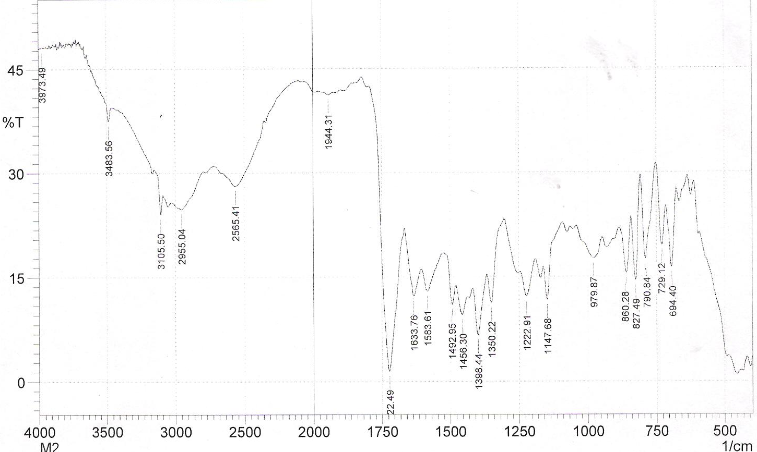
Fig. (1) FTIR spectra of N-4-antipyrinyl maleamic acid ( M1)

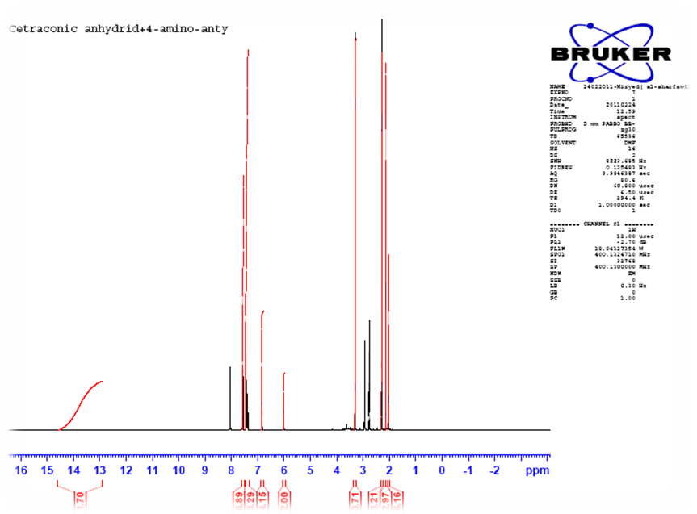
Fig.(2) 1H-NMR spectra N-4-antipyrinyl Citraconamic acid M2
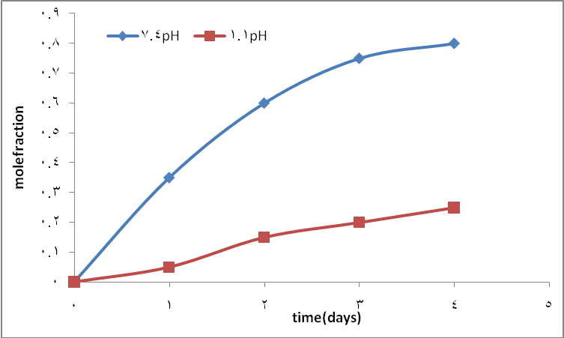
Fig. (3) Controlled release drug polymer P1 in different pH at 37C⁰.
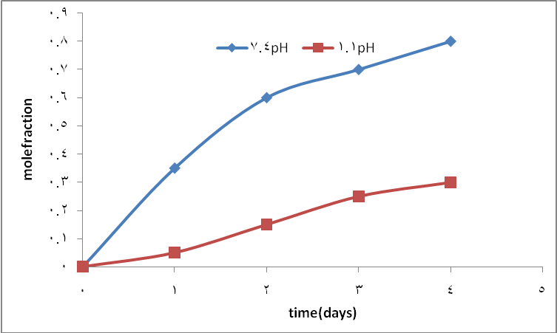
Fig. (4) Controlled release drug polymer P2 in different pH at 37C⁰.
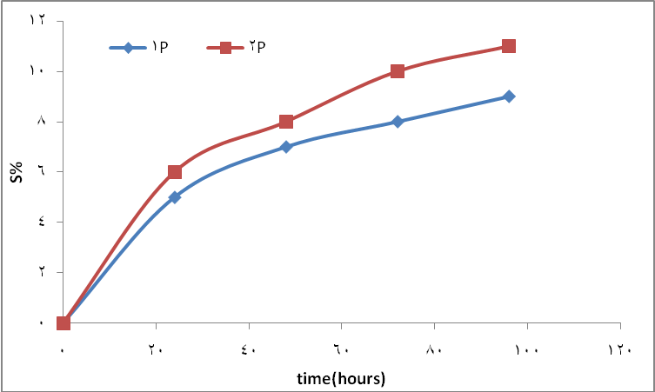
Fig.(5) Swelling curve of P1&P2 at pH7

References
- Madhu N., Radhatrishnan P., Willians E. and Linert W, J. of thermal analysis and culorimetry, 2005, 79,157-161.
- Jayapalan K.,Jatadevan S., Nagappan R., Transition Metal. Chem., 2008, 33, 899-905.
- Surendra P., Ram K., Transition Metal Chemistry, 2007, 32, 143-149.
- Alexander L., Catharina H., Aminoacids, 2009, 36, 333-340.
- Firyal M. , Abbas N. and Khudheyer G., polymers. Fourth Scientific Conference University of Waist. Iraq, 2010, 402-410.
- Firyal M. and Amin H., Iraq, J.Polymer., 2004, 2(3).
- Firyal M.A., J. Um-Salama Scince, 2005, 2(3).
- Firyal M., J, of Education, 2008, (3).
- Agur J. Grodzinki, React. Funct. Polym., 1999, 39,99.
- Ottenbrite R., Dunn R. and Ottenbrite R., eds., Polymeric Drugs and Drug Delivery Systems (ACS Sympoisum Series 469), American Chemical Society, Washington, D.C.,1991, P.3.
- Duncan R. and Kopecek J. Adv. Polym. Sci., 1984, 57, 51.
- Desmedt S., Demeester J., and Hennink W., Pharm. Res., 2000, 17, 113.
- Holmes S. Farley, J.Polym. Mater. Sci. Eng., 1999, 80, 246.

