Preparation , Idendetification and study of The biological activity of Co(II),Ni(II) and Cu(II) with the New Ligand1-[(4-Antipyril)azo]-2- naphthol (4-AAP-2-N)

Rahim. Taher Mehdi
College o Pharmacology, University of Kufa
Ebtihal kadhum kareem
College of Education for Women, University of Kufa
Sahar Aqeel Hussen
Biochemical laboratory, University of Kufa

(NJC)

(Recevied on 25/4/2011 ) (Accepted for publication 11 / 7 /2011)

Abstract
The New ligand of azo naphthol 1-[(4-Antipyril)azo]-2- naphthol (4-AAP-2-N) have been prepared . Three chelate complexes Have also been prepared by reacting this ligand with the metal ions Co (II),Ni(II) and Cu(II). The preparation has been conducted after fixing the optimum conditions of concentration.U.V- visible spectra of these complexes solutions have been studied for a range of pH and concentrations which obey Lampert-Beers Law .The structures of complexes are deduced according to mole ratio method which were obtained from the spectroscopic studies of the complex solutions .The ratios of metal: ligand obtained are (1:2) for all complexes ions .(UV-Vis) absorption spectra of ethanolic solution of complexes showed bathchromic shift , as compared with that of free ligand .The infrared spectra of the chelating complexes have been studied ,this may indicate that coordination between the metal ions and the prepered ligand takes place .The conductivity measurements , Elemental analysis ,the percentage of metal ions and the measurements of magnetic susceptibility of the complexes were determined ,depending on these results , in addition to, the proposed geometrical structures of the complexes of Co (II), Ni(II), Cu(II) ions are octahedral . finally the study of the biological activity of some of these prepared compounds towards two kinds of disease bacteria, which is a positive bacteria for Gram pigment:
1- Staphylococcus aureus
Second classification for negative bacteria including:
2- pseudomonas aeruginosa
The results showed that some of the prepared compounds had inhibition activity toword some types of bacteria.

Keywords: Preparation, Idendetification , new azo naphthol ligand, metal complexes and biological activity.

الخلاصة
تم تحضير الليكاند الجديدة 1- )] 4– انتيبايرايل ) ازو [ -2 – نفثول كما تم تحضير معقدات هذه الليكاند مع ايونات الكوبلت((IIو النيكل (II) والنحاس (II) ، وقد تم التحضير بعد تثبيت الظروف الفضلى للتركيز من خلال دراسة اطياف الاشعة فوق البنفسجية – المرئية لمحاليل مزج هذه الايونات مع محاليل الليكاند ولمدى واسع من التراكيز الخاضعة لقانون لامبرت – بير .وقد تم التعرف على التراكيب المحضرة للمعقدات عن طريق ايجاد النسبة المولية لعلاقة ( الفلز : الليكاند ) بوساطة دراسة اطياف (UV-Vis.) لمحاليل خلط الايونات الفلزية مع الليكاند ، وبينت الدراسة انها (1 : 2) لكل المعقدات. شخص الليكاند والمعقدات الصلبة المحضرة بالوسائل التحليلية والطيفية المتاحة فقد تم تشخيصها بوساطة اطياف الاشعة فوق البنفسجية – المرئية ، كما تم دراسة اطياف الاشعة تحت الحمراء ( IR) للمعقدات. وقد بينت دراسة التوصيلية المولارية انعدام الصفة الايونية للمعقدات المذكورة كما تم اجراء التحليل الدقيق للعناصر وحساب نسبة الايونات الفلزية لهذه المعقدات ًَ ، وبالاعتماد على النتائج المستحصلة فضلا عن قياسات الحساسية المغناطيسية لهذه المعقدات استطعنا الاستنتاج بان المعقدات الكيليتية اتخذت الشكل الهندسي الثماني السطوح في كل من معقدات الكوبلت (II) والنيكل(II) والنحاس(II) . أما المرحلة الأخيرة من البحث فشملت دراسة الفعالية البيولوجية لبعض هذه المركبات المحضرة تجاه صنفين من البكتريا المرضية وهي بكتريا موجبة لصبغة كرام (Gram positive) وضمت النوعين:
1- Staphylococcus aureus
والصنف الثاني بكتريا سالبة لصبغة كرام (Gram negative) وضمت النوعين:
2- pseudomonas aeruginosa
وقد اظهر قسم من هذه المركبات المحضرة فعالية تثبيطية ضد بعض أنواع البكتريا قيد الدرس , ولم يُبدِ القسم الآخر من هذه المركبات أية فعالية تثبيطية تجاه أي نوع من أنواع البكتريا المستعملة .

Introduction
In recent years the azo dye compounds such as imidazole azo and thiazolyl azo have been synthesized and proposed for the determination of several metals ions. These azo compounds are suitable for the analysis of trace heavy metals^{[1]}. Azo colorants are the most important class of synthetic dyes representing (60-80%) of all organic colorants they are used widely in substrates such as textile fibbers , leather, plastic , papers , hair , mineral oils , waxes ,food stuffs and cosmetics ^{[2]}.
Aromatic amines are of growing significance in environmental chemistry due to their hazardous wastes and potential carcinogenic properties ^{[3,4]}. Many other in dustrial applications, such as the manufacturing of dyes, cosmetics, medicines and rubber, release wastes into streams with concentrations as high as 10 g l-1 ^{[5,6]}. Because of their threat to the environment, different methods have been developed to provide a rapid and sensitive means to detect these compounds ^{[7-10]}.
Different colorimetric methods described for phenol determination ^{[11,12]} are based on the
reaction between phenols and 4-AAP to form antipyrine dyes where 4-AAP is found to be the
most sensitive, fast, and precise colorimetric reagent. The reaction product may be any color from red to purple depending on the type of phenolic compounds^{[13]}.the amino group of 4-AAP condenses with phenol to give substance which is oxidized to a colored quinine^{[14,15]}. 4-Aminoantipyrine (4-AAP) is an important derivative of the 5 - pyrazolone class and is used for the detection and determination of number of compounds.However ,literature on the use of 4-aminoantipyrine as an electrophilic coupling reagent in analytical chemistry is very scanty^{[16]}.

Experimental
Materials and physical measurements
All chemicals used were of highest purity (BDH or Fluka) and used with out further purification.
Elemental analysis was carried out by means of micro analytical unit of (Euroverctor, EA300A,Italy) C.H.N element analyzer .Absorption spectra were recorded using Shimadzu UV-Vis 1700 spectrophotometer, for solution of the complexes in aqueous ethanol at room temperature. Using 1cm quartz cell. IR spectra were recorded with FT-IR-8000 Shimadzu, in the range of (4000-400) cm⁻¹ using KBr disc. The magnetic susceptibilities of the complexes were measured on powered samples using the faraday method, for this purpose Balance Magnetic susceptibility model – M.S.B. Auto.Electrical conductivity measured by Digital conductivitymeter Alpha – 800 with solute concentration of 10⁻³M in ethanol at room temperature. pH measurements were carried out using ( PH– meter ), 720 , WTW 82362. ,the metal percentages were determined using atomic absorption technique by Shimadzu -AA-160.
Synthesis and characterization of azo ligand (4-AAP-2-N)
The ligand prepared by dissolving (0.01 mol) of 4-aminoantipyrine in 10 ml of distilled water and 5ml of concentrated hydrochloric acid, then the solution was cooled below 5 °C. To this mixture a solution of (0.01 mol) of sodium nitrate in 10 ml of distilled water was added drop wise at 0-5 °C and the mixture was stirred for 15 min. This diazonium solution was added drop wise to a 500 ml beaker containing (0.01 mol) of 2- Naphthol dissolved in 150 ml of alkaline ethanol. The mixture was allowed to stand over night and acidified with dilute hydrochloric acid to pH = 7.0. The crude dyes were collected by filtration and recystallized from hot Ethanol and then dried in the oven at 60 °C for three hrs. The structural formula of the ligand is shown in figure.1.

_
Figure(1):- Structure of the ligand1-[(4-Antipyril)azo]-2- naphthol (4-AAP-2-N)

Synthesis of complexes
The chelate complexes have been synthesized at optimal pH values dissolved (0.716gm, 0.002 mol) of ligand (4-AAP-2-N)in 10 ml ethanol and then (0.01 mol) of metal chloride, M= Co(II), Ni(II), or Cu(II) dissolved in 10 ml of buffer solution of ammonium acetate (at optimal pH) is added drop wise with vigorous stirring to the ligand solution. The reaction mixture was left over night then the complexes are filtered off washed with distilled water, then with ethanol and dried in desiccators over anhydrous CaCl₂. Table.1 collects the physical properties and analytical data for those complexes are shown in Table 1.

Table(1):- Physical properties and analytical data of the ligand (4AAP-2-N) and its complexes.
No. | Compound | Color | m.p  C° | Found (Calc.)%
 |  |  |  | C | H | N | M
1 | C₂₁H₁₈N₄O2 | Orange | 142 | 70.39  (70.40) | 5.02  (4.90) | 15.64  (15.38) | __
2 | [Co(C₂₁H₁₈N₄O2 )₂] | Red | 201 | 65.03  (65.22) | 4.38  (3.98) | 14.45  (14.09) | 7.60  (7.78)
3 | [Ni (C₂₁H₁₈N₄O2 )₂] | Dark  Red | 176 | 65.05  (64.86) | 4.38  (4.22) | 14.45  (14.62) | 7.57  (7.17)
4 | [Cu (C₂₁H₁₈N₄O2 )₂]. | Brawn | 192 | 64.65  (64.44) | 4.36  (3.95) | 14.36  (14.02) | 8.15  (8.45)

Results and Discussion
Effect of pH
Suitable pH values for metal complex solutions were found to be in the range of (5 – 10). To evaluate the optimal pH values of metal complex solutions by using buffer solution of ammonium acetate The preparation of the complexes has been conducted after fixing the optimum conditions of concentration which obey Lampert-Beers Law these concentration were (5 x 10⁻⁴- 9 x 10⁻⁴⁾M. The effect of pH on the absorbance were studied, and the results are shown in Figs. 2, 3 and 4.

Figure(2):-The effect of pH on the absorbance Of metal complexe Co(II) with the ligand(4-AAP-2-N))at optimal conc. = 9 x 10⁻⁴ M

Figure(3):-The effect of pH on the absorbance Of metal complexe Ni(II) with the ligand (4-AAP-2-N)at optimal conc. = 9 x 10⁻⁴ M

Figure(4):-The effect of pH on the absorbance
Of metal complexe Cu(II) with the ligand(4-AAP-2-N)at
optimal conc. = 9 x 10⁻⁴ M

Metal: ligand ratios
The metal : ligand ratio (M:L)of complexes were determined by the molar ratio method at the wavelength of maximum absorption (λ_{max)} and fixed PH and concentration .The ligand (4-AAP-2-N)was found to form chelates with all metal ions mention as shown in Figs. 5, 6and 7. The results are in agreement with the values reported for some antipyrilazo complexes^{[17,18]}.

Figure(5): the molar ratio (M:L) Of metal ion Co(II) with the ligand(4-AAP-2-N)
at optimal conc. = 9 x 10⁻⁴ M

Figure(6):the molar ratio (M:L) Of metal ion Ni(II) with the ligand (4-AAP-2-N) at optimal conc. = 9 x 10⁻⁴ M

Figure(7):- the molar ratio (M:L) Of metal ion Cu (II) with the ligand (4-AAP-2-N) at optimal conc. = 9 x 10⁻⁴ M

Absorption spectra
The absorption spectra of ligand (4-AAP-2-N) and its complexes were studied and shown in figures 8,9,10 and 11. The wavelength for the maximum absorption ($λ$_{max}) of the ligand was found at 450nm. The spectra of metal complexes were recorded within wavelength range (497– 503) nm. The absorption maxima ($λ$_{max}) of each complex also shown in Table.2. .two absorption bands were appear at the free ligand (4-AAP-2-N) spectrum. The bands at 273 nm referring to the π→π* transitions of Antipyrin ring while the band at 450 nm is due to the charge transfer characters^{[17]}.

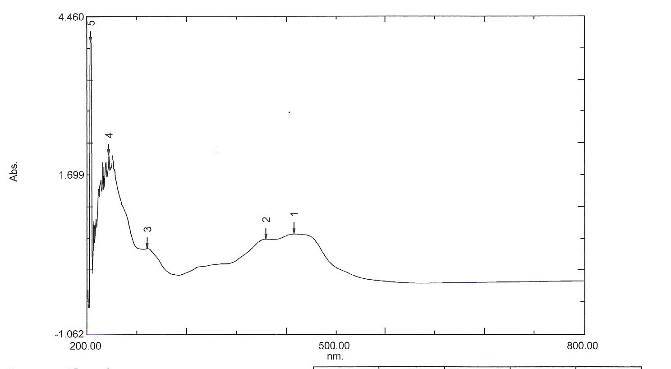

Figure(8):- Absorbance spectra of ligand (4AAP-2-N)

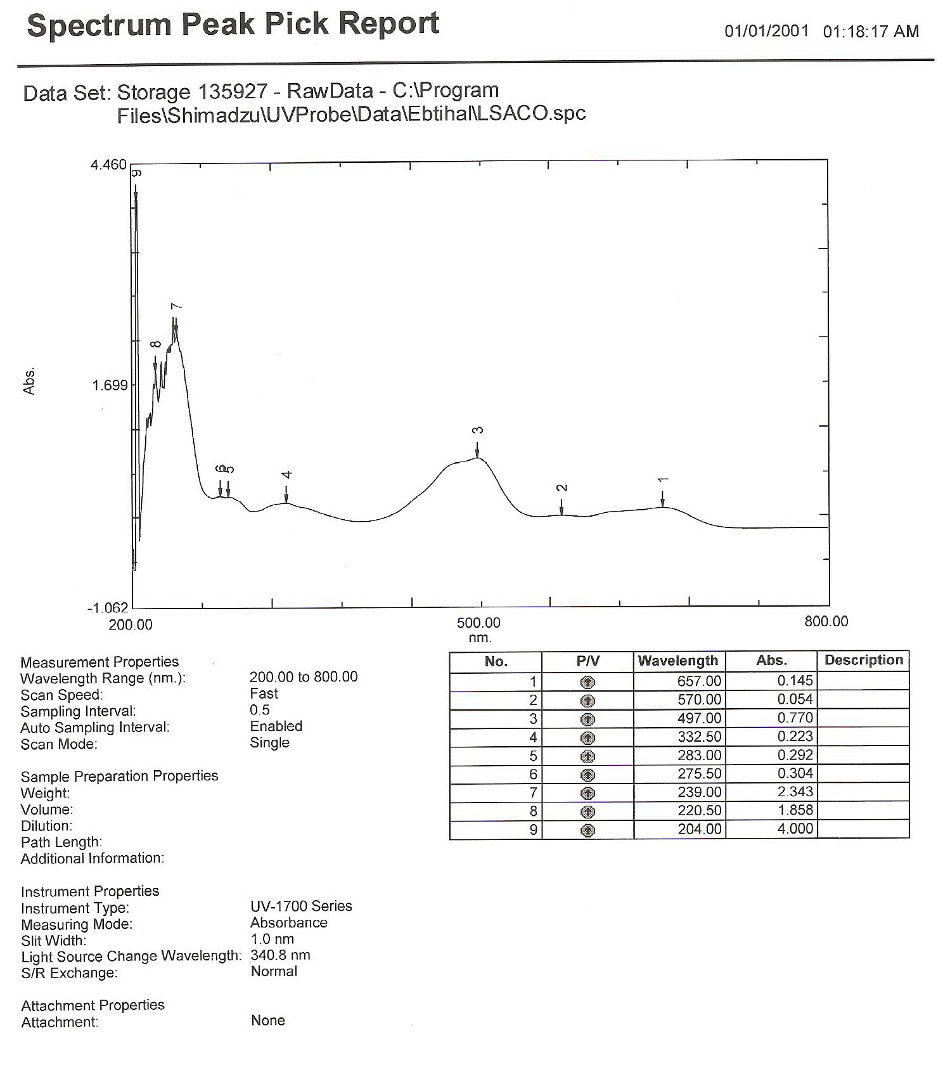

Figure(9):- Absorbance spectra of ligand (4AAP-2-N) with ion complex of Co(II)
Conc.9x 10⁻⁴ M at$λ$max =497
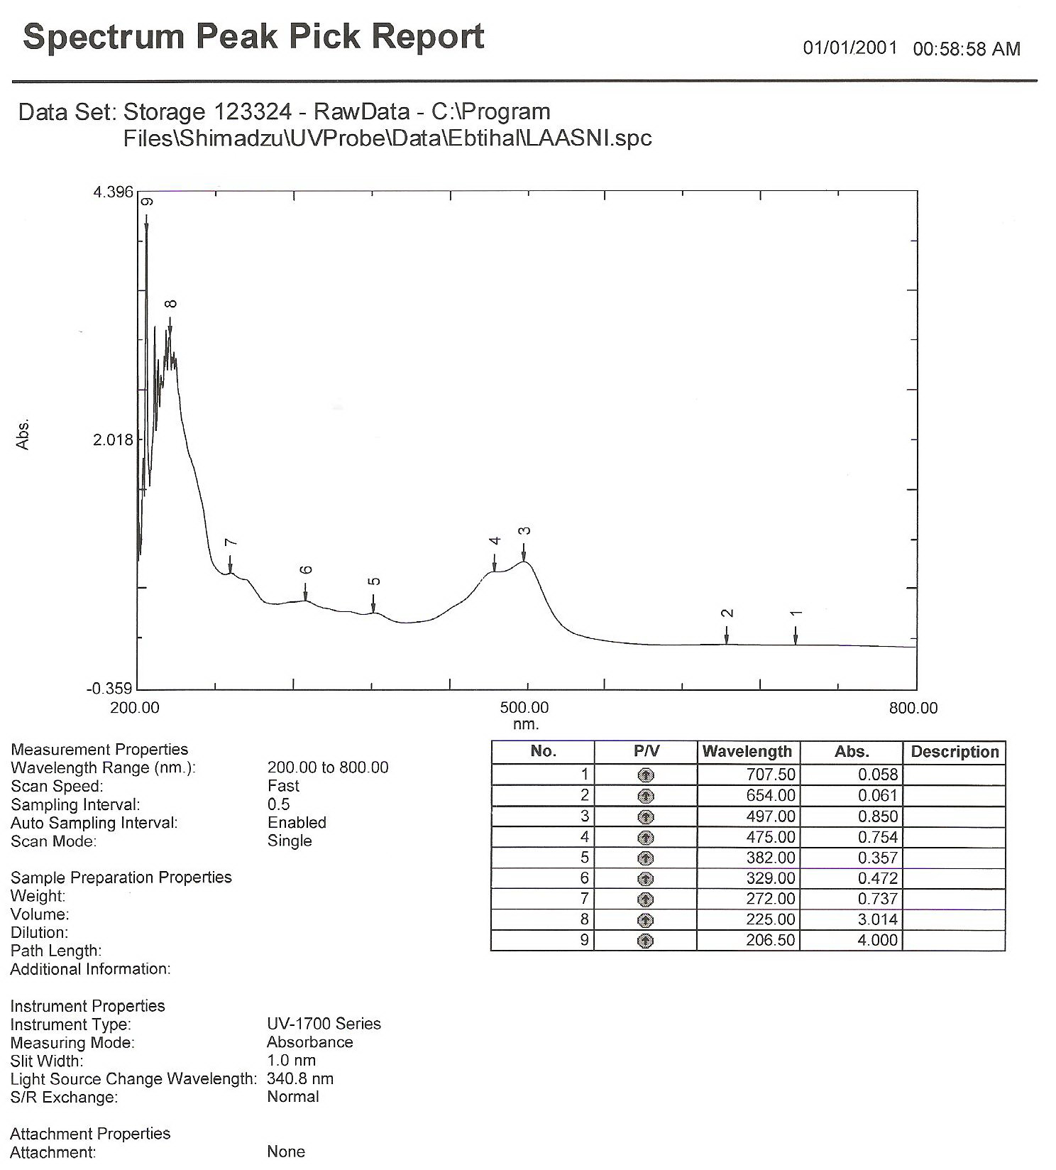

Figure(10):- Absorbance spectra of ligand (4AAP-2-N) with ion complex of Ni(II)
Conc. 9x 10⁻⁴ M at$λ$max =499

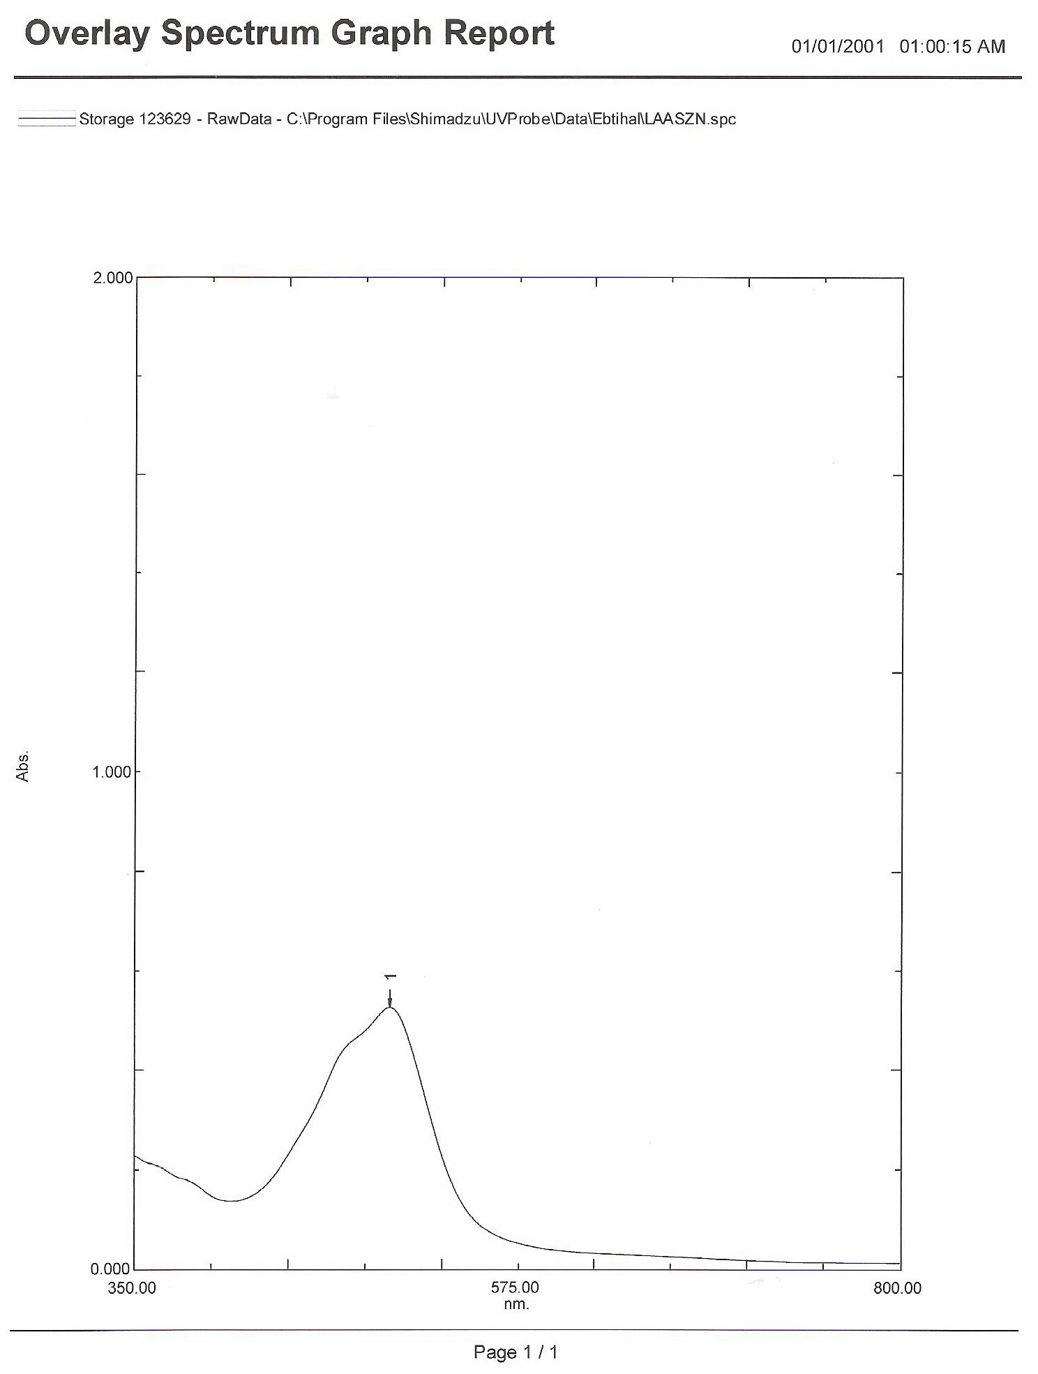

Figure(11):- Absorbance spectra of ligand (4AAP-2-N) with ion complex of Cu(II) Conc. 9x 10⁻⁴ M at$λ$max =503

Table(2):- The optimal pH values, optimal molar concentration and wavelength ($λ$_{max}) metal ions

Metal  Ions | Optimal pH | Optimal molar conc. X 10⁻⁴ M | Optimal wave length ($λ$_{max} )nm
Co(II) | 8 | 9 | 497
Ni(II) | 9 | 9 | 499
Zn(II) | 8 | 9 | 503

Infrared spectra
The infrared spectra of the free ligand (4AAP-2-N) and its complexes with Co (II),Ni (II) ) and Cu(II) are given in Table.3. These spectra are complicated owing to the extensive overlap of number of bands arising from υ(O─H), υ(C═C), υ(C═O), υ(N═N) and other bands due to the Antipyrin and Naphthole rings which appeared in the region below 1700 cm-1. The comparison between the IR spectral data of the free ligand with that of its complexes are discussed as follow:-
- The spectrum of azo ligand (4AAP-2-N) show absorption band around 1680 cm⁻¹due to the υ(C═0)groups. This suggests that the band due to(C═0)group in Antipyrin ringe^{[17]}. band in each of Co (II),Ni(II) and Cu (II) complexes indicates that this band share in complexation. This band is observed with a little change in shape and shifted to lower frequencies (1608 – 1612) cm⁻¹ in complexes. These differences may suggest the linkage of metal ions with oxygen of carbonyl group of heterocyclic Antipyrin ring

- The spectrum of ligand shows absorption band at 1580 cm⁻¹ due to υ(C═C) of Antipyrin and naphthole rings^{[17-19]}.This band is observed with a little change in shape and shifted to lower frequencies (1521 – 1570) cm⁻¹ in complexes. These differences may suggest the linkage of metal ions with nitrogen of heterocyclic Antipyrin ring^{[17]}.
- The azo group (N═N) appears at 1462 cm⁻¹ in the free ligand spectrum. This band has been shifted to different frequencies (1420-1478) cm⁻¹ in complexes spectra; this means that some linkage of metal ions with nitrogen atom of azo group takes place^{[20,21]}.
- The spectrum of azo ligand (4AAP-2-N) show absorption band around 3500 cm⁻¹due to the υ(O-H)group. This suggests that the band due to(O-H)group in naphthole ringe^{[17]}.band in each of Co (II),Ni(II) and Cu (II) complexes indicates that this band share in complexation. This band is observed with a little change in shape and shifted to lower frequencies (3480 – 3487) cm⁻¹ in complexes. These differences may suggest the linkage of metal ions with oxygen of Hydroxide group of heterocyclic naphthole ring
- Finally a new weak bands appears at (412-432) cm⁻¹in the complexes spectra which may suggest the linkage of metal ions with nitrogen atom^{[17,21]}. The IR spectra indicate that azo naphthole ligand (4AAP-2-N) behaves as a tridentate chelating agent coordinated through nitrogen of azo group and the oxygen of carbonyl group of heterocyclic Antipyrin ring and the oxygen of hydroxide group of naphthole ring.

- . Figs. 12, 13, 14 and 15 shows the spectra of ligand (4AAP-2-N), and it,s complexes spectra .

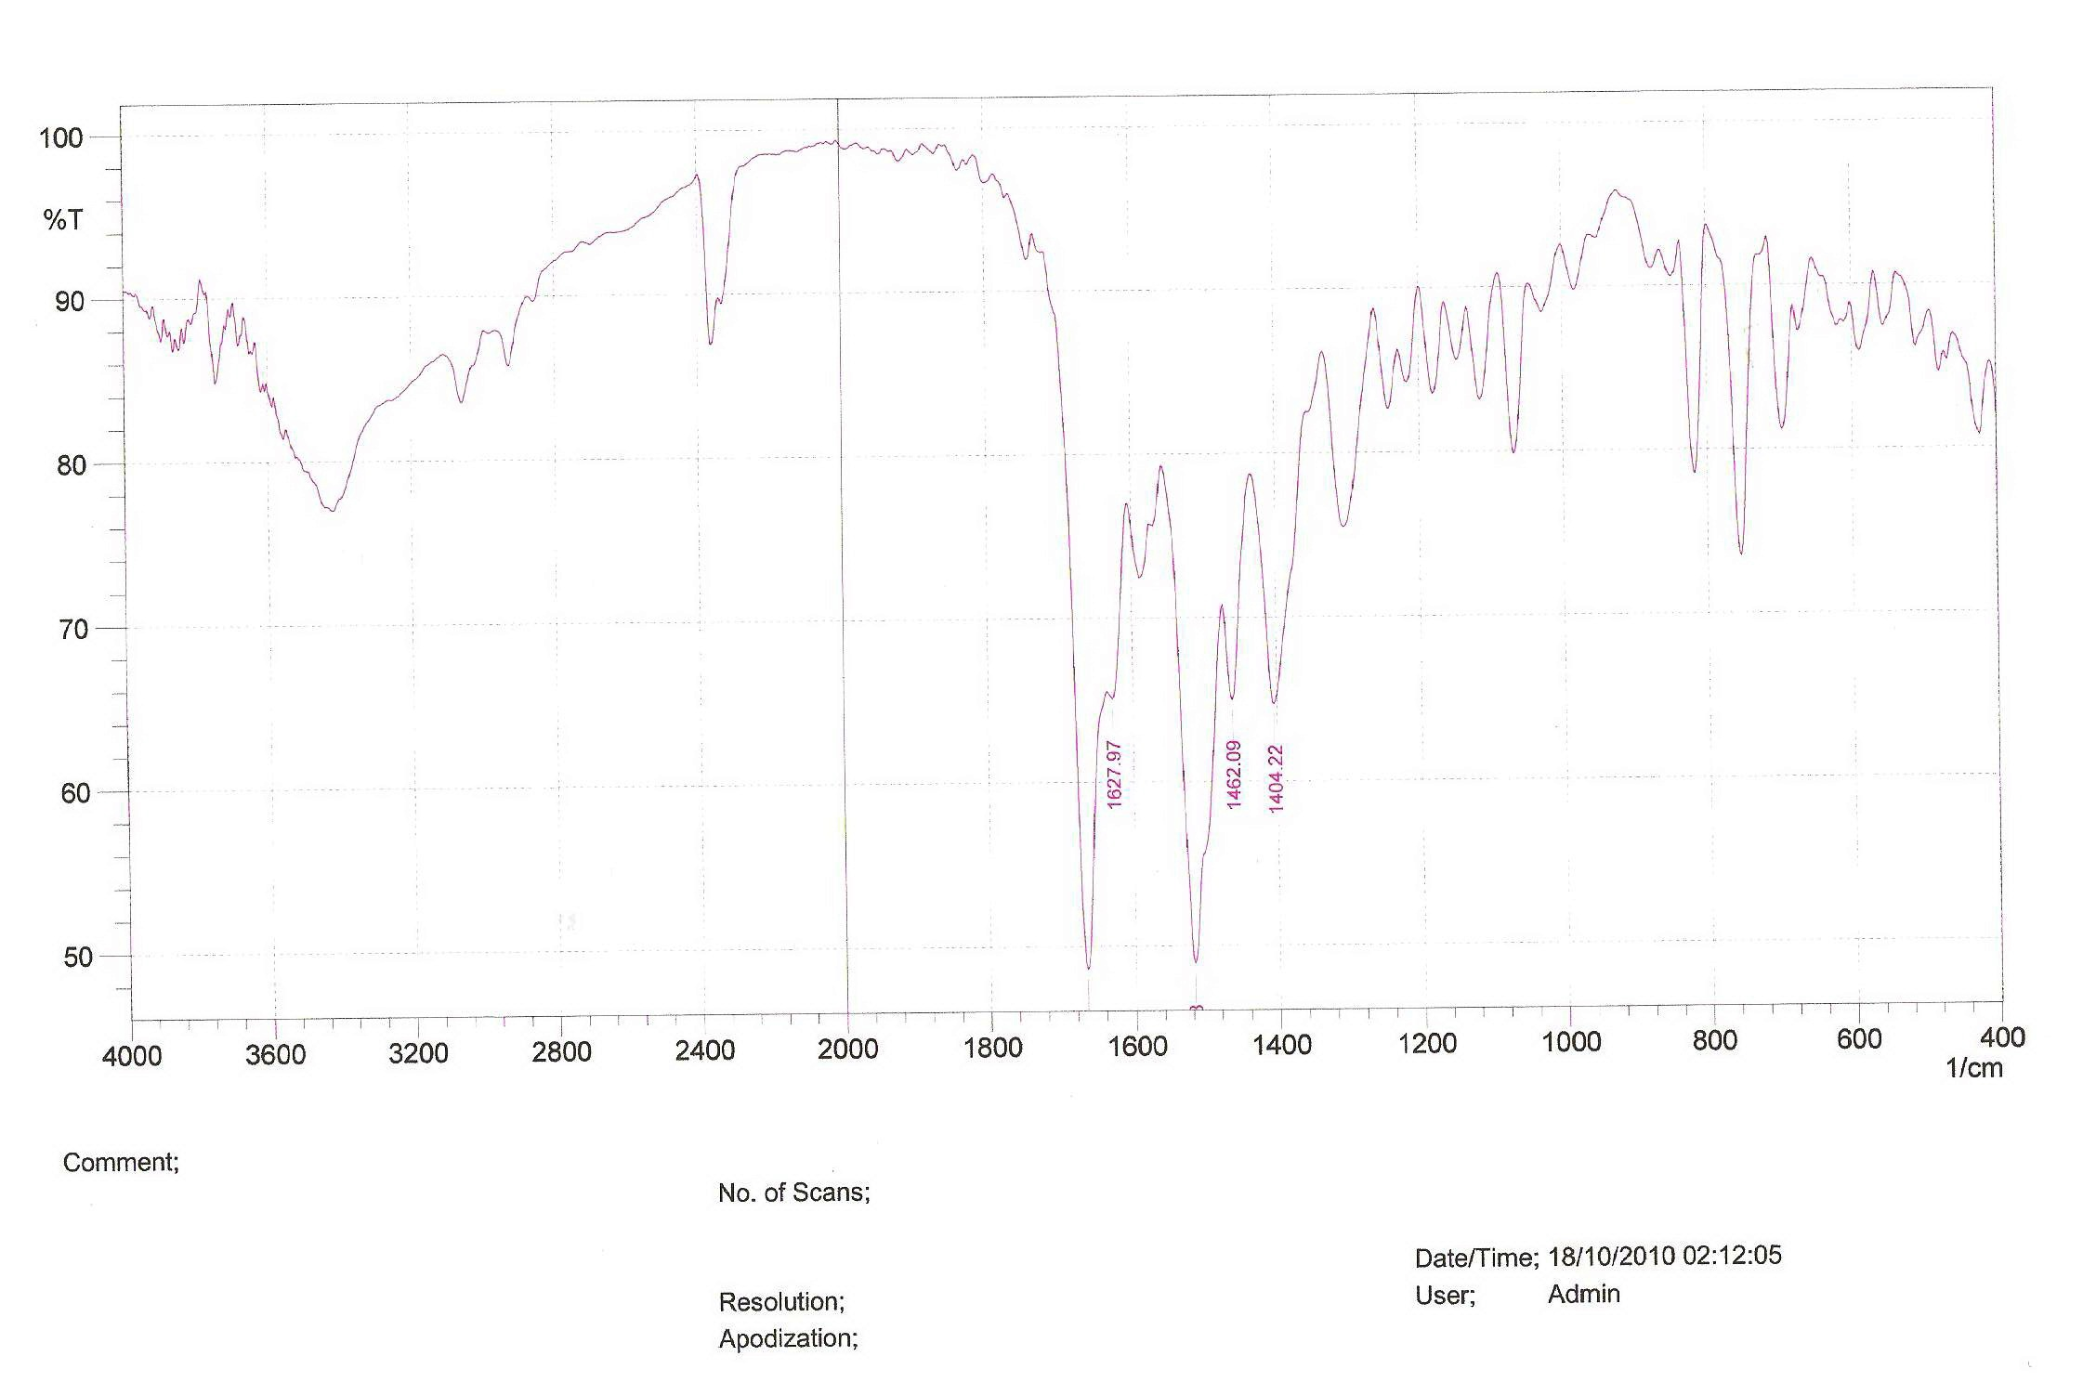

Figure(12):- IR spectrum of the ligand (4AAP-2-N)

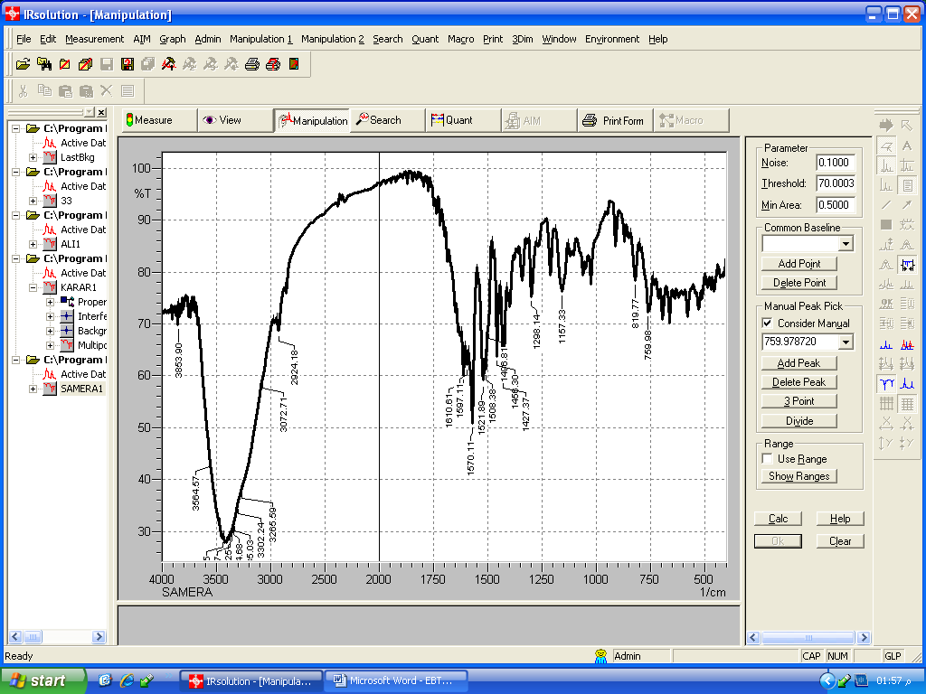

Figure(13):- IR spectrum of ion complex of Co(II) with the ligand (4AAP-2-N)

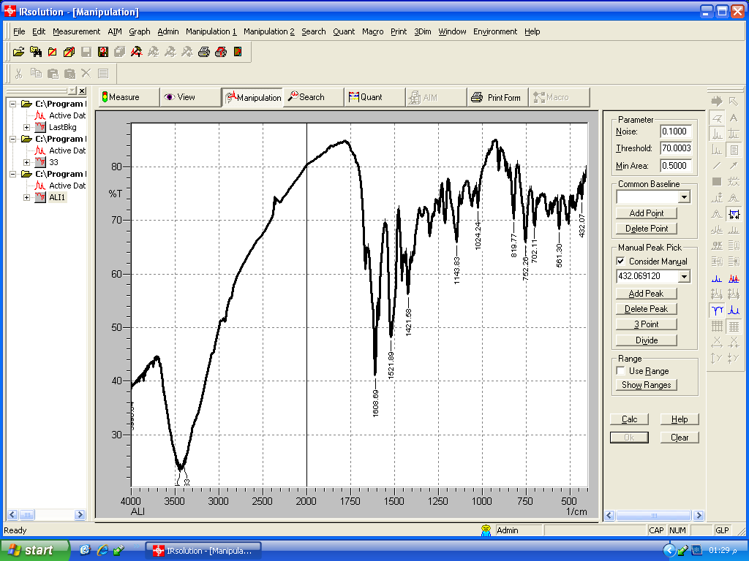

Figure(14):- IR spectrum of ion complex of Ni(II) with the ligand

(4AAP-2-N)

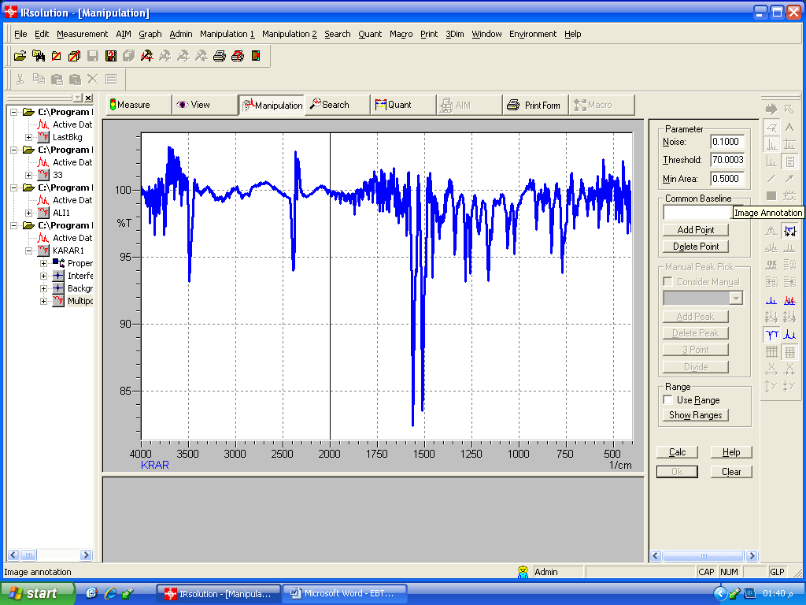

Figure(15):- IR spectrum of ion complex of Cu (II) with the ligand

(4AAP-2-N)

Table(3):- Characteristic IR absorption bands of the ligand (4AAP-2-N) and its complexes in cm⁻¹ units.
No. | Compound | υ(O─H) | υ(C═0) | υ(C═C) | υ(N═N) | υ(M─N)
1 | C₂₁H₁₈N₄O₂ | 3500 | 1680 | 1580  . | .  1462 | ─
2 | [Co(C₂₁H₁₇N₄O₂ )₂] | 3487. | 1610 | 1570 | 1478  . | 420
3 | [Ni(C₂₁H₁₇N₄O₂)₂ ] | 3480 | 1608 | 1521  . | 1421 | 432
4 | [Cu (C₂₁H₁₇N₄O₂)₂]. | 3486 | 1612 | 1560  . | 1420  . | 412

Magnetic susceptibility and electronic spectra measurements
The magnetic momentum and electronic spectra studies have been used to confirm geometry of the complexes .These data are listed in Table.4.

Cobalt (II) complex:The value of magnetic moment of Co (II) was found to be 4.52 B.M, which can be a normal value for octahedral ^{[22,23]}. The magnetic momentum of the Co (II) complex has been found to be paramagnetic and the high spin behavior of this complex indicates that Co (II) is not oxidized to Co (III) during complexation.. Nickel (II) complex :The value of magnetic moment of Ni (II) was found to be 2.85 B.M, which can be a normal value for octahedral Ni (II) complex ^{[24]} . Copper (II) complex :The magnetic moment value of this complex was found to be 1.68 B.M, suggest the presence of one unpaired electron in this complex. It is reasonable to assign distorted octahedral structure^{[25]}

Conductivity measurements
All complexes show the conductivity measurement values ranging between (8.31 – 13.22) S.cm². mol⁻¹in DMSO at room temperature, these values indicating nonionic structure of these complexes^{[7]}.The conductivity values are listed in table 4.

Table(4):- Conductivity measurements, Magnetic moment of complexes

Complex | Conductivity  S.cm².mol⁻¹ | µ_{eff} B.M
[Co(C₂₁H₁₇N₄O₂ )₂] | 8.31 | 4.52
[Ni(C₂₁H₁₇N₄O₂)₂ ] | 6.52 | 2.85
[Cu (C₂₁H₁₇N₄O₂)₂]. | 13.22 | 1.68

According to the results the coordination number of all metal ions is found to be six with bonding through the N of azo group and the O of carbonyl group of heterocyclic Antipyrin ring and the O of hydroxide group of naphthole ring. The structural formula of prepared complexes is most probably octahydral shown in fig.16.

M= Co (II), Ni(II) and Cu (II)

Figure(16):- The proposed structural formula of Co (II), Ni (II)and Cu (II)

Biological Activities of(4-AAP-2-N) and its complexes:
Chemicals on facing the biological system may express multiple effects like, anti bacterial, antifungal, antiviral as well as anti neaplastic effects Besides, they may be inert ^{[26]} In the present work the Biological Activities studied using -Mueller – Hinton agar technique
The diameter of the radius of the inhibitory zone reflects the potency of the tested compound.
using -Mueller – Hinton agar technique was applied in the work to measure the bacterial sensitivity of Staphylococcus aureus, pseudomonas aeruginosa to the ligand(4-AAP-2-N) and its complexes of Co(II), Ni(II), and Cu(II) were tested against each of agram positive and gram negative at the concentration 1x10⁻³M using ethanol as suitable solvent . the results of antibacterial activities show that all the complexes and the the ligand were active against each of agram positive and gram negative except the complex of Nickel was non active against gram negative (pseudomonas aeruginosa). The size of the inhibition zones were determined of each complex the results shown on table(5).

Table(4):- Inhibition area of the bacterial sensitivity to (4-AAP-2-N) and its complexes
Inhibition area  pseudomonas aeruginosa(-) | Inhibition area  Staphlococcus aureus (+) | COMPOUND
+ | ++ | C₂₁H₁₈N₄O₂
+ | ++ | [Co(C₂₁H₁₇N₄O₂ )₂]
- | +++ | [Ni(C₂₁H₁₇N₄O₂)₂ ]
+ | ++ | [Cu (C₂₁H₁₇N₄O₂)₂].

Not:
(0-6)mm =- (Non active)
(6-9)mm =+ ( Slightly active)
(9-12)mm=++ ( Moderately active)
(12-17)mm=+++ ( Highly active)

References
1.A. A. M. Ali, H. J. Mohammed & K. J. AL-adely, J. OF AL-Qadisia for pure science, 2008, 13, 439.
2.Dr.A.Puntener and Dr.C.Page,TFL Leather technology Ltd .V2(2004)1..
3.L.S. Debruin, J.B. Pawliszyn, P.D. Josephy, Chem. Res.Toxicol.,1999, 12, 78.
4. S. Mishra, V. Singh, A. Jain, K.K. Verma, Analyst, 2001, 126, 1663.
5. E.A. Clark, R. Anliker, O. Hutzinger, The Handbook of Environmental Chemistry Berlin: Springer-Verlag, 1980, 3A, 181.
6. D.A. Villalobos, I.D. Buchanan, J. Environ. Eng. Sci., 2002, 1, 65.
7. M. Oyama, K. Kirihara, Electrochimica. Acta, 2004, 49, 3801.
8. M. Kadar, Z. Nagy, T. Karancsi, G. Farsang, Electrochimica. Acta, 2001, 46, 1297.
9. E. Pramauro, A.B. Prevot, V. Augugliaro, L.Palmisano, Analyst, 1995, 120, 237.
10. E.H. Seymour, N.S. Lawrence, E.L. Beckett, J. Davis,R.G. Compton, Talanta, 2002, 57, 233.
11. I. Nukatsuka, S. Nakamura, K. Watanabeand K. Ohzeki, Anal. Sci., 2000, 16, 269.
12. C. Kang, Y. Wang and R. Li, Microchem. J., 2000, 64, 161.
13. Theia'a N. Al-Sabha, Pak. J. Anal. Environ. Chem., 2010, 11(1), 01.07
14.M.E.A.Powell and M.J.H. Smith, J. Clin .Path., 1954, 7, 245.
15. J. Kasthuri, J. Santhanalakshmi, and N. RajendiranJ,. Iran. Chem. Soc., 2008, 5(3), 436.
16. S. Manjula, S. Khana and A. A. Syedb ,Science Asia, 2007, 33,455.
17.F.Karipcin and E.Kablcilar , Acta Chim . Slov , 2007, 54 , 242
18.Muheey.A.Y; Thesis M.SC ,Chemistry Department ,college of Education for Girls ,University of Kufa(2008).
19.B.Sing.R.N.Sing and R.C.Aygarwa Lipolyhhedrones, (1985) ,401.
20.C.Sinha ,and D.Banerjiee , Proc .Indian Acad .Soc ., 2003, 115 ,160.
21.M.Momar and G.Mohamed ,Spectro . Chim .Acta, 2005, A61 , 929 .
22. Figgis B.N , and Lewis .J, Interscience ,New York, 1964, 37(6),141.
23.Lever .A.B.P.Amesterdam,Elsevier, Amsterdam ,London, New York The Netherlands., 1968, 225-243.
24.A..MohamadAli , M.S. Mohamad and M.A.Hadi ,J.of Kufa for Chemical Science, 2011, 2, 64-71.
25.Nicholas.D,Pergamon Press Oxford .1stEd,24 ,(1973),1152-1154.
26. gorove,N.S.Antibiotics Scientific Approach Mirpublishers .Moscow. (1985).

