Preparation and characterization of 4-[6-(purinyl)azo]-1-naphthol and some transition metal complexes

Hasan Sh. Mohammed

College of Science , AL-Qadisia University

(NJC)

(Recevied on 24 /11 /2010 ) (Accepted for publication 10 / 7 /2011)

Abstract

The New bidentate azo dye ligand 4-[(6-purinyl)azo]1-naphthol (PAN) was prepared by reacting a diazonium salt solution of 6-amino purine with 1-naphthol in alkaline solution .
The ligand and its complexes with metal ions; Fe(Ⅱ), Co )Ⅱ(, Ni (Ⅱ)and Cu )Ⅱ(were prepared and characterized by infra-red ( FT.IR) , Uv-visible spectroscopy , atomic absorption ,(C.H.N) analysis , Magnetic susceptibility and molar conductivity measurements .
All complexes were found to have a general formula [M(PAN)₂(H₂O)₂]Cl₂ . The complexes with 1:2 (M:L) showed octahedral geometry around metal ions .The molar conductance data reveal that complexes are electrolytes 2:1, IR spectra show that the ligand is coordinated to the metal ions in a 4-(6-purine azo )-1-naphthol through the azo N and purine heterocyclic N .

الخلاصة
تضمن البحث تحضير الليكاند الجديد صبغة الازو (4-[6-(بيورينيل) ازو]-1- نفثول) ثنائي السن مختصره (PAN), من تفاعل محلول ملح الديازونيوم للقاعدة 6-امينو بيورين مع 1- نفثول في المحلول القلوي .
الليكاند ومعقدات ايوناته الفلزية: الحديد ((II , الكوبلت ((II , النيكل ((II , والنحاس ((II ,شخصت بمطيافية الاشعة تحت الحمراء وكذلك مطيافية الاشعة فوق البنفسجية – المرئية والامتصاص الذري والتحليل العنصري والحساسية المغناطيسية وقياسات التوصيل المولاري, كل المعقدات وجدت بان لها الصيغة [M(PAN)₂(H₂O)₂]Cl₂ وان نسبة الفلز الى الليكاند (M:L) هي (1:2) وان المعقدات المحضرة ثمانية السطوح .
كما بينت قياسات التوصيل المولاري بأن المعقدات المحضرة الكتروليتية بنسبة 2:1 , كذلك الأشعة تحت الحمراء بينت بأن الليكاند ( PAN ) يتناسق مع الايونات الفلزية عن طريق ذرة النتروجين لمجموعة الازو وذرة نتروجين حلقة البيورين غير المتجانسة الخماسية .

Introduction
Azo compounds are a very important class of chemical compounds receiving attention in scientific research ⁽¹⁾.
The azo compounds are used in the determination of trace metals in food and drinking water .They have a great biological activity as well as industrial importance ⁽²⁻⁴⁾.Technological applications of these dyes result from the combination of the properties of the azo-group and several types of aromatic – substituted ligands that confer to them intense color over the whole visible range , thermal and photochemical stability ,non –complex synthetic methodologies and low costs of production ^{(5,6)} .This paper report the preparation and identification of new azo dye(4-[(6-purinyl)azo]1-naphthol ) and some of it's transition metal complexes.
Experimental
The metal percentage in the complexes was determined by using shimadzu flame atomic absorption model ; A.A-160A . Melting points of the studied compounds were measured by stuart scientific melting point apparatus .Magnetic susceptibility for the metal complexes were determined by using Brucker Magnet B.M.6 instrument at 25°C .UV-visible spectra were carried out at (200 – 1000 nm ) with Shimadzu UV –160A Ultra violet -visible spectrophotometer . Molar conductivity for the ligand and complexes with the concentration 10⁻³ M and DMF as a solvent were measured by Philips PW-Digital conductimeter .

IR spectra were recorded on (Shimadzu FTIR-8400 S) , in the 4000 – 400 cm⁻¹ range by using K Br disk .

Preparation of the ligand (4-(6-purine azo )-1-naphthol )(PAN) :

The azo ligand was prepared by dissolving ( 0.5gm,0.00367mol ) of 6-amino purine in 20 mL of distilled water and 3 mL of concentrated hydrochloric acid and diazotized below 5Cº with NaNO₂ (0.25gm , 0.00367mol ) dissolved in 5mL distilled water .

The resulting diazonium chloride solution was mixed with 1- naphthol (0.53 gm , 0.00367mol) dissolved in(20) mL alkaline ethanol and cooled to under 5Cº . The dye was formed immediately . The precipitate was filtered off , recrystallized from ethanol then dried in the oven at 70 Cº . The yield of azo dye 70% and green color .

Preparation of metal complexes:

An ethanolic solution of ligand (PAN) ( 0.0018 mol, 20mL) was added with an aqueous solution of Fe (ІІ) ,Co(ІІ), Ni(ІІ) and Cu(ІІ) chlorides (0.0009 mol ,10 mL). The complexes were filtrated and the precipitates were washed with hot ethanol and dried with air .

Results and Discussion
Infrared Spectra:
The active sites of the ligand and their bonding to the metal ions were characterized by careful comparison of the main Infrared absorption bands of the free ligand and their complexes (Table 1) .
The IR spectrum of the ligand (Fig-1) exhibited two bands at 1670 cm⁻¹ and 1628 cm^{-1 ,} to the stretching frequency ν(C=N) to heterocyclic ring^{(7,8 )} .
These bands assigned were shifted to lower frequencies 1662–1651 cm⁻¹ and 1608. –1593 cm⁻¹ in the spectra of prepared complexes . Which refers to coordinate of nitrogen atom of heterocyclic ring with metal ions ^{(7,9 )}.
The stretching vibration of (N=N) of the ligand appeared at 1454 and 1435 cm⁻¹ ^{(10,11 )}.In the spectra of metal compound this band was shifted to relatively lower frequencies (1456 - 1438 cm⁻¹ ) and (1400 – 1337 cm⁻¹ ) respectively which indicates the coordination of metal ion with the N=N group ⁽¹²⁾.

Table (1 ):The IR spectral data of azo dye (ligand) and its complexes
(KBr,cm⁻¹)

ν(M-O) | ν(M-N) | ν(N=N) | ν(C=N) | ν(O-H) | Componds
 |  | 1485w  1435s | 1670m  1628m |  | Ligand  PAN))
443m | 424m | 1454w  1377m | 1662s  1593m | 3417b | [Fe(PAN)₂(H₂O)₂]Cl₂
470sh | 424m | 1456m  1400 s | 1651sh  1608m | 3417b | [Co(PAN)₂(H₂O)₂]Cl₂
451m | 428w | 1438m  1337m | 1662m  1593w | 3337s.b | [Ni(PAN)₂(H₂O)₂]Cl₂
451sh | 424m | 1442m  1381s | 1658m  1604m | 3380b | [Cu(PAN)₂(H₂O)₂]Cl₂

Spectrum of ligand shows two additional bands at 3414 cm⁻¹ and 3236 cm⁻¹ assigned to ν(O-H) naphthol and ν(N-H) heterocyclic ring respectively combined with broad band at (3417-3337cm⁻¹) due to ν(O- H) of water molecule of the prepared complexes ^{(9,13,14)}.
Two new stretching bands were observed at 428- 424 cm⁻¹ and 470-443 cm⁻¹ and were assignable to the ν(M-N) and ν(M-O) ⁽⁴⁾ .

Magnetic Measurement and Electronic spectra :
The spectral date and the Magnetic Moment of metal complexes are listed in (Table 2 ).
The ligand is characterized by two absorption bands, a modrate intensity band at 36101 cm⁻¹ is attributed to π→π* transition of the benzenoid moiety of the compounds and intra-ligand and a second band with high intensity appeared at 28985 cm⁻¹ ,can be assigned to π→π* transition involving the whol electronic system of the azo –dye ⁽¹⁵⁻¹⁸⁾ . Both bands showed a red shift or absence on coordination with a metal ion . These observation represent a further indication for the coordination of the ligand to the metal ions ^{(1,4)} .
Fe (II) complex

:
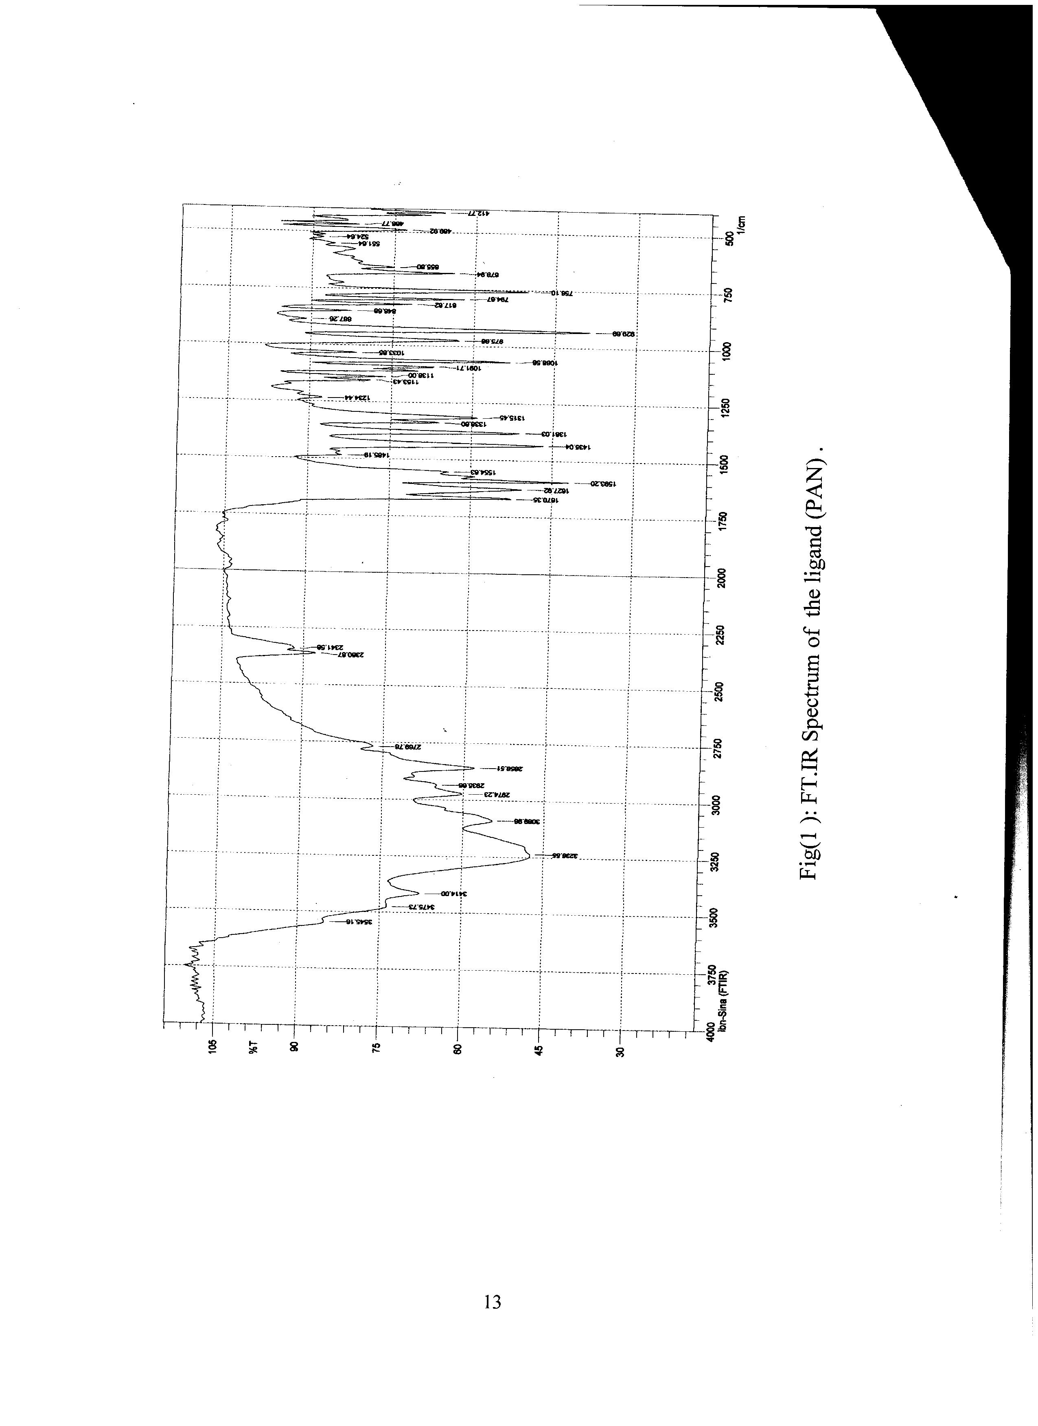

Table (2):UV- Vis ,Magnetic Susceptibility and Conductance Measurements Data:

μ_{eff}  (BM) | Conductivity  (S.cm².mol⁻¹)  in Dmf | Transition | Absoretion  Bands(cm⁻¹) | Compounds
 |  | π→π*  π→π* | 36101  28985 | Ligand(PAN)
4.9 | 140 | π→π* red shift  ⁵T_{2g}→⁵E_{g} | 32894  20080 | [Fe( PAN )₂(H₂O)₂]Cl₂
4.2 | 145 | π→π* red shift  π→π* red shift  ⁴T_{1g}(F) →⁴T_{1g}(P)  ⁴T_{1g}(F) →⁴A_{2g}(F)  ⁴T_{1g}(F)→⁴T_{2g}(F) | 32786  27322  18761  16949  9175 | [Co( PAN )₂(H₂O)₂]Cl₂
2.9 | 145 | π→π* red shift  ³A_{2g}(F) →³T_{1g}(P)  ³A_{2g}(F) →³T_{1g}(F)  ³A_{2g}(F) →³T_{2g}(F) | 31446  21929  14662  7444 | [Ni( PAN )₂(H₂O)₂]Cl₂
1.9 | 135 | π→π* red shift  ²Eg → ²T₂g | 32890  14598 | [Cu( PAN )₂(H₂O)₂]Cl₂

In the spectrum of Fe(II) complex was observed band at 20080 cm⁻¹ and was assigned to ⁵T_{2g}→⁵E_{g} of octahedral complexes for iron (ІІ) ^{(19,20)} .
The magnetic moment of the Fe (II) complex (4.9 B.M) lies well withen the range of octahedral high spin Fe(II) complexes ⁽¹⁹⁾ .
Co (II) complex :
The spectrum of Co(II) complex showed two peaks at 18761 cm⁻¹ and 16949 cm⁻¹ and were assigned to the spin-allowed transition ⁴T_{1g}(F) →⁴T_{1g}(P) , υ₃ and ⁴T_{1g}(F) →⁴A_{2g}(F) , υ₂ respectively . The band υ₁ assigned to to ⁴T_{1g}(F) →⁴T_{2g}(F) , was not observed but was calculated by using υ₂ and υ₃ band positions. The calculated value is 9175 cm⁻¹ characteristic of octahedral stereochemistry ^{(4,10,21)} .
The value of magnetic moment for this complex was found to be (4.2) referring to the presence of three unpaired electron in this compound ^{(10,20)} .
Ni(II) complex :
The electron spectrum of this complex showed two bands spin –allowed transitions at 21929 cm⁻¹ and 14662 cm⁻¹ assigned to the ³A_{2g}(F) → ³T_{1g}(P) υ₃ , ³A_{2g}(F) → ³T_{1g}(F) υ₂ respectively .
The band υ₁ due to ³A_{2g}(F) →³T_{2g}(F) transition was not observed but was calculated by using υ₂ and υ₃ band positions ,the calculated value is 7444cm⁻¹ ^{(22,23)}.
The magnetic moment of Ni (II) complex moment (2.9 B.M) lie well withen the range of octahedral high spin nickel (II) complexes ⁽²⁴⁾ .
The spectrum of the Cu (II) complex exhibited only one broad band observed at 14598 cm⁻¹ and was attributed to the ²Eg → ²T₂g , transition which is consistent with octahedral geometry around copper (II) ion ⁽²⁵⁾ .

The value of magnetic moment for this complex was found to be (1.9 B.M) due to the presence of unpaired electron in this complex ⁽¹⁰⁾ .

The observed molar conductance values in DMF fall in the range (145-130 S.cm².mol⁻¹) . These values of ratio are well consistent with the expected range for electrolyte (2:1).
The molar ratio method was followed to determine the M:L ratio .The results of complexes in ethanol (solvent) , suggest that the metal to ligand ratio was 1:2 , which were comparable to those obtained from solid state study .

The physical analytical data of azo dye (Ligand) and its complexes are given in Table (3 ) , which are in a satisfactory agreement with the calculated values .The suggested molecular formulas also supported by subsequent spectral and molar ratio as well as magnetic moment and the (C.H.N) and atomic absorption .
General suggested stereochemistry structure of complexes according to the above data may be proposed in figure (11) .

Table(3) :Some physical and analytical data of ligand (PAN) and its complexes

Analysis % found (calculated) |  |  |  |  |  |  | Melting point °C |  | color | Compounds
M |  | N | H |  |  | C |  |  | color | Compounds
 | 28.11  (28.92) |  |  | 3.29  (3.44) | 61.32  (62.02) |  |  | 180 | Green | Ligand(PAN)
7.42  (7.50) | 22.34  (22.59) |  |  | 2.87  3.22)) | 48.27  (48.42) |  |  | 225 | red | [Fe( PAN)₂ (H₂O)₂]Cl₂
7.53  (7.89) | 22.37  (22.49) |  |  | 3.20  (3.21) | 47.93  48.22)) |  |  | 230 | violet | [Co( PAN )₂ (H₂O)₂]Cl₂
7.50  (7.86) | 22.34  (22.50) |  |  | 3.23  (3.21) | 47.45  (48.24) |  |  | 227 | Deep red | [Ni( PAN )₂ (H₂O)₂]Cl₂
8.17  (8.45) | 21.36  (22.36) |  |  | 2.97  (3.19) | 48.11  (47.93) |  |  | 268 | Green red | [Cu( PAN )₂ (H₂O)₂]Cl₂

Figure( 11 )Proposed structure for preparation complexes
M=Fe(II) , Co(II) , Ni(II) , Cu(II) .
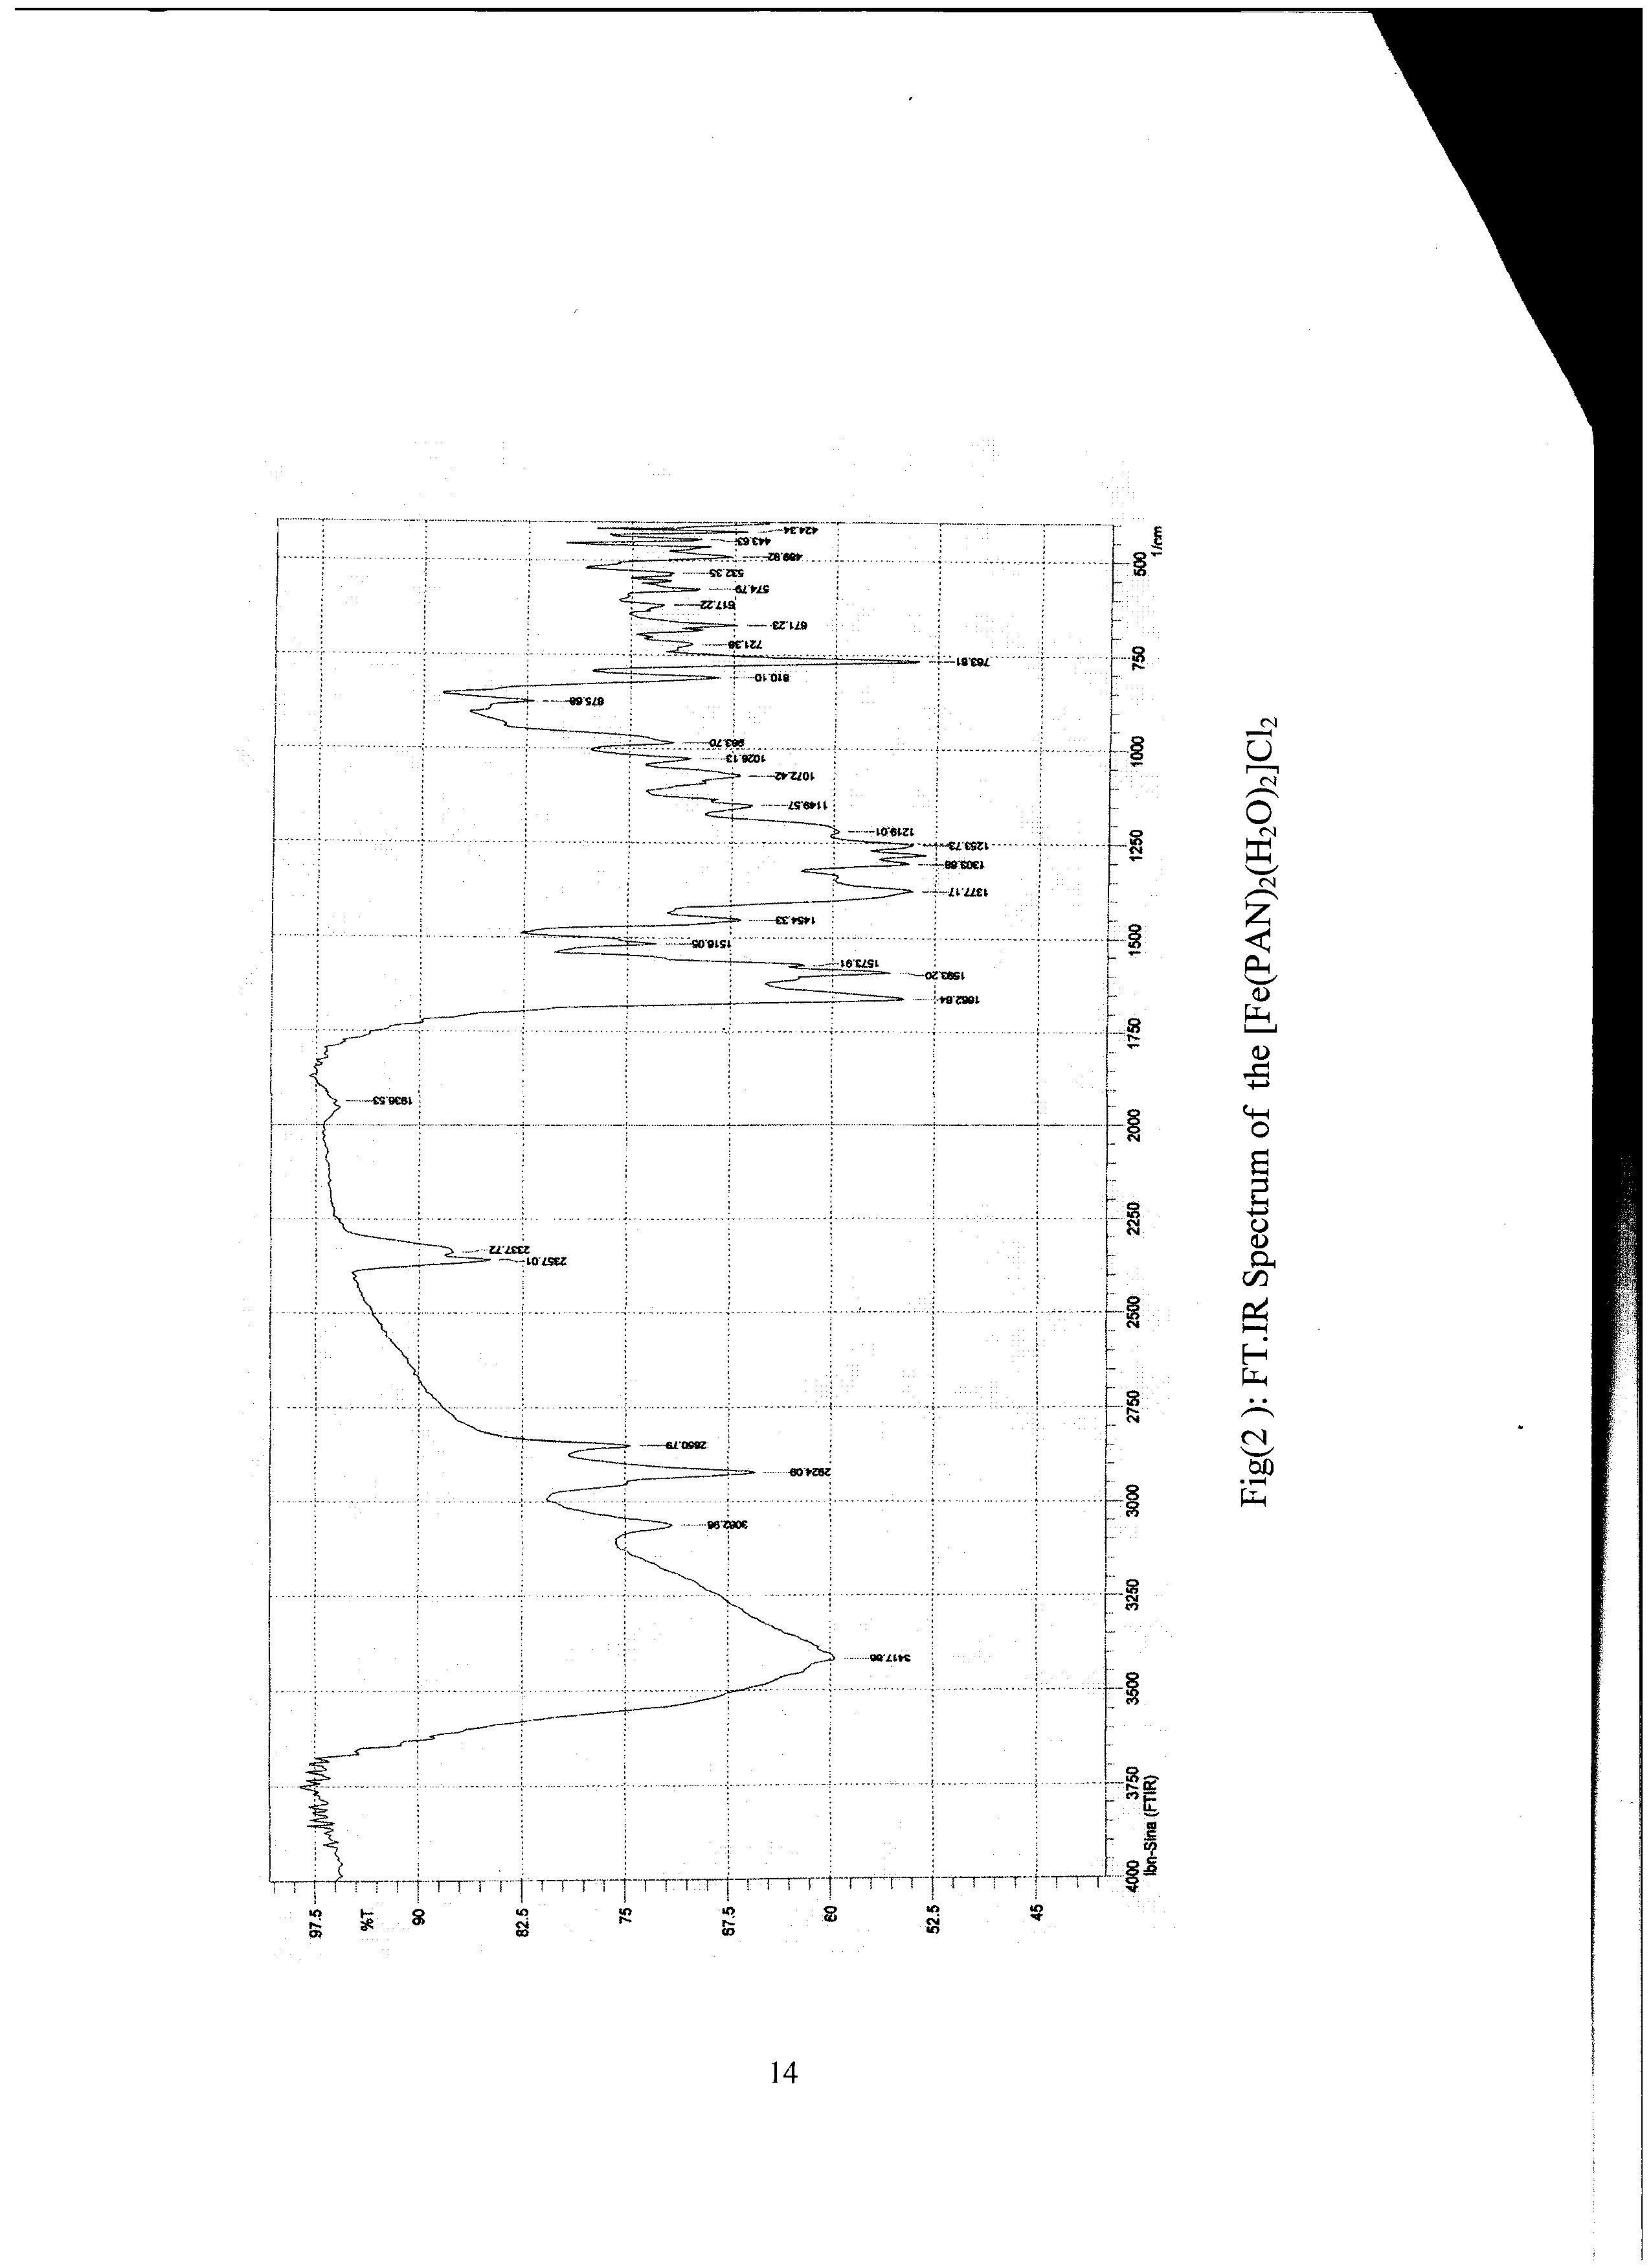
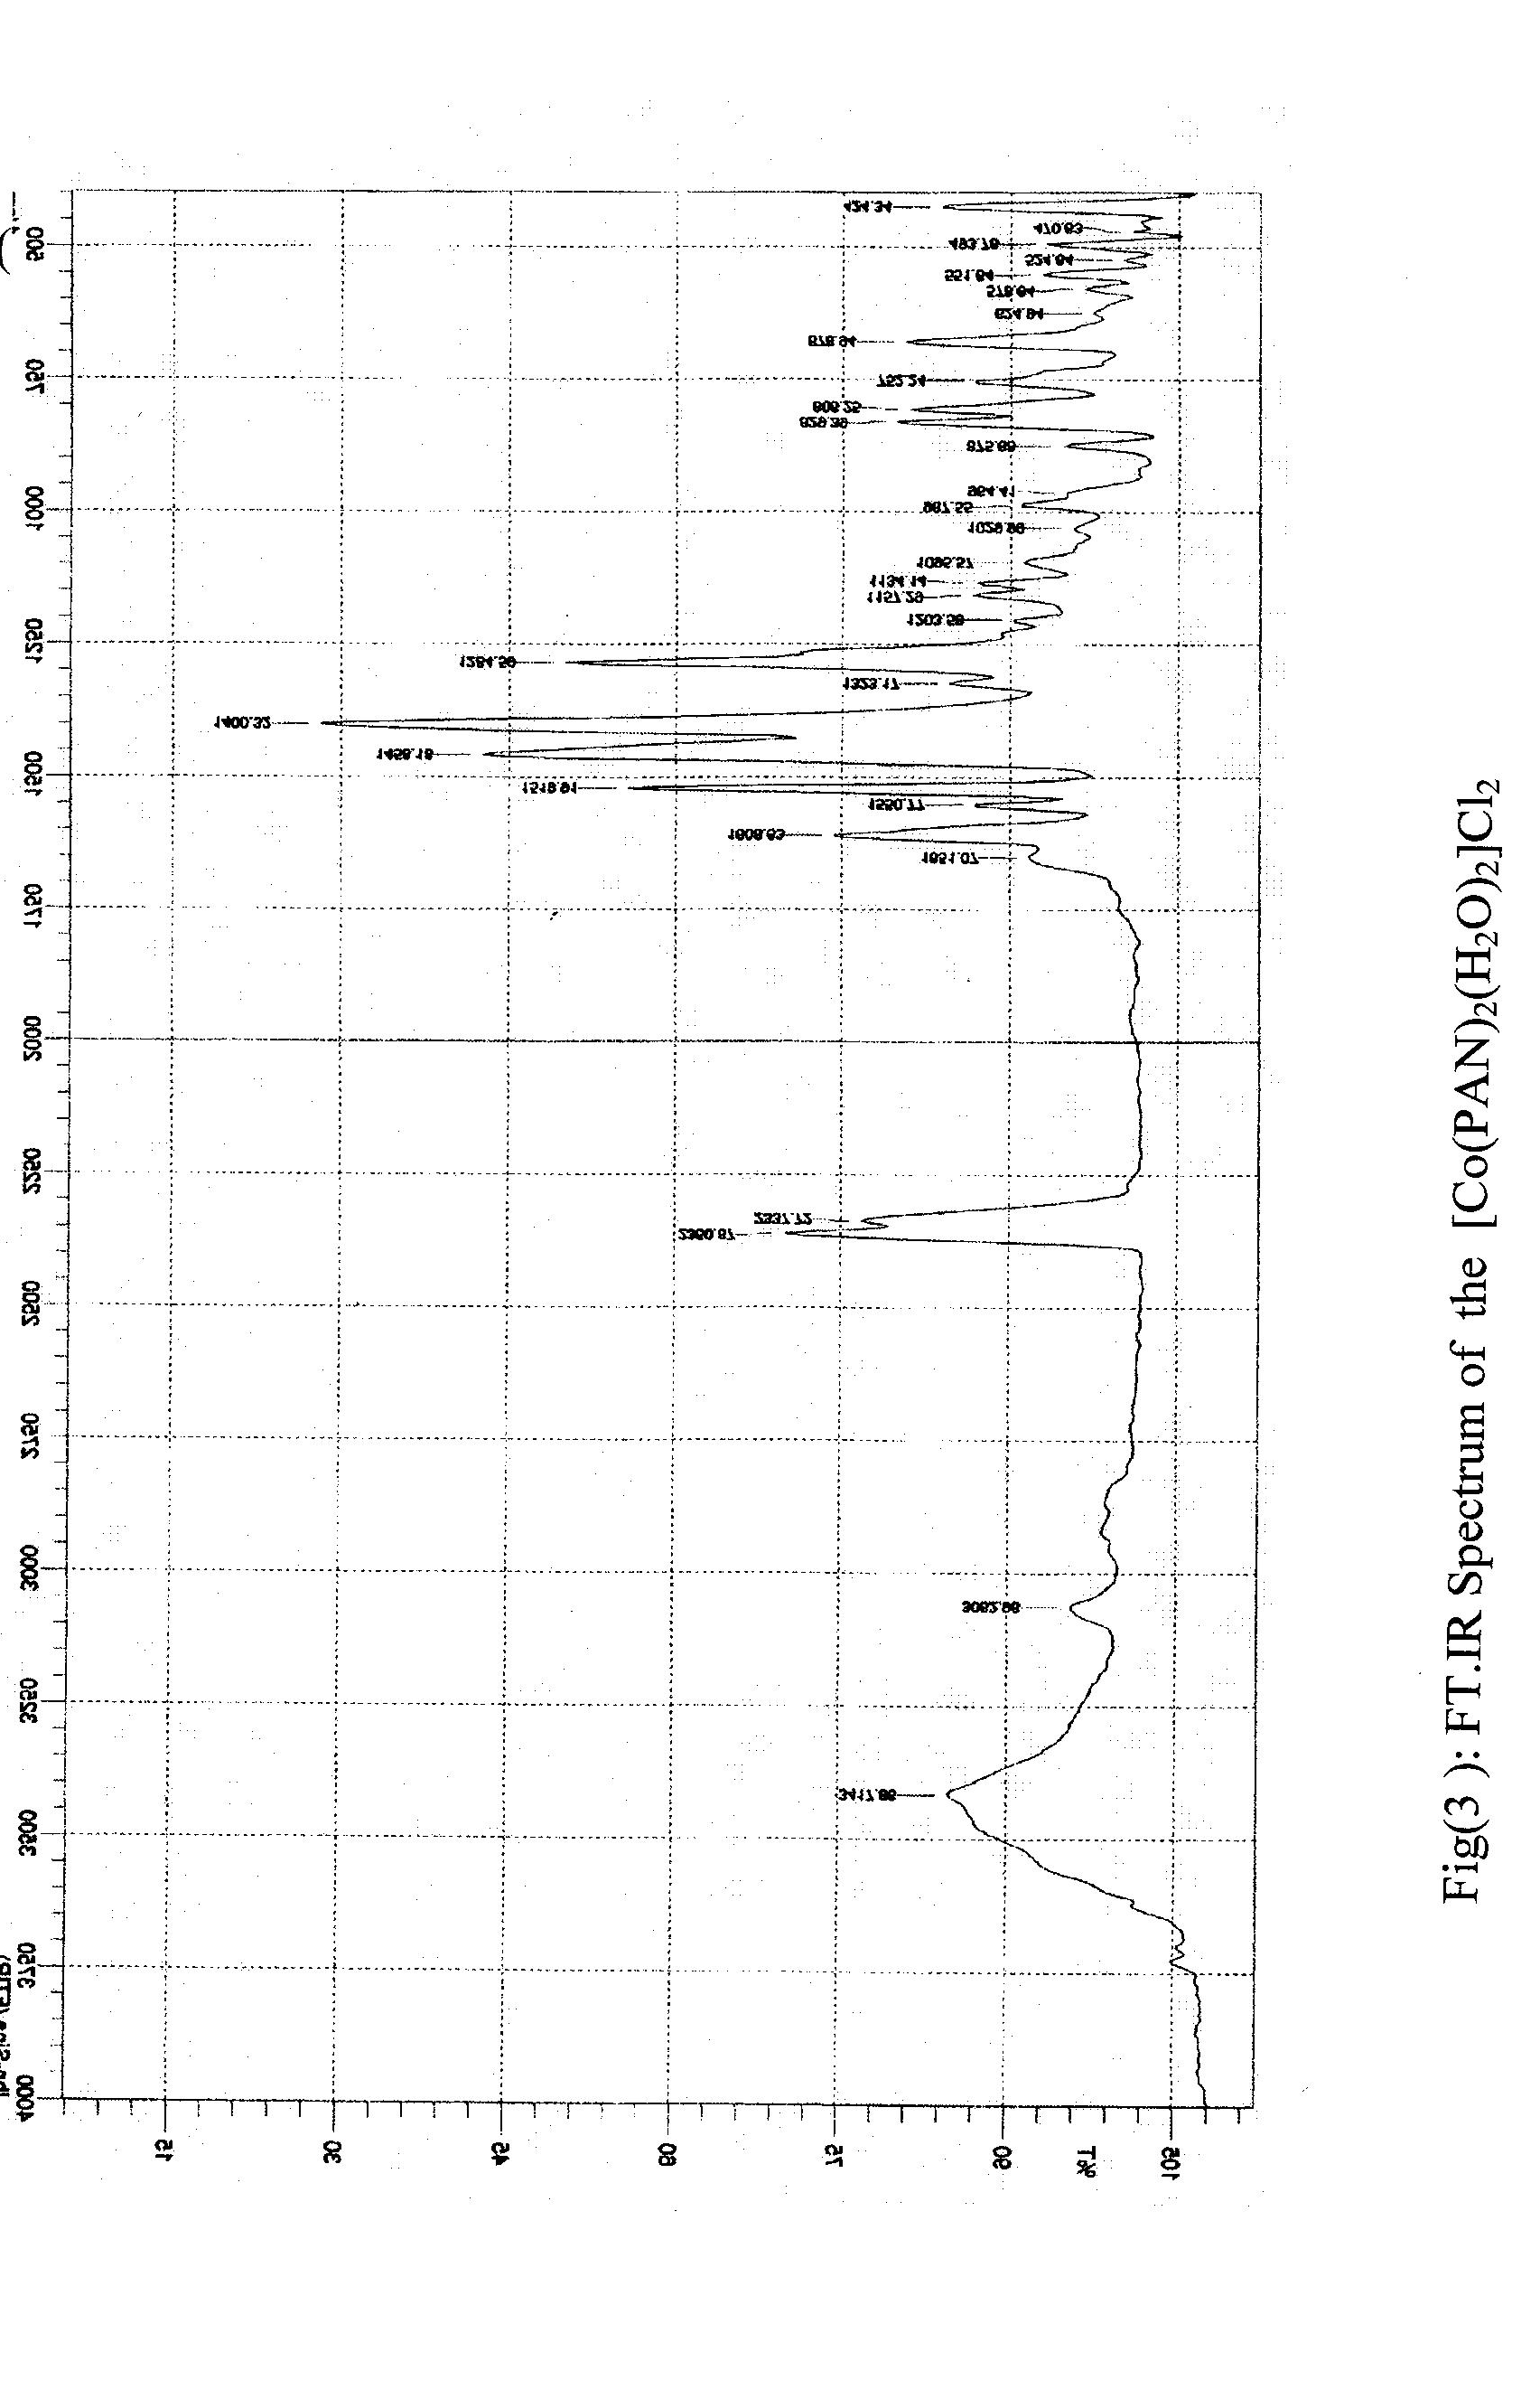

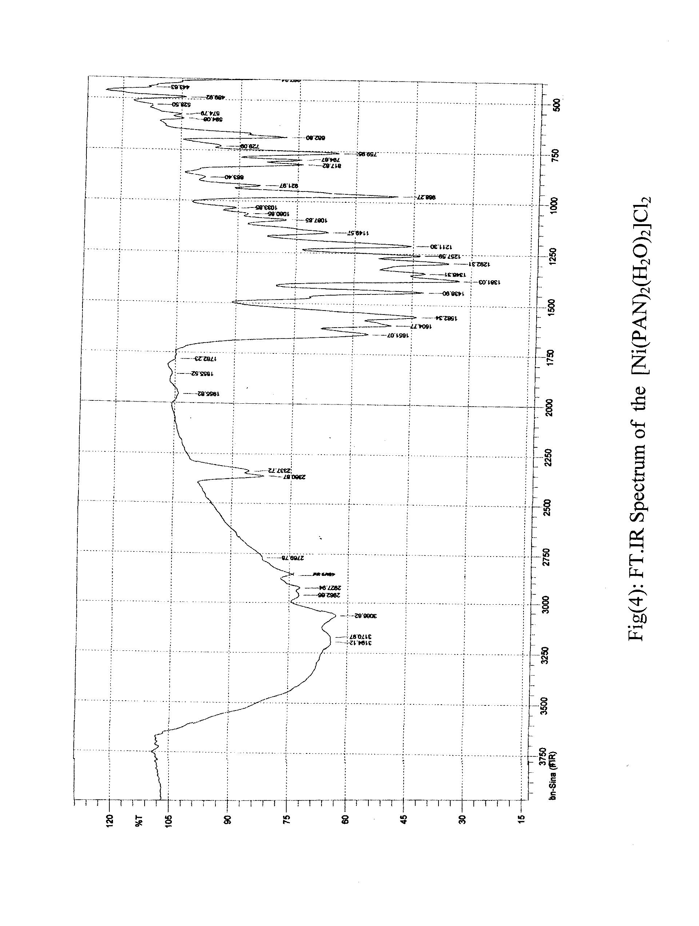

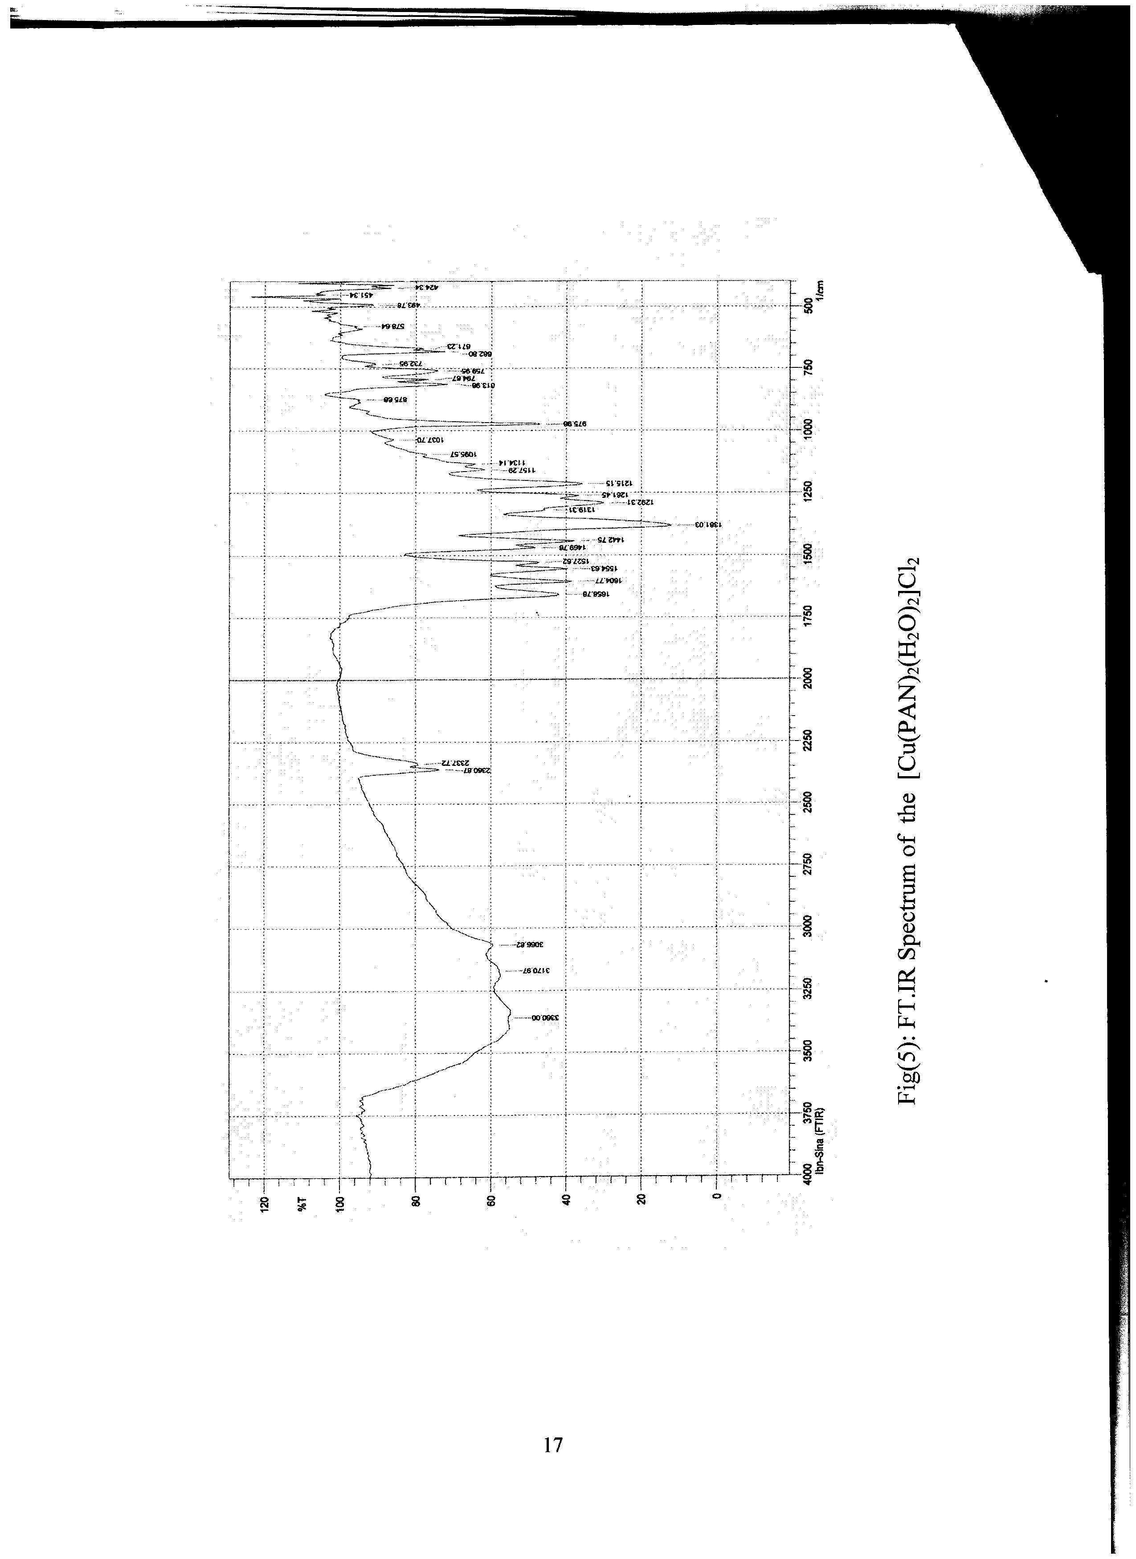

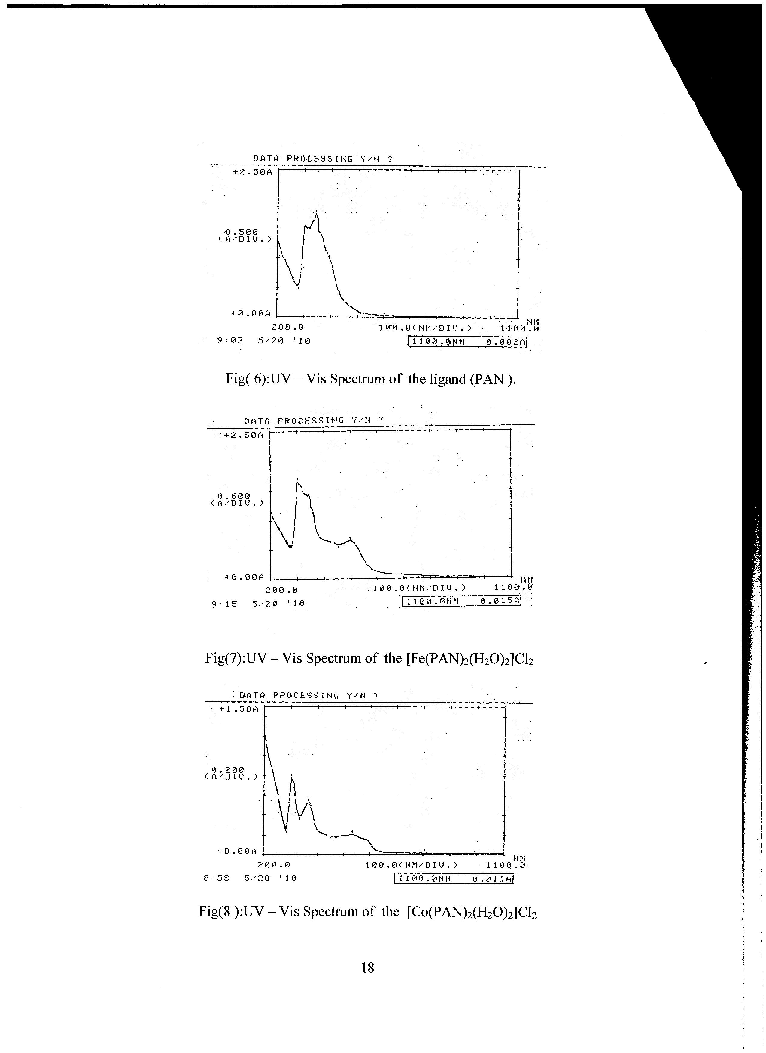

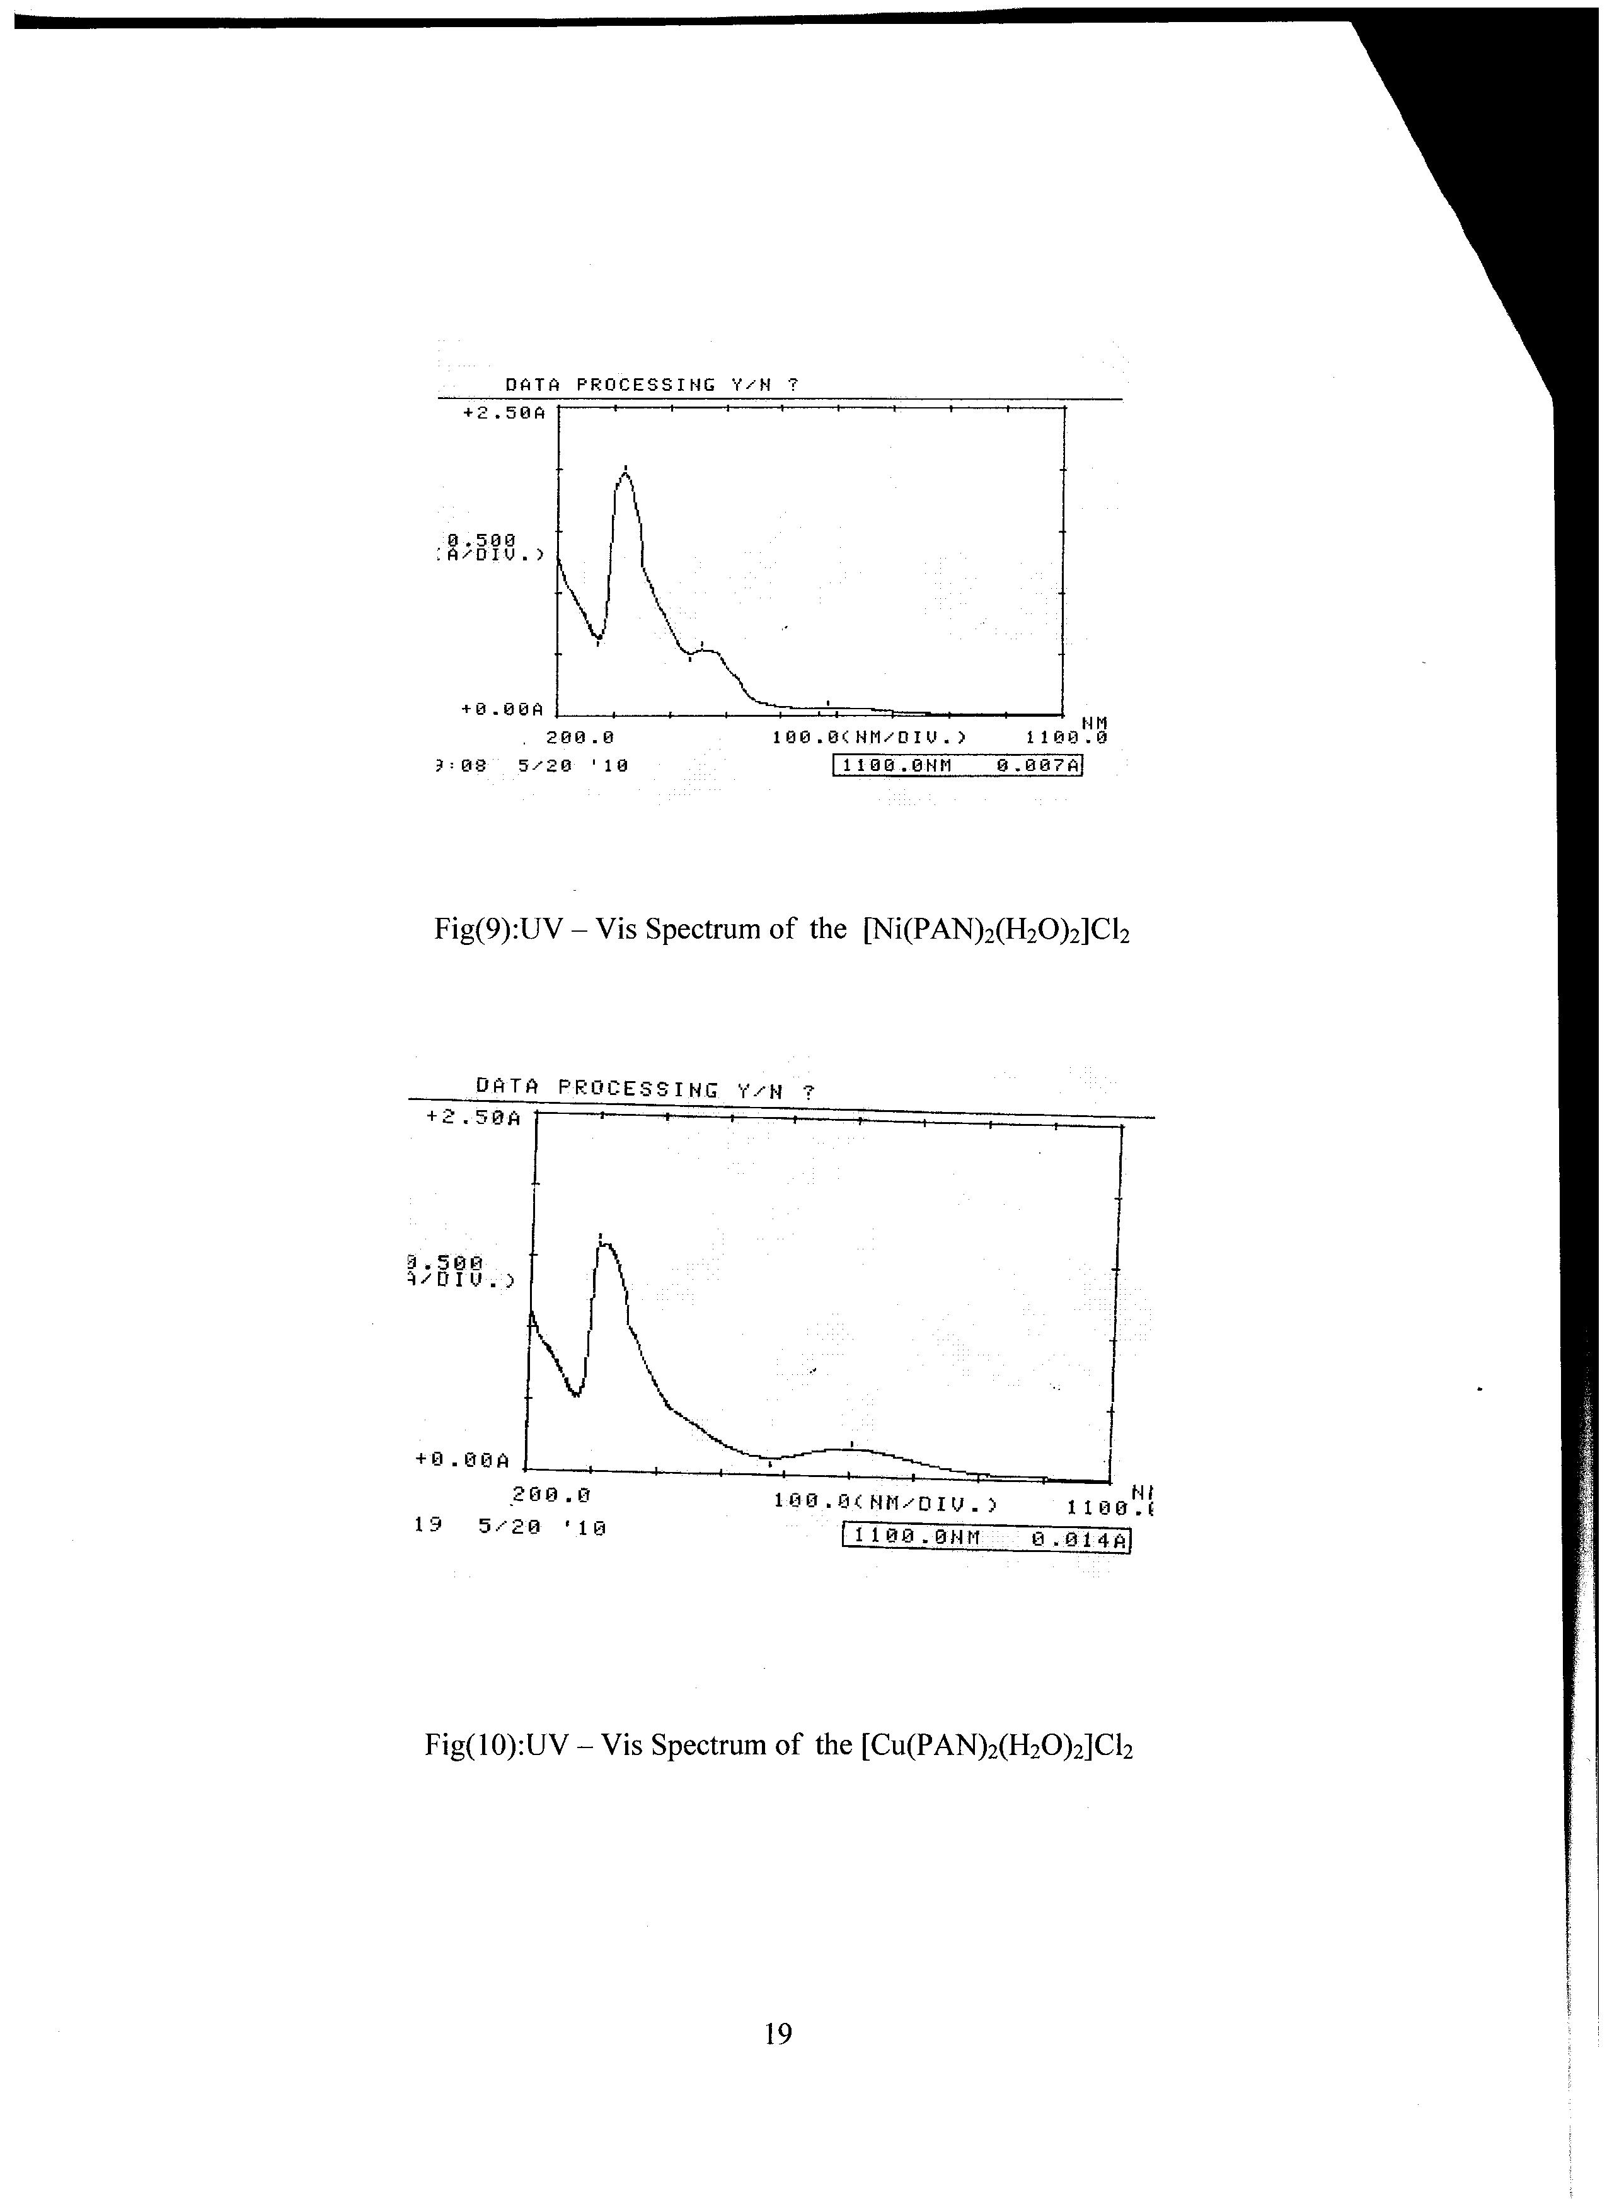

References
- Bulent Kirkan and Ramazan Gup , Turk .J.Chem ., 2008, 32, 9-17 .
- Masoud , Mohamed., J. Kore. Chem.Soc ., 2002, 46, 122-134.
- Alexander D. Garnovskii ,Ali I. Uraev and Vladimir I. Minkin., ARKIVOC., 2004, 3, 29-41.
- Rahim. T. Mehdi and A. M. Ali , National Journal of Chemistry ; 2005, 20, 540-546.
- Salem A. Hameed , Jordan Journal of Chemistry., 2007, 2,133-144.
- Sakkat Z. , Dumont M. , Appl. Phs ., 1992, 54, 487 .
- Aymen Abd Al.Rassol Jewad , Thesis , Babylon .University ,2005 .
- Guser, Zhvakina and . Kozhevnikov , Zh.Aanlit Khim., 1971, 26, 859.
- Sami, W. Radhi , Al-Qadisyah Journal for pure science ; 2009, 14, 171-181.
10- Khalid ,J. Al-Adely , Al-Qadisyah Journal for pure science ; 2007, 12, 134.
11- Lefever , M.F. Odwyer and R.J werners , Aust , J . Chem ; 1953, 6, 341.
12- Azhar A. Ghali , Kasim H. Kadhim , Al-Qadisyah Journal for pure science ; 2009, 14, 71-78.
13- Barvera , Sola and Vinas , Transt . Met. Chem ; 1985, 10233.
14- Kazuo Nakamato ,(1997) "Infrared and Raman spectra of inorganic and coordination compounds" , part B ,5th edition , John Wiley and Sons , Inc.
15- Rageh , A.M. Abd El Mawgoud and H.M. Mostafa , Chem.Papers , 1999, 53, 107.
16- Fan , G . Zhang and C. Zhu , Analyst ; 1998, 123,109.
17- Suzuki T, Shiotsuki M. , Wade K. , Kondo T. and Mitsudo T. , Organ . Metal . Lics ; 1999, 18,18.
18- Mohamoud, A.M. Hammon and S.A. Ibrahim , Z. Phys . Chem., 1984, 265, 203.
19- Fatma Karipcin , Eser Kobalcilar ,Acta .Chim .Slov , 2007, 54, 242 .
20-James E. House (2008) "Inorganic chemistry" Elsevier Inc.
21- Sandhu S.S , Jaswal J. S and Sandhu G. K, Ind . J. Chem ., 1996, 35, 218 -222.
22- Guany P.X.Y and Guang P. F. , J. Med . Gen . Mede., 2002, 22, 6.
23- W. Manchand and W.C. Ferhetins , J. Chem . Educ. , 1661, 38,192.
24 –Hussain Reddy , Indian .J.Chem., 1996, 35, 681.
25- Sacconi and Champolin ,J. Chem. Soc., 1964, 276.

