UV-derivative Spectra of Co-enzyme Q₀. Determination
of trace amounts.

I. J. Al-Nuri K. Y. Rahawi N. B. Sharif
College of Science, University of Mosul, Mosul

(NJC)

(Recevied on 15 /12/2010 ) (Accepted for publication 10/7 /2011)

Abstract
UV derivative spectra were used for the direct quantitative determination of coenzyme Q₀, ubiquinone Q₀, in aqueous solution, the quantification was accomplished according to the integrated area under the peaks and peak amplitude. The zero-order spectrum of coenzyme Q₀ show an absorption band at 268 nm, with molar extinction coefficient ε_{max}=15162 l.mol⁻¹cm⁻¹, the determination limit was 0.02-18.2 µg/ml with R²=0.9999 and relative standard deviation RSD=0.1382 %.
The first, second, and third order spectra were recorder for coenzyme Q₀ in water at different concentrations and the determination limits were estimated.
الخلاصة
لقد استخدمت مشتقة أطياف الأشعة فوق البنفسجية لتحديد كميات مرافق الأنزيم Q₀ في المحاليل المائية بصورة مباشرة، وتم انجاز القياس الكمي وفقا للمساحة المتكاملة في إطار سعة القمم وارتفاع القمة. إن طيف المرتبة الصفرية لمرافق الأنزيم Q₀ أظهرت أقصى امتصاص لها عند 268 نانو متر بمعامل امتصاص مولاري 15162 لتر مول⁻¹ سم⁻¹ ضمن المدى 0.02-18.2 مايكرو غرام/مل بقيمة R²=0.9999 والانحراف النسبي القياسي بلغ 0.1382 %.
كما تم تسجيل أطياف المشتقة الأولى، الثانية والثالثة لمحاليل مائية مختلفة التركيز لمرافق الأنزيم Q₀ وحسب مدى القياس لكل مشتقة.

Introduction
The coenzyme Q series of compounds was first described and named by Crane and coworkers ^{[1,2]}. This group of quinones is also known as the ubiquinone series ( Q series) as named by Morton and coworkers^{[3]}. According to the recommendations of the IUPAC-IUB commission on Biochemical Nomenclature ^{[4]} ubiquinone is the recommendation trivial name for coenzyme Q. However, here, the older name , i.e. coenzyme Q, will be used interchangeably
The chemical structure of coenzyme Q0, C₉H₁₀O₄, 2,3-dimethoxy-5-methyl-1,4-benzoquinone, was first reported by Folker's group^{[5]}. The whole series of coenzyme Q, homologs were synthesized by Mayer and Ister^{[6]} Schame 1.

Scheme 1 Structures of coenzyme Q₀ and Q₁₀

The most important aspect of coenzyme Q chemistry in relation to function are the redox properties of the quinone group and the physical properties of the isoprenoide sidechains. All aspects of the coenzyme Q structure have been modified by synthesis, while some modified coenzyme Q analogs such as the epoxyubiquinone series^{[7]}, and rhodoquinone ^{[8]} occur in nature.
CoQ₁₀ is a vitamin-like nutrient that plays a vital role in cellular energy production. It is also known as ubiquinone because its chemical structure is that of a quinone and it is ubiquitously distributed in nature. The vital role of CoQ₁₀ in the electron transport chain was first described by Dr. Peter Mitchell from England who was awarded the Nobel prize for his work. "Protonmotive Q cycle” in the mitochondrial electron transport chain proposed by Dr. P. Mitchell in 1975 ^{[9]}.
Quinones such as ubiquinone are the lipid soluble electron and proton carriers in the membranes of mitochondria, chloroplasts and oxygenic bacteria. Quinones undergo controlled redox reactions bound to specific sites in integral membrane proteins such as the cytochrome bc₁ oxidoreductase ^{[10]}.
The spectral features of ubiquinones are mainly due to their substituted benzoquinone ring. All ubiquinone homologs display almost identical spectral feature, with a main absorbance in the 268 - 284 nm region given by a π - π* electronic transition of benzoquinone ring. An extensive study of spectral feature of all ubiquinone homologs had been accomplished.^{[11-14]} and as tabulated in Table 1.

Table 1 Spectroscopic properties of various ubiquinone homologs in different solvents.
Ubiquinone | Water  λ_{max}, (nm) | Ethanol  λ_{max}, (nm) | Isooctane  λ_{max}, (nm)
Q₀ | 268 | 263 | 259
Q₁ | 278 | 275 | 271.5
Q₂ | 278 | 275 | 271.5
Q₃ | 278 | 275 | 271.5
Q₄ | 281-284 | 275 | 271
Q₅ - Q₁₀ | 282 | 275 | 271

Different methods such as polarography, spectrophotometric methods ^{[15-16]} and derivative spectrophotometry ^{[17,18]} had been reported for determination of ubiquinone homologs. Some of these methods are time consuming and suffer from lack of selectivity or good sensitivity and/or have short linear dynamic range or have higher limit of detection and/or used reagents not commercially available.
Although, chromatographic methods are characterized by high selectivity and sensitivity, and are giving reliable results, they need expensive equipment and demand highly trained operating personnel. The high performance liquid chromatography (HPLC) method has been highly used in the quality control of drugs because of its sensitivity, reproducibility and specificity. On the other hand, the derivative spectrophotometric (DS) method is very simple, rapid, and economic and allows the determination of drugs with sufficient reliability. DS method is selective, accurate, precise and excellent alternative to the HPLC method.^{[19]}.
Experimental
Pure coenzyme Q solution (1.0×10⁻³ M).
A stock solution of coenzyme Q₀ was prepared by dissolving 0.0182 gm of pure coenzyme Q₀ (supplied by fluka) in 100 ml distilled water. Other concentrations were prepared from this solution by proper dilution with distilled water and their spectra were recorded .
Instrumentation
Shimadzu UV-Visible spectrophotometer model UV-1650 PC, connected to a computer with Pentium 4 processor, The optimized conditions for spectrophotometric measurements were derivative modes ¹Dr (d¹A/dλ¹), ²Dr (d²A/dλ²), ³Dr (d³A/dλ³) scan speed fast, slit width 2nm, derivative UV spectra were recorded over a wavelength range of (200-400) nm, using (1×1×3) cm matched quartz cells.
HPLC apparatus Shimadzu LC 2010 HT were used for the measurement.
Result and Discussion
The zero order spectrum of coenzyme Q₀ in water shows an absorption band at λ_{max}=268 nm with molar extinction coefficient 15162 l. mol⁻¹. cm⁻¹ and another band at λ_{max}=406 nm with molar extinction coefficient ε _{max} = 740 l. mol⁻¹. cm⁻¹. For quantification of coenzyme Q₀ the band at λ_{max} =268 nm where chosen.
The zero, first, second and third order derivative spectra of coenzyme Q₀ in water for a series of different molar concentrations ranging between 1.0×10⁻⁸ - 1.0×10⁻⁴ M were recorded Figure 1. The zero-order spectrum shows an absorption at λ_{max} = 268 nm with a molar extinction coefficient ε _{max}=15162 l. mol⁻¹cm⁻¹. The plot of the recorded absorbance against the molar concentration of pure coenzyme Q₀ result in a straight-line obeying the Beer's-Lambert law within a concentration range of 1.0×10⁻⁷- 1.0×10⁻⁴ M and a determination range of 0.02 - 18.2 µg/ml, with R² = 0.9999, and RSD =0.1382 % (Table 2, Figure 2).

Table 2. The absorbance and integrated area for various derivatives spectra of pure coenzyme Q₀ in water.
Molar Concentration of Q₀ | Absorbance | Integrated area
Molar Concentration of Q₀ | zoro order | +ve 1st.order | -ve 1st.order | 2nd.order | -ve 3rd.order | +ve 3rd.order
Molar Concentration of Q₀ | 268 nm | 230-268 nm | 268-342 nm | 254-284 nm | 222-268 nm | 268-292 nm
1.00E-04 | 1.533 | 9.964 | 13.262 | 11.093 | 9.623 | 11.385
9.00E-05 | 1.357 | 8.851 | 11.743 | 9.797 | 8.611 | 10.103
7.00E-05 | 1.060 | 6.881 | 9.173 | 7.663 | 6.751 | 7.878
5.00E-05 | 0.764 | 4.933 | 6.602 | 5.506 | 4.916 | 5.660
3.00E-05 | 0.456 | 2.887 | 3.941 | 3.274 | 3.009 | 3.369
1.00E-05 | 0.151 | 0.873 | 1.291 | 1.053 | 1.136 | 1.088
9.00E-06 | 0.141 | 0.830 | 1.212 | 0.990 | 1.058 | 1.020
7.00E-06 | 0.109 | 0.624 | 0.938 | 0.758 | 0.858 | 0.781
5.00E-06 | 0.079 | 0.438 | 0.676 | 0.540 | 0.677 | 0.560
3.00E-06 | 0.048 | 0.244 | 0.411 | 0.320 | 0.487 | 0.332
1.00E-06 | 0.019 | 0.059 | 0.164 | 0.107 | 0.304 | 0.113
9.00E-07 | 0.017 | 0.046 | 0.149 | 0.092 | 0.292 | 0.098
8.00E-07 | 0.017 | 0.037 | 0.143 | 0.083 | 0.283 | 0.090
7.00E-07 | 0.016 | 0.028 | 0.134 | 0.073 | 0.274 | 0.078
6.00E-07 | 0.015 | 0.017 | 0.124 | 0.061 | 0.266 | 0.067
5.00E-07 | 0.014 | 0.012 | 0.115 | 0.053 | 0.254 | 0.058
4.00E-07 | 0.010 | - | 0.088 | 0.042 | 0.226 | 0.046
3.00E-07 | 0.009 | - | 0.076 | 0.031 | 0.221 | 0.035
2.00E-07 | 0.005 | - | 0.054 | 0.021 | 0.210 | 0.022
1.00E-07 | 0.004 | - | 0.037 | 0.010 | 0.206 | 0.012
5.00E-08 | - | - | 0.025 | - | 0.196 | -
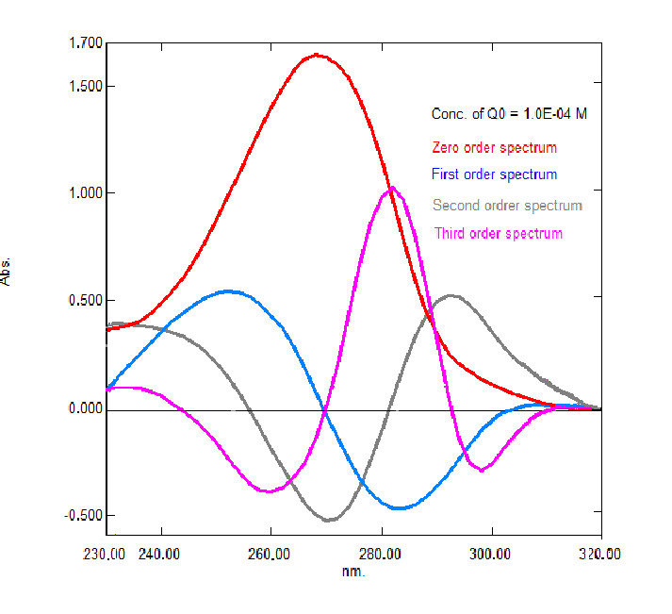  1.00E-08 | - | - | - | - | 0.191 | -

Fig 1. The UV-spectra of pure coenzyme Q₀ (1.0×10⁻⁴ M) in water .

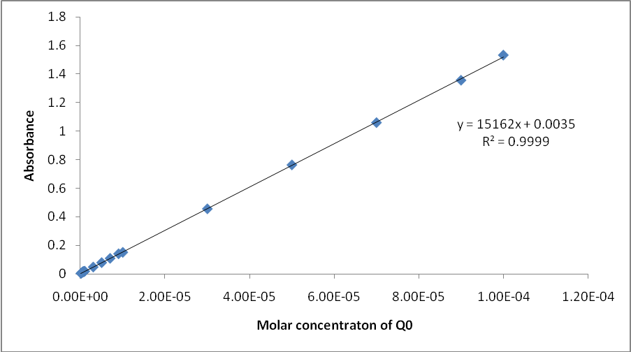

Fig 2.The calibration curve of the zero-order spectra of pure coenzyme Q₀ solutions.

The first-order derivative spectrum of pure coenzyme Q₀ shows a positive peak at (λ=230-268) nm, crossing the zero-axis at λ = 268 nm and a negative peak at (λ = 268-314) nm (Figure 3). The quantitative determination of pure coenzyme Q₀ was accomplished through plotting of a calibration curve between the integrated area under the positive peak against the molar concentration of pure coenzyme Q₀ solutions. The result was a straight- line obeying the Beer's-Lambert law with a determination limit of (0.1-18.2) μg/ml, R²=0.9999 and RSD =0.7061 % (Table 2, figures 4).

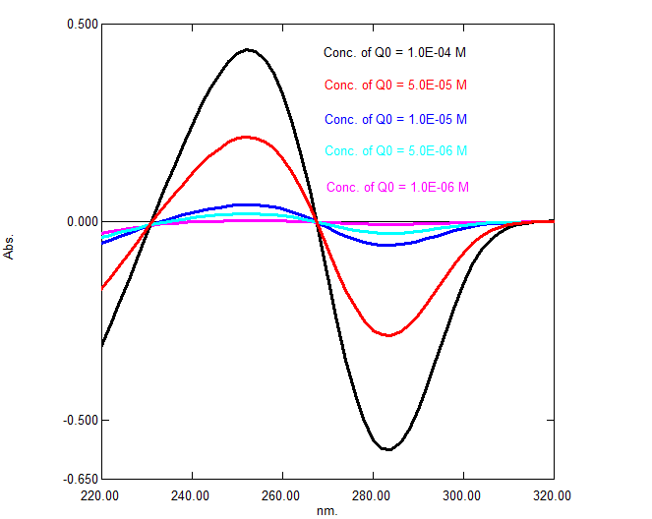

Fig. 3. The first-order spectra for different concentration of pure coenzyme Q₀ in water.

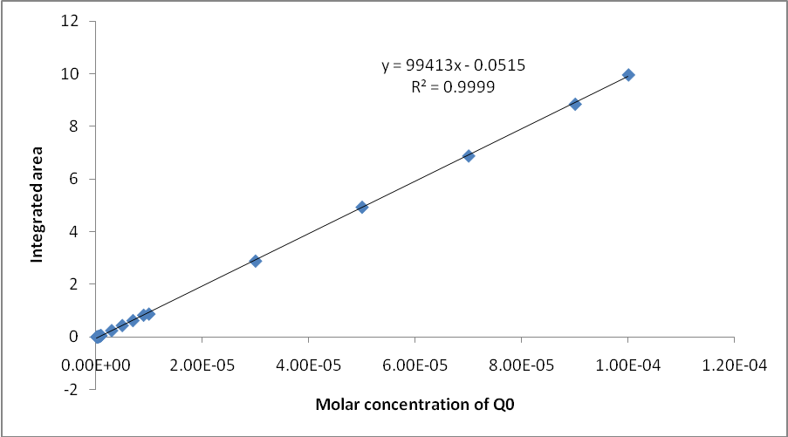

Fig 4. The calibration curve of the positive peak of the first–order derivative spectra of pure coenzyme Q₀ in water.

Whereas the quantitative determination of pure coenzyme Q₀ according the plotting of a calibration curve between the integrated area under the negative against the molar concentration of pure coenzyme Q₀ solutions gave a straight line obeying the Beer's-Lambert law with a determination limit of (0.01 - 18.2) μg/ml, R² = 0.9999 and RSD =0.2873 % (Table 2, Figure 5).

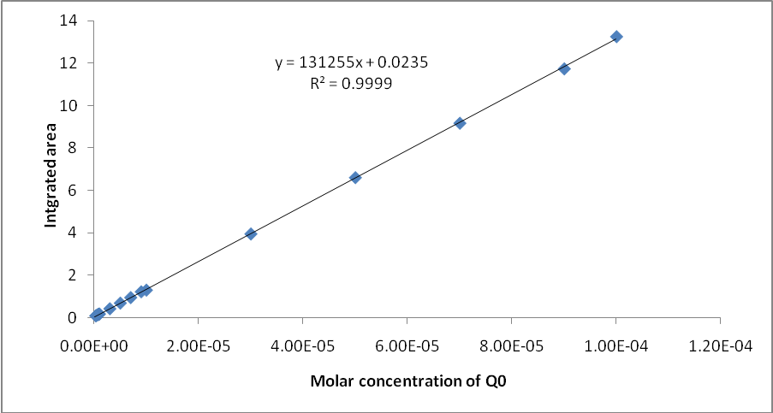

Fig 5. The calibration curve of the negative peak of the first–order derivative spectra of pure coenzyme Q₀ in water.

This indicate that quantification of pure coenzyme Q₀ by the first derivative spectra according to the negative peak at (λ = 268-342) nm is more reliable than that according by the positive peak at (λ = 230-268) nm which was explored the values of the determination limits.
The second order-derivative spectrum of coenzyme Q₀ in water shows a main negative peak at (λ = 254-284) nm and two satellites one at each side of the peak Figure 6. The spectra of the second-order derivative at different concentrations of pure coenzyme Q₀ were recorded, the integrated area under the peak were plotted against the molar concentrations, the result is a straight-line relationship obeying the Beer’s-Lambert law within the range of molar concentration between 1.0×10⁻⁷ - 1.0×10⁻⁴ M, with determination limits 0.02-18.2 μg/ml, R² = 0.9999, and RSD =0.3370 %. (Table 2, Figure 7).

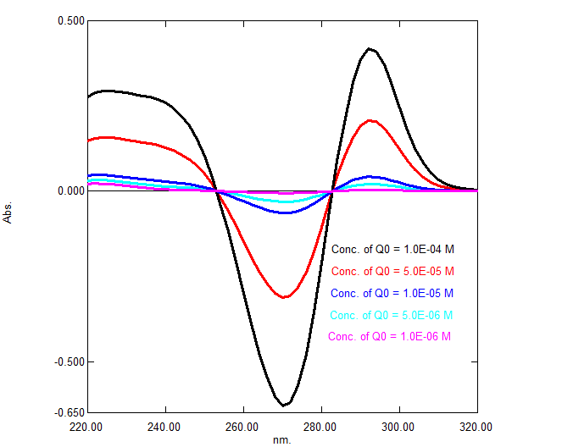

Fig 6. The second-order spectrum for different concentration of pure coenzyme Q₀ in water.

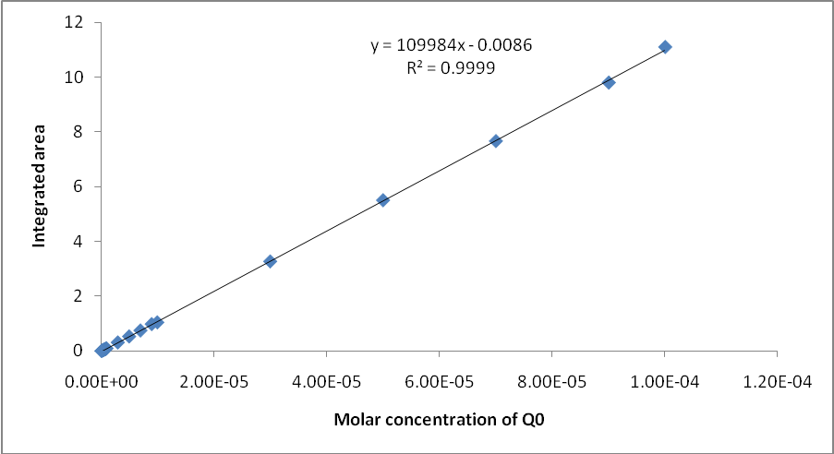

Fig 7. The calibration curve of pure coenzyme Q₀ in water measure by the second–order derivative spectra.

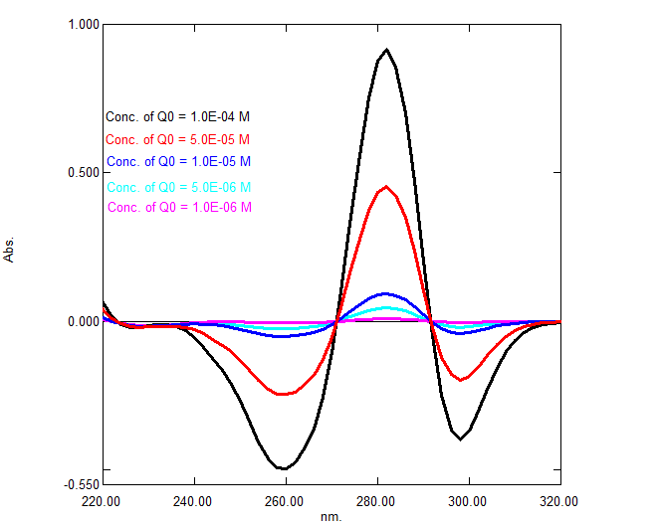
The third-order derivative spectrum of pure coenzyme Q₀ shows a negative peak at (λ=222-268) nm, crossing the zero-axis at λ = 268 nm and a positive peak at (λ = 268-292)nm (Figure 8). The quantitative determination of pure coenzyme Q₀ was accomplished through plotting of a calibration curve between the integrated area under the negative peak against the molar concentration of pure coenzyme Q₀ solutions. The result was a straight-line obeying the Beer's-Lambert law within a concentration range (1.0×10⁻⁸ - 1.0×10⁻⁴)M, determination limit of (0.002-18.2) μg/ml, R² = 1.00 and RSD =0.7092 % (Table 2, Figure 9).

Fig 8. The third-order spectrum for different concentration of pure coenzyme Q₀ in water.
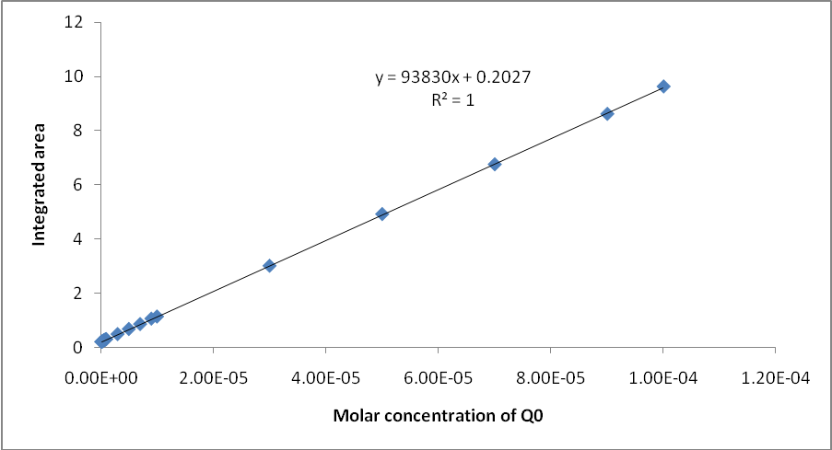

Fig 9. The calibration curve of pure coenzyme Q₀ in water according to the negative peak at (222-268) nm of third–order derivative spectra.

The quantitative determination of pure coenzyme Q₀ was accomplished through plotting of a calibration curve between the integrated area under the positive peak of third order derivative spectra against the molar concentration of pure coenzyme Q₀ solutions. The result was a straight-line obeying the Beer's-Lambert law within a concentration range (1.0×10⁻⁷- 1.0×10⁻⁴) M, a determination limit of (0.02-18.2)μg/ml, R² = 0.9999 and RSD=0.3593 % (Table 2, Figure 10).

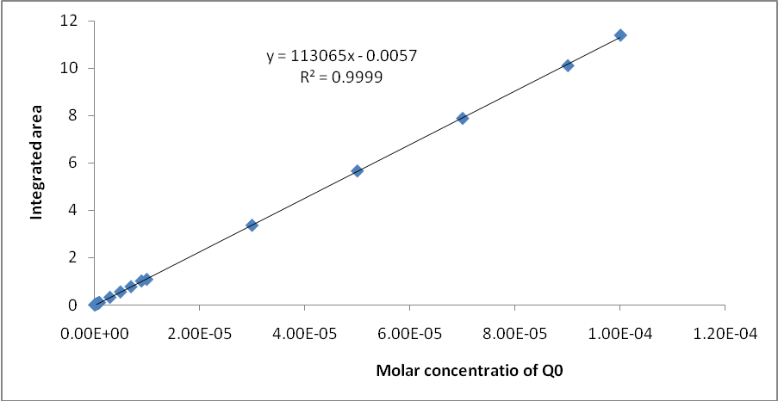

Fig 10. The calibration curve of different concentration of pure coenzyme Q₀ solutions versus the integrated area under the positive peak of third–order derivative spectra.

This indicate that the quantification of coenzyme Q₀ in water by the third order UV derivative spectra according to the integrated area under the negative peak at (λ= 222-268) nm to be more reliable than that according to the positive peak at (λ= 268-292) nm which was clear by the values of the determination limits.
Thus according to the recorded results by the zero, first, second and third order derivative one can detect that the third order derivative is the more reliable technique, which is simple, rapid and economical.
HPLC measurement of coenzyme Q₀
Quantification of coenzyme Q₀ was made by HPLC using a column (150×4.6 mm,C8). The mobile phase was distilled water with flow rate of 1 µL/min, and the eluent was monitored with UV-spectroscopy at λ=268 nm. The concentrations of pure coenzyme Q0 (1.0×10⁻⁴-1.0×10⁻⁶ M) were obtained by comparison of the peak areas with those of solutions of known concentrations. Values indicate that a determination limit (0.2-18.2 µg/ml) with R²=0.9884, Table 3.

Table 3. The integrated area measurement of different concentrations of pure coenzyme Q₀ in water by HPLC technique.

Molar concentration of Q₀ | Integrated area under the peak
1.0E-04 | 38035
5.0E-05 | 23188
1.0E-05 | 6457
5.0E-06 | 2692
1.0E-06 | 1043

The comparison of the results obtained by HPLC and derivative UV-spectroscopy for the quantifacation of coenzyme Q₀ in water indicate that the direct measurment of the UV-spectroscopic technique to be a more reliable than HPLC measurement within these conditions.

References
1. Crane, F. L., Hatefi, Y., Lester, R. L., and Widmer, C., Biochem. Biophys. Acta., 1957, 25, 220-221.
2. Lester, R. L., Crane, F. L., and Hatefi, Y., J. Am. Chem. Soc., 1958, 80, 4751-4752.
3. Morten, R. A., Wilson, G. M., Lowe, J. S., and Leat, W. M. F., Chem. Ind., 1957, 1649-1650.
4. IUPAQ-IUB Commission on Biochemical Normenclature (CBN). Biochm. J., 1975, 147, 15-21.
5. Wolf, D. E., Hoffman, C. H., Trenner, N. R., Ariston, B. H., Shunk, C. H., Linn, B. O., McPherson, J. F., and Folkers, K., J. Am. Chem. Sco., 1958, 80, 4752.
6. Mayer, H., and Ister, O., In Methods Enzymology, Vol. XVIII, Part C ( D. B. McChormick and L. D. Wright, ads. ). Academic press , New York., 1971, 182-213.
7. Friis, P., Daves, G. D.. Jr., and Folkers, K., Biochemistry, 1967, 6, 3618-3624.
8. Clover, J., and Threlfall, D. R., Biochem. J., 1962, 85, 14-15.
9. Mitchell, p., J. Theor. Biol., 1976, 62, 327-367.
10. Gunner, M. R., Madeo, J., and Zhu, Z., J Bioenerg Biomembr., 2008, 40(5): 509–519.
11. Morton, R. A., In Biochemistry of Quinones , (Morton R. A. ed.), Academic Press, New York, 1965, 23-65.
12. Shanshal, M. and Hassan, K. H., StudiaBiophyscal., 1985, 105, 59-64.
13. Shanshal, M., Wahab, H. A. and Khalil, S. M., Studia, Biophysical., 1987, 118, 75-78.
14. Shanshal, M., Al-Rufaie, E.M., Al-Saidi, S. F. and Mammo, M., Iraqi J. of Science, 1990., 31, 69-82.
15. Shanshal, M. A. Mammo, M., Z. natrforsch, 1977, 33a, 55-68.
16. Shanshal, M. A., Al-Khuzzaii, S., Al-Rufaia, E, M., and Khalil, S. M., Z. natrforsch, 1979, 34a, 1003-1008.
17. Karpilska, J., R. Frankowska, Instrum. Sci. Technol.,2004, 32, 281.
18. Karpinˇıska, J., B. Mularczyk, Spectrochim. Acta: Part A, 2004, 60, 2189.
19. Rojas, F. S., Ojeda, C. B., Analytical Chemica Acta, 2009, 635 (1), 22-44.

