The In-Situ Reaction of Hexachlorocyclotriphosphazene with (2- and 4- hydroxyaniline) In the Presence of 25 mole Percent Epoxidized Natural Rubber

Salah Mahdi Al-Shukri
Polymer Research Unit, College of Science, University of Al-Mustansiriya

(NJC)

(Recevied on 10/4/2011 ) (Accepted for publication 28 / 7 /2011)

Abstract
In this study, the entrapment of 25 mole percent epoxidized natural rubber (ENR-25) within the matrix of organocyclotriphosphazene has been explored. Two different matrices, tight and loose were prepared via a one-step condensation polymerization of hexachlorocyclotriphosphazene (CTP) with 2-hydroxyaniline (o-aminophenol) or 4-hydroxyaniline (p-aminophenol) in molar ratio (1:3) in the presence of 25-mole percent epoxidized natural rubber resulting, PO2APC/ENR-25 and PO4APC/ENR-25, respectively. The morphology study of PO2APC/ENR-25 showed two separated entities present at the surface of the material, indicating that the entrapment of ENR-25 chains within the tight matrix (1-oxy-2-minophenyl)cyclotriphosphazene (PO2APC) seized to happen. On the other hand, the morphology of PO4APC/ENR-25 showed a very smooth and homogenous surface texture, indicating the effective entrapment and uniform dispersion of the ENR-25 chains within the loose matrix (1-oxy-4-minophenyl)cyclotriphosphazene (PO4APC). The DSC analysis of pure PO4APC showed a glass transition temperature (Tg) at 120ºC while the neat ENR-25 showed Tg at about -44ºC. The DSC thermogram of PO4APC/ENR-25 reveals a soul glass transition temperature at 76ºC which is more than 120ºC higher than the Tg of ENR-25 and 44ºC lower than the Tg of PO4APC. The TGA thermogram of neat ENR-25 showed one main decomposition step at 416 ºC, while that of PO4APC showed three decomposition steps at 220, 500, 645ºC. The TGA thermogram of PO4APC/ENR-25 showed two decomposition steps, the
first occurred at 213°C is attributed to partial decomposition of the cyclomatrix, PO4APC, and the second (main) occurred at 460°C is due to decomposition of ENR-25 trapped in PO4APC. The structural study of PO4APC/ENR-25 by FT:IR showed all the characteristic absorptions due to PO4APC and ENR-25 without any changes or shifting, indicating that there is no bonds braking or forming taken place between PO4APC and ENR-25. The ¹HNMR analysis of PO4APC/ENR-25 revealed that the relative integral ratio of the epoxy proton at δ 2.70 ppm and olefinic proton at δ 5.17 ppm remains practically similar to that observed in the ¹HNMR spectrum of neat ENR-25 which is equal to about 25%, affirming that the microstructure of ENR-25 remains intact in PO4APC/ENR-25.

الخلاصة
في هذه الدراسة بحث امكانية اصطياد (احتواء) السلاسل البوليمرية للمطاط الطبيعي الحاوي على 25% من وحدات الايبوكسي (ENR-25) في منبت السايكلوتراي فوسفازين. تم تحضير منبتين من المركبات العضوية للسايكلوتراي فوسفازين (ضيق و واسع) من خلال البلمرة التكاثفية للسداسي كلوروسايكلوتراي فوسفازين مع 2-هايدروكسي انلين او 4-هايدروكسي انلين بنسبة مولية 3:1 بوجود ENR-25,لينتج المركبين (PO4APC/ENR-25, PO2APC/ENR-25)على التوالي. دراسة السطح الخارجي لمركب (PO2APC/ENR-25) بواسطة مجهر المسح الاليكتروني أظهر وجود بلورات االسايكلوتراي فوسفازين منفصلة على سطح المطاط وهذا يدل على عدم امكانية احتواء سلاسل ENR-25 ضمن المنبت الضيق للسايكلوتراي فوسفازين. في حين ان دراسة سطح النسيج لمركب PO4APC/ENR-25 أظهر سطح سوي متجانس بشكل كبير ولا وجود لأي جزيئات بلورية منفصلة على السطح مما يشير على ان احتواء السلاسل البوليمرية ل ENR-25 ضمن المنبت PO4APC قد تم بفعالية وكفاءة وقد تم تاكيد ذلك بدراسة الخواص الحرارية بواسطة جهاز المسح التفاضلي DSC و التحليل الحراري الوزني TGA. تحليل DSC للمنبت الخالي أظهر درجة حرارة انتقال الزجاج(Tg) حوالي 120 درجة مئوية في حين ان ENR-25 أظهر (Tg) بحدود -44 درجة مئوية اما مركب PO4APC/ENR-25 فقد أظهر Tg واحدة فقط في 76 مئوية وهي اكثر 120 مئوية من درجة انتقال الزجاج ل ENR-25 و 44 درجة مئوية اقل من Tg للمنبت الخالي. تحليل TGA للمطاط ENR-25 أظهر ان التفكك الحراري في جو خامل من غاز النتروجين يحدث بخطوة واحدة في درجة 416 درجة مئوية في حين ان منبت السايكلوتراي فوسفازين يتجزأ حراريا تحت نفس الضروف بثلاث مراحل بدرجة 220 و 500 و 645 درجة مئوية. تحليل TGA لمركب PO4APC/ENR-25 بين ان منبت السليكلوتراي فوسفازين الحاوي على سلاسل المطاط أظهر اختلاف واضح عن التفكك الحراري لكل من PO4APC الخالي و ENR-25 اذ ان التفكك يحدث بخطوتين فقط الاولى بدرجة 213 درجة مئوية وهذا ينسب الى تفكك منبت السايكلوتراي فوسفازين والثانية (الرئيسية) بدرجة 460 درجة مئوية وتنسب الى تفكك سلاسل المطاط (ENR-25) المحتواة ضمن منبت السايكلوتراي فوسفازين. تحليل FT:IR لمركب PO4APC/ENR-25 أظهر جميع قيم الامتصاص العائدة للمنبت والمطاط بدون اي تغير او انحياز مما يدل على عدم تغير التركيب الكيميائي لكلا المكونين. تحليل ¹HNMR لمركب PO4APC/ENR-25 أظهر ان نسبة بروتون مجموعة الايبوكسي في الموقعδ 2.70 ppm الى نسبة بروتون الفاينيل الموقع δ 5.17 ppm باقية كما هي بدون اي تغير وبنسبة 25% , مما يدل على ان التغيرات الفيزيائية لل ENR-25 حدثت بدون تغير في التركيب البنائي للمطاط (ENR-25) المحتواة في المركب PO4APC/ENR-25.

1. Introduction
Considerable interest exists in the use of cyclotriphosphazenes for improving properties of organic polymers particularly those obtained from natural resources which are usually exhibited useful structural and mechanical attributes but poor thermal characteristics. Cyclotriphosphazenes exhibit useful thermal properties such as self-extinguishibility, flame retardancy and oxidative stability which are mainly imparted by the presence of nitrogen and phosphorus atoms in the ring.^{(1,2)} To date, hexachlorocyclotriphosphazene [(NPCl₂)₃] (CTP) is the most widely used starting material in phosphazene chemistry. It is a white crystalline solid material that melts at 114ºC and is soluble in polar and non-polar organic solvents. All six chlorine atoms on the phosphorus atoms can be replaced with a large variety of functional organic and organo metallic molecules via nucleophilic substitution reaction.⁽³⁾ Known applications of these compounds include the compatibilizing agents between two immiscible polymers blend,⁽⁴⁾ polymers with organic backbones and cyclotriphosphazene as pendant units,⁽⁵⁾ liquid-crystalline cyclotriphosphazene derivatives,⁽⁶⁾ high thermal and fire retardant polymers,⁽⁷⁾ transparent adhesive polymeric materials,⁽⁸⁾ and inclusion (clathrate) compounds for the entrapment of micro- and macro- molecules.^{(9, 10)}
Hexachlorocyclotriphosphazene undergoes dehydrochlorination reactions with aromatic ortho-, meta- or para- bifunctional groups such as catechol, resorcinol, hydroquinone, when allowed to reacts with them in the presence of triethylamine. However, two pathway reactions are involved, they are: intra-molecular reaction (the bifunctional group reacts with two chlorine atoms of same CTP ring) and inter-molecular reaction (the bifunctional group links two CTP rings by reacting with one chlorine atom of two different phosphazene rings). Due to the steric hindrance effect, intra-molecular reaction pathway is predominant when CTP reacts with ortho-substituted bifunctional groups such as 2,3-naphthalenedihydroxy, 1,8-naphthalenedihydroxy, 3,6-dimethylphenylenedihydroxy results in crystalline inclusion compounds,⁽¹¹⁻¹³⁾ and minimum amount of polymers can be formed when the reaction takes place through inter-molecular reaction pathway.⁽¹⁴⁾ However, only inter-molecular reaction pathway involves when CTP reacts with meta- or para- substituted nucleophile, such as m-aminophenol, resorcinol or hydroquinone in equal molar ratio resulting low molecular weight linear polycyclotriphosphazene (Figure 1(a)). On the other hand, when the bifunctional groups are in excess, cyclomatrix polymers (network) are obtained (Figure 1(b)).^{(15, 16)}

In this study, the entrapment efficiency of the ENR-25 chains within two different organocyclotriphosphazene matrices is investigated. The first matrix (tight matrix), (1-oxy-2-minophenyl)cyclotriphosphazene (PO2APC) formed from the reaction of CTP with 2-hydroxyanilin in molar ratio 1:3. The second matrix, (loose matrix), poly(1-oxy-4-aminophenyl)cyclotriphosphazene (PO4APC) formed from the reaction of CTP with 4-hydroxyaniline in same molar ratio. For entrapment process, both matrices PO2APC and PO4APC were formed in the presence of ENR-25, resulted in PO2APC/ENR-25 and PO4APC/ENR-25, respectively. The SEM, EDX were used to study the morphology of the products. The DSC and TGA techniques were used to study the miscibility (compatibility) of the systems and the effects of presence of cyclophosphazene on the thermal stability of ENR-25. The infrared spectroscopy was used to prove the presence of the components (phosphazene matrix and ENR-25) within the resulted products. ¹HNMR spectroscopy was utilized to compromise the argument whether the changes of the physical properties of ENR-25 is due to altering of the ENR-25 microstructure or to the entrapment (inclusion) of rubber within the cyclotriphosphazene matrix. Furthermore, on structural point of view, the selection of epoxidized natural rubber possess an advantage over the parent polymer, natural rubber, because any change in the microstructure of the former can be easily discerned and verified with the aid of quantitative ¹HNMR technique.

Figure 1: Ideal structure for (a) linear, (b) cyclomatric cyclotriphosphazene

2.Experimental
2.1 Materials
Hexachlorocyclotriphosphazene [(NPCl₂)₃], (CTP, Aldrich,) was purified by recrystallization from n-hexane. 2-hydroxyaniline (o-aminophenol) and 4-hydroxyaniline (p-aminophenol) (BDH) were purified by sublimation at 90ºC and 0.03 torr. Triethylamine (Merck) was dried over grinded potassium hydroxide, distilled and received over molecular sieves type 4ºA. 1,4-dioxane (AJAX Chemicals) was freshly distilled prior to use from sodium benzophenone ketyl in an atmosphere of dry nitrogen gas. Chloroform, methylene chloride and anhydrous Na₂SO₄ (Merck) were used as received. 25 mole percent Epoxidized Natural Rubber (ENR-25) with glass transition temperature (Tg) of -44ºC, weight average molecular weight (Mw) of 3.76×10⁵ and polydispersity (Mw/Mn) of 2.55 was used without further purification.
2.2 Instruments
Infrared spectra (KBr pellets and KBr windows) were recorded using a Perkin- Elmer 2000 Infrared Spectrometer. ¹HNMR spectra were obtained with the use of a Bruker Avance-300 NMR spectrometer operating at 300 MHz. Samples were dissolved in CDCl₃, and the solvent was used as an internal lock. Chemical shifts were recorded in parts per million relative to TMS (0.00 ppm). Differential Scanning Calorimetry (DSC) analysis was carried out using Perkin-Elmer DSC, equipped with an internal cooler 2P-cooling accessory. Samples containing ENR-25 were annealed at heating rate of 20ºC/min (for both heating and quenching) and the second scan was performed after 2-5 minutes of waiting time at −50ºC. Thermal weight loss measurements were made using Perkin-Elmer TGA–7 thermogravimetric analyzer (TGA). Testing was carried out under a stream of dry nitrogen gas at temperature range of 30 to 800ºC with heating rate of 20ºC/min. Scanning Electron Microscope (SEM) Leica Cambridge S–360 was used to study the surface morphology of samples. The samples were coated with gold using sputter coater Polaron Sc-515, with thickness ≈ 20nm. Energy Dispersive X–ray (EDX) microanalyzer (Camscam Editor) was used to obtain qualitative and semi quantitative information of the elements present in the specimen. Beam voltage of 15 kV was used for all specimens.
  - Reaction of CTP with 4-hydroxyaniline, synthesis of loose matrix PO4APC

To a stirring solution of CTP (6.00 g, 0.017 mol) in 50 mL of freshly distilled 1,4-dioxane (inside a 150 mL 2-necked round bottom flask fitted with a reflux condenser, a magnetic stirrer, and placed in an oil bath) a solution of 4-hydroxyaniline (5.81 g, 0.053 mol) and triethylamine (29.0 mL, 0.204 mol) in 30 mL of 1,4-dioxane was added dropwise via a dropping funnel over a period of 10 minutes and subsequently, subjected to refluxing condition for 6 hours. Triethylamine hydrochloride salt that precipitated was filtered off. The filtrate was evaporated to dryness under reduced pressure, and the resulting residue was reconstituted in 60 mL CHCl₃, washed with distilled water, dried over the anhydrous of sodium sulfate and filtered. The solvent was removed, and the product PO4APC was further dried at 90ºC and 0.03 Torr for about 6 hours, affording a whitish solid product with a percentage yield of 90 %.

  - In-situ reaction of CTP with 4-hydroxyaniline in the presence of ENR-25 (preparation of PO4APC/ENR-25)
ENR-25 (3.0 g) and 1,4-dioxane (150 mL) were introduced into a 250mL 2–necked round bottom flask equipped with a condenser and a magnetic stirrer, and the flask placed in an oil bath. The content of the flask was stirred and refluxed under nitrogen atmosphere until a clear slightly yellowish solution formed, indicating complete dissolution of the ENR-25. Then, while the solution was allowed to slowly cool to room temperature, CTP (6.0 g, 0.017 mol) was added into the flask and the content of the flask was stirred for 5 minutes before a 1,4-dioxane solution (70 mL) containing 4-hydroxyaniline (8.28 g, 75.93 mmol) and triethylamine (29.0 mL, 0.204 mol) was added dropwise via a dropping funnel over a period of 15 minutes. Then the content of the flask was maintained under constant stirring at room temperature for 14 hours and, subsequently, subjected to refluxing condition for 10 hours. Triethylamine hydrochloride salt that precipitated was filtered off and the filtrate was concentrated. Upon addition of chilled distilled water (200 mL) with continuous stirring, a yellowish material precipitated which was collected and dissolved in 200 mL of CH₂Cl₂. The solution was washed with sodium bicarbonate (60 mL) in a separatory funnel and the organic layer was further washed with 60 mL of distilled water before been dried over anhydrous Na₂SO₄. The solvent was removed and finally the product was further dried at 55°C under reduced pressure (0.03 Torr) for 6 hours. A whitish product was obtained with a yield of 80%. The PO2APC/ENR-25 was prepared according to the similar procedure.
Results and Discussion
The reaction of one mole of CTP with three moles of two different bifunctional benzenes namely 2-hydroxyaniline and 4-hydroxyaniline in the presence of ENR-25 affording the respective products designated as PO2APC/ENR-25 and PO4APC/ENR-25, respectively. 1,4-dioxane was the solvent used while the function of triethlyamine (12 moles) was to scavenge the by-product, hydrogen chloride. The amount of ENR-25 used in each case was equivalent to half the weight amount of CTP .The products (PO2APC/ENR-25 and PO4APC/ENR-25) isolated were washed repeatedly with a solution of sodium bicarbonate and then with ample amount of distilled water and dried under reduced pressure.

3.1 Analysis of the surface morphology of PO2APC/ENR-25
The SEM micrographs obtained at different magnifications for PO2APC/ENR-25 are depicted in Figure 2. The present of crystal-liked compound phased out at the surface of the polymeric portion of the product is apparent. The crystal-like compound is due to the molecular inclusion taking place in (1-oxy-2-aminophenyl)cyclotriphosphazene (PO2APC), resulting in a complete separation of the molecules at the surface of ENR-25. The appearance of two distinct entities at the surface of the material implies that ENR-25 chains cannot be dispersed through the matrix of PO2APC. Therefore, PO2APC and ENR-25 exist as two incompatible components in PO2APC/ENR-25. No other data was obtained for this product except EDX spectrum, which it depicted Figure 3. From this spectrum the presence of P, 33.02%; Cl, 9.15%; C, 13.39; O, 26.91 and Na, 17.53%; on the surface of the product is readily discernible. The appearance of the high percentage of phosphorus content compare to the carbon indicates presence of crystalline phosphazene compound on the surface. The presence of 3.68% of chlorine is due to the presence of unreacted P–Cl bonds of the cyclotriphosphazene matrix. Therefore, we believe that the replacement of the chlorine atoms is incomplete due to the rigid geometry and steric strain of the hindered o-substituted molecule. The 17.35% of sodium is attributable to the residual sodium bicarbonate trapped in the polymeric matrix during the washing process.

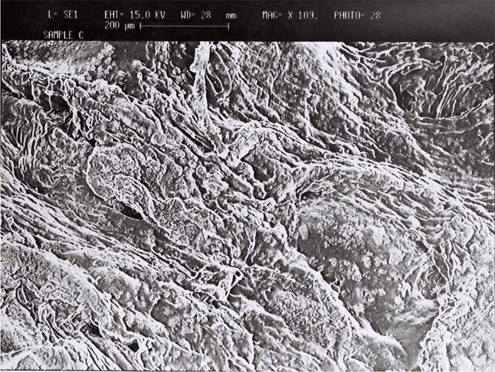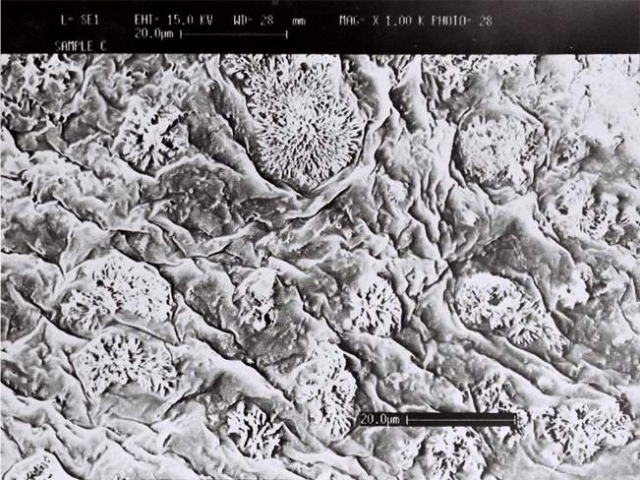
(a) (b)

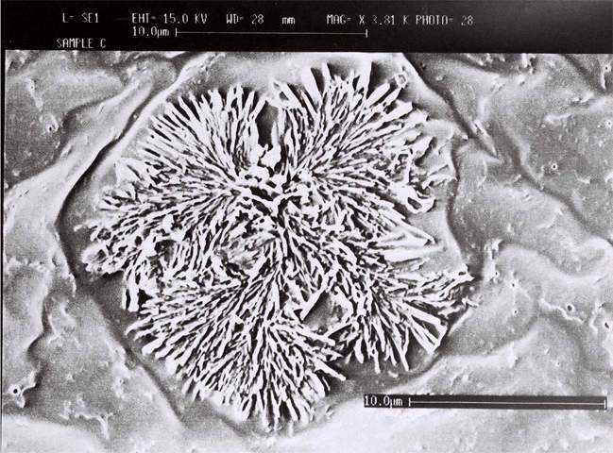
Crystal-like
compounds

(c)Figure 2: SEM micrographs of PO2APC/ENR: (a) scale bar 200 µm, Mag. X 109.0; (b) scale bar 20 µm, Mag. X 1.00 K; (c) scale bar 10 µm, Mag. X 3.81 K
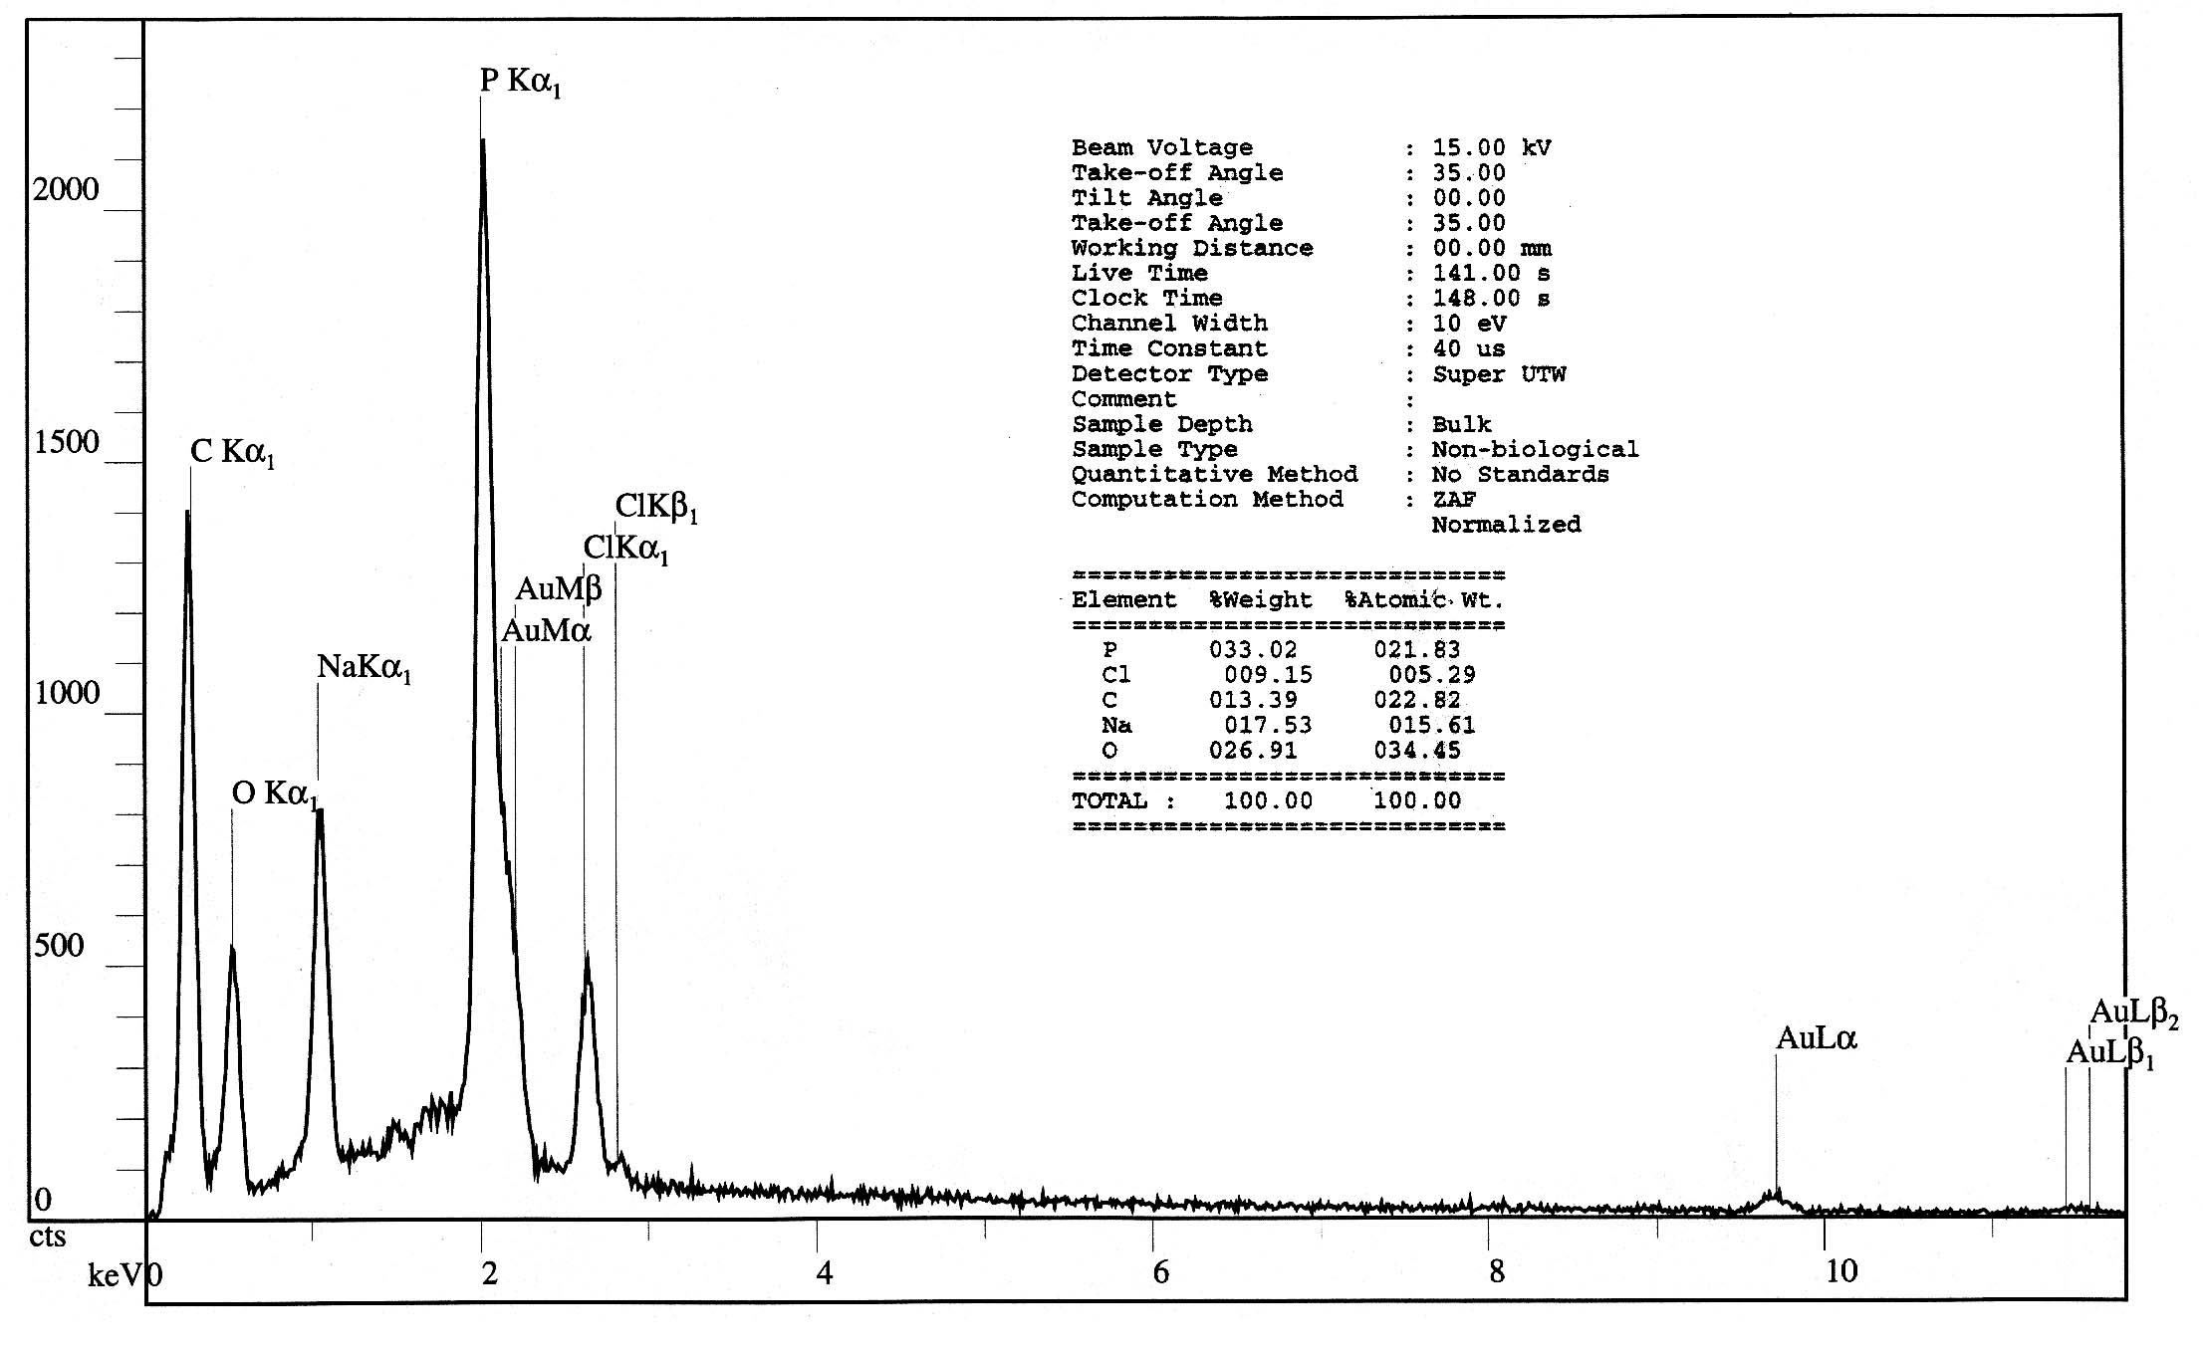
Figure 3: EDX spectrum of crystal-like compounds at the surface of PO2APC/ENR

3.2 Analysis of the surface morphology of PO4APC/ENR-25
The SEM micrographs of PO4APC/ENR-25 depicted in Figure 4 exhibited smooth and homogenous texture suggesting that the ENR-25 chains are uniformly dispersed and completely trapped in the matrix of PO4APC. No crystal-like compound could be observed on the surface of the material.
The EDX analysis of the surface shown in Figure 5 confirmed the presence of the components (phosphazene and ENR-25) as indicate by the quantification relative approximate weight percentage of the elements present on the surface of the material, that is: P, 5.02%; Cl, 3.68%; C, 84.07; O, 7.24%

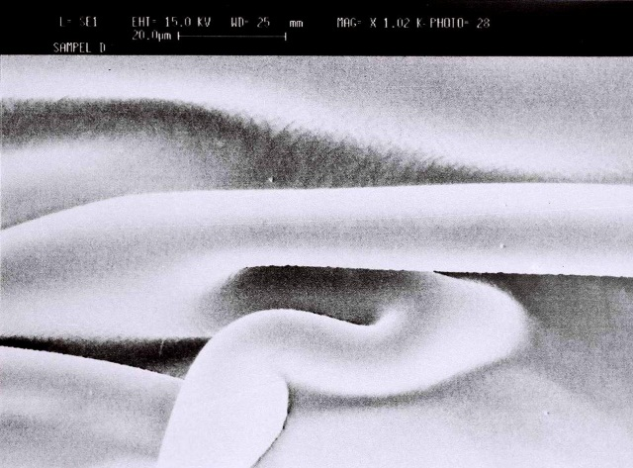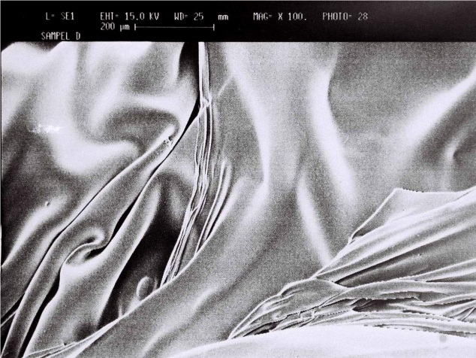
- (b)
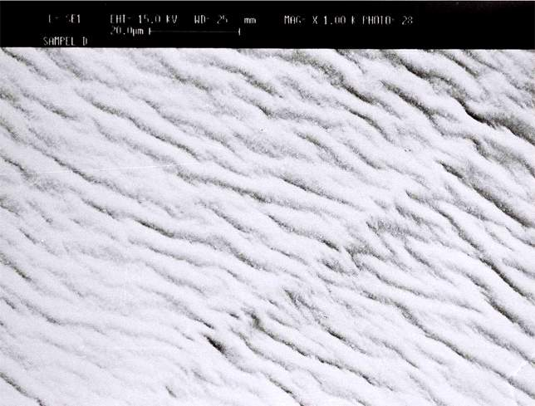
(c)
Figure 4: SEM micrographs of PO4APC/ENR: (a) scale bar 200 µm, Mag. X 100.0. (b) scale bar 20 µm, Mag. X 1.02K. (c) scale bar 10 µm, Mag. X 1.00 K
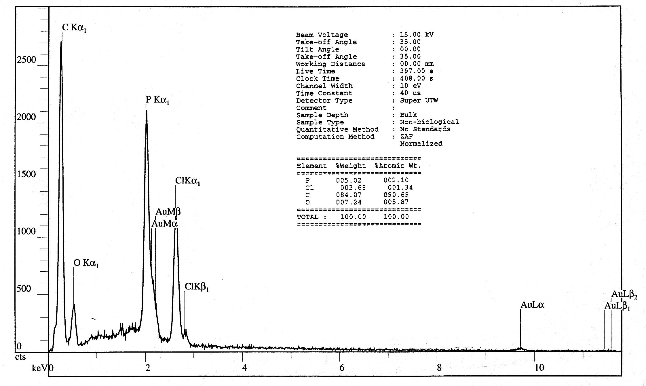
Figure 5: EDX spectrum of PO4APC/ENR

3.3 Thermal analysis of the products:
3.3.1 DSC and TGA analysis of PO4APC
The DSC thermogram of the pure cyclomatrix (PO4APC) depicted in Figure 6 reveals a strong endothermic transition at 120ºC, which is assigned to the glass transition temperature (Tg) of the matrix. This relatively high Tg value is due to rigidity of the matrix backbone and also to the presence of N–H groups that might cause some hydrogen bonding through the matrix backbone.
The TG and DTG curves of the thermal degradation of PO4APC are depicted in Figure 7. The DTG curve depicted in Figure 7 shows that the decomposition of PO4APC is a three-step process. The first step occurred at 220ºC with weight loss of about 10 % within the temperature range of 150-355°C. This step is due to the cleavage of the P–Cl bonds of Cl–POAr or Cl–PNHAr groups. The second step occurred at 500 ºC with weight loss of about 11 % within the temperature range of 360-592°C. In this step the cyclomatrix underwent cleavage of the phosphorus-oxygen or -nitrogen bonds of the P–(OAr) or P–(NHAr) groups to relieve the steric strain of the hindered p-substituted benzene ring. The third step occurred at 645°C with total weight loss of 6% within the temperature range of 592-730°C. This step is attributed to the scission and partial volatilization of ≡P=N– chains. The char residue at 800°C as deduced from the TG curve is 70 %.

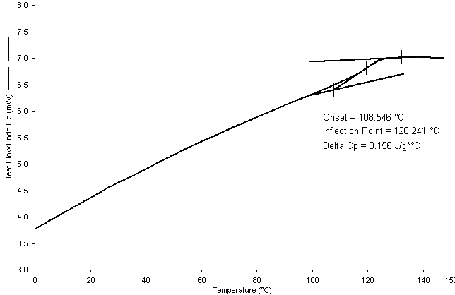
Figure 6: DSC thermogram of PO4APC
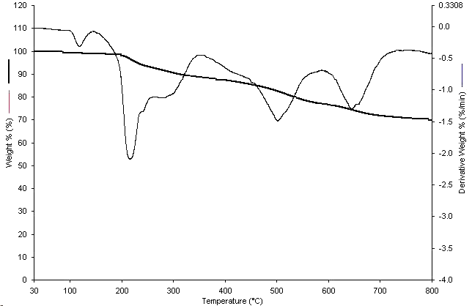
Figure 7: TG and DTG curves of PO4APC

3.3.2 DSC and TGA analysis of neat ENR-25
A typical DSC thermogram of ENR-25 is given in Figure 8. The sole endothermic transition temperature (inflection point) at about – 44°C is due to the Tg of the polymer.
The TG and DTG curves of the thermal degradation of ENR-25 are shown in Figure 9. The DTG curve shows a one-step degradation process with rapid weight loss of 36.6 %/min at 416°C. The total weight loss occurred within the temperature range of 310 - 570°C is about 96 %. The amount of char residue deduced from the TG curve beyond 600°C is less than 2.5 % and practically 0 % beyond 800°C.

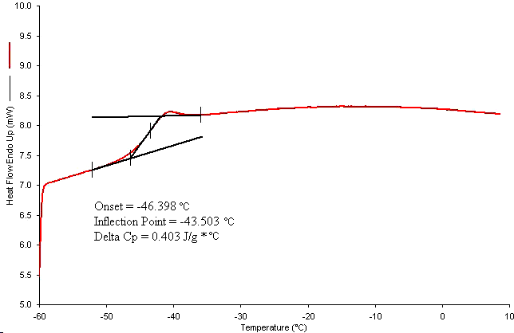
Figure 8: DSC thermogram of ENR-25

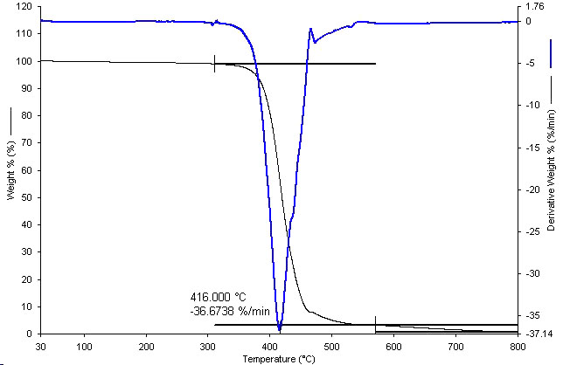
Figure 9: TG and DTG curves of ENR-25 thermal degradation

3.3.3 DSC and TGA analysis of PO4APC/ENR-25
The DSC thermogram of PO4APC/ENR-25 shown in Figure 10 provide strong evidence of presence of miscible (compatible) system as indicated by the appearance of a single endothermic transition that due to the glass transition temperature of the product appeared at 76ºC. The complete disappearance of the Tg of ENR-25 at around -44ºC indicates that ENR-25 chains were fully trapped (dispersed) within the phosphazene matrix.
The TG and DTG curves of the thermal degradation of PO4APC/ENR-25 are depicted in Figure 11. The first decomposition step with weight loss of 11 % occurred within the temperature range of 180 -265°C is attributed to partial decomposition of the cyclomatrix, PO4APC. The second (main) decomposition step occurred within the broad temperature range of 310-580°C with rapid weight loss of 18.3 %/min at 460°C and weight loss of about 50 % is due to the decomposition of material composed of ENR-25 trapped in PO4APC. The increase in thermal stability of the trapped ENR-25 is likely due to the partial decomposition of the cyclomatrix that took place earlier, forming molten char residue that blanketed and consequently provided a heat transfer barrier to the underlying ENR-25 chain layers. The amount of the char residue at 800°C as deduced from the TG curve is about 34 %.

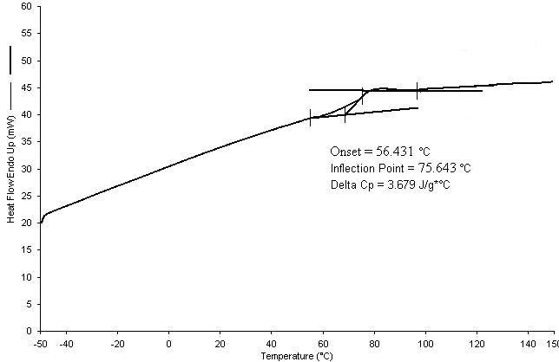
Figure 10: DSC thermogram of PO4APC/ENR-25
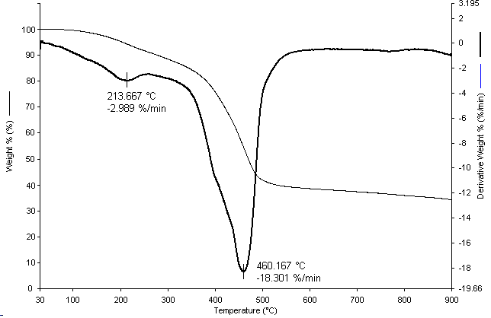
Figure 11: TG and DTG curves of PO4APC/ENR-25

3.4 Analysis of FT:IR spectra of ENR-25, PO4APC, and PO4APC/ENR-25
The spectrum of neat ENR-25 given in Figure 12(a) shows the characteristics peaks at 2961–2852 cm⁻¹ are due to C–H (asymmetric and symmetric stretchings of –CH₂– and –CH₃ groups), Absorption peaks at 1662 and 1575 cm⁻¹ is due to C=C group, peaks at 1259 and 1018 cm⁻¹ are due to C–O–C stretching and bending of epoxy ring, and the important peak due to C–H (bending of the epoxy ring) at 835 cm⁻¹ is discerned in the spectrum.
Infrared spectrum of PO4APC depicted in Figure 12(b) reveals all the expected characteristic absorptions due to cyclotriphosphazene matrix. The characteristic stretching and bending absorption peaks due to N–H and O–H terminal group (unreacted) appeared at 3357 and 3201 cm⁻¹, respectively. The stretching absorptions at 1609 and 1490 cm⁻¹ are assigned to C=C of the benzene ring, absorptions due to –P=N– asymmetric and symmetric stretching appeared at 1215 and 1133 cm⁻¹, respectively, and peak at 991.3 cm⁻¹ is assigned to P–OAr bond.
The infrared spectrum of PO4APC/ENR-25 given in Figure 12(c) did not clearly show all the rubber characteristic peaks except those belonging to –CH₂– and –CH₃ stretching absorptions at 2961-2855 cm⁻¹. The weak rubber absorptions are due to the less amount of rubber compare to phosphazene matrix in the product. However, peaks due to cyclomatrix phosphazene clearly appeared in the spectrum without any shifting. More spectral details are illustrated in (Table 1).
It is evident that the position of each absorption frequency of the product remains almost the same as that of the starting materials. Furthermore, no new absorption frequency could be discerned from the IR spectrum of PO4APC/ENR-25. Therefore, it is likely that bond breaking and/or forming between PO4APC and ENR-25, if any, is negligible. The weak interaction may be due to favorable Van Der Waals forces between the cyclotriphosphazene matrix and ENR-25 chains. Thus, the apparently good miscibility of ENR-25 with PO4APC is a result of effective and complete entrapment of the former in the latter. This behavior is termed as “locked-in-matrix” phenomenon.

(a)

(b)
(c)

Figure 12: Infrared spectra of: (a) neat ENR-25, (b) PO4APC and (c) PO4APC/ENR-25

Table 1: Infrared spectral data of ENR-25, PO4APC and PO4APC/ENR
Compound | Frequency (cm⁻¹) | Assingment
ENR-25^{(a)}  PO4APC^{(b)}  PO4APC/ENR-25 | 3036.4  2961.0, 2727.8  2917.7, 2852.4  1662.5, 1575.5  1448.5  1376.7  1259.6, 1018.4  871.1  835.5  740.6  705.0  690.1  3357.9  3201.6  3077.4  1609.6,1490.1  1391.4  1215.0, 1133.8  991.3  851.0  774.6  684.4  557.6  525.3  3247.7  2961.5  2928.0, 2855.7  1608.9, 1494.3  1384.4  1214.7, 1136.5  988.6  848.0  771.6  685.0  562.1  525.3 | C–H (stretching of isoprene unit)  C–H(asymmetric and symmetric stretchings of-CH₃ Croup)  C–H (asymmetric and symmetric stretchings of the –CH₂– group)  C=C (asymmetric and symmetric stretchings)  C–H (in-plane bending of –CH₂– group)  C–H (in-plane bending of –CH₃ group)  C–O–C (stretching and bending of epoxy ring)  C–H (bending of the epoxy ring)  C–H (bending of the isoprene unit)  C–H (out-of-plane bending of –CH₃)  C–H (out-of-plane bending of –CH₂–)  C=C (out-of-plane bending)  N–H (stretching)  O–H (stretching)  C–H (stretching)  C=C (asymmetric and symmetric stretchings)  C–H (in-plane bending of benzene)  P=N (asymmetric and symmetric stretchings)  P–OC (stretching of the P–OAr group)  P=N ring skeletal vibration  (out of plane bending of p-disubstituted benzene)  (deformation of benzene ring)  P–Cl (stretching of the PCl(OAr) overlapped with the asymmetric stretching band of a PCl₂  P–Cl (symmetric stretching of a P–Cl₂)  O–H and N–H stretchings (overlapped broad band)  C–H (asymmetric stretching of –CH₃)  C–H (asymmetric and symmetric of –CH₂ group)  C=C (asymmetric and symmetric stretchings)  C–H (in-plane bending of benzene)  P=N (asymmetric and symmetric stretchings)  P–OC (stretching of the P–OAr group)  P=N ring skeletal vibration  out of plane bending of p-disubstituted benzene  deformation of benzene ring  P–Cl (stretching of the PCl(OAr) overlapped with the asymmetric stretching band of a PCl₂  P–Cl (symmetric stretching of a P–Cl₂)
ª The ATR (Attenuated total reflectance) with 50 accumulative scan was used to obtain the spectrum, the
sample was pressed on the ZnSe window. ^{b} Sample was dissolved in CH₂Cl₂ and applied between two
KBr windows

3.5 Analysis of ¹HNMR spectrum of PO4APC/ENR-25
The spectrum of compound PO4APC/ENR-25 depicted in Figure 13(a) clearly shows the resonances due to olefinic proton at δ 5.15 ppm and at δ 2.75 ppm due to the proton attached to the epoxy ring (oxirane ring) of ENR-25 appeared without any change. Furthermore, the appearance of the resonance at δ 3.73 ppm due to H–N and at δ 6.20-7.20 ppm due to aromatic protons of PO4APC matrix are further evidences of presence phosphazene matrix within the system. Also in this spectrum small resonances at ( δ 3.00 and 1.30 ppm) due to the presence of triethylamine hydrochloride salt (Et₃N.HCl) can be observed. These molecules are believed to be trapped in the polymer matrices. Trapping of molecules in cyclotriphosphazenes is not an unprecedented phenomenon.⁽¹⁷⁾
A very important feature in the ¹HNMR spectrum of PO4APC/ENR-25 is that the relative integral ratio of the epoxy proton (δ 2.70 ppm) and vinylic proton (δ 5.17 ppm) remains practically the same as that observed in the standard ¹HNMR spectrum of ENR-25 given in Figure 13(b), that is about 1:3 (≈ 25 %).
Therefore, it can be judged that the modification of the rubber properties was taken place without altering the microstructure of ENR-25%.

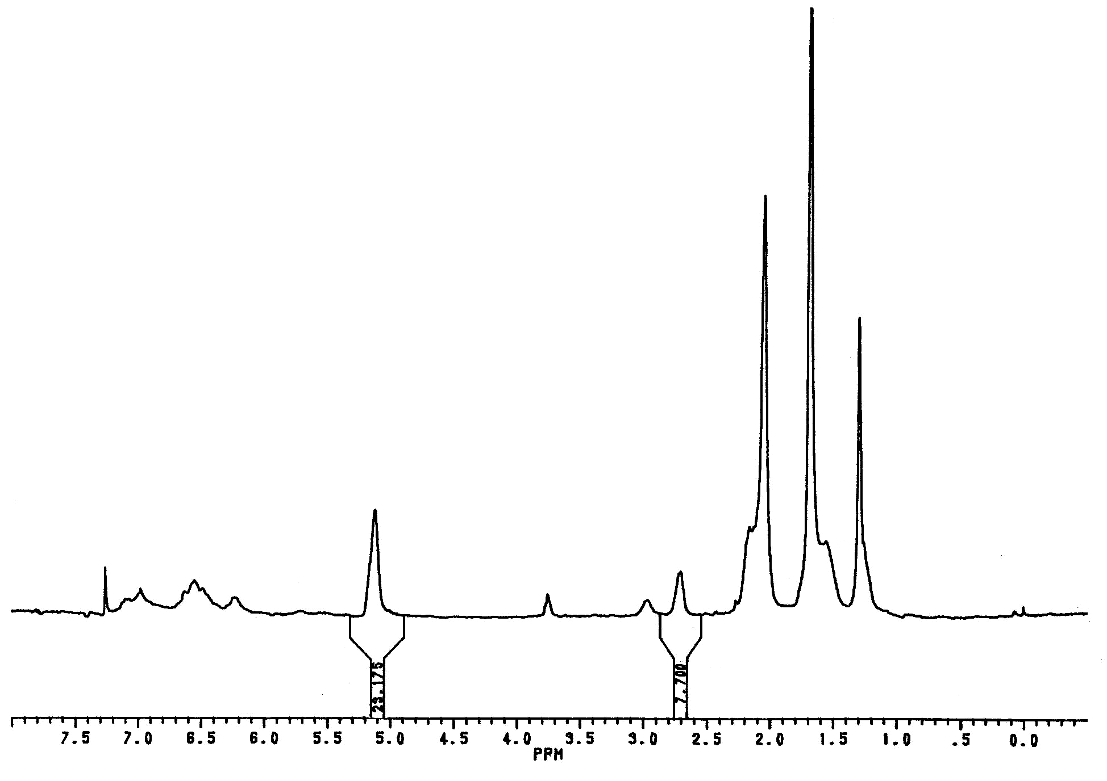
2
(CH₃CH₂)₃NHCl

NH
(CH₃CH₂)₃NHCl
CHCl₃
3
7
5
1 & 4
6
8

(a)
(a)

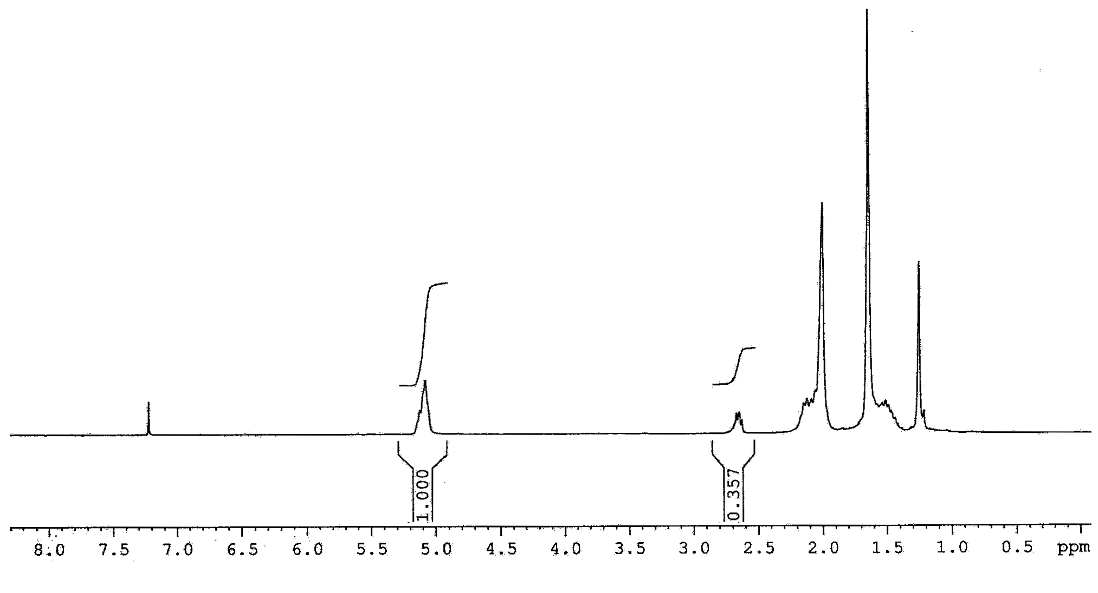
(a)
3
7
8
5
2
1&4
6
(b)

(b)
Figure 13: ¹HNMR spectra of: (a) PO4APC/ENR-25 and (b) Standard ENR-25

- Conclusions:
Entrapment of ENR-25 within the tight cyclomatrix cyclotriphosphazene (PO2APC) is not possible due to rigidity of molecule geometry, whereas the entrapment within a loose cyclomatrix (PO4APC) is effective. Based on the thermal analysis results of both compounds, PO4APC and PO4APC/ENR-25, it can be deduce that the inwardly shifting of the Tg of PO4APC/ENR-25 and the rising of the thermal degradation temperature of ENR-25 is attribute to the inclusion of ENR-25 within the cyclotriphosphazene matrix, indicating, formation of miscible polymer blend system consist of phosphazene matrix and ENR-25. The spectroscopic analysis results (FT-IR and ¹HNMR) for both compounds did not show any shifting of the peaks, which indicates that there is no strong interaction between the functional groups of the components, therefore the changes in the overall thermal properties of the ENR-25 and phosphazene matrix are thought to be due to favorable Van der Waals forces between the cyclotriphosphazene matrix PO4APC and ENR-25 in PO4APC/ENR-25.

References:

- El Gouri, M., El Bachiri, A., Hegazi, S. E., Rafik, M., El Harfi, A., Polym Degrad Stab.; 2009, 94, 2101.
- Wang, X., Liu, R., Polym Degrad Stab.; 2009, 94, 617.
- Allcock, H.R., Stein, M.T. and Stanko, J.A., J. Am. Chem. Soc.; 1971, 93(13), 3173-3178.
- Miyata, K., Watanabe, Y., Itaya, T., Tanigaki, T. and Inoue, K. Macromolecules.; 1996, 29(11), 3694-3700.
- DuPont, J.G. and Allen, C.W., Macromolecules.;1979,12(2),169-72.
- Miyajima, S., Moriya, K., Suzuki, T. and Yano, S., J. Phys. Chem., 2001, 105(33), 7920- 7927.
- Shi, W., Ding, J., Liang, H., Shen, X., J. App Polym Sci, 2005, 97, 1776.
- Al-Shukri, S.M., Mahmood, A.T., Al-Hanbali, O.A., Journal of applied polymer science.;2011, 122(2), 1058-1056.
- Allcock, H.R., Primrose, A.P., Sunderland, N.J., Chem. Mater.; 1999, 11(5), 1243-1252.
- Ainscough, E.W., Brodie, A.M. and Derwahl, A., Polyhedron.;2003, 22, 189-197.
- Allcock, H.R., Levin, M. L., Whittle,. R. R., Inorg. Chem.;1986, 25,41.
- Allcock, H.R., Stein, M.T., Am. Chem. Soc.; 1974, 96(1), 49-52.
- Allcock, H.R., sunderland, N.J, Primrose, A.P, Rheingold, A.L, Guzei, I.A, Parvez,M., Chem. Mater.; 1999, 11(9), 2478-2485.
- Allcock, H.R. and Siegel, L.A., J. Am. Chem. Soc.;1964, 86, 5140-5144.
- Stewart, F.F., Luther, T.A., Harrup, M.K. and Lash, R.P. Journal of Applied Polymer Science.; 2001, 80, 242-251.

- Stewart, F.F., Harrup, M.K., Luther, T.A. and Lash, R.P. Journal of Applied Polymer Science.; 2001, 80, 422-431.
- Femec, D.A. and McCaffrey, R.R. Journal of Applied Polymer Science.; 1994, 52, 501-505.

