Synthesis and Characterization of Some New Binuclear Complexes of Schiff Base as a Dibasic Tetradentate Ligand

Najla H. Taher
Department of Chemistry, College of Education for Girls, Mosul University
Akram A. Mohammed
Department of Chemistry, College of Education, Mosul University

(NJC)

(Recevied on 13/2/2011) (Accepted for publication 3/5/2011)

Abstract
A dibasic tetradentate Schiff base ligand; 2,5-bis(o-hydroxyphenylimino)hexane, (H₂L), and their new binuclear complexes have been synthesized and characterized on the basis of analytical, spectral, magnetic and conductance measurements. The compositions of these complexes were found to be [(M)₂(L)₂(H₂O)₄] (where M = Co(II) or Cu(II)) ; [(Zn)₂(L)₂].2H₂O ; and [(Ni)₂(L)₂].14H₂O (in molar ratio of 2:2 as metal : ligand) ; also [(M)₂(L)(Cl)₂)(H₂O)₂] (where M =Co(II), Ni(II), Cu(II) or Zn(II) (in molar ratio of 2:1 as metal : ligand). The overall IR data suggest the dibasic, tetradentate (N₂O₂) nature of the ligand. The decomposition degrees and insolubility in common organic solvents support the binuclear structure of these complexes. Conductance measurements show a non electrolytic nature of the complexes.
الخلاصة
تضمن البحث تحضير وتشخيص ليكاند قاعدة شيف رباعي السن ثنائي القاعدة ، 2 ،5-بس
(اورثو-هيدروكسي فنيل إيمينو) هكسان ، (H₂L) ، وكذلك معقداته ثنائية النوى الجديدة . شخصت المعقدات بالطرق الفيزيائية، الكيميائية ، والطيفية المعروفة. ان الصيغ الكيميائية لهذه المعقدات هي : [(M)₂ (L)₂ (H₂O)₄] (عندما M = كوبلت (II) او نحاس (II)) ؛ [(Zn)₂(L)₂].2H₂O وكذلك [(Ni)₂(L)₂].14H₂O (بنسبة مولارية 2 : 2 فلز : ليكاند) ؛ كذلك [(M)₂(L)(Cl)₂(H₂O)₂] (عندما M = كوبلت (II) ، نيكل (II) ، نحاس (II) او خارصين (II)) ؛ (بنسبة مولارية 2 : 1 فلز : ليكاند). اظهرت قياسات الاشعة تحت الحمراء بان الليكاند رباعي السن (N₂O₂) ثنائي القاعدة. ان درجات التفكك وكذلك عدم ذوبان المعقدات بالمذيبات العضوية المعروفة دعمت التراكيب ثنائية النوى لهذه المعقدات . دلت قياسات التوصيلية الكهربائية للمعقدات بانها غير اليكتروليتية.

Introduction
In coordination chemistry, Schiff bases have a significant role as ligands still a century after their discovery ^{(1,2)}. The importance of Schiff bases and their metal complexes are important owing to their biochemical ⁽³⁾, electrochemical ⁽⁴⁾, analytical ⁽⁵⁾, antifungal, antibacterial activities ⁽⁶⁻⁹⁾ and redox catalysts ^{(10, 11)}. Schiff bases with NO donors have structural similarities with natural biological systems and imports in elucidating the mechanism of transformation and rasemination reaction in biological systems due to presence of imine (-N = CH-) group ⁽¹²⁾, also the presence of nitrogen and oxygen donor atoms tunes the properties of the complexes to a great extent as effective and stereo specific catalysts for oxidation, reduction and hydrolysis ⁽¹³⁾. 2-Hydroxy Schiff bases and their metal complexes have been extensively studied and exhibit wide applications, especially in biological systems ⁽¹⁴⁾. The studies on binuclear metal complexes in which the two metal centres are held in closed proximity have addressed ligand environment , redox behaviour, magnetic exchange interactions and spectroscopic properties, therefore these kind of complexes still continue to play a very important role in our understanding of various aspects of coordination chemistry of metals. Also binuclear Schiff bases complexes have been found to be better catalysts than the mononuclear Schiff bases complexes ⁽¹⁵⁾.
Keeping all these facts into consideration, Co(II), Ni(II), Cu(II) and Zn(II) complexes with the Schiff base derived from 2,5-hexanedione and 2-aminophenol are reported (in molar ratios 2:2 and 2:1 metal : ligand).
Experimental
Materials :
2-Aminophenol (Fluka), 2,5-hexanedione (Merck), CoCl₂.6H₂O, NiCl₂.6H₂O, CuCl₂2H₂O and ZnCl₂ (Fluka) were used as supplied. All solvents used in this study were obtained from Merck and used without further purification.
a. Synthesis of the Ligand (H₂L) :
An ethanolic solution of 2,5-hexanedione (0.01 mol.) was added to an ethanolic solution of 2-aminophenol (0.02 mol.) and refluxed for ~ 6 hrs. The resulting solution was concentrated and the precipitate was separated by filtration, washed with ethanol and then air-dried.
b. Synthesis of the Complexes:
A general method has been used for the synthesis of the binuclear complexes as follows:
An ethanolic solution of the metal chloride was added to an ethanolic solution of the ligand in molar ratio (2:2 M:L) or (2:1 M:L). An aqueous solution of NaOH (0.02 mol.) was added to the resulting mixture. The mixture was refluxed for 4 hrs. The formed precipitate was collected by filtration, washed several times with ethanol and water and finally dried in oven at 110°C.
Analyses and Physical Measurements:
The metal contents were determined according to the standard procedure ⁽¹⁶⁾. Melting point and decomposition degree were determined by using Electrothermal 9300 digital apparatus. Molar conductivities of the complexes have been measured by electrolytic conductivity measuring set LF-42 using 0.001 M dimethylsulphoxide (DMSO) solutions at 25ºC. IR spectra were recorded on a Bruker (Tensor 27) spectrophotometer in the 4000-400 cm⁻¹ range using KBr disc. Electronic spectra were recorded on a Shimadzu 1601 spectrophotometer in DMSO at 25ºC for 0.001 M solution of the compounds using a 1 cm quartz cell. Magnetic susceptibility measurements of the complexes in the solid state were determined by the Faraday method using a Bruker BM6 apparatus.

Results and Discussion
All the prepared complexes are powders, stable in air at room temperature. Their analytical data together with some physical properties are summarized in Table (1). The reaction of metal salt with the Schiff base ligand (H₂L) in ethanol (molar ratio 2:2 of M:L) yields the proposed complexes as in the following equations:

2MCl₂.nH₂O+2H₂L+2NaOH→
[(M)₂(L)₂(H₂O)₄]+2HCl+2NaCl+(2n-2) H₂O

(M=Co(II), n=6; M=Cu(II), n= 2)

2MCl₂.nH₂O+2H₂L+2NaOH→ [(M)₂(L)₂].XH₂O + 2HCl + 2NaCl
(M=Ni(II),n=6, X=14, M=Zn(II), n=0, X= 2)
While the reaction of metal salt with the Schiff base ligand (H₂L) in ethanol when the molar ratio is (2:1) of (M:L) yields complexes as in the following equations :
2MCl₂.nH₂O+H₂L+2NaOH→ [(M)₂(L)(Cl)₂(H₂O)₂]+2HCl+2NaCl +2nH₂O
(M=Co(II),n=6; M=Ni(II), n=6, M=Cu(II), n =2 or M=Zn(II), n=0)
The proposed complexes have been supported by the metal content measurements. Insolubility of these complexes in common organic solvents such as acetone, methanol, and chloroform and the decomposition degrees support the binu-clear structure of these complexes.
The molar conductance of the complexes in DMSO were in the range (19-3) ohm⁻¹ cm² mol⁻¹ (Table 1). Based on these data, it is clear that these complexes are considered as non-electrolytes⁽¹⁷⁾.

Table (1) : Analytical and some physical properties of the compounds
Compound | decomp.  degree | Colour | Yield % | % Metal  Cal. (Found( | Λ_{M}  ohm⁻¹ cm² mol⁻¹
H₂L | 185-187* | Caramel | 83 | ------ | ------
[(Co)₂(L)₂(H₂O)₄] | 322 | Dark Brown | 57 | 15.15  (14.35) | 7
[(Ni)₂(L)₂].14H₂O | 341 | Dark Brown | 44 | 16.23  (15.37) | 3
[(Cu)₂(L)₂(H₂O)₄] | 392 | Black | 63 | 16.14  (16.98) | 18
[(Zn)₂(L)₂].2H₂O | 304 | Dark Brown | 47 | 17.74  (18.12) | 13
[(Co)₂(L)(Cl)₂ (H₂O)₂] | 347 | Dark Brown | 56 | 24.35  (24.22) | 19
[(Ni)₂(L) (Cl)₂(H₂O)₂] | 344 | Brown | 29 | 24.28  (25.27) | 8
[(Cu)₂(L)(Cl)₂ (H₂O)₂] | 382 | Dark Brown | 31 | 25.77  (24.96) | 3
[(Zn)₂(L)(Cl)₂(H₂O)₂] | 291 | Dark Brown | 66 | 24.58  (25.46) | 17
* Melting point ; Cal. = Calculated

Infrared Spectra :
The characteristic IR bands of the complexes show significant changes when compared with that of the free ligand and shift of some of characteristic vibrational frequency of the ligand upon complexation provides evidence for the mode of binding of the ligand to the metal ion. The important IR frequencies of the complexes along with their relative assignments are presented in Table 2. In the IR spectrum of the Schiff base ligand, (H₂L), a sharp band observed at 1603 cm⁻¹ was assigned to the ν(C = N) mode of the azomethine group. This was shifted to lower wavenumbers in all the complexes, suggesting the coordination of the azomethine nitrogen to the metal ions centres ⁽¹⁸⁾ (Table 2). This is further substantiated by the presence of a new band at 419-499 cm⁻¹, assignable to ν(M-N). The characteristic phenolic ν(O-H) mode due to presence of a hydroxy group at ortho position in the ligand was observed at 3375 cm⁻¹.A band at 1293 cm-¹ due to ν(C-O) phenolic was also observed in the spectrum of ligand ⁽¹⁹⁾. The disappearance of phenolic ν(O-H) band in all the complexes under study suggests the coordination by the phenolic oxygen after deprotonation to the metal ion. This is further supported by the shifting of ν(C-O) phenolic to lower wavenumbers in all the metal complexes ⁽¹⁹⁾ (Table 2). The appearance of a new non-ligand band at 517-584 cm⁻¹ in the complexes due to ν(M-O) further substantiates it. The IR spectra of the complexes also show a band in the 3411-3453 cm⁻¹ region, indicating the presence of coordinated water in these complexes (except for the nickel complex and the zinc complex, when the molar ratio is 2:2 of M:L, these values assigned for a lattice water). The presence of coordinated water was further confirmed by the appearance of a non-ligand band in the 848-892 cm⁻¹ and 721-765 cm⁻¹ regions, assignable to the rocking and wagging modes of water, respectively ⁽²⁰⁾. Finally, the ν(M-Cl) band of complexes (molar ratio 2:1) does not appear due to instrument limitation.

Table (2) : Important IR spectral data of the complexes (cm⁻¹)
Compound | ν(H₂O) | ν(C=N) | ν(C-O) | Rocking ν(H₂O) | Wagging ν(H₂O)
[(Co)₂(L)₂(H₂O)₄] | 3411 | 1590 | 1272 | 875 | 759
[(Ni)₂(L)₂].14H₂O | 3411 | 1592 | 1247 | 875 | 755
[(Cu)₂(L)₂(H₂O)₄] | 3453 | 1584 | 1275 | 848 | 762
[(Zn)₂(L)₂].2H₂O | 3417 | 1595 | 1265 | 875 | 721
[(Co)₂(L)(Cl)₂ (H₂O)₂] | 3411 | 1593 | 1271 | 892 | 757
[(Ni)₂(L)(Cl)₂ (H₂O)₂] | 3415 | 1594 | 1277 | 867 | 754
[(Cu)₂(L)(Cl)₂ (H₂O)₂] | 3446 | 1594 | 1250 | 875 | 765
[(Zn)₂(L)(Cl)₂(H₂O)₂] | 3453 | 1585 | 1276 | 850 | 745

Electronic Spectra and Magnetic Moments :
The electronic spectra of the free ligand (H₂L) and its complexes were recorded in DMSO at room temperature. UV-Vis. spectral data of the ligand and its complexes are given in Table 3. Electronic absorption spectral data of H₂L shows the π→π* transition related to benzene ring at 43290 cm⁻¹ and the imine n→π* transition at 30581 cm⁻¹ ⁽²¹⁾. The [(Co)₂(L)₂(H₂O)₄] complex exhibits bands at 9852 and 23866 cm⁻¹ (Table 3), are assigned to the transitions ⁴T_{1g}(F)→⁴T_{2g}(F)(ν₁) and ⁴T_{1g} (F)→⁴T_{1g}(P)(ν₃), respectively ⁽²²⁾. The observed room temperature magnetic moment of [(Co)₂(L)₂(H₂O)₄] complex is 4.67 B.M. per Co atom. From the position of the bands and the magnetic moment value, the geometry of the [(Co)₂(L)₂ (H₂O)₄] complex is presumably octahedral (Figure 1). The diamagnetism of the [(Ni)₂(L)₂].14H₂O complex indicates an essentially square planar environment about Ni(II), which is in agreement with the electronic spectrum of the [(Ni)₂ (L)₂].14H₂O compound. The bands at 20876 and 23640 cm⁻¹ can be assigned to the transitions ¹A_{1g}→¹B_{1g} and ¹A_{1g}→¹A_{2g} , respectively ^{(23, 24)} (Figure 2). The [(Cu)₂ (L)₂(H₂O)₄] complex spectrum shows a low energy band at 10341 cm⁻¹, typically is expected for an octahedral configuration, corresponding to the transition ²E_{g}→²T_{2g} ⁽²³⁾. The magnetic moment per Cu(II) ion, 1.98 B.M., supports the octahedral geometry of the Cu(II) ⁽²⁴⁾ (Figure 1). Since the zinc ion has d¹⁰ configuration, the Zn(II) complex (molar ratio 2:2) is diamagnetic as expected for the d¹⁰
configuration and tetra-coordinated square planar geometry [(Zn)₂(L)₂].2H₂O is suggested (Figure 2).
Although the square planar complexes of Co(II) are not very common, the electronic spectrum of the [(Co)₂(L) (Cl)₂(H₂O)₂] complex exhibits a band at 22522 cm⁻¹. This is attributable to ²A_{1g}→²$E^{'}$_{g} transition in square planar geometry. The magnetic moment of this complex was found to be 2.18 B.M. (per Co ion). This may be due to the mixing of the higher ligand field term ²A_{2g} with ²A_{1g} ground term on account of spin-orbit coupling whereby the magnetic moment of the cobalt complex goes above the spin value of 1.73 B.M. ⁽²⁵⁾ (Figure 3). The electronic spectrum of the [(Ni)₂(L)(Cl)₂ (H₂O)₂] complex shows bands at 21367 and 23866 cm⁻¹, which could be attributed to the ¹A_{1g}→¹B_{1g} and ¹A_{1g}→¹A_{2g} , respectively, suggesting square planar geometry for the nickel ion ⁽²³⁾. The diamagnetism of the Ni(II) complex indicates a square planar geometry around Ni(II), which is in agreement with the electronic spectrum of the [(Ni)₂(L)(Cl)₂ (H₂O)₂] compound ⁽²⁴⁾ (Figure 3). The [(Cu)₂(L)(Cl)₂(H₂O)₂] complex shows a d-d absorption band at 23094 cm⁻¹ corresponding to ²B_{1g}→²A_{1g} transition, supporting square planar configuration⁽²³⁾. The magnetic moment of the copper(II) complex has been found to be 1.69 B.M. This corresponds to the presence of one unpaired electron in the complex ⁽²⁴⁾ (Figure 3). The [(Zn)₂(L)(Cl)₂ (H₂O)₂] complex gives a band situated at 23148 cm⁻¹, which can be assigned to the charge transfer transition ⁽²⁶⁾. The electr-onic spectroscopy does not permit the establishment of a clear stereochemistry for the [(Zn)₂(L)(Cl)₂(H₂O)₂] compound, but taking into consideration the tetradentate behaviour of the ligand as well as the tendency of this Zn(II) complex to be a binuclear complex and also the tendency of the Zn(II) ion for the tetrahedral geometry in the tetracoordination complexes, we propose this type of stereochemistry (Figure 4).

Table (3) : The electronic spectra and magnetic moments of the complexes
Compound | Absorption region (cm⁻¹) | Possible assignments | Magnetic moment (B.M)
H₂L | 43290 | π→π* | -----------
H₂L | 30581 | n→π* | -----------
[(Co)₂(L)₂(H₂O)₄] | 23866 | ⁴T₁g(F)→ ⁴T₁g(P) | 4.67
[(Co)₂(L)₂(H₂O)₄] | 9852 | ⁴T₁g(F)→ ⁴T₂g(F) | 4.67
[(Ni)₂(L)₂].14H₂O | 23640 | ¹A₁g → ¹A₂g | Diamagnetic
[(Ni)₂(L)₂].14H₂O | 20876 | ¹A₁g → ¹B₁g | Diamagnetic
[(Cu)₂(L)₂(H₂O)₄] | 10341 | ²Eg → ²T₂g | 1.98
[(Zn)₂(L)₂].2H₂O | 22988 | Charge transfer | Diamagnetic
[(Co)₂(L)(Cl)₂ (H₂O)₂] | 22522 | ²A₁g → ²$E^{'}$g | 2.18
[(Ni)₂(L)(Cl)₂ (H₂O)₂] | 23866 | ¹A₁g → ¹A₂g | Diamagnetic
[(Ni)₂(L)(Cl)₂ (H₂O)₂] | 21367 | ¹A₁g → ¹B₁g | Diamagnetic
[(Cu)₂(L)(Cl)₂ (H₂O)₂] | 23094 | ²B₁g → ²A₁g | 1.69
[(Zn)₂(L)(Cl)₂(H₂O)₂] | 23148 | Charge transfer | Diamagnetic

Conclusions

It is concluded that the free Schiff base ligand, H₂L, acts as dibasic tetradentate (NNOO) donor coordinated through the nitrogen atoms of C=N groups and the negative phenolic oxygen atoms , forming a stable chelate ring structure. All the complexes are found to be binuclear (Figures 1-4).

Fig.1 : The proposed structure of the complexes [(M)₂(L)₂(H₂O)₄]
(M = Co (II) or Cu (II))

. XH₂O

Fig.2 : The proposed structure of the complexes [(M)₂(L)₂].XH₂O
(M = Ni (II), X=14 or Zn (II), X=2)
Cl
Cl

Fig.3 : The proposed structure of the complexes [(M)₂(L)₂ (Cl)₂(H₂O)₂]
(M = Co (II) , Ni (II) or Cu (II))

Fig.4 : The proposed structure of the [(Zn)₂(L)(Cl)₂(H₂O)₂] complex
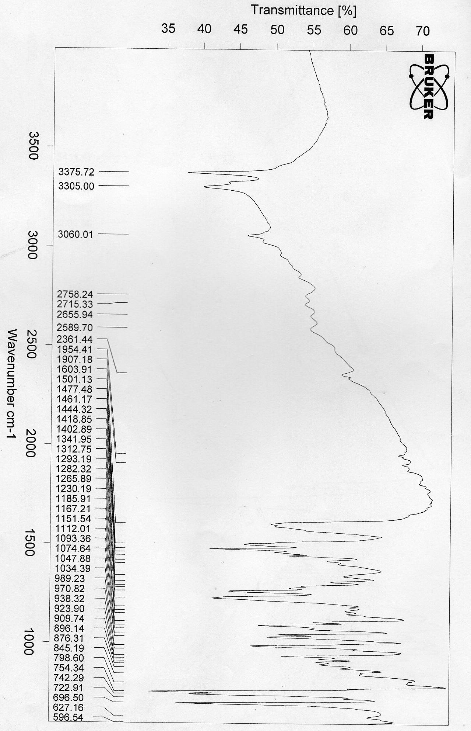
Fig.5: The IR spectrum of the ligand (L)
Fig.5 : The IR spectrum of the ligand (L)
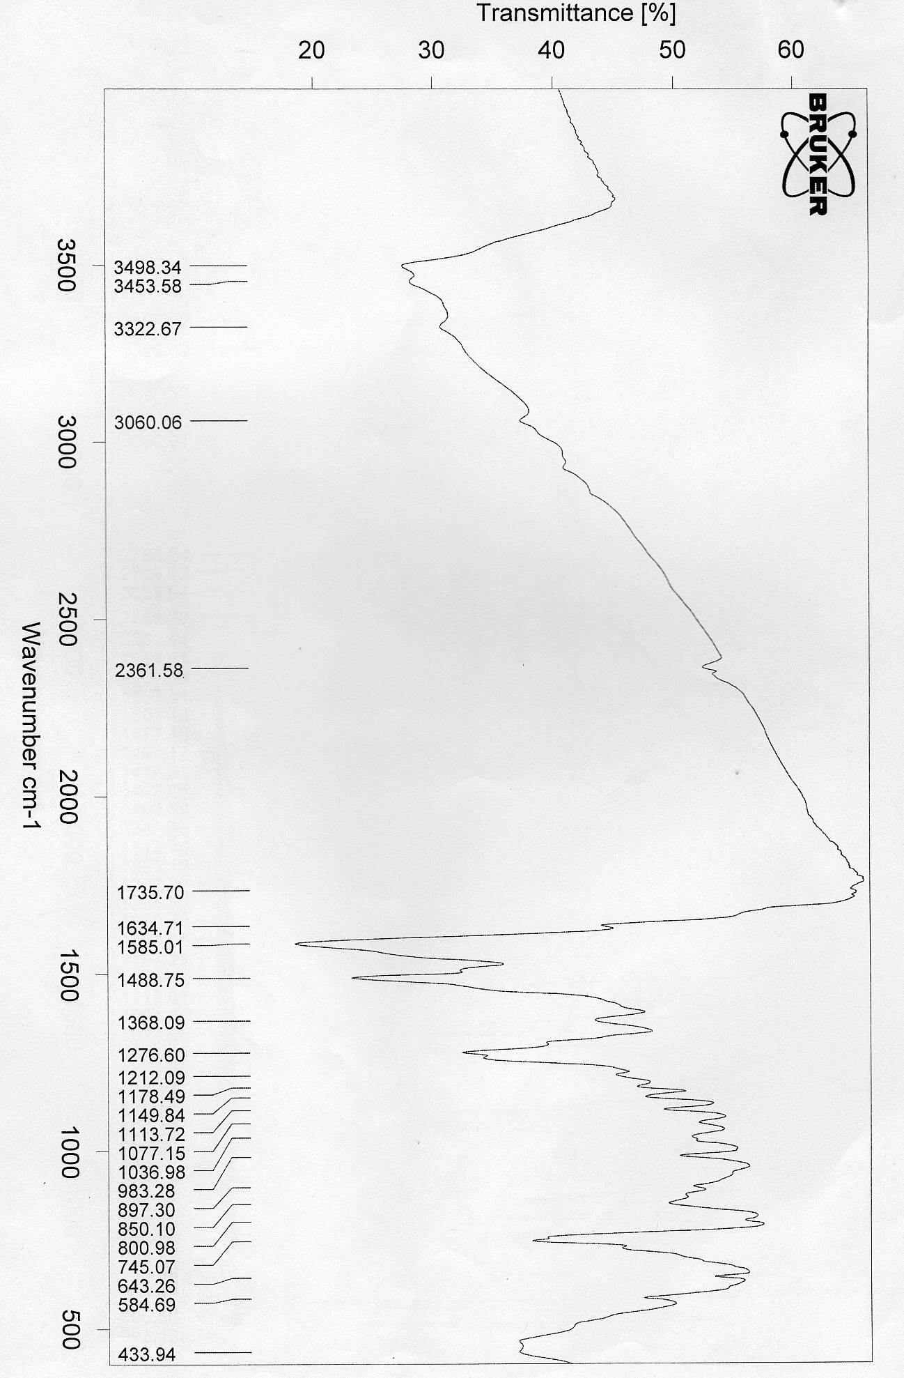
Fig.6: The IR spectrum of the [(Zn)₂(L)(Cl)₂(H₂O)₂] complex
Fig.6 : The IR spectrum of the [(Zn)₂(L)(Cl)₂(H₂O)₂] complex

References
1. Ayad, M.I., Sallam, S.A. and Mabrouk, H.E., Thermo-Chemica. Acta, 1991, 189, 65-73.
2. Temel, H., Cakir, U. and Ugras, H.I., Russian J. Inorg. Chem., 2001, 46, 1846-1850.
3. Johnson, D.K., Murphy, T.B., Rose, N.J. and Goodwin, W.H., Inorg. Chim. Acta., 1982, 67,159-165.
4. Yildirum, L.T., Emregul, K.C., Kurtaran, R. and Atakol, O., Cryst. Res. Tech., 2002, 37,1344-1351.
5. Hao, Y., and Shen, H., Spectro. Chim. Acta A, 2000, 56, 1013-1020.
6. Miniyar, P.B., and Makhija, S.J., Int. J. Drug Dev. and Res., 2009,1,19-26.
7. Bulut, H., Karatepe, M., Temel, H., Sekerci, M. and Koparir, M., Asian J. Chem., 2005,17, 2793-2796.
8. Cukurovali, A., Yilmaz, I., Gur, S. and Kazaz, C., Europe. J. Med. Chem., 2006, 141, , 201-207.
9. Ispir, E., Dyes and Pigments, 2009, 82, 13-19.
10. Tsuchida, E. and Oyaizu, K., Coord. Chem. Rev., 2003, 237,213-228.
11. Kwiatkowski, E., Romanowski, G., Nowicki, W., Kwiatkowski, M. and Suwinska, K., Polyhedron, 2003,22, 1009-1018.
12. Keskioglu, E., Balaban, G.A., Cete, S., Hamurcu, F. and Erk, B., Spect. Chem. Acta A, 2008, 70 , 634-640.
13. Katsuki, T., Coord. Chem. Rev., 1995, 140, 189-214.
14. Metzler, C.M., Cahill, A., and Metzler, D.E., J. Am. Chem. Soc., 1980, 102 (17-18) ,6075.
15. Li, M.Y., Hu, P. .Z., Zhu, J.C., Liu, Y., and Xu, K.X., Chin. J. Chem., 2004, 22, 162-166.
16. Vogel, A.I., 1972. A Textbook of Quantitative Inorganic Analysis, Longman Inc., 3rd. ed., New York.
17. Geary, W.J.,Coord. Chem. Rev., 1971, 81-122.
18. Panchai, P.K., Pansuriya P.B., and Patel, M.N., J. Enzy. Inhib. Med. Chem., 2006, 21(4), 453-458.
19. Sonmez, M., Erci. Uni. Fen. Bil. Enst. Derg., 2008, 24 (1-2), 308-314.
20. Nakamoto, K., 1970. Infrared Spectra of Inorganic and Coordination Compounds. Wiley Interscience , 3rd. ed., New York, PP. 159, 167, 214.
21. Drago, R.S., 1992. The electronic structure and spectra of transition metal ions. In physical methods for chemists, W.B. Soaunders College Publishing, New York, P. 431.
22. Dunn, T.M., Lewis, J. and Wilkins, R.C., 1960. The visible and ultraviolet spectra of complex compounds in modern coordination chemistry, Interscience, New York.
23. Lever, A.B.P., 1984. Inorganic electronic spectroscopy, Elsevier, Amsterdam.
24. Duta, R.L., and Syamal, A., 1992. Elements of Magneto-Chemistry. Elsevier, 2nd. Ed., New Delhi.
25. Carlin, R.L., 1995. Transition metal chemistry, Mercel Dekker, Vol. I.
26. Radovanovic, B.C.S., and Andjelkovic, S.S., 1997. Analytical Laboratory, P. 190.

