Study of Stoichiometry of Ferric Thiocyanate Complex for Analytical Purposes Including F⁻ - Determination
Fadhil M.Najib and Omed I. Hayder
College of Science, Sulaimani University

(NJC)

(Recevied on 4/10/2010) (Accepted for publication 26/4/2011)

Abstract
The rather old and well known Fe(III)-thiocyanate system has been restudied. The stepwise mole ratio complexation between them has been carefully confirmed. A wavelength shift from 460 t0 480 nm has been observed by increasing SCN⁻ ion concentration and remained constant at 480nm.where Fe(III): SCN⁻ was 1:6. An improvement in the problem of stability of the complex has also been achieved by creating an oxidizing medium using 9.5x10⁻⁴ M KMnO₄ , to prevent the inner redox reaction between SCN⁻ and CNS⁻. The stability has been improved from zero time to about 47 mins. Total iron has been determined in water and drugs down to 0.06ppm Fe³⁺ with r² = 0.9997 ,recovery of 99.1-102% and precision of 0.13%. A hypsochromic shift from 480 to 410 nm. caused by the effect of fluoride ion was exploited for its indirect determination down to 0.019ppm F – .This concentration can be lowered even more than that obtained with fluoride ion selective electrode if standard addition method was used. The recovery of F – ion was between 105-95%, with C.V. 2%. This method was .used for the determination of F – ion in water and toothpaste and compared with the results obtained with fluoride ion-selective electrode using statistical treatments.
Keywords: Ferric thiocyanate system, Total Fe(III) determination, Fe(III)/thiocyanate stoichiometry, indirect determination of fluoride.

الخلاصة
تـمـت اعـاده دراسـة النسبة التركيبية للنظام القـديـم للتـفـاعـل بـيـن ايـون Fe_{III} و الثـايـؤ سـايـانـات SCN⁻ . تضـمـنـت الدراسـه اجـراء تــفـاعـل تـدريـجـي دقيق جدا" للتـاكـد مــن النـسـب المــؤلـيـة بـيـن Fe_{III} و SCN⁻ اذ لـوحـظ انـتـقـال الطـول المـوجـي مـن 460 نانوميتر الـى 480 نانوميتر و ذلك عـنـد ازديـاد تـركـيــز SCN⁻ حتى اصـبـح ثـابـتـا ِ" عـنـد الـطـول المـوجـي 480 نانوميتر عـنـدهـا كـانـت النـسـب المــولـيـة بـيـن SCN⁻ : Fe_{III} = 6: 1 . كـمـا تـم التـوصـل الـى تـحـسـيـن ثـبـات المـعـقـد بـيـن Fe(III) و SCN⁻ و ذلك بتوفير جـو تاكسـد ي فـى المـحـلـول بـاضا فة x10 ⁻⁴ M9.5 مـن برمنكنـات البوتاسوم لـمنـع حـصـول الاخـتـزال الداخـلـي بين CNS⁻ و SCN⁻بذلك حفظ ثبات المـعـقد مـن التحلل الانى الى البقـاء ثـابـتـا حـوالـي 47 دقـيـقـة . و كذلك تم تقدير تركيز ايون الحديد الكلي فـى المـاء و فـي الادويه نـزولا" لـحـد 0.06 مغم /لتر مـع قيمة عـالـيـه مـن مـعـامـل الارتبـاط تـصـل الى 0.9997 , و نـسـبـة الاسـتـعـاده بـيـن 99.1 – 102% و دقـة الـتـكراريـه 0.13 % .
تم اسـتخدام الازاحة الزرقاء من 480 نانوميتر الى 410 نانوميتر بتاثير ايون فلوريد لتقدير ايون F⁻ بصورة غير مباشرةونزولاً لتركيز 0.019 مغم /لتر وقريباً من الحد الادنى لالكترود الفلوريد الانتقائى الحســاس وذلك باســتعمال طريقة الاضافة القياسـية.وكانت نســبة الاستعادة بين 95% و 105% مع معامل التباين 2% وطبقت الطريقة لتقدير ايون الفلوريد فى الماء ومعجون الاسنان وتمت مقارنتها مع طريقة الكترود الفلوريد الانتقائى ووثقت النتائج احصائياً

Introduction
Thiocyanate is an old reagent used for the determination of Iron(III) in 1853[1]. Later, in addition to Fe(III), it has extensively been used directly or indirerctly, for the determination of some cations such as Bi(III), Co(II), Zn(II) and Mo(VI) [2-8], anions such as, F⁻, Cl⁻, CN⁻ and SCN⁻[9-16] . The determination of SCN⁻ itself by using Fe ³⁺ was an important test to indicate its level in serum and saliva of smokers[17,18]. The system has also been used for the determination of, surfactants, drugs, L-ascorbic acid and antioxidant activities in Curcumin and Silymarin[19-24].
This review is a proof that thiocyanate is a valuable reagent and it is still extensively used for the determination of iron(III)[25]; even though other reagents may give better results and in spite of its limitations, which are often not too serious. This is because the reagent is cheap readily available, and can be used in strong acid medium, moreover, the procedure is simple and rapid.
There has been some contradictions on the number of the products formed when thiocyanate reacts with ferric ion. Depending upon the thiocyanate concentration and solvent medium, some workers believe that a series of complexes represented by [Fe (SCN) n] ^{(3 – n)+} where (n = 1-6), can be obtained[26-28] while others think that in dilute solutions only one product is formed and that is Fe (SCN)²⁺[29-31]. Sultant and Bishop [32] reported that they have analyzed the products and found no evidence for the formation of more than one product. They confirmed that the rest of the coordination sphere has been filled with hydroxyl, H⁺, SO4²⁻ ,HSO⁴⁻ and water molecules.
The above references also include studies confirming that the color intensity of iron –thiocyanate depends upon a number of factors such as the problem of stability[25,32,33], concentration and type of acid, ratio of iron/thiocyanate and temp. [24,26,28].
The present work is a search for real stoichiometry of Fe(III)-SCN⁻ complex and to improve its stability to be more reliable for Iron(III) determination. Furthermore a careful study is undertaken to exploit the system for indirect determination of fluoride ion. Although fluoride ion-selective electrode is a common method for the determination of F⁻ ion[34-37], old spectrophotometric [38-43] and newer methods are still among research subjects of investigation by many workers [44].
Experimental
Apparatus
All spectra were taken on a (Heλiosα UV. Visible spectrophotometer V4.6 ).
All pH measurements were carried out by a (PW 9420 pH meter Philips- England) equipped with a combined glass electrode from Jenway; Fluoride ion measurement was performed using a Combined Fluoride ion selective electrode (fluoride comb. ISE / BNC Ser.19508/001) and digital Ion meter 3345 Jenway. All Glass wares used were of grade (A).

Reagents and Preparations
Distilled water (D.W) prepared from all glass apparatus was used for all preparations.
All chemicals used were analytical reagent grade.
A 2 ppm Fe(III) solution was prepared from Fe NH₄ (SO₄)₂·12 H₂O in 0.1M HCl, HCl (37 %), KSCN, NH₄SCN, all from Fluka, NaSCN (>98.5%),from E-Merck, HClO₄ (70 %), Riedel de-Hein( Germany), NaF, KMnO₄(BDH).
Other chemicals used were from (BDH, Merck and Fluka) .
Results and Discussion
Selection of a salt for SCN- Reagent
Three common salts of thiocyanate, NaSCN, KSCN and NH₄SCN were tested for complexes with iron (III), and the results showed that NaSCN gave a slightly higher absorbance at 480 nm. followed by KSCN and NH₄SCN. Therefore NaSCN has been chosen for the rest of the studies in this work.
3
Selection of a Suitable Acid for the Medium
Obviously the system must be acidic to prevent Fe(III) hydrolysis, therefore the following acids (HCl, H₂SO₄ , HClO₄ , HNO₃ , HAc ) were tested, together with the three salts mentioned before, and the results are given in table (1). It shows that, although the results are very close to each
other but, HCl as a medium and again NaSCN are the most reasonable combination to be chosen for all other studies in this work.

Table 1: Effect of salts and acids
The acids | Absorbance
The acids | NaSCN | KSCN | NH₄SCN
HCl | 0.466 | 0.451 | 0.461
H₂SO₄ | 0.380 | 0.420 | 0.410
HClO₄ | 0.366 | 0.386 | 0.388
HNO₃ | 0.365 | 0.327 | 0.287
HAC. | 0.314 | 0.260 | 0.279

Optimization of the Acid Concentration at Different Ratios of(Fe (III) / SCN⁻)
Fig.(1) shows that for all ratios of (Fe (III) / SCN⁻) studied, the HCl concentration must be
0.1M or higher to obtain maximum absorbance and to prevent Fe (III) ion hydrolysis. At high pH, the color intensity has decreased because of iron hydrolysis. Thus a medium of (0.1 – 0.2) M HCl was chosen for the rest of the work.

Fig (1): Effect of HCl medium concentration with different ratio of Fe(III) / SCN⁻.

Optimization of SCN – Concentration
The contradictions of the number of components formed when iron(III) reacts with thiocyanate, mentioned in the introduction, have been studied in this work as follows:
Depending upon the thiocyanate concentration, a series of intensive studies were undertaken in the present work shown in Figs.(2,3 and 4 ), which has not been found in the literature, to assure the nature of the complex between iron (III) and thiocyanate.
In Fig (2) a shift in the wave length of the complex with increasing concentration of SCN– is observed. The shift has stopped at 0.15 M SCN– where the ratio of Fe(III) / SCN – reached 1/7222, and remained constant at 480 nm. Therefore it was assumed that the complex at this wave length has reached its maximum formation of[Fe(SCN)₆]³⁻. With no clear studies, literatures have given various optimum wave lengths such as 460 nm. [30], and 480 nm.[14,20,28,31]. Ovenstion and Parker [30] have shown that the wave length of Fe(III) – SCN – complex has shifted from 450 to 480 nm. by increasing the SCN– concentration, confirming results of the present work as shown in both figures (2 ) and (3). It is shown in these two figures that, increasing the concentration of SCN⁻ another three folds (to about 0.4M, which makes the ratio of Fe(III)/ SCN– nearly 19250 folds) the maximum wavelength remained constant at 480 nm. confirming the previous statement of maximum formation of [Fe(SCN)₆ ] ³⁻.

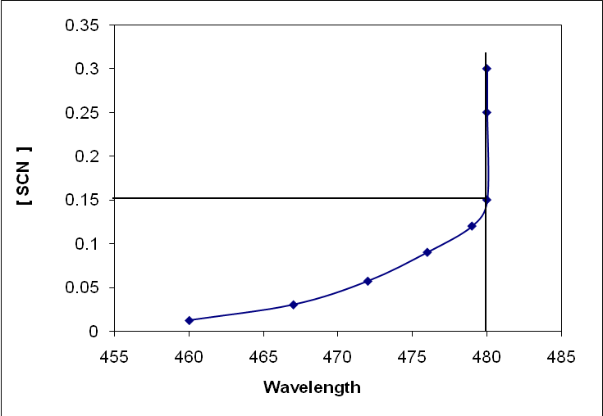
Fig (2): - Optimization of SCN⁻ concentrations. NaSCN between
0.012 and 0.36M, iron(III) 1.16 ppm in 0.1 M HCl.
Fig (3) :- Fe(III) – SCN spectra for different concentrations of SCN – with
1.16 ppm Fe(III) in 0.7 ml conc.HCl
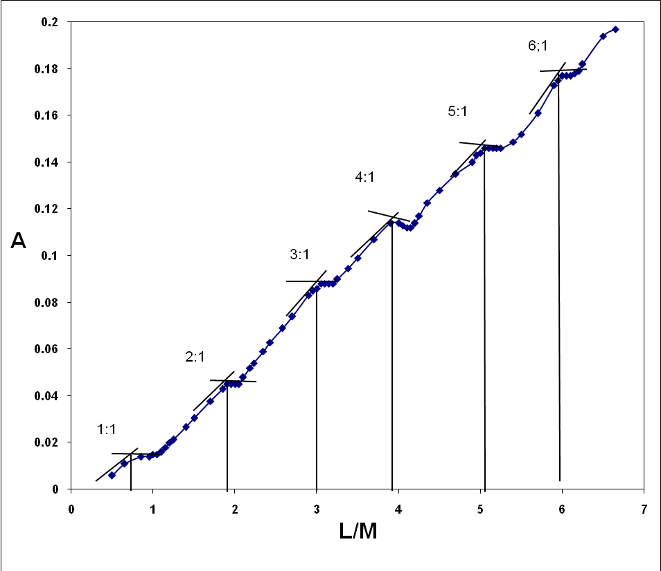
Fig (4): Mole ratio titration for different concns. of SCN⁻ with 8 x 10 ⁻⁴ M. Fe(III) in 1 ml
conc.HCl. at 480nm

Determination of the Stoichiometry of (Fe(III)-SCN⁻) Stepwise Complexes
1:4
1:6
1:5
There is an agreement in the literature that Fe(III) forms complexes with SCN⁻ from 1:1 to 1:6 Fe (III): SCN⁻ but no experimental studies have been found to confirm that. Some workers [32] confirm that only one product Fe(SCN)²⁺ can form. The present study has attempted to find out the answer.
For this purpose and using a microburet, a careful and slow mole ratio titration method was performed with a constant concentration of Fe(III) and changing the concentration of SCN⁻ as shown in Fig.4. The figure shows clearly step by step formation of all forms of the Fe (III) - SCN⁻ complexes from 1:1 to 1:6stoichiometry
Effect of Time on the Complex
All previous workers using Fe (III) - SCN⁻ system mentioned the nonstability of the complex so that the reagent SCN⁻ must be added the last after which measurement is taken immediately.
In the present work attempts were made to improve the stability of the complex.
Experiments showed that high excess of SCN⁻ with time did not show more than 6 mins. to reach the tolerance level of 5% error in absorbance. Adjusting ionic strength by 0.5 M (KCl, KNO₃ and NaCl) gave slight increase in stability. to about (7-10 and to17 min. in case of NaCl ). Therefore, attempt was concentrated on minimizing the causes of the instability which thought to be due to the inner redox reaction between SCN⁻ and Fe (III) and also the existence of some CNS– [3] usually present with or may be produced by SCN⁻ itself. All these factors contributed in the redox performance disturbing the stability of the complex :-

CNS⁻ + 4H₂O SO₄²⁻ + HCN + 7H⁺ + 6e-

If this is the reason, maintaining the medium in an oxidizing condition may prevent those effects. Therefore in addition to the adjustment of ionic strength, oxidizing agents.such as K₂Cr₂O₇ and KMnO₄ were tested. Variation of absorbance(Fig.5 a,b) compared to that at zero time, approaches the tolerance level of 5% at about 47 mins. by using (9.5 x 10⁻⁴M)KMnO₄ and only 7 mins. with 4x10⁻³ M K₂Cr₂O₇. It is worth mentioning that KMnO₄ in addition to stability improvement of the complex, has another important advantage and that is the elimination of organic matter in the sample [32]. The function of KMnO₄ is tested on the calibration curve of
Fe(III) – SCN⁻ system. The presence of (9.5 x 10⁻⁴M) KMnO₄ proved to have a good slope, detection limit 0.02ppm and linearity (0.2- 2) ppm as shown in Fig. 6 .

b
a

Fig(5):Effect of 4 x 10⁻³ M K₂Cr₂O₇ or 0.7)ml of (0.014 M) KMnO₄
added to 1 ppm Fe(III) complex. Abs. vs. Time in(a) and E% in (b).
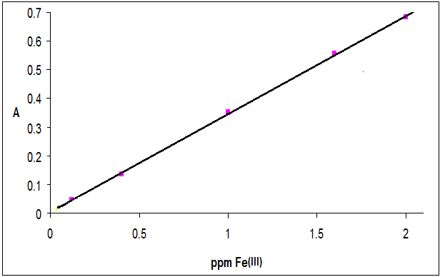
Fig. (6):- Calibration curve for Fe(III) in the presence of 9.5 x 10⁻⁴ M KMnO₄.

Study of Interferences and their Treatments
Results presented in table 2 show the tolerance level of many anions and cations that will produce not more than ±5.0 % error. From the results, it is concluded that the method is almost free from interferences of many foreign ions. It is noticed that the most strongly interfering anion were oxalate and F⁻ ions while among the cations, Co²⁺ was the strongest and in a positive direction

.Table (2):- Tolerance Concentration Levels of Interfering Ions
on 1.328 ppm Iron(III) Which Cause not More than ±5% Error.
Anions | IonX/Fe(III) folds&(E. dir.)* | Cations | IonX/Fe(III) folds&(E. dir.)
Oxalic acid | 1 (-) | Co⁺² | 7 (+)
F⁻ (as NaF) | 13 (-) | Al⁺³ | 91 (-)
MnO₄⁻ | 45 (+) | Sn⁺² | 95 (+)
Cr₂O₇⁼ | 77 (+) | Hg⁺² | 350 (-)
H₂PO₄⁻ | 100 (-) | Cu⁺ | 392 (+)
I⁻ | 115 (-) | Mg⁺² | 732 (-)
CN⁻ | 380 (-) | NH₄⁺ | 788 (-)
ClO₃⁻ | 592 (-) | Ni⁺² | 854 (+)
SO₄⁼ | 827 (-) | Sn⁺⁴ | 1581 (-)
HSO₄⁻ | 1116 (-) | Mn⁺² | 1703 (-)
Citric Acid | 1340 (-) | TeO₃⁺² | 1836 (+)
Br⁻ | 5640 (-) | Ca⁺² | 2275 (-)
D(+)glucose | 14273(+) | Cd⁺² | 3382 (-)
CO₃⁼ | 33338(+) | Na⁺ | 25632(-)
D(+)galactose | 46190(+) | Fructose | 64774(-)
NO₃⁻ | 61375(-) | K⁺ | 78934(-)
Cl⁻ | 71758(-)
*E.dir. = Error direction

Different mechanisms were applied to minimize the effect of interferences. First; the addition of (9.5 x 10⁻⁴M) KMnO₄ has eliminated the effect of oxalate and changed the oxidation state of other ions, which interfere at their lower oxidation state, such as Sn²⁺,as shown in the following equations:

5C₂O₄⁼ + 2 MnO₄⁻ + 16 H⁺↔ 10CO₂ + 2 Mn ²⁺ + 8 H₂O
5Sn²⁺ + 2 MnO₄⁻ + 16 H⁺↔ 5Sn⁴⁺ + 2 Mn ²⁺ + 8 H₂O

Another mechanism was by using a masking agent. It was found that 22 ppm Al³⁺ were needed to minimize the interference of 120 ppm F⁻ to cause only 4% error . The reverse of this process can be applied if the interference from Al³⁺ is required to be minimized.
It was also found that combination of the mechanisms, masking and error compensation, can be used if Cu⁺ interference is needed to be minimized. Using CN – ion can act in two ways, first as a usual masking of Cu⁺ and second, the opposite direction of their interference effect.
The addition of 479 ppm CN – ion was needed to minimize the interference of 13 ppm Cu⁺ to cause only 3.5 % error. A comparison between the addition and non-addition of (22 ppm Al³⁺+ 479 ppm CN⁻) in the presence of interferences is given in Fig.(7) which shows the calibration curves for the determination of total iron (III). The evaluation of these two figures and their applications for the determination of a synthetic sample of iron (III), is given in table (3). All parameters shown in this table confirm the usefulness of addition of Al³⁺ and CN⁻ in the quantities mentioned above.

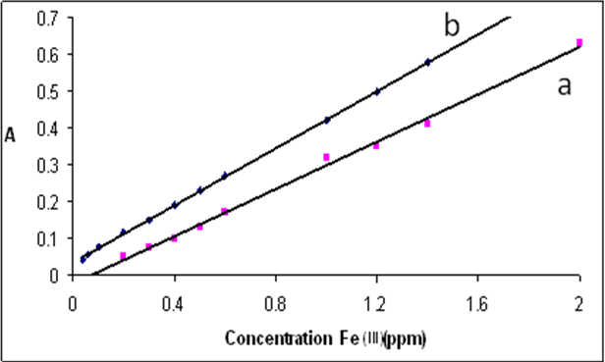
Fig.(7) Calibration curve for total iron(III) determination,
a) Before addition. and b) After addition of (22 ppm Al³⁺
and 479 ppm CN⁻).
Table (3) Statistical Handling for the Calibration Curves (Fig.7),
a)Before Addition and b) After Addition of (22 ppm Al³⁺and 479 ppm CN⁻).
Intercept | a | B
Intercept | - 0.0223 | 0.0351
r² | 0.996 | 0.9997
%recovery | 96 - 98.8 | 99.1 – 101.4
% E | 2.6 | 0.98
% C.V | 0.2 | 0.13
ε L.mol⁻¹.cm⁻¹ | 1.85 X 10⁴ | 1.97 X 10⁴
D.L (ppm) | 0.02 | 0.014
Range (ppm) | 0.2 – 2 | - – 2

Recommended Procedures
a) Drug Samples:
Iron in pharmaceutical preparations is normally in the form of ferrous sulphate, gluconate or
ferrate. The active ingredients are normally held in a matrix which must be destroyed before the iron can be effectively determined.
A suitable weight (0.014 - 0.015 )g from the crushed mixture of 10 tablets or capsules was taken and the matrix was destroyed by 25 ml of 2M HCl and heated for 15 mins. then completed to 100 ml. A suitable volume (0.1- 0.3) ml of the capsule solutions was taken, iron (II) was oxidized by 0.7 ml (0.014 M) KMnO₄ to iron (III), followed by addition of quantities of Al³⁺ and CN⁻ solutions so that their concentration in the final volume of 10 ml are 22 ppm and 479 ppm respectively. Finally 2.2 mls of 1.5 M SCN⁻ were also added and then completed to the mark with D.W.
b) Water Samples
A quantity 20 ml of 4M HCl was added to 30 ml of a water sample and heated in a water bath for 20 minutes, cooled to room temperature. A portion of 5 ml of water solution was taken and the procedure was then applied.
Direct calibration method can anbalyze the sample in the analytical range of (0.06 – 2) ppm Fe (III), while lower concentrations (< 0.06 ppm Fe (III)) are determined by Standard addition method.
For direct calibration, a series of standard Fe (III) ion concentration (0.06 – 2 ppm ) in
(0.12 M HCl) in the final volume of 10 ml, or (0.1- 0.3 )ml of drug sample solution or 5 ml of water samples were mixed with 0.7 ml of 0.014 M KMnO₄, quantities of Al³⁺ and CN⁻ solutions so that their concentration in the final volume of 10 ml are 22 ppm and 479 ppm respectively, finally ( 2.2 mls of 1.5 M SCN⁻ )were also added and completed to the mark with D.W. The absorbance was measured at 480 nm not later than 45min. For concentrations of Fe (III) less than 0.06 ppm, the standard addition method was used as follows:
After performing all the additions mentioned above to each flask, volumes of (0, 0.5, 1.0, 1.5, 2) ml of 2ppm standard iron (III) are added and completed to the mark with D.W. and mixed well. The absorbance measured not later than 45 min and the results are plotted between A and volume of standard Fe (III) added.
Applications of the Method
Table (4) shows the results of the application of the standard procedures to different concentrations of synthetic and drugs samples. The results show reasonable accuracy, errors did not exceed 5%. The range of % E in the table represents the average of three different volumes of drug solutions. The calculated value of (t) at 95 % (C.L.), for 3 degrees of freedom from the known concentrations was 0.273 which is less than the tabulated value of 3.182. This indicates that the difference between the true and experimental values is not significant at 95 % (C.L.) showing that there is no or very small systematic error which is also clear from the small error values obtained in the table, especially that of the synthetic sample.
Table (5) shows a t-test for pair comparison between direct calibration and the standard addition for the determination of Fe (III) in different samples of water. It has showed that the difference between the two methods is not significant at 95 % (C.L.), DOF = 9, since t -calculated 1.55 < t- tabulated 2.26. Samples No. 9 and 10 both were taken from Rangean, but the difference was that sample 10 was stored in an old tank container which explained why the concentration of iron(III) was so high and perhaps unhealthy.

Table (4) Results of Analysis of Drug using Direct Calibration:-
Tablet name | mg Fe(III)/100ml Present | mg Fe(III)/100ml* Found | % R | % ± E
TROGE | 2.7548 | 2.7715 | 100.61 | 0.61
Ferrous Sulphate | 2.8834 | 2.8635 | 100.69 | 0.69
Fesol | 2.3048 | 2.2475 | 102.49 | 2.49
Synthetic sample | 0.16 | 0.1629 | 101.81 | 1.81
x = -0.00688 | S.D = 0.044 | Texp. = 0.273

S. No. | Place ground area | (ppm)Iron(III) by Standard addition | ( ppm )Iron(III) by calibration
S1 | Raparean ( ground ) | 0.4552 | 0.3963
S2 | Sardaw(ground+from tank ) | 0.257 | 0.2999
S3 | Kanee Speaka (ground ) | 0.0906 | 0.0806
S4 | Hawaree Taza (ground ) | 0.1344 | 0.1338
S5 | Chwarbag (tap) | 0.021 | 0.049
S6 | Majid bag ( ground ) | 0.213 | 0.1113
S7 | Mlkandee ( ground ) | 0.4415 | 0.417
S8 | (Chwarbag | 0.082 | 0.083
S9 | Rangean (well direct ) | 0.3238 | 0.1732
S10 | Rangean (well+ from tank + 3 day) | ------------------ | 6.934
n = 9 | x = 0.0305 | S.D = 0.0592 | t_{exp} = 1.55
Table (5) Analysis of Iron (III) in Ground Water of Different Places in Sulaimani City by (direct calibration and standard additionn.).

Indirect Determination of Fluoride Ion
The accurate determination of fluoride in drinking water has become important with the practice of fluoridation of water supplies to reduce tooth decay.
In the present work, the Fe(III)-SCN⁻ system has been exploited for indirect determination of fluoride. There is no information in the literature about the real mechanism of F⁻ ion reaction with ferric thiocyanate complex. If the reaction is just a simple replacement, a negative effect would have been observed, but this was not the case here. Thus, based on the authors hypothesis the F⁻ ion may (a). acts as a catalyst causing an increase in the intensity of the absorbance of the complex without a shift of the peak maximum, or (b).A possibility that Fe(III)-SCN⁻ can make a mixed complex with F⁻ due to:
1-The small size of SCN⁻ ion can be released by another ligand for example, Cl⁻ ion [11,12,14,15], or F⁻ and forming a mixed complex which can be indicated by shifting of the wave length maximum.
2-SCN⁻ ion is a weak ligand and it is in the intermediate rank between those producing smallest ligand field splitting and those producing largest ligand field splitting shown below. Thus SCN⁻ can be released easily by F⁻ ion.

I⁻ < Cl⁻ < F⁻ < OH⁻ < H₂O < SCN⁻ < NH₃ < NO₂⁻ < CN⁻< CO
largest ligand field splitting smallest ligand field splitting
3- The stability constant
Fe³⁺ + SCN ⁻ Fe(SCN)²⁺ , Fe(SCN)₂⁺ . log K₁ =3.02 , log K₂ = 0.62……….
Fe³⁺ + F⁻ FeF²⁺ , FeF₂⁺ … log K₁ =5.18, log K₂ =3.89.........
The stronger complex of Fe³⁺ with F⁻ ion makes the replacement of SCN⁻ ion by F⁻ possible, perhaps in the following way:-
Fe(SCN)_{n} ^{(3-n)} + m F⁻ (FeFm)^{(3-m)+} + n SCN⁻ ………

The Effect of Both F⁻ and SCN⁻ on the Behavior of Fe(III)-SCN⁻ Complex
At a constant concentration of (14ppm. iron (III), Fig (8 )shows a hypsochromic shift from 480 nm when no F⁻ is present, to 410nm in the presence of 285 ppm fluoride ion and increasing concentration of SCN⁻. This may indicate the formation of a ternary complex between Fe³⁺ ion and both SCN⁻ and F⁻ ions. The effect is certainly caused by fluoride in comparison with Figs.2 and 3, in which SCN⁻ effect was a bathochromic type of shift. This behavior was exploited in this work for indirect determination of fluoride after optimization of each of Fe(III) and SCN⁻ to obtain a maximum change in ΔA at 480 nm. in which:

ΔA = A_{b} – A_{a} …………. at 480 nm
A _{b} = The Absorbance of (Fe (III) – SCN⁻) complex without fluoride.
A _{a} = The Absorbance of (Fe (III) – SCN⁻) complex for any concentration of fluoride.
Fig (8): Fe (III)-SCN– spectra showing the behavior
of the complex affected by both F⁻ and SCN, before
and after addition of fluoride

Optimization of Fe(III) Concentration
Keeping the concentration of SCN – constant at (4050 ppm),which was also used in Fig.8, the variation of Fe(III) concentration 3-14 ppm in the absence and presence of 285 ppm F⁻ are shown in table (6). The table shows that at 480 nm the maximum ΔA is caused by 14 ppm Fe(III) giving Fe(III)/ SCN – ratio of (1/289). This ratio was regarded optimum and should be maintained when there is a need to change both Fe(III) and SCN⁻ concentrations.

Table (6): Effect of Different Concentrations of Iron (III) on ΔA(ΔA = A_{b} – A_{a} )
ppm Fe(III) | ΔA at 480nm.
3 | 0.161
6 | 0.312
8 | 0.357
10 | 0.50
12 | 0.562
14 | 0.616

Optimization of Fe(III) –SCN⁻ Complex Concentration
At the optimum ratio of Fe(III)/SCN⁻ of (1/289) obtained in the previous sections, the concentrations of both Fe(III) and SCN⁻ were also changed around this optimum to give the same ratio at a maximum sensitivity of ΔA, and the results are shown in Table 7. The results of this study has shown that 11.2 ppm Fe(III) with 3240 ppm SCN⁻ gave maximum ΔA difference caused by the F⁻ effect, confirming the results of table (6).

Table (7) The Effect of 285 ppm Fluoride on the Fe (III) – SCN⁻
Complex by the Addition of Different Concentrations of SCN⁻
ppm Fe(III) | ppm SCN⁻ | ΔA
5.6 | 1740 | 0.043
8.4 | 2430 | 0.410
11.2 | 3240 | 1.315
14 | 4050 | 0.625
16.8 | 4860 | 0.334
18.2 | 5265 | 0.040

Order of Addition
All possible orders of addition of the iron (III), SCN⁻, HCl, and fluoride ion were tried. The best order of addition was that when iron (III) is added first, and then HCl followed by thiocyanate and F⁻ ion.
Calibration Curves
At the optimum conditions obtained in the previous studies, a calibration curve was drawn which showed two distinct regions, one with a reasonable slope between 0 and 2 ppm F⁻, and the other region was between 7.6 ppm and about 20 ppm F⁻.
The evaluation of these regions showed that the first region of (0 – 2) ppm F⁻,is suitable for fluoride determination, while the second is not.
A part of the chosen region of (0 - 1 ppm F⁻), shown in Fig.9, was examined for the determination of a known concentration of F⁻ ion. The accuracy, precision and r² were:
(E = -0.83%, C.V = ±2.14 % and r² = 0.9967) which are all quite reasonable. It is also interesting to note that the minimum linear range of the calibration curve is 0.019 ppm F⁻ which is of the same value that of F⁻ Ion Selective Electrode, in the ideal condition, which is really very hard to obtain in practice. Furthermore, if standard addition method is used, even less than this concentration could be determined.
Study of Interferences
Table (8) shows interference studies according to the procedure given in the present work. The results show the tolerance levels of most cations and anions causing (≤ ±5%) error in absorbance of the fluoride test solution, compared to that with no interferences. Most ions have low effect showing a reasonable selectivity. This was also confirmed when the effect of accumulated interferences given in table (8) on three concentrations of fluoride ion(0.096, 0.380 and 0.665ppm) in synthetic samples, showed that even 15 folds of total interfering ions, gave E%
(4 -6 )%.

Table (8) Tolerance Concentration Level of Interfering Ions on 0.095 ppm F- , Which Causes not More Than ≤ ±5% Error:-
Anions | Ion(X/F⁻) Fold & E. dir.* | Cations | Ion(X/F⁻) Fold & E. dir.*
CN⁻ | 580 (-) | Sn⁺² | 105(-)
SO₄⁼ | 827(-) | Hg⁺² | 232(-)
I⁻ | 1215(-) | Zn⁺² | 1322(-)
H₂PO₄⁻ | 1762(-) | Al⁺³ | 1663(-)
BO₃⁻² | 23529(+) | Fe⁺² | 2831(-)
CO₃⁼ | 2742(-) | Ca⁺² | 5728(-)
HSO₄⁻ | 8534(-) | Cu⁺ | 6487(-)
MnO₄⁻ | 16835(+) | Cu⁺² | 6487(-)
Citric Acid | 19579(-) | Mg⁺² | 9347(-)
Br⁻ | 21203(-) | Ni⁺² | 10484(-)
B₄O₇ ⁻ | 26000(-) | Sr⁺² | 13263(-)
NO₂⁻ | 30853(+) | Cd⁺² | 14232(-)
NO₃⁻ | 56742(-) | NH₄⁺ | 14406(-)
Cl⁻ | 71758(-) | Mn⁺² | 18279(-)
ClO₃⁻ | 90240(-) | Ce⁺³ | 19263(-)
D(+)gal. | 194316(-) | Sn⁺⁴ | 21741(-)
H₂O₂ | 663158(-) | K⁺ | 35693(-)
D(+)glu. | 955010(+) | SiO₃⁺² | 60456(-)
Fructose | 109368(-) | Co⁺² | 19660(+)

The Standard Procedure
For direct calibration, a series of F⁻ ion concentration (0.019 – 2) ppm F⁻ or 2 ml toothpaste solution or (5 ml of water sample) instead of F⁻ ion] in 4.5 ml 25 ppm Fe (III), 0.1ml conc. HCl and finally 0.4 ml 1.5 M SCN⁻ are added to 25mls.-capacity volumetric flask, and the volume is completed to the mark with D.W. The absorbance was measured at 480nm.
For concentrations of F⁻ less than 0.019 ppm , the standard addition method is used as follows:
A 5 ml of water sample or 2 ml of toothpaste solution is taken in 5 volumetric flasks of (10 ml capacity) then 0.1ml conc. HCl , ( 0.5, 1.0, 1.5, 2.0,) ml of 1.9 ppm fluoride and finally 0.4 ml 1.5 M SCN⁻ are added and completed to the mark with D.W.

A Comparison Between the Present Method and a Published Method (ISE)
A comparison was performed between the present method and fluoride ISE for the determination fluoride in tooth paste and water samples. For the determination of fluoride ion in water and toothpaste using F⁻ -ISE, reference [36] was used. In this method addition of total ionic strength adjusting buffer (TISAB) was used to adjust ionic strength, pH and complexing those metal that remove F⁻ from the samples. The calibration curves for F⁻ - ISE according to this reference and the present spectrophotometric method are shown in figs (9) and (10) respectively.
Using these two calibration curves, table (9) shows the %E of both the present work and ISE when they were used for the determination of known F⁻ concentrations. This comparison, indicates that the present method is as good as the F⁻ ISE method or better in accuracy

.
Fig.(9 )-Calibration curve using F⁻ -Ion selective electrode
in the range (0.019 - 0.76) ppm, according to ref.[ 36 ]
Table (9): A Comparison Between the Present Work and ISE in the Range (0.1- 0.855) ppm of Fluoride
Known F⁻  Concentration | The present method |  | ISE
Known F⁻  Concentration | Found ppm F⁻ | % E ± | Found ppm F⁻ | % E±
0.095 | 0.0996 | 4.8 | 0.1 | 5.3
0.38 | 0.3951 | 4 | 0.401 | 5.5
0.665 | 0.671 | 0.9 | 0.682 | 2.56

Application of the Present Method
The present method has been used for the determination of F⁻ ion in toothpaste and water samples and compared with F⁻-ISE. Methods of normal calibration curves and standard addition were used in both cases as shown in table (10).
To evaluate the present method and assure its validity, all the results of table (10) have been statistically analyzed by t-test of paired comparison.. The results indicate that the difference between the present method and ISE is not significant at 95 % (C.L.), DOF = 6. This indicates that the present method is as good as F⁻ ISE for the determination of F⁻ in toothpaste and water.

Table(10): A Comparison of Fluoride Determination in Drinking
Water and Tooth Past Samples Between the Present Method and F⁻-ISE
 | D. Cal. |  | Standard Addition
Sample | ISE | Present method | ISE | Present method
Rangean (ground) | 0.32 | 0.34 | 0.3 | 0.320
Sardaw ( ground ) | 0.288 | 0.287 | 0.285 | 0.284
Kanee Speaka (ground ) | 0.368 | 0.344 | 0.341 | 0.340
Sanino | 0.223 | 0.2212 | 0.223 | 0.227
Clous Up | 0.167 | 0.1655 | 0.167 | 0.17
Crest | 0.438 | 0.524 | 0.438 | 0.714
Dental clinic | 0.32 | 0.315 | 0.32 | 0.325
∑(d-D⁻)^2 = 0.1247 | n = 7 | x₁ = - 0.0104 | x₂ = -0.0437 | ∑(d-D⁻)^2  = - 0.3194
S.D₁ = 0.0208 | n = 7 | t_{exp.1} =1.324 | t_{exp.2} =2.17 | S.D₂ = -0.0532
t- tabulated at 95% DOF 6 = 2.45

Conclusions
The work presented here is an attempt to re-investigate an old very useful analytical system of ferric thiocyanate. The authors have been able to improve the stability of the complex formed between Iron(III) and thiocyanate ions and to establish the correct stoichiometry of this reaction. The work has also presented another advantage of this system for Indirect determination of Fluoride ion with accuracy, precision and detection limit close to the properties of Fluoride Ion-selective electrode method.
Acknowledgements
The authors would like to thank the Chemistry Department and College of Science of the Sulaimani University for their help.
References
1-Herapath;J.Chem.Soc.,1853,5,27.
2. Kingery W.D.and Hume D.N.; J.Amer. Chem.Soci.,1949,71,2393-2397.
3.Sandell E.B.;Colorimeteric Determination of Traces of Metals Analysis”3rd Ed.,1959.
4. Yoshimura K., Waki H. and Ohashi S.;Talanta,1976,23(6),449-454.
5. Rao T.P., and Ramakrishna T.V.; Analyst, 1980,105,674-678.
6. Barakat S.A., Mahmoud T.Y.; Acta Chim. Slov.,2003,50,799-806.
7. Riganakos K.A. and Veltsistas P. G.; Food Chemistry, 2003, 82(4),637-643.
8. Pons. C., Forteza R.and Cerda V.; Analytica Chimica Acta 2005, 528(2),197-203.
9. Foster M.D.; J.Amer.Chem.Soc., 1932, 54,4464.
10.Smith O>M. and Dutcher H.A.; Ind.Eng.Chem.Anal.Edu.;1934,6,61.
11. Ruzicka J.,Stewart J.W.B.and Zagatto E.A.; Analytica Chimica Acta, 1976, 81(2), 387-396
12. Vekic B.and Razem D.;Analytica Chimica Acta,1987,193,331-336.
13. Meeussen , T.C.L ,Erwin J.M.T., Keizer,M.G., and Novozamsky, I; Analyst, 1989,114,959-963.
14. van Staden J.F., Saling C., Malan D. and. Taljaard R.E; Analytica Chimica Acta,
1997,350(1-2),37-50.
15. Rocha F.R.P., and J.A. Nobrega ; J.Braz.Chem.Soc.,1997,8(6),625-629.
16. Van Staden J.F.and Botha A.; Analytica Chimica Acta,2000,403,279-286.
17-Degiampietro P., Peheim E.,Drew D., Graf H., and Colombo J.P.;J.Clin. Chem. Clin.Biochem.;1987,25,711-717.
18. Zil-a-Rubab and Ataur Rahman M., J.Pak.Med. Assoc.; 2006, 56(7) ,323-326.
19. Rajmani Patel and Khageshwar Singh Patel;Talanta,1999,48,923-931
20. Basavaiah K., Chandrashekar U.and Prameela H.C.;Turk J Chem.,2003,27,591-599.
21. Noroozifar M., Khorasani-Motlagh M.and Farahmand A-R.; Acta Chim. Slov. 2004,51,717-727.
22. Misiuk W.;Farmaco.,2005, 60(1), 61-69.
23. Ak T. and Gülҫin I.; Chem.Biol.Interact.,2008,174(1),27-37.
24. Köksal E., Gülҫin I., Beyza S.,Sankaya O.and Bursal E.; J.Enzyme Inhib.Med.Chem.;2009,24(2),395-405.
25. Martins F.G., Andrade J.F.,Pimenta A.C.,Lourenҫo L.M.,Castro J.R.M. and
Balbo V.R.; Eclet.Quim., 2005, 30(3).
26 Melnick . L.and Freiser H.; Analytical Chemistry,1953,25(6),856-859.
27.Kolthoff I.M., Sandell E.B., Mehan E.J. and Bruckenstein S.,”Quantitative Chemical Analysis’ 4th. Ed.pp1049, The Macmillan Company, London 1969, and the references therein.
28. Ozutsumi K., Hasegawa E., Kurihara M.and Kawashima T; Polyhedron, 1993, 12(18),2185-2192.
29. Gould R.K. and Vosburgh W.C.; J. Amer.Chem. Soc., 1942, 64, 1630-1632.
30. Ovenstion T.C. J. and. Parker C.A; Analytica Chimica Acta, 1949, 3, 277-284.
31.Harvey A. E, and. Manning D. L; J.Amer.Chem. Soc., 1950, 72, 4488-4493.
32. Sultan S M. and Bishop E.; Analyst, 1982,107,1060-1064.
33..Sammour H.M,. Sheglila A.T and Aly F.A.; Analyst,1977;102,180-186.
34. Boniface J .and Jenkins R.H.; Analyst , 1977,102,739-744.
35. Najib F. M., Karim M. T., Mohammad F.A. and Othman S.; Iraqi J. of Science,
1990,31,84-96.
36. Tokalioğlu Ş, Şahin U and Kartal Ş; Turk J.Chem.;2001, 25,113-121 and 2004, 28,203-211.
37. Borjigin S., Ashimura Y., Yoshioka T. and Mizoguchi T.; Anal.Sci. 2009, 25(12),1437-1443.
38. Bellack E and Schouboe P.J.; Analytical Chemistry,1958, 30(12), 2032-2034.
39. Hall R.J.;Analyst,1963,88,76-84.
40. Luisa M., Tomas C and West T.S.; Talanta,1969,16,781-788.
41. Haarsma J.P.S. and Agterdenbos J.; Talanta,1971,18,747-751.
42. Deane S.F. and Leonard M.A.; Analyst , 1977,102,340.
43. Deane S.F. and Leonard M.A., McKee V and Svehia G.; Analyst , 1978, 103, 1134-1147.
44. Zolghamein J., Shahrjerdi A., Azimi G and Ghasemi J; Anal.Sci. 2009, 25(10),1249-1253.

