Synthesis derivatives of 5, 6 -isopropylidene –N-{Methyl, Ethyl, Isopropyl, Isobutyl, Isopentyl, 2-phenylethyl}-gluconamide

Abd-AL-Jabbbar.A.Mukhlis
Baghdad University, College of Education Ibn-Al-Haitham
Oda.M.Yasser
Babylon University, College of Science
Hasan. Th.Ghanim
Kufa University, College of Education for Girls

(NJC)

(Recevied on 27/12 /2010) (Accepted for publication 2/ 5 /2011)

Abstract
Many new derivatives for L-ascorbic acid were prepared after closed the positions (2, 3, 5, and 6) in the L-ascorbic acid. Then its reaction with several amino acids (glycine, alanine, valine, leucine, phenylalanine). TLC, Elemental analysis, FTIR and H1.NMR spectroscopy, has characterized the synthesized compounds.
الخلاصة
تحضر العديد من مشتقات حامض السكوربيك بعد غلق المواقع (2،3،5،6)، بعد ذلك يفاعل مع الحوامض الامينة (كلايسين، اللاتين، فالين، ليوسين وفنيل اللانين)، استخدمت TLC ، والتحليل العنصري الدقيق والـ FTIR و الرنين النووي المغناطيسي للبروتون لتشخيص المركبات المحضرة.

Introduction
There are four hydroxyl groups in the structure of vitamin C molecule and these groups were given several products in the reactions, in the selective reaction for synthesis any derivative, it was require a specific program to give the specific product without side interference, Vargha ⁽¹⁾ was the first worker, he was prepared the derivative (5, 6-O-isopropylidene-L-ascorbic acid) by treatment ascorbic acid with acetone in existence of anhydrous copper sulfate for (24hr).
Jackson and Jones ⁽²⁾ were prepared the same derivative by additionally drop of acetyl chloride to the mixture of reaction (ascorbic acid and acetone) which have been as a catalyst, shaking along the reaction ,filtration and recrystalization after completely reaction with mixture of hexane-acetone, the percentage of product was more than 90%.
Vestling ⁽³⁾ was synthesized (2, 3-diacetyl-5, 6 -isopropylidene-L-ascorbic acid) (8) by using ketene as catalyst in the reaction below:

(1) (8)

Methyl glyoxal acetal was prepared on the position 2, 3 of L-ascorbic acid ⁽⁴⁾
as in the compound (9)

(9)

These compounds use in photography, anti- oxidation ,and anti- microbe growth ,thus, these medial compounds were used for prepared another derivatives⁽⁵⁻⁶⁾ ,worth mentioning derivative of 5,6-isopropylidene-L-ascorbic acid(2),its have activity against the following diseases⁽⁷⁾ ,anti-oxidation for nourishment productions⁽⁸⁾ , against dissociation by radiation^{(9).} .Its also soluble in oil, this properties of solubility gives utilization in grants industry and beatification materials⁽¹⁰⁾, and used as anti- decomposition oils⁽¹¹⁾. The goal of this study synthesis new derivative for L- ascorbic acid.

Experimental
Materials and Methods.
All chemicals were used of highest purity from (BDH, Fluka and Merck).The solvents were distilled and dried before use according to standard procedures. Reaction progress was monitored by TLC technique by using silica gel coated plates type (F254, 0.2mm). Melting points were recorded on a Stuart Melting point apparatus. FTIR spectra were recorded by Testcan Shimadzu FTIR 8000 series with nujol or by KBr disc and film. Elemental analysis of all samples were carried out on C.H.N analyzer type perkine Elmer 240B.The H¹NMR spectra were recorded with SFO1 300 MHz and solvent CDCl₃.
Synthesis
Synthesis of 5, 6 -isopropylidene-L- ascorbic acid (2).
The derivative (2) was prepared according to (Jackson and Jones) ⁽²⁾ method.
Synthesis of 2, 3 -diacetyl-5,6-isopropylidene-L- ascorbic acid [15].
(10g, 0.046mol) of 5, 6-O-isopropylidene-L-ascorbic acid (2) was dissolved in 30 ml pyridine and (25ml, 0.026 mol) acetic anhydride was added drop by drop (in separation funnel) with shaking and cooling for 2 hour. Then the reaction was leaved on over night at room temperature and the finishing reaction was observed by distinguish with TLC (solvent Benzene-methanol 8:2, R_{F=}0.85). The mixture was transfer of reaction on beaker with ice and then shaking for one hour, the extraction product was repeated at last three times with chloroform, then the extraction was repeated for one time with 5% hydrochloric acid to remove the pyridine, also the extraction was repeat with water. Small quantity of anhydrous magnesium sulphate was added to the product of extraction, filtration, and evaporate under weak pressure.
Synthesis of 5, 6 -isopropylidene –N-methyl gluconamid (12)
(1.25g, 0.016mol) of glucine was added to the mixture of (0.36g, 0.016mol) sodium in 30 ml absolute ethanol and shaking for (10 minutes), then
(5 g,0.01 mol) of compound (12) (2,3-di-O-acetyl-5,6-O-isopropylidene –L-ascorbic acid) was added, reflux the mixture for 90 minute⁽³⁰⁾ .after that the mixture was cool and filtered, detection the reaction by TLC with solvent of benzen:methanol 7:3, shows R_{f} =0.75 .Obtained one material.

Synthesis of 5,6-O-isopropylidene –N-ethyl gluconamide(13)
1.87g,0.01mol of valine was added to mixture of( 0.21g ,0.016 mol) of sodium ethanol and shaking for (20 minutes ),then (5g,0.01 mol) of compounds (8) (2,3-di-o-acetyl-5,6-o-propylidene-L-ascoric acid)was added , and reflux the mixture for(60
Minutes) ⁽³⁰⁾ .After that cool and filtered the product, obtained brown crystals, continuation of reaction with TLC by solvent (benzene: methanol) (7:3) R_{F} =0.7.

Synthesis of 5,6-O-isopropylidine-N-isopentyl gloconicamide (15)
(5g,0.01mole) of compound (8) (2,3-di-o-acetyl-5,6-O-iso propylidene -L-ascorbic acid) added to (2.09g,0.016 mol) of L-Leucine and mixture of sodium in 40 ml absolute ethanol with shaking for 20 minutes ,at last cool and filtered the product obtained white crystals ,and TLC method shows R_{f}=0.65 by and solvent (Benzene :methanol) (7:3).
Synthesisof5,6-O-isopropylidene-N-(2phenylethyl)glyconamide (16)
Added (2.13 g,0.016mol ) phenyl alanine to mixture of (0.28g,0.01mol) sodium in 30 ml of absolute ethanol and shaking for (25 minutes) at last added (5g ,0.01mol) from compound (2,3-di-O-acetyl-5,6-o-isopropylidene-L-ascorbic acid) ,reflux the mixture for (80 minutes )then cool and filtered ,obtained brown crystals ,TLC method with solvent (Benzene: methanol )(7: 3 )shows R_{f} =0.7

Scheme (1): The reaction steps for the synthesis of the derivatives

Results and Discussion
The sequences of reactions for the synthesis compounds of aim study were shown in scheme ( 1). The starting material of work was 5,6-O-isopropylidene-L-ascorbic acid (2) synthesized according to Jackson and Jones⁽²⁾ method by treatment of ascorbic acid with dry acetone in existence of acetyl chloride to remove water produce in reaction (that method was gave high product and pure ,The second derivative was prepared,to product 2,3-o-diacetyl -5,6-o-isopropylidene –L-ascorbic acid (8) by reaction compound (2) with acetic anhydride at room temperature, on the other hand the new derivatives of compound(8) was prepared by reaction with some amino acids (glycine,alanine,valine,leucine,phenylalanine) in the presence of sodium ethoxide and then refluxed the mixture reaction. The analytical data with some physical properties of the derivatives are summarized in Tables (1) .The elemental analysis data for new compounds that summarized in Tables (2) are consist with the calculated results from empirical formula of each compound.

FTIR Spectra
FTIR spectroscopic studies was showed of compound (1)[ Figs (1,2)Table(3)], disappearance absorption peaks of stretching vibrations for hydroxyl groups at (5,6) position at wave number 3411, 3317 cm⁻¹, ⁽¹²⁻¹³⁾ and was appearance of two new absorption peaks at (1650, 1433) cm⁻¹ which is returning to bending vibrations of (CH) to methyl groups attached to isopropylidene ring, and with remained absorption peak at (1755) cm⁻¹ representation to stretching vibrations of lactone carbonyl .The second derivative (8) as in Fig(3) was showed disappearance of absorption at 3527 cm⁻¹ belong to stretching vibration of (OH) group and appearance absorption peak of stretching vibration for esteric carbonyl group (CO) at 1720 cm⁻¹ was interference with absorption peak for lactonic (CO) at position 1750 cm^{-1 .} FTIR spectra for new derivatives (12, 13) Figs (4-5) was appear wide absorption peak in (3445-3550) cm⁻¹ returning to stretching vibration of two hydroxyl groups at (2,3) position ,absorption peak of stretching vibration of NH group was appeared at(3155-3340)cm⁻¹.

H¹NMR spectra
H¹NMR spectra studies of some new compounds were prepared in demonstration at Table(5).The derivative (8) was showed H¹NMR spectra at Fig(6) singlet signal (s) at δ=3.2 ppm for methyl acetyl protons⁽¹⁴⁾ ,but protons of methyl isopropylidene was showed singlet signal at δ=1.8 ppm .The derivative(12) Fig(7)was gave singlet signal at δ=7.2ppm of NH ,isopropylidene protons were appeared singlet signal at δ=1.7ppm ,the signal at δ=1.4ppm was returning to proton of methyl attached to nitrogen ,proton OH group was gave a singlet signal at δ=3.1ppm.
H¹ NMR spectra of derivative (13) Fig (8) was showed signal at δ=7.3 ppm of NH ,with disappearance of single signal at δ=3.2ppm. was return to proton of esteric methyl, singlet signal at δ=2.9 ppm was represent proton of OH group. The derivative (15) Fig(9) was gave singlet signal at δ=7.2ppm for NH which is not found in compound(8) ,also double signal at δ=1.3ppm belong the proton of methyl isopentyl with multiple signal at δ= 0.5-0.9ppm for protons (CH₃CH₂CH) was attached to nitrogen , with appearance singlet signal at δ=3ppm for proton hydroxyl group.
H¹NMR spectra of compound (16) Fig (10) was gave multiple signal at δ=6.4-7.8ppm was return to phenyl ring, Amide was showed singlet signal at δ=8.2ppm, in addition was appear multiple signal at δ=2.3ppm of proton of methylene group attached to nitrogen was showed multiple signal at δ=1.4-1.8ppm, while proton hydroxyl group was gave signal at δ=2.9ppm.

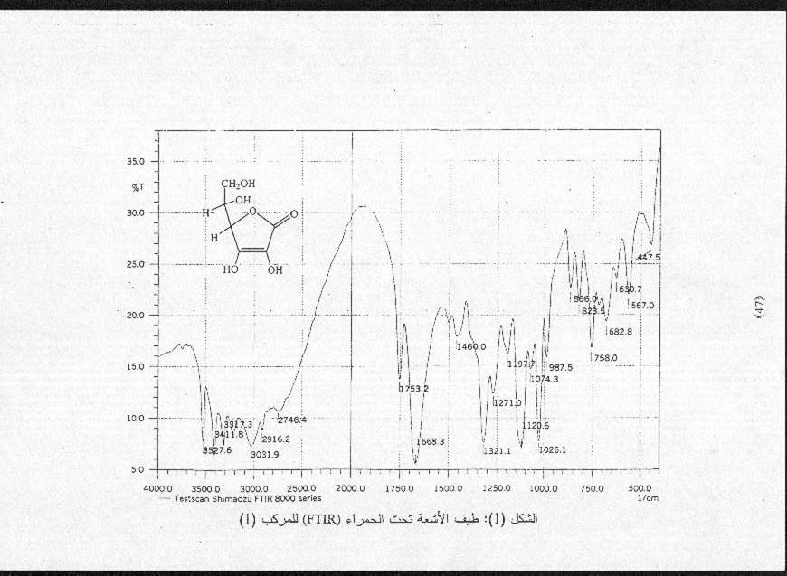
Fig (1): FTIR spectra for L-Ascorbic acid
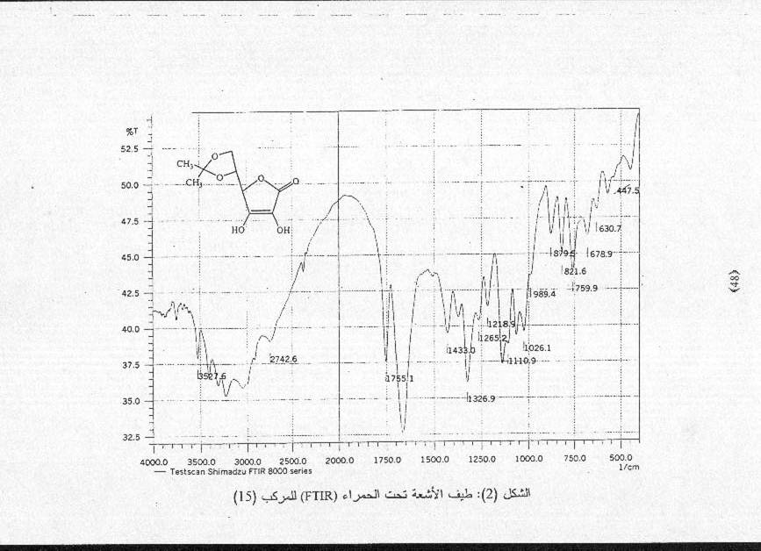
Fig (2): FTIR spectra for derivative (2)
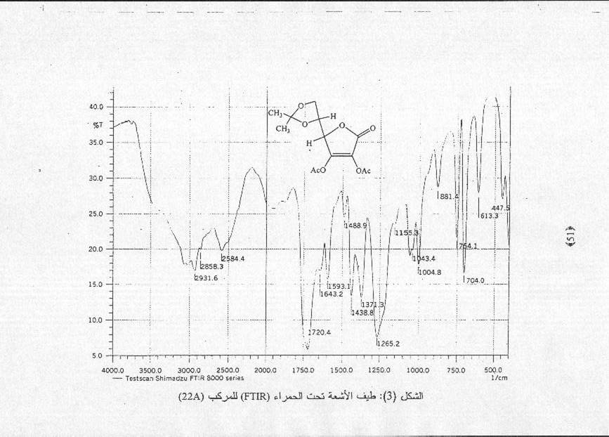
Fig (3): FTIR spectra for derivative (8)
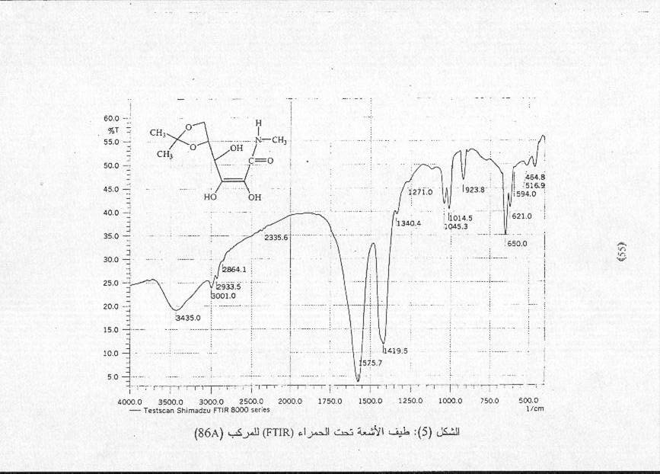
Fig (4): FTIR spectra for derivative (12)
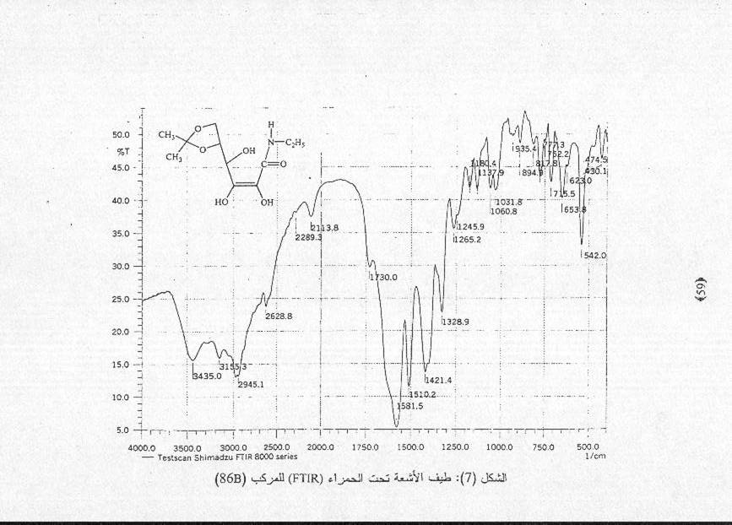
Fig (5): FTIR spectra for derivative (13)

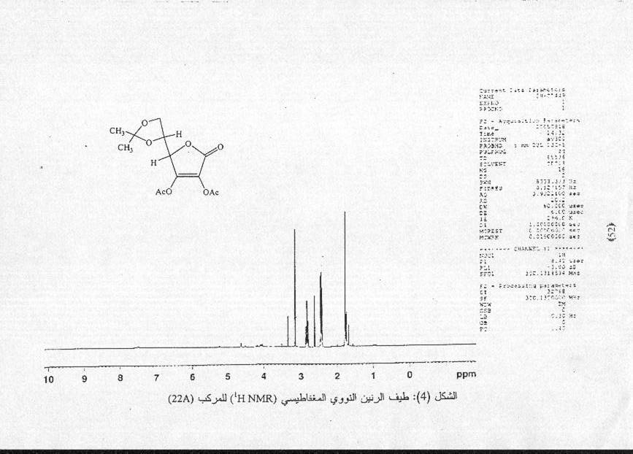
Fig (6): HNMR spectra for derivative (8)
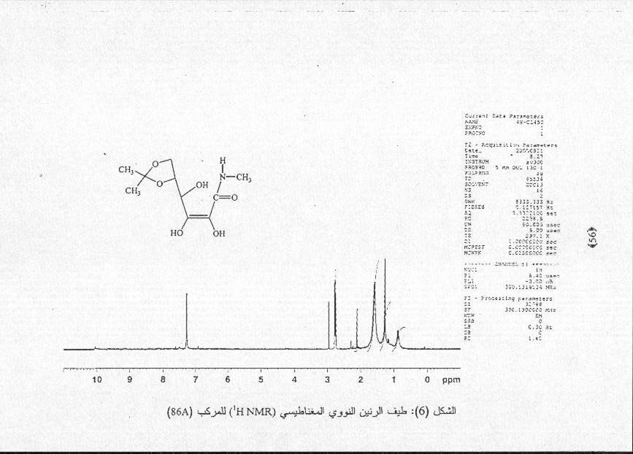
Fig (7): HNMR spectra for derivative (12)

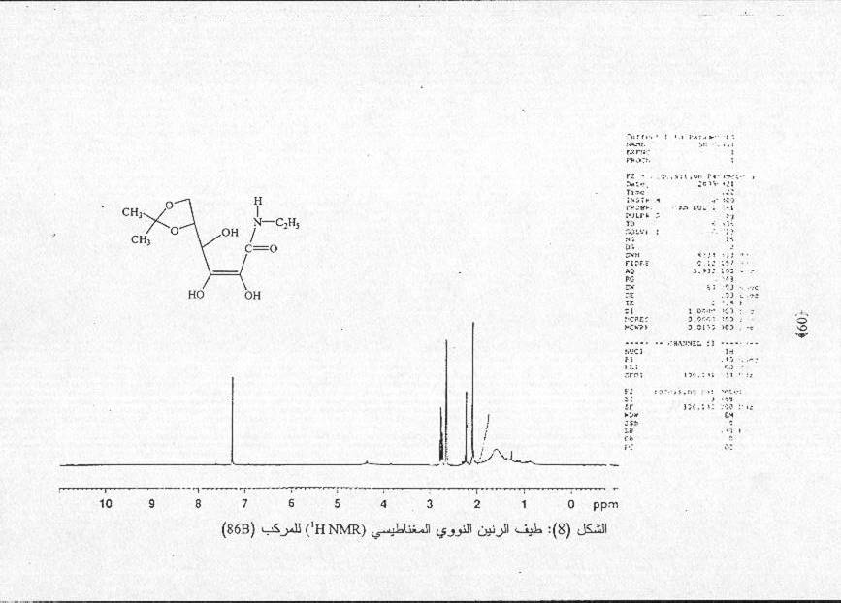
Fig (8): HNMR spectra for derivative (13)
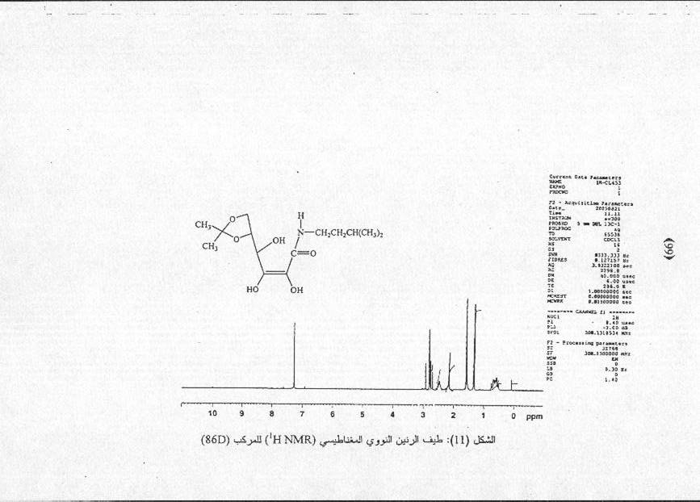
Fig (9): HNMR spectra for derivative (15)

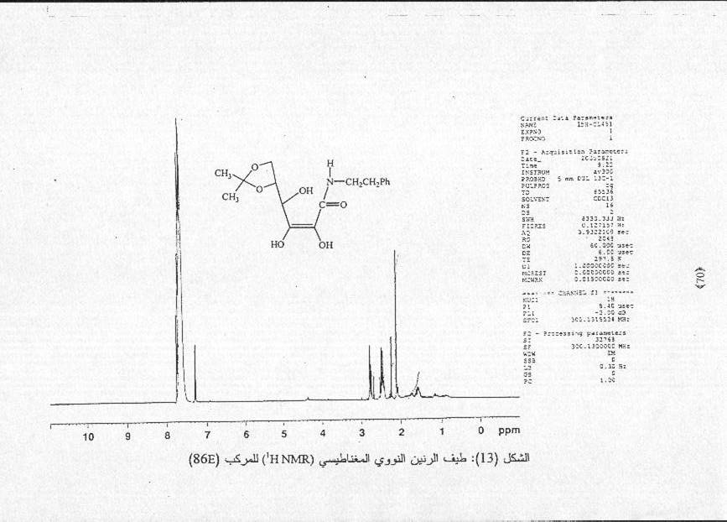
Fig (10): HNMR spectra for derivative (16)

Table(1): Some physical properties of the synthesized compounds
No. | M.F | M.wt | (M.p) ˚C | Yield %
2 | C₉H₁₂O₆ | 216 | 216 – 220 | 92%
8 | C₁₃H₁₆O₈ | 300 | Syrup | 85%
12 | C₁₀H₁₇O₆N | 247 | 198 – 201 | 75%
13 | C₁₁H₁₉O₆N | 261 | 182 – 186 | 87%
14 | C₁₃H₂₃O₆N | 289 | 192 – 195 | 70%
15 | C₁₄H₂₅O₆N | 303 | 215 dec. | 68%
16 | C₁₇H₂₃O₆N | 337 | 210 – 213 | 80%

Table (2): Analytical data and R_{f} of the synthesized compounds
N% | H% | C% Calc.  Found | R_{f} | M.w.t. | M.F. | No.
 | 5.55  5.51 | 50.00  49.75 | 0.8 | 216 | C₉H₁₂O₆ | 2
 | 5.37  5.62 | 52.00  52.48 | 0.85 | 300 | C₁₃H₁₆O₈ | 8
5.66  5.61 | 6.88  6.62 | 48.58  49.02 | 0.75 | 247 | C₁₀H₁₇O₆N | 12
5.36  5.55 | 7.33  7.42 | 50.57  50.92 | 0.68 | 261 | C₁₁H₁₉O₆N | 13
4.84  4.96 | 7.95  7.85 | 53.97  54.09 | 0.7 | 289 | C₁₃H₂₃O₆N | 14
4.62  4.67 | 8.31  8.33 | 55.44  55.86 | 0.68 | 303 | C₁₄H₂₅O₆N | 15
4.15 4.08 | 6.82 6.79 | 60.53  60.21 | 0.80 | 337 | C₁₇H₂₃O₆N | 16

\Table (3): Characteristics IR absorption bands of the synthesized compounds
v(N – H_{str.} ) cm⁻¹ | v(C=C) cm⁻¹ | vCO_{amid} cm⁻¹ | vOH cm⁻¹ | δ_{bend.}CH₃ (twin) cm⁻¹ | vCH_{arom.} cm⁻¹ | vCH_{aliph.} cm⁻¹ | Compound | No.
3155 | 1580 1421 | 1610 – 1650 | 3435 – 3485 | 1394 | / | 2945 |  | 13
3210 | 1610 1445 | 1583 – 1650 | 3415 – 3485 | 1394 | / | 2945 |  | 14
3190 | 1610 1465 | 1587 – 1670 | 3450 – 3510 | 1352 | / | 2956  2868 |  | 15
3220 | 1610 1460 | 1610 – 1715 | 3435 – 3550 | / | 3030 – 3150 | 2940 |  | 16
Table (4): Characteristics IR absorption bands of the synthesized compounds
vCO_{ester} cm⁻¹ | v(C=C) cm⁻¹ | v(N H_{str.}) cm⁻¹ | vCO_{amid} cm⁻¹ | vOH cm⁻¹ | δ_{bend.}CH₃ (twin) cm⁻¹ | v(C=O_{lactone}) cm⁻¹ | vCH_{aliph} cm⁻¹ | compound | No.
/ | 1668 1460 | / | / | 3317  3411  3527 | / | 1753 | 2914 |  | 1
/ | 1650 1433 | / | / | 3527 | 1326-1380 | 1755 | 2981 |  | 2
1720 | 1643 1438 | / | / | / | 1371 | 1750 | 2931  2858 |  | 8
/ | 1600 1419 | 3340 | 1600 – 1650 | 3435 – 3500 | 1390 | / | 2933  2867 |  | 12
Table(5): H¹NMR data for the synthesized compounds (CDCl₃ Solvent)
No. | Compound | Notes
8 |  | δ1.8 ppm (s, for the isopropylidene methyl proton)  δ2.4 – 2.9 ppm (m, H₄, H₅, H₆)  Δ3.2 ppm (s, for the acetyl group)
12 |  | δ1.7 ppm (s, for the isopropylidene methyl proton)  δ3.1 ppm (s, for the OH), δ1.4 ppm (s, for the CH₃ )  δ7.2 ppm (s, NHgroup)
13 |  | δ1.2 – 1.8 ppm (m, for CH₂, CH₃ )  δ2.1 ppm (s, for the isopropylidene methyl proton)  δ2.9 ppm (s, for the OH), δ7.3 ppm (s, NHgroup)  δ2.5 – 2.9 ppm (m, H₄, H₅, H₆)
15 |  | δ1.7 ppm (s, for the isopropylidene methyl proton)  δ1.3 ppm (d, for the methyl proton of side chain)  δ3.0 ppm (s, for the OH), δ7.2 ppm (s, NHgroup)  δ0.5 – 0.9 ppm (m, for the CHCH₂CH₂), δ2.3 – 2.7 ppm (m, H₄, H₅, H₆)
16 |  | δ2.1 ppm (s, for the isopropylidene methyl proton)  δ2.3 ppm (m, for the CH₂ proton attach phenyl group)  δ1.4 – 1.8 ppm (m, for the CH₂ proton attach nitrogen)  δ2.9 ppm (s, for the OH), δ7.3 ppm (s, NHgroup)  δ7.4 – 7.8 ppm (m, for the proton phenyl group)

References
1. L. V. Vargha; "Nature", 1932, 130, 847.
- K. G. A. Jakson & J. K. N. Jones; Canada, J., Chem", 1969, 47, 2498.
- S. Patai; The Chemistry of the Ether Linkage, Interscience, London, 1967, 309 – 336.
- C. Vestling & M. Rebstock; J., Biochem., 1944, 52, 585 – 591.
- P. Elvin & T. Slater; Eur. J. Cancer Clin. Oncol, 1981, 17(7), 759; Cited, Chem. Abst", 1982, 96, 11559y.
- M. Tsujimuva, T. Fukuda, T. Kasai & S. Kitamtina; Bitamin, 1981, 55 (1), 31; Cited, Chem. Abst., 1981, 94 (19), 150221C.
- M. O. Miric, Z. V. Cupric & A. F. Damanski; Conger Expertise Chim. Spec. Conf. Commun., 4th, Athens 1964, P. 273; Cited, Chem. Abst., 1967, 66, 64422j.
- C. S. Vestling & M. C. Rebstock; J., Biochem., 1945, 161, 285.
- N. S. Salih, M.Sc. Thesis; "Periodic Acid Oxidation of L-Ascorbic Acid At Position 5,6-A. and It's Reaction with 2-Amino-5-phenyl-1,3,4-oxadiazole", College of Education, University of Kufa, (2002). P. 13.
- Y. Ayano; T. Furuhashi; Y. Watanable and K. Motohashi, Nippon Shokuhin Kogyo Gakkashi, (1977), 24(7), 372 - ., Cited., Chem. Abst.", , 1979, 91 (23), 495.
- R. D. Guthrie and J. Honeyman, "An Introduction to the Chemistry of Carbohydrate", William Clowes and Sons, Ltd., London, (1968) 3rd. Ed., PP. 44 – 57.
- A. L. Smith; "Applied Infrared Spectroscopy Fundamentals, Techniques, and Analytical Problem – Solving", John Willey & Sons, 1979, New York, Chiechester.
- J. J. Maitland; Organic Chemistry, Norton & Company, USA, 1997, 702 – 703.
- S. Hanessian; Preparative Carbohydrate Chemistry", Marcel Dekker Inc., New York, 1997), 7 – 8.

