Preparation, Characterization, and Diltiazem HCl Release Study of Chitosan / poly(vinyl alcohol) Microspheres

Nadia A. Al-Assady
Chemistry Dept., Education College, Basrah University, Iraq
Wesam a. K. Hussein
Chemistry Dept., Science College, Babylon University, Iraq
Hadi A. Jabir
Chemistry Dept., Education College, Basrah University, Iraq

(NJC)

(Recevied on 27/9/2010) (Accepted for publication 28/2/2011)

Abstract
The aim of this study was to develop a procedure for prepared ,and characterization a controlled-release microspheres polymers like chitosan , polyvinyl alcohol (PVA) containing Diltiazem HCl (DTZ), as a model drug, was obtained using a modified emulsification/solvent-evaporation method, induced by addition of glutaraldehyde (GA) as a crosslinking agent. The microspheres were characterized by Fourier transform infrared spectroscopy, differential scanning calorimetry (DSC), and photomicrographs microscopy. The effect of different process parameters, such as drug/polymer ratio and stirring rate during preparation of microspheres, on the morphology, size distribution, and in vitro drug release of microspheres was studied. As expected, stirring rate influenced particle size distribution of microspheres and hence drug release profiles. By increasing the stirring speed from 400 to 1200 rpm, the mean diameter of microspheres decreased from 350 μm to 104 μm. The drug release rate from smaller microspheres was faster than from larger microspheres. Increasing the drug content of microspheres from 20% to 40% w/w led to significantly faster drug release from microspheres. It was also studied the release of (DTZ) at different pH values (1.2, and 7.4) at 37°C. The results indicated that drug release was much higher at pH 1.2 than that of at pH 7.4.
الخلاصة
تهدف هذه الدراسة إلى استخدام طريقة مطوره في تحضير الهلاميات الكروية ذات الإطلاق المسيطر عليه باستخدام البوليمرات كالكيتوسان وبولي فنايل الكحول والتي تحتوي ديلتيازم هيدروكلورايد كماده دوائية مختارة , باستخدام طريقة المستحلب/ تبخير المذيب المطور وإضافة الكلوترالديهايد كعامل تشابك.
تم تشخيص الهلاميات الكروية بمطيافية الأشعة تحت الحمراء والتحليل الحراري التفاضلي ودراسة الشكل باستخدام المجهر الضوئي. وقد تم دراسة تأثير تغيير بعض العوامل كنسبة الدواء/ البوليمر وسرعة المزج على كفاءة تحميل الدواء وحجم الهلاميات والشكل وسرعة إطلاق الدواء خارج الجسم الحي. ولقد أظهرت النتائج إن حجم الهلاميات الكروية تنخفض بزيادة سرعة المزج, كذلك تزداد سرعة إطلاق الدواء بزيادة تركيز الدواء. كما تم دراسة سرعة الإطلاق بقيم مختلفة من الأس الهيدروجيني ( 2¸1 و 4¸ 7) في 37 م˚ وقد أظهرت النتائج إن سرعة إطلاق الدواء في الأس الهيدروجيني 2¸1 أعلى من إطلاقه في الأس الهيدروجيني4¸7 .

Introduction
Oral sustained release systems continue to dominate the market despite the advancements made in other drug delivery systems in order to increase the clinical efficiency and patient compliance. From a practical pharmaceutical view point, numerous types of polymers are currently employed to control the drug release from the pharmaceutical dosage form. Oral sustained release systems are mainly grouped into three types, e.g. reservoir, monolithic and matrix types^{1,2}. Among these hydrophilic matrix tablets are preferred in the formulations since most display good compression characteristics, even when directly compressed and have adequate swelling properties that lead to a rapid formation of external layer, allowing drug release modification . Various natural gums and mucilages have been examined as polymers for sustained drug release, in the last few decades^{3,4}. The physical and structural properties and the drug release mechanisms and kinetics of these sustained release preparations determine the in vivo performance of these dosage forms⁵. Polymers have drug delivery applications achieving sustained/controlled release profiles. The use of natural polymers and their semi-synthetic derivatives in drug delivery continues to be an area of active research despite the advent of synthetic polymers⁶. Natural polymers remain attractive primarily because they are inexpensive, readily available, capable of multitude of chemical modifications and potentially degradable and compatible due to their origin⁷ .
Microspheres of biodegradable polymers have been widely studied as drug delivery systems ^{8,9}. Besides their ability to improve the delivery of drugs to the target site, they have been reported to control drug release, reduce drug associated adverse effects. A great variety of both natural and synthetic biodegradable polymers such as chitosan, gelatin, polylactic-coglycolic acid, polyalkylcyanoacrylate, polymethylmethacrylate, polylactic acid and polycaprolactone are used for the preparation of drug loaded microspheres ^{10,11}.
Several methods, including phase separation or coacervation¹², emulsification diffusion ^{12,13}, spray-drying¹⁴, and emulsion-solvent evaporation techniques ¹⁵ have been used to obtain chitosan microspheres. With the emulsion solvent evaporation technique, numerous hydrophilic drug substances including proteins and peptides have been encapsulated into chitosan nano- and microparticles using o/w methods and the mechanism of drug release from these particles has been thoroughly studied ^{16,17}.
Diltiazem HCl (DTZ) (Figure 1) is a calcium channel blocker¹⁸ used in the treatment of hypertension and angina (variant and classical angina) ¹⁹. Diltiazem was selected as a model drug for investigation because of its suitable properties like half-life of 4.5 hrs, optimum partition coefficient (158) and molecular weight (450.98 g/ mole) make it suitable for administration by buccal route. A suitable buccal drug delivery system should posse’s good bioadhesive properties. So, that it can retain in oral cavity for desired duration and localize the dosage form in a specific region and control the release rate of drug.

Figure( 1) The structural formula of DTZ

The aim of this study was, design, development and characterization of a buccoadhesive controlled-release microspheres of DTZ using some selective polymers like chitosan , poly(vinyl alcohol) (PVA). Also the interaction between polymers and drug-polymers, bioadhesion and in vitro release characteristics of DTZ from different buccoadhesive microspheres was evaluated to assess the suitability of such formulations.
Experimental
Materials:
The used chemicals in this study supplied by several sources, polyvinyl alcohol (PVA) average MW 72,000 g/mol) , acetic acid, Sodium hydroxide were provided by Sigma-Aldrich Company(Germany), glutaraldehyde, methylene chloride were provided by Fluka Company (Germany), Diltiazem HCl (DTZ) was provided by Egyptian Int. pharmaceutical Industries CO. , distilled water was used throughout the study .

Methods:
Preparation Chitosan ²⁰
A) Isolation of Chitin from Shells of Shrimp
Shrimp shells was washed with water ,dried and crushed to fine powder. and treated (30 g )with (250 ml ) boiled acidic water (10% HCl) in the( 500ml ) reaction vessel fitted with condenser for one day then the product was filtered , washed with distilled water and dried at 50˚C under vacuum . the powder was treated with (250ml ) of (5% NaOH ) solution for 12hrs at 80˚C in water bath .
The product was filtered ,dried and dissolved in (200 ml) of (90 %) formic acid at room temp. , formic acid was removed by rotary evapourator at 90˚C . The product was washed with distilled water (3 times), dried and powdered , the yield was 35%. B)Deacetylation of Chitin (Chitosan)
Chitin was deacetylated by heating in a 50 w/w % NaOH solution with 0.5 w/w % sodium borohydride (NaBH₄ ) based on the weight of chitin to prevent depolymerisation . The ratio of chitin to NaOH solution was 1g of chitin in 10 ml of NaOH solution . The deacetylation was performed in an a autoclave at 110˚C for 3hrs. The deacetylation product obtained was washed with deionized water until neutral . The resulting chitosan (Figure 2) flakes were dried in an oven at 60 ˚C for 24 hrs.

Figure 2 The structural formula of a) chitin b) Chitosan

Preparation of microspheres
A modified emulsification/solvent-evaporation method²¹ was used for preparation of DTZ microspheres. Appropriate amounts of chitosan were added to 10 mL (2 w/w %)of acetic acid to provide concentrations of 2.5%, 3%, 3.5%, and 4% w/v; then different amounts of DTZ were dissolved in methylene chloride then added to the polymer solution to give 1% to 2.5% w/v drug solutions to yield theoretical drug loading of 20%, 30%,or 40% w/w, respectively. The solution was then added drop-wise to a 200-mL aqueous phase solution containing 0.5% w/v (PVA) with glutaraldehyde (GA) as a crosslinking agent (Figure 3), while the mixture was stirred by an overhead stirrer to form a stable oil/water emulsion system at room temperature (25 ± 2°C). Stirring was continued for up to 5 hours to allow the evaporation of methylene chloride and the formation of solid microspheres. Microspheres were filtered, washed with distilled water, and dried overnight until no weight loss was observed.

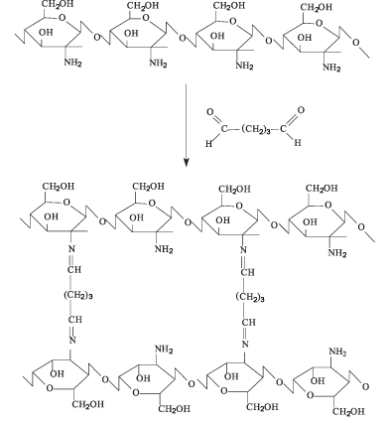

Figure 3 Cross linking process of chitosan treated with glutaraldehyde

Morphological Study
Photomicrographs of microspheres characterized using a digital optical microscope(model Motic B1 series system Microscoopes) . A small amount of dry microspheres was ultras .
Determination of Percentage Drug Entrapment
An aliquot of 100 mg of microspheres was immersing in 250 mL of phosphate buffer saline pH 7.4 to dissolve the drug dispersed inside the microspheres and was sonicated for 2 h. It was then filtered to remove debris and the absorbance was measured by using UV/Vis spectrophotometer, model-SP8-100Pye Unicam(U.K.) at 237 nm. Quantitative estimation of diltiazem hydrochloride was calculated by using equation obtained by linear regression analysis of the calibration data of diltiazem hydrochloride in phosphate buffer saline pH 7.4 ²² . Results are shown in [Table - 1]. The drug loading in microspheres was estimated using the formula,
PDL = (Actual Drug loading / theoretical drug loading ) × 100
Where (PDL) is the percentage drug loading.

Diltiazem hydrochloride calibration curve
Calibration curve of Diltiazem HCl was prepared using buffer pH 7.4 and pH1.2 in the concentration range of 3–15μg/ml. The drug concentration was analyzed spectrophotometrically (model-SP8-100Pye Unicam(U.K.) at 237 nm.
In vitro Release Studies
Release studies were carried out in simulated gastric fluid (SGF) PH= (1.2) and simulated intestinal fluids (SIF) (PH =7.4) by using United pharmacopoeia . To determine the quantity of drug released by the microspheres. 25 mg sample of drug-loaded microspheres was suspended in 50 ml of n-saline phosphate buffer (PH=7.4) or (PH =1.2 )in a conical flask .The mouth of the flask was closed with a cotton .The system was placed in the Lap-Shaker at constant temperature 37 ˚C . Three millilitres of the dispersion medium was withdrawn and filtered through 0.22 µm Millipor filters and the solution were replaced by fresh release media .All release studies were conducted in Lab–Shaker at, shaking velocity 150 rpm at 37 ˚C .
The drug concentration was measured at (λ =237 nm )using UV spectrophotometer .The measurements were carried out each on hour in the first four hours then each 2 hrs and at the last each 5 hrs .The drug release was evaluated using the following definitions : : %Drug release=( Entraped drug mg / Total Drug Added mg ) ×100

Results and Discussion
The FT- IR spectrum of Chitosan /PVA microspheres:
The IR spectrum of Chitosan Figure 4 showed peaks around (905 cm ⁻¹) and (1157 cm ⁻¹) corresponding to saccharide structure ²³ .In spite of several peaks clustering in the amide Π peak at (1570 cm ⁻¹). The peaks at (1650 cm ⁻¹and 1322 cm ⁻¹), which are characteristic of chitin and chitosan have been reported as amide 1 and C-H bending vibration respectively .The broad band at (1083 cm ⁻¹) indicate the C-O-C stretching vibration in chitosan . Another broad band at (3450 cm ⁻¹) is caused by amin (N-H) symmetrical vibration ,which used with (1650 cm ⁻¹)for quantitative analysis of deacetylation of chitosan .Also absorption bands at (2850 cm ⁻¹)and (2900 cm ⁻¹) are the typical (C-H) stretching vibrations. Figure 5 show the IR of trace PVA prominent peaks at(3347cm ⁻¹) and (2942 cm ⁻¹)relates to the O-H and C-H stretching vibration respectively , peak at (1424 cm ⁻¹) indicates the O-H bending where as the sharp peak at (1094 cm ⁻¹) indicates the C-O stretching of secondary alcohol group .The IR spectrum of the chitosan /PVA microspheres Figure 6 ,all the characteristic peaks of chitosan and PVA are present and high intensity broad bands of hydroxyl stretching and bending at (3340 cm ⁻¹) and (1421 cm ⁻¹)are observed .This clearly indicates the high inter molecular interactions and formation of hydrogen bonding between the functional groups of both the polymers The IR spectrum of Diltiazem Hydrochloride contains two carbonyl groups, shows the values around 1679 and 1745 cm⁻¹. Infrared studies reveal that both characteristic bands around 1679 and 1745 cm⁻¹ were present in spectra. While no new bands or shift in characteristic peaks appeared. IR spectra are shown in Figure 7 and 8 . .
Differential Scanning Calorimetry (DSC
Differential scanning calorimeter (DSC) (Detector type:Shimadzo DSC-50(measured by Micro Analytical Egypt), results revealed that the physical mixture of Diltiazem with polymers showed superimposition of the thermograms. The DSC thermograms are shown in Figure 9. A sharp endotherm was observed for diltiazem hydrochloride at 213.17 º . This melting endotherm was also observed at 222.32 º , indicating absence of drug to polymer interactions Figure 10.

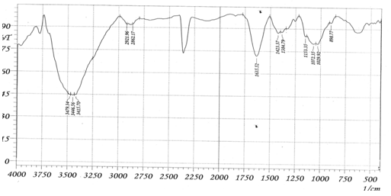
Figure 4 The IR spectrum of Chitosan
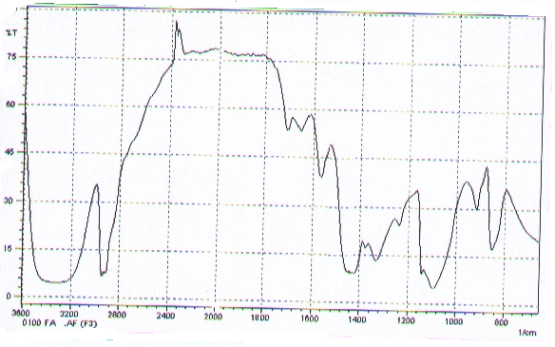
Figure 5 The IR spectrum of PVA
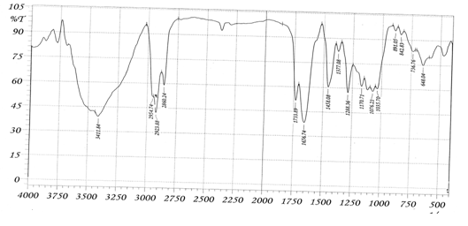
Figure 6 The IR spectrum of Chitosan/PVA microspheres

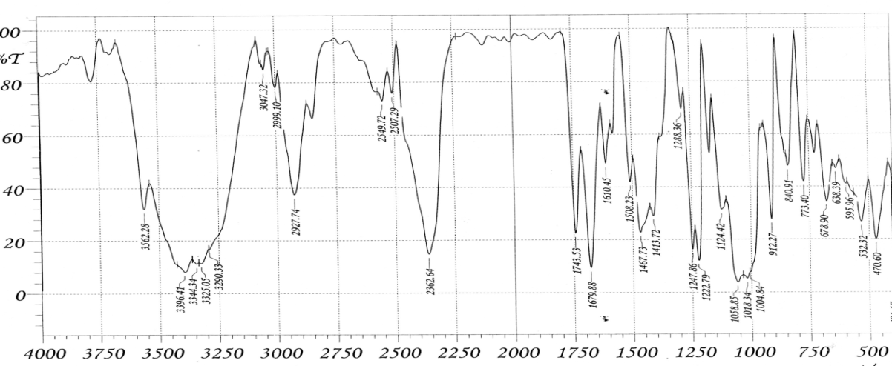
Figure 7 The IR spectrum of Diltiazem Hydrochloride
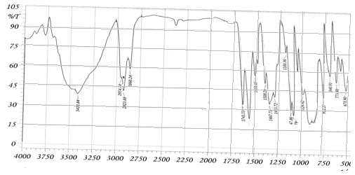
Figure 8 The IR spectrum of microspheres with Diltiazem Hydrochloride
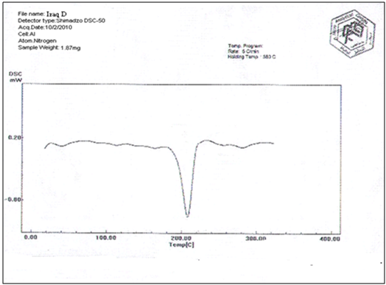
Figure 9 The DSC thermogram of Diltiazem Hydrochloride
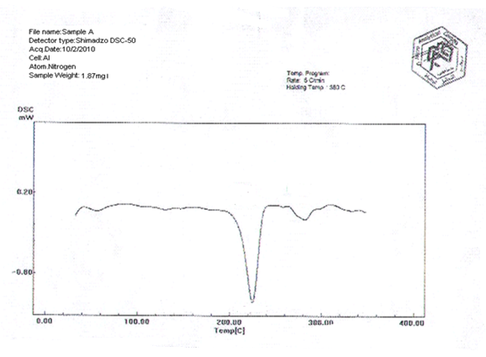
Figure 10 The DSC thermogram of microspheres with Diltiazem Hydrochloride

Morphology and Size Distribution
It was shown that microspheres prepared in this study at stirring rates of 400 and 800 rpm were spherical with smooth surfaces (Figure 11). However, increasing the stirring rate to 1200 rpm caused microspheres to become slightly irregular

.

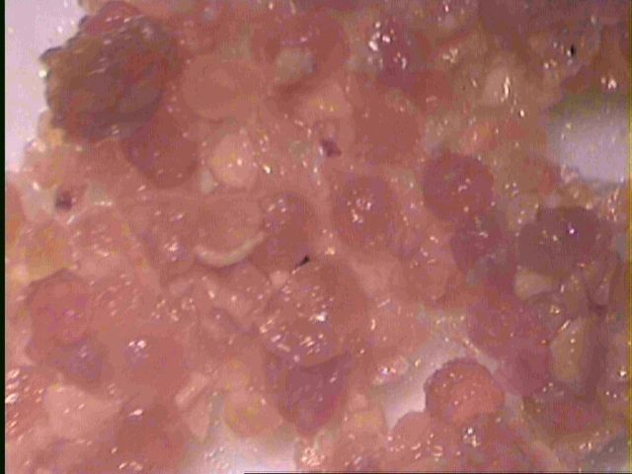
Figure 11 photograph of chitosan microspheres containing 40% Diltiazem prepared at 400 rpm.

The effect of stirring rate on the particle size of microspheres is shown in Figure 12. It can be seen that by increasing the rate of stirring from 400 to 1200 rpm, the mean size of microspheres decreased from 350 to 104 μm. This was expected because high stirring rates provide the sheering force needed to separate the oil phase into smaller droplets.²⁵

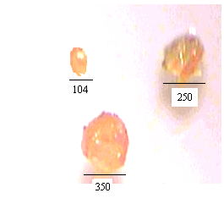
Figure 12 photograph of chitosan microspheres containing 40% Diltiazem prepared at various stirring rate

By increasing the concentration of chitosan, the mean particle size of microspheres increased (Figure 13). This observation may be attributed to an increase in the viscosity of the dispersed phase, making the coalescence of emulsified dispersed droplets easier.
Formulations prepared with drug loading of up to 40% produced spherical particles with smooth surfaces (Figure 8).

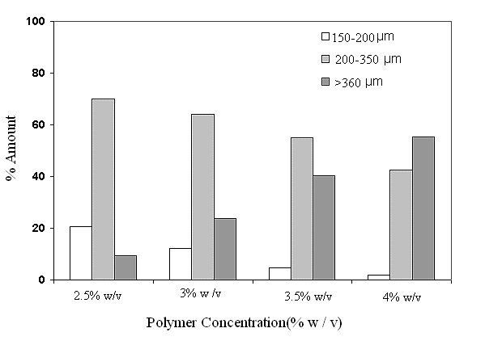
Figure 13: Effect of chitosan concentration on particle size of microspheres: (a) 2.5% (w/v), (b) 3% (w/v), (c) 3.5% (w/vt), and (d) 4% (w/v).

Drug Loading Efficiency
Drug loading efficiency of chitosan microspheres prepared in this study was shown to be approximately 73% (Table 1).

Table 1 Targeted and Actual Drug Loading of DTZ Microspheres

Sample | Stirring Rate  (rpm) | Targeted Drug  Loading% | Actual Drug  Loading% | Drug Loading  Efficiency %
A1 | 400 | 20 | 12.4 | 62
A2 | 400 | 30 | 23.2 | 67
A3 | 400 | 40 | 27.5 | 69
B1 | 800 | 20 | 14.3 | 71
B2 | 800 | 30 | 21.5 | 72
B3 | 800 | 40 | 29.6 | 73

Drug Release
The effect of particle size on drug release from microspheres is shown in Figures 14. Figure 14 shows drug release from microspheres of different particle sizes with drug loading of 40%. It is shown that drug release is affected by particle size when drug loading is high (40%). In the case of smaller microspheres, greater surface area produces a higher number of drug molecules at the surface of microspheres ready for faster release.²⁶
The effect of drug loading of microspheres on DTZ release from microspheres is shown in Figure 15. It can be seen that by increasing the amount of drug loading from 20% to 40%, the rate of drug release from the microspheres increases dramatically. With higher drug loading, more drug molecules are available at the surface of microspheres, leading to higher initial release.

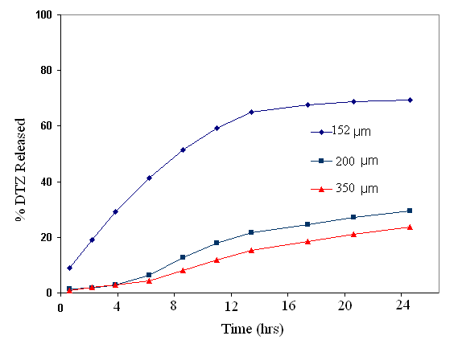

Figure 14: Effect of particle size on drug release from microspheres with 40% drug loading

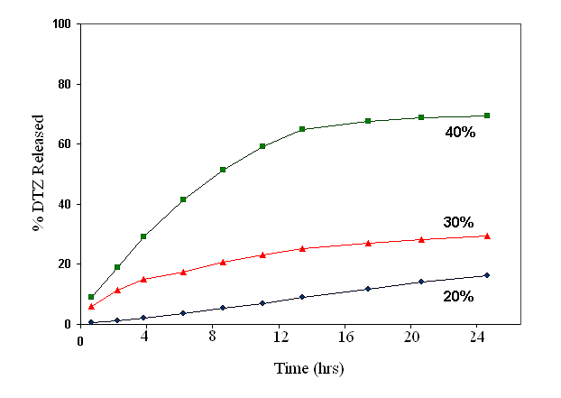
Figure 15: Effect of drug loading on drug release from microspheres with the same size range.

In Vitro release studies were carried out in simulated gastric fluid (SGF) PH= (1.2) and simulated intestinal fluids (SIF) (PH =7.4) by using United pharmacopoeia .The drug concentration was measured at (λ =237nm )using UV spectrophotometer .The measurements were carried out each on hour in the first four hours then each 2 hrs and at the last each 5 hrs.
Figure 16 shows that in the acidic rang the dissolution is so rapid because of the solubility of the polymer and (DTZ) ,they where dissolved in gastric fluid rapidly (SGF ). Whereas ,dissolution rate is slower at neutral (PH =7.4).

.
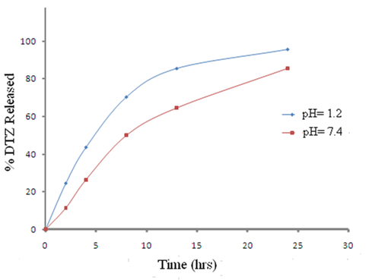
Figure 16 The effect of pH on Diltiazem Hydrochloride
release ( 40% drug loading)

This is in good agreement with the results of swelling of the microspheres ,it appeared that the highest values of degrees of swelling were obtained at pH 1.2 and the degrees of swelling of the microspheres tended to decrease as the pH of the swelling solution was increased .This can be explained by the fact that in an acidic medium the amino groups of chitosan are protonated, resulting in the hydrogen bonds between chitosan and PVA being broken and the network dissociating ²⁷. The blend microspheres exhibited a lower degree of swelling in neutral medium . This may correspond to the decrease in the number of protonated amino groups of chitosan at this pH . The pK_{a} of chitosan is 6.3 – 6.5, indicating that chitosan tends to protonate in acidic solution . Therefore , the degrees of swelling of the microspheres at pH7.4 were lower than those of the microspheres in acidic solution ( Figure 17).

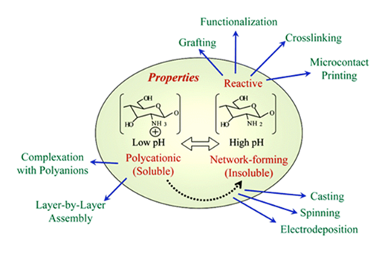
Figure 17 Fabrication of chitosan under pH values

At (SGF) media, from 24.35% of the total diltiazem is released after 2 hours of measurement in said apparatus, from 43.45% of the total diltiazem is released after 4 hours of measurement in said apparatus, from 70% of the total diltiazem is released after a total of 8 hours of measurement in said apparatus and from 80 to 95% of the total diltiazem is released after 24 hours of measurement in said apparatus.
In the (SIF) media , from 11.5% of the total diltiazem is released after 2 hours of measurement in said apparatus; from 26.3% of the total diltiazem is released after 4 hours of measurement in said apparatus; from 49.78% of the total diltiazem is released after a total of 8 hours of measurement in said apparatus and from 64 to 85% of the total diltiazem is released after 24 hours of measurement in said apparatus.
References
1. Y. A. Mørch, I. Donati, and B. L. Strand. Biomacromolecules., 2006, 7,1471–1480.
2. M. L. González-Rodríguez, M. A. Holgado, C. Sánchez-Lafuente, A. M.
Rabasco, and A. Fini. Int. J. Pharm., 2002, 232, 225–234 .
3. R. Russo, M. Malinconico, and G. Santagata. Biomacromolecules., 2007, 8, 3193– 3197.
4. L. Becherán-Marón, C. Peniche, and W. Argüelles-Monal. Int. J. Biol. Macromol., 2004, 34, 127–133.
5. X. Liu, W. Xue, Q. Liu, W. Yu, Y. Fu, X. Xiong, X. Ma, and Q. Yuan. Polym., 2004, 56, 459–464.
6. A. Polk, B. Amsden, K. de Yao, T. Peng, and M. F. A. Goosen. J. Pharm. Sci., 1994, 83,178–185.
7. M. George, and E. Abraham. J. Control. Release., 2006, 114, 1–14 .
8. K. Douglas, and M. Tabrizian. J. Biomater. Sci. Polym. Ed., 2005, 16, 43–56 .
9. G. Vandenberg, C. Drolet, S. Scott, and J. de la Noue. J. Control. Release.,
2001, 77, 297–307 .
10. K.Wang, and Z. He. Int. J. Pharm., 2002, 244, 117–126 .
11. B. Sarmento, D. Ferreira, F. Veiga, and A. Ribeiro. Polym., 2006, 66, 1–7.
12. A. Ribeiro, C. Silva, D. Ferreira, and F. Veiga. Eur. J. Pharm. Sci. , 2005, 25, 31–40 .
13. S. Ye, C. Wang, X. Liu, and Z. Tong. J. Control. Release., 2005, 106, 319–328.
14. K. Mladenovska, O. Cruaud, P. Richomme, E. Belamie, R. S. Raicki, M.-C. Venier- Julienne, E. Popovski, J. P. Benoit, and K. Goracinova Int. J. Pharm, 2007, 345, 59–69 .
15. S. K. Bajpai, and R. Tankhiwale. Part-1. React. Funct. Polym., 2006, 66, 645–658.
16. C. Tapia, Z. Escobar, E. Costa, J. Sapag-Hagar, F. Valenzuela, C. Basualto, M. N. Gai, and M. Yazdani-Pedram. Eur. J. Pharm. Biopharm., 2004, 57, 65–75.
17. C. Tapia, V. Corbalán, E. Costa, M. N. Gai, and M. Yazdani- Pedram., Biomacromolecules., 2005, 6, 2389–2395.
18. R.Anders and HP Merkle. Int J Pharm., 1989, 49, 231-240.
19. KD Tripathi. Essentials of Medical Pharmacology, New Delhi, J.P. Medical Publishers, 2003, 5th Edn, 453-454.
20.A.Nadia Hussein Al-Assady. Ph.D. Thesis, University of Basrh Iraq(2006).
21. Oya Sanl, lker Karaca,and Nuran Iklan.J .A .polymer science., 2008, 111, 2731- 2740.
22. “The United States Pharmacopeia 27”, 27th Rev, United States Pharmacopeial
Convention, Rockville, 2004.
23. Tao W., Mahir T., and Sunasekaran .Polym Int , 2004, 53, 911-918.
24. E.DeMia Peters, Microgram Journal, 2004, 2, 1-4.
25. S. Wang, A. Chen, L.-J. Weng, M.-Y. Chen, and X.-L. Xie. Macromol. Biosci., 2004, 4, 27–30.
26. SC.Basak, Jayakumarreddy BM, and Lucasmani KP. Indian J Pharm Sci ., 2006, 68(5), 594-598..
27.X.Chen , W.Li, W.Zhong, Y.Lu, J.Appl.polym.Sci., 1997, 65, 2257..

.

