Preparation and Investigations of Some Homobinuclear
Mixed Ligands Complexes Derived From
Bidentate Ligands

Najla H. Taher
Department of Chemistry, College of Education for Girls, University of Mosul
Akram A. Mohammed
Department of Chemistry, College of Education, University of Mosul
Mosul, Iraq

(NJC)

(Recevied on 16/6/2010) (Accepted for publication 20/2/2011)

Abstract
Mixed ligand complexes of the type [(M)₂L$L^{'}$(OH)₂(H₂O)₄] (where M = Co(II), Ni(II), Cu(II) or Zn(II) ; L = biacetyl ; while $L^{'}$ = deprotonated ethylene glycol) have been synthesized by 2:1:1 molar reactions of metal salts with biacetyl and ethylene glycol. Also [(M)₂L₁L₂(OH)₄(H₂O)₂] complexes (where M = Co(II), Ni(II), Cu(II) or Zn(II) ; L₁ = biacetyl ; while L₂ = ethylenediamine) have been synthesized by 2:1:1 molar reactions of metal salts with biacetyl and ethylenediamine. The resulting complexes have been characterized by the metal content measurements, molar conductance measurements, infrared, electronic spectra and magnetic moment measurements. The complexes are non-electrolytes as is evident from low values of their molar conductance. The infrared spectral studies of the complexes indicate that the ligands behave as bidentate chelating ligands. Also the IR studies show that the water molecules are coordinated in all the complexes and the metal centres are bridged by (OH) groups. Also (OH) group is coordinated to each metal ion in the [(M)₂L₁L₂(OH)₄(H₂O)₂]. The different studies reveal dinuclear nature of all the complexes and the two metal atoms are hexacoordianted with octahedral geometry.
الخلاصة
$L^{'}$تم تحضير معقدات مزيج الليكند ذات الصيغة [(M)₂L (OH)₂(H₂O)₄] (M تمثل ايون الكوبلت (II) ، النيكل (II) ، النحاس (II) او الخارصين (II) و L= ثنائي اسيتيل بينما $L^{'}$ = اثيلين كلايكول المزال منه بروتونين). حضرت هذه المعقدات بنسبة مولارية 2 : 1 : 1 (فلز : ليكاند : ليكاند). كذلك تم تحضير المعقدات [(M)₂L₁L₂(OH)₄(H₂O)₂] (M = تمثل ايون الكوبلت (II) ، النيكل (II) ، النحاس (II) او الخارصين (II) و L₁ = ثنائي اسيتيل بينما L₂ = اثيلين ثنائي امين). شخصت المعقدات من خلال التحليل الدقيق للفلز ، قياسات التوصيلية المولارية ، الاشعة تحت الحمراء، الطيف الالكتروني والقياسات المغناطيسية. دلت القيم الواطئة للتوصيلية الكهربائية للمعقدات بانها ذي طبيعة متعادلة. اوضحت اطياف الاشعة تحت الحمراء للمقعدات بان جميع الليكاندات تعمل بشكل ثنائي السن مخلبي. كما اظهرت دراسات الاشعة تحت الحمراء للمعقدات اتصال جزيئات الماء بالفلز وكذلك وجود مجموعتي هيدروكسيل جسرية. كذلك اتصال مجموعة هيدروكسيل لكل فلز في معقدات [(M)₂L₁L₂(OH)₄(H₂O)₂] . اعتمادا على هذه الدراسات المختلفة ، دلت القياسات بان هذه المعقدات ثنائية النوى وان كل فلز في المعقد يكون سداسي التناسق وذي بنية ثماني السطوح.

Introduction
A large number of mixed ligand complexes involving ligands containing functional groups such as nitrogen, hydr-oxyl and carbonyl groups, have been studied for their interesting properties, e.g., their important role in biological processes^{(1,2)}, electrochemistry⁽³⁾ and pharmaceutical syn-thesis⁽⁴⁾. Also, they are known to posses interesting antimicrobial⁽⁵⁾ antitumour⁽⁶⁾ properties. There is growing awareness associated with electrochemical, magnetic and spectroscopic studies of homobinuclear mixed ligand complexes^{(7,8)} due to their biological interest. The synthesis of bimet-allic complexes is interesting because they exhibit magnetic exchange between the two metal ions⁽⁹⁾ or tendency to undergo multie-lectron redox reactions⁽¹⁰⁾.
Keeping this in view, it was consi-dered worthwhile to synthesize homob-inuclear mixed ligand complexes and the main goal of the recent work is to find novel homobinuclear mixed ligands complexes by interacting Co(II), Ni(II), Cu(II) or Zn(II) salts with biacetyl and ethylene glycol or with biacetyl and ethylenediamine as biden-tate chelating ligands (Figures 1 and 2).
Experimental
Materials :
All chemicals used in this work were either Analar or Reagent grade used without purification such as CoCl₂.6H₂O (98%), NiCl₂.6H₂O (99%), CuCl₂.2H₂O (99%), ZnSO₄.7H₂O (99%), biacetyl (99%), ethyl-ene glycol (99%)and ethylenediamine (99%).

Analysis and physical measurements:
Cobalt, nickel, copper and zinc contents have been determined by applying precipitation methods⁽¹¹⁾ after the decomp-osition of the complexes with concentrated nitric acid. Melting points were determined by using electrothermal 9300 digital appar-atus. Molar conductivities of the complexes have been measured in an electrolytic conductivity measuring set LF-42 using 0.001 M of the complexes in dimethylfor-mamide (DMF) solutions at room temper-ature. IR spectra were recorded on a Bruker TENSOR 27 spectrophotometer in the 400-4000 cm⁻¹ range using KBr discs. Electronic spectra were recoded on a Shimadzu 1601 spectrophotometer in DMF at 25ºC for 0.001 M solution of the compounds using a 1 cm quartz cell. Magnetic susceptibilities of the complexes have been measured by Bruker B.M.6.

a. Preparation of the homobinuclear mixed ligand complexes [(M)₂L$L^{'}$(OH)₂
(H₂O)₄] :
The complexes were synthesized by the reactions of a hot ethanolic solution of (0.02 mol) of metal chlorides (except ZnSO₄.7H₂O was dissolved in distilled water) with a hot solution of (0.01 mol) of ethylene glycol. The pH has been adjusted to 6-8 with NaOH solution (1.25 M). The pH was measured by using of a pH paper. The mixture was refluxed for four hours, then (0.01 mol) of biacetyl in the same solvent was added to the mixture and the pH readjusted again. Refluxing was continued for extra three hours. The complexes thus formed were collected and washed with distilled water and ethanol to remove the unreacted starting materials, and then were dried in air.

b.Preparation of the homobinuclear mixed ligand complexes [(M)₂L₁L₂(OH)₄ (H₂O)₂] :
The complexes were prepared by the same general method as described above except using ethylenediamine with 0.01 mole instead of ethylene glycol.
Results and discussion
All the prepared complexes were as powders, stable in air at room temperature. Their analytical data together with some physical properties are summarized in Table 1. The reaction of metal salt with biacetyl (L) and ethylene glycol ($L^{'}$) in ethanol (molar ratio 2:1:1) yields complexes of the general formula
[(M)₂L$L^{'}$(OH)₂(H₂O)₄](M=Co(II),Ni(II),Cu(II) or Zn(II)) as in the following equations:
2MCl₂.nH₂O+L+H₂$L^{'}$ +4NaOH$\vec{\text{EtOH}}$
[(M)₂L$L^{'}$(OH)₂(H₂O)₄] +4NaCl +mH₂O
m= (n+4) when M=Co (II) or Ni(II) ;
m=n when M= Cu(II)
2ZnSO₄.7H₂O+L+H₂$L^{'}$+4NaOH$\vec{H_{2}O/{\text{EtOH}}}$
[(Zn)₂L$L^{'}$(OH)₂(H₂O)₄]+ 2Na₂SO₄+12H₂O
and the reaction of metal salt with biacetyl (L₁) and ethylenediamine (L₂) in ethanol (molar ratio 2:1:1) yields complexes of the general formula [(M)₂L₁L₂ (OH)₄(H₂O)₂] (M=Co(II), Ni(II), Cu(II) or Zn(II)) as in the following equations:
2MCl₂.nH₂O+L₁+L₂ +4NaOH$\vec{\text{EtOH}}$
[(M)₂L₁L₂(OH)₄(H₂O)₂] +4NaCl +mH₂O
m= (n+4) when M=Co (II) or Ni(II) ;
m=n when M= Cu(II)
2ZnSO₄.7H₂O+L₁+L₂ +4NaOH$\vec{H_{2}O/{\text{EtOH}}}$
[(Zn)₂L₁L₂(OH)₄(H₂O)₂]+2Na₂SO₄+12H₂O
Based on the metal content measurements have been supported the general formulas [(M)₂L$L^{'}$(OH)₂(H₂O)₄] and [(M)₂L₁L₂ (OH)₄(H₂O)₂], which show that in each complex the ratio of metal:ligand:ligand is 2:1:1. The molar conductance of the complexes in DMF are in the range (23-9) S cm² mol⁻¹ (Table 1) indicating a non-electrolytic in nature and that no inorganic anions such as ŌH ions are present in outer sphere coordination⁽¹²⁾. The non-conducting character reveals the presence of (OH) groups and metal ions in the coordination sphere.

Table (1) : The physical and analytical properties of the ligands and their complexes

Compound | Colour | m.p  C⁰ | Yield % | % Metal | Λ_{M}  S cm² mol⁻¹
 |  |  |  | Calc. (Found( | Λ_{M}  S cm² mol⁻¹
Biacetyl | Yellow | 88(bp*) | ------ | ------ | ------
Ethylene glycol | Colourless | 198(bp) | ------ | ------ | ------
Ethylenediamine | Yellow | 118(bp) | ------ | ------ | ------
[(Co)₂L$L^{'}$(OH)₂(H₂O)₄] | Brown | 250 | 62 | 31.85(30.88) | 11
[(Ni)₂L$L^{'}$(OH)₂(H₂O)₄] | Brown | 187 | 51 | 31.77(32.69) | 23
[(Cu)₂L$L^{'}$(OH)₂(H₂O)₄] | Dark Green | 255d | 66 | 33.50(32.74) | 12
[(Zn)₂L$L^{'}$(OH)₂(H₂O)₄] | Light Yellow | 232 | 53 | 34.41(35.09) | 10
[(Co)₂L₁L₂ (OH)₄(H₂O)₂] | Violet | 279d | 84 | 32.02(31.14) | #
[(Ni)₂L₁L₂ (OH)₄(H₂O)₂] | Black | 291d | 50 | 31.90(32.78) | 19
[(Cu)₂L₁L₂ (OH)₄(H₂O)₂] | Dark Olive | 201d | 69 | 33.68(32.71) | 18
[(Zn)₂L₁L₂ (OH)₄(H₂O)₂] | Pale Brown | 198d | 47 | 34.32(35.22) | 9

* bp= boiling point , # = Very poor soluble , d = decomposition , Calc. = Calculated

IR spectra
The IR spectra provide valuable infor-mation regarding the nature of functional group attached to the metal atoms, Table 2.

a. IR spectra of [(M)₂L$L^{'}$(OH)₂(H₂O)₄]
The IR spectrum of ethylene glycol (H₂$L^{'}$) shows a very broad band at 3384 cm⁻¹, assignable to ν(OH). The absence of this band, noted in the spectra of the complexes, indicates the deprotonation of the (OH) group on complexation. Instead, a band characteristic to ν(OH) of coordinated water was observed in the region (3422-3237)cm⁻¹ ⁽¹³⁾. Also, the IR spectra of complexes show peaks in the regions (881-854) and (779-607) cm⁻¹. This was a good confirmation for the presence of coordinated water, assignable to the rocking and wagging modes, respectively. The IR spectrum of biacetyl (L) shows a band at 1722 cm⁻¹, assignable to ν(C=O) (carbonyl group). In the IR spectra of the complexes, this band is shifted to lower frequencies (1668-1619)cm⁻¹,indicating the involvement of (C=O) oxygen in coordination with the metal ion⁽¹⁴⁾ and forming five membered chelate ring. The (C-O) stretching vibrations appeared at 1254 cm⁻¹ in the spectrum of ethylene glycol. This band is shifted to lower frequencies in the spectra of complexes (1207-1142) cm⁻¹ (Table 2). This shift confirms the participation of oxygen of ethylene glycol in the (C-O-M) bond⁽¹⁵⁾ and forming five membered chelate ring. Also, the appearance of new bands in the complexes at the region (1287-1206) cm⁻¹ are attributed to the presence of bridged bond (M-OH)⁽⁹⁾.Assignment of the proposed coordination sites is further supported by the appearance of new bands in the region (565-505) cm⁻¹, which could be attributed to the formation of (M-O) bond⁽¹⁶⁾.

b. IR spectra of [(M)₂L₁L₂ (OH)₄(H₂O)₂]
The IR spectrum of ethylenediamine (L₂) shows a very broad band at (3354) cm⁻¹ and also a strong band at (1592) cm⁻¹, assignable to ν(NH₂) and δ(NH₂), respect-ively. In the IR spectra of the metal comp-lexes, this bands are shifted to lower frequ-encies, Table 2, indicating the involveement of nitrogen in coordination with the metal ion⁽¹⁷⁾ and forming five membered chelate ring. A band characteristic to ν(OH) of coordinated water was observed in the region (3452-3303)cm⁻¹⁽¹³⁾ in the spectra of the complexes. Also, the IR spectra of complexes show peaks in the regions (879-842) and (749-668) cm⁻¹. This was a good confirmation for the presence of coordinated water, assignable to the rocking and wag-ging modes, respectively. The IR spectrum of biacetyl (L₁) shows a band at (1722) cm⁻¹, assignable to ν(C=O), carbonyl group. In the IR spectra of all the metal complexes, this band is shifted to lower frequencies (1683-1612) cm⁻¹, indicating the involve-ement of (C=O) oxygen in coordin-ation with the metal ions⁽¹⁴⁾ and forming five membered chelate ring.
The IR spectra of the complexes show a band in the region (3553-3386)cm⁻¹, assignable to ν(OH).Also ,the appearance of new bands in the region (1271-1234)cm⁻¹for the complexes, is attributed to the presence of bridged bond (M-OH)⁽⁹⁾. Assignment of the proposed coordination sites is further supported by the appearance of new bands in the regions (558-529) and (425-414)cm⁻¹, which could be attributed to the formation of (M-O) and (M-N) bonds^{(16,18)}, Table 2. Finally, the ν(NH₂) for the nickel complex is not observed in the IR spectrum since is hidden under the broad band of ν(H₂O) at (3452) cm⁻¹.

Table (2): Important IR spectral bands (cm⁻¹)
Assignment | [(M)₂L$L^{'}$(OH)₂(H₂O)₄] |  |  |  | [(M)₂L₁L₂ (OH)₄(H₂O)₂]
Assignment | Co | Ni | Cu | Zn | Co | Ni | Cu | Zn
ν(OH) | ------- | ------- | ------- | ------- | 3392 | 3553 | 3444 | 3386
ν(H₂O) | 3342 | 3422 | 3346 | 3237 | 3306 | 3452 | 3303 | 3357
ν(NH₂) | ------- | ------- | ------- | ------- | 3208 | Hidden | 3233 | 3291
ν(C=O) | 1668 | 1642 | 1619 | 1624 | 1683 | 1612 | 1630 | 1615
δ(NH₂) | ------- | ------- | ------- | ------- | 1561 | 1536 | 1572 | 1583
Bridging (OH) | 1287 | 1206 | 1259 | 1278 | 1234 | 1253 | 1271 | 1248
ν(C-O-M) | 1207 | 1151 | 1184 | 1142 | ------- | ------- | ------- | -------
Rocking (H₂O) | 867 | 881 | 854 | 873 | 879 | 842 | 845 | 857
Wagging (H₂O) | 779 | 607 | 756 | 752 | 712 | 668 | 682 | 749
ν(M-O) | 505 | 527 | 509 | 565 | 558 | Hidden | 529 | 539
ν(M-N) | ------- | ------- | ------- | ------- | 425 | 414 | 414 | 418

Electronic absorption spectra and magnetic moments
Electronic absorption spectra of the complexes were recorded in DMF solution, Table 3.
a. The electronic spectra and the magnetic moments of [(M)₂L$L^{'}$(OH)₂(H₂O)₄]
The cobalt complex spectrum shows a band observed at 10893 cm⁻¹, which may be assigned to ⁴T₁g(F)→⁴T₂g(F). Also this spectrum shows another band at 26041cm⁻¹, is assigned to the charge transfer transition. Unfortunately, some of the expected weak d-d transitions in the visible region for the Co(II) complex cannot be detected even with concentrated solution, may be due to their very low intensity or lost in the low energy tail of the charge transfer trans-ition^{(19,20)}. The UV spectrum of Co(II) complex is consistent with the formation of an octahedral geometry⁽²¹⁾. The magnetic moment of 3.42 B.M. per cobalt atom, indicates that, as expected, magnetic exch-ange occurs between the two cobalt sites. On the basis of the magnetic data, the cobalt(II) complex has a binuclear struc-ture⁽²²⁾. The nickel(II) complex shows three absorption bands at 9416, 11086 and 22522 cm⁻¹, which are attributed to the ³A₂g(F) →³T₂g(F)(ν₁),³A₂g(F)→³T₁g(F) (ν₂) and ³A₂g(F)→³T₁g(P) (ν₃) transitions, respect-ively, on the basis of an octahedral geom-etry^{(19,20,23)}. The complex has a low μ_{eff} value (2.23 B.M. per nickel). This may be caused by a strong nickel-nickel interaction. The electronic spectrum of the copper(II) complex shows a broad low energy band at 11415 cm⁻¹, typically is expected for an octahedral configuration, corresponding to the transition ²Eg→²T₂g⁽²³⁾. Also the Cu (II) complex spectrum shows two bands at 23041 and 30303 cm⁻¹, which is attributed to the charge transfer band and n→π* transition, respectively, Table 3. The magn-etic moment per Cu(II) ion, 1.49 B.M., is well below the calculated value, 1.73 B.M., indicating spin-exchange interaction betw-een the copper(II) ions⁽²⁴⁾. Since the zinc ion has d¹⁰ configuration, the absorption at 25641 cm⁻¹ for the zinc complex could be assigned to a charge transfer transition⁽²⁵⁾. Zn(II) complex is diamagnetic as expected for the d¹⁰ configuration. However, taking into account the spectra and other physio-chemical evidences, hexa-coordinated octa-hedral geometry is suggested for Zn(II) complex⁽²³⁾.
b. The electronic spectra and the magnetic moments of [(M)₂L₁L₂ (OH)₄(H₂O)₂]
The electronic spectral study of the cobalt(II) complex was unsuccessful due to its poor solubility in common organic solvents such as DMF and actually it shows a band at 11709 cm⁻¹, assigned to ⁴T₁g(F) →⁴T₂g(F)(ν₁)⁽²¹⁾. Also this spectrum shows a band at 32894, is assigned to the charge transfer. The magnetic moment of 3.57 B.M. per Co atom, is below the calculated value, 3.87 B.M., indicating spin-exchange interaction between the cobalt (II) ions. Unfortunately, the expected weak d-d transition ³A₂g(F)→³T₁g(F)(ν₂) in the visible region for the Ni(II) complex cannot be detected even with concentrated solution, may be due to its very low intensity. However, the Ni(II) complex spectrum shows three bands at 9803, 23041 and 29411 cm⁻¹, assigned to ³A₂g(F)→³T₂g(F) (ν₁), ³A₂g(F)→³T₁g(P)(ν₃) and the charge transfer^{(19,20,23)}, respectively. The magnetic moment of 2.52 B.M. per Ni atom, indicates that magnetic exchange occurs between the two nickel sites. On the basis of the magn-etic data, the nickel(II) complex has a binuclear structure. The electronic spectrum of the copper(II) complex shows alow energy band at 10309 cm⁻¹, typically is expected for an octahedral configuration, corresponding to the transition ²Eg→²T₂g⁽²³⁾ and also a band at 36496 cm⁻¹ assigned to n→π*transition. The complex has a low μ_{eff} value (1.58 B.M. per copper). This may be caused by a strong copper-copper intera ction⁽²⁴⁾. Finally, the absorption spectrum of Zn(II) complex shows no bands due to d-d transition, since it has d¹⁰ configuration, while the absorption at 28248 cm⁻¹, is assigned to the charge transfer transi tion⁽²⁵⁾.Taking into account the spectra and other physiochemical evidences, hexa-coor-dinated octahedral geometry is suggested for the Zn(II) complex⁽²³⁾.

Table (3) : The electronic spectra and magnetic moments of the complexes

Complexes | Band (nm) | Absorption region (cm⁻¹) | Possible assignments | Magnetic moment (B.M)
[(Co)₂L$L^{'}$(OH)₂(H₂O)₄] | 918 | 10893 | ⁴T₁g(F)→ ⁴T₂g(F) | 3.42
[(Co)₂L$L^{'}$(OH)₂(H₂O)₄] | 384 | 26041 | Charge transfer | 3.42
[(Ni)₂L$L^{'}$(OH)₂(H₂O)₄] | 1062 | 9416 | ³A₂g(F)→ ³T₂g(F) | 2.23
[(Ni)₂L$L^{'}$(OH)₂(H₂O)₄] | 902 | 11086 | ³A₂g(F)→ ³T₁g(F) | 2.23
[(Ni)₂L$L^{'}$(OH)₂(H₂O)₄] | 444 | 22522 | ³A₂g(F)→ ³T₁g(P) | 2.23
[(Ni)₂L$L^{'}$(OH)₂(H₂O)₄] | 314 | 31847 | Charge transfer | 2.23
[(Ni)₂L$L^{'}$(OH)₂(H₂O)₄] | 272 | 36764 | n→π* | 2.23
[(Cu)₂L$L^{'}$(OH)₂(H₂O)₄] | 876 | 11415 | ²Eg → ²T₂g | 1.49
[(Cu)₂L$L^{'}$(OH)₂(H₂O)₄] | 434 | 23041 | Charge transfer | 1.49
[(Cu)₂L$L^{'}$(OH)₂(H₂O)₄] | 330 | 30303 | n→π* | 1.49
[(Zn)₂L$L^{'}$(OH)₂(H₂O)₄] | 390 | 25641 | Charge transfer | Diamagnetic
[(Co)₂L₁L₂ (OH)₄(H₂O)₂] | 854 | 11709 | ⁴T₁g(F)→ ⁴T₂g(F) | 3.57
[(Co)₂L₁L₂ (OH)₄(H₂O)₂] | 304 | 32894 | Charge transfer | 3.57
[(Ni)₂L₁L₂ (OH)₄(H₂O)₂] | 1020 | 9803 | ³A₂g(F)→ ³T₂g(F) | 2.52
[(Ni)₂L₁L₂ (OH)₄(H₂O)₂] | 434 | 23041 | ³A₂g(F)→ ³T₁g(P) | 2.52
[(Ni)₂L₁L₂ (OH)₄(H₂O)₂] | 340 | 29411 | Charge transfer | 2.52
[(Cu)₂L₁L₂ (OH)₄(H₂O)₂] | 970 | 10309 | ²Eg → ²T₂g | 1.58
[(Cu)₂L₁L₂ (OH)₄(H₂O)₂] | 274 | 36496 | n→π* | 1.58
[(Zn)₂L₁L₂ (OH)₄(H₂O)₂] | 354 | 28248 | Charge transfer | Diamagnetic

Conclusions
From the above discussion, and from the data given in Tables 1,2 and 3,it is concluded that the both ligands in [(M)₂L$L^{'}$(OH)₂(H₂O)₄] coordinated as bidentate chelating ligands. Further coordi-nation at the metal ion was occurred with two molecules of water on the Z axes (axial ligand) to each metal. Also additional coordination of the hydroxyl groups was observed for metal complexes, in which the metal centre is bridged by OH

moieties, giving hexacoordianted metal ions, Figure 1. In [(M)₂L₁L₂ (OH)₄(H₂O)₂], the both ligands also coordinated as bidentate chelating ligands. Further coord-ination at the metal ion was occurred with one molecule of water and one hydroxyl group on the Z axes (axial ligand) to each metal. Also additional coordination of the hydroxyl groups was observed for metal complexes, in which the metal centre is bridged by (OH) moieties, giving hexacoor-dinated metal ions, Figure 2.

M=Co(II) , Ni(II) , Cu(II) or Zn(II)
Figure 1. The proposed structure of complexes [(M)₂L$L^{'}$(OH)₂(H₂O)₄]

M=Co(II) , Ni(II) , Cu(II) or Zn(II)
Figure 2. The proposed structure of complexes [(M)₂L₁L₂ (OH)₄(H₂O)₂]
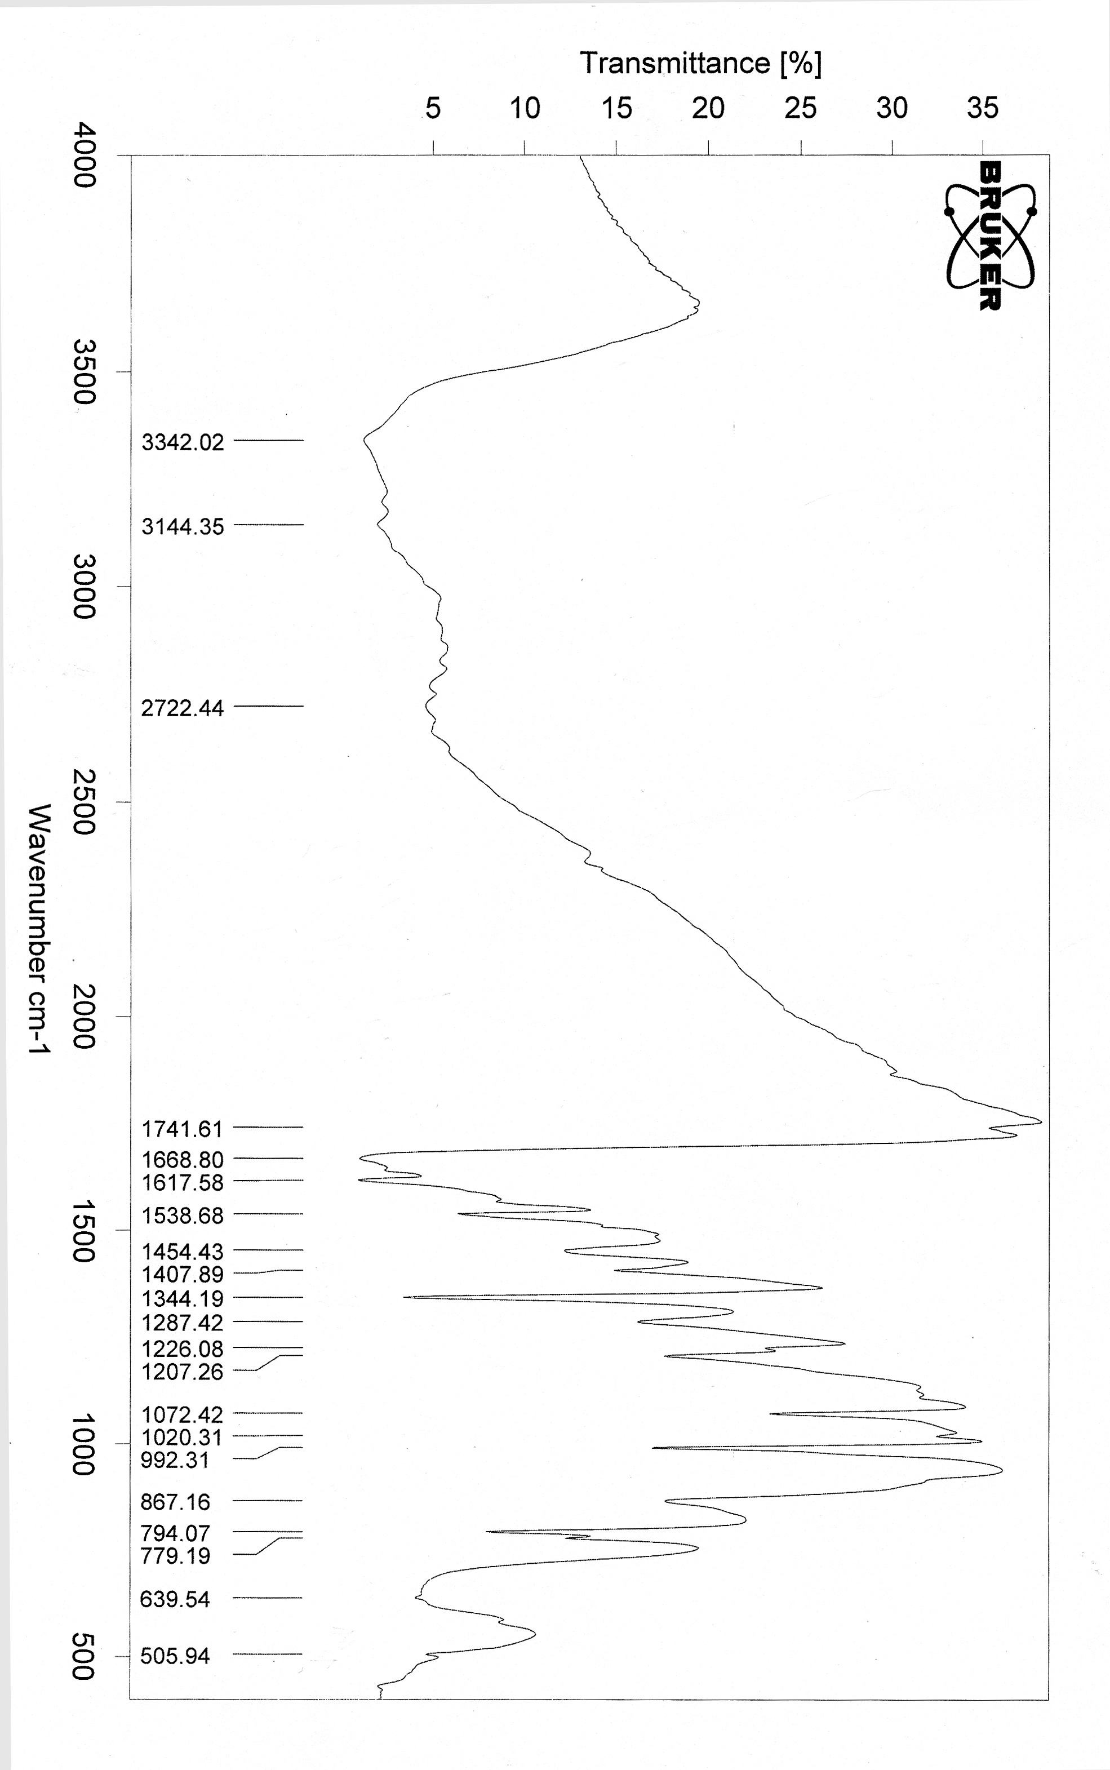
Figure (3): The IR spectrum of the [(Co)₂LL(OH)₂(H₂O)₄] complex

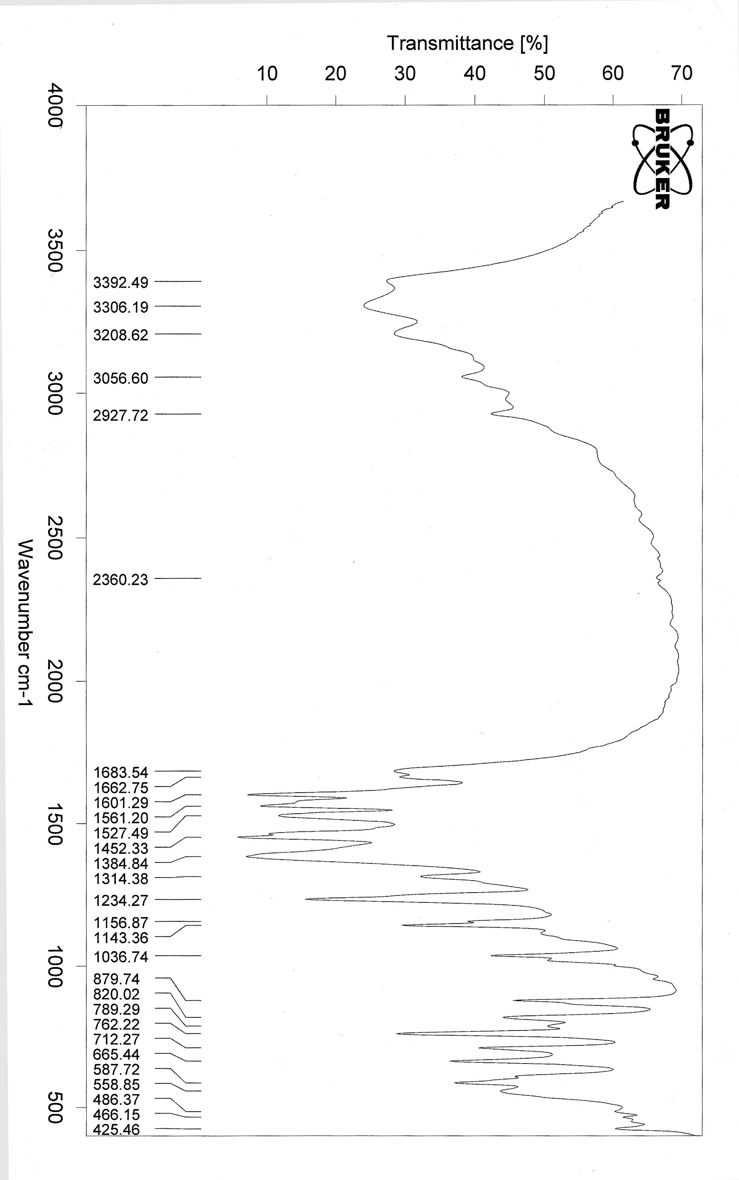
Figure (4): The IR spectrum of the [(Co)₂L₁L₂(OH)₄(H₂O)₂] complex
References
1. C. Yenikaya, M. Poyraz, M. Sari, F. Demirci, H. Ilkimen and O. Buyukgungor, Polyhedron, In Press, (2009).
- R.N. Patel, N. Singh, K.K. Shukla, U.K. Chauhan, J. Niclos-Gutierrez and A. Castineiras, Inorg. Chim. Acta, 2004, 357, 2469.
- M. Murali and M. Palaniandavar, Polyhedron, 2007, 26, 3980.
- J.K. Lim, C.J. Mathias and M.A. Green, J. Med. Chem., 1997, 40, 132.
- Y. Reza, B. Hassain and M.S. Islam, Paki. J. Bio. Sci., 2003, 6, 1494.
- L. Mishra, A.K. Yadaw, S. Bhattacharya and S.K. Dubey, J. Inorg. Biochem., 2005, 99, 1113.
- B. Mondal, M.G.B. Drew, R. Banerjee and T. Ghosh, Polyhedron, 2008, 27, 3197.
- A.S. El-Tabl, Trans. Met. Chem., 1997, 22, 400.
- A.A. Maihub, M.M. El-ajaily, M.A. Abuzwida, H.F. Al-Amari and E.S. Ahmed, J. Basic and Appli. Sci., 2005, 15,41.
- D.E. Fenton, V. Casellato, P. A. Vigato and M. Vidali, Inorg. Chim. Acta, 1982, 62, 57.
- A.I. Vogel, "A Textbook of Quantitative Inorganic Analysis", 1972, Longman Inc, 3rd. ed., New York.
- W.J. Geary, Coord. Chem. Rev., 1971, 7, 81.
- A.A. El-Bindary, Trans. Met. Chem., 1996, 22, 381.
- J.A. Faniran, K. S. Patel and L.O., Nelson, J. Inorg. Nucl. Chem., 1976, 38, 77.
- G. Wang and J.C. Chang, Synth. Inorg. Met. – Org. Chem., 1994, 24, 1091.
- G. Scargill, J. Chem. Soc., 1961, 4400.
- V.M. Parikh, "Absorption Spectroscopy of Organic Molecules", 1974, Addison Wesley Publishing Co.
- T. Dupuis, T. Duval and T. Lecomte, J. Compt. Rend., 1963, 257, 3080.
- S. Naskar, S. Biswas, D. Mishra, B. Adhikary, L.R. Falvello, T. Soler, C.H. Schwalbe and S.K. Chattopadhyay, Inorg. Chim. Acta, 2004, 357, 4257.
- R. Gup and B.Kirkan, Spectrochim. Acta Part A, 2005, 62, 1188.
- A.D. Liehr, J. Phys. Chem., 1967, 67, 1314.
- M. Sonmez and M. Sekerci, Synth. React. Inorg. Met.-Org. Chem., 2004, 34, 489.
- A.B. P. Lever, "Inorganic Electronic Spectroscopy", 1984, Elsevier, 2nd ed., New York.
- R.N. Carlin and A.J. Van Dryneveldt, "Magnetic Properties of Transition Metal Compound", 1997, Springe-Berlag, New York.
- B.C.S. Radovanovic and S.S. Andjelkovic , "Analytical Laboratory", 1997.

