Preparation and Characterization of Some Metal Complexes
With 2-(Caproic-6-Yliminomethyl) Furan as a Ligand

Akram A. Mohammed

Department of Chemistry, College of Education, University of Mosul
Mosul , Iraq

(NJC)

(Recevied on 9/5/2010) (Accepted for publication 20/2/2011)

Abstract
A tridentate ligand (FAC), 2-(caproic-6-yliminomethyl) furan, derived from 2-furaldehyde and 6-aminocaproic acid and its cobalt(II), nickel(II) and copper(II) complexes have been synthesized by the template condensation of the 2-furaldehyde with 6-aminocaproic acid in the presence of cobalt(II), nickel(II) or copper(II)
salts in molar ratio of M:L (1:2) which forms the metal complexes of type [M(L)₂] (where M = Co(II), Ni(II) or Cu(II)), and of M:L (1:1) of type [M(L)(H₂O)₃]Cl (where M = Co(II), Ni(II) or Cu(II)). The prepared complexes were characterized by metal content analyses, IR, electronic spectroscopy, magnetic susceptibility and conductivity measurements. IR spectra confirm coordination of imine nitrogen, the negative oxygen atom of the carboxyl group and oxygen of the furan ring to the central metal ion. The magnetic moment data suggested for all complexes to have an octahedral geometry around the central metal ion. The electronic spectral data also agree with their proposed structures.
الخلاصة
تضمن هذا البحث تحضيرا لاحد الليكاندات ثلاثية السن (FAC) ، 2-(كابرويك- 6- يل ايمينو مثيل) فيوران، نوع قاعدة شيف وذلك من تفاعل التكثيف بين 2-فيورالديهايد وحامض 6- امينو كابرويك. تم استخدام التفاعل التكثيفي الاني بين 2-فيورالديهايد وحامض 6-امينو كابرويك مع املاح الكوبلت (II) ، النيكل (II) او النحاس (II) لتحضير المعقدات . تم الحصول على المعقدات ذات الصيغة العامة [M(L)₂] من تفاعل الاملاح الفلزية مع الليكاند بنسبة مولارية فلز : ليكاند (1 :2) (حيث ان M = ايون الكوبلت ، النيكل او النحاس الثنائية الموجبة) والحصول على المعقدات ذات الصيغة العامة [M(L)(H₂O)₃]Cl بنسبة مولارية فلز : ليكاند (1 :1) (حيث ان M = ايون الكوبلت ، النيكل او النحاس الثنائية الموجبة).شخصت المعقدات المحضرة بالطرق الفيزيائية والكيميائية المختلفة مثل قياس محتوى الفلز، التوصيل الكهربائي ، الخواص المغناطيسية ، قياسات الاشعة تحت الحمراء والالكترونية. لقد وجد من دراسات الاشعة تحت الحمراء بان الليكاند يعمل بشكل ثلاثي السن ويرتبط بالايون الفلزي من خلال ذرة النتروجين لمجموعة الازوميثاين وذرة الاوكسجين الحاملة للشحنة السالبة لمجموعة الكاربوكسيل وكذلك ذرة الاوكسجين لحلقة الفيوران لجميع المعقدات. لقد اتضح من قياسات الحساسية المغناطيسية وقيم الاطياف الالكترونية ان لجميع المعقدات بنية ثماني السطوح الاكثر احتمالا.

Introduction
Schiff base (imine) ligands have been used in the construction of sophisticated metallosupramolecular compounds such as double and triple helicates, grids and coordination polymers, as well as in the preparation of innumerable simple mononuclear complexes⁽¹⁻⁷⁾. Many complexes of Schiff base ligands with metal ions have been investigated as models for active sites of enzymes^{(7,8)}, including DNA-cleavage systems^{(9,10)}, and as antibacterial⁽¹¹⁻¹³⁾ and anticancer⁽¹⁴⁾ drugs. They also provide useful magnetic materials^{(5,15)} and have a wide range of catalytic applications, such as in polymerization⁽⁸⁾ and olefin oxidation⁽⁹⁾. Tridentate Schiff bases ligands containing nitrogen and oxygen donor atoms sets are well known to coordinate with various metal ions, and this has attracted the interest of many authors⁽¹⁶⁻²³⁾. Various heterocyclic Schiff bases and their complexes having nitrogen and also oxygen donor atoms, have been reported by several scientists⁽²⁴⁻²⁶⁾. The furan ring, as a part in ligand, has been studied and has attracted great attention for long time and significant progress has been made in understanding the structure of its complexes^{(24,27,28)}.
Finally, metal template synthesis (one pot synthesis) was found to be an effective method to synthesize Schiff bases complexes⁽²⁹⁾. Here we report, the synthesis and characterization of heterocyclic Schiff base complexes obtained from the template condensation reaction of 2-furaldehyde with 6-aminocaproic acid in the presence of Co(II), Ni(II) or Cu(II) ions in molar ratios 1:2 and 1:1 (Figures 1 and 2).
Experimental
Materials :
All chemicals used in this work were either Analar or Reagent grade used without purification such as CoCl₂.6H₂O (98%), NiCl₂.6H₂O (99%), CuCl₂.2H₂O (99%) and 6-aminocaproic acid (97%) except for 2-furaldehyde which was purified according to a given procedure⁽³⁰⁾.
a. Preparation of the ligand (FAC):
An ethanolic solution of 2-furaldehyde (0.01 mol.) was added to aqueous solution of 6-aminocaproic acid (0.01 mol.) and refluxed for 4 hours followed by concentration of the solution. The precipitate was separated by filtration, washed with ether and then dried in air.
b. Preparation of the complexes :
All the complexes were prepared by the same general method using the template synthesis (one pot synthesis) as following :
Metal(II) chloride was added to a mixture of 2-furaldehyde (in 100 mL ethanol) and aqueous solution of 6-aminocaproic acid (in 100 mL dis. H₂O) having a required molar ratio of M:L (1:2 and 1:1). The mixture was refluxed for 6 hours. The solid thus obtained was filtered, washed with diethyl ether and finally dried in air.
Analytical and physical measurements
Cobalt, nickel and copper contents have been determined by applying precipitation methods⁽³¹⁾. Melting points were determined by using Electrothermal 9300 digital apparatus. Molar conductivities of the complexes have been measured in an electrolytic conductivity measuring set LF-42 using 0.001 M dimethylformamide (DMF) solutions at room temperature. IR spectra were recorded on a Bruker (Tensor 27) spectrophotometer in the 4000-400 cm⁻¹ range using KBr disc. Electronic spectra were recorded on a Shimadzu 1601 spectrophotometer in DMF at 25ºC for 0.001 M solution of the compounds using a 1 cm quartz cell. Magnetic susceptibility measurements of the complexes in the solid state were determined by the Faraday's method at room temperature using a Bruker BM6 apparatus.
Results and discussion :
All metal(II) complexes were prepared by using the respective metal salts as chloride with the ligand in two different molar ratios of metal : ligand as 1:2 and 1:1 (using one pot synthesis). All these complexes are colored. They are insoluble in common organic solvents and soluble in DMF. Molar conductance values of the complexes in DMF indicated that complexes having molar ratio of metal : ligand as 1:2 have lower values (Table 1) indicating that they are nonelectrolytic in nature. However, complexes having molar ratio of metal : ligand as 1:1 showed higher values (Table 1) indicating them as electrolytic⁽³²⁾.

Table (1) : Analytical and some physical properties of the compounds

Compound | m.p  C⁰ | Colour | Yield  % | % Metal Calc.(Found) | ΛM(DMF)  cm²ohm⁻¹ mol⁻¹
(FAC) | 112-114 | Black | 70 | ……… | ………
[Co(FAC) ₂] | 287 | Turquoise | 79 | 12.40  (11.89) | 11
[Ni(FAC) ₂] | 256 | Yellowish Orange | 81 | 12.36  (12.73) | 28
[Cu(FAC) ₂] | 261 | Light Green | 82 | 13.25  (12.74) | 18
[Co(FAC)(H₂O)₃]Cl | 222 | Dark Gray | 77 | 16.53  (15.98) | 62
[Ni(FAC)(H₂O)₃]Cl | 209 | Orange | 85 | 16.48  (17.03) | 67
[Cu(FAC)(H₂O)₃]Cl | 189 | Dark Olive | 84 | 17.59  (16.79) | 75
Calc. = Calculated

IR spectra
The IR spectra of the complexes were compared with this of the free ligand (FAC) in order to determine the coordination sites that may be involved in coordination. Upon comparison, it was determined that the v(C=N) stretching vibration from the azomethine group is found in the Schiff base at 1541 cm⁻¹. This band is shifted to lower (84-30) cm⁻¹ wave numbers in the complexes (Table 2), indicating the participation of azomethine nitrogen in coordination^{(33,34)}. A band due to
v(C-O-C) stretching vibration of the furan ring appeared at 1067 cm⁻¹ in the Schiff base ligand⁽³⁵⁾. This band also shifted to (1120-987) cm⁻¹ in the metal complexes, suggesting the involvement of the oxygen atom from the furan cycle to the central metallic ion. In the ligand (FAC), the asymmetric and symmetric stretching vibration of the carboxyl group, v as(COO) and v s(COO) appear at 1635 and 1446 cm⁻¹, respectively. In the complexes, these bands occur at (1647-1605) and (1418-1389) cm⁻¹, with difference Δ v (COO) of (229-193) cm⁻¹ and indicate the unidenticity of the carboxyl group⁽³⁶⁾ (Table 2). Also the band of the OH of COOH group at 2861 cm⁻¹ of the free ligand disappeared on coordination with the metal ion. These overall data suggest that the azomethine-N and carboxyl
–O and furan –O atoms are involved in coordination with the metal(II) ion in complexes. The appearance of new low frequency bands in the range (566-501) cm⁻¹, were assigned to metal-oxygen v(M-O). These bands were only observable in the spectra of the metal complexes and not in the spectrum of its Schiff base which in turn confirmed the participation of the negative oxygen atom of the carboxyl group and also the heteroatom (oxygen) in the coord-ination. The other new bands in the range (457-418) cm⁻¹ in the spectra of the metal complexes were assigned to v(M-N) stretching vibrations^{(35,37)}.
The presence of coordinated water molecules in the [M(L)(H₂O)₃]Cl (when M = Co(II), Ni(II) or Cu(II) ion) is determined by the appearance of bands in the range (3451-3228) cm⁻¹. Also the appearance of other bands at (918-873) and (756-744) cm⁻¹, which could be assigned to rocking and wagging modes⁽³⁸⁾, respectively, support the presence of coordinated water.

Table (2) : Important IR spectral bands (cm⁻¹)

Compound | νas  (COO) | νs  (COO) | Δν  (COO) | ν  (C=N) | ν  (C-O-C)
(FAC) | 1635 | 1446 | 189 | 1541 | 1067
[Co(FAC) ₂] | 1605 | 1389 | 216 | Hidden | 1120
[Ni(FAC) ₂] | 1606 | 1413 | 193 | 1510 | 1109
[Cu(FAC) ₂] | 1647 | 1418 | 229 | 1457 | 987
[Co(FAC)(H₂O)₃]Cl | 1624 | Hidden | N.A | 1510 | 1101
[Ni(FAC)(H₂O)₃]Cl | 1609 | 1413 | 196 | 1511 | 1109
[Cu(FAC)(H₂O)₃]Cl | 1618 | 1403 | 215 | 1507 | 1095
N.A = Not Available

Electronic spectra and magnetic moments
The electronic spectrum of the ligand (FAC) and its complexes were recorded in DMF (Table 3). A band was observed at 36363 cm⁻¹ in the spectrum of the ligand, which is attributed to n→π* transition in the C=N chromophore⁽³⁹⁾. This band shows a red shift in the spectra of the complexes (Table 3) due to the polarization in the C=N bond caused by the metal-ligand electron interaction during bond formation, indicating the involvement of (C=N) group in metal complexation.
The [Co(FAC)₂] complex exhibits bands at 9852, 14792 and 16447 cm⁻¹ (Table 3), which are assigned to the transitions ⁴T₁g(F)→⁴T₂g(F) (ν₁), ⁴T₁g→⁴A₂g (ν₂) and ⁴T₁g(F)→⁴T₁g(P) (ν₃) respectively, belonging to the high spin octahedral geometry⁽⁴⁰⁾. The magnetic susceptibility measurement (4.31 B.M.) for the solid Co(II) complex is also indicative of three unpaired electrons for Co(II) ion, suggesting consistency with their octahedral environment⁽⁴¹⁾. The [Co(FAC)(H₂O)₃]Cl complex exhibits four bands were observed at 10245, 14858, 16447 and 32573 cm⁻¹, assigned to ⁴T₁g(F)→⁴T₁g(P) (ν₁), ⁴T₁g→⁴A₂g (ν₂), ⁴T₁g(F)→⁴T₂g(F) (ν₃) and n→π∗ transitions⁽⁴⁰⁾, respectively. The magnetic moment obtained for [Co(FAC)(H₂O)₃]Cl (Table 3) is in favor to infer the presence of high spin octahedral geometry around the central cobalt(II)⁽⁴¹⁾.
The electronic spectral study of the complex [Ni(FAC)₂] shows four bands at 10384, 12330, 25188 and 31250 cm⁻¹, may be assigned to the ³A₂g(F)→³T₂g(F)(ν₁), A₂g(F)→³T₁g(F) (ν₂), ³A₂g(F)→³T₁g(P) (ν₃) and n→π* transitions, respectively and is consistent with the formation of an octahedral geometry⁽⁴²⁾. The octahedral geometry of Ni(II) ion in the complex is confirmed by the measured
magnetic moment value , 3.08 B.M.⁽⁴¹⁾. The electronic spectrum of [Ni(FAC)(H₂O)₃]Cl shows also four bands at 9737, 11299, 24271 and 32679 cm⁻¹, which is attributed to the same transitions of the [Ni(FAC)₂] (Table 3), suggesting the octahedral structure of nickel complex⁽⁴²⁾ . The magnetic measurement (2.98 B.M.) showed two unpaired electrons for Ni(II) ion supporting an octahedral geometry⁽⁴¹⁾. The electronic spectrum of [Cu(FAC)₂] shows a low energy band at 13123 cm⁻¹, typically is expected for an octahedral configuration, corresponding to the transition ²Eg→²T₂g⁽⁴²⁾ and a band at 33112 cm⁻¹ assigned to n→π* transition. The magnetic moment value (2.18 B.M.) for this complex showed one unpaired electron for Cu(II) supporting an octahedral geometry⁽⁴¹⁾ (Table 3). The electronic spectrum of [Cu(FAC)(H₂O)₃]Cl shows also bands at 13262 and 32225 cm⁻¹, is attributed to the same transitions of the [Cu(
FAC)₂] complex (Table 3), suggesting the octahedral geometry of copper complex⁽⁴²⁾. Magnetic moment value of 2.05 B.M. supports the hexacoordinated configuration of the copper complex⁽⁴¹⁾.

Table (3) : The electronic spectra and magnetic moments of the compounds

Compound | Band (nm) | Absorption region (cm⁻¹) | Possible assignment | Magnetic moment (B.M)
(FAC) | 275 | 36363 | n→π* | ---------
[Co(FAC) ₂] | 1015 | 9852 | ⁴T₁g(F)→ ⁴T₁g(P) | 4.31
[Co(FAC) ₂] | 676 | 14792 | ⁴T₁g(F)→ ⁴A₂g | 4.31
[Co(FAC) ₂] | 608 | 16447 | ⁴T₁g(F)→ ⁴T₂g(F) | 4.31
[Ni(FAC) ₂] | 963 | 10384 | ³A₂g(F)→ ³T₂g(F) | 3.08
[Ni(FAC) ₂] | 811 | 12330 | ³A₂g(F)→ ³T₁g(F) | 3.08
[Ni(FAC) ₂] | 397 | 25188 | ³A₂g(F)→ ³T₁g(P) | 3.08
[Ni(FAC) ₂] | 320 | 31250 | n→π* | 3.08
[Cu(FAC) ₂] | 762 | 13123 | ²Eg→ ²T₂g | 2.18
[Cu(FAC) ₂] | 302 | 33112 | n→π* | 2.18
[Co(FAC)(H₂O)₃]Cl | 976 | 10245 | ⁴T₁g(F)→ ⁴T₁g(P) | 4.47
[Co(FAC)(H₂O)₃]Cl | 673 | 14858 | ⁴T₁g(F)→ ⁴A₂g | 4.47
[Co(FAC)(H₂O)₃]Cl | 608 | 16447 | ⁴T₁g(F)→ ⁴T₂g(F) | 4.47
[Co(FAC)(H₂O)₃]Cl | 307 | 32573 | n→π* | 4.47
[Ni(FAC)(H₂O)₃]Cl | 1027 | 9737 | ³A₂g(F)→ ³T₂g(F) | 2.98
[Ni(FAC)(H₂O)₃]Cl | 885 | 11299 | ³A₂g(F)→ ³T₁g(F) | 2.98
[Ni(FAC)(H₂O)₃]Cl | 412 | 24271 | ³A₂g(F)→ ³T₁g(P) | 2.98
[Ni(FAC)(H₂O)₃]Cl | 306 | 32679 | n→π* | 2.98
[Cu(FAC)(H₂O)₃]Cl | 754 | 13262 | ²Eg→ ²T₂g | 2.05
[Cu(FAC)(H₂O)₃]Cl | 310 | 32225 | n→π* | 2.05

Conclusion
Based on the reported results, it may be concluded that the ligand acts as a mononegative tridentate molecule and the nitrogen of the azomethine group, the negative oxygen atom of the carboxyl group and oxygen of the furan ring take part in coordination. All the complexes are found to be mononuclear. The coordination number six is attained by coordination with the two molecules of (FAC) for the formulae [M(FAC)₂] (M = Co(II), Ni(II) or Cu(II)) while the same number of coordination is attained for [M(FAC)(H₂O)₃]Cl by the one ligand molecule and three coordination water molecules (also M = Co(II), Ni(II) or Cu(II)). Based on the physicochemical and the spectral studies ; the tentative structures suggested for the complexes are shown in figures 1 and 2.

(CH₂)₅
(CH₂)₅

Figure (1): The proposed structure of the [M(FAC)₂] complexes
M = Co(II) , Ni(II) or Cu(II)
(CH₂)₅
Cl

Figure (2): The proposed structure of the [M(FAC)(H₂O)₃]Cl complexes
M = Co(II) , Ni(II) or Cu(II)

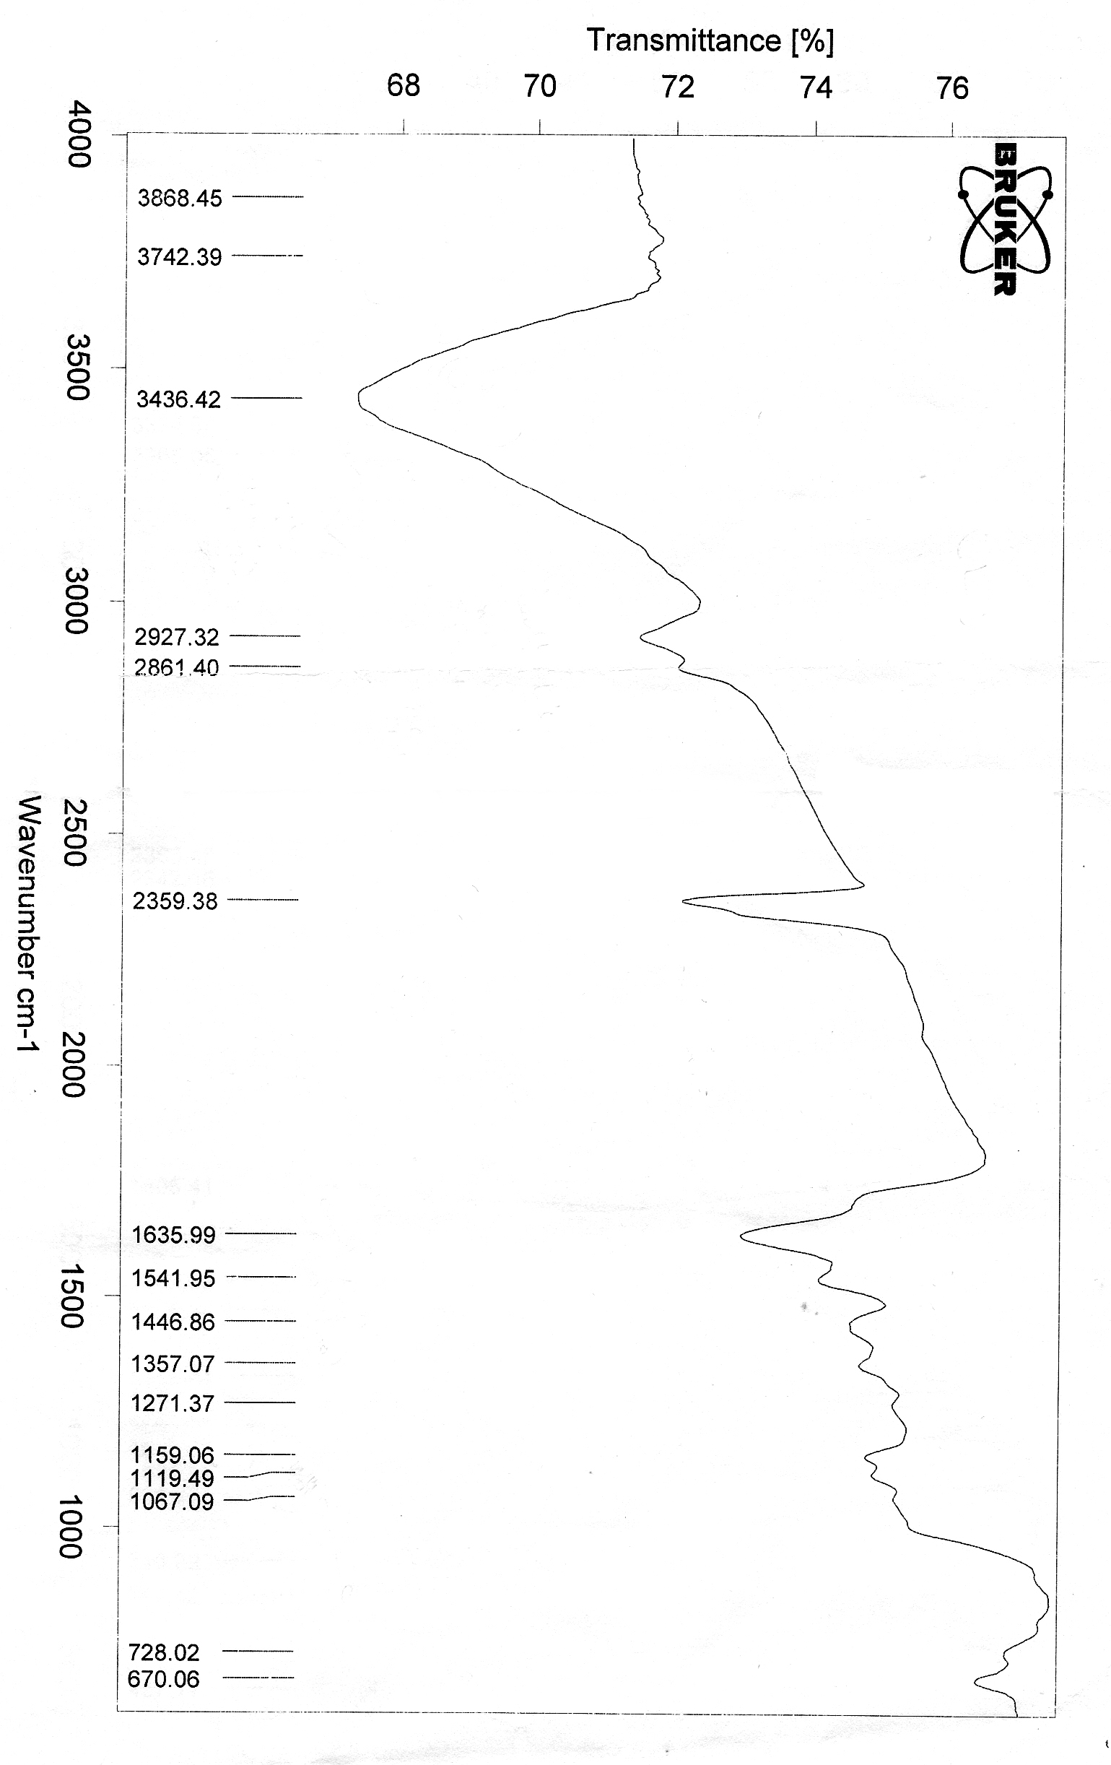
Figure (3): The IR spectrum of the ligand (FAC)
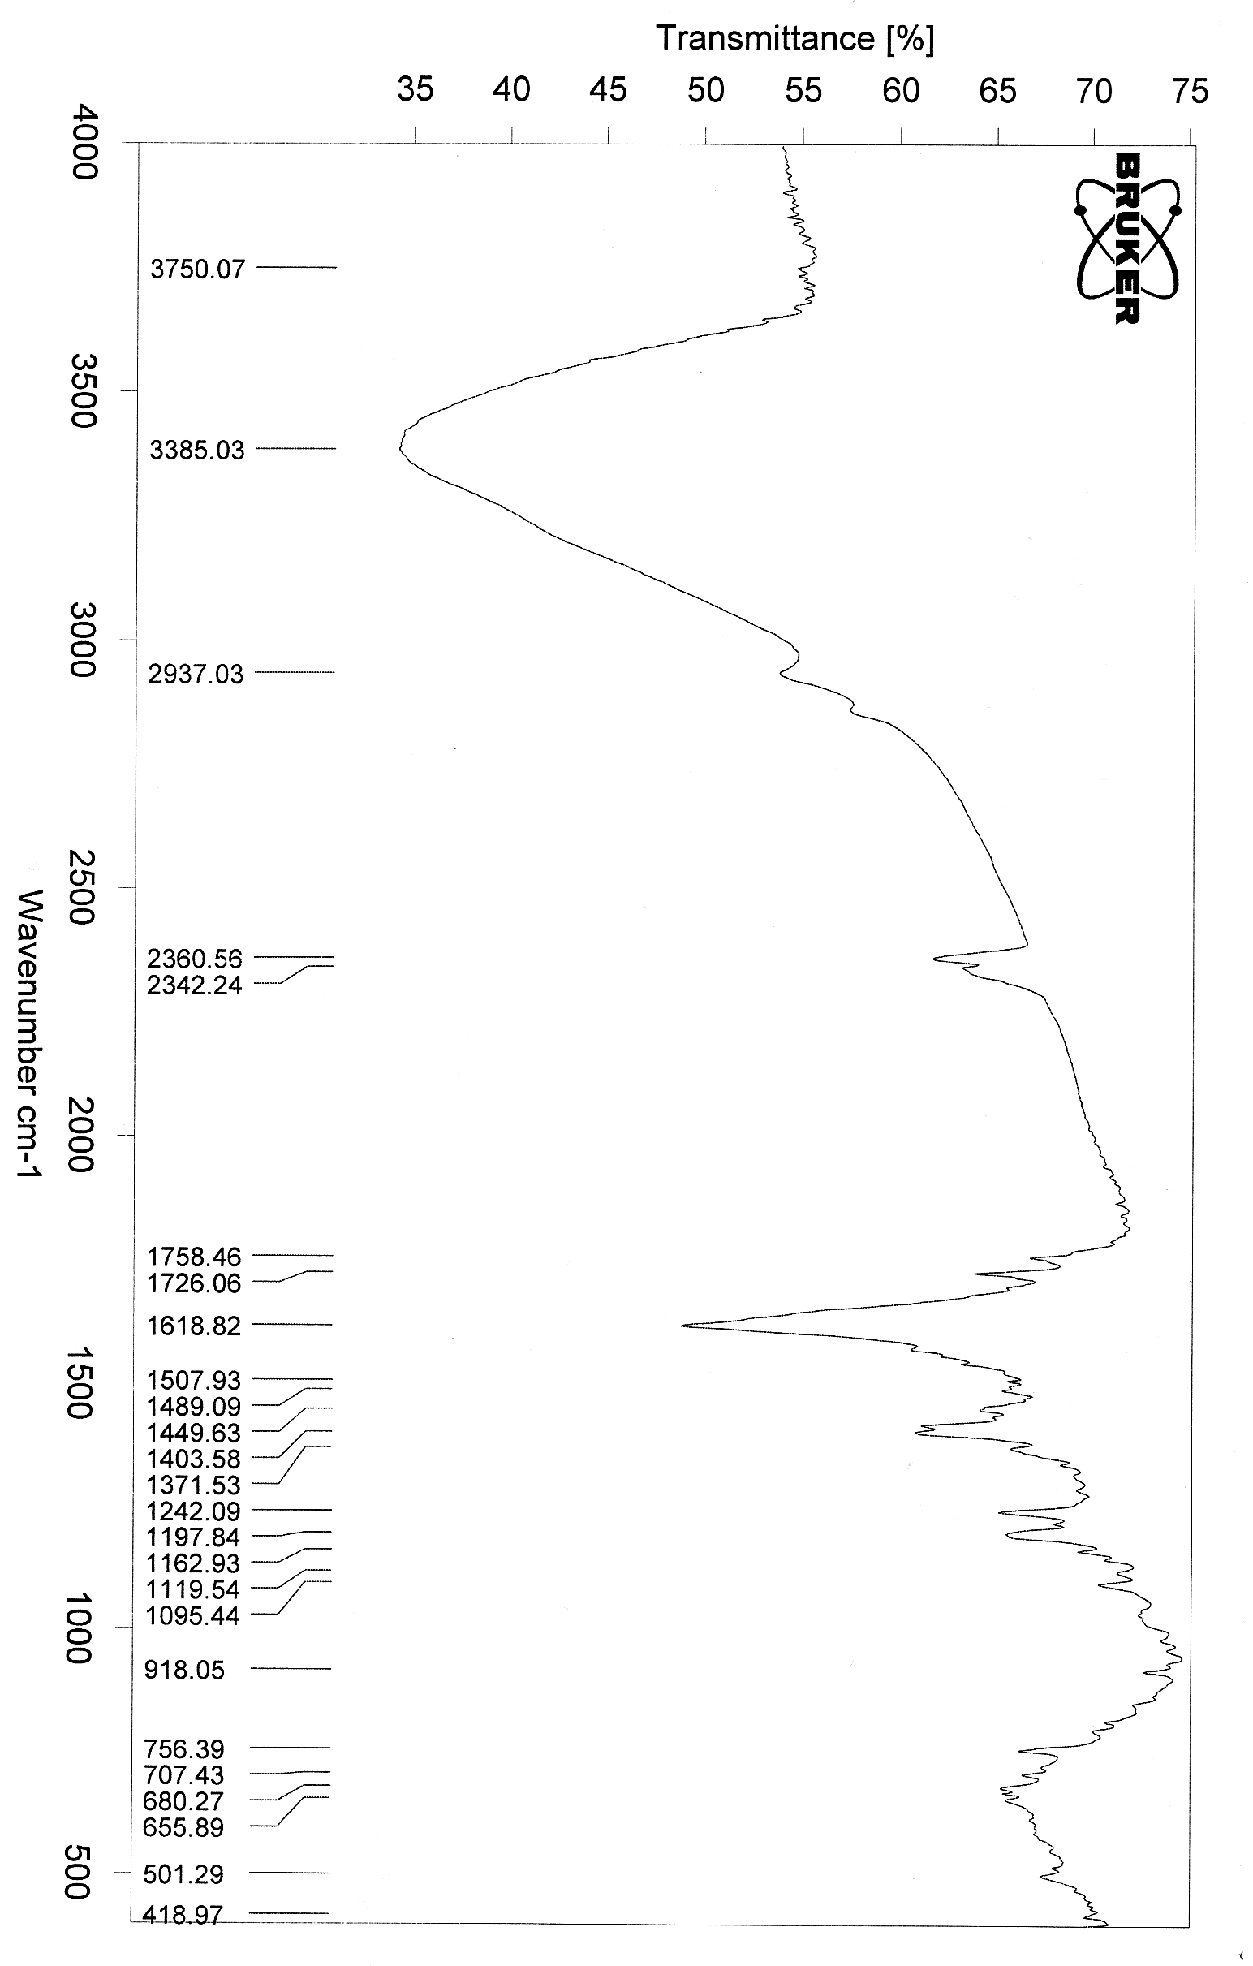

Figure (4): The IR spectrum of the [Cu(FAC)(H₂O)₃]Cl complex

References
- J. Rojo, J.M. Lehn, G. Baum, D. Fenske, O. Waldmann and P. Mueller, Chemistry, 1999, 517.
- R. Ziessel, Coord. Chem. Rev., 2001, 216, 195.
- C.R.K. Glasson, L.F. Lindoy, and G.V. Meehan, Coord. Chem. Rev., 2008, 252, 940.
- C.D. Meyer, C.S. Joiner and J.F. Stoddart, Chem. Soc. Rev., 2007, 36, 1705.
- J.R. Nitschke and J.M. Lehn, Proc. Natl. Acad. Sci., USA, 2003, 100, 11970.
- A.R. Stefankiewicz and J.M. Lehn, Chem. Eur. J., 2009, 15, 2500.
- J.R. Nitschke, Acc. Chem. Res., 2007, 40, 103.
- T. Opstal and F. Verpoort, Angew. Chem. Int. Ed., 2003, 42, 2876.
- C. Adhikary, R. Bera, B . Dutta, S. Jana, G. Bocelli, A. Cantoni, S. Chaudhuri and S. Koner, Polyhedron, 2008, 27, 1556.
- P.R. Kumar, S. Upreti and A.K. Singh, Polyhedron, 2008, 27, 1610.
- V. Patroniak, A.R. Stefankiewicz, J.M. Lehn and M. Kubicki, Eur. J. Inorg. Chem., 2005, 10, 4168.
- A. Balamurugan, G. Balossier, D. Laurent-Maquin, S. Pina, A.H.S. Rebelo, J. Faure and J.M.F. Ferreira, Dent. Mater., 2008, 24, 1343.
- Z.H. Chohan and S. Kausar, Chem. Pharm. Bull, 1993, 41, 951.
- M. Kurtoglu, F. Purtas and S. Toroglu, Trans. Met. Chem., 2008, 33, 705.
- A.I. Anzellotti and N.P. Farrell, Chem. Soc. Rev., 2008, 37, 1629.
- A. Majumder, G.M. Rosair, A. Mallick, N. Chattopadhyay and S., Mitra, Polyhedron , 2006, 25, 1753.
- G. Juhasz, S. Hayami, O. Sato and Y. Maeda, Chem. Phys. Lett., 2002, 364, 164.
- S. Hayami and Y. Maeda, Inorg. Chim. Acta, 1997, 255, 181.
- J.R. Dilworth, S.D. Howe, D.J. Hutson, J.R. Miller, J. Silver, R.M. Thompson, M. Harman and M.B. Hursthouse, J. Chem. Soc. Dalton Trans., 1994, 3553.
- A. Mukhopadhyay and S. Pal., J. Chem. Crystallogr., 2005, 35, 737.
- N. Reedig, M. U. Triller, D. Purshe, A. Rompel, B. Krebs and Z. Anorg., Allg. Chem., 2002, 628, 2458.
- D.M. Epstein, S. Choudhary, M.R. Churchill, K.M. Keil, A. V. Eliseev and J. R. Morrow, Inorg. Chem., 2001, 40, 1591.
- V. Patroniak, A.R. Stefankiewicz, J.M. Lehn, M. Kubicki and M. Hoffmann, Chemistry, 2006, 144.
- S. Chandra and A. Kumar, Spect. Chim. Acta Part A, 2007, 66 (4-5), 1347.
- I. Kizilcikli, B. Ulkuseven, Y. Dasdemir and B. Akkurt, Synth. and React. in Inorg. and Met. –Org. Chem., 2004, 34( 4), 653.
- A.E. Liberta and D.X. West, Biometals, 1992, 5(2), 121.
- S. Sharma, F. Athar, M.R. Maurya, F. Naqvi and A. Azam, Europ. J. Med. Chem., 2005, 40(6), 557.
- N.S. Youssef and K.H. Hegab, Synth. and React. in Inorg., Met. _Org. and Nano-Met. Chem., 2005, 35(5), 391.
- S. Chandra and K. Gupta, Synth. and React. in Inorg. Met. – Org. and Nano-Met. Chem., 2001, 31(4), 661.
- D.D. Perrin, W.L.F. Armarage and D.R. Perrin, "Purification of Laboratory Chemicals", 1980, Pergamon Press, 2nd ed., 553.
- A.I. Vogel, "Textbook of Quantitative Inorganic Analysis", 1981, Longman Inc., 4th ed., New York.
- W.J. Geary, Coord. Chem.. Rev., 1971, 7, 81.
- Y. Feng, C. Wang, Y. Zhao, J. Li, D. Liao, S. Yan and Q. Wang, Inorg. Chim. Acta, 2009, 362(10), 3563.
- C. Suksai, C. Pakawatchai and K. Thipyapong, Polyhedron, 2008, 27(2), 759.
- B.K. Patel and S.C. Chaudhury, J. Indian Chem.. Soc., 1988, LXV, 661.
- K. Dey, A.K. Biswas and R.A. Sinha, Indian J. chem., 1981, 20, 848.
- M.M. Omar, G.G. Mohamed and A.M.M. Hindy, J. therm. Anal. Cal., 2006, 86(2), 315.
- K. Nakamoto, "Infrared Spectra of Inorganic and Coordination Compounds", 1970, Wiley Interscience, 2nd ed., New York.
- D.H. Williams and I. Fleming, "Spectroscopic Methods in Organic Chemistry", 1989, Mc Graw-Hill, 4th. Ed., London.
- A.B.P. Lever, J. Lewis and R.S. Nyholm, J. Chem. Soc., 1963, 2552.
- R.L. Duta and a. Syamal, "Elements of Magneto Chemistry", 1992, Elsevier, 2nd. Ed., New York.
- A.B.P. Lever, "Inorganic Electronic Spectroscopy", 1997, Elsevier, 2nd. Ed., Amsterdam.

