Gas Chromatography Method for Separation Synthesized Methylethoxysilan Compounds

Jameel M. Dhabab
Department of Chemistry, College of Science, Al-Mustansiriya University
Muayed G. Jalhoom , Hakki E. Ibraheem
Ibn Sina State Co., Ministry of Industry and Minerals

(NJC)

(Recevied on 5/7/2010) (Accepted for publication 20/2/2011)

Abstract
Modification of gas chromatographic technique for separation methylethoxysilane compounds which were synthesized by the reaction the absolute ethanol with methylchlorosilane compounds. The addition of dry absolute ethanol to methylchlorosilane compounds in the presence of a dry stream of nitrogen gas to eliminate the liberated HCl gas. This method was found to be the suitable method for preparation methylethoxysilane compounds. The optimum parameter selected after careful and precise studies were between 20 – 30 ml \ min to carriers gas flow rate, while applied temperature of detector and injection part are 250 °C and 225 °C respectively. The results showed that suitable chromatographic column for the separation of methylchlorosilane compounds is 50% [5% dioctyl phthalate ] + 50% [10% OV- 101 ] .While 10 % OV – 101 column was found to be the best for the separation of methylethoxysilane compounds . Accordingly , a linear relationship for the calibration curve between concentration and peak area was achieved for methylchlorosilane and methyl ethoxysilane with correlation coefficients were ranged between 0.9991- 1. The results of percentage RSD for the methylchlorosilane and methylethoxysila were 0.51-2.08 and 0.053-1.37 respectively.
Key words: silicon compounds, halosilicon compounds ,methylethylsilicon, gas chromatography.
الخلاصة
اختيرت طـريقة كرومـــاتوغرافيا الغاز احدى الطرق التحليليه لفصــل وتحليل مركبات مثيل أيثوكســي سـايلان المحضرة بدورها من خلال تفاعل الأيثانول المطلق الجاف مع مركبات مثيل كلورو سايلان . ولقد وجد من خلال هذا البحث إن إضافة الأيثانول المطلق إلى مركبات مثيل كلورو سـايلان بوجود تيار من غازالنتروجــين الذي يعمل على إزاحة غاز HCl المتولــد من عمليـــة التفاعــــل . أنسب الطـرق لتحضير هذه المركبات . ثبتت الظروف المثلى و الادق لفصل و تحليل مركبات مثيل ايثوكسي سيلان, حيث تتراوح سرعة الغاز الناقل من 20-30 مل بالدقيقة و بدرجات حرارة المتحسس و غرفة الحقن 250 و 225 درجة مئوية على التوالي. و بينت نتائج التحليل ان أفضل عمود كروماتوغرافي يمكن أستخدامه لفصـــــل وتحليل مركبات مثيل كلورو ســــــايلان هو 50%[5%dioctyl phthalate]+50%[10%OV – 101] أما أفضل عمود لفصل و تحليل مركبات مثيل أيثوكسي سايلان فكان 10% OV – 101 . تم الحصـــــــــول على علاقة خطية عند عمل منحنى المعايرة بين التركيز والمساحة تحت المنحنى لجميع مركبات مثيل كلوروسايلان ومثيل ايثوكسي سايلان وبمعامل ارتباط (R) تتراوح بين 1- 0.9991 وقيم RSD% لها بمدى من 2.08-0.51 و1.37-0.53 على التوالي.

Introduction
Silicon element has unique properties in synthesis of organic silicon compounds like alkyl alkoxysiline derivatives. These properties are due to its low value of electronegative, presence of empty d orbital and its big radii comparison with Carbon element¹ Silicon compounds are used as surfaces isolated polymers, cross linking agents and chain initiators². Also silicon has wide uses in industry^{3.} Recently silane and siloxane compounds which are containing alkyl or aryl and associated to the silicon directly have great interest in silicon industries field^{4.} These compounds are decreased the chemical pollutions through the decreasing of solid waste after the completing of reaction^{5.} The chromatography analysis represents one of the most methods which is used in analysis and determination of organic silicon compounds^{6.} This technique provided with thermal sensor^{7.} Polar or semi polar columns are the best in analysis and separation of these compounds⁸⁻¹². In this paper we report the synthesis of methylethoxysilane from chloromethylsilane with separation and determination of products by using Gas chromatography technique.
Experimental
Instruments
GC type Shimadzu 14 A with thermal conductivity detector (TCD), Data process Apparatus type Shimadzu CR4A, Sensitive Balance A & D 200, Stirring hotplate , Heating mental , Micro syringe , ESSG 10 ml.

Chemicals
All reagents are commercially available and used without further purification.
Columns preparation
Stainless steel columns have been used in separation and analysis of compounds as shown in Table (1)
Chromatography analysis.
1%, 5%, 10%,20%, 30%, 50%,80% and 95% v/v standard solutions of Chloromethylsilane and methyethoxysilane which were prepared by dissolved CCl₄ as a solvent.10 µL from each solution of standard silicon compounds has been injected , after selected the best separation methods in order to determination the retention time of each compounds exactly. Determination optimum conditions by analyzed standard compounds of chloromethylsilan and methylethoxysilan.
Standard calibration curve
A standard calibration graph has been carried out for each study compounds under optimum conditions. The concentrations range 1%-95% v/v were prepared and used to determine the amounts of methylethoxysilan compounds using the method of least squares ( MLS) by using the following regression equation^{13;}
Y= Xb+ a , where Y is the area under peak , x is the calculation unknown concentration , b is the slope.
Calculation the efficiency of chromatographic column
The efficiency of used columns has been calculated through the injection (10 µl) of prepared standard compound solutions in different columns, then The efficiency of all columns has been calculated through the calculation of plate number(n) and length of columns(L) by using the following equation ;
H = L/n , where H is height of plate.
Calculations of thermodynamic functions
The Molar enthalpy and entropy (Δ H and ΔS) were calculated from the graphically relationship between specific retention time and 1/T at deferent temperatures(120-180 C).
Results and discussion
After the preparation of chromatography separation columns, Table (1), and injected 10µL from mixture of standard compounds (chloromethylsilane and methyl ethoxy silane ), the results show that the column 50%[5%dioctylphthalate] +50%[10%OV – 101] was the best one for separation of these mixture of compounds, Fig (1). While the column 10%OV – 101 is more suitable for the separation of mixture containing standard methylethoxysilane compounds, Fig (2). The retention time (t_{R}) is very important in GC specific identification ^{14.} Its depends on many factors , average gas follow , type of stationary phase, interferences between the substance and stationary phase , column temperature and type of carrier gas. Tables (2) and (3) showed the retention time of the studied compounds on different columns.
Physical properties of chloromethylsilane refer to a closely in range of boiling points between trichloromethylsilane and dichloromethylsilane. This makes their chromatography separation so difficult, because the two compounds have a same kinetic energy on solid support. Also have a closely retention times^{15.} Therefore we have concerned on the poor polarity of the two compounds and used high polar stationary phase. Dioctylphthalate was used as a stationary phase due to its high polarity. This phase was effected on adsorption and retention time of the two compounds. Consequently the two compounds have been separated through the inductive phenomenon of polar molecules. We can improve the efficiency of this column by using large mesh size of solid support. On the other hand methylethoxysilane compounds have a wide range deferent in boiling points (25 – 30) C . This is give the chance to separation the two compounds easily on different kinds of columns. But we could not ignore the effect of stationary phase polarity. Where the higher separation efficiency was achieved, when 5% SE – 30 column has been used.
Calculation the efficiency of chromatographic column
The efficiency of all columns has been calculated through the calculation of plate numbers(n) and height of theoretical plate(H). It can be seen from tables (4 '5) shows that the two columns award the best results as well the values of (n) and (H) were 15.7 and 12.3 respectively for the first column, while for the second column were 9.55 and 16.26 respectively.
Calibration Curve
The quantitative analyses of GC depend on the relationship between the concentration of sample and the peak area of the analyzed compound. Table (6) and Fig(4) show straight line equation and association coefficient.
Statistical data of chromatography analysis
The relative standard deviation and recovery of compounds have been calculated . It can seen from table (6) the slightly deviation in accuracy of experimental results comparison with theoretically calculations.
Thermodynamic properties
The net retention volume depends on the amount of stationary phase in column with considering the weight of liquid phase in order to obtain the specific retention volume (Vg) under column temperature, Table (7). The ΔH and ΔS have been calculated from through the graphically relationship of (Vg) against (1/T) with equation followining;^{16-17.}

∆Hs ∆Ss
log Vg = ————— + Cº = ————— + Cº 2.303RT 2.303RT

where ( ∆Hs ) is partial molar enthalpy and ( ∆Ss) is partial molar entropy

Practical applications of the suggested analytical method
Preparation method of the compounds which was used in this study gave clear and corresponded results to the standard method, Fig (3) with good yield and without any side products.
Conclusions The experimental results demonstrate that the column 50%[5% dioctylphalate ] + 50%[10%OV-101] is the best one which could used for separation and determination of halosilan compounds and the more suitable column for separation and determination of methylthoxy silan was 10%OV -101.
Modification of gas chromatographic technique have been suitable for the separation and determination of methylethoxysilane compounds products which were synthesized by the addition of absolute ethanol to methylchlorosilane compounds¹⁸ .

Table -1: the preparative columns which were used for separation and analysis of compounds
Dimention  length X OD | Support  Mesh size | Formula | Chemical  Name | Liquid phase
2 m X 1/8" | Chromosorb  60-80 mesh | [(CH3)2SiO]n | Dimethyl  Poly  Siloxane | 10%SE-30
= | = | = | = | 5 % SE-30
= | = | [(ph)CH3SiO]n  +  (CH3)2SiO]n [ | Phenyl methyl +  Dimethyl poly –  Siloxane | 5 % OV-07
1.5 m X 1/4" | = | [(CH3)2SiO]n | Dimethyl  Poly  Siloxane | 10% OV-101
2 m X 1/8" | = | [(ph)2SiO]n  +  [(CH3)2SiO]n | 50% phenyl  +  50% methyl polysiloxane | 5% OV-17
2m X 1/8" | = | [(CH3)2Si-O]n  +  [C6H₄ ]_{n}  (C₇H₁₉COOH)₂ | 75% phenyl  +  25% alkyl group | 50%  [10%ov-101]  +  50% [5%dioctyl  phthalate]
OD = out side diameter

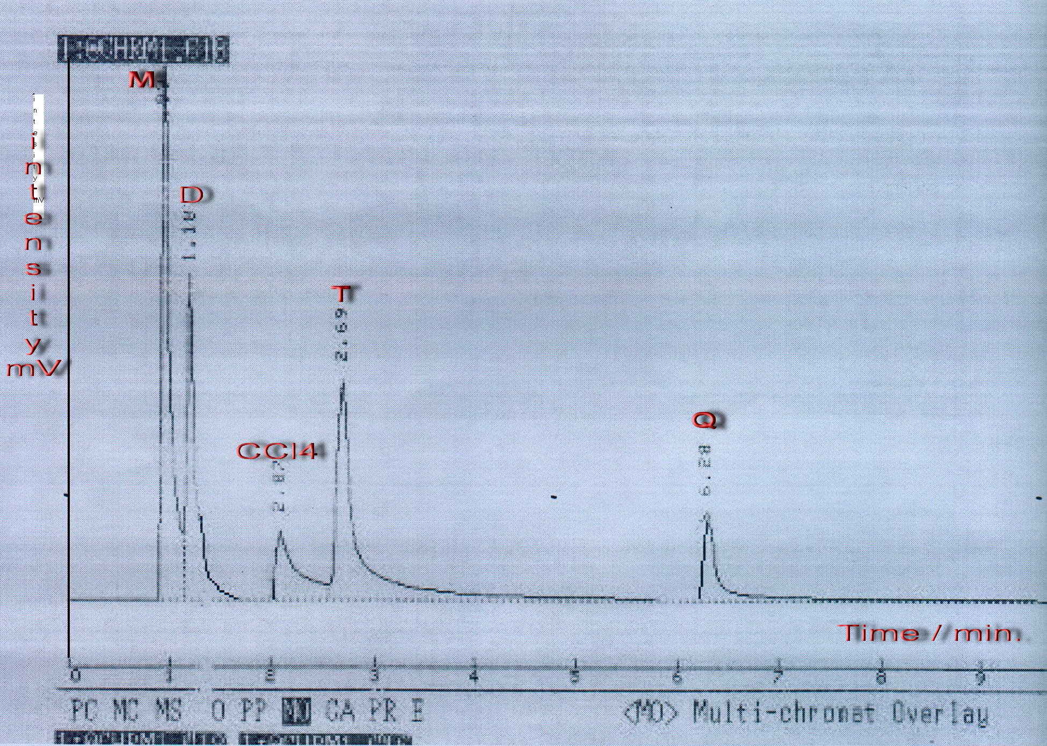 | 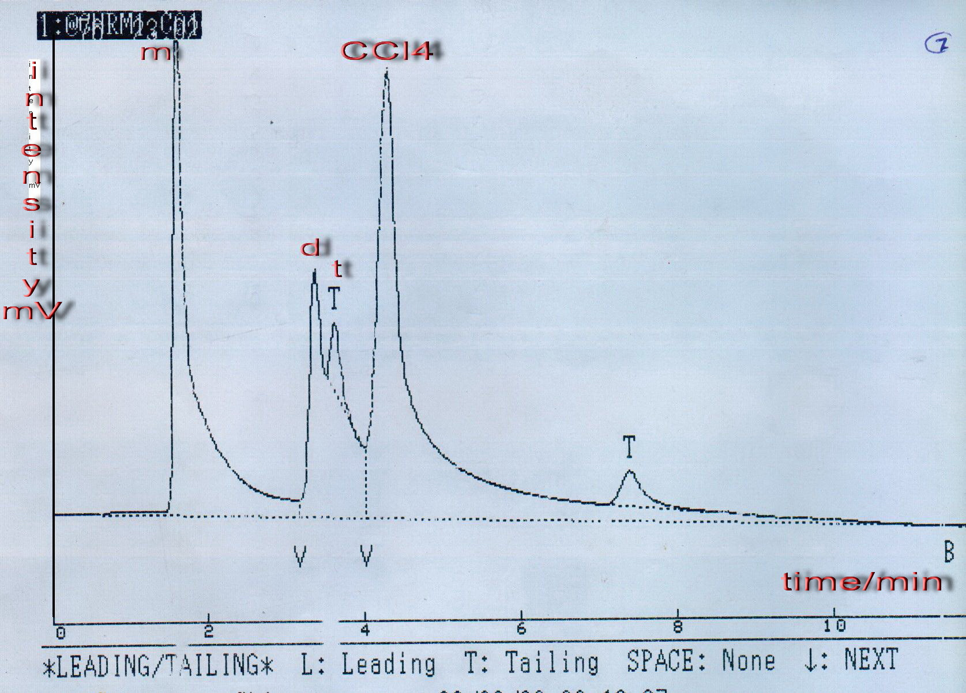
Fig-2: Chromatograph of standard methylethoxysilan compounds mixture on column of 10% OV-101 | Fig. 1:chromatograph of mixture of t, m and d compounds on column type {50%[10%OV – 101] + 50%[5%dioctyl phthalate] oven programme: int. temp.=35 C◦\6 min. rate=5 C◦\min.fin. Temp.=60 C◦\5 min flow=15ml\min. H
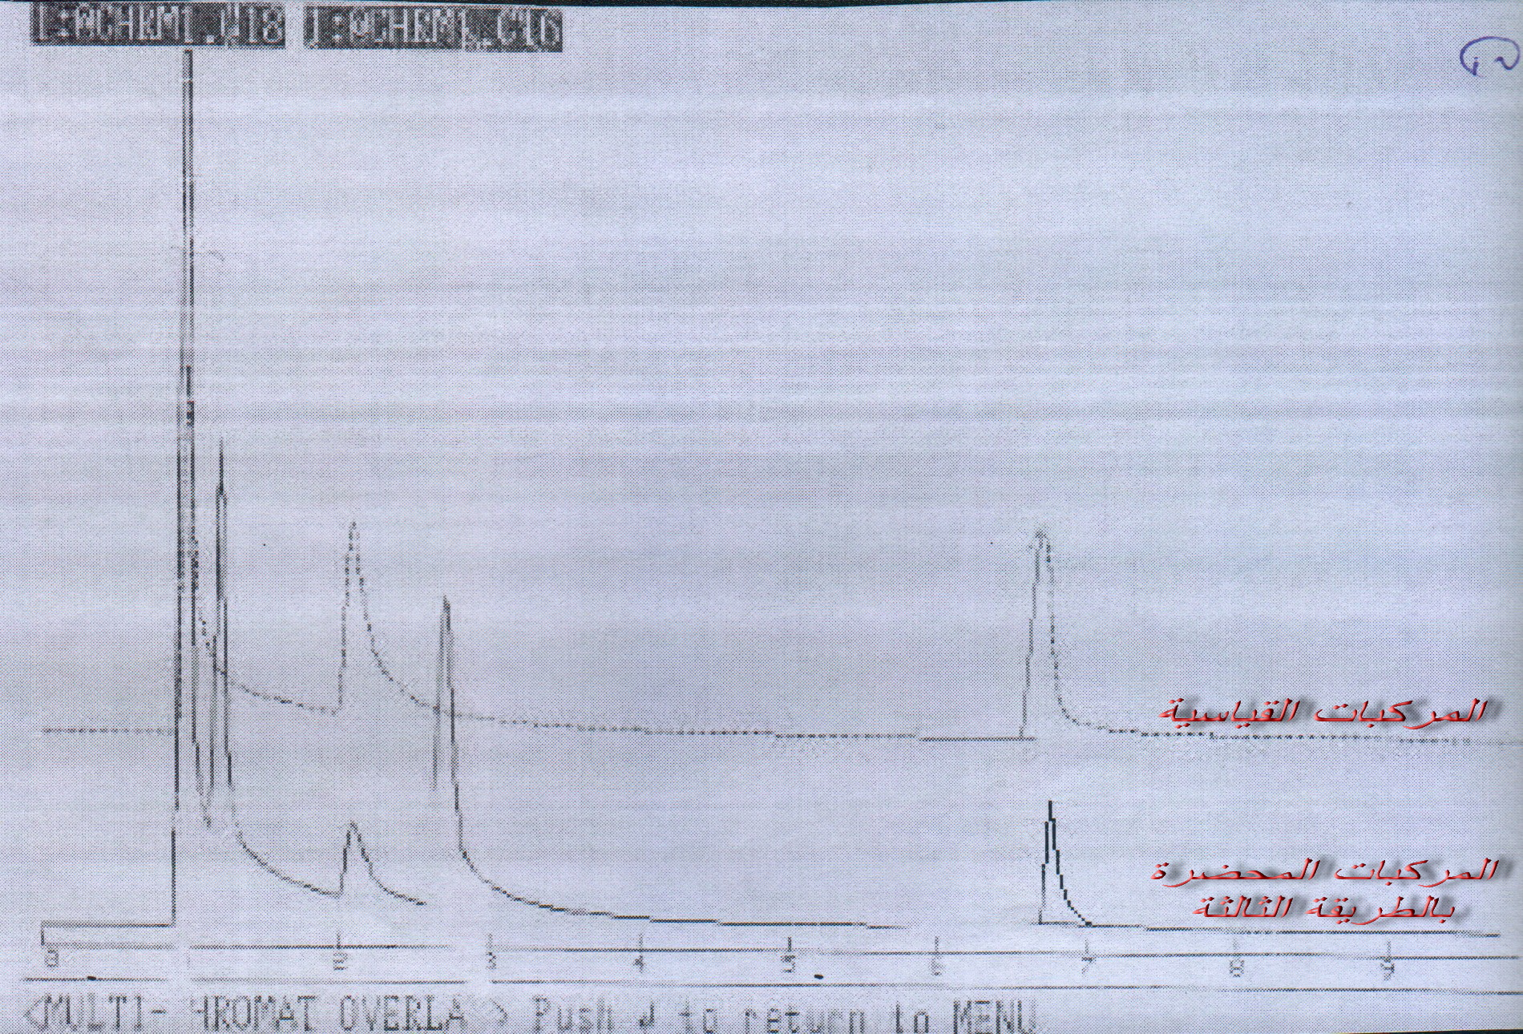
Fig.-3: Comparision of methyjmethoxysilan chromatograph which was synthesized by second method(13) with standard compounds chromatograph .

2
1
3
4
Fig (4) calibration curves of methylethoxysilane compounds on column 10% OV – 101
1- Triethoxy methyl silane .Y = 11310 X + 6116.6 R= 0.9999

2- Diethoxy dimethyl silane .Y = 13596 X + 3271.8 R= 1
3- Monoethoxy trimethyl silane .Y = 14167 X + 6616 R = 1
4- Tetraethoxy silane .Y = 9749.9 X + 131.64 R= 0.9996

Table-2: Retention time of standerd methylchlorosilan compounds on deferent columns
5%  Dioctyl  oven int.  T = 35 C | 5%  Dioctyl  oven int.  T = 45 C | 5%  OV-17 | 5%  OV-7 | 10%  OV-101 | 10%  SE-30 | 5%  SE-30 | compound
1.83 | 1.57 | 0.95 | 1.40 | 0.867 | 1.195 | 0.881 | SiCl4
3.42 | 3.57 | 2.86 | 1.90 | 1.15 | 1.675 | 1.15 | (CH3)3SiOC2H5(m)
3.89 | 3.84 | 6.89 | 2.05 | 1.717 | 2.558 | 1.681 | (CH3)2Si(OC2H5)2(d)
4.83 | 4.61 | 6.89 | 2.05 | 1.717 | 2.558 | 1.681 | CH3Si(OC2H5)3(t)
Table -3: Retention time value of methylethoxysilan compounds on deferent columns
10%  OV-101 | 5%  SE-30 | 10%  SE-30 | Compound
1.10 | 2.01 | 1.35 | (CH3)3SiOC2H5
2.07 | 5.92 | 3.56 | (CH3)2Si(OC2H5)2
2.69 | 12.76 | 11.69 | CH3Si(OC2H5)3
6.28 | 17.88 | 14.10 | Si(OC2H5)4

Table -4: theoretical plate value of methoxyethoxysilan compounds

10%SE-30 | 5%SE-30 | 10%OV-101
12.3 | 14 | 15.7 | n

Table -5: H value of used columns for separation of methlethoxysilan compounds

10%SE-30 | 5%SE-30 | 10% OV 101
16.26 | 14.28 | 9.55 | H

Table -6: statistical parameters of methylethoxysilan compounds
R | Y=bX+a | RSD % | Recovery % | Calc. conc.% | Compound
0.9999 | Y = 11310 X + 6116.6 | 0.93 | 99.44 | 9.94 | Si(OC2H5)4
1 | 13596 X + 3271.8 | 1.08 | 99.72 | 9.97 | CH3Si(OC2H5)3(t)
1 | 14167 X + 6616 | 1.08 | 99.71 | 9.97 | CH3)2Si(OC2H5)2)d)
0.9996 | = 9749.9 X + 131.64 | 1.09 | 99.6 | 9.96 | CH3)3Si(OC2H5))m)

Table -7- calculations of – ΔHS and ΔS of methylethoxysilan compounds 1n CCl4 solvent .
Column50%[10%ov-101]50%[5%dioctylpht-halite] |  | Column 10 % OV-101 |  | Compound
ΔS_{S}(J/k.mole) | - ΔH_{S} (KJ/mole) | ΔS_{S}(J/k.mole) | - ΔH_{S}(kj/mole) | Compound
6.44 | 2.416 | 0.675 | 17.114 | (CH3)3SiOC2H5(m)
5.872 | 2.748 | 0.887 | 16.372 | (CH3)2Si(OC2H5)(d)
7.116 | 3.191 | 1.275 | 18.304 | CH3Si(OC2H5)3(t)
6.284 | 3.335 | 1.399 | 16.758 | Si(OC2H5)4

References
- Marcelo A. , L. Mercado, 2000 , Higher Coordination in Organosilicon Compound, Electronic Docttoral issertations.
- Mult H. C. and Karl H. Heinz, 2007 , Industrial Inorganic Chemistry , 2nd ed. Wiley – VCH Verlag Gmbh, 34.
- Matsuyama H. and T. Shiraishi, J. of Applied Polymer Science , 2003, 54, 1665 – 1672
- Robert West, Chemical Reactions and Properties of Organosilicon compo-unds , Academic Press N.Y. , 2001, 46 – 53.
- Edward R. and S. Lawrence, 2005 , Organosilicon Compounds and Their Uses as Photoinitiators , U.S. Patent 6849668.
- Yates D. J. C. , S. K. Behal and B. H. Kear, 2000, Materials Research Society , Studies of Reactions Between Gaseous Organosilicon compounds and Metal Surface , Vol. 3 , 714 – 722 .
- Brinker C. J. , and G. W. Schener, 1990, "The phsics and chemistry of Sol – Gel processing " Academic press , N. Y.
- Lewis L. N., F. J. Schattenmann , T. M. Jordan , J. C. Carnahan , W. P. Flanagan , R. J. Wroczynski , J. M. Anostario , and M. A. Othon, 2002 , Inorg. Chem., 41, 2608 – 2615 .
- , N.Y. , Tokyo,P Smith and Albert Lee , 1975, Analysis of silicones , Widey , New York,P.149.
- Albertin H.,1982,separation methods, Baghdad university.
- Jeffry A. , 1958, Gas analysis by gas chromatography , welly , N.Y. , 1978 , P.127.
- Kanner B. and R. E. King, 1990, In silicon – based polymer science , Adv. Chem.Ser. , 1990, 224, 1987, 607 – 618 , J. M. Ziegler and F. M. G. Fearon , editors . Am. Soc. Washington DC
- James N. Miller, Jane C. Miller (2000) ; statistics chemo metric for analytical chemistry; 4th Ed,
14-Jonhson H. W. and F. H. Stross , Analytical chem., 1958, 30 .
15-Kenrrick M. Lewis, 1993 , Catalyzed direct reactions of silicone , Elsevif London. 265 .
16-Martin R. L., Anal. Chem. , 1961, 33, 34
17-P. W. Atkins Physical Chemistry , Oxford University Press , Oxford ,
2nd ed ,2002 , P.438
18–Kanner B. ,Ziegler j. and fearon F, silicon –based polymer science, Adv.Chem,.1990, Ser.224, 607-618..

