Thermodynamic Confirmation of Unresponding of Ion-Selective Electrodes to Oxidation-Reduction Potentials.

Ismail K.Al_Hitti & Nagham K. Kareem
Chem. Dept. , College of Science , Al_Anbar Univ. ,Ramadi , Iraq .

(NJC)

(Recevied on 13/10/2010) (Accepted for publication 21/2/2011)

Abstract
The potentials with iodimetric reaction of sulphur reducing agents using sulphide and Cyanide ion_Selective electrodes were all negative resulting from ion_exchange of produced iodide ions on the membrane surfaces of the electrodes .The calculated free energy changes values were positive with negative entropy change values which are an inverse to corresponding values obtained with Platinum electrode .∆H values were mostly low and positive while equilibrium constants were extremely low as it seems to be no occurrence of iodimetric reactions that have been trustly confirmed by platinum electrode . This discrepancy was attributed to high input impedance of ISEs membranes which prevent the flow of electrons across their membranes, and the conductivity is ionic . Therefore , this research confirmed experimentally that these ISEs are unresponsive to oxidation _ reduction potentials and the results obtained might well be considered for other ISEs.

Keywords :Ion-Selective Electrodes(ISEs),Ion-exchange potential , oxidation-reduction potential ,Iodimetric technique , Sulphur-reducing agents.
الخلاصة
كانت الجهود المسجلة لتفاعلات العوامل المؤكسدة الكبريتية مع اليود باستعمال قطبي الكبريتيد والسيانيد الانتقائيين سالبة نتيجة التبادل الايوني لايونات اليوديد الناتجة من هذه التفاعلات على سطوح اغشية هذه الاقطاب . وكانت قيم الطاقة الحرة المحسوبة موجبة وقيم التغير في الانتروبي سالبة وهي عكس القيم التي تم الحصول عليها باستعمال قطب البلاتين . أما قيم المحتوى الحراري فكان معظمها واطئة وموجبة اضافة الى القيم الواطئة جداً لثوابت التوازن بما يبدو للباحث عدم حصول هذه التفاعلات والتي تم التأكد من حدوثها بثقة عالية باستعمال قطب البلاتين. لذا أثبت هذا البحث عملياً عدم استجابة هذه الاقطاب الانتقائية للأيونات لجهود التأكسد والاختزال وان النتائج التي تم الحصول عليها يمكن تعميمها على الاقطاب الانتقائية الاخرى.

Introduction
The field of analytical potentiometry was sparked by the development of novel Ion-Selective Electrodes ISEs which are widely used in analytical chemistry⁽¹⁾.ISEs are characterized by their rather thick membranes (either glass or solid –state and liquid membranes ) which render these electrodes of high electrical resistance (1-100 megohms) .Therefore , these membranes require measuring circuits with high input impedance and
is accompanied by large temp. coefficient of resistance which changes exponentially with temperature .⁽²⁾ The main advantage of ISEs over metal ion electrode is their insensitivity to redox interferences and surface poisoning . Since oxidation-reduction reactions involve transfer of electrons from reductant into oxidant , ISEs are unresponsive to the oxidation-reduction potentials⁽³⁾. Negligible current must be drawn during measurements by ion-selective electrodes and the current drawn should be 10⁻¹²Ampere or less . This
phenomenon has limited the choice of
instrument to a high impedance electronic Voltmeter⁽⁴⁾.Thus electronic conductance in metal electrodes is replaced by an ionically conducting membranes . For example , the fluoride electrode , the active membrane is a single crystal of LaF₃ doped with europium(II) to lower its electrical resistance and facilitate ionic charge transferring and the activity calibration curve shows that the electrode follows Nernstian behavour to fluoride concentrations as low as 10⁻⁵M .⁽⁵⁾
The modern pH/mV meter measures pH and millivolts and it is an electronic voltmeter with an operational amplifier designed to have high input impedance . The electrochemical cells used with ion-selective electrodes are simple in construction without potential and current controlling (as in polarography and electrolysis ) and including just an indicator and reference electrodes , electronic voltmeter and magnetic or mechanical stirrer .⁽⁶⁾ However , from our experience with ISEs , we were always asked : Which electrode is negative (Cathode) and Which electrode is positive (Anode) due to their thoughts that these cells resemble the elctrolysis cells or the reactions may be oxidation-reduction reactions . This obscurity with many scientists and even chemists have led us to present an experimental proof that the ISEs are unresponsive to oxidation-reduction potentials, but they respond to the potential developed as a result of ion-exchange on the surface of the ISE relative to the reference electrode . Five sulphur reducing agents were determined by exploitation of iodimetric technique using Iodine prepared in glacial acetic acid as a titrant . ⁽⁷⁾ The change in potential was followed using sulphide and cyanide (ISEs) in comparison to platinum electrode .Potentials were obtained from potentiometric titeration curves at different temperatures and applied in the calculation of thermodynamic variables and constants .The aim of this research is to prove thermodynamically that ISEs do not respond to oxidation-reduction potentials.
Experimental
Materials : All chemicals were A.R.Grade from BDH and Fluka companies . Double distilled water was used for the preparation of solutions . Measurements of potentials at equivalence points were done at 25,30,35 and 40 °C.
pH/mV_ meter ⁽⁸⁾ : Ion-analyzer type Digital from Mettler_ TOLEDO (China) to follow potential changes through potentiometric titerations . The same instrument was used for pH measurements during titration and calibration modes .
Electrodes : Two ion-selective electrodes were used to monitor potential difference during titration and calibration relative to Calomel reference electrode with a precision of ±0.1 mV as mentioned on the electrodes. These two electrodes were cyanide and sulphide solid_state membranes from Mettler_TOLEDO company . The third type is the platinum electrode in a ring shape with conductive wire to mV_meter from EIL company to record the oxidation – reduction potentials . Acombined glass electrode from Mettler-TOLEDO company was used to measure solution pH through calibration and titration with a precision of ±0.01 pH unit as clarified by the company. The Calomel reference electrode of constant potential from Mettler_TOLEDO containing 1M KNO₃ in its external compartment to avoid chloride ion interferences .
Water bath with temperature regulator : Gallen Kamp (UK) for temperature adjustment of the reaction cell with a precision of ±0.1°C as written on the instrument.
Magnetic stirrer :from minJank and Kunkel company for stirring the solutions through calibration and titration processes .
Titration cell : It is a glass cell with cover of three openings ; two to introduce indicator and calomel reference electrodes and the third for introduction the end of the burette. The cell possesses two side openings for internal and external water from water bath for temperature adjustment with a precision of ± 0.1°C as written on the instrument.(Fig.1).
Preparation of solutions : The solutions of the materials (Na₂S₂O₃,Na₂SO₃,Na₂S,Na₂S₂O₄, Na₂S₂O₅ and I₂) were prepared in 0.1N from their corresponding weights in a previously boiled and cooled distilled water to avoid the effect of dissolved oxygen and reserved in firmly tightened bottles . Most of them were freshly prepared to avoid oxidation with dissolved oxygen . Standardisation of sodium thiosulphate solution ⁽⁹⁾: This solution was standardized by titration with 0.1N KIO₃ solution in the presence of 10% of KI solution in acidic medium of 0.1M sulphuric acid until the solution became pale yellow . 1 ml of starch solution was added and the titration was continued to colourless . The titration was repeated four times and the concentration of Na₂S₂O₃ solution was adjusted .
Standardisation of iodine solution⁽¹⁰⁾
The iodine prepared in glacial acetic acid (its solubility 25 g/L at 25°C compared with 0.335 g/L in water ) was standardised with standardised thiosulphate solution in the presence of starch indicator . Iodine solution was also standardised with 0.1 N Na₃AsO₃ in the presence of 1g of NaHCO₃ with starch indicator to confirm the standardization with thiosulphate solution .
Standardisation of Na₂SO₃ , Na₂S , Na₂S₂O₄⁽¹⁰⁾ and Na₂S₂O₅ solutiuons : These solutions were standardised individually by addition an excess of Standardised I₂ solution . The excess of iodine was back-titrated with standardized thiosulphate solution in presence of starch indicator .

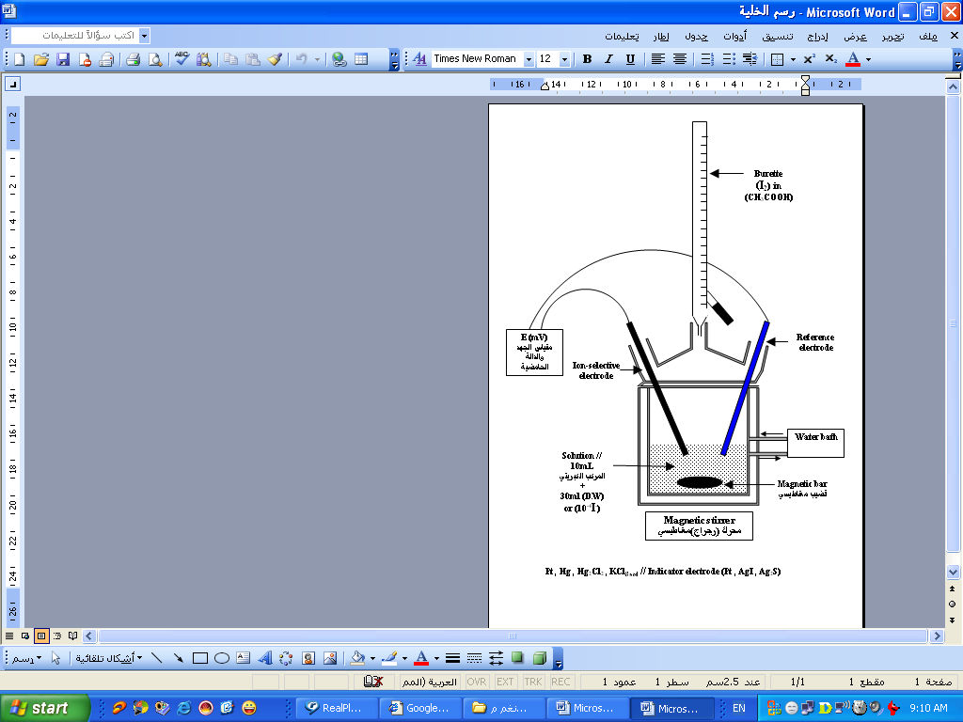
Burette(I₂)in (CH₃COOH)
Reference electrode
Solution :- 10mL sulphur compound
₊
_{30mL(D.W)}

Water bath
Magnetic bar

Magnetic stirrer

Ion-selective
electrode
E(mV)

Fig.1 Schematic diagram for the potentiometric titration cell

Stepwise potentiometric titrations of sulphur reducing agents with Iodine solution : A volume of 10ml of the prepared solution of sulphur reducing agents was transferred into the titration cell and diluted to 30ml with distilled water . The cell was connected to the water bath and the potentiometric titration was performed at 298,303,308 and 313°K with iodine solution from the burette , using cyanide and sulphide ion-selective electrodes and platinum electrode relative to calomel reference electrode.The titration was continued with magnetic stirring until a clear , suitable and practical shifts were observed at equivalence points .The potentials were picked up from the titration curves at equivalence points .

Results and Discussion
Pattern of Electrodes response during the course of potentiometric titration :
- Platinum electrode relative to calomel electrode : The electrode response was of s-shaped and there was clear and high potential shift at equivalence point with three different concentrations (Fig .2) The potential values at equivalence points were confirmed by first and second derivatives curves . These potentials are all positive and called oxidation – reduction potentials (Tables 1 to 5) .

mV
Vs.
Calomel
الحجم (مللتر) I₂
V=8.6
V=8.4

Fig.2: Potentiometric titration curve of sodium sulphide solution with
Iodine solution at 25°C using platinum electrode versus Calomel reference electrod.

- Sulphide electrode relative to
calomel electrode: The response was also of s-shaped but not so clear as obtained with platinum electrode (Fig .3) There was continous deflection toward negative potential as a result of liberation of iodide ions produced by the reaction of iodine with the sulphur reducing agents followed by high inflection to the lower negative potential (more positive) as a result of consumption of all sulphur reducing agent and the combination of added iodine with the liberated iodide to form triiodide associated with almost constant potential⁽¹⁰⁾:
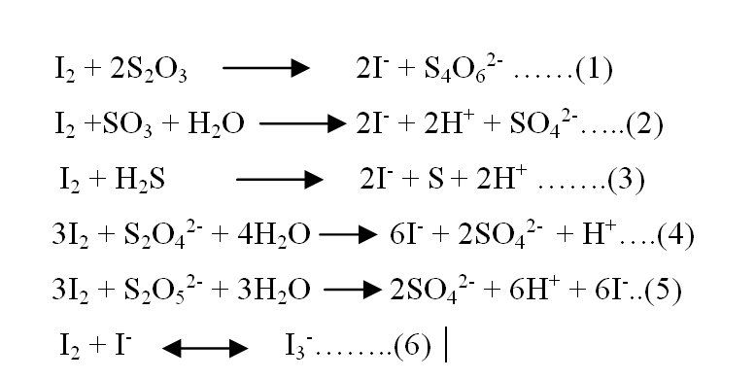

(

3) Cyanide electrode relative to
calomel electrode : Unlike
platinum and sulphide electrodes
there was no high potential shift at
equivalence point with cyanide electrode response . There was gradual increase of potential to more positive till the equivalence point which became constant indicating the completion of the reaction and the equivalence point was identified by extrapolation of the straight line after equivalence point (Fig.4). All potential values obtained by sulphide and cyanide ion-selective electrodes at equivalence points for different concentrations were negative (Tables 1-5). This was as a result of response of both electrodes to the iodide anions liberated from the reaction of iodine with the sulphur reducing agents as mentioned above (equtions 1-5) in contrast to platinum electrode which responds exclusively to oxidation-reduction potential .

mV
Vs.
Calomel
الحجم (مللتر) I₂
V=13. 6

Fig.3: Potentiometric titration curve of sodium thiosulphate solution with Iodine solution at 25°C using Sulphide electrode versus Calomel reference electrode.

mV
Vs.
Calomel
الحجم (مللتر) I₂
V=13. 8
V=13.6

Fig.4: Potentiometric titration curve of sodium sulphite solution with
Iodine solution at 25°C using cyanide electrode versus Calomel reference electrode.

Table(1) Thermodynamic results for sodium thiosulphate ( Na₂S₂O₃).

K_{eq} | ∆H  (KJ/moL) | ∆S  (KJ/K.moL | ∆G  (KJ/moL) | Potential  E  (V) | Temp.  (K) | Electrode | Compound | اNo.
10³×4.52 | -0.010 | 0.070 | -20.87 | 10⁻³×216.3 | 298 | Pt | Na₂S₂O₃.5H₂O | 1
10³×4.24 | -0.142 | 0.076 | -23.17 | 10⁻³×240.1 | 303
10³×3.30 | -0.166 | 0.077 | -23.55 | 10⁻³×244.1 | 308
10³×5.53 | +0.150 | 0.080 | -24.89 | 10⁻³×257.9 | 313
10⁻⁴×8.0 | -0.082 | -0.059 | +17.5 | 10⁻³×-181.4 | 298 | CN⁻
10⁻⁴×18 | -0.005 | -0.052 | +15.85 | 10⁻³×-164.3 | 303
10⁻⁴×40 | -0.078 | -0.046 | +14.09 | 10⁻³×-146.1 | 308
10⁻⁴×78 | -0.004 | -0.040 | +12.61 | 10⁻³×-130.7 | 313
10⁻⁴×18 | +0.013 | -0.072 | +21.35 | 10⁻³×-221.3 | 298 | S²⁻
10⁻⁴×32 | +0.029 | -0.067 | +20.33 | 10⁻³×-210.7 | 303
10⁻⁴×34 | +0.144 | -0.067 | +20.78 | 10⁻³×-215.4 | 308
10⁻⁴×16 | +0.126 | -0.062 | +19.28 | 10⁻³×-199.8 | 313

Each value in the table for electrode potentials is an average of four measurements and the relative standard deviation values are in the range of 1.30 – 2.57% .

Table(2) Thermodynamic results for sodium sulphite (Na₂SO₃).

K_{eq} | ∆H  (KJ/moL) | ∆S  (KJ/K.moL | ∆G  (KJ/moL) | Potential  E  (V) | Temp.  (K) | Electrode | Compound | اNo.
10¹⁰×2.001 | -0.114 | 0.197 | -58.82 | 10⁻³×304.8 | 298 | Pt | Na₂SO₃ | 2
10¹⁰×3.65 | -0.058 | 0.204 | -61.87 | 10⁻³×320.6 | 303
10¹⁰×9.15 | -0.010 | 0.210 | -64.69 | 10⁻³×335.2 | 308
10¹⁰×4.2 | +0.049 | 0.223 | -69.75 | 10⁻³×361.0 | 313
10⁻⁶×0.3 | -0.032 | -0.124 | +36.92 | 10⁻³×-191.3 | 298 | CN⁻
10⁻⁶×4.6 | +0.014 | -0.102 | +30.92 | 10⁻³×-160.2 | 303
10⁻⁶×6.7 | +0.140 | -0.100 | +30.94 | 10⁻³×-160.3 | 308
10⁻⁶×10.0 | +0.115 | -0.095 | +29.85 | 10⁻³×-154.7 | 313
10⁻⁶×0.7 | +0.038 | -0.117 | +34.99 | 10⁻³×-181.3 | 298 | S²⁻
10⁻⁶×1.7 | +0.070 | -0.110 | +33.40 | 10⁻³×-173.1 | 303
10⁻⁶×4.2 | +1.330 | -0.100 | +32.13 | 10⁻³×-166.5 | 308
10⁻⁶×8.5 | -0.021 | -0.097 | +30.34 | 10⁻³×-157.2 | 313

Each value in the table for electrode potentials is an average of four measurements and the relative standard deviation values are in the range of 1.30 – 2.57% .

K_{eq} | ∆H  (KJ/moL) | ∆S  (KJ/K.moL | ∆G  (KJ/moL) | Potential  E  (V) | Temp.  (K) | Electrode | Compound | اNo.
10¹¹×1.82 | +0.068 | +0.216 | -64.30 | 10⁻³×333.2 | 298 | Pt | Na₂S.9  H₂O | 3
10¹¹×1.43 | +0.112 | +0.214 | -64.73 | 10⁻³×335.4 | 303
10¹¹×1.51 | +0.012 | +0.214 | -65.90 | 10⁻³×341.5 | 308
10¹¹×5.38 | -0.118 | 0.224+ | -70.23 | 10⁻³×363.9 | 313
10⁻³×14 | +0.050 | -0.035 | +10.48 | 10⁻³×-54.3 | 298 | CN⁻
10⁻³×16 | +0.058 | -0.034 | +10.36 | 10⁻³×-53.7 | 303
10⁻³×18 | +0.005 | -0.033 | +10.20 | 10⁻³×-52.9 | 308
10⁻³×35 | -0.094 | -0.028 | +8.67 | 10⁻³×-44.9 | 313
10⁻⁴×11 | -0.116 | -0.057 | +16.87 | 10⁻³×-87.4 | 298 | S²⁻
10⁻⁴×46 | -0.105 | -0.045 | +13.53 | 10⁻³×-70.1 | 303
10⁻⁴×45 | -0.060 | -0.045 | +13.80 | 10⁻³×-71.5 | 308
10⁻⁴×61 | -0.219 | -0.043 | +13.24 | 10⁻³×-68.6 | 313
Table(3) Thermodynamic results for sodium dithionite (Na₂S).

Each value in the table for electrode potentials is an average of four measurements and the relative standard deviation values are in the range of 1.30 – 2.57% .

Table(4) Thermodynamic results for sodium dithionite (Na₂S₂O₄).

K_{eq} | ∆H  (KJ/moL) | ∆S  (KJ/K.moL | ∆G  (KJ/moL) | Potential  E  (V) | Temp.  (K) | Electrode | Compound | اNo.
10⁷×2.75 | +0.134 | +0.143 | -42.48 | 10⁻³×220.1 | 298 | Pt | Na₂S₂O₄ | 4
10⁷×3.14 | +0.132 | +0.144 | -43.50 | 10⁻³×225.4 | 303
10⁷×3.41 | +0.260 | +0.145 | -44.40 | 10⁻³×230.1 | 308
10⁷×1.05 | +0.415 | +0.155 | -48.10 | 10⁻³×249.3 | 313
10⁻⁷×5.0 | +0.120 | -0.120 | +35.88 | 10⁻³×-185.9 | 298 | CN⁻
10⁻⁷×7.0 | +0.252 | -0.116 | +35.40 | 10⁻³×-183.4 | 303
10⁻⁷×12 | +0.096 | -0.113 | +34.90 | 10⁻³×-181.1 | 308
10⁻⁷×14 | -1.095 | -0.115 | +34.90 | 10⁻³×-180.9 | 313
10⁻⁵×0.8 | +0.124 | -0.097 | +29.03 | 10⁻³×-150.4 | 298 | S²⁻
10⁻⁵×4.5 | +0.051 | -0.083 | +25.20 | 10⁻³×-130.6 | 303
10⁻⁵×1.1 | -0.148 | -0.076 | +23.26 | 10⁻³×-120.5 | 308
10⁻⁵×3.2 | -0.051 | -0.067 | +20.92 | 10⁻³×-108.4 | 313

Each value in the table for electrode potentials is an average of four measurements and the relative standard deviation values are in the range of 1.30 – 2.57% .

Table(5) Thermodynamic results for sodium disulphite (Na₂S₂O₅).

K_{eq} | ∆H  (KJ/moL) | ∆S  (KJ/K.moL | ∆G  (KJ/moL) | Potential  E  (V) | Temp.  (K) | Electrode | Compound | اNo.
10⁸×2.3 | -0.080 | +0.160 | -47.76 | 10⁻³×247.5 | 298 | Pt | Na₂S₂O₅ | 5
10⁸×2.0 | -0.093 | +0.159 | -48.27 | 10⁻³×250.1 | 303
10⁸×2.5 | -0.240 | +0.160 | -49.52 | 10⁻³×256.6 | 308
10⁸×2.7 | -0.410 | +0.160 | -50.49 | 10⁻³×261.6 | 313
10⁻⁶×6 | +0.258 | -0.099 | +29.76 | 10⁻³×-154.2 | 298 | CN⁻
10⁻⁶×8 | +0.272 | -0.096 | +29.36 | 10⁻³×-152.1 | 303
10⁻⁶×10 | +0.110 | -0.095 | +29.37 | 10⁻³×-152.2 | 308
10⁻⁶×19 | +0.040 | -0.090 | +28.21 | 10⁻³×-146.2 | 313
10⁻⁶×18 | +0.240 | -0.090 | +27.06 | 10⁻³×-140.2 | 298 | S²⁻
10⁻⁶×25 | +0.269 | -0.087 | +26.63 | 10⁻³×-138.0 | 303
10⁻⁶×35 | +0.090 | -0.085 | +26.27 | 10⁻³×-138.1 | 308
10⁻⁶×11 | +0.055 | -0.075 | +23.53 | 10⁻³×-121.9 | 313
Each value in the table for electrode potentials is an average of four measurements and the relative standard deviation values are in the range of 1.30 – 2.57% .

Calculation of some thermodynamic variables and constants for sulphur reducing agents: The potentiometric titrations of sulphur reducing agents with iodine have been accomplished at different temperatures ranged from 298-313°K and the potentials were determined at equivalence points . As the potential values are known , the changes in free enegy (∆ G) were caculated from the following relation: ⁽¹¹⁾
∆G = - n F E……(7)
Where E= cell potential at equivalence point which associated with passage of nF coloumbs of electricity
Enthalphy changes (∆H) were determined using Gibbs –Helmhultz equation⁽¹²⁾:
∆G = ∆H + T ( ∂∆G/ ∂T)_{p}…….(8)
at constant pressure . The entropy changes for at the reaction cell were obtained from the relation :-

∆G = ∆H - T∆S or ∆H = ∆G + T∆S….(9)
The equilibrium constants (K_{eq}) of sulphur reducing agents reactions with iodine have been calculated using free renergy change values at different temperatures from the following relation: ⁽¹²⁾
∆G =-RT ln K_{eq} ….(10)
These thermodynamic variables and constants were compiled in the tables (1-5) . For platinum electrode , the free energy changes of all the sulphur reducing agent were negative. Therefore the reactions are irreversible which are confirmed by the positive values of entropy changes . The enthalpy change were of lower values and some of them are negative (exothermic) and the others are positive (endothermic) . Therefore , these reactions are spontaneous and displaced completely to the right ( eqns.1-5)⁽¹²⁾. There is no large role of the temperature on the reactions and then has little effect on the potential at equivalence points . The spontancity of the reaction of sulphur reducing agents with iodine was confirmed by the high values of equilibrium constants which refer to the complete displacement to the products and complete oxidation of the sulphur reducing agents. ⁽¹²⁾The case was quite different with cyanide and sulphide ion-selective electrodes. The potential values were all negative as a result of ion exchange of produced iodide ions on the surface of the electrodes . Therefore the calculated free energy values were positive while negative for entropy changes values which are an inverse to the corresponding values obtained with platinum electrode. ∆H values were mostly low and positive whereas the equilibrium constants were extremely of low values as it seems to be no reactions between the sulphur reducing agents and the iodine . This discrepancy is attributed to the high input impedance of ISEs membranes which prevent the flow of electrons across them ⁽¹³⁾ . The current is zero or very little and the conuctivity is ionic (by Ag⁺ ions in Ag₂S and AgI membranes ) . The potentials recorded by sulphide and cyanide electrodes are the ion-exchange potentials developed on the surface of the membranes which are directly proportional to logarithm of ion activity or concentration of the iodide ion ^{(6,14)} . As a conclusion , ISEs are insensitive to the oxidation – reduction processes occurred inside the electrochemical cell and don,t respond to this type of potentials as has achieved with metal ion electrodes . Therefore the potentials obtained with platinum electrode are only reliable for thermodynamic calculations of sulphur reducing agents .

Conclusion
It was ascertained experimentally from thermodynamic data that ISEs don,t respond to oxidation – reduction potentials and the conductivity across the membranes is ionic rather than electronic since there is no passage of electrons as was attained with metal ion electrodes.The results obtained in this research might well be considered for other ISEs.

References
- Moss,S.D. , Janata , J. and Johnson , C.C , Anal. Chem., 1975, 47, 2238 .
- Ariano , J. M. and Gutnecht ,W. F. , Anal. Chem., 1976, 48, 281 .
- Valsov , Y.G. and Bychkov ,E. A.,Hung., Sci. Instrum., 1982, 53, 35.
- Freiser , H(ed) , Ion-Selective Electrodes in Anal. Chem., New York , Plenum Press, 1978, 1 , 1980, 2 .
- Arnold , M.A. and Meycrhohff. , M.E, Anal. Chem. (1984) , 56,20R .
- Pungor,E.,Electroanalysis (1996), 8,348.
- Al-Hitti ,I.K and Kareem, N.Kh. J.of Univ.of Anbar for Pure Sciences, 2009, 3(2), 57.
- Guide to Ion-Selective Measurements, Instruction Manual, MettlerTOLEDO (2006),GmbH,Analytical,Switzerland.
- Vogel,s Textbook of Quantitative Chemical Analysis, (1998) , Revised by G . H. Geffery , T . Basset , Mendham and R.C. Denney , 12th edition , Longmans , England .

(10) Williams , W. J, Handbook of Anion Determination (1997) Butterworths and Co (Publishers) Ltd. , P.500 .
(11) Saleh, J.M., Electrochemistry (1977), 1st ed . Baghdad Univ., College of Science , P.122 .
(12) Atkins , P.W. , Physical Chemistry (2001) , 6th ed ., Oxford Univ. Press , Oxford ,P.130
(13) Willard , H.W, Merrit , L.L. , Dean , J.A and Settle (JR) , F.A. Instrumental Methods of Analysis (1981),6th ed. , D.van Nostrand Co. , New York , P.659 .
(14) Bailey , P.L, Analysis with Ion – Selective Electrodes(1980) , 2nd ed. , Heyden and Son Ltd. , London , PP. 53-60.

