Synthesis and Characterization Of Some
3-Phenylthio/3-Phenoxyazetidine-2- One: Application of Two Dimensional NMR HMQC ¹H-¹³C, Cosy ¹H–¹H And Mass Spectroscopy

Mahmood Shakir Magtoof and Z. S. Hassan
Chemistry Dept., Science College Thiqar University, Thiqar, Nashyria,Iraq

Keywords: Azetidin-2-ones; antibiotics ,ketene, phosphorusoxychloride,
cosy nmr.

(NJC)

(Recevied on 7/9/2010) (Accepted for publication 20/2/2011)

Abstract
This study is concerned with the synthesis and characterization of the 3–phenylthio/3-phenoxyazetidine-2-one 3(a-e). These compounds were prepared by phenylthio/phenoxyacetic acid (1) with the appropriate Schiff bases 2(a-d) in the presence of triethylamine with phosphorusoxychloride in dry methylene chloride under nitrogen atmosphere at 0˚C. The active acid chloride reacts with triethylamine to generate corresponding ketene in situ which further reacts with Schiff’s base to furnish corresponding 3–phenylthio/3-phenoxyazetidine-2-one 3(a-e) in moderate yields .
الخلاصة
تضمنت الدراسه تخليق وتشخيص بعض مركبات 3-فنيل ثايو/3-فينوكسي ازيتيدين-2-ون التي تم تحضيرها من تفاعل فنيل ثايو/فينوكسي اسيتك اسد مع بعض قواعد شف بوجود ثلاثي اثيل امين واوكسي كلوريد الفسفور في كلوريد الاثيلين الجاف عند درجه الصفر المئوي.حيث ينتج كيتين والذي يتفاعل مع قواعد شف ليعطي الناتج 3-فنيل ثايو/3-فينوكسي ازيتيدين-2-ون.شخصت المركبات باستخدام اطياف تحت الحمراء وطيف الكتله ومطيافيه الرنين النووي المغناطيسي البروتوني وكاربون 13 واقتران طيف الرنين البروتوني البروتوني والبروتوني وكاربون 13.

Introduction
Azetidin-2-ones (figure1), commonly known as -β-lactam constitute a well-known class of heterocyclic compounds.

β-Lactams, being a structural motif in most widely used antibiotics which have occupied a pivotal position in medicinal chemistry for almost a century now^{1,2} With the microorganisms retaliating the

traditional antibiotics via β-lactamase enzymes, the need for novel antibiotics prevails making synthesis of newer β-lactams ever more important. Besides their use as antibiotics, β-lactams are increasingly being used as synthons for biologically important molecules^{3,4,5,6} Apart from this, the recent literature has seen a spurt in the number of other diverse applications of the β-lactams.
They have been shown to increase the expression of glutamate transporters through gene Activation⁷ .
β-Lactams have also been found to act as cholesterol acyl transferase inhibitors^{8,9} ,[thrombin inhibitors¹⁰ ,human cytomegalovirus protease inhibitors¹¹.

Results and Discussion
Taking a lead from our earlier studies,¹² it was considered to utilise ketene-imine cyclization in the presence of triethylamine use C₃–C₄ bond formation of β-lactam by employing Et₃N: as key steps for the synthesis of 3-phenylthio/3-Phenoxy substituted β-lactams of type A and B.

A B

So,the key step for the synthesis of 3-phenylthio/3-phenoxyazetidine-2-ones 3(a-e) involve the treatment of imines 2(a-d) with phenylthioacetic acid/phenoxyacetic aci d in the presence of triethylamine and phosphorusoxychloride with dichloromethane as solvent under dry system(N₂ atmosphere) as shown in scheme 2:

2(a-d) Azetidine-2-ones
3(a-e)

Scheme 2

The required Various Schiff's bases 2(a-d) for the β-lactam formation 3(a-e) were prepared from reacting of equimolar amounts of appropriate aromatic aldehydes and aromatic amines either in dry methylene chloride in the presence of molecular sieves (4Aº) or in refluxing ethanol. The structures of these imines 2(a-d) were confirmed on the basis of their spectral data (IR and NMR).

Table(3-1) : Schiff's bases 2(a-d)
S.No. | Schiff’s Base | R¹ | R²
1. | 2a
2. | 2b
3. | 2c
4. | 2d

As, mentioned in the beginning ,the 3-phenylthio/3-phenoxyazetidine-2-ones 3(a-e) were prepared from phenylthioacetic acid/phenoxyacetic acid 1 and appropriate Schiff’s bases 2(a-d) in the presence of triethylamine. The active acid chloride formed from an appropriate acid (1) with POCl₃ was reacted with triethylamine to gave the corresponding ketene in situ which subsequently reacted with Schiff’s base 2(a-d) and afforded the corresponding β-lactam in moderate yields .The proposed mechanism for their formations was shown as below in scheme 3 :

The structures of these azetidine-2-ones were established on the basis of spectral data UV, IR, Mass,¹H NMR,¹³C NMR and ¹H-¹H, ¹H-¹³C COSY NMR spectra . IR spectra of these compounds 3(a-e) showed strong stretching absorption band at 1743-1658 cm⁻¹ for (C=O) as shown Fig (3-1.The IR absorption frequencies of carbonyl groups (C=O) depended upon the nature of substituents at adjacent
nitrogen atom .So the substitution of the phenyl ring by electron-donating groups such as N,N-dimethylamino, methoxy or N,N-diethylamino group lowered the absorption frequencies where as the substitution by an electron-withdrawing chloro group increased the absorption frequency.Asimilar trend in IR absorption frequency is reported by Lacroix et al. ^{13, 14,15}
The protons at C₃-H and C₄-H positions of the ring have been observed to resonate from 4.93 to 5.61 ppm^{16,17}. The ¹H-NMR spectroscopy is the most powerful tool for the determination of relative stereochemistry at C₃-H and C₄-H positions of 3-phenylthio/3-phenoxyazetidine-2-ones. The coupling constant for vicinal protons at C₃-H and C₄-H is 4.5-6.0 Hz for cis derivatives and 2.0-2.5 Hz for trans derivatives for examples, the compound 3a the stereochemistry is trans then the compound 3b the stereochemistry is cis . The ¹H-NMR spectra of these compounds 3(a-e) showed two singlets around δ 4.93-5.72and 4.58-5.61 ppm corresponding to C₃-H and C₄-H positions of the β-lactam ring .The ¹H-NMR spectra of the compounds showed 13 aromatic protons at 6.52-7.54 ppm
The 2D NMR COSY ¹H-¹H studies led to assignment of signals to protons and protons in the azetidine-2-ones 3(a-e) .
The application of COSY using ¹H-¹H COSY NMR spectra in characterization of such compounds is discussed in succeeding paragraphs by taking representative examples of 3a,3b,3cand
As stated in the ¹H and ¹H NMR subsections,the characterization of 3a required assignment of proton signals at δ 4.94 and 4.58 ppm, showed the correlation with the protons signals at 4.58,4.59,4.93,4,94; thus the signal could be assigned to the C₃-H and C₄-H positions of azetidine-2-ones .
Also, the COSY ¹H-¹H spectrum of 3a showed the correlation of the each aromatic proton signal at 6.52-7.46 ppm with6.52,6.54,6.91,6.93,6.99,7.00,7.26,7.27,7.28,7.29,7.30,7.32,7.33,7.34, 7.44,7.46 which led to the assignment of this signal to the aromatic protons .
The ¹³C-NMR spectra of azetidine-2-ones showed the typical carbonyl resonance at δ 162.02-167.40 ppm. However,the values outside this range are possible if strong electron withdrawing or electron donating groups are present on the adjacent carbon atoms . For example, the ¹³C-NMR spectra of 4-(4-chlorophenyl)azetidine-2-one 3e showed the carbonyl carbon signal at δ 167.40 ppm where as the carbonyl group in 1-(4-N,N-diethylamino)phenylazetidine-2-one 3a resonated at 162.35^{18,19}
The 2D NMR HMQC ¹H-¹³C spectram of 3c showed the correlation of the methoxy proton in compound 3c signal at δ 3.72 ppm with carbon signal at δ 55.60 ppm, which led to the assignment of this signal to the methoxy group carbon. The HMQC spectrum showed the correlation of proton signals at δ 5.60-5.61and 5.71-5.72 ppm with carbon signals at δ 61.02 and 81.02, respectively.^{20,21,22}
The aromatic protons from δ 6.60 to 7.40 ppm correlation with carbon aromatic signals at 112.06,113.05,114.02,118.72,122.84,125.22,125.75, 130.22,143,02 ppm Fig(3-6)-(3-10)

Schme 4: ¹H-¹H COSY and ¹H-¹³C COSY of compounds 3a and 3c

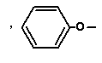
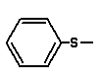
The Mass spectra of the compounds 3a and 3b showed the molecular ion peak corresponding to the particular compound (M+,432,18%,420,21%). The fragmentation of the 3-phenylthio/3-phenoxy azetidine-2-one leading to the imine (282,7%,286,6.6%) base peak and the corresponding ketene (150,1.5%,134,2%) also the fragmentation of this compound showed the alkene peaks (242,34%,230,1.4%) and isocyanates (190,100%,190,72%).The fragmentation mechanism of compounds 3a and 3b were shown below ^{23,24}fig(3-1)and(3-2):

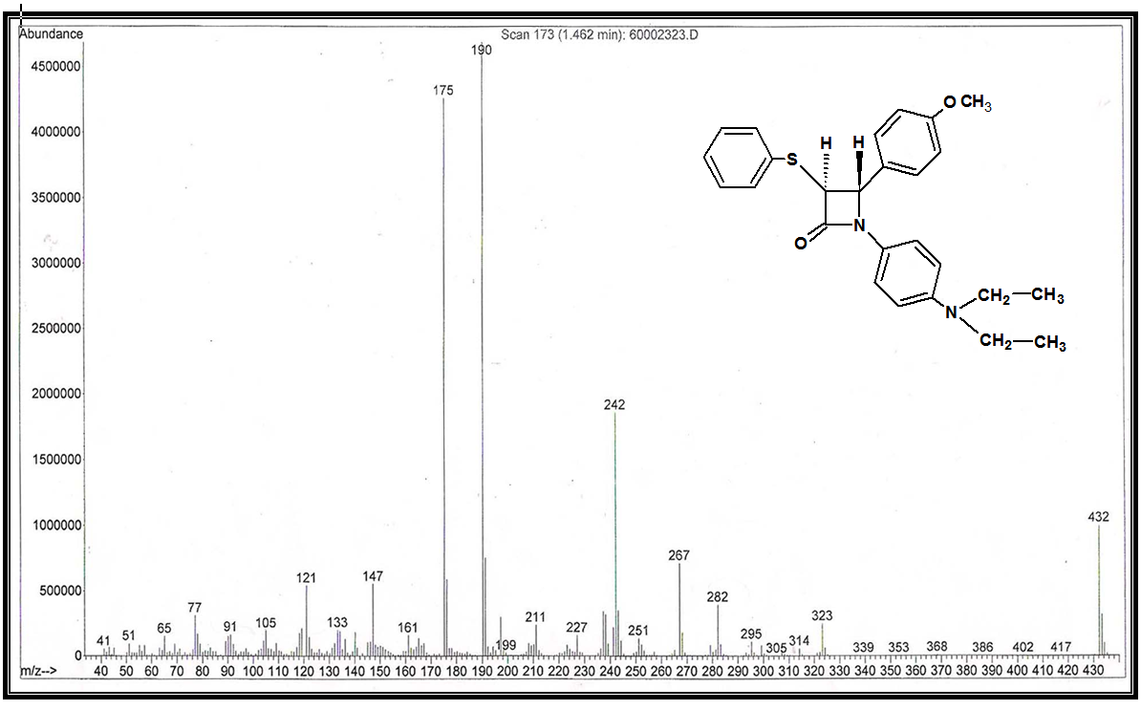

Figure(3-1) : `Mass spectra of 1-(4-N,N-diethylamino)phenyl-3-phenylthio-4-(4-methoxyphenyl) azetidine-2-one 3a .

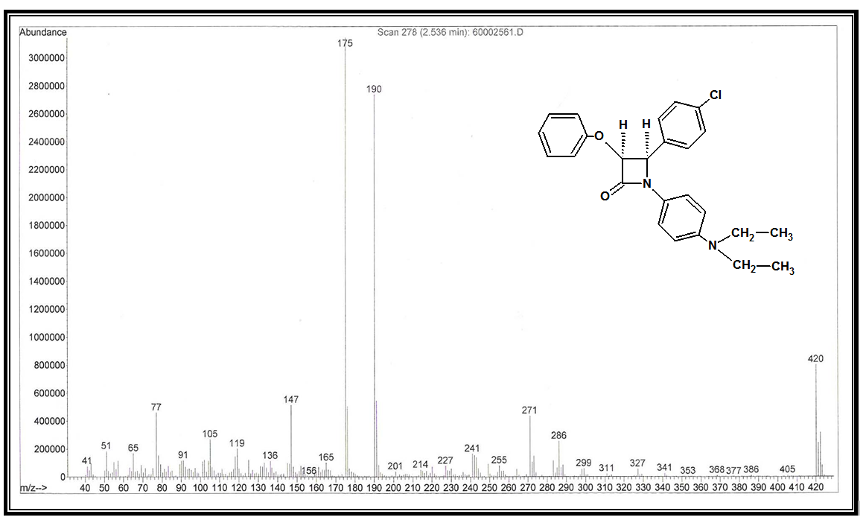
Figure(3-2): Mass spectra of 1-(4-N,N-diethylamino)phenyl-3-phenoxy-4-(4-chlorophenyl) azetidine-2-one 3b .

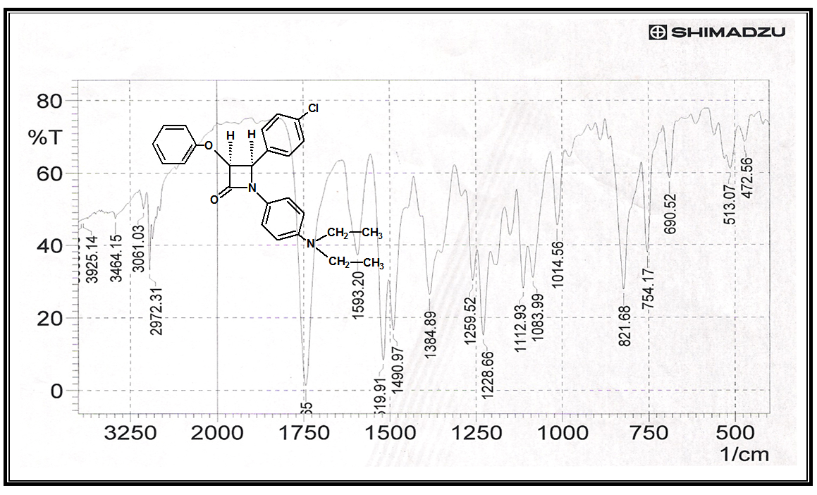
Figure (3-3): IR spectra of 1-(4-N,N-diethylamino)phenyl-3-phenoxy-4-(4-chlorophenyl) azetidine-2-one 3b .
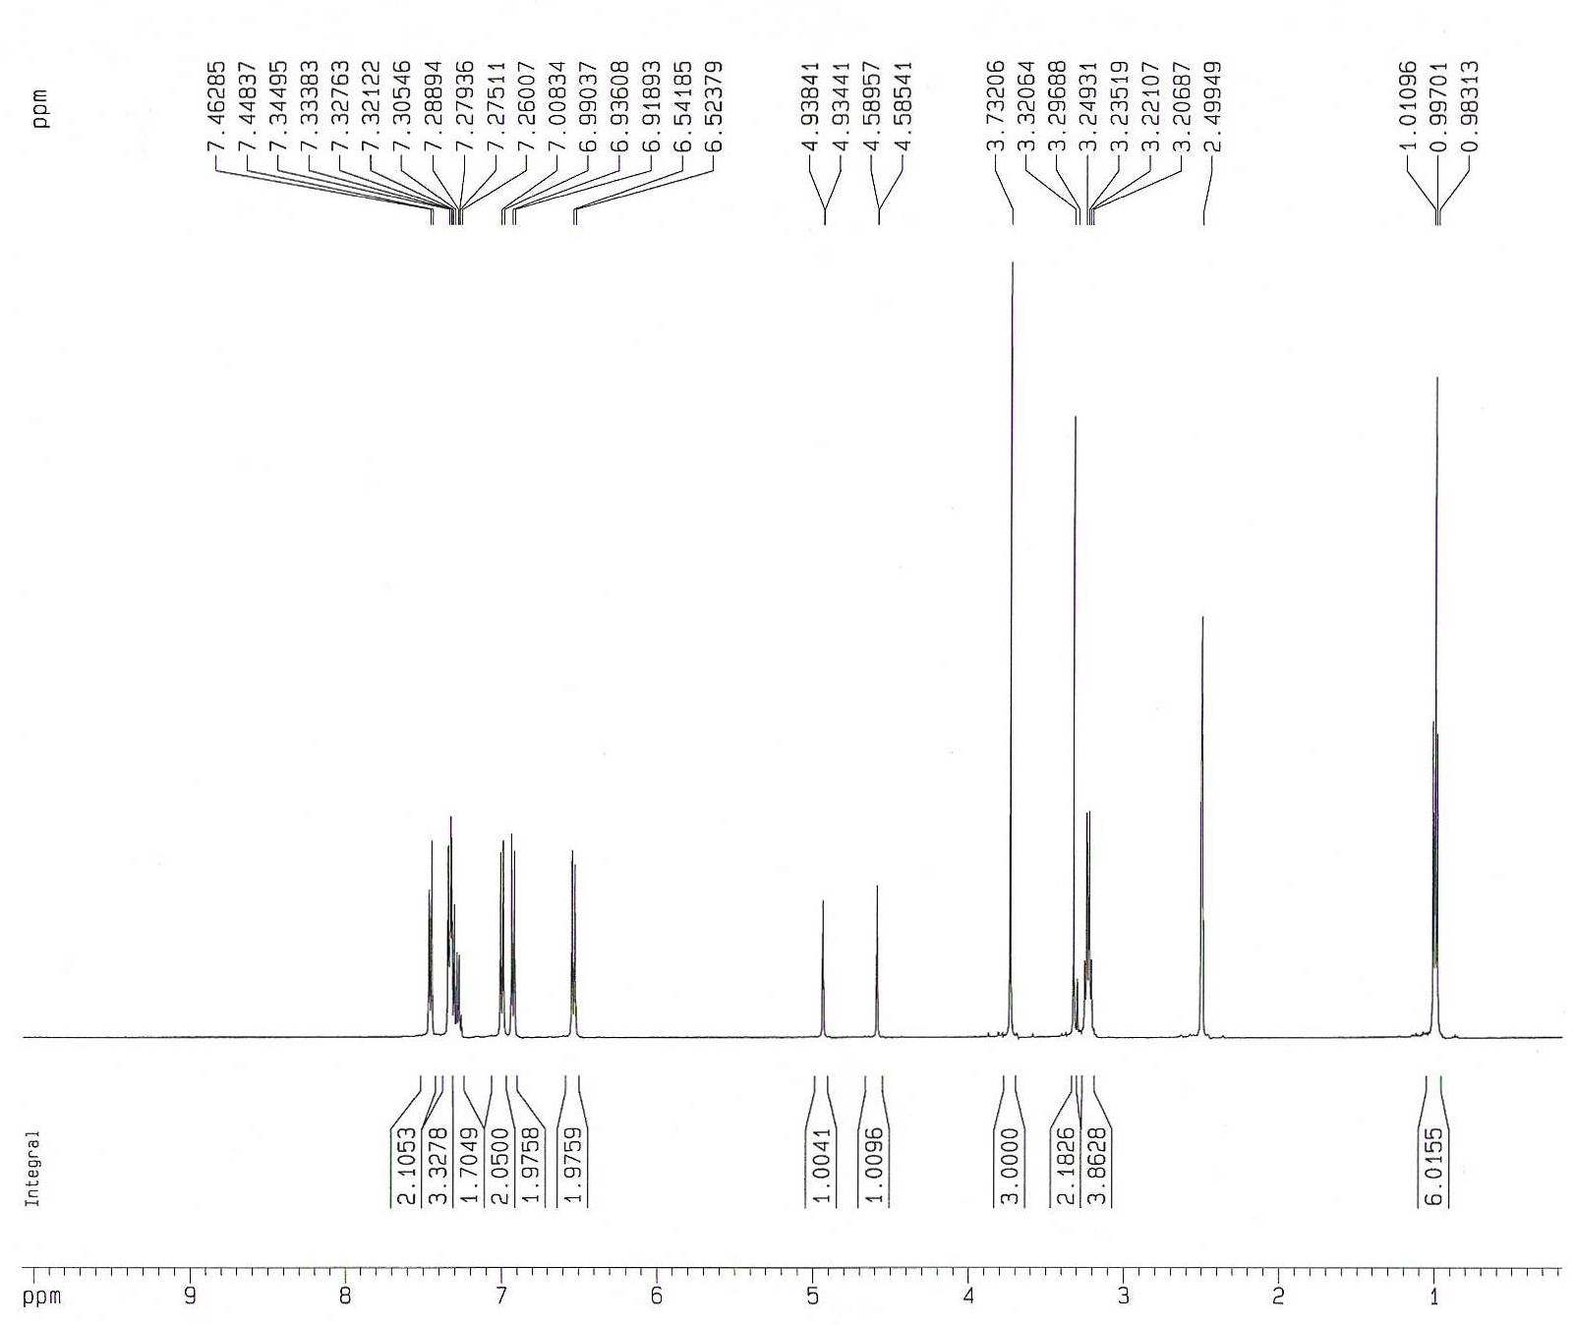

Figure(3-4) : ^{`1}H NMR spectra of 1-(4-N,N-diethylamino)phenyl-3- phenylthio-4-(4-methoxyphenyl)azetidine-2-one 3a .

Figure(3-5) : ^{`13}C NMR spectra of 1-(4-N,N-diethylamino)phenyl-3- phenylthio-4-(4-methoxyphenyl)azetidine-2-one 3a .
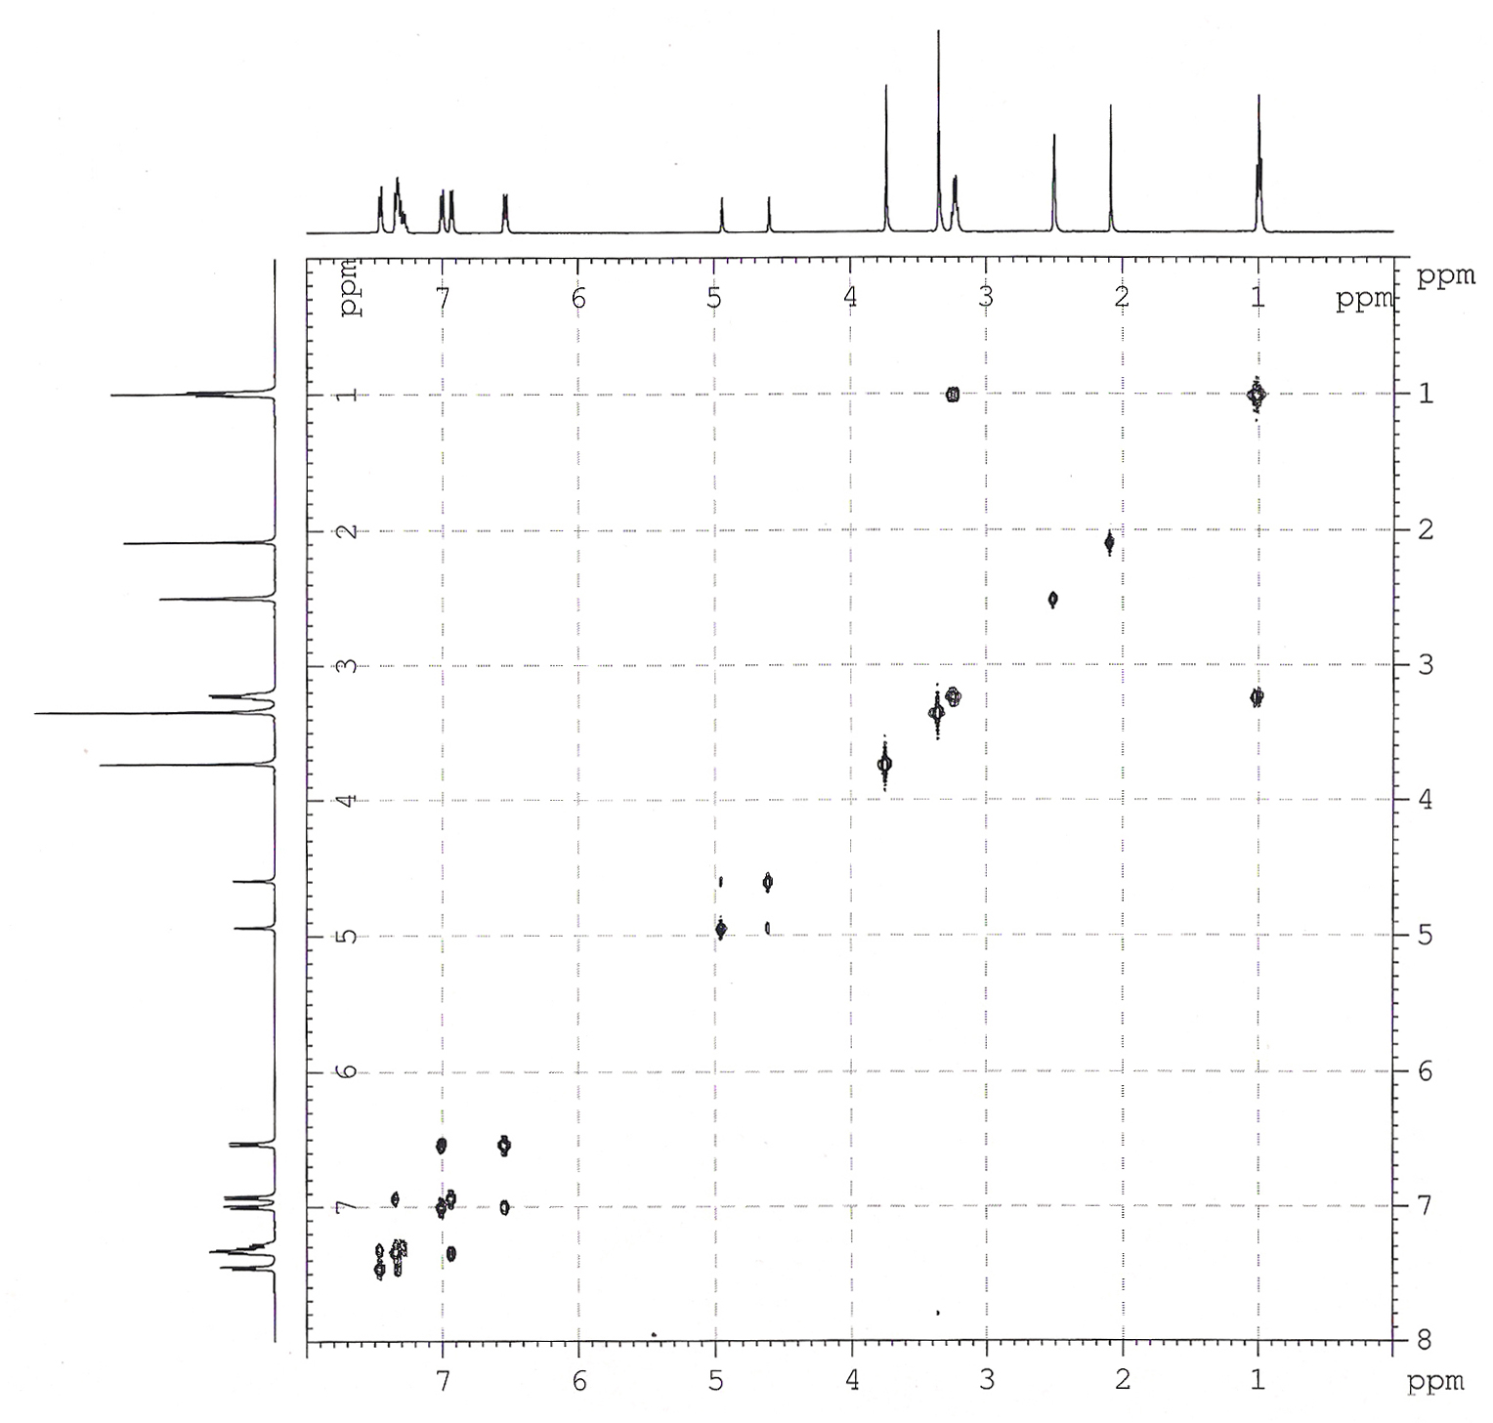
Figure (3-6): COSY ¹H-¹H spectra of 1-(4-N,N-diethylamino) phenyl-3-phenylthio-4-(4-methoxyphenyl)azetidine-2-one 3a .

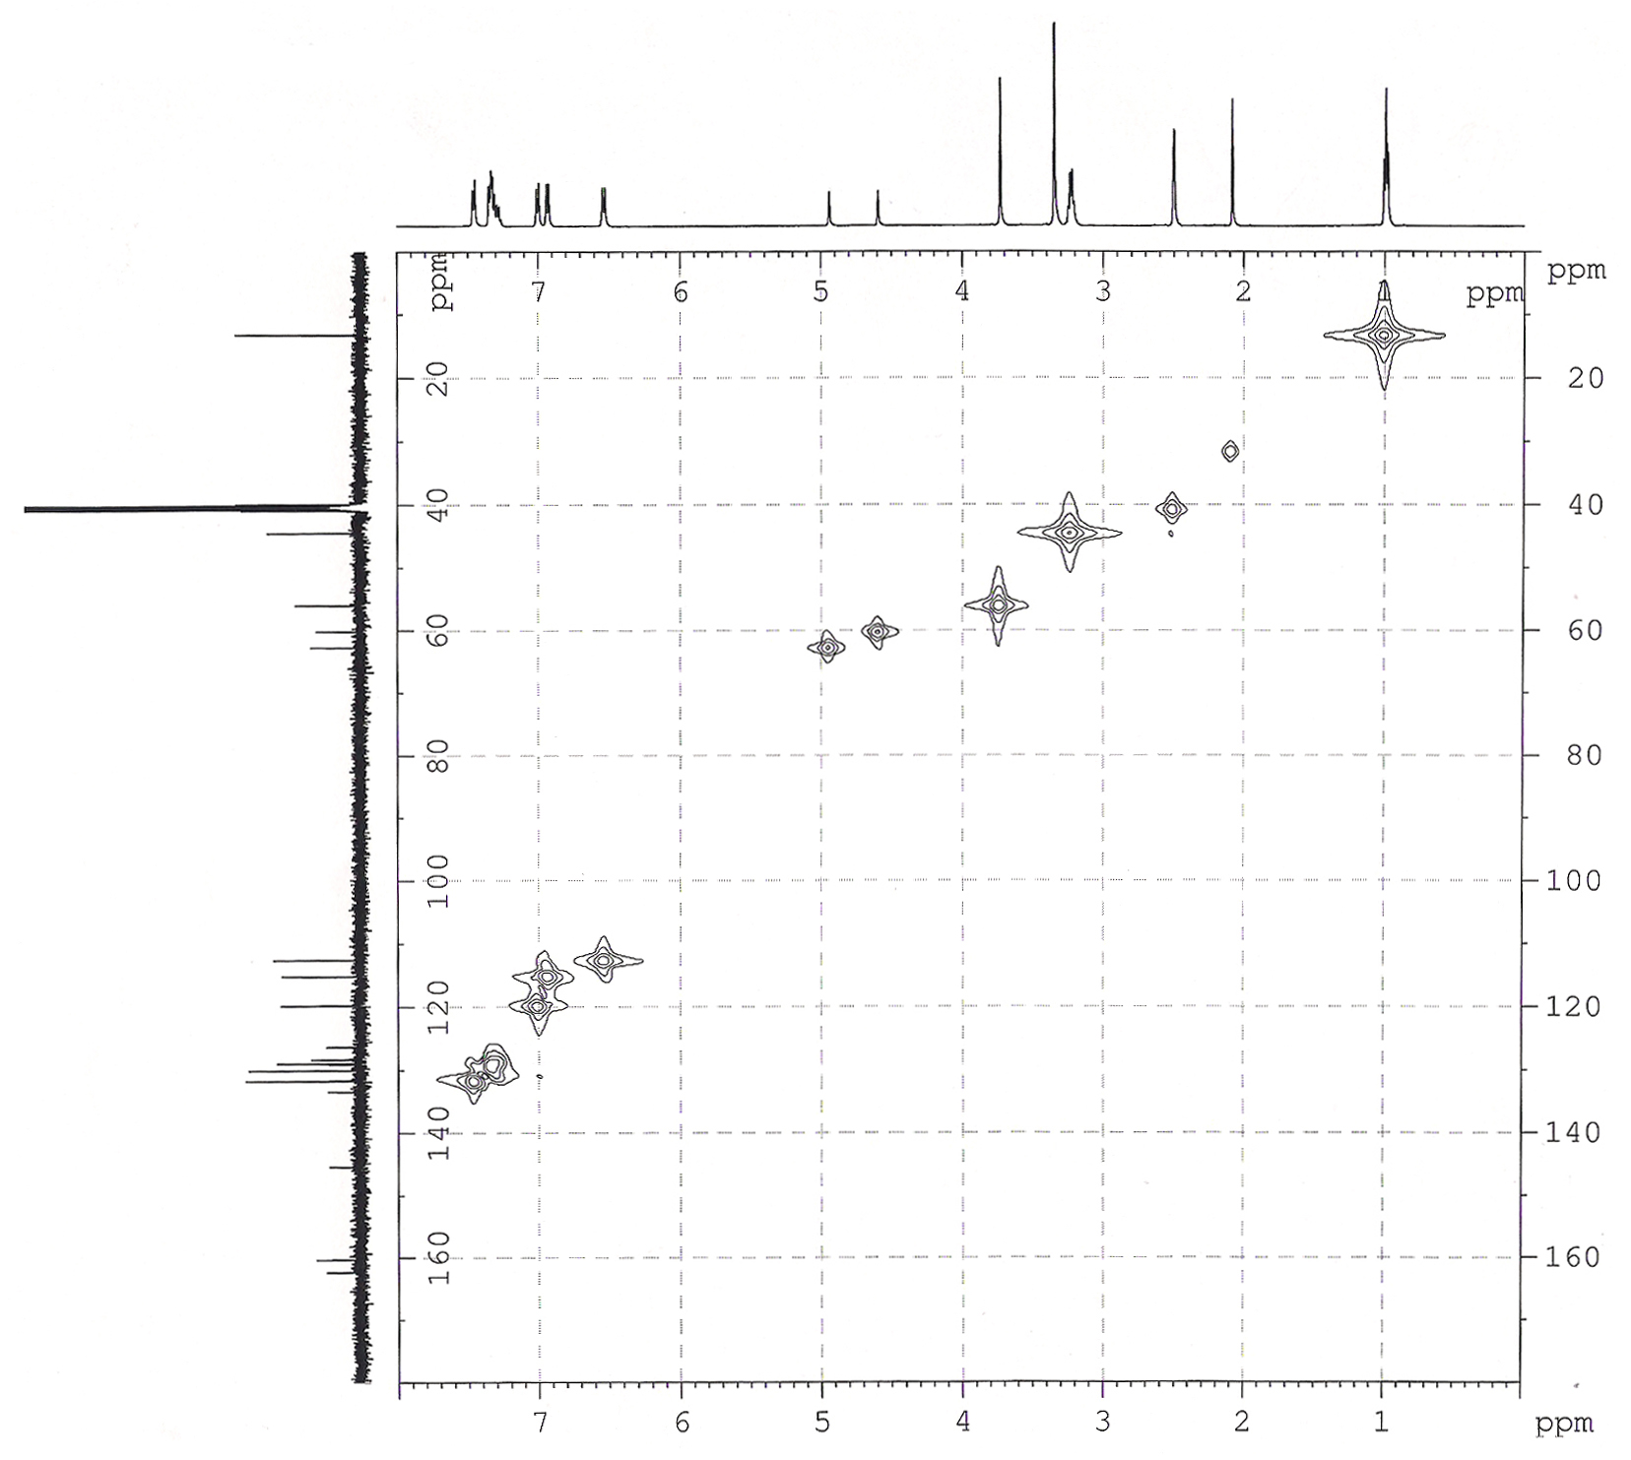
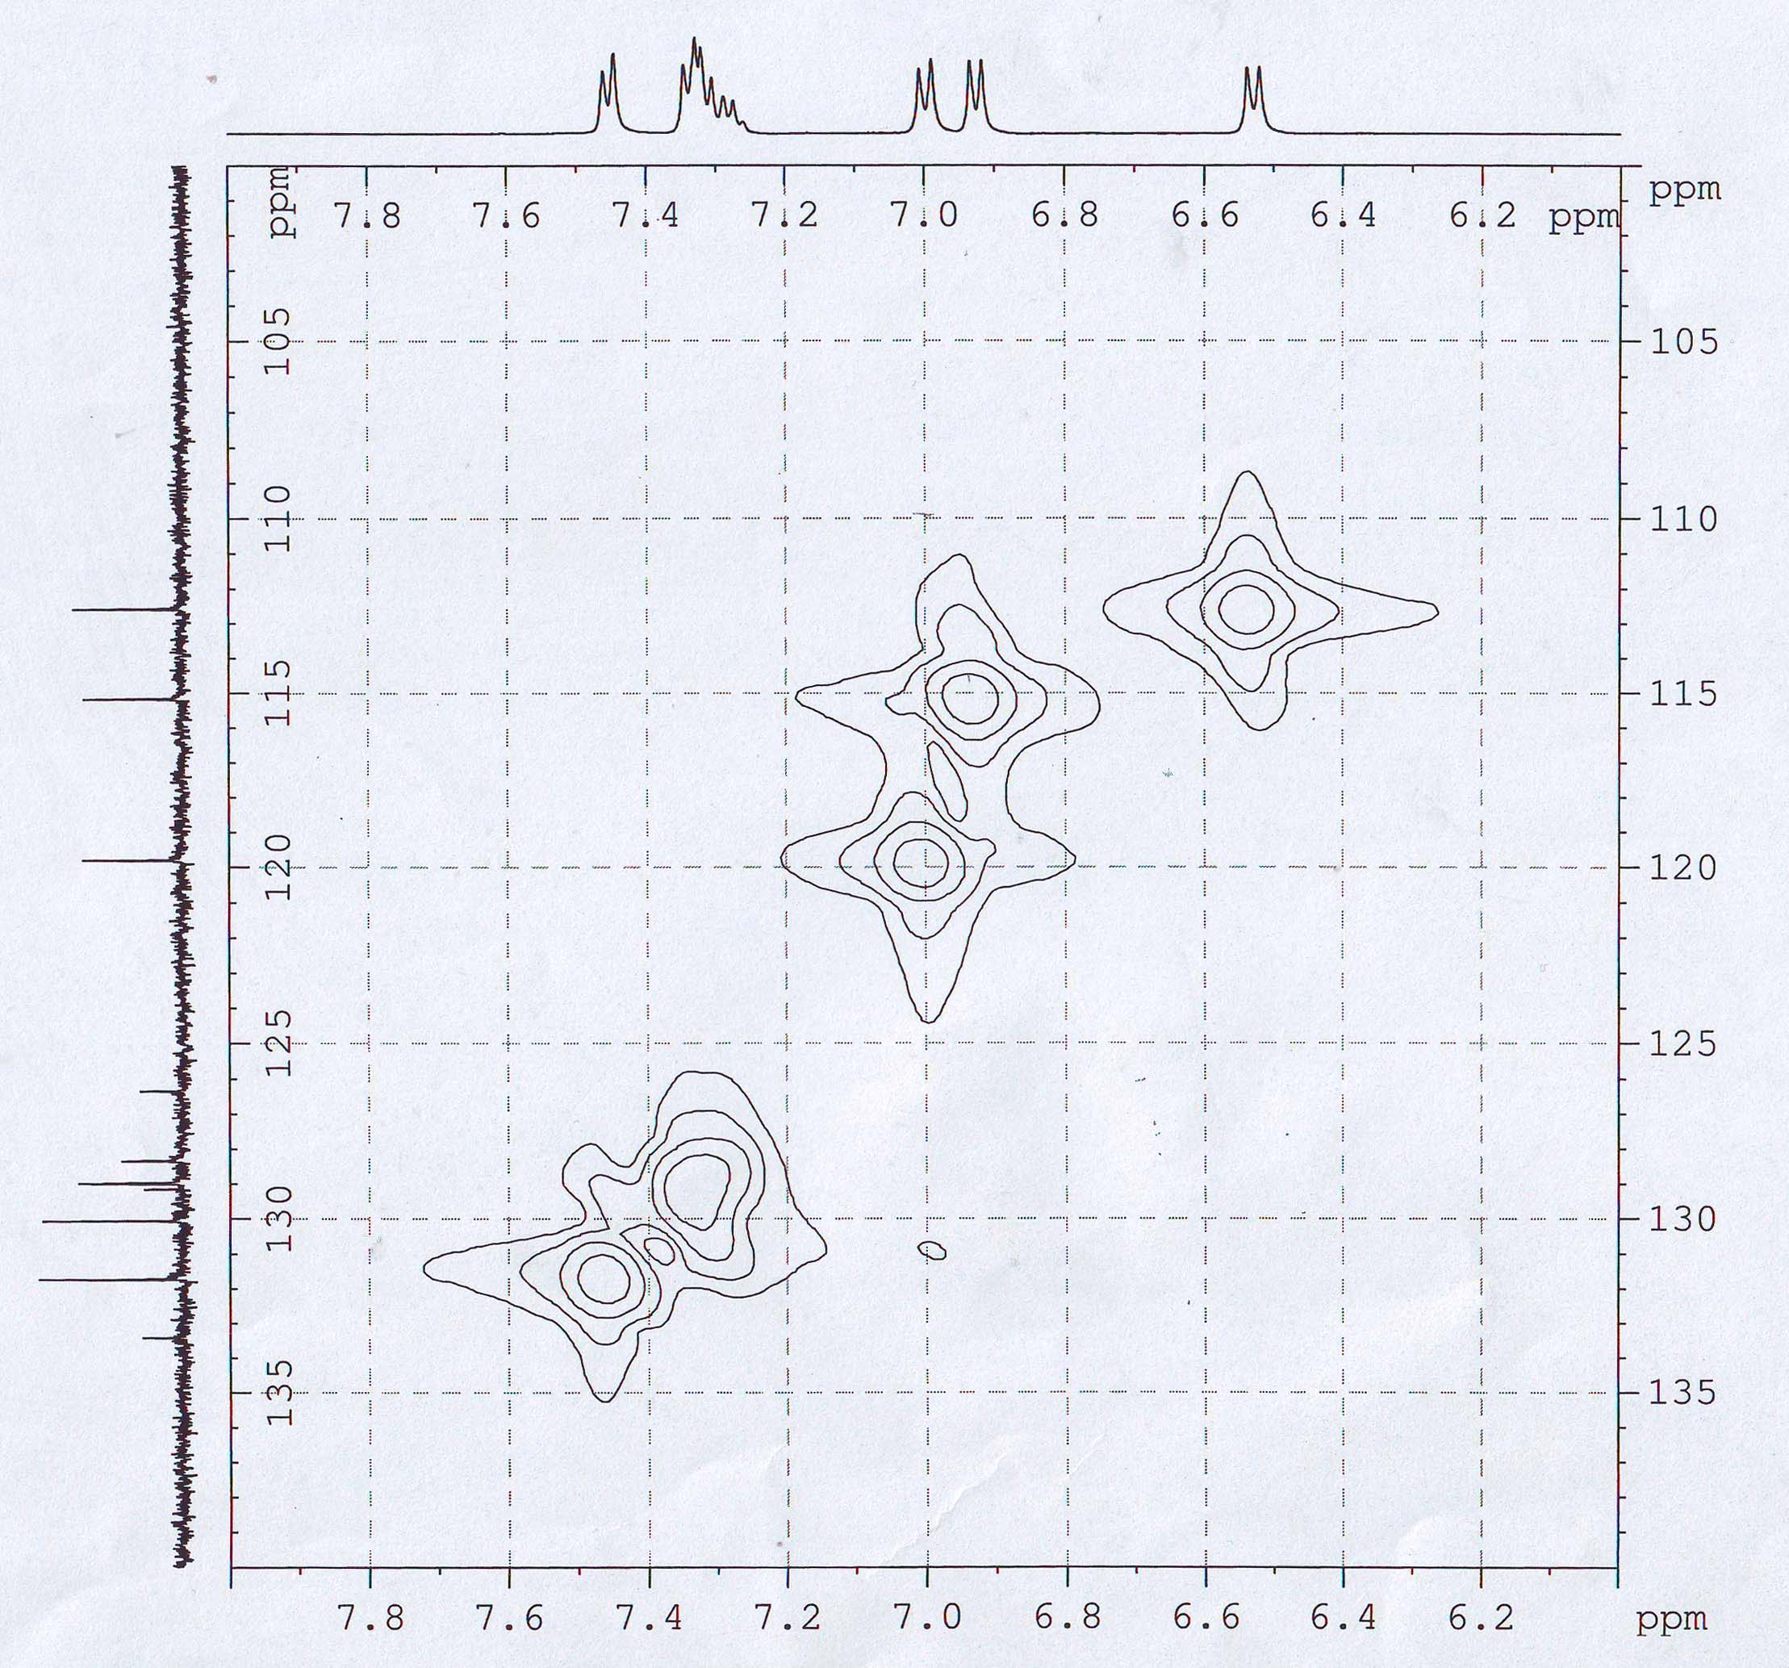

Figure (3-7): COSY ¹H-¹³C spectra of 1-(4-N,N-diethylamino) phenyl-3-phenylthio-4-(4-methoxyphenyl)azetidine-2-one 3a .

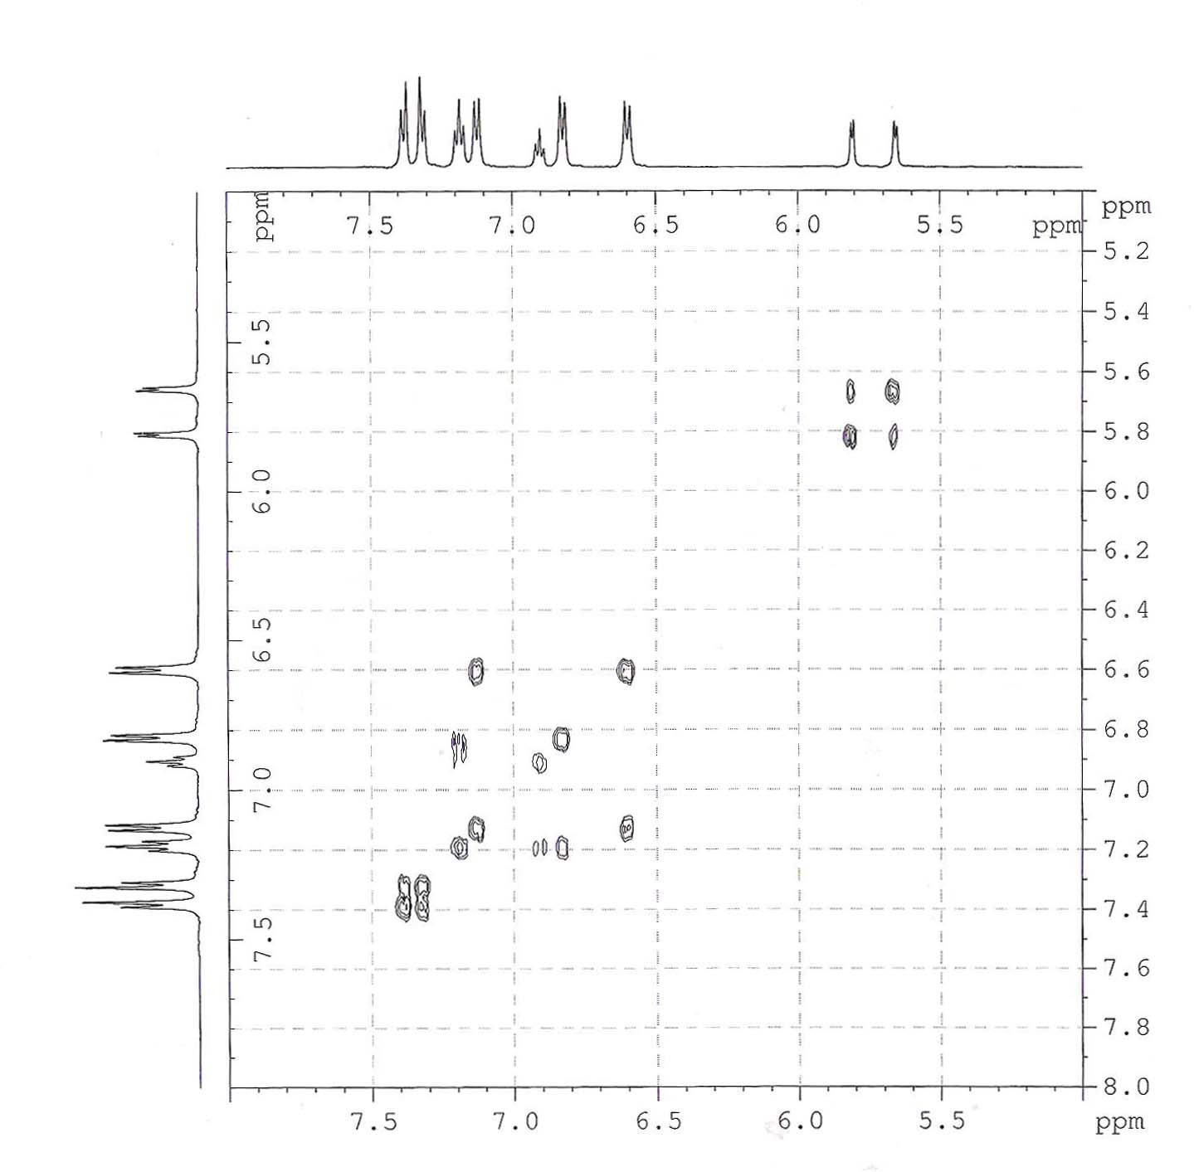

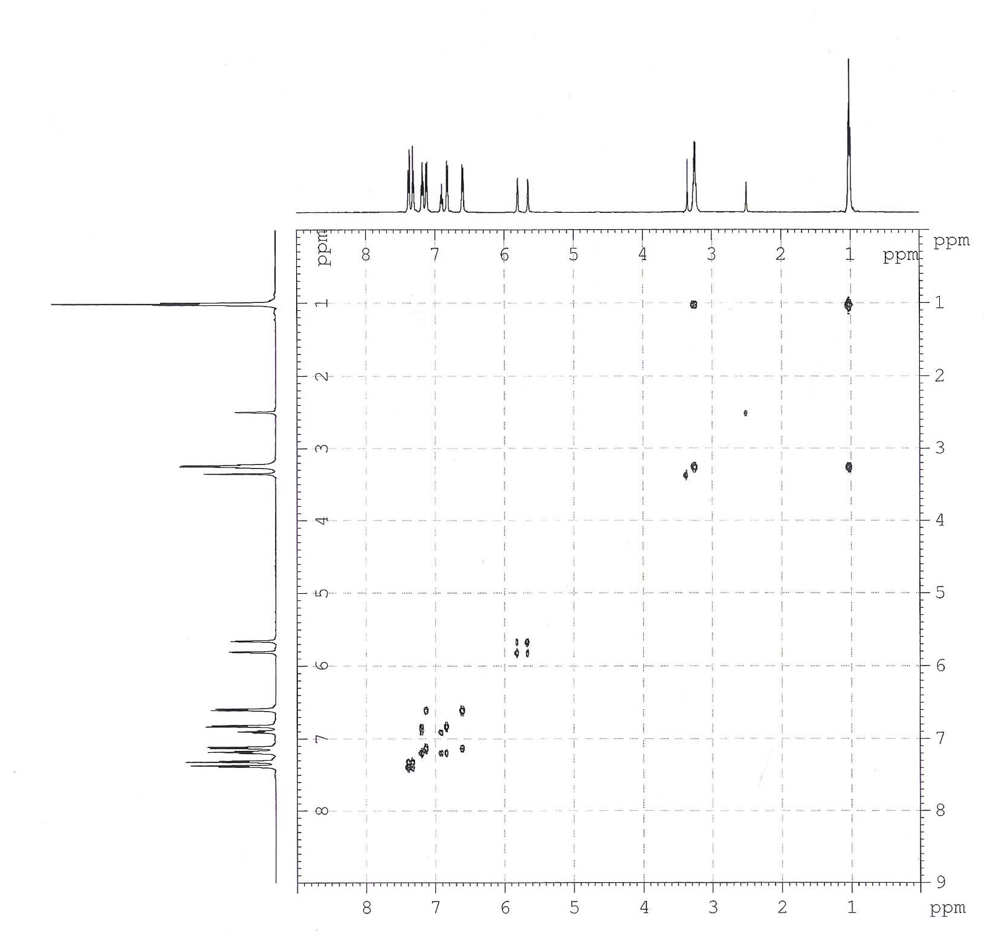

Figure (3-8): COSY ¹H-¹H spectra of 1-(4-N,N-diethylamino) phenyl-3-phenoxy-4-(4-chlorophenyl)azetidine-2-one 3b .

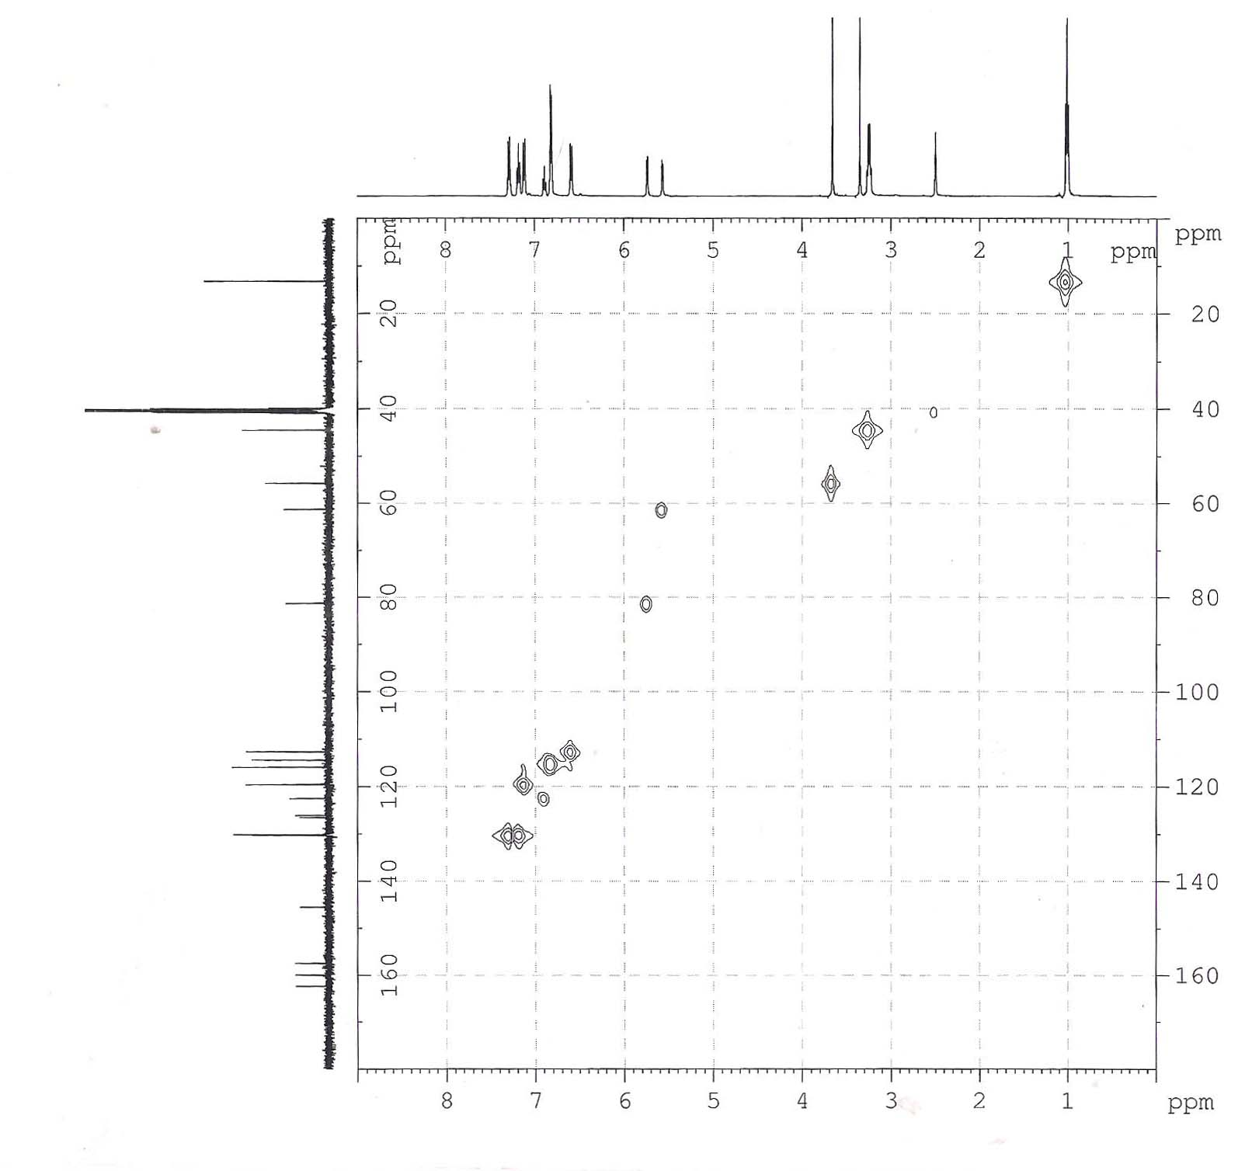

Figure (3-9): COSY ¹H-¹³C spectra of 1-(4-N,N-diethylamino) phenyl-3-phenoxy-4-(4-methoxyphenyl)azetidine-2-one 3c .
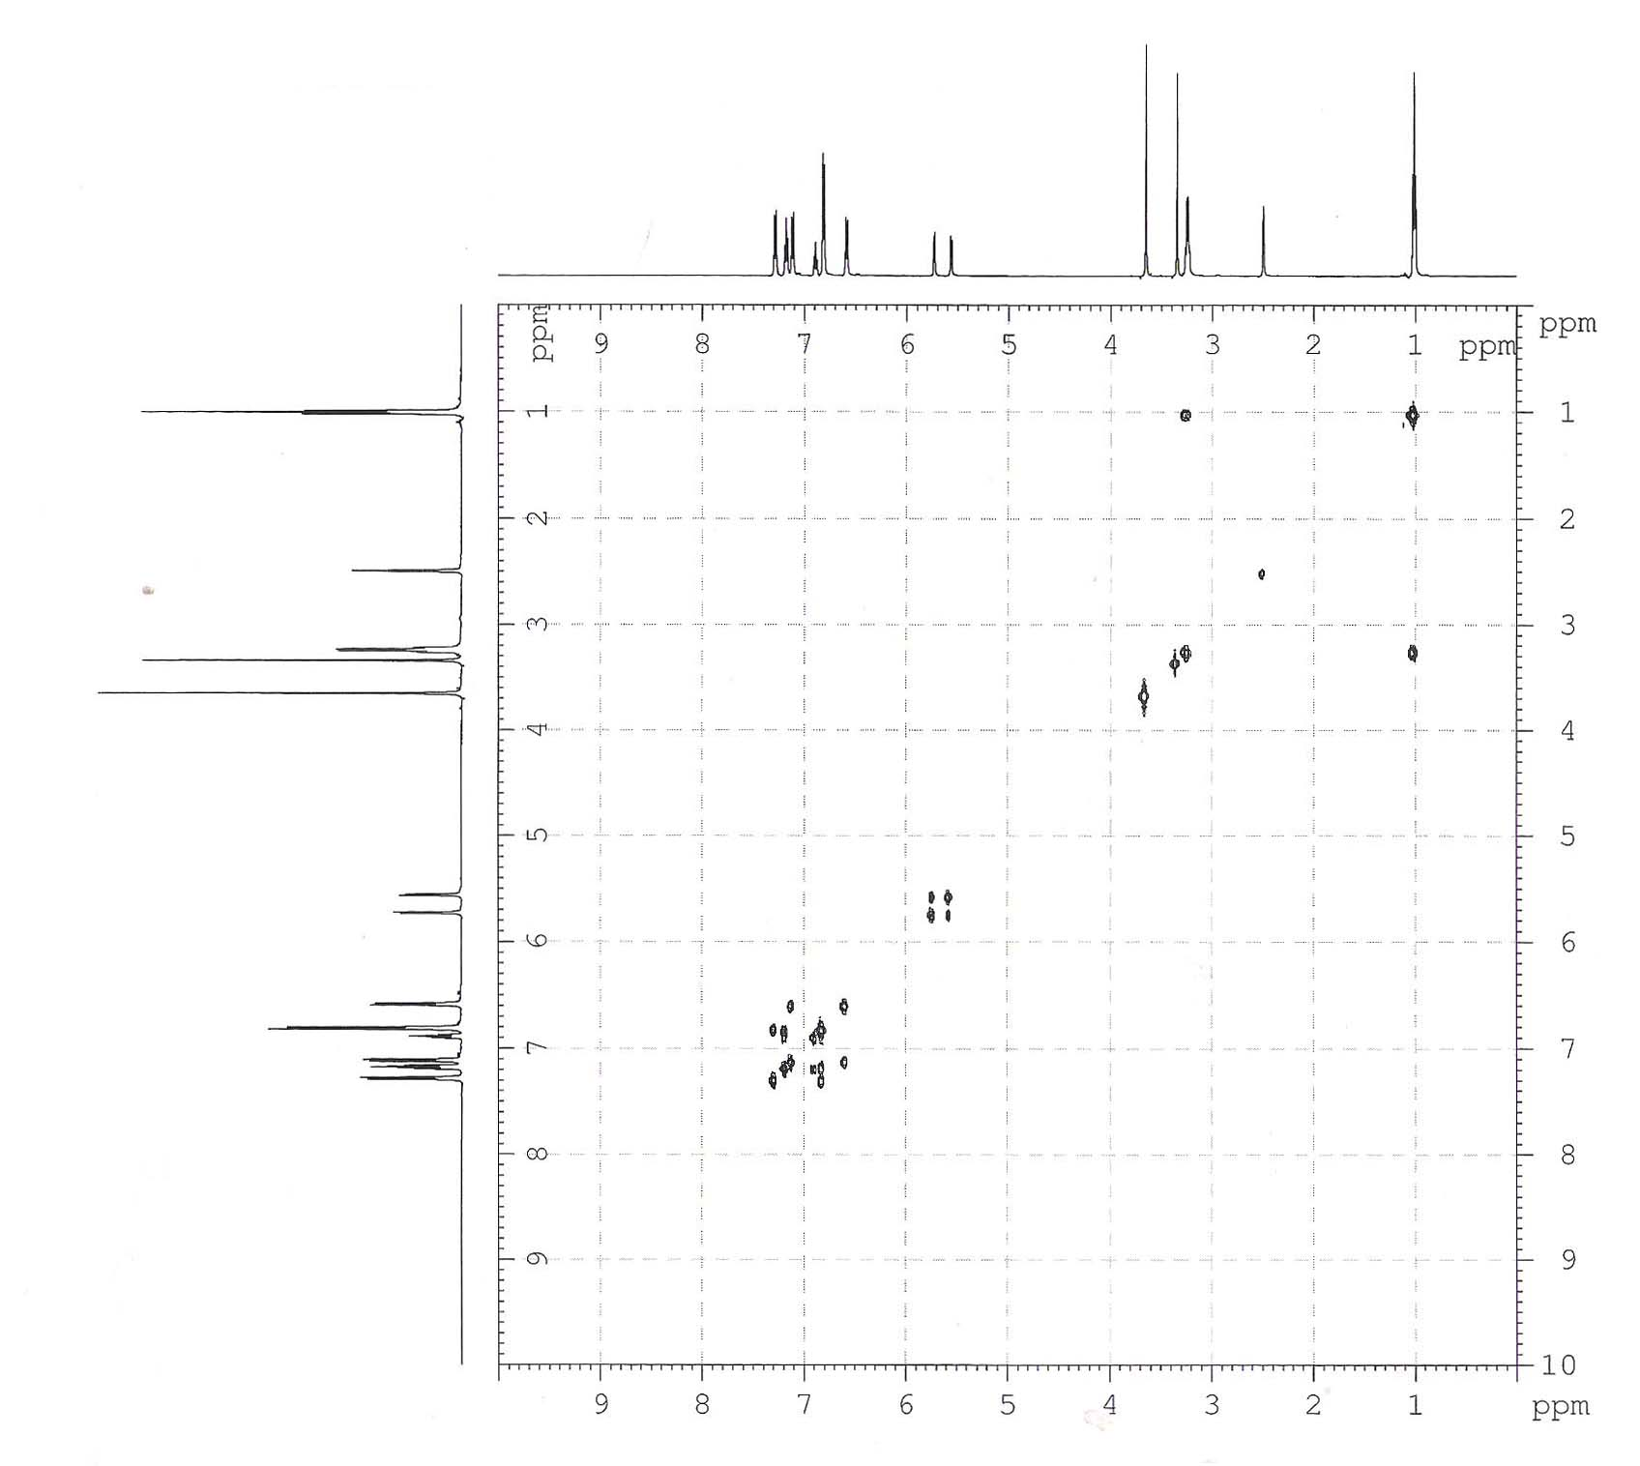
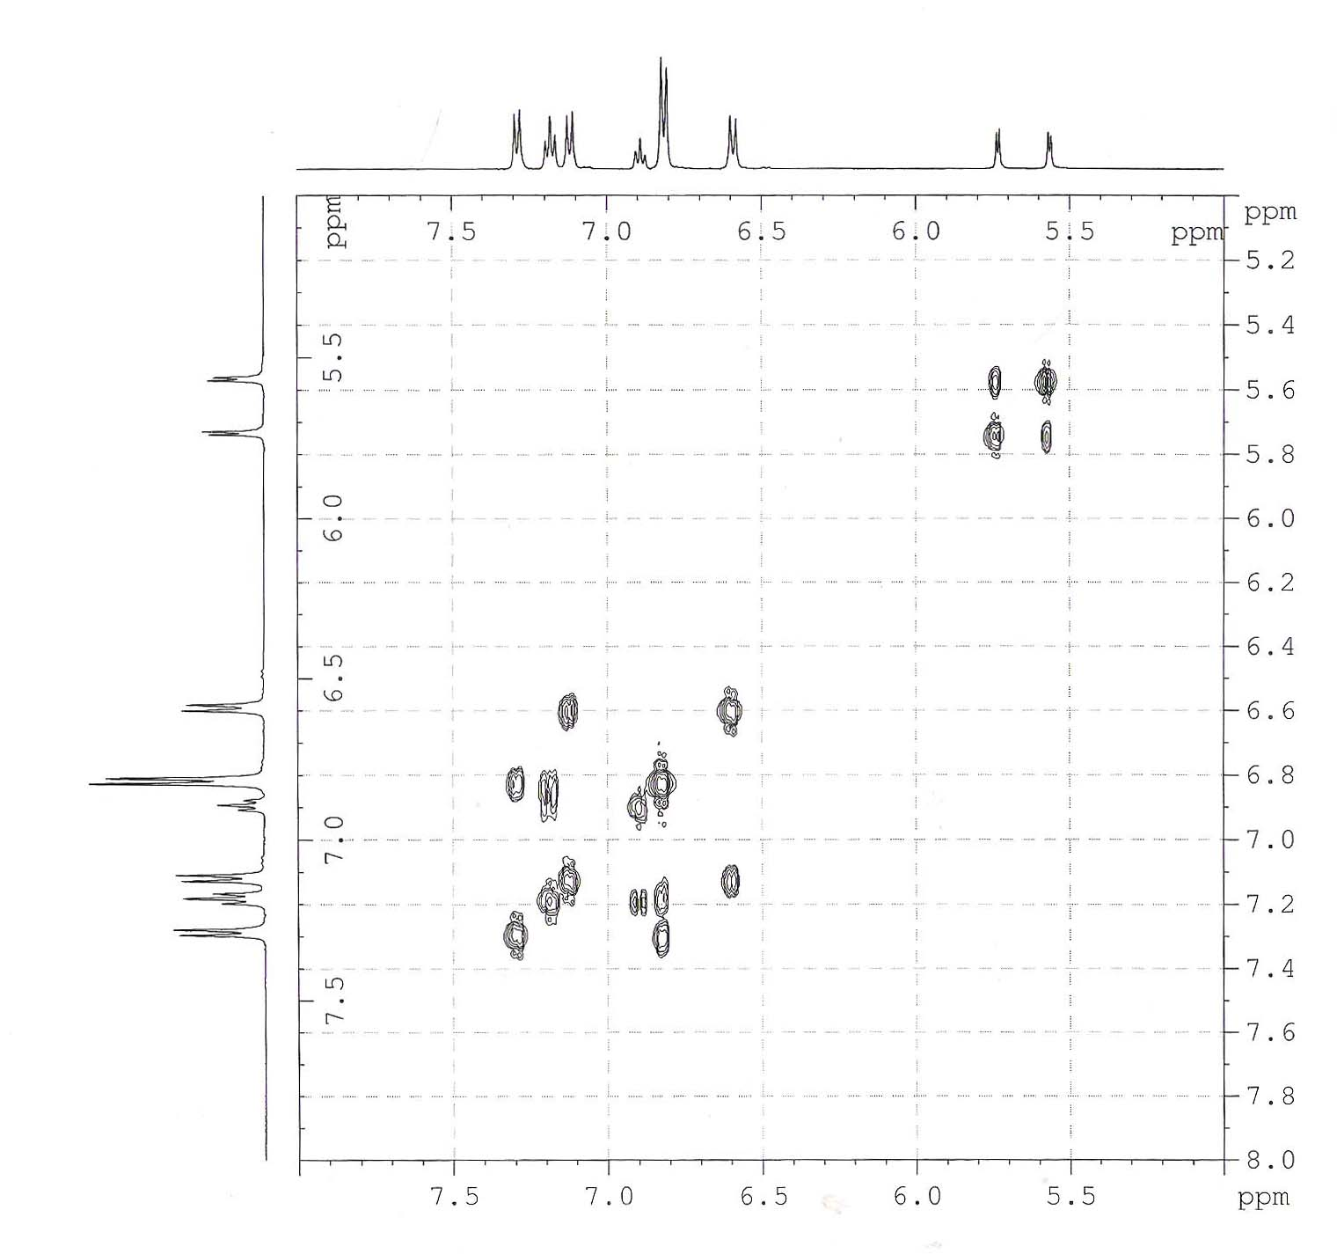

Figure (3-10): COSY ¹H-¹H spectra of 1-(4-N,N-diethylamino) phenyl-3-phenoxy-4-(4-methoxyphenyl)azetidine-2-one 3c .

The Expermental
All solvents were distilled / dried prior to use, when this seemed necessary by standard methods. All solvent extracts were dried over anhydrous sodium sulphate unless other wise specified. All the melting points are uncorrected and are expressed in degree(°C), using melting point \SMP31.
¹³C NMR; ¹H-¹³C Heteronuclear 2D Correlation Spectroscopy (Cosy), HETCOR; ¹H-¹H Homonuclear 2D Correlation Spectroscopy (Cosy) were recorded using Bruker DRX system AL 500 (500 MHz). in the Department of Chemistry ,Sharif University, Tahran, Iran. Mass spectrum were recorded at 70 ev using agalint technologes Spectrum 5973 in the Department of Chemistry,Tahran Uinversity, Tahran,Iran. Preparation of Schiff base 2(a-d) ^{24,25}
General Procedure
A mixture of an appropriate aromatic amine (0.01 mole) and an aromatic aldehyde (0.01 mole) in 10 ml of absolute ethanol and one drop of glacial acetic acid was heated in water bath at (70-80˚C) for 30 min .The progress of the reaction was checked by TLC. After completion the solvent was evaporated then recryastalized from a suitable solvent
3. Preparation of 3-phenylthio/3-phenoxyazetidine-2-one 3(a-e) ^{26,27}
3.1 Trans 1-(4-N,N-Diethylamino) phenyl-3-phenylthio-4-(4-methoxy phenyl) azetidine-2-one 3a . To a mixture of phenylthioacetic acid (0.89g , 1.5mmole), imine 2a (1g , 1. mmole) and triethylamine (1.074 g , 3mmole) in dry dichloromethane 40 mLat 0˚C under N₂ atm. , asolution of POCl₃ (0.813g , 1.5mmole ) in dry dichloromethane 20 mL was added as dropwise . The mixture was stirred overnight at room temperature. Thereafter ,the contents were washed successively with 1N HCL30mL,water (3×30mL) ,5% NaHCO₃ 30mL and brine 30mL.The organic layer was separated and dried over anhydrous sodium sulphate (Na₂SO₄).The solvent was removed under reduced pressure and the crude product was column chromatographed over silica gel using ethyl acetate – hexane 3:7 as eluent , solvent evaporation furnished pure β-lactam- 3a, 70%Yield,m.p°C 120-122 IR (CCl₄) : 1741 cm⁻¹ ;MS,M⁺ 432 :+44% ^{;1}H NMR(CDCl3): 0.9(t,6H,-CH₂CH₃) 3.73 (s,3H,-OCH₃),3.20(q,4H,- CH₂CH₃) 4.94 (d,1H, J = 2.4 Hz C₃-H),4.59(d,1H, J = 2.2Hz C₄-H), 6.52-7.46(m,13H,aromatic) ¹³C NMR(CDCl₃/DMSO)162.35,160.36,145.44,133.42, 131.73, 130.07, 129.16, 128.99128.34, 126.35,119.81,115.18, 112.59, 62.71,60.19,55.99, 44.47,31.20
Anal. Calcd. for C₂₆H₂₈N₂O₂S : C, 72.22; H, 6.48; N, 6.48;
Found: C, 72.18; H, 6.45; N, 6.41

3.2 Cis 1-(4-N,N-Diethylamino)phenyl-3-phenoxy-4-(4-chlorophenyl) azetidine-2-one 3b .
To a mixture of phenoxyacetic acid ( 0.795g , 1.5mmole) ,Imine 2b ( 1g , 1mmole ) and triethylamine (1.056 g , 3 mmole) in dry dichloromethane (40 mL) at 0˚C under N₂ atm. , asolution of POCl₃ ( 0.801g , 1.5 mmole ) in dry dichloromethane (20 mL) was added as dropwise . The reaction mixture after completion of reaction was worked up as usual . The crude product was column chromatographed over silica gel using ethyl acetate – hexane 3:7 as eluent ,solvent evaporation furnished pure -β- lactam 3b64.75%Yield, m.p°C 140-142, IR (CHCl₃) : 1743 cm⁻¹ ;MS,M⁺ 420 :+48%; ^{; 1}H NMR(CDCl3): 1.01 (t,6H,-CH₂CH₃) 3.20(q,4H,-CH₂CH₃), ,5.61(d,1H, J = 4.8 Hz,,C₄-H), ,5.72( d,1H, J = 4.8 Hz, C₃-H), 6.60-7.51 (m,13H,aromatic),¹³C NMR (CDCl₃/DMSO162.02, 158.33, 145.65, 133.03131.77, 131.03,129.05,127.03123.43,120.01,115.04,112.82,81.02, 61.02, 42.10, 12.20.
Anal. Calcd. for C₂₅H₂₅O₂N₂Cl : C, 71.34; H, 5.94; N, 6.65;
Found : C, 71.23; H, 5.87; N, 6.61.
3.3 Cis 1-(4-N,N-Diethylamino)phenyl-3-phenoxy-4-(4-methoxy phenyl) azetidine-2-one 3c .
To a mixture of phenoxyacetic acid (0.808 g , 1.5mmole), Imine 2a (1g , 1mmole), and triethylamine (1.074 g ,3mmole) in dry dichloromethane 40 mLat 0˚C under N₂ atm. , asolution of POCl₃ (0.813g , 1.5mmole ) in dry dichloromethane (0 mLwas added as dropwise .The reaction of the mixture after completion of reaction was worked up as usual . The crude product was column chromatographed over silica gel using ethyl acetate – hexane 3:7 as eluent, solvent evaporation furnished pure -β- lactam 3c . 68%Yield, m.p °C 119-120: IR (CCl₄) : 1741 cm⁻¹ ; ¹H NMR(CDCl3): 0.99(t,6H,-CH₂CH₃) ,3.72(s,3H,-OCH3),3.30(q,4H,-CH₂CH₃) ),5.72 (d, J = 2.7 Hz ,1H,C₃-H),5.61(d,1H, J = 2.7 Hz, C₄-H), 6.60-7.40(m,13H,aromatic),¹³CNMR(CDCl₃/DMSO). 162.06,160.09,158.55,145.08131.44,128.82,128.04,122.05, 120.01, 116.04, 115.02, 113.4581.20, 61.10, 55.60, 43.80, 12.03
:C,72.22; H, 6.48; N, 6.48;
Anal.Calcd. for C₂₆H₂₈N₂O₂S :C,72.18; H, 6.45; N, 6.41. Found
3.4 Cis 1-(4-Methylphenyl)-3-phenoxy-4-(4-N,N-dimethylamino) phenylazetidine -2-one 3d To a mixture of phenoxyacetic acid ( 0.95 g , 1..5mmole) , imine 2c (1g , 1mmole ) and triethylamine (1.27g , 3mmole ) in dry dichloromethane 40 mLat 0˚C under N₂ atm. , asolution of POCl₃ (0.96 g , 1,5mmole) in dry dichloromethane 40 mL was added as dropwise. The reaction of the mixture after completion of reaction was worked up as usual . The crude product was column chromatographed over silica gel using ethyl acetate – hexane 3:7 as eluent, solvent evaporation furnished pure -β- lactam 3d 50. %Yield, m.p°C ; 116-118, IR (CCl₄) :1753cm⁻¹;¹H(CDCl3). 3.35(s,3H,CH₃),2.25(d,6H,CH3) 6.95-7.54(m,13H,aromatic), ¹³CNMR(CDCl₃/DMSO).167.18,158.70,136.74,133.51, 130.37,129.95,122.03,120.61 115.55,68.02,21.31
:C,78.64; H, 6.79; N, 6.79; Anal. Calcd. for C₂₇H₂₈N₂O₂
:C, 72.58; H, 6.74 N, 6.71.Found
3.5 Trans 1-(4-N,N-Diethylamino)phenyl-3-phenylthio-4-(4-chloro phenyl) azetidine-2-one 3e This was prepared from phenylthioacetic acid (0.87 g, 1.5 mmol), imine 2c (1.0 g, 1 mmol), triethylamine (1.46 mL, 3 mmol) and POCl₃ (0.48 mL, 1.5 mmol). Following the procedure reported for β-lactam3a. The residue obtained after usual workup and chromatographic purification furnished the desired β -lactam3e(1.24 g, 65%) as a crystalline solid and its structure was confirmed on the basis of following data :
m.p. : 124-126°C; IR (CCl₄) : 1753 cm⁻¹ ; ¹H-NMR (CDCl₃)δ: 1.1 (t, 6H, 2xCH₃), 3.3 (q, 4H, 2xCH₂), 4.1 (d, 1H, J = 2.19 Hz, C₄-H), 4.7 (d, 1H, J = 2.11 Hz, C₃-H), 6.7-7.6 (m, 13H, aromatic protons) ;
¹³C-NMR (CDCl₃) δ : 12.4, 44.4, 61.3, 63.4, 112.2, 119.2, 126.1, 126.3,

127.1, 128.1, 129.1, 132.9, 132.4, 135.6, 144.1, 162.6;
Anal. Calcd. for C₂₅H₂₅N₂OSCl : C, 68.72; H, 5.72; N, 6.41;
Found: C, 68.59; H, 5.69; N, 6.35.
References
1.W. Durckheimer, J. Blumbatch, R. Lattrell, K. H. Scheunemann, Angew.Chem., Int. Ed. Engl., 1985, 24,180-202.
2 S. Coulton, E. Hunt, Recent Progress in the Chemical Synthesis of Antibiotics and Related Microbial Products; Lukacs, G., Ed.; Springer: Berlin, 1993, 2, 621-675.
3 F. Broccolo, G. Carnally, G. Caltabiano, C. E. A. Cocuzza, C. Fortuna, G. Galletti, P.D. Giacomini, G. Musumarra, R. Musumeci, A. Quitavalla, J. Med.
Chem., 2006, 49, 2804-2811.
4 B. Alcaide and P. Almendros, Curr. Med. Chem., 2004, 11, 1921-1949.
5 A.R.A.S. Deshmukh, B.M. Bhawal D. Krishnaswamy, V.V. Govande, B. A.Shinkre, A. Jayanthi, Curr. Med. Chem. , 2004, 11, 1889-1920.
6 G. S. Singh, Tetrahedron, 2003, 59, 7631-7649.
7 J. D. Rothstein, S. Patel, M.R. Regan, C. Haenggelli, Y.H. Huang, D.E. Bergles,L. Jin, M.D. Hoberg, S.Vidensky, D.S. Chung, S.V. Toan, L.I. Bruijn,; Z.Z. Su, P. Gupta, P. B., Fisher, Nature, 2005, 433, 73-7.
8 D.A. Burnett, M.A. Caplen, H.R. Jr. Davis, R.E. Burrie, J.W. Clader, J. Med.Chem., 1994, 37, 1733-1736.
9 S. Dugar, N. Yumibe, J.W. Clader, M. Vizziano, K. Huie, M. Van Heek, D.S.Compton, H. R. Davis, Jr. Bioorg, Med. Chem. Lett., 1996, 6 ,1271-1274.
10 W.T. Han, A.K. Trehan, J.J.K. Wright, M.E. Federici, S.M. Seiler, N.A.Meanwell, Bioorg. Med. Chem., 1995, 3,1123-1143.
11 A.D. Borthwick, G. Weingarte, T.M. Haley, M. Tomaszewski, W. Wang, Z.Hu, J. Bedard, H. Jin, L.Yuen, T.S. Mansour, Bioorg. Med. Chem. Lett., 1998, 8, 365-370.
12 Enders D. and Gries G., Synthesis, 2005, 3508.
13 Pannecoucke X., Outerquin F., and Paulmier C., Eur. J. Org. Chem., 2002, 995.
14 Lacroix, S., Cheguillaume, A., Gerard,S.,and Marchand-Brynaert, J., Synthesis, 2003, 2483
15 Kiyota H., Takai T., Saitoh M., Nakayama O., Oritani T., and Kuwahara S., Tetrahedron Lett., 2004, 45, 8191
16 Madan, S.; Arora, R.; Venugopalan, P.; Bari, S. S. TetrahedronLett., 2000, 41, 5577.
17 Jarrahpour, A; Nazari, M;Jalbout,A,E;Molecules, 2007, MS39.
18 Singh , G . S ., Pheko , T ., Spectrochimica Acta , 2007, part A, 111.
19 Cremonesi , G., Croce , P. D., and Rosa , C. L., Tetrahedron, 2004, 60, 96.
20 Sander,J.K.M.,Hunter,B.K.,Modern NMR spectroscopy. AGuide for chemists,2 nd edn,Oxford university press,Oxford, 1993 .
21 Ernst, R. R., Bodenhausen, G., Wokaun, A.,Principles of NMR in one and two dimensions ,Oxford university press,Oxford 1990 .
22 Upadhyaya , A . K ., and Mehrotra .K . N ., J . Chem . Soc., Perkin , Trans . , 1988, 2 , 958 .
23 Singh , G. S. ; Pheko, T.; Spectrochem.Acta, 2007, part A, 6316.
24 Upadhyaya, A. K., and Mehrotra. K. N., J. Chem Soc., 1988, Perkin,Trans , 2, 958.
25 Hello, K. M.; Iraqi, J. of Chem. 2000, 24, 266.
26 MAGTOOF .M.S. J. indian org. chem., 2010, 32, 2390.
27. MAGTOOF .M. S. J. monatshefre fur cheme ,.2010, 141, 9, 987-991

