Synthesis and Characterization of New Seven-Membered Heterocyclic Compounds from Reaction of New Schiff-Bases with Maleic and Phthalic anhydrides

Haitham Dalol Hanoon
Dept. of Chemistry, College of Science, University of Kerbala

(NJC)

(Recevied on 25/10/2010) (Accepted for publication 20/2/2011)

Abstract
A series of new Schiff base and 1,3-Oxazepine compounds have been synthesized. 4-Aminophenazone was condensed with various aromatic aldehydes in ethanol in the presence of glacial acetic acid as catalyst to yield the Schiff base [2-4]. These Schiff bases were reacted with maleic anhydride and phthalic anhydride in dry benzene to give a seven-membered heterocyclic ring derivatives [5-7] and [8-10], respectively.
The prepared compounds were identified by their uncorrected melting points, elemental analysis and FT-IR spectra.

الخلاصة
تم تحضير عدد من قواعد شيف الجديدة ومركبات 1،3– أوكسازيبين. بتكاثف المركب 4-أمينوفينازون مع ألديهايدات مختلفة بوجود حامض الخليك الثلجي كعامل مساعد تم الحصول على قواعد شيف [2-4]. فوعلت قواعد شيف هذه مع أنهدريد الماليك وأنهدريد الفثاليك في البنزين الجاف فأعطت مشتقات سباعية الحلقة غير متجانسة [5-7] و[8-10] على التوالي.
شخصت جميع المركبات المحضرة باستخدام درجات انصهارها غير المصححة وتحليل العناصر الدقيق وأطياف الأشعة تحت الحمراء.

Introduction
Oxazepine ring is unsaturated seven-membered hetrocycle. 1,3-Oxazepine ring containing two hetero atoms are oxygen in position (1) and nitrogen in position (3) in addition of five carbon atoms. The classical methods for preparing oxazepine ring are limited ⁽¹⁾. Recently, cycloaddition reaction, which is a type from a pericyclic reactions is used to synthesis of 1,3-oxazepine ring ⁽²⁻⁷⁾. This type of reactions is not limited and gives various1,3-oxazepine derivatives. Synthesis of these compounds in this work is a class of a pericyclic reaction which is classified as a 5+2 7, implying five-atom component plus two-atom component leading to seven-membered cyclic ring ⁽⁸⁻¹¹⁾. Oxazepine derivatives showed biological activities against different types of bacteria, in addition of their uses as inhibitors of some enzymes action ^{(4,12)}.
The chemistry of the carbon-nitrogen double bond plays a vital role in the progresses of chemistry science ^{(13,14)}. Schiff-base compounds have been used as fine chemicals and medical substrates. Synthesis of schiff-base through classical condensation of aldehydes (or ketones) and amines were pursued ^{(17,18)}. Schiff-bases are associated with antibacterial, antifungal and antitubercular activities and have diverse biological activities ⁽¹⁹⁾.
In this work, we synthesized three new Schiff-base compounds and sex new 1,3-oxazepine compounds. The chemical structures of both Schiff-bases and 1,3-oxazepine compounds were studied.
Experimental
General
- All chemicals were supplied from commercial sources and used as received.
- TLC were performed on pre-coated sheets with 0.25 mm layer of Silica Gel GF254 of the Merck company, the detection was followed by coloring with iodine or H₂SO₄ in ethanol (60%) followed by heating .
- All measurements were carried out by:-
- Melting point: Gallen kamp capillary melting point apparatus.
- FT-IR spectra: Fourrier transform infrared Testscan Shimadzu model 8400s.
- Elemental analysis (C. H. N.): E.A.300, Euro-Vector, Italy, 2003.
Synthesis of compounds
Synthesis of 4-[4-(dimethylamino) benzylideneamino]-1,5-dimethyl-2-phenyl-1H-pyrazol-3(2H)-one [2]
4-(Dimethylamino)benzaldehyde (0.745g, 5mmol) containing three drops of glacial acetic acid was dissolved in absolute ethanol (15mL), then 4-Aminophenazone [1] (1.015g, 5mmol) was dissolved in absolute ethanol (15mL) and then added dropwise. The reaction mixture was refluxed with stirring on a water bath at 75ºC for 1.5h. Then the mixture was allowed to cool down at room temperature and the solvent was evaporated. The colored precipitate was filtered and washed well with cold ethanol; yield and melting point were shown in Table (I).
Synthesis of 4)-4-isopropylbenzylideneamino)-1,5-dimethyl-2-phenyl-1H-pyrazol-3(2H)-one [3]
4-Isopropylbenzaldehyde (0.740g, 5mmol) containing three drops of glacial acetic acid was dissolved in absolute ethanol (15mL), then 4-Aminophenazone [1] (1.015g, 5mmol) was dissolved in absolute ethanol (15mL) and then added dropwise. The reaction mixture was refluxed with stirring on a water bath at 75ºC for 4h. Then the mixture was allowed to cool down at room temperature and the solvent was evaporated. The colored precipitate was filtered and washed well with cold ethanol; yield and melting point were shown in Table (I).
Synthesis of 4-(4-bromobenzylideneamino)-1,5-dimethyl-2-phenyl-1H-pyrazol-3(2H)-one [4]
4-Bromobenzaldehyde (0.925g, 5mmol) containing three drops of glacial acetic acid was dissolved in absolute ethanol (15mL), then 4-Aminophenazone [1] (1.015g, 5mmol) was dissolved in absolute ethanol (15mL) and then added dropwise. The reaction mixture was refluxed with stirring on a water bath at 75ºC for 1h. Then the mixture was allowed to cool down at room temperature and the solvent was evaporated. The colored precipitate was filtered and washed well with cold ethanol; yield and melting point were shown in Table (I).
Synthesis of 3-(1,5-dimethyl-3-oxo-2-phenyl-2,3-dihydro-1H-pyrazol-4-yl)-2-[4-(dimethylamino)phenyl]-2,3-dihydro-1,3-oxazepine-4,7-dione [5]
Schiff base derivative [2] (0.1670g, 0.5mmol) and Maleic anhydride (0.0490g, 0.5mmol) were dissolved in (20mL) of dry benzene. The reaction mixture was refluxed with stirring at 85ºC for 5h. The mixture was then allowed to cool down at room temperature, a colored precipitate developed, filtered and recrystallized from dioxan, yield and melting point were shown in Table (I).

Synthesis of 3-(1,5-dimethyl-3-oxo-2-phenyl-2,3-dihydro-1H-pyrazol-4-yl)-2-(4-isopropylphenyl)-2,3-dihydro-1,3-oxazepine-4,7-dione [6]
Schiff base derivative [3] (0.1665g, 0.5mmol) and Maleic anhydride (0.0490g, 0.5mmol) were dissolved in (20mL) of dry benzene. The reaction mixture was refluxed with stirring at 85ºC for 5h. The mixture was then allowed to cool down at room temperature, a colored precipitate developed, filtered and recrystallized from dioxan, yield and melting point were shown in Table (I).
Synthesis of 2-(4-bromophenyl)-3-(1,5-dimethyl-3-oxo-2-phenyl-2,3-dihydro-1H-pyrazol-4-yl)-2,3-dihydro-1,3-oxazepine-4,7-dione [7]
Schiff base derivative [4] (0.1850g, 0.5mmol) and Maleic anhydride (0.0490g, 0.5mmol) were dissolved in (20mL) of dry benzene. The reaction mixture was refluxed with stirring at 85ºC for 5h. The mixture was then allowed to cool down at room temperature, a colored precipitate developed, filtered and recrystallized from dioxan, yield and melting point were shown in Table (I).
Synthesis of 4-(1,5-dimethyl-3-oxo-2-phenyl-2,3-dihydro-1H-pyrazol-4-yl)-3-(4-(dimethylamino)phenyl)-3,4-dihydrobenzo[e][1,3]oxazepine- 1,5-dione [8]
Schiff base derivative [2] (0.1670g, 0.5mmol) and Phthalic anhydride (0.0740g, 0.5mmol) were dissolved in (20mL) of dry benzene. The reaction mixture was refluxed with stirring at 85ºC for 5h. The mixture was then allowed to cool down at room temperature, a colored precipitate developed, filtered and recrystallized from dioxan, yield and melting point were shown in Table (I).

Synthesis of 4-(1,5-dimethyl-3-oxo-2-phenyl-2,3-dihydro-1H-pyrazol-4-yl)-3-(4-isopropylphenyl)-3,4-dihydrobenzo[e][1,3]oxazepine-1,5-dione [9]
Schiff base derivative [3] (0.1665g, 0.5mmol) and Phthalic anhydride (0.0740g, 0.5mmol) were dissolved in (20mL) of dry benzene. The reaction mixture was refluxed with stirring at 85ºC for 5h. The mixture was then allowed to cool down at room temperature, a colored precipitate developed, filtered and recrystallized from dioxan, yield and melting point were shown in Table (I).
Synthesis of 3-(4-bromophenyl)-4-(1,5-dimethyl-3-oxo-2-phenyl-2,3-dihydro-1H-pyrazol-4-yl)-3,4-dihydrobenzo[e][1,3]oxazepine-1,5-dione [10]
Schiff base derivative [4] (0.1850g, 0.5mmol) and Phthalic anhydride (0.0740g, 0.5mmol) were dissolved in (20mL) of dry benzene. The reaction mixture was refluxed with stirring at 85ºC for 5h. The mixture was then allowed to cool down at room temperature, a colored precipitate developed, filtered and recrystallized from dioxan, yield and melting point were shown in Table (I).
Results and Discussion
The objective of this work is the synthesis of new seven-membered heterocyclic compounds by using a pericyclic reaction between new imines with cyclic anhydrides are maleic anhydride and phthalic anhydride in dry benzene. These compounds may have biological effects besides being prepared for the first time.
First, the aromatic aldehydes were condensated with 4-aminophenazone to give Schiff-bases [2-4] according to well-known procedure ^{(20,21)}. Compounds [2], [3] and [4] were reacted ^{(2,3,4,5,10,11)} with each one of anhydrides (maleic anhydride and phthalic anhydride) to produce seven-membered heterocyclic compounds [5-10] of oxazepine as it is shown in scheme (I):

Scheme (I): a) Appropriate aldehydes, abs.Ethanol, ref. 1-4hrs b) Maleic anhydride, dry benzene, ref. 5hrs c) Phthalic anhydride, dry benzene, ref. 5hrs

Mechanism of the percyclic reaction between an imine group and maleic anhydride for preparing 1,3-oxazepine ring systematically investigated as (5+2) cycloaddition. The breaking and formation of bonds occur simultaneously and thus the reaction proceeds via a single cyclic transition state and there is no chance for formation an intermediate as it was shown in scheme (II) ⁽¹⁰⁾:

Scheme (II): Approximate transition state geometry for addition of maleic anhydride to imine group

All new synthesized compounds [2-10] have been characterized by their melting points, FT-IR spectra and (C. H. N.) analysis {all results showed in Table (1) and Table (2)}. These results are compared with those obtained earlier ^{(3,4,5)}. Elementary analysis showed good agreement of the calculated and found percentages.
Compound [1] showed identical melting point with that published. Compound [1] was also characterized with FT-IR spectrum which showed the two bands at 3432cm⁻¹ and 3320cm⁻¹ were due to asymmetric and symmetric stretching vibration of (-NH₂) group. Moreover, FT-IR spectrum of compound [1] showed appearance of another important characteristic absorption bands shown in Table (2). FT-IR spectra of Schiff-bases derivatives [2], [3] and [4] showed disappearance of absorption bands at 3432cm⁻¹ and 3320cm⁻¹ attributed to the (-NH₂) stretching vibrations and appearance of a strong absorption bands at 1656cm⁻¹, 1652cm⁻¹ and 1650cm⁻¹, respectively due to the Schiff-base group (C=N), while this bands disappear and two bands appeared at (1720-1730/1639-1676)cm⁻¹ due to (lactone/lactam) groups of 1,3-oxazepine compounds [5-10]. Also, the absorption bands at (505-509)cm⁻¹ were due to the presence of (C-Br) group of compounds [4], [7] and [10] ^{(22,23,24)}. This information above evidence to formation of compounds [2-10]. Other data of functional groups shown in Table (2). (C. H. N.) Analysis and melting points of compounds [1-10] shown in Table (1).

Table (I): Melting points, yield, molecular formula (M.F.), molecula weight (M.Wt.) and element analysis of compounds [1-10]
Comp  No. | M.P.ºC | Yield% | M.F. | M.Wt. | Calculated |  |  | Found
 |  |  |  |  | C% | H% | N% | C% | H% | N%
[1] | 108-110 | --- | C₁₁H₁₃N₃O | 203 | --- | --- | --- | --- | --- | ---
[2] | 152-155 | 77 | C₂₀H₂₂N₄O | 334 | 71.85 | 6.58 | 16.76 | 72.03 | 6.67 | 16.88
[3] | 160-162 | 88 | C₂₁H₂₃N₃O | 333 | 75.67 | 6.90 | 12.61 | 75.81 | 7.02 | 12.14
[4] | 168-171 | 78 | C₁₈H₁₆BrN₃O | 370 | 58.37 | 4.32 | 11.35 | 58.44 | 4.21 | 11.19
[5] | 210-212 | 70 | C₂₄H₂₄N₄O₄ | 432 | 66.66 | 5.55 | 12.96 | 66.50 | 5.73 | 13.18
[6] | 198-200 | 55 | C₂₅H₂₅N₃O₄ | 431 | 69.60 | 5.80 | 9.74 | 70.01 | 5.94 | 9.23
[7] | 190-193 | 60 | C₂₂H₁₈BrN₃O₄ | 468 | 56.41 | 3.84 | 8.97 | 56.50 | 3.98 | 8.89
[8] | 210-213 | 67 | C₂₈H₂₆N₄O₄ | 482 | 69.70 | 5.39 | 11.61 | 69.25 | 5.63 | 11.77
[9] | 206-209 | 59 | C₂₉H₂₇N₃O₄ | 481 | 72.34 | 5.61 | 8.73 | 72.59 | 5.90 | 8.32
[10] | 220-222 | 62 | C₂₆H₂₀BrN₃O₄ | 518 | 60.23 | 3.86 | 8.10 | 60.38 | 3.27 | 8.28

Table (II): The major FT-IR absorption (cm⁻¹) of compounds [1-10]
$υ$/  C-Br | $δ$/  C-H  arom.  o.o.p. | $υ$/  C=C  arom. | $υ$/  C=N | $υ$/  C=O  Lactame | $υ$/  C=O  Lactone | $υ$/  C=O  Ketone | $υ$/  C-H  aliph. | $υ$/  C-H  arom. | $υ$ /  NH₂ | Comp  No.
--- | 839  754 | 1579  1498  1435 | --- | --- | --- | 1876 | 2895 | 3066 | 3432  3320 | [1]
--- | 821  761 | 1591  1525  1425 | 1656 | --- | --- | 1818 | 2900 | 3050 | --- | [2]
--- | 833  756 | 1595  1500  1452 | 1652 | --- | --- | 1826 | 2953  2872 | 3051 | --- | [3]
509 | 827  761  704 | 1579  1487  1419 | 1650 | --- | --- | 1818 | 2935 | 3059 | --- | [4]
--- | 866  825  765 | 1593  1541  1489 | --- | 1654 | 1722 | 1801 | 2926 | 3066 | --- | [5]
--- | 839  758 | 1597  1558  1491 | --- | 1653 | 1720 | 1801 | 2958  2866 | 3057 | --- | [6]
505 | 831  777 | 1579  1490  1400 | --- | 1639 | 1726 | 1803 | 2941 | 3059 | --- | [7]
--- | 880  817  702 | 1593  1535  1480 | --- | 1664 | 1728 | 1791 | 2897 | 3093 | --- | [8]
--- | 880  835  758 | 1595  1496  1440 | --- | 1676 | 1730 | 1790 | 2955  2868 | 3061 | --- | [9]
509 | 829  761  705 | 1637  1580  1490 | --- | 1672 | 1722 | 1786 | 2945 | 3070 | --- | [10]
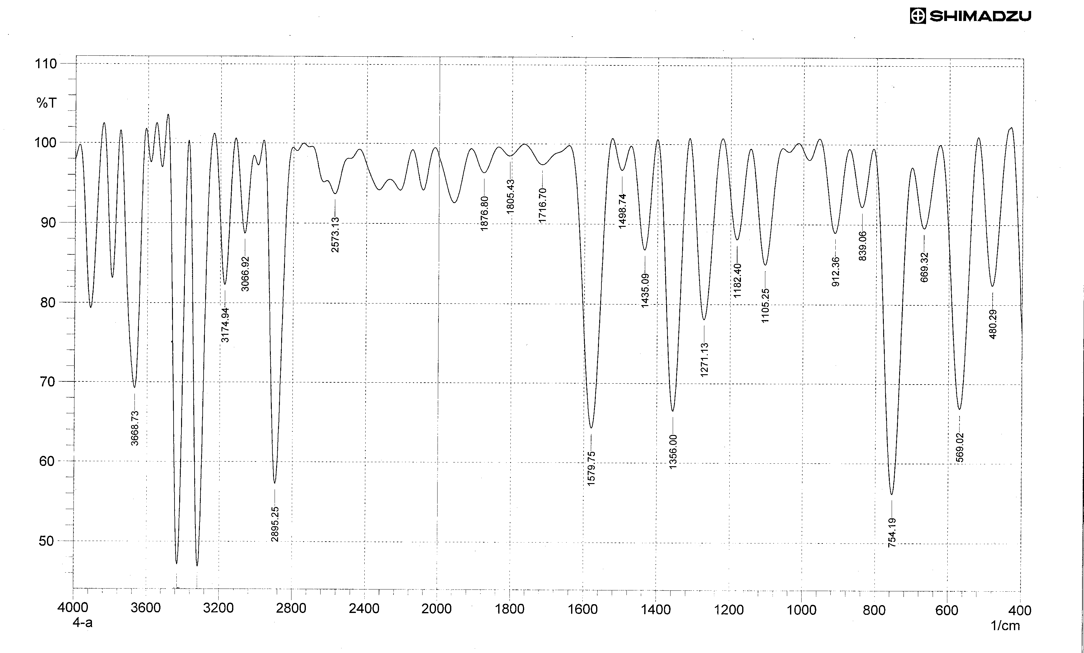
FT-IR spectrum of compound [1]
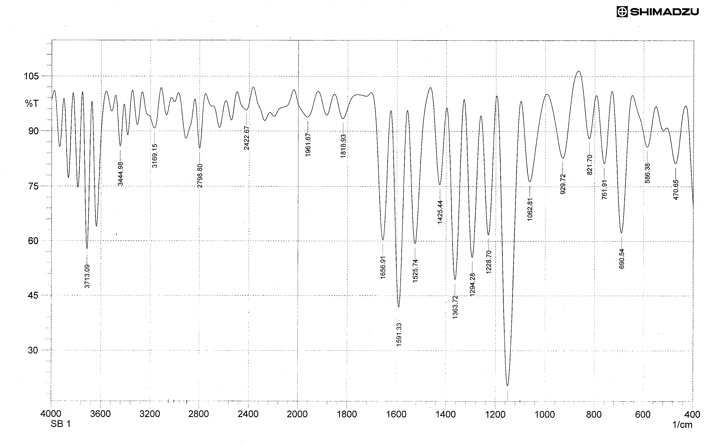
FT-IR spectrum of compound [2]

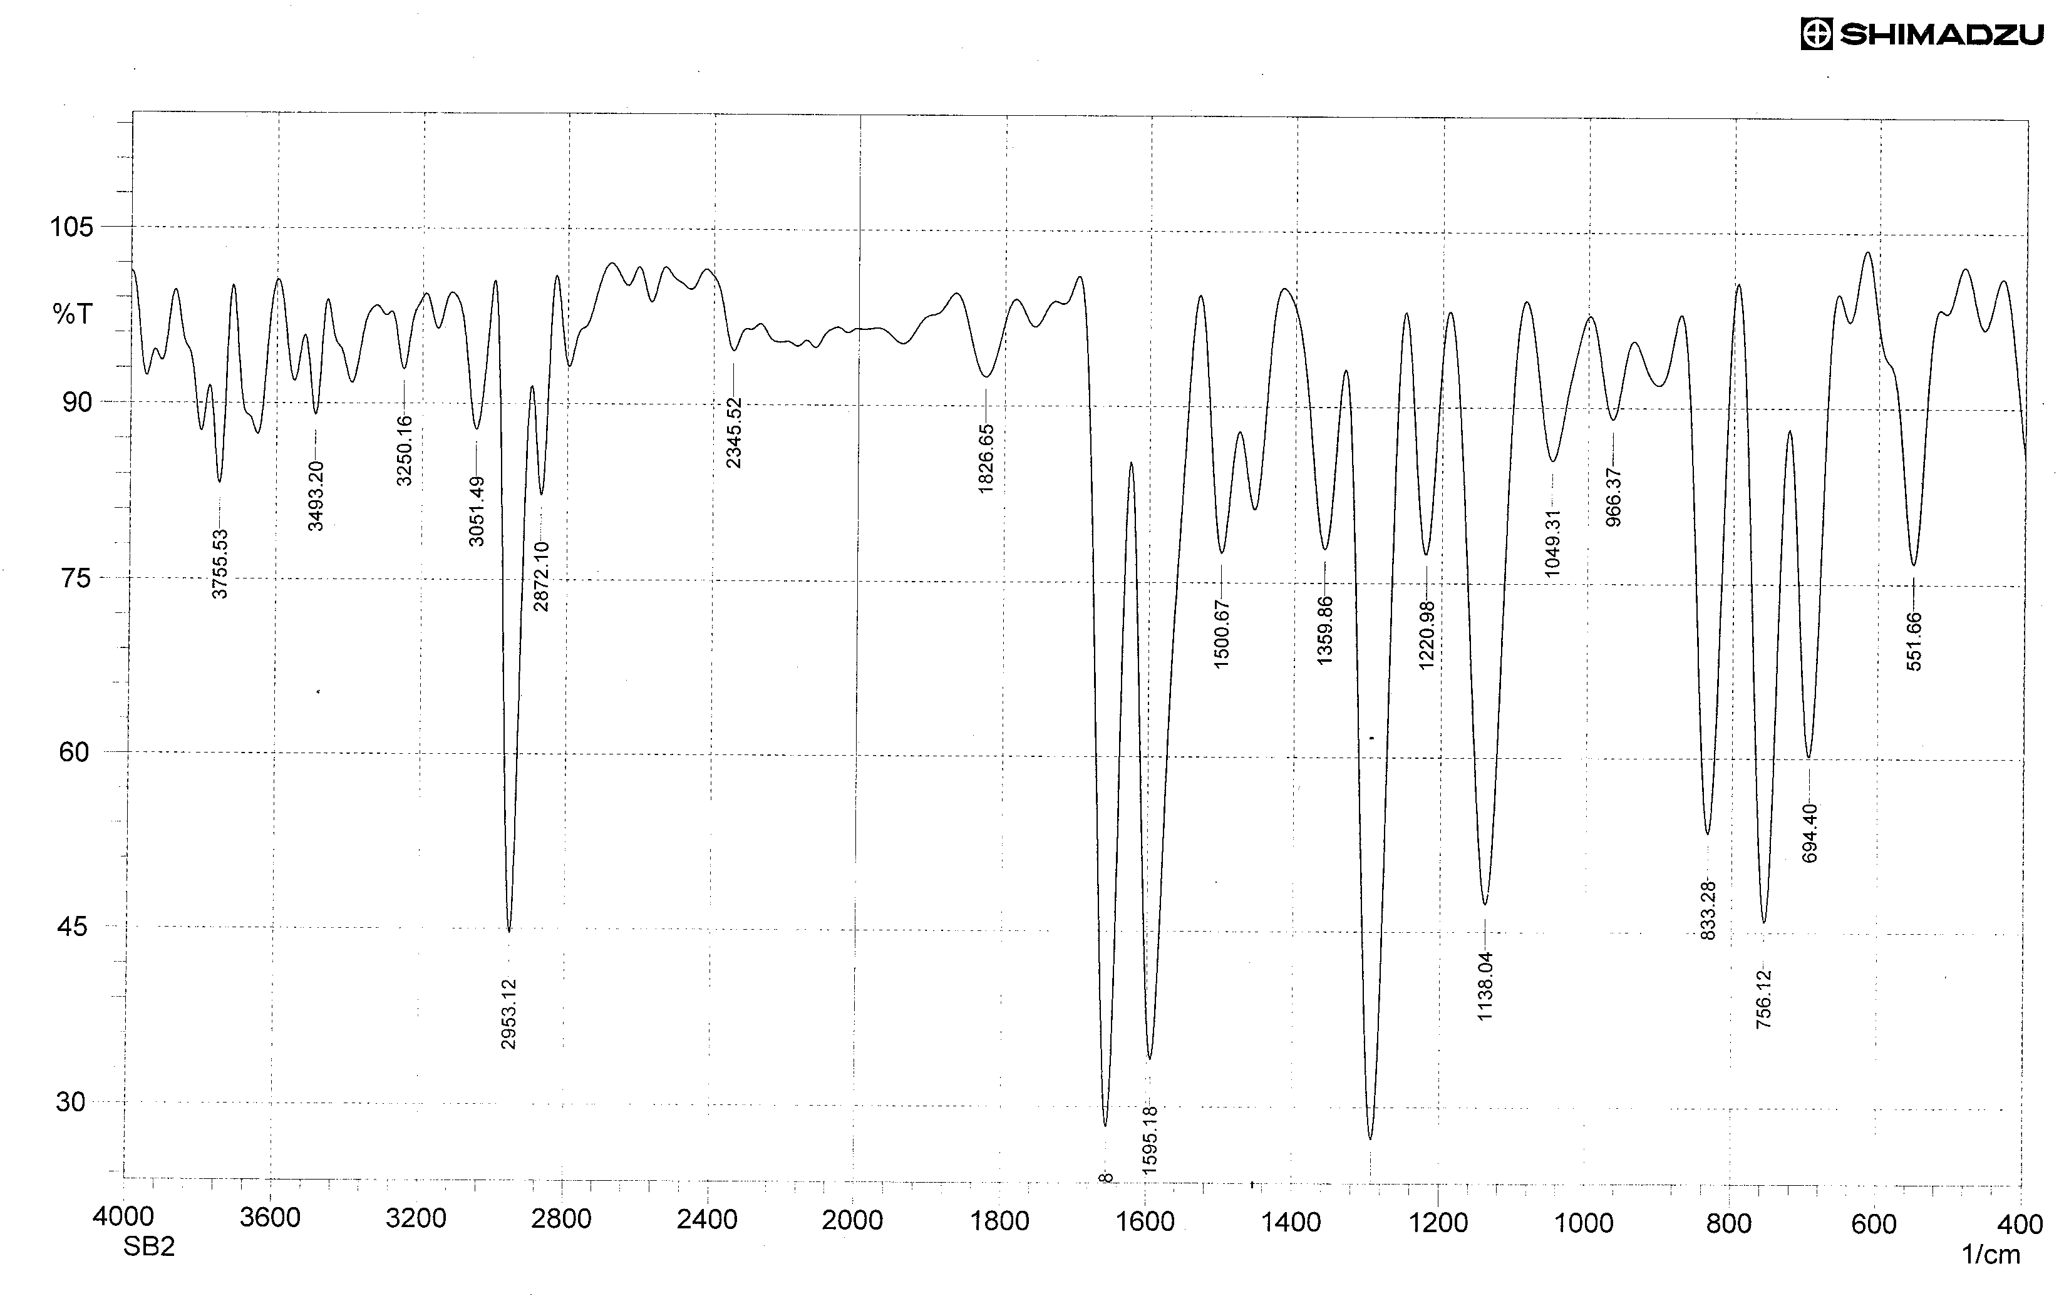
FT-IR spectrum of compound [3]
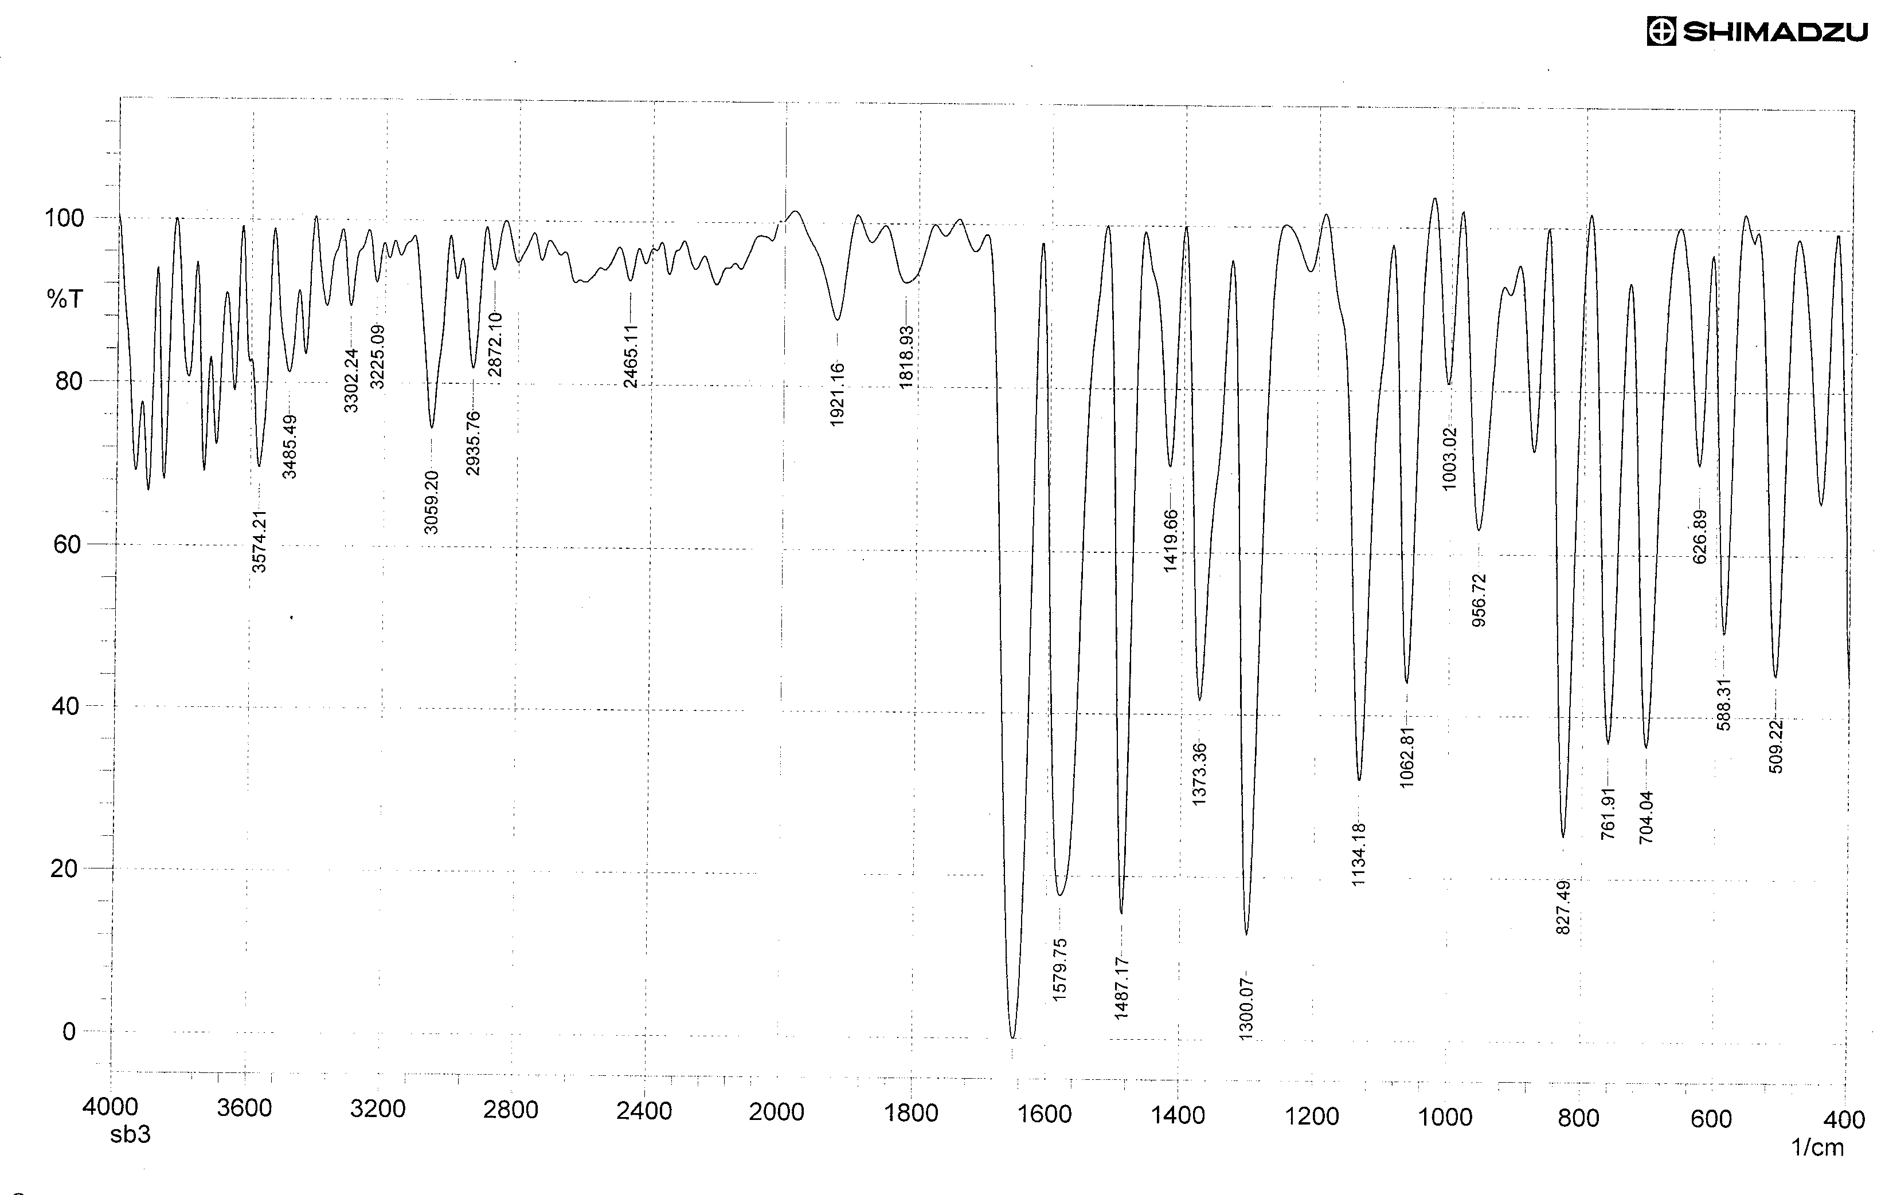

FT-IR spectrum of compound [4]
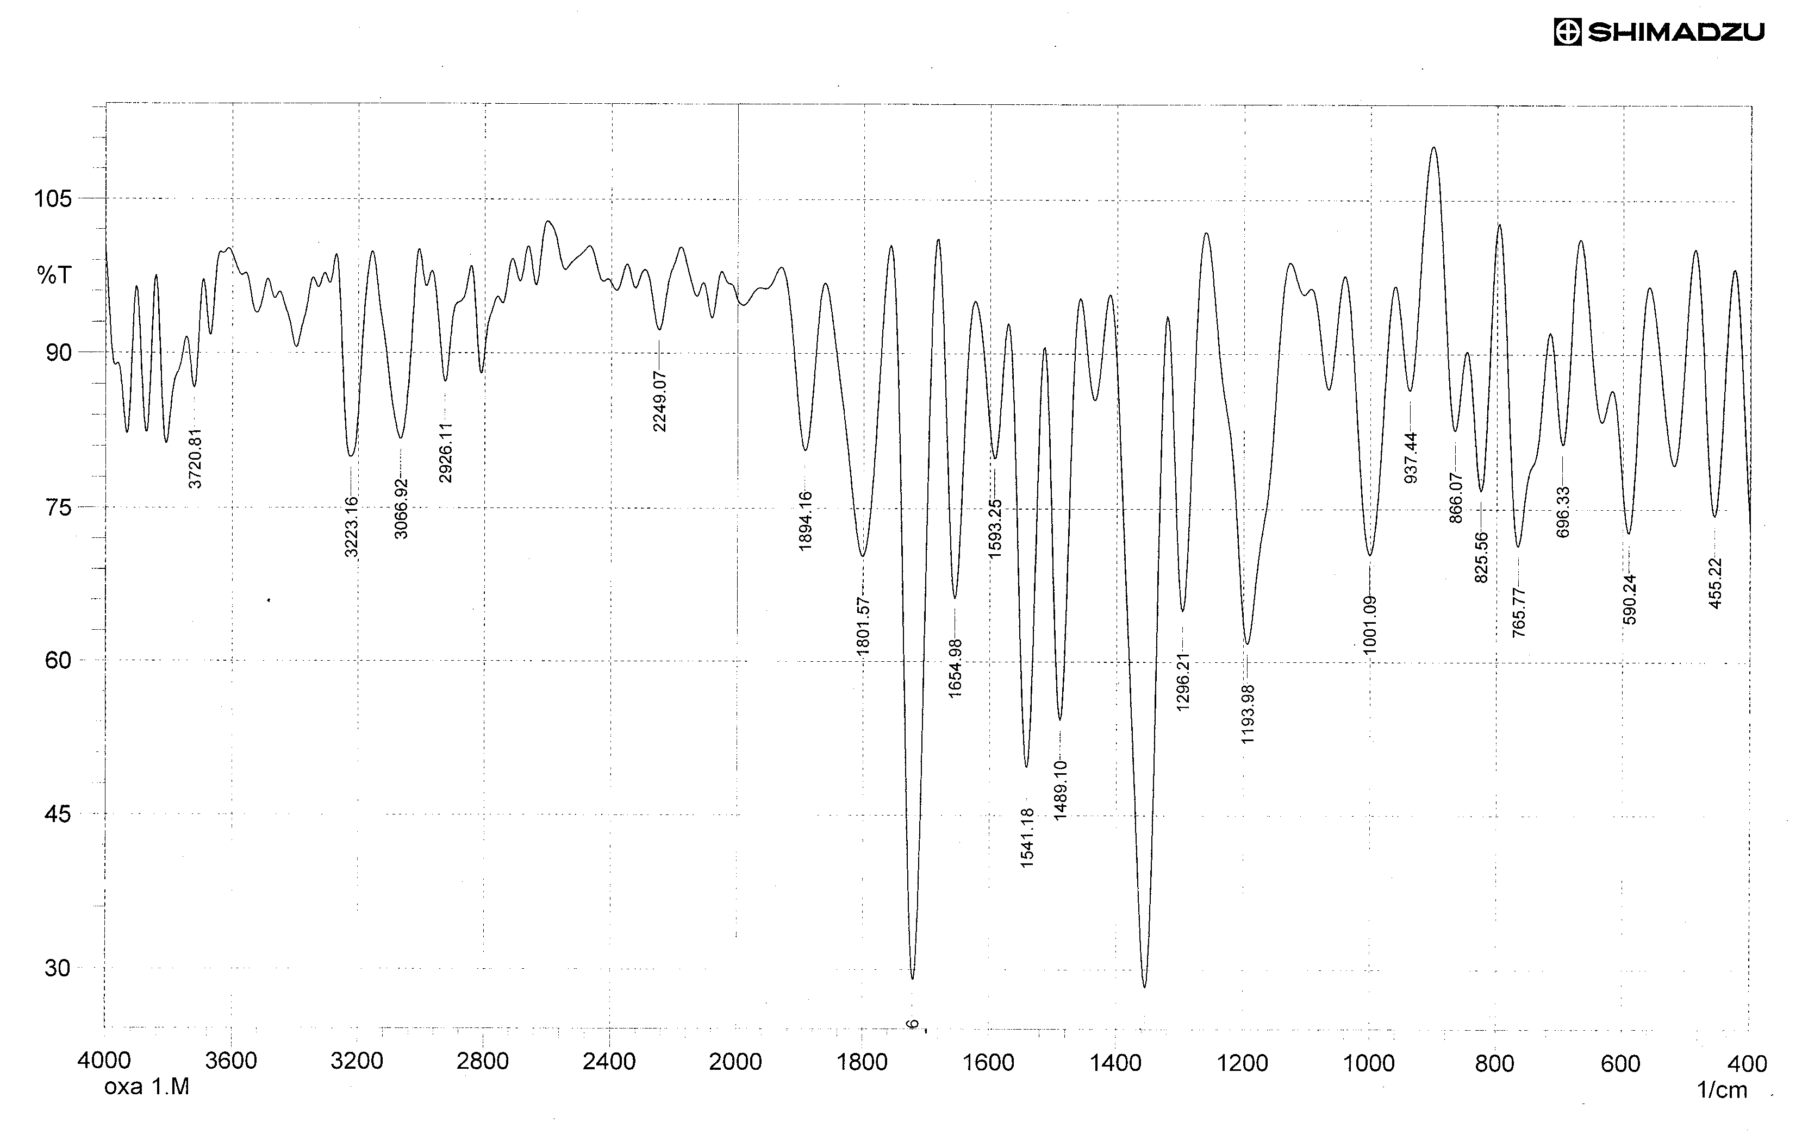
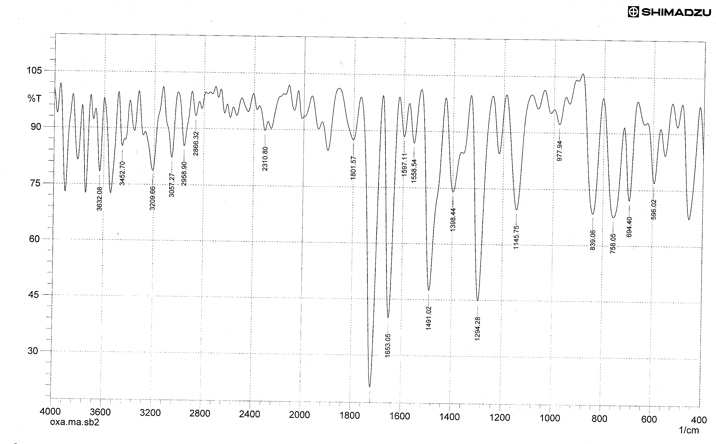
FT-IR spectrum of compound [5]
FT-IR spectrum of compound [6]
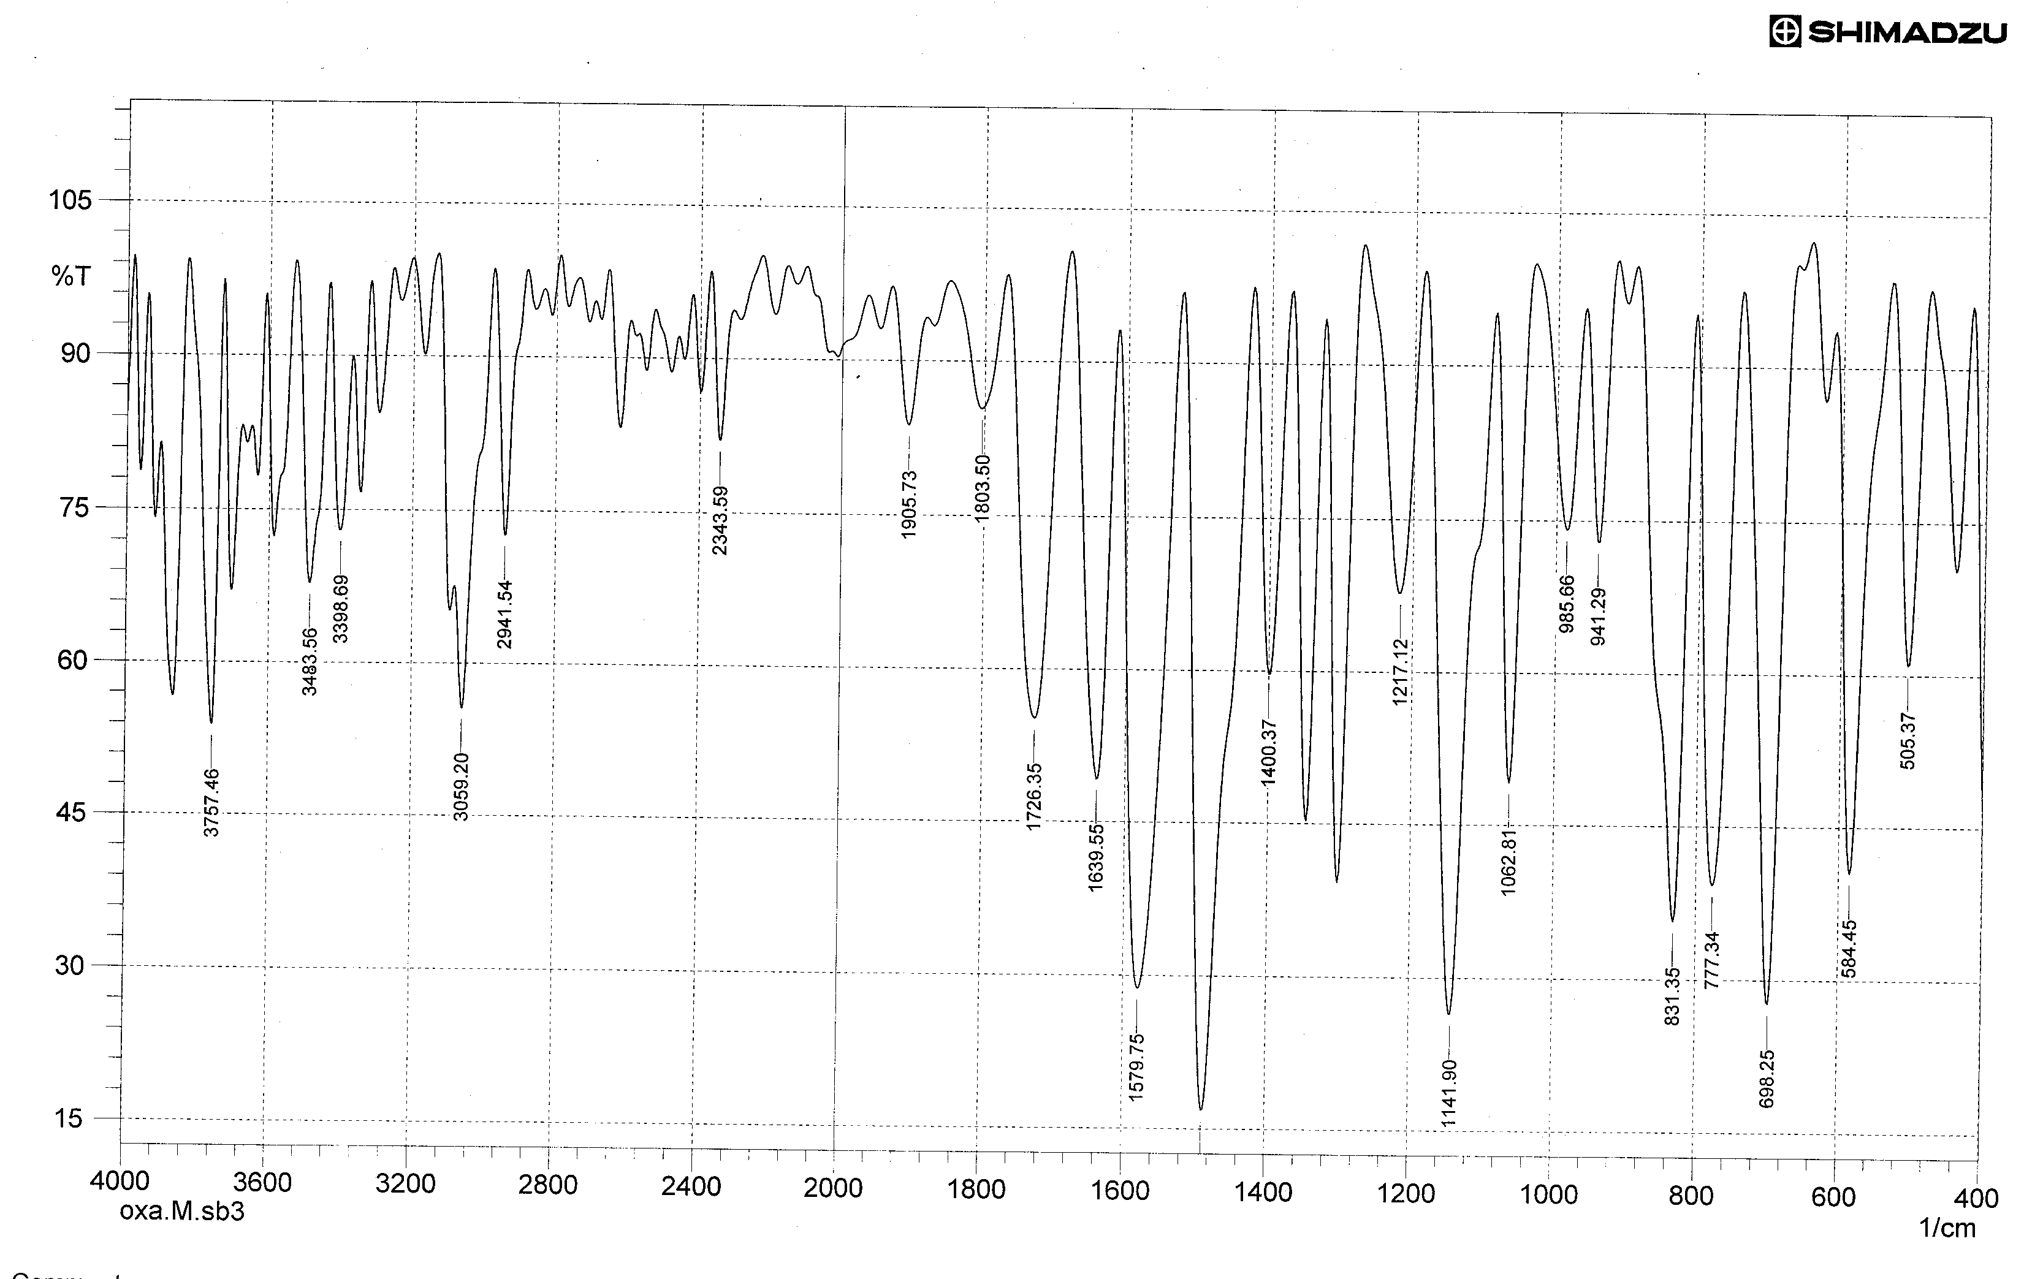
FT-IR spectrum of compound [7]
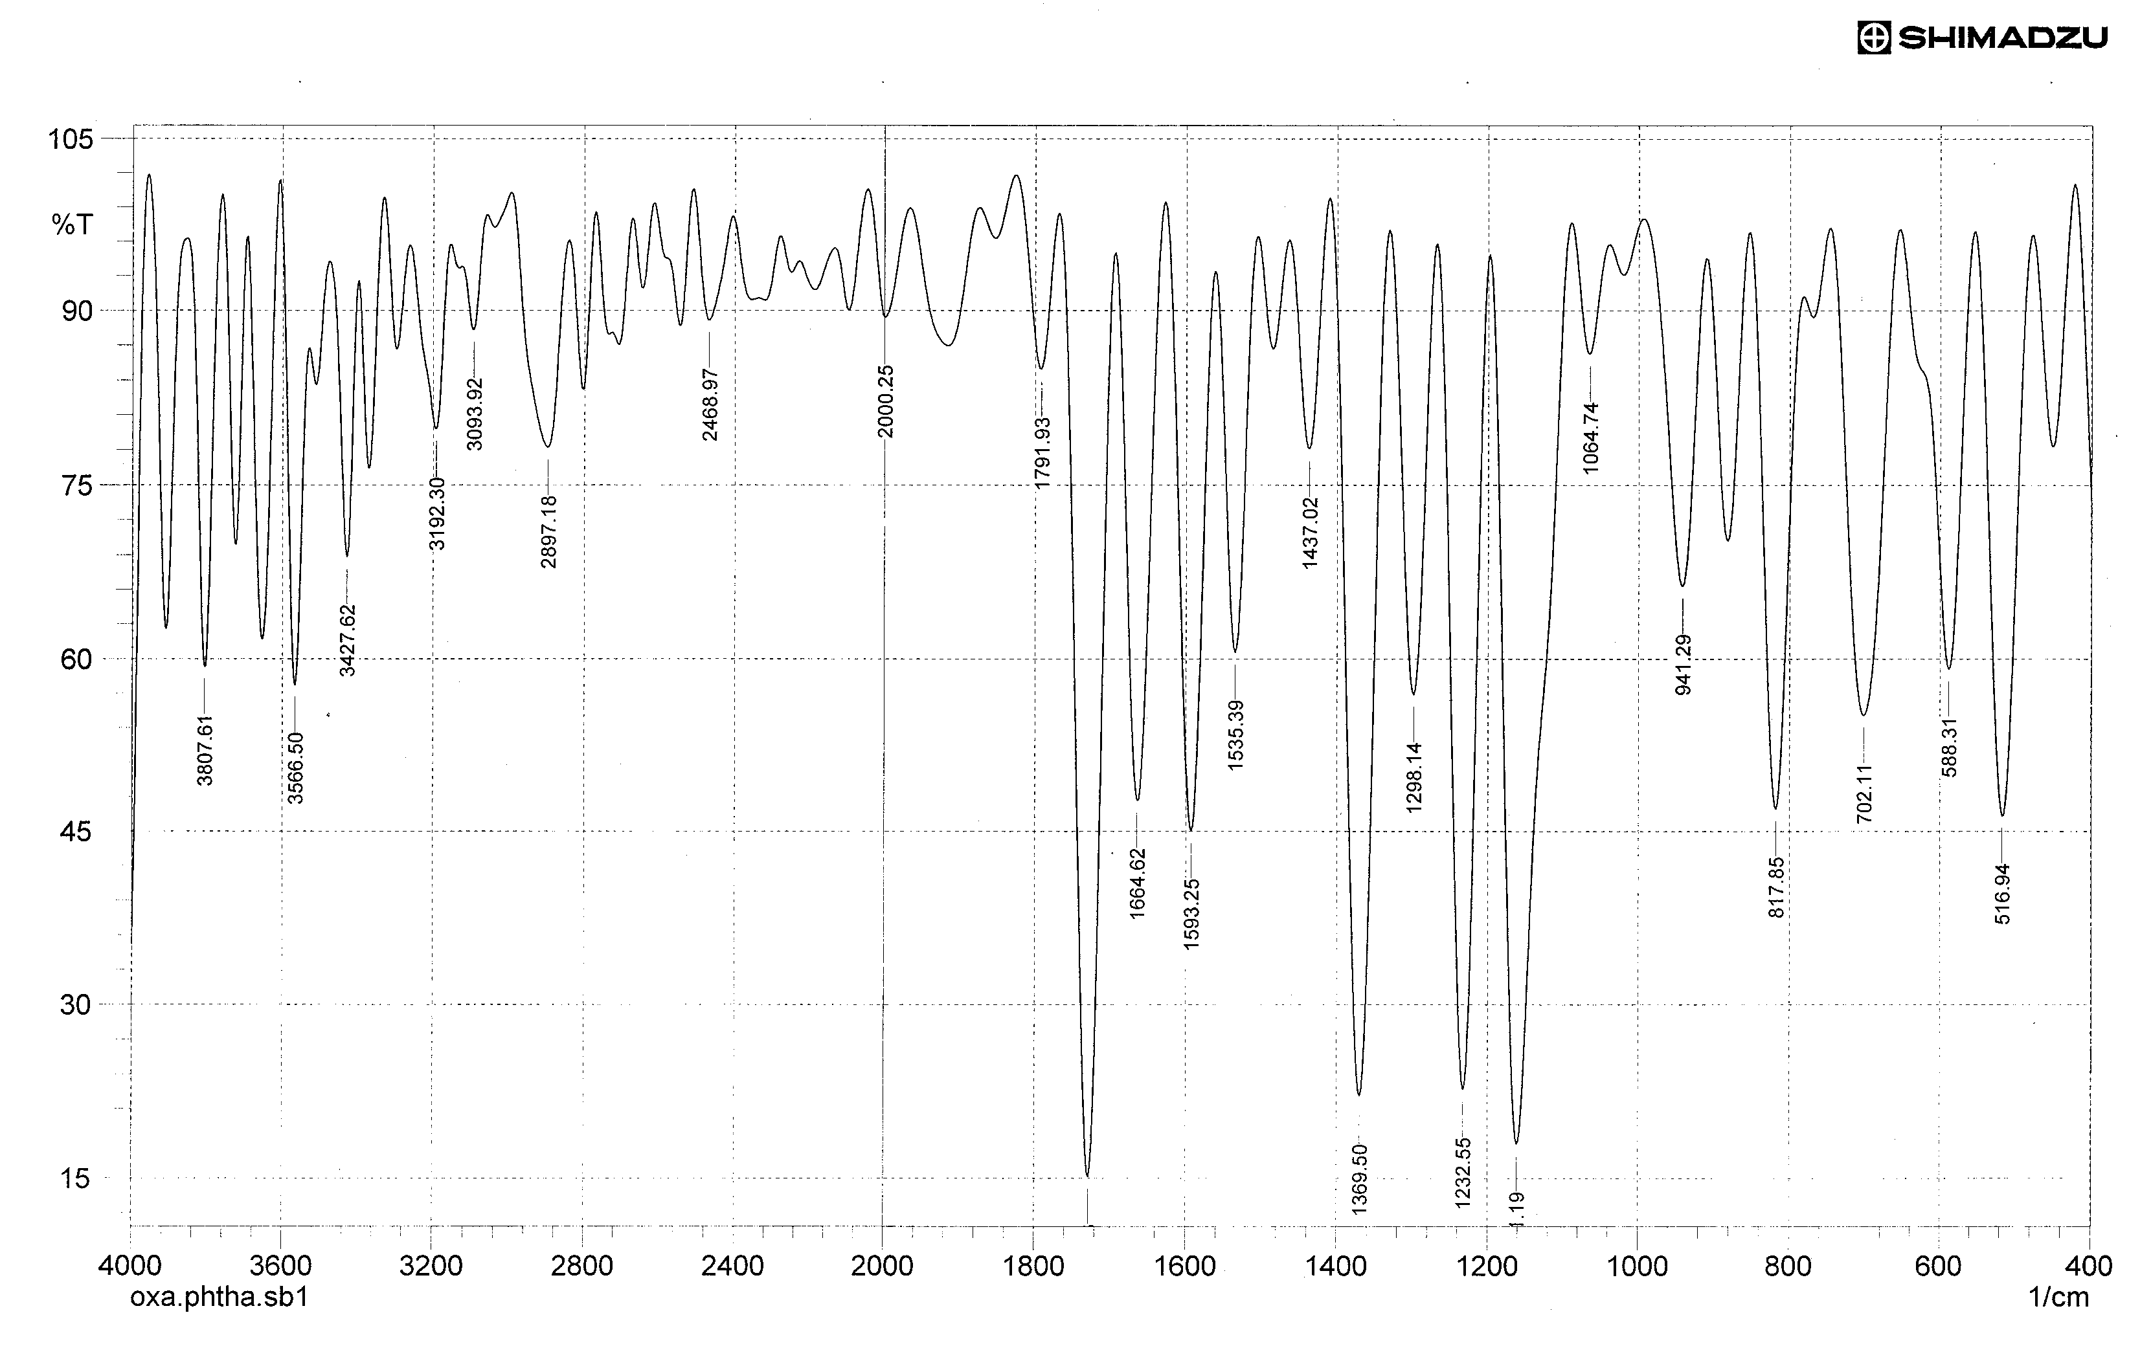
FT-IR spectrum of compound [8]

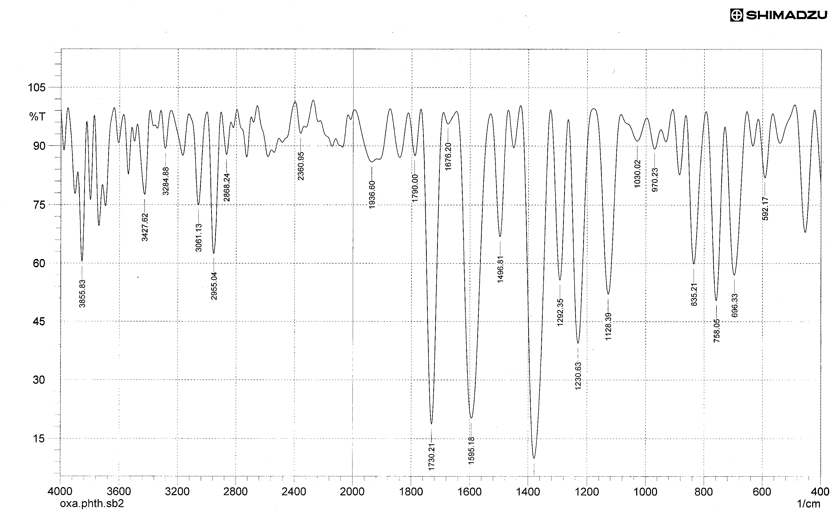
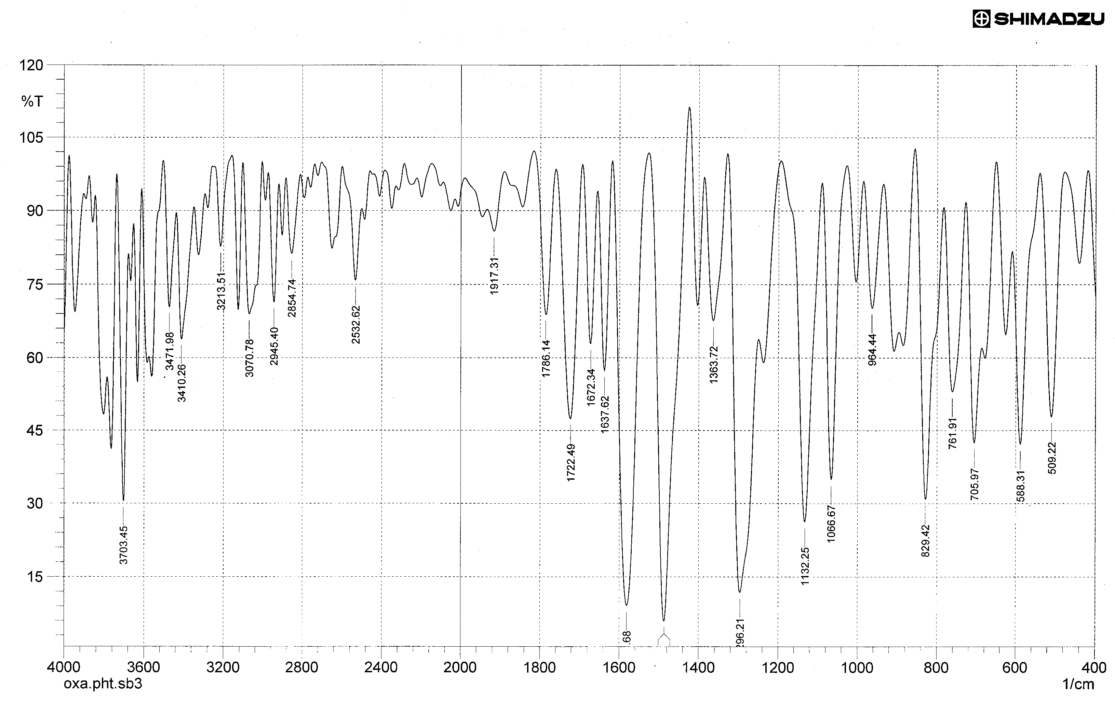
FT-IR spectrum of compound [9]

FT-IR spectrum of compound [10]

References
- O. Elias, L. Karolyhazy, G. Stajer, V. Harmath, O. Barabas and P. Matyus, J.Heterocyclic Chem., 1998, 35,1075.
- N. M. Al-Jamali, Ph.D Thesis, University of Baghdad, 2008.
- R. T. Haiwal, J. Kerbala University, 2008, 6, 4, 216.
- Z. H. Abood, J. Kerbala University, 2009, 7, 1, 297.
- H. D. Hanoon, Proceeding of the 6th Sci. of K. U., 2010, 109.
- T. Carlin, P. Thuery, O. Loreau and F. Taran, Organic Letters, 2010, 12, 1, 40.
- Z. H. Abood, J. Kerbala University, 2010, 8, 1, 354.
- K. F. Hussein, Ph. D. Thesis, University of Baghdad, 2005.
- M. A. Al-Hadithi, Journal of pure and applied science, 2006, 3, 3, 25.
- Z. H. Abood, Ph. D. Thesis, University of Babylon, 2007.
- N. M. Al-Jamali, J. Kerbala University, 2009, 7, 1, 323.
- M. Serrano-Wu, D. Laurent and Y. Chen, Bioorganic and Medicinal Chemistry Letters, 2002, 12, 19, 2757.
- H. J. Yang, W. H. Sun and Z. L. Li, Chinese Chemical Letters, 2002, 13, 1, 3.
- M. J. Al-Jeboori and A. H. Dawood, J. Kerbala University, 2008, 6, 1, 268.
- S. Samadhiya and A. Halve, Orient. J. Chem., 2001, 17, 119.
- C. M. Delpiccolo and E. G. Mata, Tetrahydron: Asymmetry, 2002, 13, 905.
- C. Celik, M. Aslantas, E. Sahin, A. Kayraldiz and M. Tumer, J. of Optoelectronics and Advanced Materals, 2009, 11, 10, 1404.
- N. A. Salih, Ph.D. Thesis, Al-Nahrain University, 2005.
- S. J. Wadher, M. P. Puranik, N. A. Karande and P. G. Yeole, International Journal of PharmTech Research, 2009, 1, 1, 22.
- N. A. Salih, Ph.D. Thesis, Al-Nahrain University, 2005.
- N. M. Al-Jamali, Journal of Babylone, 2006, 11, 3, 452.
- D. Williams and I. Fleming, "Spectroscopic Method in Organic Chemistry", 5th Ed., McGraw-Hill Book, Co.UK. Limited, 1995.
- R. M. Silverstein and F. X. Webster, "Spectroscopic Identification of Organic Compound", 6th Ed., John- Wiely and Sons, Inc. New York, 1998.
- D. L. Pavia, G. M. Lampman and G. S. Kris, "Introduction To Spectroscopy", 3th Ed., Thomson Learning, United States, 2001.

