Some Polarographic behaviour of ambilhur drug in
different media (vitro)

Faris H. Abdul Razzak
Basic Science Brank, College of Agricultural and Forestry, Mosul University

(NJC)

(Recevied on 22/9/2010) (Accepted for publication 20/2/2011)

Abstract
The polarographic behaviour of ambilhur (niridazole) [1-(5-Nitro-2-thiazolyl)-2-imidazolidinone(I)] have been studied. The drug give a well sensitive defined single peak at about -0.45V in carbonate buffer solution at pH 7.4 and -0.46V in serum-carbonate buffer and at -0.34V in urine-carbonate buffer.
The lowest determined concentration in aqueous carbonate buffer 9.1×10⁻⁷ M , in serum-carbonate buffer media was 5.4×10⁻⁷ M and 3.2×10⁻⁷ M in urine-carbonate media with correlation coefficient 0.998, 0.996, 0.999. the relationship between concentration and diffusion current Ip was linear for all solutions.
الخلاصة
الخواص البولاروكرافيه لدواء الامبلهر (النيريدازول) تم دراستها حيث اعطى الدواء موجه اختزال قوية وحساسة عند -0.45 فولت في محلول منظم للكاربونات عند الرقم الهيدروجيني 7.4 وعند -0.46 فولت بوجود مصل الدم مع الكاربونات كمحلول منظم وعند -0.34 فولت بوجود الادرار مع الكاربونات، أن اقل تركيز أمكن تحديده هو9.1×10⁻⁷ مولاري في محلول منظم لكاربونات , وفي وسط الكاربونات بوجود مصل الدم 5.4×10⁻⁷ , أما في وسط الكاربونات بوجود الإدرار 3.2×10⁻⁷ مولاري وكانت قيم R (معامل الارتباط) تساوي 0.998، 0.996، 0.999 على التوالي وكانت العلاقة خطية بين تيار الانتشار والتركيز لكافة المحاليل.

Introduction
The polarography and other voltammetric methods of analysis are successfully applied to the determination of pharmaceutical compounds . ⁽¹⁻³⁾.
The Differential pluse and DC polarographic behaviour of pencilloic have been reported. ⁽⁴⁾ .
Niridazole a yellow crystalinc, solid it is used against blood flukes especially schistoma, hoematabium, the helmintic disease caused by certain schistosoma (Bilharzia). ⁽⁵⁾ Niridazole effect on central nervous system, toxicity and cause dangerous side effects such as hallucinations, also allergic reactions. ^{(6,7)}
polarography was used to determination drugs such as chloramphenicol by many workers. ⁽⁸⁾ applied DC polarography at pH 4 to about 30ppm, differential-pulse polarography were also used for the determination of chloramphenicol. ^{(9,10)} A high performance liquid chromatography method has been developed for the determination of niridazole in bulk form and in pharmaceutical dosege form. ⁽¹¹⁾ In the present paper and continuously our interest in this field its worthwhile to study this compound by differential pulse polarography to the rapid study of niridazole. the structure of azathioprine is shown in I.
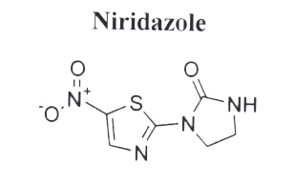

I

Experimental
Apparatus:
A Metrohm polarcord model E506 polarographic analyser was used in the three electrode mode as described previously (Sulaiman et al., 1994). A model PW 9420 (Philips) pH-meter was also used.
Reagents:
All chemicals used were of analytical reagent grade. All solutions were prepared with deionized distilled water. The stock solution of 10⁻³ M niridazole was prepared by dissolving appropriate amount of niridazole in 25ml of (pH 7.4) carbonate buffer, (0.025m sodium bicarbonate and 0.025M sodium carbonate).
Procedure:
The differential pulse mode was used with a 100-mV pulse amplitude, a 2 sec. drop time and 3 mV/S scan rate, the solution de-acrated by passing a slow steam of purified N₂ for 15 min. to remove the dissolved oxygen.
For polarographic measurements appropriate amount of Niridazole stock solution was added to the pH 7.4 carbonate buffer solution to yield the desired concentration (Calibration curve was then constructed). The same procedure was also followed in serum-carbonate and urine-carbonate media. In case of serum-carbonate, (0.5ml) of normal serum was added to polarographic cell containing (20ml) carbonate buffer at a pH 7.4. In urine-carbonate media (2ml) of normal urine was added to plarographic cell together, with the carbonate buffer (10ml) at pH 7.4.
RESULTS AND DISCUSSION
In this work, the differential pulse polarographic behaviour of niridiazole was studied in different media containing carbonate 2.4×10⁻⁵ M niridiazole aqueous carbonate buffer solution (carbonate-serum and carbonate-urine solution). Typical differential pulse polarograms of 2.4×10⁻⁷M; niridazole recorded in the aqueous media is shown in figure 1.

Fig 1: the differential pulse polarographic behaviour of niridiazole
The peak potential (Ep) was found to be almost the same in the case of aqueous carbonate buffer -0.45V vs. Ag/AgCl electrode while in the case of serum-carbonate solution the peak potential shifted to the more negative value -0.46V vs. Ag/AgCl electrode this is due to the presence of albumin in serum which acts as surfactant and causes damping in current, while the shift in potential to more negative due to the interaction of peak with albumin peak.
stability of niridazole in aqueous-carbonate media pH 7.4 and serum carbonate media pH 7.4.
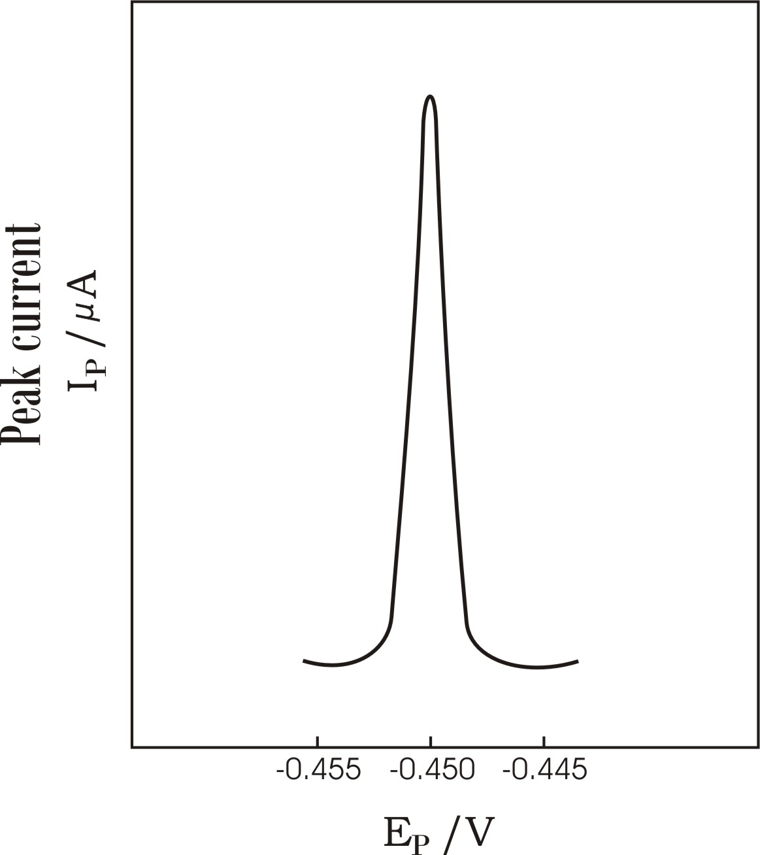
The differential pulse polarograms of 2.4×10⁻⁵M niridazole solution, pH (7.4), were recorded at different time for both aqueous-carbonate and serum-carbonate solution. It has been that niridazole is stable for more than (100) minutes. It has also been that the value of the peak current in serum-carbonate medium is always less than that in aqueous-carbonate buffer because of albumin interaction with drug.
Current
Ip/µA
10⁻²µA ×4.39
Analytical consideration:
The degree of resolution and sensitivity of differential-pulse peak current are dependent on pH, drop time and pulse amplitude. According to the differential pulse polarography of 2.4×10⁻⁵M niridazole investigated at various pulse amplitude (20-100)mv, drop time (0.4-2) sec. and pH values (2-11) using carbonate buffer. The greatest sensitivity is obtained with the largest drop time is 2.0 sec. and the largest pulse amplitude is (100V).
The effect of pH is summarized in Table (1), the results indicate that peak current (Ip) is slightly depended on pH, an intermediate pH value 7.4 has been chosen for the present study because it is quite similar to the blood pH value 7.4. On the other hand the peak potentials Ep were found to be highly pH-depended, a linear dependence of (Ep) on pH was observed with slope of (56mV pH⁻¹) which in fact very close to the theoretical value (60mV pH⁻¹). ⁽¹²⁾

Table 1: Effect of pH on the differential pulse peak current (Ip) at 2.4×10⁻⁵M.
pH | Ip (10-2µA) | Ep (V)
2.4 | 539 | -0.2
3.4 | 580 | -0.25
4.4 | 630 | -0.3
5.4 | 670 | -0.35
6.4 | 712 | -0.4
7.4 | 748 | -0.45
8.4 | 785 | -0.49
9.4 | 830 | -0.54
10.4 | 850 | -0.59

Pulse amplitude (20-100 mv) and drop time (0.6-2 Sce) illustrate how the height of the peak increases as the pulse increased and drop time increased as shown in table (2,3). Therefor , the selected adjustment of the pulse amplitude and drop time are important parameters to be considered in analytical application of the differential pulse technique.

Table 2: Effect of pulse amplitude on the differential pulse peak current (Ip) at 2.4×10⁻⁵M.
Pulse amplitude (mv) | Ip (10-2µA) | Ep (V)
20 | 93 | -0.44
40 | 245 | -0.435
60 | 465 | -0.425
80 | 705 | -0.415
100 | 975 | -0.41

Table 3: Effect of drop time on the differential pulse peak current (Ip) at 2.4×10⁻⁵M.
Drop time (sec) | Ip (10-2µA) | Ep (V)
0.4 | 228 | -0.44
0.6 | 348 | -0.43
0.8 | 462 | -0.425
1 | 571 | -0.42
1.2 | 672 | -0.415
1.4 | 768 | -0.41
2 | 975 | -0.41
3 | 1344 | -0.41

Also the urine volume effect on peak current of the drug, it was reported as shown in table (4), an intermediate urine value (2 ml) has been chosen because the greatest Ip (346 × 10⁻² µA) obtained.

Table 4: Effect of urine volume differential pulse peak current (Ip) at 2.4×10⁻⁵M.
Urine of volume (ml) | Ip (10-2µA) | Ep (V)
0.5 | 680 | -0.44
1 | 467 | -0.435
1.5 | 376 | -0.435
2 | 346 | -0.435
2.5 | 324 | -0.435
3 | 298 | -0.425
4 | 247 | -0.42
5 | 195 | -0.415
Using the above optimum conditions,
the calibration curves were constructed
using a serial dilution of a standard
niridazole aqueous-carbonate buffer,
serum-carbonate buffer and urine-
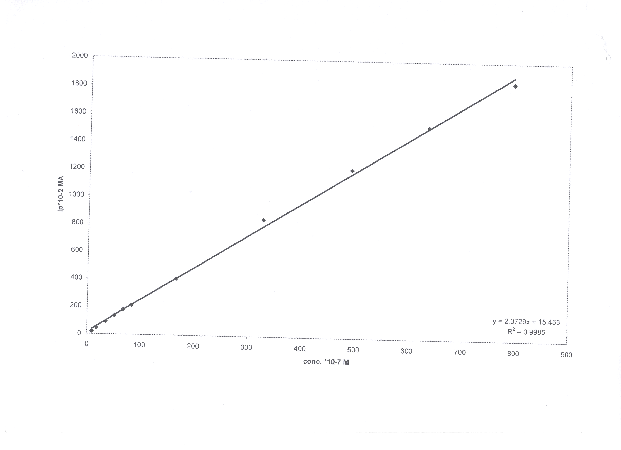
carbonate buffer pH 7.4. the results
are listed in Figures (2, 3, 4).

Ip x 10⁻²µA

Conc. x 10⁻⁷M
Fig 2: Calibration curve of niridazole at pH 7.4 in aqueous-carbonate buffer.

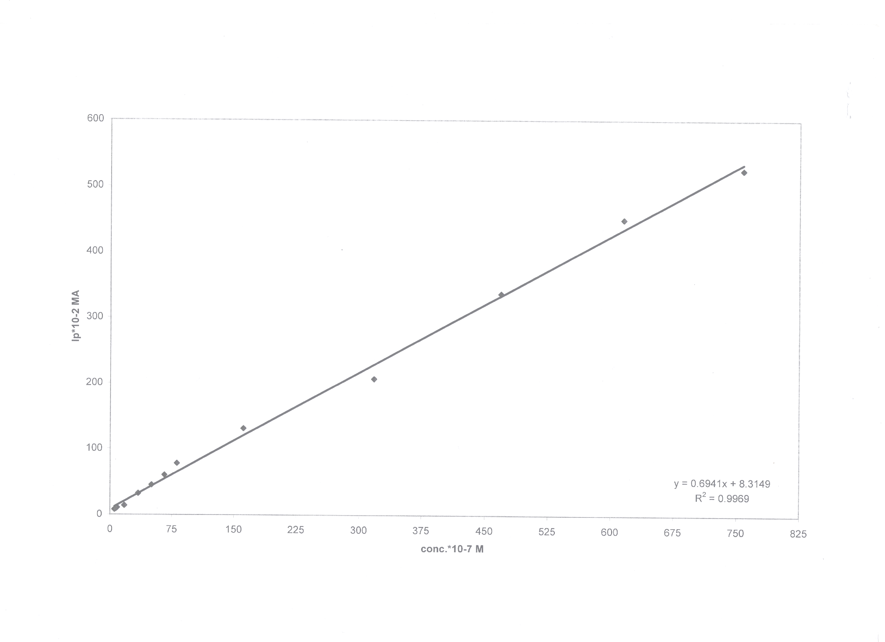
Fig 3: Calibration curve of niridazole at pH 7.4 in presence of serum-carbonate buffer.
Ip x 10⁻²µA
Ip x 10⁻²µA
Conc. x 10⁻⁷M
0.999
Fig 4: Calibration curve of niridazole at pH 7.4 in presence of urine-carbonate buffer.
Conc. x 10⁻⁷M

The solution was prepared by adding a 2ml of normal urine to 20ml carbonate buffer inside polarographic cells.
Regression analysis of standard curves indicated:
- Linear relationship between peak current and concentration for the drug in the free different media.
- Correlation coefficient (R) of the plots are shown in tables no. (2, 3 and 4).
- The lowest determined concentration for drug was found to be (9.1×10⁻⁷M) in aqueous-carbonate buffer. While in serum-carbonate buffer the lowest concentration of drug (5.4×10⁻⁷M) and (3.2×10⁻⁷M) in urine carbonate buffer.
References
1- S.A. Francis, J. of Phar. Science, 1965, 54(3), 442-444.
2- K. Fossdal, and Jacobson, E. Anal. Chim. Acta,. 1971, 56, 105-115.
3- L.Z. Cai, and W.M. Lian, Analyst, 1988, 113, 21.
4- U. Forsman, and Ksrlsson, A. Anal. Chim. Acta., 1981, 128, 135.
5- J. W. Tracy, B. A. Caha, and L. T. Webster, Molecular Pharmacology, 1983, 24(2),. 291-294.
6- R. Barat, A. Srinatha, J. Pandit, D. Ridhurker, J. Balasabramaniam, N. Mittal, and D. Misbra. Drug Delivery , 2006, 13, 5-365-373.
7- R. Barat, A. Srinatha, J. Pandit, N. Mittal, and S. Anypurba, Drug Delivery, 2007, 14(8), 531-538.
8- G.B. Hess, Anal. Chim. Acta., 1965, 22(5), 649-651.
9- S.T. Sulaiman, and F.H. Abdu Razzak, Raf. J. of science., 2000, 11(2), 8-13.
10- T.T. Van Der Lee, Van Bennekom, W.P. and Dejany, H.T., Anal. Chim. Acta., 1980, 117, 171.
11- A. Nawal, H. Hussan, E. Michael, and H. Ibrahim, HPLC Talanta, 1990, 37(5), 481-483.
12- J. Hilson, and P. Brinbaum, Trans. Faraday Soc., 1952, 48, 478-482.

