An Indirect Atomic Absorption Spectrophotometric Determination of Cefotaxime in Pharmaceutical Formulations by Using Rhodium(II) As a Mediating Metal

Mohammed K. Hammood
University of Baghdad, Collage of Science, Department of chemistry, Jadiriya, Baghdad, Iraq
Ameen W. Qasim
Baghdad Collage of Pharmacy, Bab Al-Mua’adem, Baghdad, Iraq
Fadhel Jasim
University of Baghdad, Collage of Science, Department of chemistry, Jadiriya, Baghdad, Iraq

(NJC)

(Recevied on 8/11/2010) (Accepted for publication 20/2/2011)

Abstract
A new application of an indirect atomic absorption spectrometric (AAS) method was offered for the assay of low concentrations of cefotaxime (CFX) in pharmaceutical in pure and pharmaceutical dosage form with good accuracy and precision. The method is depended on the formation of chelating complex between the drug cefotaxime and rhodium(II) to form orange-yellowish product. All experimental parameters such as, pH, concentration of rhodium, reaction time, extraction time and phase ratio have been investigated. The linearity (2-50) μg mL⁻¹, detection limit (S/N) of 0.13 μg mL⁻¹, accuracy as the %E_{rel} of 1.59, and recoveries ranged from 101.2-101.87%, with mean value of 101.59±0.73. The proposed method was applied for the determination of CFX in the drug Sefotak by both direct calibration and standard additions procedures and found to be 989.87 and 970.93 mg per unite, respectively compared with the stated value of 1000 mg per unite. This method is also compared statistically with direct determination by using UV-VIS spectrophotometric technique which is preformed in our laboratory and found to be insignificant at 95% confidence level. All statistical calculations were implemented via the chemsoftware Minitab version 11.
Key words: Cefotaxime, Rhodium, Atomic Absorption, Sefotak Vial
الخلاصة
جرى في هذا البحث تطبيق جديد لمطيافية الامتصاص الذري اللهبي غير المباشرة لتقدير التراكيز النزرة للمضاد الحيوي سيفوتاكسيم النقي وفي المستحضرات الصيدلانية بضبط ودقة عالية. تعتمد هذه الطريقة على تفاعل الدواء (CFX ) مع ايون الروديوم الثنائي في وسط حاضي لتكوين معقد برتقالي مصفر قابل للاستخلاص في المذيب العضوي. درست الظروف الفضلى للتكوين المقعد من تاثير الحامضية، تاثير تركيز الروديوم، زمن التفاعل، زمن الاستخلاص، نسبة الطور. تراوح مدى منحني المعايرة من (50-2) مايكروغرام.مل⁻ ¹ وحد الكشف ( 0.13) مايكروغرام.مل⁻ ¹ والدقة 1.59% ، كما تراوح الاسترداد بالمئة بمعدل 101.2-101.87%. طبقت الطريقة المقترحة على تعيين السيفوتاكسيم في المستحضر الدوائي التجاري سيفوتاك بطريقتي المعايرة المباشرة واضافات القياس ووجد بانه يساوي989.87 و970.93 ملغم/ وحدة على التوالي مقارنة بالقيمة المصرح بها وهي 1000 ملغم/ وحدة. كذلك، جرى مقارنة الطريقة المقترحة مع طريقة المطيافية الجزيئية المباشرة احصائيا والمنجزة في مختبرنا ووجد بانها لاتختلف معنويا مع تقنية الامتصاص الذري غير المباشرة عند %95من الثقة.

Introduction
Cefotaxime (Fig.1) chemically Sodium (6R,7R)-3-[(acet-yloxy) methyl]-7-{[(Z)-2-(2-aminothiazol-4-yl)-2-(methoxyimino)acetyl]-8-oxo-5-thia-1-azabicyclo [4.2.0] oct-2-ene-2-carboxylate. The presence of methoxyimino group in cefotaxime molecule is very important for its chemical and electrochemical behavior ^{[1]}. Cefotaxime has wide clinical applications including treatment of infection in respiratory tract, gynecologic, skin, bone and joint, urinary tract, septicemia, and documented or suspected meningitis ^{[2]}.
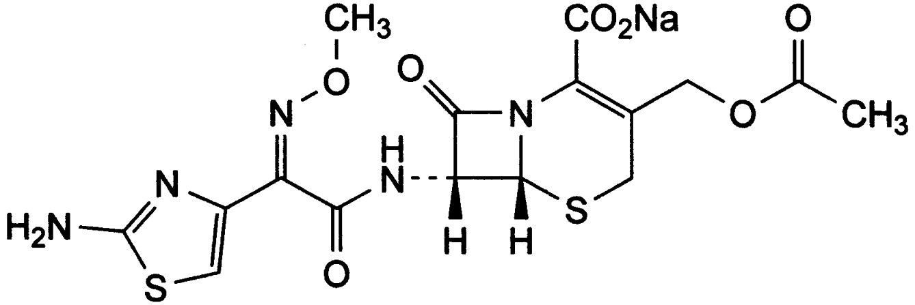
C₁₆H₁₆N₅NaO₇S₂
Fig.(1): The chemical structure of cefotaxime

Due to the attractive chemical structure of the cephalosporins from which cefotaxime is belong to analytical chemists have paid most of their interest in using these compounds as chemical reagents evenly for the determination of metal ions and organic compounds ^{[3]}. In parallel, owing to of their extensive use as broad-spectrum antimicrobial agents which exhibit activity against Gram negative and Gram positive bacteria ^{[4]}. Many authors have also dedicated their efforts to develop a simple, rapid and sensitive analytical method for the assay of cephalosporins in pure, dosage form and biological samples. Generally, the assay of cephalosporins previously been achieved by several analytical techniques such as, HPLC ^{[4-10]}, voltametry ^{[10, 11]}, ionometry ^{[12]}, spectrophotometry ^{[13,16]}, flow injection analysis ^{[17, 20]}, fluorimetry ^{[22]}. In this work, an indirect FAAS method used for the determination of the drug CFX in pure form and pharmaceutical sample (Sefotak). The method is based on the reaction of drug with rhodium(II) in acidic medium to form stoichiometrically a yellow CFX-Rh(II) complex at optimum conditions. The complex was extracted into benzyl alcohol and aspirated into air/acetylene flame for indirectly assay of CFX via the measurement of AA signal of Rh in the formed complex. The proposed method was compared statistically with direct molecular spectrophotometric technique.
Experimental
- Apparatus
Atomic absorption measurement were carried out on a GBC (933 plus) flame atomic absorption spectrophotometer equipped with background corrector GBC D₂ Lamp and rhodium hallow cathode lamp under the following conditions: wavelength 357 nm, lamp current 10mA, slit width 0.2 nm, air/acetylene flame (oxidant, lean). All the molecular absorption measurements were made using UV-Vis spectrophotometer type Shimadzu model UV-160 equipped with 10mm matched quartz cell. Infrared spectrum for the produced complex was recorded on Shimadzu Fourier Transform Infrared model FT-IR8000. For pH measurement it is used a pH Meter Jenway 3020 with combined electrode.
- Reagents and Chemicals
All the chemicals used were of analytical reagent grade; deionized water was used for diluting the reagents and samples. AAS standard of rhodium solution (1000 μg mL⁻¹), hydrochloric acid (36.4%) and Benzyl alcohol were purchased from local market.
Cefotaxime standard solution (1000 μg mL⁻¹) was prepared by dissolving 0.1 g of pure CFX in sufficient water and diluted to 100 mL into a volumetric flask. A 100 μg mL⁻¹of working rhodium standard was prepared by diluting of the stock solution in water.

- General Procedure and Analytical Curves
- Direct Calibration Method
Aliquots (0.1-2.5 mL) of a stock standard solution of Cefotaxime (100 μg mL⁻¹) were transferred into 5 mL volumetric flask, then 0.5 mL of 100 μg Rh mL⁻¹ was added to each flask followed by adjusting the pH of all solution to 2.3 using dilute HCl or NaOH solution. The solutions were set aside for 4 minutes and then diluted to 5 mL with water. The mixtures were heated on water bath at 85ºC for 4 min. These solutions were corresponding to (2-50 μg CFX mL⁻¹). After cooling, each solution was extracted with 1 mL of benzyl alcohol after shaking for 1 min. The organic layer for each solution was transferred into a test tube from which aspirated into air/acetylene flame and the AA signals were measured at 357 nm. The analytical curve was obtained by plotting absorbance (in mode of peak height) against CFX concentration and the corresponding linear regression equation was used to convert absorbance into CFX concentration, for all analyzed Sefotak samples.
- Preparation of Drug Sefotak Vial
10 vials of Sefotak were mixed in a clean agate mortar, A quantity of 0.100 g of fine powder was dissolved in sufficient water with continuous shaking, then was transferred into 100 ml volumetric flask and dilutes to mark with water.
- Standard Additions Method
Aliquots (0.25 mL) of the above prepared Sefotak sample solution were pipetted into seven 5-mL calibrated flaks containing 0.000,
0.250, 0.500, 0.750, 1.000, 1.250, 1.500, 1.750, 2.000, and 2.250, 2.500 mL of 100 μg CFX mL⁻¹, then the same steps were proceeded according to the procedure previously mentioned under direct calibration method.
Results and Discussion
- Absorption Spectra
UV-Vis spectra of the pure CFX drug and its complex with Rh(II) were recorded the spectra at 100 mg L⁻¹ of CFX standard solution and CFX-Rh(II) in benzyl alcohol to verify of the formation of complex. It was shown that the pure drug gave one absorption maximum at 253 nm (Fig.2) and rhodium(II) solution gave one absorption maximum at 230 nm (Fig.3), while the spectrum of the orange-yellowish chleate shows a new absorption maximum at 357 nm (Fig.4) indicating the formation of complex between the drug CFX and Rh(II) solution in organic medium.

Fig.(2): The absorption spectrum of Cefotaxime against water as blank

Fig.(3): The absorption spectrum of Rhodium (II) against water as blank

Fig.(4): The absorption spectrum of CFX-Rh(II)

- Optimum of Extraction Conditions
  - Effect of pH value
The effect of pH on the AA response for the formation of CFX-Rh(II) complex at different pH values. Fig.5 showed the absorbance was at maximum value sharply at the pH of 2.3.
Fig.(5): Effect of pH for the determination of CFX-Rh(II)

  - Effect of Concentration of Rh (II) solution
Different amounts of Rh(II) solution, 0.1-1 mL aliquots (100 μg Rh mL⁻¹) were added to 1.5 mL aliquots of 100 μg mL⁻¹ CFX. The maximum absorbance was attained 0.5 mL amounts of 100 μg.mL⁻¹ of Rh(II) solution which correspond to 10 μg.mL⁻¹ (Fig. 6). Thus, this concentration was employed to achieve a constant and maximum absorbance for complete formation of chelating complex.

Fig.(6): Effect of Concentration of Rhodium ion on the determination of CFX

  - Effect of Phase Ratio
This experiment was conducted to obtain the organic/aqueous ratio for the extraction of CFX-Rh(II) complex, keeping the other variables constant, via varying the volume of aqueous phase from 3-10 mL and keeping the volume of organic solvent at 1 mL. The results have shown that the AA signal was almost independent of A/O phase ratio from 4:1 to 5:1 (Fig. 7). From the absorbance data, the percent extraction (%E) and distribution ratio of the complex were also estimated and found to be 94.64% and 88.43% respectively, at one stage extraction.

Fig.(7): Effect of phase ratio on the determination of CFX-Rh(II) complex

  - Effect of Temperature
A preliminary study indicates that the reaction of Rh(II) with CFX is very slow and took about one hour. Therefore, the optimization of this variable was found to be 85ºC (Fig.8) with reaction time 4 min which gave maximum absorbance. Beyond this temperature, the absorbance was decreased due to the decomposition of the complex. This factor was shortening the reaction time to about 4 min.

Fig.(8): Effect of reaction temperature on determination of CFX-Rh(II) complex

  - Effect of Reaction Time
Fig.9 shows the effect of reaction time on the formation of complex before the extraction process. It was shown that the absorbance increases rapidly , at optimum temperature 85ºC with reaction time up to 4 min and then decrease, which indicates that there is no advantages in going beyond 7 minutes., perhaps lead to partial dissociation of the complex with longer time in aqueous phase.

Fig.(9): Effect of reaction time on the determination of CFX-Rh(II) complex

  - Selection of Solvent
Since this procedure comprises the measurement of CFX-Rh(II) complex in organic medium, it was necessary to use suitable solvent that will extract the complex alone, not the excess of Rh(II) . Consequently, the effect of different solvents, namely, o-xylene, toluene, carbon tetrachloride, 1-butanol, cyclohexanone, benzene, acetyl acetone, diethyl ether, benzyl alcohol, dichloromethane and petroleum ether was investigated. Experiments indicated that, benzyl alcohol was proved to be the most suitable solvent because for extraction of the complex at optimum conditions excluding other species in the extraction system and does not extract the blank but merely the complex. The other solvents were not suitable, because the complex formed in these solvents had low absorbance.
  - Effect of Extraction Time
It was observed that the absorbance of the CFX-Rh(II) complex increases readily with shaking time and reach approximately a plateau, indicating the stability of the absorbance values with increasing shaking time, and hence a one min was selected as an optimal for complete extraction of the complex (Fig.10).
Fig.(10): Effect of extraction time on the determination of CFX-Rh(II) complex

Suggested Structure of the Complex
Several spectroscopic techniques, such as FTIR, FAAS and mole-ratio procedure performed by UV-Vis spectrophotometry have been used to elucidate the probable structure of CFX-Rh(II) complex produced at optimum conditions. Fig.8 shows that the mole ratio between CFX and Rh(II) was 1:1 complex. The stability constant was estimated by using the following equation ^{[23]}:
$$K=\frac{(A_{1}−A_{3})(A_{2}−A_{3})}{(A_{2}−A_{1})^{2}C}$$

Where K is stability constant, A₁, A₂, A₃ refers to the absorbance of intercept point of the two slopes, at constant absorbance, first point absorbance on the Fig.11, respectively and C is the molar concentration of complex vs. A_{1.} It was found to be 79.39x10³ M⁻¹ at λ_{max} 357 nm.
Fig.(11): Mole ratio method for CFX-Rh(II) complex

An FTIR spectra of cefotaxime and its complex are similar and the main frequencies can be seen in(Fig 12 and 13). The lactam (C=O) band appears at 1780 cm⁻¹ in the spectrum of cefotaxime while the overlapped amide and ester (C=O) bands appears at 1640 cm⁻¹; the complexes show these bands at around 1720-1740 and 1630-1650 cm⁻¹ ranges respectively. All this suggests that coordination of the ligand occurs through the oxygen atom from the lactam carbonyl group rather than the amide and ester carbonyl groups. The lactam carbonyl bands were substantially shifted toward lower frequencies (40-60 cm⁻¹) relative to the value of the uncomplexed cefotaxime while in the overlapped amide and ester carbonyl bands the shifting was not significant ^{[24]}.

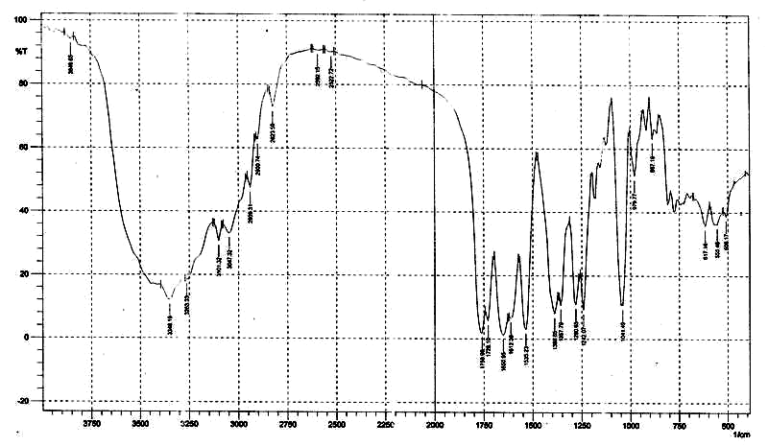
Fig.(12): FTIR spectrum for the pure CFX

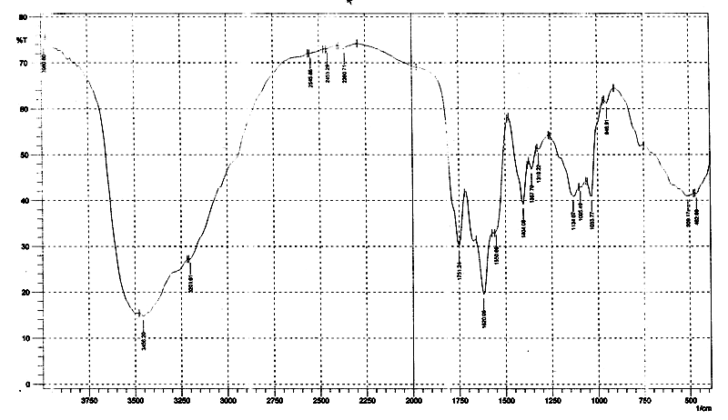
Fig.(13): FTIR spectrum for CFX-Rh(II) complex

Consequently, we can propose the structure of the complex formed (Fig.14).
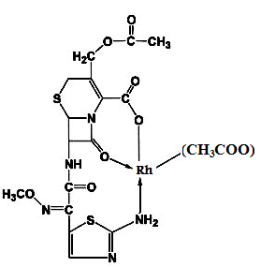
Fig.(14): Probable chemical structure of CFX-Rh(II) formed

To ensure the stability of the complex in organic medium throughout measurements by AAS, we used the recovery percentage measurements with different time interval as a clue, for the complex containing 25 μg mL⁻¹ of CFX. Excellent recovery of 100.02±2.88% as a mean were obtained up to 24 h duration time.

- Analytical Data
The proposed method was evaluated under the optimum conditions with regard to response linearity, detection limit, accuracy and precision. Beer's law was obeyed in the concentration range 2-50 μg mL⁻¹ of CFX. Linear regression analysis using least square method for calibration points (n=10) was made to evaluate the slope, intercept and correlation coefficient. The regression calibration equation obtained was; A=3.4×10⁻³C +16.1×10⁻³ (where A is the absorbance and C the CFX concentration as µg mL⁻¹) with a correlation coefficient of r= 0.9984 and the coefficient of determination (R²) of 99.70% which suggests statistically valid. This fitted linear calibration model was used to estimate the CFX concentration in the drug samples which appears justified, on statistical basis. The confidence limits of slope and intercept of the regression line were computed using the formulas b ± ts_{b} and a ± ts_{a} at 95% confidence level and found to be 3.4×10⁻³±1.1×10⁻⁴ and -1.9×10⁻³±0.3×10⁻³ respectively. Limit of detection was calculated on the statistical basis from the calibration graph data and found to 0.13 µg ml⁻¹.
The accuracy in term of recovery percent and precision were established by spiking of 10, 25 and 40 µg mL⁻¹ using the recommended procedure previously mentioned in standard additions methods statement. The results were shown in Table 1.

Table 1: The accuracy and precision of the proposed method for the determination of CFX in pharmaceutical preparation
Amount of Cefotaxime taken (μg.mL⁻¹) | Amount of Cefotaxime found (μg.mL⁻¹) | %Rec. | %E_{rel.} | %RSD  n = 3 | Conf. Limit. for %Rec.±S.D | Mean %E_{rel.}
10  25  40 | 10.12  25.43  40.75 | 101.2  101.72  101.87 | 1.20  1.72  1.87 | 1.49  0.94  0.56 | 101.59 ± 0.73 | 1.596
- Determination of CFX in Sefotak
The proposed method was applied for the determination of CFX in Sefotak vials with stated value of 1000 mg per unite by using direct calibration and standard additions procedures (Fig.15) under optimum conditions. The CFX was determined through the atomization of the complex extracted as a result of the reaction of CFX present in the pharmaceutical preparation with rhodium (II) and found to be 989.87 and 970.93 mg / unit with relative error of (-1.01%) and (-2.9%) respectively. The results found by both procedures were agreed with stated concentration value and in a good agreement with results obtained by direct UV-Vis spectrophotometric method that was carried out in our laboratory under optimum conditions.

Fig.(15): Determination of CFX in pharmaceuticals by using direct and standard additions procedures

y = 0.0034x+ 0.0019
r = 0.9985

It can also be observed from (Fig. 15), that the ratio of the slopes of the direct calibration and standard additions is found to be same, which indicates that the interferences resulting from drug constituents are insignificant using the proposed procedure. Thus, it is possible to use direct calibration procedure for the determination of CFX in drugs without need the standard additions method which requires more effort, more amount of sample and time-consuming. This is also support the specificity of the proposed method, indicating that the excipients did not interfere with the analysis of CFX.
Since the majority of the determinations of CFX drug have been performed by using UV-Vis spectrophotometric technique as intimated by literatures survey, this technique was also used in our laboratory for the detection of CFX as CFX-Rh(II) after taking into account all optimized conditions that were carried out with indirect FAAS, in an effort to compare it with the proposed method, to infer whether there is a significant difference in the results in term of systematic errors between two techniques at 95% confidence level. The numbers of merit of two techniques were summarized in Table 2.

Table 2: Analytical statistics data for both indirect AAS and UV-Vis spectrophometry for the determination of CFX as CFX-Rh(II)
Expression | Indirect AAS | UV-Vis Spectrophotometry
Range of concentration (µg.mL⁻¹) | 2–50 | 5-120
Detection limit (µg.ml⁻¹) for n=13 | 0.13 | 0.223
Regression line | y=0.0034x+ 0.0019 | y=0.0059x+0.0253
Correlation coefficient (r) | 0.9985 | 0.9987
Coefficient of determination (R²) | 99.70% | 99.74%
C.L. for the slope(b±ts_{b}) at 95% | 0.0034±0.0001 | 0.0059±0.0002
C.L. for the intercept(a±ts_{a}) at 95% | -0.0019±0.0003 | 0.0253±0.0131
RSD% (n=3) | 0.99% | 1.71%
Mean Recovery% | 101.59±0.73 | 102.03±0.38
Molar absorptivity  (L mol⁻¹ cm⁻¹) | ---- | 4.85×10³
Sandell's sensitivity (μg.cm⁻²) | ---- | 0.1041
Extraction Efficiency (%E) | 0.1041 | 97.34
Distribution ratio (D) | 61.68 | 61.63

To validate the proposed method with UV-Vis method, the regression line between two methods was constructed after taking into consideration the common concentrations of calibration range (Fig. 16). The t-test for (r) was computed according to formula adapted by Miller and Miller ^{[25]} .It was found that the calculated value of t is 31.57 compared with tabulate (t=2.776) at 95% confidence level, using two-sided t-test and (N-2) degree of freedom, indicate that a significant correlation does exist between two methods at the cited concentrations range.
This means that no discrepancy in the application of each method for the detection of CFX in pharmaceutical preparations. Also, the precision of two methods was compared statistically using F-test for triplicate measurements of CFX in pure form. The value of F was calculated and found to be 1.057 which was less than F-tabulated (5.05) at 95% confidence level, indicating there is no significance difference in precision of both techniques.

Finally, the amount of CFX in pharmaceutical was determined by each method using direct calibration curves .It was shown that the indirect AAS gave 989.87 mg per unite with relative error of (-1.01%) compared with UV-Vis spectrophotometry which gave 990.58 mg per unit with relative error of (-0.94%).
An alternative indirect AAS method has been reported for the analysis of cefotaxim in pure form and pharmaceuticals. To the best of our knowledge, no report has been considered the reaction between CFX with Rhodium(II), and determined the drug by FAAS. The proposed method is simple, accurate, precise, and specific and can be used for routine quality control in both the pure form and pharmaceuticals without fear of interference that caused by the presence of excipients in pharmaceutical preparations. The results show that the quantity of CFX in Sefotak are in a good agreement with given labeled quantity. Furthermore, Due to its low detection limit, the indirect AAS method could be applied for the assay of CFX in biological samples such blood and urine.

Fig.(16): Regression line between indirect AAS and direct UV method for the determination of CFX as CFX-Rh (II)

References
- "The Merck Index an CD-Rom" 12th ed., copy right by Merck Co., Inc. Whiteho, 2000.
- Nigam P, Mohan S, Kundu S, and Prakash R Talanta 2009, 77, 1426-1431.
- El-Maali N A, Osman A H, Aly A A M and Al-Hazmi G A A J. of Bioelectrochemistry 2005, 65, 95-104.
- Samanidou V F, Tsochatzis E D, and Papadoyannis I N J. of Microchim Acta 2008, 160, 471-475.
- Bafeltowskaa J J, Buszmana E, Mandatb K, and Hawranekb J J. of Chromatography A 2002, 976, 249-254.
- Zendelovska1 D, Stafilov T, and Miloševski P J. of Bulletin of the Chemists and Technologists of Macedonia 2003, 22(1), 39-45.
- Sharma P, Chawla H P S and Panchagnula R J. of Pharmaceutical and Biomedical Analysis 2002; 27(1-2), 39-50.
- Samanidou V F, Hapeshi E A and Papadoyannis I N J. of chromatography B 2003, 788(1), 147-158.
- Ling S S N, Yuen K H and Barker S A J. of chromatography B 2003, 783(1), 297-301.
- Aleksi M M, Kapetanovi V, Atanackovi J, Joci B and Zeˇcevic M Talanta 2008, 77, 131-137.
- Aleksic M M and Kapetanovic V J. of Electroanalytical Chemistry, 2006, 593, 258-266.
- Kulapina O I, Baraguzina V V and Skoblikova N V Pharmaceutical Chemistry Journal , 2008, 42(3), 48-50.
- Ayad M M, Shalaby A A, Abdellatef H E and Elsaid HM J. of Pharmaceutical and Biomedical Analysis, 1999, 18(6), 975-983.
- Saleh G A, Askal H F, Radwan M F and Omar M A Talanta, 2001, 54(6), 1205-1215.
- Amin A S and Ragab G H Spectrochimica Acta Part A, 2004, 60(12), 2831-2835.
- Rao G D, Kumar K G and Chowdary K P R Indian Journal of Pharmaceutical Sciences, 2000, 60(2), 161-163.
- Al-Momani I F J. of Pharmaceutical and Biomedical Analysis, 2001, 25(5-6), 751-757.
- Metwally F H, Alwarthan A A, Al-Tamimi S A IlFarmaco, 2001, 56(8), 601-607.
- El-Maali N A, Osman A H, Aly A A M and Al-Hazmi G A A Bioelectrochemistry, 2005, 65(2), 95-104.

- Aleksić M. M. and Kapetanović V J. of Electroanalytical Chemistry, 2006, 593(1-2), 258-266.
- Morelli B J. of Pharmaceutical and Biomedical Analysis, 2003, 32(2), 257-267.
- Albert S Meyer Jr., and Gilbert H Ayres, J Am Chem Soc., 1957, 79, 49-53.
- Meyer J A and Ayers G J. Am. Chem. Soc., 1957, 79, 49-53.
- Anacona J R and Da Silva G J. of the Chilean Chemical Society, 2005, 50(2), 447-450.
- Miller J N, and Miller J C, Statistics and chemometrics for analytical chemistry; Pearson Education Ltd, England 2000, 126.

