Study of Removal of Pb,Zn,Cu and Ni Ions from Iraqi factories wastewater using local porcelanite rocks

Jameel M. mousa
Department of Chemistry, College of Science, Al-Mustansyria University
Adnan H. Afaj and Esam A.bd-Alwahed
Ministry of Science and Technology

Key words : adsorption, pollution, porcelanite rocks , Heavy metals.

(NJC)

(Recevied on 18/4/2010) (Accepted for publication 7/7/2010)

Abstract
The present study aims to remove some ions of heavy metals such as Cu, Zn, Ni, and Pb ions from industrial wastewater of plant manufacturing batteries, electrical industries, and detergent factories, using Iraqi porcelanite rocks from western desert in Iraq. It was found that, these siliceous rocks have a high susceptibility to remove the ions of heavy metals from industrial wastewater with efficiency of removal ions ranged from 90-100%, under controlled conditions such as flow rate, practical size , temperature , and pH of solution which were 30 ml/hr, 3mm, 30°C, and 2 respectively. The study had indicated appositive relationship between the removal efficiency of the heavy metals with the increasing weight of the adsorbent materials within the column. The selectivity sequence can be given as, Pb> Zn> Cu> Ni. These results show that Iraqi porcelenite rocks hold great potential to remove cationic heavy metal species from industrial wastewater.
الخلاصة
تهدف الدراسة الى ازالة بعض الايونات الفلزية الثقيلة: الرصاص ,الخارصين, النحاس والنيكل من مخلفات مياه المصانع المحلية , مصنع البطاريات , الصناعات الكهربائية و مصانع المنظفات , باستعمال صخور البورسلينات العراقية الماخوذة من الصحراء الغربية . لقد تبين ان لهذه الصخور القابلية على ازالة هذه الايونات من مياه المخلفات الصناعية وبكفاءة تتراوح بين 90 – 100 % عند ظروف مسيطر عليها تتمثل في معدل الجريان, حجم الدقائق, درجة الحرارة, و الاس الهيدروجيني وكانت 30 مل / ساعة , 3 ملم , 30 ºم , 2 على التوالي . توصلت الدراسة الى علاقة طردية بين كفاءة الازالة لهذه الايونات مع زيادة وزن المادة المازة (الصخور) الموجودة في العمود. كان ترتيب الانتقائية هو الرصاص > الخارصين > النحاس > النيكل . اظهرت هذه النتائج القدرة الكبيرة لصخور البورسلينات العراقية على ازالة الايونات الثقيلة من مخلفات مياه المصانع المختلفة .

Introduction
Nowadays, industrial revolution has accelerated the release of pollutants into the environment and heavy metals are among the most important pollutants in our environment. Many of the heavy metals, e.g ,Hg , Pb , Ni, As and Sn are highly toxic to humans and other living organisms and their presence in surface and underground waters at above background concentrations is undesirable ⁽¹⁻³⁾ . Removal of heavy metals from water is important to protect public health, as natural processes can no longer cleanse the environment of the enormous quantities of pollutants that are generated daily. Usually, treatment at source is the only practical means of controlling toxic metal pollution ⁽³⁾. Wastewater containing toxic metals may be treated by addition of anions that cause the precipitation of the metals as insoluble salts ⁽⁴⁾. Other methods include membrane filtration, activated carbon adsorption, co-precipitation, adsorption, ion exchange and extraction⁽⁵⁻¹⁰⁾. On the other hand the Iraqi porcelanite rocks represent one of the most and great adsorbents , because it is containing high percentage of silicon reached to 50% .However , our search through the literature reveals that limit works have been done on the adsorption of metal ions by using Iraqi porcelanite rocks as adsorbents .In this study was reported the ability of different kinds of Iraqi porcelanite rocks as adsorbents for the removal of some metal ions (Ni⁺²,Cu⁺²,Zn⁺² and Pb⁺²) from water .
Materials and Methods
1) Many geological sample rocks had supplied from the general company of geological scanner, Baghdad, and then brooken into many pieces of rocks with different particle size by especial mechanical cracking.
2) Characterization of porcelanite rocks.
a- Characterization by X-ray diffraction type Shimadzu 6000.
b- Characterization by FT-IR type Shimadzu with range (400- 4000) cm⁻¹by using KBr to analysis the sample.
3) Preparation the column ; special column of glass been selected by length 100 cm length and 2cm diameter ,with Teflon stopcock (Rotaflo)in the bottom to control flow rate. The column was filled with small pieces of rock using slurry packing technique.
4) Preparation of synthetic wastewater ; special mixture of Pb, Zn, Cu and Ni ions was prepared from analytical stock standard at quite concentration of 1000 ppm to each ion . Another solution was prepared to get concentration of 100 ppm to each ion by using serial dilution method with constant pH. After adsorption process the effluent solution was taken to measurement the concentration of metal ions using atomic absorption spectrophotometer type Shimadzu AA-6200 .
5) Column sorption experiment; this experiment wast done at room temperature with constant pH. 1M of HCl and NaOH to provide 100 ml volume of mixture solution of Pb, Zn, Cu and Ni ions. Another experiment tested with special optimization conditions involving (flow rate of mixture solution, particle size of porcelinite rocks, weight of adsorbent and pH of solution). The down draft solution to determine the concentration of metal ions that not adsorbed on this column was determined by atomic absorption spectrometer.
6) Calculation of the adsorbed cations on porcelanite rocks; to calculate the concentration of adsorbed ions, the following equation was used;
Q_{e} = v (C_{o} – C_{e})/M where Q_{e} = quantity of adsorbed material (mg) v= volume of solution (ml) C_{o} = initial concentration (mg/l) C_{e} final concentration (mg/l) M= weight of adsorbed material.
7) Practical application of porcelanite rocks as adsorbed material; many samples of wastewater collected from unit treatment of factories (batteries industry, electric industries and detergent industries) before and after treatment. These samples were put in plastic containers with volume 20 liters. All above steps repeated to determined concentration of adsorbed ions on the porceliniate rocks.
Results and Discussion
Characterization of the surface of the local porcelanite rocks:
The XRD spectrum (Fig. 2) indicates existence of certain amount of Quarts and opal ; which are known as irregular interferents between two phases, krestoplyte and traidamayte-alpha; and also some other (kaolin and samktite )which can be found together with fine size silica .
The FT-IR spectra (Fig.1) shows existence of Si-O groups at 1530 cm⁻¹ or Si-OH at 3500 cm⁻¹ , as its percentage, in porcelanite might reach as much as 66%. This might have influence on the adsorption process as a result of binding of this group with the cations of metals.

Study of the optimum conditions required for the adsorption process on the local porcelanite rock :
1) pH Effect.
Study of the effect of pH for the solution of ions ( Fig 3) together with measurement of adsorption percentage has been illustrated that the best value of adsorption is at pH 2. It has been noticed that the adsorption process increases with the increase acidity of the medium; due to the ease adsorption of the cations on the rock surface, the acidity has an influence on the active adsorption sites within the adsorbent matter ⁽¹¹⁾. The (basic) solution has decreased the adsorption. When the surface becomes in contact with basic solution, so the Si-O groups, which situated at the end of rock's surface, will be affected by the alkali solution ⁽¹²⁾.
2) Effect of flow rate. :
It presents the contact time between adsorbed material and metal ions, so if the flow rate ranges (20-50) ml/hr for Pb⁺², Cu⁺², Ni⁺², and Zn⁺² as shown in figure (4) ,the % adsorption was equal to 98.98.
3) Effect of porcelanite rocks weight.
Figure (5) shows the effect of adsorbent weight on the ions removal, It was observed from the range of weight (16-67gm) of adsorbent has optimized the surface area to induce the adsorption of metal ion, and lessened the contact time at efficiency of 99.93% at constant conditions.
4) Effect of particle size
From the Table (1), the efficiency of adsorption is increasing with decreasing of particle size, so that the surface area of adsorbent increases because the bore surface will be occupied by metal ions.
Isothermal studies
The removal of metal ions by porcelanite rock which was reported as the experimental data were processed in accordance with the two of the most widely used adsorption isotherms; langmuir and Freundlich isotherms.the data were found to be best fit the Freundlich isotherm model assuming chemical adsorption between ions and porcelanite rock.
The Freundlich isotherm is given by the following equation.
Q_{e} = v (C_{o}-C_{e})/M
Where Q_{e} = quantity of adsorbent (mg), V= volume of solution (ml), C_{o}= initial concentration (mg/l), C_{e} =final concentration (mg/l),
M = weight of adsorbent(mg)
Fig,( 6 ) shows a plot of log Q_{e} against log. C_{e} for Zn (II) sorption on porcelanite rock as representative example for the application of freudlich model, The plot gives a straight line. The slope of isotherms model as constants were found to be 0.723, 0.8149, 0.7967, and 0.7387 for the adsorption of Pb, Cu, Zn and Ni on porcelanite rock, respectively.
Ion selectivity
The adsorption selectivity of different ions (Cu,Pb,Zn and Ni) were studied . Lead ion gives the best results with 100% adsorption compared with other ions.
Application of porcelanite rock as adsorbent.
1) Factory of batteries industries, Table (2) shows the concentrations of ions before and after the treatment. The percent removal of Pb and Cu ions were 100% while for the Ni and Zn ions were 99.9% and 98.3% respectively.
2) Factory of electrical industries, Table (3) shows the concentrations of Pb, Zn, Cu and Ni ions .The adsorption percent was 100% for Cu and 95% and 99% for Zn and Ni respectively.
3) Factory of detergents, Table (4) reveals the ions concentration after adsorption .The adsorption for all ions were 100%.
4) Additional measurements for removal of metal ions using porcelanite rock, Table (5) shows the measurements of pH, T.S.S., T.D.S. and conductivity before and after the treatment of wastewater. As shown from table, there are excellent results to removed metal ions using porcelanite rock
Conclusions
Order of adsorption, Pb (95-100), Zn (98.3-100), Cu (100%) and Ni (94.100%) for wastewater of electric factory, detergent factory, and batteries industrial factory were carried out in Baghdad –Iraq. The using of porcelanite rocks showed an efficiency removal of Pb, Zn, Cu and Ni ions, which present in aqueous solution of these materials ions. The removal percentages of the studied ions were depended on the following parameters, flow rate, pH of solution ,partical size and weight of the adsorbent .

Fig.(1) : FT.IR of porcelanite rocks

Fig (2): XRD of porcelanite rocks.

Adsorption %
PH

Fig. ( 3 ) :Effect of pH of solutio on removal% of metal ions.

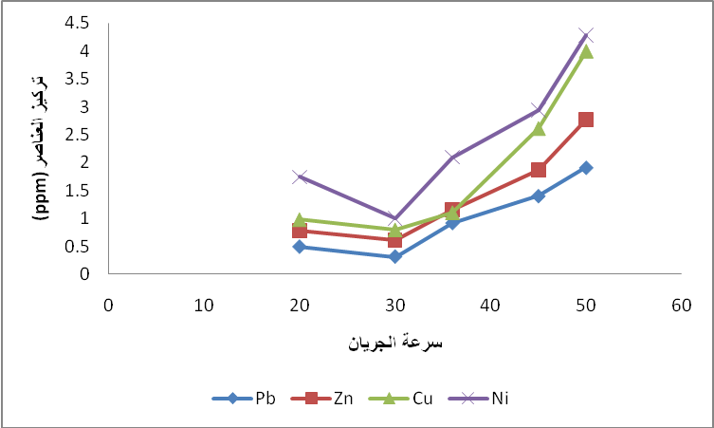
flow rate
Conc. (PPM)

Fig.(4) :Effect of flow rate of aqueous solution on the removal%
of metal ions.

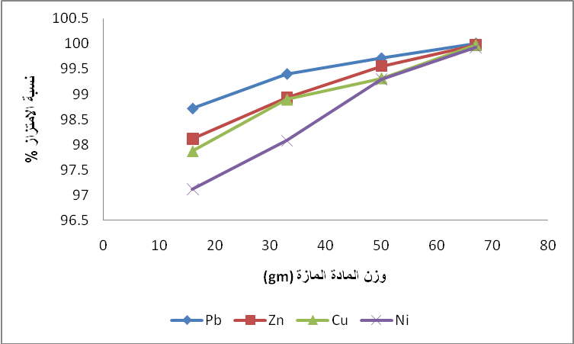
weight of adsorbed material (gm)
Adsorption %

Fig. (5) effect of loadig weight of of porcelanite rocks.

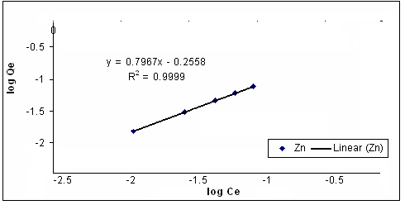

Fig.( 6 ) : Isothermal profile of removal% of Zn ion using
porcelanite rock.

Table ( 1) : Effect of particle size of porcelanit rock

Removal% of Ni | Removal% of Cu | Removal%  of Zn | Removal%  of Pb | Flow Rate  ml/hr | Particle  size  mm
99.0 | 99.3 | 99.6. | 99.7 | 30 | 3 mm
98.1 | 98.6 | 98.6 | 98.1 | 30 | 5 mm
97.0 | 97.1 | 97.9 | 98.2 | 30 | 8 mm

Table( 2 ) :Concentrations of metals ions in factory of batteries. industries
Removal% | Con. after treatment  µg/ml | Con. before treatment  µg/ml | metal
100 | Nil | 6.7741 | Pb
98.3 | 0.0668 | 3.3668 | Zn
100 | < L.D | 0.3304 | Cu
94.9 | 0.24 | 3.9596 | Ni

Table( 3 ) :Concentration of metals ions in factory of electrics industries

Removal% | Con. After treatment  µg/ml | Con. Before treatment  µg/ml | Metal
- | _ | _ | Pb
95 | 1.2041 | 23.6884 | Zn
100 | < L.D | 0.8281 | Cu
99 | 0.001 | 1.0134 | Ni

Table ( 4 ): Concentrations of metal ions in factory of detergents industries

Removal% | Con. After treatment  µg/ml | Con. before treatment  µg/ml | Metal
100 | < L.D | 2 | Pb
100 | < L.D | 0.9411 | Zn
100 | < L.D | 0.6258 | Cu
100 | < L.D | 0.3895 | Ni

Table( 5 ) : Measurement of wastewater of factories using porcelanite rocks
Conductivity  µs/cm |  | pH | T.S.S | T.D.S | Factory
 | 654 | 8.2 | 340 | 103 | Batteries(a)
 | 55 | 8.8 | 22 | 31 | Batteries(b)
 | 690 | 4 | 1648 | 607 | Electric's(a)
 | 19 | 7.1 | 37 | 76 | Electric's(b)
 | 89 | 5.6 | 180 | 532 | Detergents(a)
 | 12 | 7.6 | 25 | 25 | Detergents(b)
a=before treatment. , b=after treatment.

References
- Microslav R and Vladimir N.B., The Royal Society of Chemistry ,U.K., 1999, 6,7-267
- Jackson A.R. and Jackson I.M., Longman, London, 1995, 289-336
- ManahanS. E., (1994), Environmental Chemistry" ,6th edn , Lewis Publishing London 676-677.
- Abdl-ghani, N.T.,Hefny, M.,El.changhaby G.A., J.Environ.Sci.Tech., 2007, 4(1) ,67-73.
- SinghK.K., Rastogi R., and Hassan S.H., J. Hazard Mater , 2005, 121,(1-3),51-58.
- Abdel-ghani,N.T. and El-chaghaby G.A., Int. J. Environ. Sci. Tech., 2007, 4(4) ; 451-456.
- Gardea-Torresdey J.I., Tiemann K.I., Gonzalez I.H.., HenningT.A. and Townsend M.S., J. Hazard Mater , 1996, 57, 29-3 .
- Ajmal M.., Khan A.H.., Ahmed S.H., and Ahmed A.,Water Res., 1998, 32(10), 3085-3091.
- Kamel,M.M..,Ibrahim M.A.Ismaeel A.M. and El-motaleeb M.A., Ass. Uviv. Bull. Environ. Res., 2004, 7,(1).
- Ihan Uzun, and Fuat Guzel,(2000) , Turk.J.Chem., 2000, 24, 291-297.
- Egozy yair ,(1980), "Adsorption of cadimium and cobalt on montmorillonite as a function of solution composition clay and clay minerals",28,4,311.
- Forstner U. and Wittman G.j., (1981), "Metal pollution in the aquatic environment”, Springer-Verlag. Berlin, Germany, 2nd Edition

