Theoretical study to synthesis 1,3,5,-tri glycerol benzene using Semi-empirical and Ab-Initio calculation methods

Abbas .Abid Ali.Drea
Babylon University, College of Science, Chemistry Department

(NJC)

(Recevied on 12/8/2009) (Accepted for publication 14/6/2010)

Abstract
Theoretical study has been carried out through simulation of synthesis using quantum methods (semiemprical &Ab-initio ),that’s included in Hyper Chem 6.02 program. to under standing the Substitution reaction mechanism, and intermediates ,and transition structures involved during the reactions.
Chemical activity and chemical interaction of reactants and products have been studied by surface potential energy calculations . estimation of the high probable active sites in attachment of esterification and alkylations, the energetic properties have been studied ,as total energy, atomic charge , bond stability bond torsion, electric static field, and heat formation content.
The probable of first alkylation step has been studied through calculation of total energy , electric dipole moment constant , and heat change formation . In addition activation energy barrier calculation of all probable reactions have been carried out steps of the alkylation reaction.
Thermodynamically of ester hydrolyzed been estimated for 1,3,5,-tri glycerin benzene ,when chemical activity of synthetic compound has been studied through calculation of total energy ,electrostatic potential, electric dipole moment constant ,atomic charge distribution, electronic spectrum and heat formation change .
Twenty two of different chemical structure have been suggested and studied ,that’s represent the most important components of reactions mechanism involved during reactions. All probable occurrence reactions of substitution reactions were studied . high probable reactions that is having lowest activation energy value are testing by comparing with other probable competitive reactions(another probabilities),also the total change in heat content of reactions has been calculated.
Calculations show that’s , hydroxyl group and hydrogen atom in glycerol molecules of secondary carbon atom are more active than of primary carbon atom for esterification and alkylation reactions respectively. glycerol react efficiently with acetic acid in three steps to produced tri acetate glycerol through endothermic reaction ∆H_{re} = 28.157 kCal mol⁻¹ .
Alkylation reactions at aromatic ring take place through controlling system of orientation to give up 1,3,5- Tri (glycerol tri acetate) benzene by endothermic reaction ∑ ∆H_{rea} = 8.967(kCal mol⁻¹ ).
1,3,5- Tri glycerin benzene produced during hydrolysis the ester derivative with nine mole of water molecule by exothermic reaction ∆H_{rea} = -120.991(kCal mol⁻¹ ).large electronic density occurs through new products for nine polar functional gropes of hydroxyl.

الخلاصة
أجريت الدراسة النظرية لمحاكاة التخليق بوساطة طرق ميكانيك الكم(الشبة التجريبية والأولية الأساسية),المتضمنة في البرنامج هايبر كم 6.02 ,لغرض تفهم ومعرفة آليات تفاعلات الاستبدال والمركبات الوسطية وكذلك الحالات الانتقالية المتولدة خلال هذه التفاعلات.
تم دراسة الفعالية الكيميائية والتأثر الكيميائي للمواد المتفاعلة والناتجة بوساطة حسابات سطوح جهد الطاقة,لبيان المواقع الفعالة الأكثر احتمالا في عمليات الاتحاد لتفاعلات تكون الاستر والالكلة . درست المواصفات الطاقية مثل:الطاقة الكلية والشحن الذرية وقوة الآصرة والتواء الآصرة والمجال الكهربائي ومحتوى حرارة التكون.
تم دراسة خطوة الالكله المحتملة الأولى من خلال حسابات الطاقة الكلية وثابت عزم ثنائي القطب الكهربائي وتغير محتوى حرارة التكون وكذلك حسابات حاجز طاقة التنشيط لكل خطوات تفاعلات الالكله المحتملة.
تم بيان الدينيمية الحرارية التي يتحلل بها الاستر المتكون إلى 1 ,3 ,5 –ثلاثي كليسيرول بنزين,حيث درست الفعالية الكيميائية للمركب المخلق من خلال حسابات الطاقة الكلية والمجال الكهربائي الساكن وعزم ثنائي القطب الكهربائي الساكن وتوزع الشحن الذرية وطيف الانتقالات الاليكترونية ومحتوى حرارة التكون.
تم اقتراح ودراسة اثنين وعشرون تركيبا كيميائيا مختلفا ,والتي تمثل أهم المكونات المتولدة خلال إلية التفاعلات. درست جميع التفاعلات المحتمل حدوثها خلال تفاعلات التعويض,حيث إن التفاعل الأكثر احتمالا هو التفاعل الذي يمتلك اقل قيمة لحاجز طاقة التنشيط مقارنة مع التفاعلات المنافسة في احتمالية الحدوث(الاحتمالات الأخرى) ,كما تم احتساب التغير الكلي بمحتوى حرارة التكون لكل تفاعل .
الاستنتاجات
تبين الحسابات بان مجموعة الهيدروكسيل وذرة الهيدروجين التابعة لذرة الكاربون الثانوية في جزيئة الكليسيرول هي الاكثر فاعلية من تلك التابعة لذرات الكاربون الاولية في تفاعلات تكون الاستر والالكلة على التوالي. يتفاعل الكليسيرول بكفاءة مع حامض الخليك في ثلاث خطوات ليتكون ثلاثي خلات الكليسيرول بوساطة تفاعل ماص للحرارة ∆H_{re} = 28.157 كيلو سعره لكل مول .

تحدث تفاعلات الالكلة على الحلقة الاروماتية خلال سيطرة نظام التوجهات الفراغية لتكوين 1 ,3 ,5 - ثلاثي(ثلاثي خلات الكليسيرول)بنزين ,بوساطة تفاعل ماص للحرارة∆H_{re} = 8.967 كيلو سعره لكل مول .
يتكون المركب 1 ,3 ,5 – ثلاثي كليسيرول بنزين من خلال التحلل المائي لمشتق الاستر وذلك عن طريق تسعة مول من جزيئات الماء بوساطة تفاعل باعث للحرارة∆H_{re} =-120.991 كيلو سعرة لكل مول . يلاحظ وجود كثافة الكترونية عالية للناتج الجديد وذلك بفعل مجاميع الهيدروكسيل الوظيفية التسعة ذات القطبية العالية.

Introduction
Alcohols have applications in industry and science as reagents or solvents ,because of its low toxicity and ability to dissolve non-polar substances, its can be used in medical drugs, perfumes, and vegetable essences such as vanilla. In organic synthesis, alcohols serve as versatile intermediates⁽¹⁻³⁾ .
Different industrial applications needed poly functional compounds ,that have a soluble ability ,and flexible groups, according to their application. Modulation of structures are build up according to desired final structure. Glycerol is a poly hydroxyl alcohol ,that is interested to reaction with different functional groups like carboxylic acids ,amines ,nitrites ,metals ,and so on⁽⁴⁾. The activity can be increased by the reaction with another molecules like benzene ring to give up a highest electronic density over all molecule ⁽⁵⁾ . Preference to inter reactions will promote due combinations of about features .Resulted compound can be used in Drugs industry, bioagents ,or different industries ^{(6,7)} .
The Combinations between two molecules obey the chemical rules for interaction ,through bond broken and formations depending on reactivates. The electrostatic potential describes the interaction energy of the molecular system with a positive point charge. Electrostatic potential is useful for finding sites of reaction in a molecule .Positively charged species tend to attack the site where the electrostatic potential is strongly negative (electrophilic attack) ⁽⁸⁻¹⁰⁾ .
The present work was denoted to theoretical synthesis of 1,3,5 tri glycerin benzene using different calculation methods of quantum mechanics ,to obtaine a new characteristic of poly functional compounds .

Calculation details
Theoretical calculations of semi-empirical and ab-initio methods were performed using the Hyperchem version 6.0 program⁽¹¹⁾ , which was used to analyze the initial potential energy surface (PES). Through this study, various theoretical MO methods have been used, the geometries of the 22 structures of chemical species reactivates of reactants and products will be calculate through Ab-intio MP2 calculations methods using 3-21G*and STO3G basis set⁽¹²⁻¹⁴⁾ . Energetic properties of intermediates ,and transition states calculations by semi-empirical PM3 level ⁽¹⁵⁾configuration interaction microstate (3X3). , using the restricted Hartree – Fock (RHF) procedure have been determined⁽¹⁶⁾. The Polak–Ribier algorithm⁽¹⁷⁾ was used for the optimization, with the termination condition being a root mean square(RMS) of -0.001 kcal mol^{_1}.
Bond potential energy of length and bond torsion calculation carried out through semi-empirical UHF calculations.
Energy barrier calculation of competitive reactions are carried out by semiemprical /PM3 through algorithm of synchronous transit/Quadratic-RMS(gradient of 0.1kCal mol⁻¹ .
Result and Discussions
The total energy in the molecular orbital calculation is the net results of electronic kinetic energies and the interactions between all electrons and atomic cores in the system. This is the potential energy for nuclear motion in the Born-Oppenheimer approximation. The stable geometry of a molecule has a minimal total energy value⁽ ¹⁸⁾ .
Chemical reactivity
To begin the synthesis reaction of 1,3,5,-tri glycerol benzene ,must be blocked the hydroxyl groups in the glycerol before started with alkylation’s reaction into aromatic ring reaction . Nucleophilic substitution reactions are commonplace in organic chemistry, and they can be broadly categorized as taking place at a saturated aliphatic carbon or at (less often) a saturated aromatic or other unsaturated carbon centre⁽¹⁹⁾ . Esterification reaction by acetic acid keeping hydroxyl groups ,and then substitution reaction into aromatic ring will teak placed, at last hydrolysis reaction give-up the desired products. Majors reactant molecules are subject to their reactivates first to know what the reactive side in the reactants and products of the reation.
Figure 1 shows the energetic properties of glycerol calculated at 3-21G*basis set/full MP2. The electrostatic potential describes the interaction of energy of the molecular system with a positive point charge. Electrostatic potential is useful for finding sites of reaction in a molecule: positively charged species tend to attack where the electrostatic potential is strongly negative (electrophilic attack) . glycerol has two different sites for different reactions ,the first is hydroxyl groups for esterfication reactions ,and the second hydrogen atoms for alkylation’s reactions.
Calculation estimated that’s the two oxygen atoms O4 and O6 have lowest reactivity toward esterfication than the oxygen O5 since they have -0.694 with -0.689 and -0.710 atomic charge respectively ⁽²⁰⁾ .

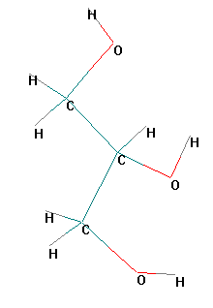 | 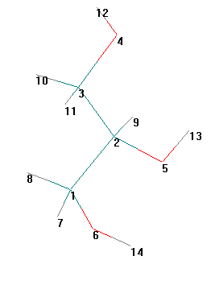 | 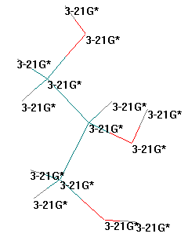
a-symbol of atoms | b-number of atom | c-basis set
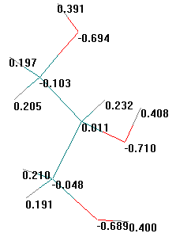 | 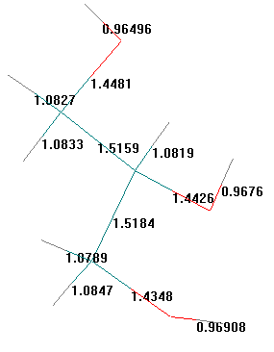 | 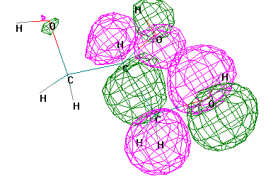
d- Atomic charge | e- Bond length | h- Molecular Orbitals
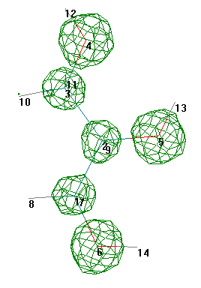
i-total charge density

Figure 1 Energetic properties of glycerol calculated at Ab-initio through 3-21G*basis set /full MP2.

Figure 2-A shows the potential energy calculated of different glycerol bonds . highest stability of O4-H12 and O6-H14 bond than O5-H13 bond . The bond distance of O4-H12 is 0.947111Aº (-1254.339 kCal mol⁻¹ ) and the torsion angle of terminal hydroxyl group (C2-C3-O4-H12) equal to -174.874º (-1248.12 kCal mol⁻¹), but bond distance of O5-H13 is 0.947884Aº (-1149.239 kCal mol⁻¹ ) , and the torsion angle of mid hydroxyl group(C1-C2-O5-H13) equal to 179.535º (-1245.37 kCal mol⁻¹ ).
The results mean that O5-H13 bond is more active in esterfication reaction than other hydroxyl groups ⁽²¹⁾ .

A-compares between the stability of hydroxyl groups .
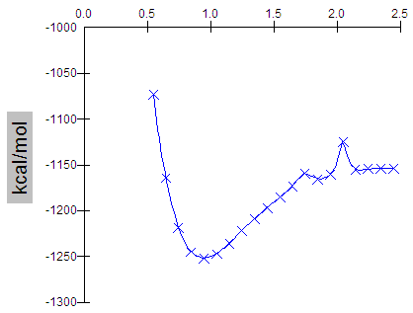 | 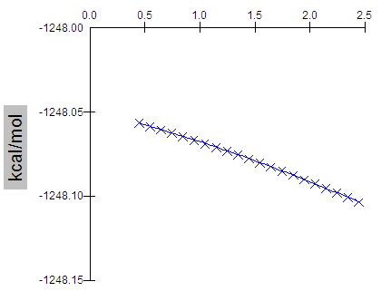
Bond distance of O4-H12 | Torsion angel of C2-C3-O4-H12
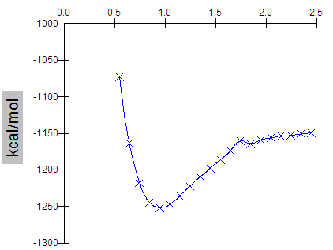 | 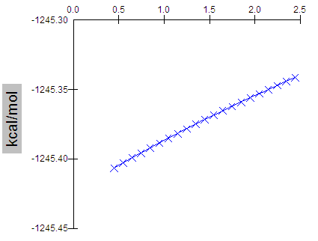
Bond distance of O5-H13 | Torsion angel of C2-O5-H13
B-The stability of hydrogen carbon bonds as foundation of bond distance an torsion angle.
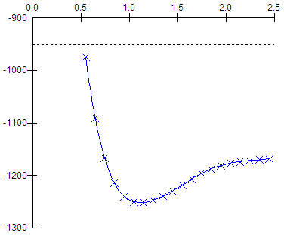 | 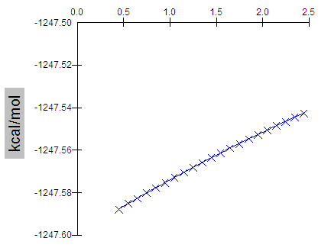
Bond distance of C1-H7 bond | Torsion ofC3- C2-C1-H7
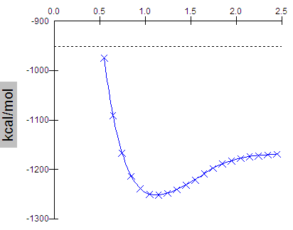 | 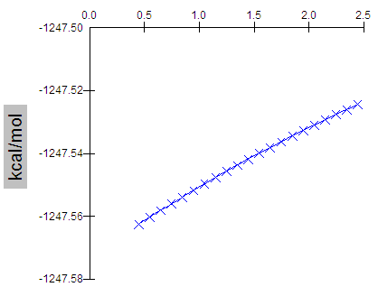
Bond distance of C2-H10 bond | Torsion of H8-C1-C2-H9

Figure2: The potential energy as foundation bond distance and torsion angle for bonds stability in glycerol molecule, calculated by semi-empirical-UHF-at PM3 level.

Figure 2-B shows that’s highest stability of C1-H7 and C3-H10 bond than C2-H9 bond . The bond distance of C1-H7 is 1.107Aº (-1248.767 kCal mol⁻¹ ) and the torsion angle of terminal hydrogen bonds (C3-C2-C1-H7) equal to -70.442º (-1247.59 kCal mol⁻¹) ,but bond distance of C2-H9 is1.118Aº (-1254.354 kCal mol⁻¹ ) , and the torsion angle of (H8-C1-C2-H9) equal to -71.842º(-1247.568 kCal mol⁻¹ ).
Results of calculus refer that H9 atom more reactive in alkylation’s reaction of aromatic ring as leaving atom than other hydrogen atoms in glycerol molecule.
Figure 3 shows the electrostatic potential and positive point charge of acetic acid for calculated molecules as a masked agent for hydroxyl groups in glycerol. The oxygen of hydroxyl group is more active ,than second oxygen atom ,since atomic charge equal to-0.712 and -0.605 respectively, therefore hydroxyl group in acetic acid is a good leaving group in esterfication reaction to produce water molecule in condensation reaction ⁽²²⁾ .
Figure 4 represents the calculated energetic properties of benzene molecule, since this molecule has homogenous electrostatic potential ,and atomic distribution charge. This phenomena will change as soon as the benzene ring participate into the alkylation’s reactions, due the change in electronic density be the effect of substituted groups ⁽²³⁾ .

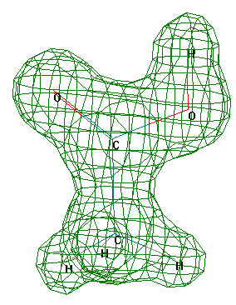 | 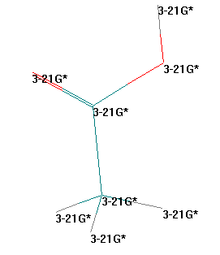
Electric field | Basis set
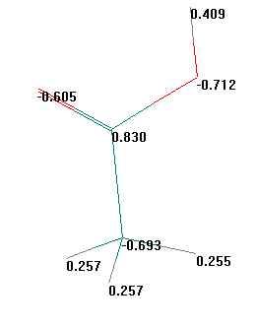 | 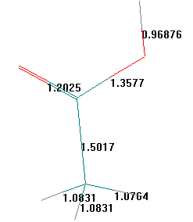
Atomic charge(A⁰) | Bond length(A⁰)

Figure 3 Energetic properties of acetic acid calculated at Ab-initio through 3-21G*basis set /full MP2.
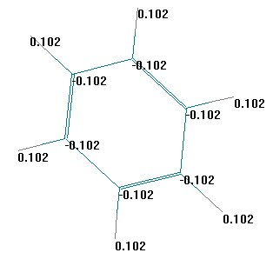 | 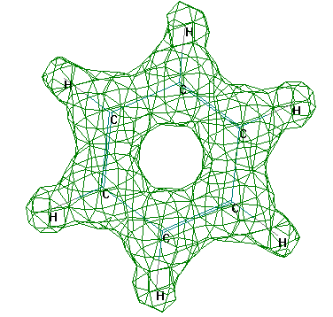
Atomic charge | Electrostatic potential
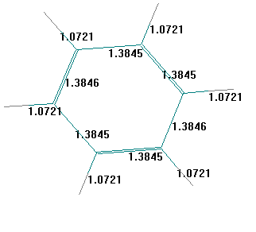 | 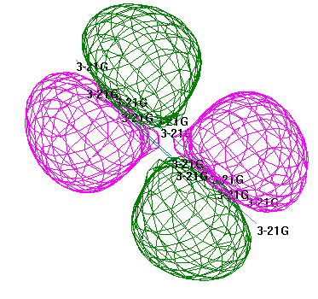
Bond length | Molecular orbital with basis set
Figure 4 Energetic properties of Benzene calculated at 3-21G*basis set /full MP2.

Esterification Reaction mechanism
The proposed mechanism of esterification reaction must be involve all the suspected generated chemical species to know the true path way of reaction. Figure 5 show the structures of proposed moieties that’s participate in esterification reaction as cylindrical-ball view.
Table1 represented some of energetic properties of proposed coded structures, were the lowest energy value consider to highest stability, also symmetry axis importance com from the side of interaction between the reactant moieties. Reaction of esterification occurs by several probabilities depending upon the reactivity if hydroxyl groups toward this reactions. Probability of reaction take please when the reaction has low value of energy barrier than other probable reactions through penetrate of transition state ⁽²⁴⁾ . Therefore simulation mechanism of esterification that’s represented in figure 6 show ,the more probable reaction occurs at hydroxyl of carbon atom number 2, and the terminal hydroxyl groups will esterifies later in glycerol molecule depending on energy barrier calculations. this result is accepted with previous results, that’s mid hydroxyl have the highest reactivity than other terminal hydroxyl groups.
Calculation estimated that is esterification reaction of glycerol is endothermic reaction (28.157 kCal mol⁻¹ )as in equation (1) ,therefore this reaction must be supplied energy through reflexes ,or catalyst must be used for reaction to take place practically ⁽²⁵⁾.

CH₂OH-CHOH-CH₂OH +3CH₃-COOH→ H₂-COCOCH₃ +3H₂O (1)

H -COCOCH₃

H₂-COCOCH₃
^{∆Hre = 28.157 kCal mol-1}
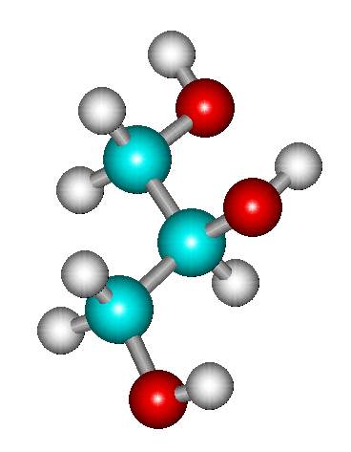 | 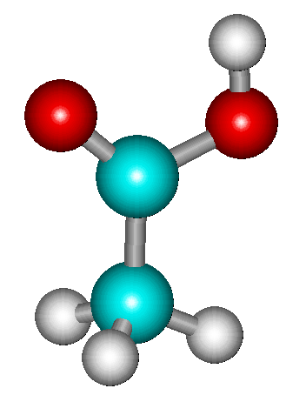 | 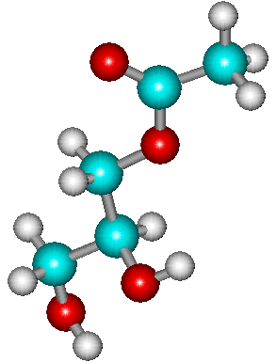
1- Glycerol | 2- Acetic acid | 3- 1-Monoacetate-Glyecrol
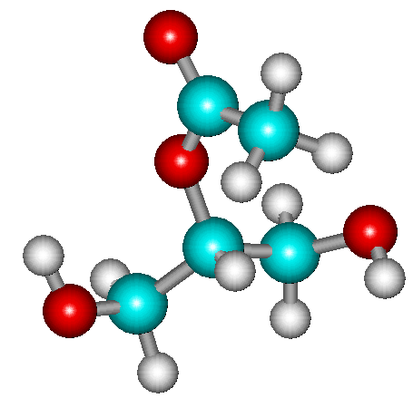 | 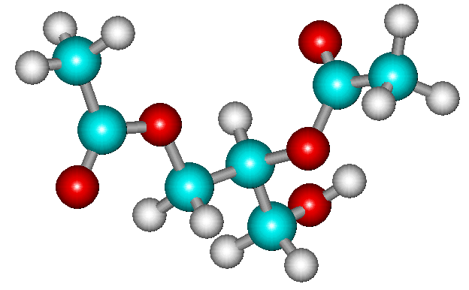 | 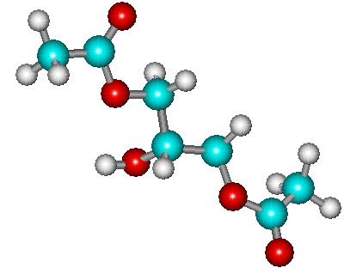
4- 2-Monoacetate-Glyecrol | 5- 1,2-Diacetate-Glyecrol | 6- 1,3-Diacetate-Glyecrol
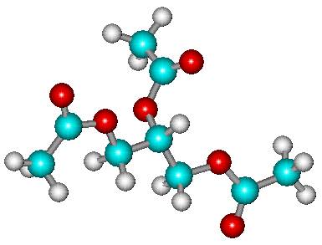 | 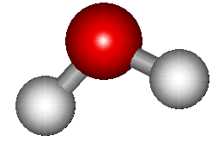 | 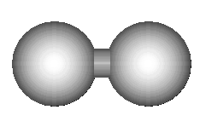
7- 1,2,3-Tri acetate Glycerol | 8- H₂O | 9- H₂
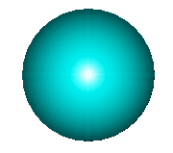  carbon atom |   Oxygen atom |   hydrogen atom

Figure 5 The proposed structures compounds calculated by configuration interaction semi-empirical PM3 for the lowest microstate (3X3) , ball and cylindrical view.

Table 1 Energetic properties of propose coded structures compounds for esterification mechanism calculated PM3CI microstate(3X3).
Code Structure numbers | Total energy  (kCal mol⁻¹) | Heat of formation  (kCal mol⁻¹) | Binding Energy  (kCal mol⁻¹)
1 | -31376.756 | -144.008 | -1252.171
2 | -20455.925 | -105.532 | -774.838
3 | -44329.185 | -185.276 | -1798.982
4 | -44327.973 | -184.064 | -1797.77
5 | -57278.560 | -223.489 | -2342.738
6 | -57278.573 | -223.502 | -2342.751
7 | -70228.010 | -261.777 | -2886.569
8 | -7496.122 | -56.890 | -220.653
9 | -723.068 | -15.911 | -120.115

CH₂OH-CHOH-CH₂OH + CH₃-COOH CH₂OH-CH-CH₂OH+H₂O
∆H_{re}=8.556
OCOCH₃
EB=199.09
∆H_{re}=7.374
_{+ CH3COOH}
EB=172.414
∆H_{re}= -0.783

CH₂-CHOH-CH₂OH +H₂O CH₂--CH₂-CH₂OH +H₂O

OCOCH₃ CH₃OCO OCOCH₃
+CH₃COOH
+CH3COOH
EB=166.981
∆H_{re}=10.354
EB=173.626
∆H_{re}=10.429
EB=139.831
∆H_{re}=10.416

CH₂OCOCH₃

CH₂OCOCH₃ CH₂OCOCH₃ CHOCOCH₃

CHOCOCH₃ CHOH CH₂OCOCH₃ +H₂O

CH₂OH +H₂O CH₂OCOCH₃ +H₂O (most probable path way)

CH₃COOH CH₃COOH
EB=166.981
∆H_{re}=10.354
EB=172.83
∆H_{re}=20.367

CH₂OCOCH₃ CH₂OCOCH₃

CHOCOCH₃ +H₂O CHOCOCH₃ +H₂O

CH₂OCOCH₃ CH₂OCOCH₃

* black colure represens the more expected path way of reaction mechanism.
Figure 6 Schematic diagram of proposed esterification mechanism reactions calculated through penetrate of transition state PM3-configuration interaction microstate (3X3).

Alkylation’s reaction Mechanism
Substitution reactions into aromatic rings controlling by the nature of substituted groups. Simulation of this reaction involved all the geometries optimized structures for suspected chemical moieties that’s participate in alkylation’s reactions have been calculated represented in figure 7 through cylindrical &ball view. All effected factors like strict hindrance ,electrical effects were taken in mind to get out the closer view of the reality structure of desire modulated products ⁽²⁶⁾ .Table 2 show the energetic properties of propose coded structures compounds . Some of these compound have critical structure because some these bulky ,also the flat structure of carbon atoms (SP²) in benzene ring have been loosed due more substituted in the ring . Table 3 shows compares between different competitive reactions, were the most probable reaction that’s have low value of energy barrier is that of low.
According to the result of calculation the first step of reaction occurrence by energy barrier equal to 415.04 kCal mol⁻¹ the reaction is endothermic by absorption 2.835 kCal mol⁻¹ as in equation (2).Second step of reaction has several probabilities as in Table 3 the reaction of lowest value of energy barrier is the most probable and its more respected ,were derivative of 1,3-Di (Triacetate glycerol) benzene is produced with EB= 16425.148 (kCal mol⁻¹ ) and ∆H_{rea} =3.466 (kCal mol⁻¹ ) as in equation (3). In third step the predominant probability produced 1,3,5-Tri (Triacetate glycerol) benzene with EB= 290.56 (kCal mol⁻¹ ) and ∆H_{rea} =2.666 (kCal mol⁻¹ ) as in equation (4) .The summation equation of total reaction can be summarized in equation (5),that is represent the formation of 1,3,5-Tri (Triacetate glycerol) benzene is endothermic reaction with 8.967(kCal mol⁻¹). In practically the energy value of this reactions can be decreased using catalyst to achieve reaction with economic values.

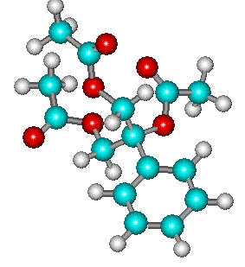 | 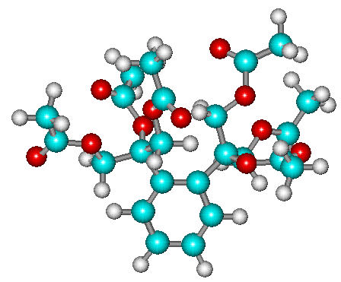
1- Mono( Glycerol tri acetate) Benzene | 2- 1,2-Di (Glycerol tri acetate) Benzene
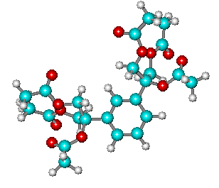 | 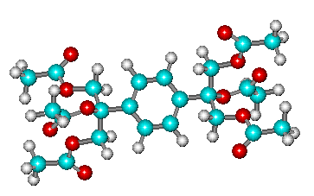
3- 1,3-Di( Glycerol tri acetate) Benzene | 4- 1,4-Di( Glycerol tri acetate) Benzene
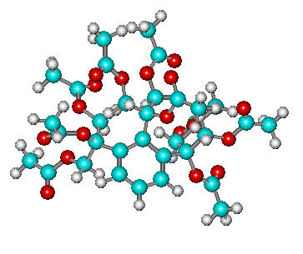 | 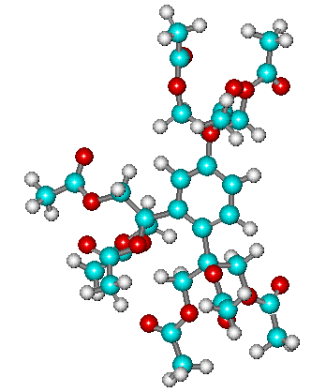
5 1,2,3Tri- (Glycerol tri acetate) Benzene | 6 1,3,4Tri-( Glycerol tri acetate) Benzene
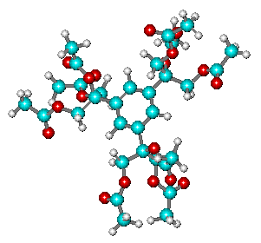 | 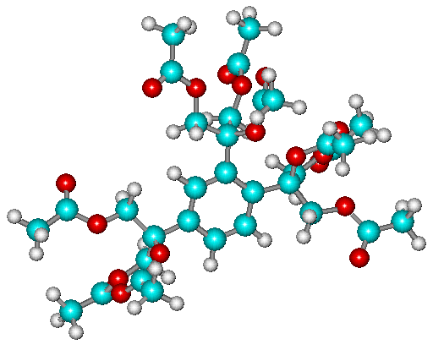
7 1,3,5- Tri (Glycerol tri acetate) Benzene | 8 1,2,5- Tri (Glycerol tri acetate) Benzene
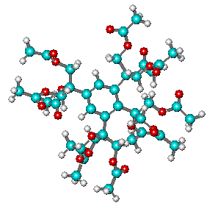 | 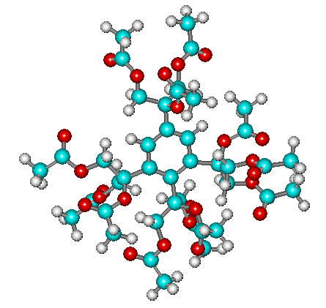
9- 1,2,3,5-Tetra (Glycerol tri acetate) Benzene | 10 1,3,4,5- Tetra( Glycerol tri acetate) Benzene
Figure7 Geometries optimized structures for suspected chemical moieties that is participate in alkylation’s reactions calculated at PM3-Configruation interaction micro state(3X3)level.
Table 2 Energetic properties of purposed coded structures compounds for Alkylation’s reactions mechanism calculated PM3/CI microstate(3X3).
Structure numbers | Total energy  (kCal mol⁻¹) | Heat of formation  (kCal mol⁻¹) | Binding Energy  (kCal mol⁻¹)
1 | -88029.622 | -233.286 | -4091.826
2 | -157510.522 | -455.109 | -6834.237
3 | -157531.098 | -475.686 | -6854.814
4 | -157528.497 | -473.084 | -6852.212
5 | -226993.227 | -678.738 | -9618.602
6 | -227007.205 | -692.717 | -9592.433
7 | -227033.375 | -718.886 | -9618.602
8 | -227009.049 | -694.560 | -9594.276
9 | -296489.952 | -916.388 | -12336.692
10 | -296482.968 | -909.403 | -12329.707

Table 3 Calculations of energy barrier and heat of reactions through penetrate of transition state PM3-configuration interaction microstate (3X3) for the most probable reactions .
Reactants | Products | Energy barrier  (kCal mol⁻¹ ) | Heat of reaction  (kCal mol⁻¹ )
benzene + Tri acetate-glycerol | Mono( Tri acetate-glycerol)- benzene +H₂ | 415.04 | 2.835
1-(Tri acetate glycerol)-benzene  + Tri acetate-glycerol | 1,2- Di (Tri acetate glycerol)-Benzene +H₂ | 93646.148 | 24.043
1-(Tri acetate glycerol)-benzene  + Tri acetate-glycerol | 1,3- Di (Tri acetate glycerol)-benzene +H₂ | 16425.148 | 3.466
1-(Tri acetate glycerol)-benzene  + Tri acetate-glycerol | 1,4- Di (Tri acetate glycerol)benzene +H₂ | 462526.856 | 6.068
1,3- Di (Tri acetate glycerol)-benzene  + Tri acetate-glycerol | 1,2,3- Tri (Tri acetate glycerol)-benzene +H₂ | 557468.889 | 42.814
 | 1,3,4- Tri (Tri acetate glycerol)-benzene +H₂ | 888976.432 | 28.835
 | 1,3,5- Tri (Tri acetate glycerol)-benzene +H₂ | 290.56 | 2.666
 | 1,2,5- Tri (glycerol tri acetate) benzene +H₂ | 889965.492 | 26.992
1,3,5- Tri (Tri acetate glycerol)-benzene  + Tri acetate-glycerol | 1,2,3,5- Tetra (Tri acetate glycerol)-benzene +H₂ | 1355678.459 | 48.364
 | 1,3,4,5- Tetra (Tri acetate glycerol)-benzene +H₂ | 1645389.731 | 55.349
*Bold numbers refers to most probable reactions energy barrier value than other probabilities.

C₆H₆ + C₉ H₁₄O₆ (C₉ H₁₃O₆)C₆H₅ + H₂ (2)
Benzene Triacetate glycerol Mono- Triacetate glycerol -benzene

EB= 415.04(kCal mol⁻¹ ) , ∆H_{rea} =2.835(kCal mol⁻¹ )

(C₉H₁₃O₆)C₆H₅ + C₉ H₁₄O₆ (C₉ H₁₃O₆)₂C₆H₄ + H₂ (3)
1,3-Di (Triacetate glycerol) benzene

EB= 16425.148 (kCal mol⁻¹ ) , ∆H_{rea} =3.466 (kCal mol⁻¹ )

(C₉H₁₃O₆)₂C₆H₅ + C₉ H₁₄O₆ (C₉ H₁₃O₆)₃C₆H₃ + H₂ (4)
1,3,5-Tri (Triacetate glycerol) benzene

EB= 290.56 (kCal mol⁻¹ ) , ∆H_{rea} =2.666 (kCal mol⁻¹ )

C₆H₆ + 3C₉ H₁₄O₆ (C₉ H₁₃O₆)₃C₆H₃ + 3H₂ (5)
Benzene Triacetate glycerol 1,3,5-Tri (Triacetate glycerol) benzene

∑ ∆H_{rea} = 8.967(kCal mol⁻¹ )

1,3,5-Tri glycerol benzene production
Production of 1,3,5-Tri glycerol benzene can be achieved through hydrolysis process of ester, where the esterification reaction has been don for protective or masking the hydroxyl group from other reactions as predict previously.

Hydrolysis of ester derivative represented in equation (6) that’s needed nine mole of water molecules to released 1,3,5-Tri glycerol, benzene with nine mole of acetic acid molecules .the reaction is exothermic and spontaneously occurs in the presence of water to give up1,3,5-Tri Glycerol Benzene with release 120.991(kCal mol⁻¹ ) of heat.
(C₉ H₁₃O₆)₃C₆H₃ + 9 H₂O (C₃H₈O₃)₃C₆H₃ +9CH₃COOH (6)
1,3,5-Tri glycerol, benzene

∆H_{rea} = -120.991(kCal mol⁻¹ )

Figure 8 represented the energetic properties of 1,3,5-Tri glycerol, benzene, this structure has nine hydroxyl groups can be enter into large different number of reactions to produced many different products ,like esterification with phosphate groups ,or any desired compound.
When they are comparing the properties of benzene Figure4,and glycerol Figure1,will estimate a new chemical characteristic compound. Calculation shows that electrostatic contribution along all the atoms in molecule also ,they have two electronic transition n→π* and π→π*.In this way the electronic densities increased due the polarity of nine hydroxyl groups, so this compound can be entered different reaction with higher performances .

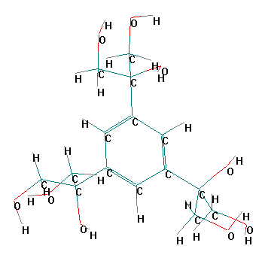 | 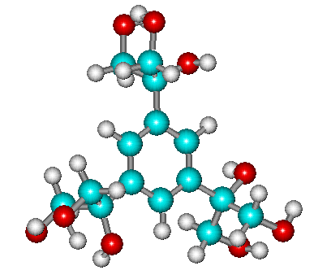
1-Symbol stick view | 2-cylindrical and ball view .
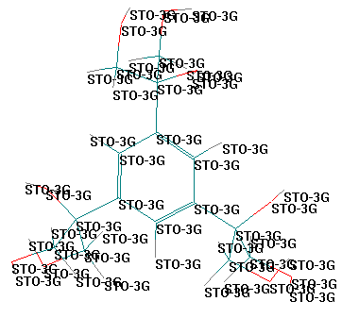 | 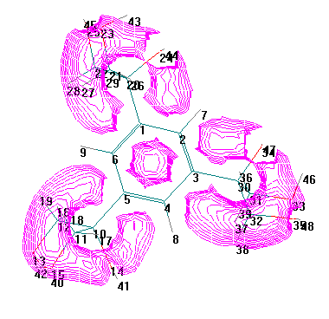
3- basis set view | 4- Electrostatic potential in two dimension
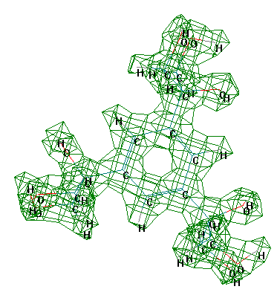 | 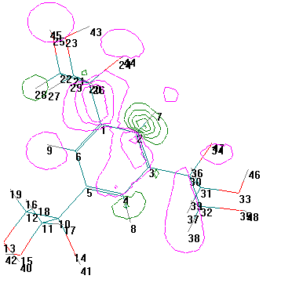
5- Electrostatic potential in three dimension | 6- orbials view
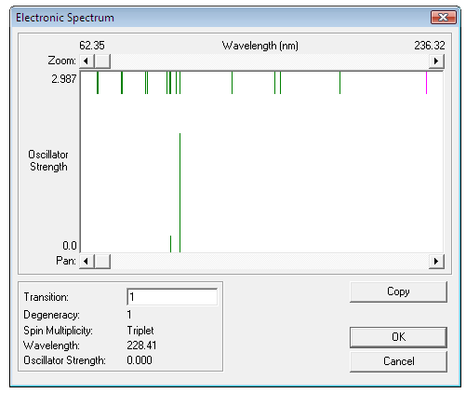 | 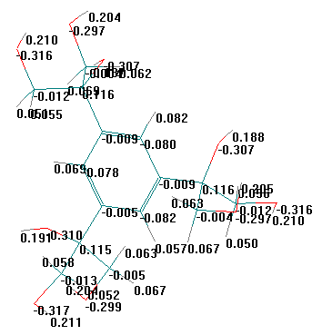
Electronic spectrum of tri glycerol benzene | atomic charge distribution

Figure 8 Geometry optimized structure and energetic properties view calculated at Ab-intio STO-3G basis set.

Conclusions
Synthesis of 1,3,5-Tri glycerol benzene production has been achieved in vacuumed using different calculation methods of quantum mechanics. There are three main steps of production through esterification , alkylation ,and hydrolysis of ester. The first two steps are endothermic ,but the third step is exothermic . Final product has high electronic density with chemical characteristics to play role in verity types of reactions.

References
- William Reusch. "Alcohols". VirtualText of Organic Chemistry. http://www.cem.msu.edu/~reusch/VirtualText/alcohol1.htm#alcnom. Retrieved on -09-14(2007).
- Global Status Report on Alcohol (2004) .
- R. S. Gable. Addiction , 2004, 99 (6), 686–696.
- N.S.Imyanitov. J. Chem. Educ., 1993; 70(1), 14 – 16.
- A .F. Jalbout , A .J. Hameed ,and B .T.kowski, .Journal of Organo metallic Chemistry ; 2007, 692 ,1039–1047 .
- R. A. Rossi, R. H. de Rossi, , ACS Monograph Series No. 178, American Chemical Society, 1983, [ISBN 0-8412-0648-1] .
- N.S.Imyanitov. J. Gen. Chem. USSR (Engl. Transl.); 1990, 60 (3); 417-419.
- J.J.Stewart, P. MOPAC: J. Computer-AidedMol. Design; 1990, 4, 1–105.
- G.J.Klopman, Am. Chem. Soc;1968, 90, 223.
- Fleming, I. Frontier “Orbitals and Organic Chemical Reactions” Wiley and Sons, London,(1976).
- Windows Molecular Modeling System; Hyperchem Release 6; Hypercube/Autodesk, Hypercube: Gainesville, FL, (2000).
- J.S.Binkley, J.A Pople, and W.J.Hehre .J. Am. Chem. Soc. , 1980, 102, 939-947.
- M.S.Gordon, J.S.Binkley,J.A. Pople, W.J. Pietro ,and W.J. Hehre ,J. Am. Chem.Soc, 1982, 104, 2797-2803.
- W.J Pietro, M.M. Francl, W.J. Hehre, D.J. Defrees, J.A.Pople, and J.S. Binkley,. J. Am. Chem. Soc., 1982, 104, 5039-5048.
- J.J.Stewart, P. J Comput Chem ; 1989, 10, 209-222.
- C.C.Roothaan, J Rev Mod Phys ; 1951, 23, 69-76.
- P. E. Gill, W. Murray, M. H. Wright, Practical Optimization ; Academic Press: New York, (1981).
- W. J. Hehre, R. F. Stewart, and J. A. Pople, J. Chem. Phys.,1969, 51, 2657.
- L. G. Wade, Organic Chemistry, 5th ed., Prentice Hall, Upper Saddle RIver, New Jersey, (2003).
- J. B. Collins, P. V. Schleyer, J. S. Binkley, and J. A. Pople, J. Chem. Phys. ,1976 ; 64, 5142.
- R. F. Stewart, Quantum Mechanics 255 Supported Methods. J. Chem. Phys. ;1970, 52, 431-442.
- J. P. Clayden, N. Greeves, S. G. Warren, P. D. Wothers , Organic Chemistry (1st ed.), Oxford: Oxford University Press, pp. 407-445,(2000).
- R. Krishnan, J. S. Kinkley, R. Seeger, and J. A. Pople, J. Chem. Phys. ;1980, 72, 650-663.
- M.D.Paulsen ,and R.L.Ornstein, .Proteins ; 1991, 11;184–204.
- H.E.Zimmerman ,K.K. Burkhart ,and J.W. Donovan . Journal of Emergency Nursing ; 1999, 2 ,116-20.
- V A.A.Drea ;National Journal of chemistry, 2008, 29,109-130.

