Spectrophotometric determination of 1-naphthol via charge transfer complex formation

Dawood .H. Mohammed
Chemistry Department, Education College for Girls, Mosul University

(NJC)

(Recevied on 1/6/2009) (Accepted for publication 20/4/2010)

Abstract
Two new simple, sensitive and economical spectrophotometric methods have been developed for the determination of 1-naphthol in pure form. These methods are based on the reaction of 1-naphthol as n-electron donor with chloranil in method A and 2,3-dichloro-5,6-dicyano-1,4-benzoquinone (DDQ) in method B as π-acceptors to give highly coloured complex species in aqueous solution which are absorb maximally at 349nm and 423 nm respectively. Beer's law is obeyed in the concentration ranges 1-36 µg ml⁻¹ and 0.4-5.0 µg ml⁻¹ with high apparent molar absorptivities of 2.59×10³and 94.9×10³ for methods A and B respectively.

Keywords: Chloranil; DDQ; charge-transfer complexes; 1-naphthol; aqueous solution.

الخلاصة
تم تطوير طريقتان طيفيتان تميزتا بالبساطة والحساسية في تقدير 1-نفثول. اعتمدت الطريقتان(A وB) على تفاعل 1-نفثول بوصفه مانحا للإلكترونات نوع n مع كل من الكلورانيل و 3،2- ثنائي كلورو-6،5- ثنائي سيانو-4،1- بارابنزوكوينون بوصفهما مستقبلات للإلكترونات نوع π لإعطاء معقدات ملونة في المحلول المائي تمتلك أقصى امتصاص عند الأطوال الموجية 349 و423نانوميتر على التوالي. أمكن تطبيق قانون بير للتراكيز 1 - 36 و 4.0 - 5 مايكروغرام/مللتر وبامتصاصيات مولارية 2.59 × 10³ و 94.9×10³ لتر.مول⁻¹سم⁻¹ للطريقتين A و B على التوالي.

Introduction
1-Naphthol, or α-naphthol is a colorless crystalline compound with a weak phenol odor ,It is used in making dyes, pigments, fluorescent whiteners, tanning agents, antioxidants, and antiseptics.
Carbaryl is abroad-spectrum N-methylcarbamate insecticide widely used in European counries (over 500 tons per annum )⁽¹⁾because effectiveness against many agricultural pests and its relatively low acute mammalian toxicology .Carbyl is degraded by chemical hydrolysis and biodegradation forming several metabolites ; 1-naphthol is the primary transformation product.

Different analytical methods are available in the literature, which are used for the determination of 1-naphthol. These methods are based on various analytical techniques such as, chromatography ^{(1, 2)}, titrimetry ⁽³⁾, spectrophotometry ^{(4, 5)}, voltammetry ⁽⁶⁾ and first-derivative synchronous phosphorimetry ⁽⁷⁾.
This work describes two rapid and simple spectrophotometric methods for the determination of 1-naphthol, by exploiting its electron donating property. The methods (A and B) are based on charge transfer complexation reactions of 1-naphthol with chloranil and DDQ.

Experimental

Apparatus
All spectral measurements were performed on Shimadzu U.V-visible recording spectrophotometer (U.V-160), where as absorbance measurements were carried out on CECIL-CE-1021spectrophotometer. pH measurements are carried out using a Philips PW 9420 pH meter.
Reagents
Chemicals used are of the highest purity available. Chloranil solution: A saturated (1×10⁻³M) ethanol solution was used. Borate Buffer solution: borate buffer solution of pH 9 is obtained by preparation of (5×10⁻²M) sodiumtetraborate in aqueous solution.
Standard solutions of 1-naphthol: (100µg/ml): This solution is prepared by dissolving 0.01g of 1-naphthol and diluted to the mark with distilled water in 100 ml-volumetric flask. These solutions were further diluted with water to required concentrations for working solutions.
DDQ (1×10⁻³M) solution: This solution is prepared by dissolving 0.0227g of 2,3-dichloro-5,6-dicyano-p-benzoquinone in ethanol in 100 ml volumetric flask. This solution is prepared daily.
Ethanol: Absolute (99-100 %) is used.
Recommended procedures
Method A.
To a series of 25ml volumetric flask , aliquots covering the range of 1-36 µg 1-naphthol are transferred , 1 ml of borate buffer solution and 2 ml chloranil solution . The solutions were diluted to the mark with distilled water. The absorbance of each solution was measured at 349 nm versus blank.
Method B.
Increasing volumes (ml) of 100ppm, of 1-naphthol solution are transferred into a series of 25-ml volumetric flasks ,followed by the addition of optimum amounts of DDQ and buffer of pH9. The solutions were diluted to the mark with distilled water. The absorbance was measured at a suitable wavelength at room temperature.
Results and Discussion
Absorption spectra
I-naphthol reacted with chloranil and DDQ reagents in the presence of a base and produced a yellow color with chloranil having maximum absorption at 349 nm and orange color with DDQ having maximum absorption at 423 nm against their respective reagent blank which show two maximum absorption bands at 305 nm for chloranil reagent and at 294 nm for DDQ reagent (Fig. 1 and 2).

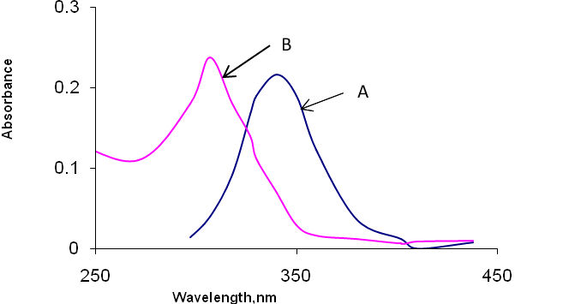
Figure1. Absorption spectra of (a) 1-naphthol (10 µg/ml) complex with chloranil reagent (1×10⁻³ M) against reagent blank and (b) reagent blank against distilled water.

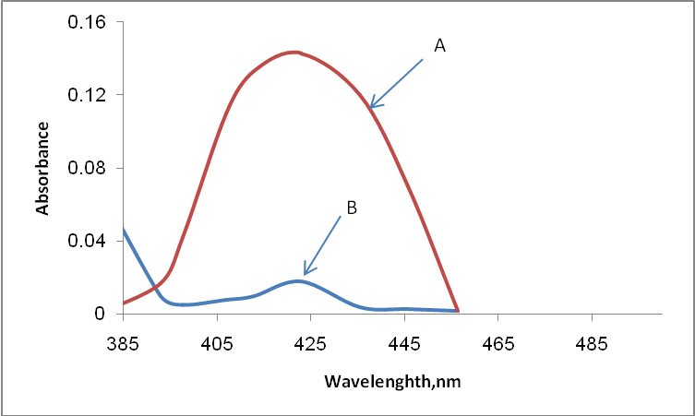

Figure 2. Absorption spectra of (a) 1-naphthol (2 µg/ml) complex with DDQ reagent (1×10⁻³ M) against reagent blank and (b) reagent blank against distilled water.

Study of the optimum reaction conditions
The effect of various parameters on the absorption of the coloured CT complexes formed with chloranil and DDQ have been investigated and the reactions conditions have been optimized for 1-naphthol.

1. Effect of pH and buffer solutions on the absorbance

The effect of pH on the absorption of 1-naphthl–chloranil product and 1-naphthl –DDQ complex was studied using different concentrations of HCl and NaOH of pH ranging from 5-10.

A. Chloranil: It was found that the product 1-naphthol –chloranil formed in the final pH9 in the presence of sodium hydroxide. Different buffers of pH9 namely bicarbonate, borate, phosphate buffers were prepared to examine the sensitivity of 1-naphthol –chloranil product. (Table 1) shows that maximum absorption is obtained by using a borate buffer solution. However, the optimum amount of this buffer has been investigated and it was found that 1ml of aliquots gave maximum absorbance and selected in subsequent experiments.

Table1: Effect of different buffers of pH 9.
Phosphate | Borate | Bicarbonate | Buffer
0.158 | 0.168 | 0.149 | Absorbance

B. DDQ: It was found that 1-naphthol – DDQ complex formed in the final pH of 9 by addition of sodium hydroxide. Therefore a fixed amount (0.5 ml) of different buffers of pH9 such as carbonate, borate, acetate, and ammonium buffers were prepared to investigate the sensitivity of the complexe. Borate buffer solution was increased the sensitivity for this complex (Table 2). However; the optimum amount of borate buffer solution of pH9 for the drug was studied and found to be 0.1 ml is the optimum amount and beyond this amount the absorbance would be decreased therefore, 0.1 ml of pH9 was recommended in the subsequent experiments.

Table 2: Effect of different buffers of pH9
Borate | Bicarbonate | Phosphate | Buffer
0.128 | 0.108 | 0.117 | Absorbance

2. Effect of reaction time and temperature
The reaction time was determined by following the colour development at room temperature and in thermostatically controlled water-bath at different temperatures. The absorbance was measured against reagent blank treated similarly. It was observed that the absorbance reached maximum after 5 min at room temperature (25°C) after addition of the reagent solution in method A and remain constant for 70 minutes and fading was observed thereafter,( Table 3). In method B, the maximum colour intensity of the reaction mixture was attained after 10 minutes at room temperature (25°C) and remain constant for 15 min at this temperature and fading was observed thereafter which may be attributed to the destruction of the complex, (Table 4). These temperatures and reaction time were chosen for colour development in both methods.

Table 3: Effect of different temperature on absorbance
Absorbance
Time (min) |  |  |  |  |  |  |  |  |  | Temp  °C
75 | 70 | 60 |  | 50 | 40 | 30 | 20 | 10 | 5
0.140 | 0.141 |  | 0.139 | 0.133 | 0.125 | 0.120 | 0.118 | 0.133 | 0.102 | 0
0.160 | 0.167 |  | 0.168 | 0.170 | 0.170 | 0.170 | 0.169 | 0.170 | 0.170 | Room temp.
0.158 | 0.164 |  | 0.168 | 0.170 | 0.166 | 0.168 | 0.168 | 0.167 | 0.165 | 40
0.126 | 0.133 |  | 0.139 | 0.145 | 0.147 | 0.148 | 0.150 | 0.146 | 0.143 | 50

Table4: Effect of different temperature on absorbance.
Absorbance
Time (min) |  |  |  |  |  |  |  | Temp  °C
40 | 35 | 30 | 25 | 20 | 15 | 10 | 5 | Temp  °C
0.124 | 0.126 | 0.125 | 0.122 | 0.118 | 0.116 | 0.111 | 0.105 | 0
0.119 | 0.121 | 0.126 | 0.130 | 0.129 | 0.129 | 0.128 | 0.118 | Room temp.
…… | …… | 0.111 | 0.117 | 0.120 | 0.123 | 0.127 | 0.122 | 40
…… | …… | …… | 0.078 | 0.083 | 0.090 | 0.094 | 0.103 | 50

3. Effect of reagent concentration
The effect of changing the reagent concentration on the absorbance of solution containing a fixed amount of 1-naphthol was studied, It was found, as shown in (Table 5)and (Table6) , that absorbance increases with increasing choranil concentration in method A and DDQ concentration in method B and reached their maximum value on using 2ml of 1×10⁻³M of chloranil and DDQ respectively which were used in subsequent experiments.

Table 5: Effect of the reagent concentration on absorbance
Chloranil(1×10⁻³M)ml | 1 | 1.5 | 2 | 2.5 | 3
Absorbance | 0.133 | 0.152 | 0.172 | 0.171 | 0.168

Table 6: Effect of the concentration of reagent on absorbance
3 | 2.5 | 2 | 1.5 | 1 | 0.5 | DDQ(1×10⁻³M)ml
0.131 | 0.133 | 0.133 | 0.105 | 0.085 | 0.062 | Absorbance

4. Effect of surfactant

Effect of various anionic, cationic and neutral surfactants including sodium dodecyl sulphate (SDS), , cetavlon (CTAB), and triton X-100 were tested for the investigation of the sensitivity of both A and B methods. The results reveal that the presence of the surfactants has no remarkable effect on the intensity of the colour. Therefore, the methods have been carried out without using surfactants.
5. Effect of order of addition
In order to obtain the high colour intensity, the order of addition of reagents should be followed as given in the recommended procedures, otherwise a loss in colour intensity was observed.
Quantification and Analytical Data
The results for the determination of 1-naphthol by both methods A and B are summarized in Table 7, which show the sensitivity, recovery and reproducibility of the proposed methods. These are reasonably precise and accurate. The calibration graph is linear in the range of 1.0 - 36 µgml⁻¹ for method A and 0.4-5.0 µgml⁻¹ for method B. The apparent molar absorptivities calculated for method A and B are 2.59×10³l mol⁻¹cm⁻¹ and 9.94 × 10³l mol⁻¹ cm⁻¹ respectively, Table 7 illustrates regression equations, and correlation coefficients (R²) for the proposed methods. The reproducibility of the proposed methods was checked by estimating three different concentration levels within the Beer's law limit in five replicates. The average recoveries were 96.54 % for method A and 99.47% for method B reveal good accuracy for the both methods. The relative standard deviation can be considered to be very satisfactory.

Table 7. Quantitative parameters of the proposed methods.
Values of

Parameter Method A Method B
423 349 λ _{max} (nm)
Beer's law limits (µg/ml) 1-36 0.4-5.0
Molar absorptivity (l.mol⁻¹ cm⁻¹) 2.59×10³ 9.94 × 10³
Slope, a 0.018 0.069
Intercept, b 0.029 0.002
Correlation coefficient (R²) 0.9950 0.9970
RSD# # ≤2.49 ≤1.23
Average recovery % 99.77 100.38

# Y = aX+ b, where X is the concentration of 1-naphthol in μg ml⁻¹.
# # Average of five determinations.

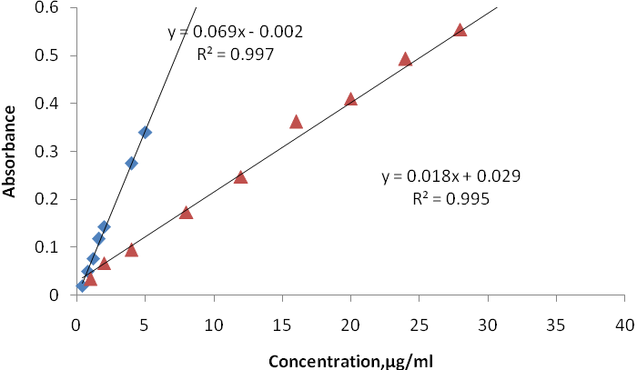
Figure 3: Calibration graphs for 1-naphthol
(▲) method A
(▪) method B

Stoichiometric Relationship
Job’s method of continuous variation ⁽⁸⁾ were used for determining the molar ratio of 1-naphthol to each of the analytical reagent employed in the A and B methods. These ratios were 1:1 1-naphthol : chloranil in the method A and1:1 1-naphthol : DDQ in the methods B [Figure 4].

Figure 4. Continuous variation plots of 1-naphthol with
with chloranil (▲) and DDQ (▪) reagents

Precision and accuracy
The accuracy and precision of the proposed methods were estimated by measuring the content of 1-naphthol in pure form at three different concentration levels (low, medium and high) within the Beer's law limit in five replicates , (Table8 ). The relative standard deviation (representing precision) and mean percent recovery (representing accuracy) obtained by the proposed methods can be considered to be satisfactory.

Table 8 : Test of precision and accuracy of the proposed methods
Proposed method | Amount  added  (µg/ml) | Recovery*  (%) | Average recovery  (%) | RSD*
A | 2 | 99.70 | 99.77 | 1.23
A | 15 | 99.98 | 99.77 | 0.02
A | 32 | 99.63 | 99.77 | 2.49
B | 0.5 | 100.75 | 100.38 | 1.23
B | 2 | 100.60 | 100.38 | 0.17
B | 4 | 99.80 | 100.38 | 0.43
* Average of five determinations.

Conclusion
The proposed methods are simple, selective, sensitive and economical and do not require any pretreatment of 1-naphthol or extraction procedure and has good accuracy and precision. Method A (used chloranil) was found to be less sensitive compared to method B (used DDQ) for the determination of 1-naphthol.
References

C. Hidalgo, J. V. Sancho, A. Roig-Navarro and F. Hernández, Chromatographia, 1998, 47, 9.
- Kurt A. Massey, Debra L. Van Engelen, and Isiah M. Warner, Talanta,1995, 42(10), 1457.
- D. Amine and M. Saleem, J. Educ &Sci 1989, 7.
- A. M. Afonso Perera, J. H. Ayala Daz, A. Gonzlez Armas , and V. Gonzlez Daz ,Anal. Lett., 1993, 26 (10), 2251 .
- S. G. Dmitrienko, E. N. Myshak, A. V. Zhigulyev, V. K. Runov and Yu. A. Zolotov, Anal. Lett., 1997, 30(14 ), 2527.
- Y. Zhang and H. Zhuang, Electrochimica Acta, 2009, 54(28), 7364.
- R.G.Machicote L, Bruzzone Anal. Sci., 2009, 25(5), 623.
- Job P.,''Spectrochemical Methods of Analysis'', Wiley Intersience: New York, 1971, 346.

