New Mixed Ligand Complexes of Co(II) & Ni(II) Containing Isatinazine and Semicarbazone

Z. F. Dawood* and F. J. A. Al-Moula
*Chemistry Department, Education College, Mosul University Mosul-Iraq

(NJC)

(Recevied on 21/5/2009) (Accepted for publication 20/4/2010)

Abstract
The preparation and characterization of new cobalt(II) and nickel(II) complexes with mixed ligands including isatinazine-IAH₂ and semicarbazone ligands (including benzoin- semicarbazone-B'SCH₂ or isatinsemicarbazone-ISCH₂ or isatinbis(semicarbazone)-ISCH₃) have been carried out in both neutral (or slightly acidic) and basic medium. The resulted complexes have been characterized using metal analysis by atomic absorption spectroscopy and by precipitation methods, relative molecular weight determina- tion, molar conductance measurements, molar refraction, magnetic susceptibilities, infrared and electronic spectra.
The resulted complexes have general formula [M(IAH₂)(LH_{2,3})](NO₃)₂ or [M(IAH₂)(LH_{2,3})NO₃]NO₃ in neutral (or slightly acidic) medium whereas neutral or negative ionic complexes of the general formula [M(IAH₂-y΄)(LH_{2,3}-y˝)] or Na_{w}[Co(IAH₂-y')(LH_{2,3-y"}) have been resulted in basic medium, (where M= Co(II) or Ni(II); w=1 or 2; y´=1 or 2; y˝=1 or 2; LH_{2,3}= the ligands B'SCH₂ or ISCH₂ or ISCH₃) in which the ligands acted as neutral or anionic (-1 or -2) in neutral (or slightly acidic) or basic medium, respectively. Accordingly, hexacoordinated mononuclear complexes have been proposed for the resulted complexes had octahedral geometry.
الخلاصة
تمّ تحضير وتشخيص مُعقدات جديدة للكوبلت(II) و النيكل(II) مع مزيج من الليكندات التي تشمل إزاتين آزاين-IAH₂ وليكندات السميكاربازون (المتضمنة بنزوين سميكاربازون- B'SCH₂ أو إزاتين سميكاربازون- ISCH₂ أو إزاتين بس(سميكاربازون)-ISCH₃) في كل من الوسطين المتعادل (أو الحامضي قليلا) والقاعدي.
شخصت المُعقدات الناتجة بإستخدام التحليل العنصري باستخدام جهاز طيف الامتصاص الذري و الطريقة الترسيبية وحساب الوزن الجزيئي النسبي وقياس التوصّيلية الكهربائية والإنكسار المولاري والمغناطيسية واطياف الأشعة تحت الحمراء والإلكترونية. اقترحت الصيغ العامة [M(IAH₂)(LH_{2,3})NO₃]NO₃ أو [M(IAH₂)(LH_{2,3})](NO₃)₂ في الوسط المُتعادل أو الحامضي قليلاً في حين تتكون مُعقدات مُتعادلة أو سالبة الشحنة ذات صيغ عامة [M(IAH₂-y´)(LH_{2,3}-y˝)] أو Na_{w}[Co(IAH_{2-y'})(LH_{2,3-y''})] في الوسط القاعدي (حيث M= Co(II) أو Ni(II) و w = 1 أو 2 وy´= 1 أو 2 و˝y= 1 أو 2 و LH_{2,3}= الليكند B'SCH₂ أو ISCH₂ أو ISCH₃) ، إذ تسلك فيها الليكندات بشكل ليكندات مُتعادلة أو ذات شحنة سالبة أحادية أو ثُنائية في الوسط المُتعادل (أو الحامضي قليلاً) والقاعدي على التوالي.
استنادا الى ذلك اقترح أنّ المعقدات تكون سداسية التناسق ذات أشكال ثُمانية السطوح أُحادية النواة.

Introduction
Agood deal of work has been reported on the preparation, spectral and structural investigation of azines and their complexes, due to their capability of acting as multidentate donor⁽¹⁻⁴⁾. Moreover azines and their complexes had important analy- tical applications, biological activities and photosensitizers in solar cells^{(5,6)}.
An extremely large number of sem- icarbazone complexes have been reported ⁽⁷⁻¹¹⁾. In addition to their ligational proper- ties, semicarbazones formed an important class of biologically active compounds and they were also used as pigments⁽¹²⁻¹⁴⁾.
Mixed ligand complexes were of considerable importance in the field of metalloenzymes and other biological acti- vities⁽¹⁵⁻¹⁷⁾. Hence a large body of mixed ligand complexes with transition and non-transition metal ions have been reported⁽¹⁸⁻²⁰⁾. Due to the importance of such ligands and mixed ligand complexes, we took a modest part in the chemistry of mixed ligands and some articles have been pub- lished on their coordination chemistry with transition and non-transition metal ions⁽²¹⁻²⁴⁾.
In the present work, new cobalt(II) and nickel(II) complexes with mixed liga- nds {isatinazine-IAH₂ and semicarbazone ligands {benzoinsemicarbazone-B'SCH₂ or isatinsemicarbazone-ISCH₂ or isatinbis(se- micarbazone)-ISCH₃}(Figure 1) have been prepared and characterized physico-chemi- cally.

Figure 1: Model structures of the ligands

Experimental
1- Starting Materials:
All the chemicals used were suppli- ed from Fluka, BDH, Aldrich, Merck, Anhdrous LAB-SCAN, U.S.A, ppl;Chem, GCC.
2- Synthetic Methods :
Isatinazine-IAH₂ has been prepared according to literature method^{(25,26)}. Semi- carbazone ligands have been prepared according to literature method^{(25,26)}.
A general procedure has been adop- ted for the preparation of the complexes in neutral and basic medium .
I- In neutral medium:
A solution of 0.5 gm (1.7x10⁻³ mm) of Co(NO₃)₂.6H₂O or Ni(NO₃)₂.6H₂O in 5 ml water has been added to the solution of 0.49 gm IAH₂ (1.7x10⁻³ mm) and 1.7x10⁻³ mm of one of the semicarbazone ligands in a small amount of ethanol and water with heating until a clear solution has been resulted (the amounts in grams were listed in Table 1). The mixtures have been refluxed for three hours followed by evaporation to half volumes then cooled. The products were separated by filteration, washed with petroleum ether and dried at 100 ºC.
II- In basic medium:
The complexes have been prepared by applying the same amounts used for neutral medium, and after mixing the metal salts with the ligands and heating, sodium hydroxide solution (1M) has been added until pH of the solutions have been adjusted to about 8-9. The mixtures have been heated on a waterbath for half an hour then allowed to stand then cooled. The products were filtered off and washed with petroleum ether and dried at 100 ºC.
3-Analytical and Physical Measurements :
Nickel contents have been determined by atomic absorption spectroscopy and cobalt contents have been determined by applying precipitation method after the decomposition of the complexes with con- centrated nitric acid⁽²⁷⁾. Sodium contents have been determined using flame photo-metry⁽²⁸⁾. Relative molecular weights of the ligands and their complexes have been determined cryoscopically {decreasing in freezing point}⁽²⁸⁾. Molar Refraction mea-surements⁽²⁸⁾ have been carried out with Atago Illumination, Atago Co-LTD, Japan using 10⁻³ M dimethylformamide solution. Conductivity measurements have been carried out with an electrolytic conductivi- ty measuring set LF-42 and Multiline f/SET-2WTW Wissenschaf Tecchnische Werkstattem 82362 Weiheim using 10⁻³ M dimethylformamide solution at 25 ºC. The infrared spectra has been recorded on FT-IR Bruker type Tensor 27 in the range 400-4000 cm⁻¹ using KBr pellets. Electronic spectra has been record-ed on Shimadzu UV-1650 PC UV-Vissible Spectrophoto-meter for 10⁻³ M solutions of the ligands and their complexes in dimethylformamide at 25 ºC, using a 1cm cell. Magnetic susceptibility of the complexes have been measured by Bruker-BM6 .
Results and Discussion
The reaction of cobalt(II) or nickel (II) nitrate, isatinazine and the semicarbaz- one ligands in 1:1:1 molar ratio in both neutral and basic medium may be represe- nted by the following equations :
M(NO₃)₂.6H₂O + IAH₂ + LH_{y} → [MIAH₂)(LH_{2,3})₂](NO₃)₂ + 6H₂O
M(NO₃)₂.6H₂O + IAH₂ + LH_{y} → [M(IAH₂)(LH_{2,3})₂NO₃]NO₃ +6H₂O
M(NO₃)₂.6H₂O + IAH₂ + LH_{y} + 2NaOH→ [M(IAH)(LH_{1,2})] + 2NaNO₃ + 8H₂O
Co(NO₃)₂.6H₂O+IAH₂+LH_{y}+(2+w)NaOH→ Na_{w}[M(IAH_{2-y'})(LH_{2,3}-y")]+(2)NaNO₃+ (6+2+w)H₂O
where LHy= B'SCH₂, ISCH₂ or ISCH₃; y'= 1or 2; y"=1 or 2; w=1 or 2;.
The resulted complexes were color- ed solid, soluble in dimethylformamide. Cobalt and nickel contents and relative molecular weights revealed that the compl- exes had the composition [M(IAH₂)(LH_{2,3})₂](NO₃)₂ and [M(IAH₂)(LH_{2,3})NO₃]NO₃ in neutral (or slightly acidic) medium and [M(IAH)(LH_{1,2})] or Na_{w}[M(IAH_{2-y'})(LH_{2,3}-y")] in basic medium (Table 1). The values of the molar conductivities (107.00-133.38, 52.47-94.78 and 6.23-25.88 Ω⁻¹cm²mol⁻¹) approached those expected for 1:2, 1:1 and non electro- lytes⁽²⁹⁾. For complexes prepared in neutral and basic medium, respectively. The room temperature (25 ºc) magnetic moments of cobalt(II) and nickel(II) complexes lied in the range 1.65-1.99, 3.44 and 2.14-3.00 B. M indicated the presence of one unpaired, three unpaired and two unpaired electrons, respectively⁽³⁰⁾, assigned to a monomeric structure, having low spin and high spin octahedral geometries, respectively (Table 1). The molar refractance of the complex- es in 10⁻³ M dimethylformamide solution were in the range 1.435500x10⁻⁴- 1.435579 x10⁻⁴.
The infrared spectra of semicarba- zone ligands (Table 3, Figue 2) showed a strong band at 1685.15-1697.80 cm⁻¹ attributed to the C=O group⁽³¹⁾ shifted towards a lower frequency on coordination in neutral medium, indicating the forma-tion of a chelation between the oxygen of the C=O group and the metal ion⁽³¹⁾. Meanwhile, in basic medium, this band was disappeared in the complexes and a new band has been observed at 1102.34-1206.87 cm⁻¹ due to C-O group, thereby establishing coordina- tion of the ligand through the enolic oxygen atom^{(8,31)}. The next strong band at 1611.91-1637.93 cm⁻¹ attributed to C=N group⁽³¹⁾ shifted towards a lower frequency on coordination due to the decrease of the bond order as a result of metal nitrogen bond formation⁽³¹²⁾. The appearance of strong bands at 1630.00-1635.00 cm⁻¹ and 1570.00-1580.00 cm⁻¹ attributed to υ_{(C=N)} + υ_{(O-C=N)} and azine chromophore υ_{(C=N-N=C)}, respecttively, supported the formation of enolic structure in basic medium^{(9,31)}. The position band of the ligand in the range 3234.21-3235.86 cm⁻¹ remained unaltered in the complexes prepared in neutral medium indicating that there is no coordination through the NH group^{(8,,31)}. whereas in basic medium, this band is disappeared in basic medium due to the enolic form. The other bands at 3390.00- 3410.00 cm⁻¹ and 1468.50-1490.31 cm⁻¹ attributed to υ_{NH2} and δ_{NH2}⁽³¹⁾. These bands remained unalter- ed on complexation indicating that there is no coordination through this group and the metal ion^{(21,31)}. The infrared spectra of B'SCH₂ ligand showed a wide band at 3552.28 cm⁻¹ due to the stretching vibrat- ion of phenolic hydroxyl shifted to a lower frequency on complexation⁽³¹⁾.The other band observed at 1330.37 cm⁻¹ attributed to the bending vibration of phenolic OH shift- ed to a lower frequency on complexation ⁽³¹⁾ indicating the coordination of this gro- up with the metal ion. Moreover the appearance of a band at 1109.16 cm⁻¹ which belongs to υ_{(C-O)} is shifted to higher frequency 1153.42-1207.91 cm⁻¹ on comp- lexation indicating the coordination of oxygen atom⁽³¹⁾. The infrared spectra of ISCH₂ showed band at 1720.37 cm⁻¹ attrib- uted to υ_{C=O} observed in the same position in complex 3 indicating the uncoordination of this group to the metal ion, whereas in complex 9 this band shifted towards a lower frequency 1637.91 cm⁻¹ due to the coordination of this group to the metal ion⁽³¹⁾. Meanwhile in basic medium this band was disappeared due to the formation of the enol isomer which was supported by the appearance of a band (Table 3) assign- ed to υ_{C-O}^{(21,22,31)}.
The infrared spectra of IAH₂ (Figure 2) showed band at 1637.93 cm⁻¹ due to υ_{C=N}^{(22,31)}. On coordination this band was splitted into two bands, one appeared at the same position, whereas the other band observed at lower frequency. This demonstrated that only one nitrogen atom was coordinated to the metal ion^{(1,2,31)}. Moreover the positive shift in N–N vibration on complexation can be added as a further support to the coordination of the azine nitrogen to the metal ion^{(3,31)}. The next band at 1687.14 cm⁻¹ attributed to υ_{C=O} shifted towards a lower frequency (Table 3) for complexes prepared in neutral (or slightly acidic) medium⁽³¹⁾. Meanwhile in basic medium this band disappeared in the complexes and a new band was observed at 1152.12-1169.15 cm⁻¹ due to υ_{C-O}, thereby establishing coordination of the ligand through enolic oxygen atom^{(1,2,31)}.
On the other hand the spectra of the complexes prepared in neutral (or slightly acidic) medium showed new bands around 1384.50-1399.82 cm⁻¹ due to ionic nitrate ⁽³⁰⁾, In addition, complexes 1, 3, 7 and 11 showed bands at 1468.50-1490.31 cm⁻¹, 1353.22-1374.90 cm⁻¹ and 920.75-999.05 cm⁻¹ due to υ_{s(NO3)}, υ_{as(NO3)} and υ_{NO} (υ₂, υ₁, υ₅), respectively⁽³¹⁾.The difference Δυ equ- el to 115.00-115.14 cm⁻¹ which supported the bonding of nitrato group as monoden- tate ligand through the oxygen atom. The spectra of all the complexes showed new bands at 400.00-484.91 and 452.31-553.03 cm⁻¹ due to υ_{M-N} and υ_{M-O}, respectively ^{(19,20,31)}. The presence of these bands supp- orted the formation of the complexes under investigation.

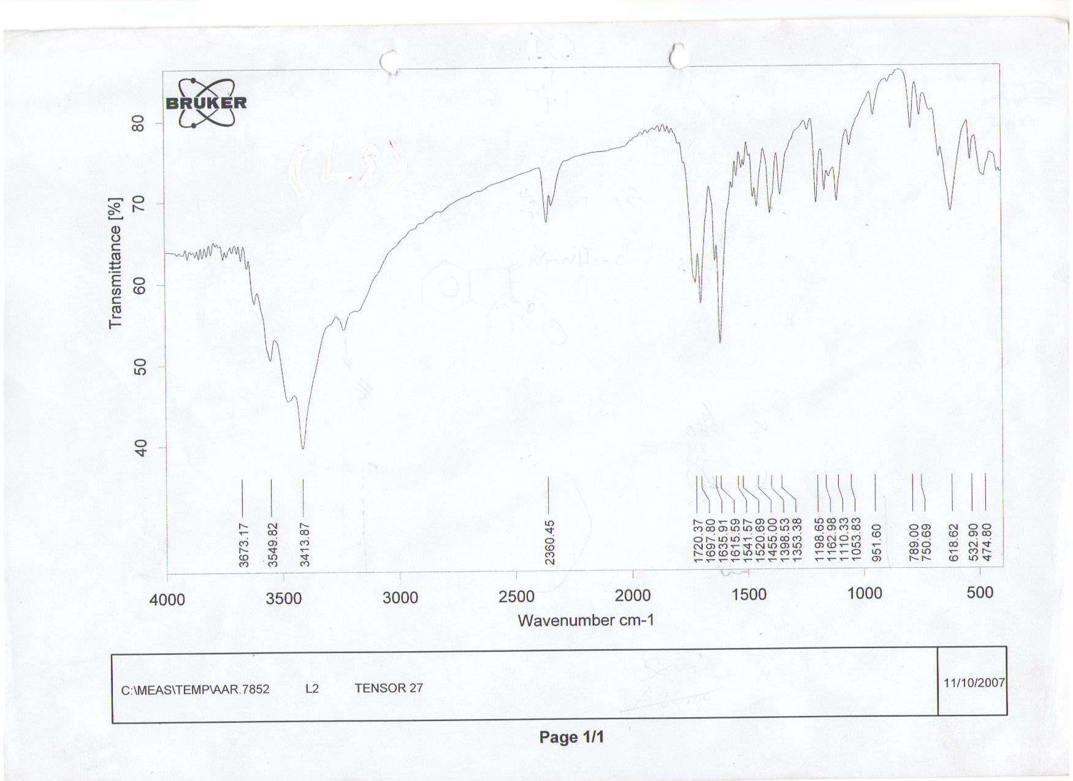
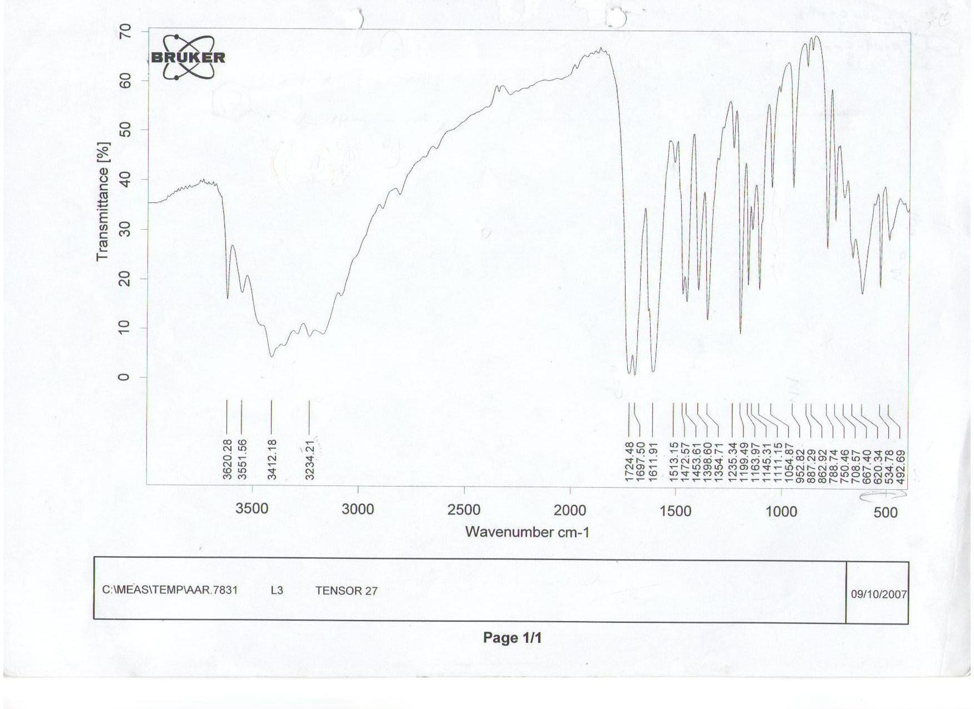
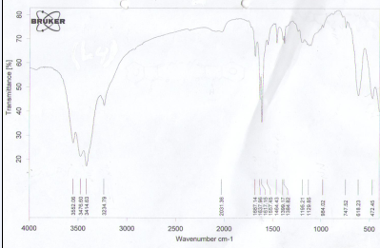
ISCH₂ ISCH₃ IAH₂

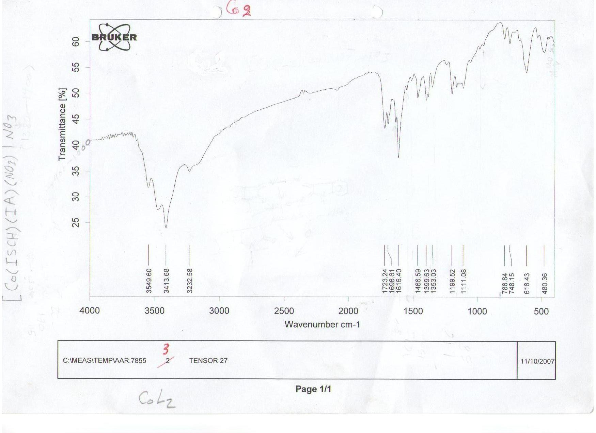
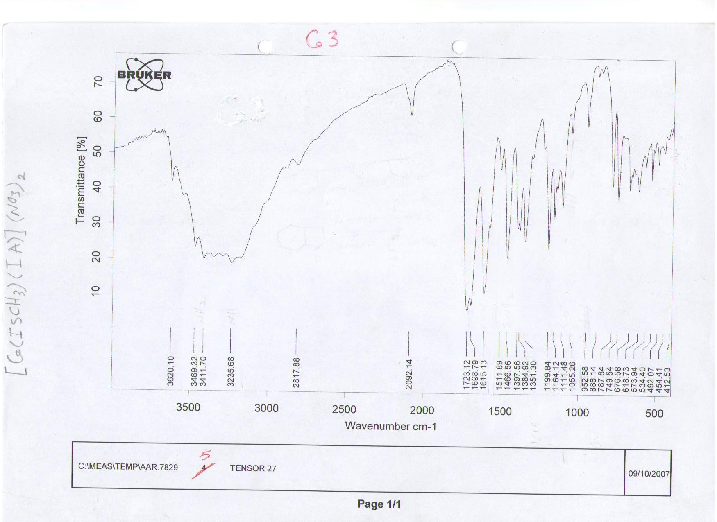

[Co(IAH₂)(ISCH₂)NO₃]NO₃ [Co(IAH₂)(ISCH₃)](NO₃)₂

Figure 2: Infrared spectra of the ligands ISCH₂, ISCH₃, IAH₂ and their complexes

The electronic spectra in the ultra-violet region (Table 4, Figure 3) of the ligands showed two bands in the regon 400000.00-43859.65 cm⁻¹ and 30120.48 - 33112.58 cm⁻¹ corresponding to π→π* and n→π* transitions⁽³²⁾, respectively. On com-plexation a blue shift was observed due to the polarization in the C=N bond caused by the elemental ligand electron inter-action during the chelation.The electronic spectra of cobalt(II) complexes (Table 5, Figure 3) showed bands at 7751.99-10183.29 cm⁻¹,11627.90- 7920.00 cm⁻¹ and 16666.67-23696.60 cm⁻¹ (υ_{1,} υ₂ and υ₃) due to the transitions ⁴T₁g(F)→⁴T₂g(F), ⁴T₁g(F)→⁴A₂g(F) and ⁴T₁g(F) → ³T₁g(P), respectively^{(32,33)}. The ligand field parameter B and the ligand field splitting energy (10Dq) in case of cobalt(II) complexes have been calculated ^{(33,34)}. The values of β of cobalt(II) complexes are between 0.73-0.99 clearly indicated the covalent character of the bond concerned. The value of Dq/B which were in the range 0.8-1.6 suggested octahedral geometry for cobalt(II) complexes.
The electronic spectra of nickel(II) complexes (Table 4) showed bands (υ_{1,} υ₂ and υ₃) at 10141.98-10204.08 cm⁻¹, 11135.85-16839.43 cm⁻¹ and 23041.40-28901.70 cm⁻¹ due to ³A₂g(F)→³T₂g(F), ³A₂g(F)→³T₁g(F) and ³A₂g(F)→³T₁g(P), transitions respectively^{(32,33)}. The ligand field parameter B and the ligand field splitting energy (10Dq) in case of nickel (II) complexes have been calculated^{(33,34)}. The values of β of nickel(II) complexes are between 0.77-0.99 clearly indicated the covalent character of the bond concerned. The value of Dq/B which were in the range 0.95-1.30 suggested octahedral geometry for nickel(II) complexes⁽³⁴⁾.The values of CFSE of cobalt(II) and nickel(II) complex- es have been also determined (as shown below) which were in the range 5125.74-9404.25 cm⁻¹ and 12170.40-13892.40 cm⁻¹, respectively.
CFSE= ﴾{o.4 x no. of electrons in t₂g} – {0.6 x no. of electrons in eg}﴿∆o (where ∆o = 10Dq).
The electronic spectral data suggested octahedral geometry for all the complexes⁽³³⁻³⁴⁾.

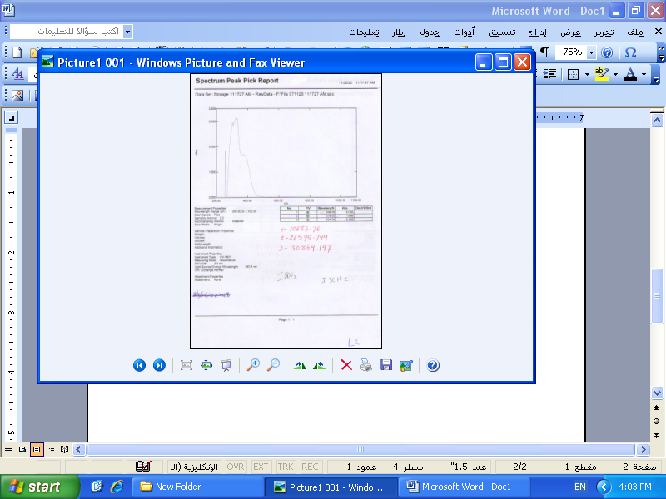
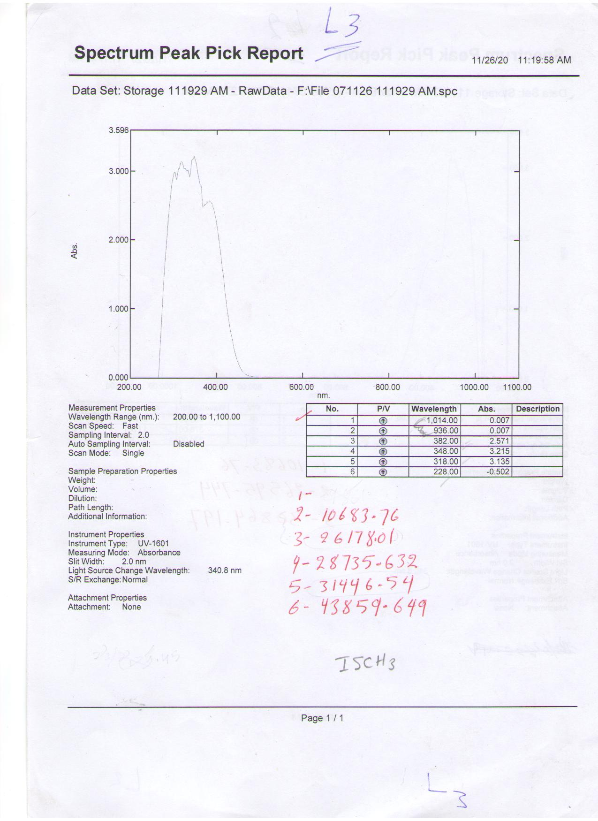

ISCH₂ IAH₂ ISCH₃

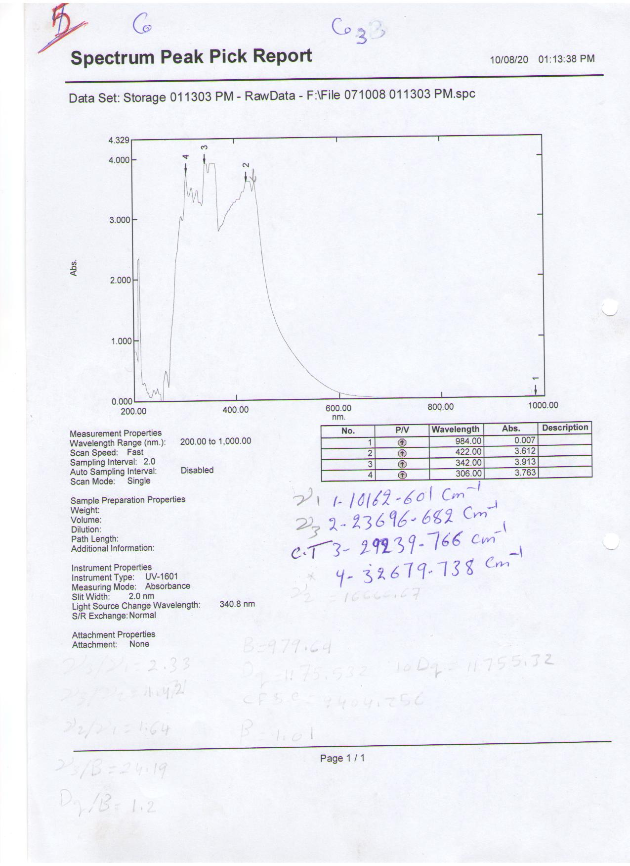
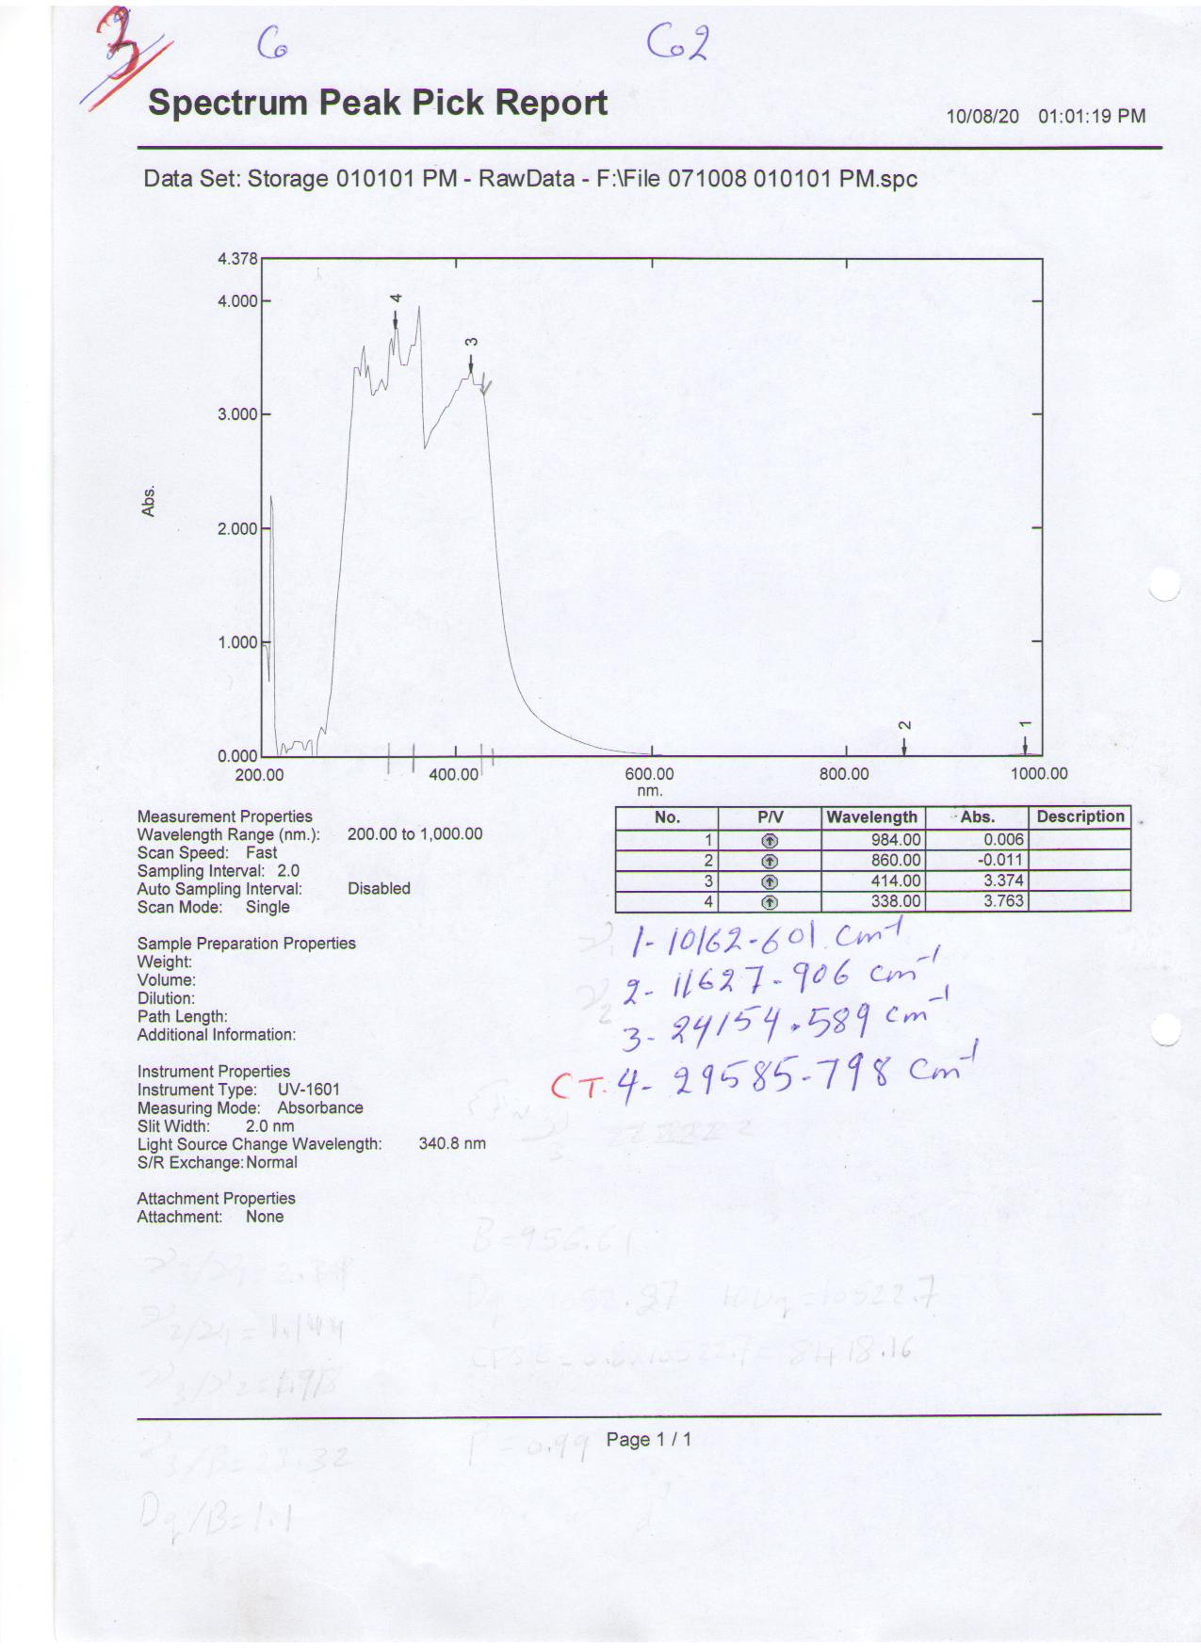

[Co(IAH₂)(ISCH₂)NO₃]NO₃ [Co(IAH₂)(ISCH₃)](NO₃)₂

Figure 3: Electronic spectra of the ligands ISCH₂, ISCH₃,IAH₂ and their complexes

Conclusion:
According to the analytical, physi- cal and spectral data, some observations have been achieved that lead to establish the following points:
- IAH₂ ligand acted as tridentate chelating ligand joint to the metal ion through the azomethine nitro- gen and the two oxygen atoms of the carbonyl groups.
- B'SCH₂ ligand acted as either bide- ntate or tridentate chelating ligand joint to the metal ion through N atom and one or two O atoms.
- ISCH₂ ligand acted as either biden- tate or tridentate chelating ligand joint to the metal ion through N atom and one or two O atoms.
- ISCH₃ ligand acted as either biden- tate or tridentate chelating ligand joint to the metal ion through the two N atoms or through the two N and one O atoms.
- Cobalt(II) and nickel(II) ions have been probably hexacoordinated, leading to octahedral geometries (Figure 4).

₊₁ +1
[Co(B'SCH₂)(IAH₂)(NO₃)]NO₃ [Co(ISCH₂)(IAH₂)NO₃]NO₃
[Ni(B'SCH₂)(IAH₂)NO₃]NO₃ 3
1, 7
+2 +2
[Ni(ISCH₂)(IAH₂)](NO₃)₂ [Co(ISCH₃)(IAH₂)](NO₃)₂
9 5
+1
[Ni(ISCH₃)(IAH₂)NO₃]NO₃ Na₂[Co(B'SC)(IA)]
11 2

[Ni(B'SCH)(IAH)] [Co(ISCH)(IAH)]; [Ni(ISCH)(IAH)]
8 4, 10

[Ni(ISCH₂)(IAH)] Na[Co(ISCH)(IAH)]
12 6
Figure 2: Proposed structures of the complexes

Table 1- Amounts, medium for the preparation of the complexes
Complex | % yield | Medium | Wt. of IAH₂ | Wt. of ISCH₃ | Wt. of ISCH₂ | Wt. of B'SCH₂ | No.
[Co(B'SCH₂)(IAH₂)(NO₃)]NO₃ | 84.25 | Neutral | 0.49 | ـ | ـ | 0.46 | 1
Na₂[Co(B'SC)(IA)] | 99.00 | Basic | 0.49 | ـ | ـ | 0.46 | 2
[Co(ISCH₂)(IAH₂)NO₃]NO₃ | 81.89 | Neutral | 0.49 | ـ | 0.35 | ـ | 3
Co(ISCH)(IAH) | 85.10 | Basic | 0.49 | ـ | 0.35 | ـ | 4
[Co(ISCH₃)(IAH₂)](NO₃)₂ | 71.73 | Neutral | 0.49 | 0.62 | ـ | ـ | 5
Na[Co(ISCH)(IAH)] | 86.00 | Basic | 0.49 | 0.62 | ـ | ـ | 6
[Ni(B'SCH₂)(IAH₂)NO₃]NO₃ | 81.88 | Neutral | 0.49 | ـ | ـ | 0.46 | 7
Ni(B'SCH)(IAH) | 99.00 | Basic | 0.49 | ـ | ـ | 0.46 | 8
[Ni(ISCH₂)(IAH₂)](NO₃)₂ | 86.20 | Neutral | 0.49 | ـ | 0.35 | ـ | 9
Ni(ISCH)(IAH) | 97.78 | Basic | 0.49 | ـ | 0.35 | ـ | 10
[Ni(ISCH₃)(IAH₂)NO₃]NO₃ | 71.01 | Neutral | 0.49 | 0.62 | ـ | ـ | 11
Ni(ISCH₂)(IAH) | 97.00 | Basic | 0.49 | 0.62 | ـ | ـ | 12
Table 2- Some analytical and physical properties
Μ_{eff}  B.M | Ref. x10⁻⁴ | M.Wt calc.(obs.) | Na% calc.(obs.) | M% calc.(obs.) | ^_{M}  Ω⁻¹cm²mol⁻¹ | Mp or d* | Color | No.
1.82 | 1.435558 | 742 (759) | - | 7.95 (7.85) | 79.73 | 110 | Yellowish brown | 1
1.93 | 1.435554 | 662 (660.5) | 6.9 (6.9) | 8.91 (8.50) | 107.00 | 180 | Brown | 2
1.99 | 1.435500 | 677 (660.5) | - | 8.71 (8.93) | 88.42 | 230 | Yellowish brown | 3
1.66 | 1.435565 | 551 (554) | - | 10.70 (9.85) | 6.23 | 204 | Greenish brown | 4
3.44 | 1.435561 | 834 (825) | - | 7.07 (6.48) | 133.38 | 207 | Yellowish brown | 5
1.65 | 1.435552 | 731 (734) | 3.2 (3.2) | 8.07 (8.01) | 52.47 | 188 | Dark brown | 6
2.86 | 1.435540 | 742 (743) | - | 7.95 (7.50) | 94.78 | 160 | Redish brown | 7
2.14 | 1.435579 | 616 (660) | - | 9.53 (9.32) | 25.88 | 200 | Brown | 8
2.93 | 1.435557 | 677 (701) | - | 8.67 (8.41) | 128.86 | 205 | Dark brown | 9
2.43 | 1.435560 | 550 (554) | - | 10.65 (9.91) | 15.80 | 225 | Brown | 10
3.00 | 1.435562 | 834 (825) | - | 7.04 (7.15) | 85.60 | 197 | Brown | 11
2.87 | 1.435575 | 707 (701) | - | 8.34 (8.41) | 9.08 | 221 | Dark brown | 12
Calc. = calculated; obs. = observed; ^_{M} = molar conductance

Table 3- Some important bands in the infrared spectra of the ligands and their cobalt(II) and nickel(II) complexes
No. | Semi |  |  |  | Azine |  |  |  |  | υ_{NO3} (ionic) | υ_{NO3} (s) | υ_{NO3} (as) | υ_{N-O} | υ_{M-N} | υ_{M-O} | Other bands
No. | υ_{C=N} | υ_{C=O} | υ_{C-O} | υ_{N-H} | υ_{C=N} | υ_{C=O} | υ_{C-O} | υ_{N-H(C)} | υ_{N-N}
IAH₂ | - | - | - | - | 1637.96 | 1687.14 | - | 3234.79 | 950.00 | - | - | - | - | - | - | -
B'SCH₂ | 1637.93 | 1685.15 | - | 3235.86 | - | - | - | - | - | - | - | - | - | - | - | υ_{C-O} (1109.16); υ_{O-H} (3552.28)
ISCH₂ | 1635.91 | 1697.80 | - | 3234.21 | - | - | - | - | - | - | - | - | - | - | - | υ_{C=O} (1720.37)
ISCH₃ | 1611.91 | 1697.50 | 1399.82 | 3234.21 | - | - | - | - | - | - | - | - | - | - | - | -
1 | 1617.41 | 1637.43 | - | 3233.68 | 1600.00  1636.71 | 1632.11 | - | 3233.68 | 982.11 | 1399.82 | 1470.18 | 1355.18 | 999.05 | 401.96  412.01 | 477.50  521.33 | υ_{C-O} (1153.42)
2 | 1617.34 | - | 1156.99 | - | 1558.00  1638.87 | - | 1152.12  1153.42 | - | 1000.00 | - | - | - | - | 405.32  410.01 | 475.53  482.13 | -
3 | 1616.40 | 1641.50 | - | 3232.58 | 1611.23 | 1637.15 | - | 3235.01 | 1000.00 | 1399.53 | 1480.50 | 1365.50 | 980.50 | 400.00  405.00 | 480.36  485.99 | υ_{C=O} (1723.24)
4 | 1557.72 | - | 1147.26 1163.02 | - | 1616.93  1637.65 | - | 1153.91  - | - | 970.05 | - | - | - | - | 401.99  409.12 | 474.16  492.10 | υ_{C-O} ( 1206.87)
5 | 1511.89  - | 1636.12  1698.79 | - | 3235.68  - | 1615.13  1637.11 | 1540.00 | - | 3234.77 | 998.01 | 1397.56 | - | - | - | 412.53  436.12 | 454.41  462.31 | -
6 | 1557.59  - | - | 1155.10 | 3234.10 | 1617.69  1637.32 | - | 1169.15 | - | 985.00 | - | - | - | - | 400.09  405.13 | 471.74  452.31 | -
7 | 1551.42  - | 1656.92 | - | 3234.00 | 1589.00  1638.12 | 1588.31 | - | 3231.99 | 979.28 | 1384.50 | 1490.31 | 1374.90 | 928.29 | 445.53  402.12 | 503.15  525.16 | υ_{C-O} (1207.91)
8 | 1586.49  - | - | 1165.32 1153.21 | - | 1606.39  1637.00 | - | 1158.13 | - | 1000.78 | - | - | - | - | 484.91  453.32 | 528.93  553.03 | -
9 | 1617.73  - | 1599.00 | - | 3236.68 | 1600.12  1637.77 | 1640.53 | - | 3236.68 | 995.56 | 1384.50 | - | - | - | 405.11  400.09 | 479.06  481.32 | υ_{C=O} (1637.91)
10 | 1617.07  - | - | 1108.58 1123.45 | - | 1595.00  1637.75 | - | 1157.20 | - | 987.54 | - | - | - | - | 401.92  400.00 | 475.38  487.31 | υ_{C-O} (1207.41)
11 | 1588.21  - | 1645.02 | - | 3234.73 | 1617.06  1637.94 | 1655.03 | - | 3235.13 | 988.06 | 1384.95 | 1468.50 | 1353.22 | 920.75 | 400.90  412.32 | 475.30  482.13 | -
12 | 1586.43  - | - | 1206.87  1102.34 | - | 1514.21  1636.14 | - | 1167.93 | - | - | - | - | - | - | 429.64  401.00 | 497.12  512.96 | -

Table 4- Electronic spectral data in uv region of ligands and their complexes
No. | n→π*; cm⁻¹ | π → π*; cm⁻¹ | No. | n→π*; cm⁻¹ | π → π*; cm⁻¹
B'SCH₂ | 33112.582 | 40000.000 | 5 | 30500.000 | 36783.783
ISCH₂ | 30120.481 | 37037.037 | 6 | 30050.750 | 34100.000
ISCH₃ | 31446.540 | 43859,649 | 7 | 30200.500 | 33883.833
IAH₂ | 30864.197 | 40000.000 | 8 | 30050.000 | 34050.500
1 | 30303.030 | 33112.582 | 9 | 29940.119 | 33783.783
2 | 30000.000 | 32679.788 | 10 | 31333.333 | 36363.636
3 | 31150.333 | 35682.539 | 11 | 30859.790 | 33444.444
4 | 31069.767 | 39682.539 | 12 | 30303.030 | 35353.535

Table 5- Electronic spectral data of cobalt(II) and nickel(II) complexes
No. | $$υ_{1}$$ | $$υ_{2}$$ | $$υ_{3}$$ | $$B$$ | $$υ_{3}/B$$ | $$\text{Dq}$$ | 10Dq | $$\text{Dq}/B$$ | $$β$$ | $$C\text{.}T$$ | $$C\text{.}F\text{.}S\text{.}E$$
1 | 10162.60 | 17920.00* | 19607.80 | 707.00 | 27.73 | 1131.20 | 11312.00 | 1.60 | 0.73 | 29411.76 | 20361.60
2 | 10183.20 | 17850.00* | 21000.00 | 809.56 | 25.94 | 1133.384 | 11333.84 | 1.40 | 0.83 | 30864.19 | 20400.91
3 | 10162.60 | 11627.90 | 22222.00 | 956.61 | 23.32 | 1052.270 | 10522.70 | 1.10 | 0.99 | 29585.79 | 18940.86
4 | 7751.99* | 16666.67 | 23364.48 | 932.34 | 25.06 | 1212.044 | 12120.44 | 1.30 | 0.96 | 29069.76 | 21816.79
5 | 10162.60 | 16666.67* | 23696.60 | 913.52 | 25.94 | 1276.922 | 12789.22 | 1.40 | 0.94 | 29239.76 | 10231.37
6 | 10183.29 | 11682.24 | 16666.67 | 800.89 | 20.81 | 640.714 | 6407.17 | 0.80 | 0.83 | 29585.70 | 11532.98
7 | 10162.60 | 11655.00 | 28409.00 | 1016.20 | 27.95 | 1016.200 | 10162.00 | 1.00 | 0.94 | 29500.00 | 12194.40
8 | 10183.29 | 11135.85 | 26666.67 | 960.60 | 27.76 | 1018.300 | 10183.00 | 1.00 | 0.89 | 29940.11 | 12219.60
9 | 10162.60 | 16839.43* | 23041.40 | 830.00 | 27.76 | 1016.200 | 10162.00 | 1.22 | 0.77 | 28248.50 | 12194.40
10 | 10141.98 | 16805.30* | 24038.40 | 865.90 | 27.76 | 1014.200 | 10142.00 | 1.20 | 0.80 | 30864.19 | 12170.40
11 | 10162.60 | 11682.24 | 23809.50 | 1069.70 | 22.26 | 1016.200 | 10162.00 | 0.95 | 0.99 | 29940.11 | 12194.40
12 | 10204.08 | 13227.50 | 28901.70 | 840.50 | 32.15 | 1157.700 | 11577.00 | 1.30 | 0.82 | 29761.90 | 13892.40

References

- R.C. Aggarwal, N.K. Singh and R.P. Singh; J. Indian Chem. Soc.; 1986, LXIII, 466-468.
- A. Abbotto, S. Bradamante, A. Facchetti and G.A. Pagani; J. Org. Chem.; 2002, 67, 5753-5772.
- W. Dinkn, N. Megersa, V.J.T. Raju, J.A. Jonsson and N. Retla Bull. Chem. Soc. Ethio-pia; 2003, 15 (1), 29-38.
- B. Singh and U.R. Singh; Cryst. Res. Tech.; 2006, 26 (8), 1039-1045.
- K. Kalyanasundaram; Int. J. Enorgy Res.; 1997, 21(14), 1345-1350.
- B. Chaloner-Gill, W. B. Euler, P. D. Mumbauer and J. E. Roberts; J. Am. Chem. Soc.; 1991, 113, 6831.
- C. B. Mahto; J. Indian Chem. Soc.; 1980, 57(5), 553.
- M. Zentkova, J. Kovac, A. Zentko, A. Hudak and A. Kosturiak; IEEE Transactions on Magnet.; 1994, 30(2), 1120-1121.
- A. Para and S. T. karolczyk-kostuch; Carbohydrate Poly- mers; 2002, 48 (1), 55-60.
- Z. Jian, L. Xing, Ch. Zhenfeng and L. Hong; Chinese J. Synth. Chem.; 2006, 14(5), 471-475.
- V.M. Leovac, L.S. Jovanovic, V. Divjakovic, A. Pevec, I. Leban and Th. Armbruster; Polyhedron; 2007, 26(1), 49-58.
- D. Sriram and Colleagues; from Internet; 2004.
- Z.H. Chohan, H. Pervcz, K.M. Khan and C.T. Supuran; J. Enzyme Inhib Med. Chem.; 2005, 20(1), 8-81.
- J. Patole, S. Padhyes, M.S. Moodbidri and N. Shirsat; Eur. J. Med. Chem.; 2005, 40(10), 1052-1055.
- B. K. Rai, K. Kumar and Y. P, Srivastava; Asian J. Chem.; 2005, 17(3), 1773-1779.
- B. Peng, H. Chao, B. Sun, H. Li, F. Gao and Liang-Nian Ji; J. Inorg. Biochem.; 2006, 22, 17196659.
- M.M. Ajaily, A.A. Maihub, S. F. Ben-Gweirif, A.M. Belazi and R.S. El-Zweay; Orient. J. Chem.; 2007, 23, 1
- S.A. Ibrahim, M.A. El-Gahami, A.M. Hamam and D.M. Fouad; Synth. React. Inorg. Met.-Org. Chem.; 2003, 33, 8, 1505-1514.
- M.W. Ibrahim; Preparation of Cobalt(II) and nickel(II) comp- lexes containing mixed ligands and their radiolytical study, M. Sc. Thesis, 2002, Mosul Univ. Educ. College Chem. Dept.; 2002.
- M.R. Sharif; “Preparation and studies of a number of new nickel(II) complexes with semicarbazone, dithiocarba-mate ligands and their deriva- tives’’, M. Sc. Thesis, Mosul Univ., Educ. College, Chem. Dept.; 2008.
- Z.F. Dawood; Sci. & Tech.; 2000, 4, 47-50.
- Z.F. Dawood, M.A. Al-Sha- maa; Al-Taqani; 2006, 19(1), 23-32.
- Z.F. Dawood, A.Y. Shareef and M.A. Al-Shames; J. Edu & Sci., The first conf. Bio-logy; 2007, 20 (3), 105-115.
- Z.F. Dawood and Y.T. Mah- mood; Nat. J. Chem.; 2007, 25, 206-216.
- A.I. Vogel; “Textbook of Prac-tical Organic Chemistry’’, 3rd ed., Longman Green, London; 1964, 344.
- F.J.A. Al-Moula; Preparation and characterization of some complexes of 3d transition elements containing mixed ligands, M.Sc. Thesis, Mosul University; 2008, 50-53.
- A.I. Vogel; “Textbook of Quantitative Inorganic Analy-sis’’, 3rd ed., Longman Green, London; 1978, 344, 722.
- J.W. Danials; “Experimental Physical Chemistry’’, McGraw Hill, 6th ed; 1962, 81.
- W.J. Geary, (1971), Coord. Chem. Rev., 7, 81 ).
- K.M. Daoud, Z.F. Dawood and M.A. Mohammad; Mu'tah J. Res. & Stud.; 1992, 7(1), 325-333.
- K. Nakamoto; “Infrared and Raman Spectra of Inorganic and Coordination Compound’’, John Wily and Sons, New York, 3rd ed.; 1976, 166-322.
- D. Nicolls; “Complexes and first-row transition elements’’, Trans. by Wissam Ibrahim, University of Mosul; 1984, 167-257.
- D. Sutton; “Electronic Spectra of transition metal complexes’’, McGraw-Hill publishing Co., London; 1968, 11-21, 146-149.
- A.B.P. Lever; J. Chem. Edu.; 1968, 45, 711-712.

