Doping of Ninivite Silica Gel with Selenato and Oxalato Chromium Complex, Structural and physical properties and their application
in petroleum refining

R. A. Buker & A. S. A. AL-Botani
Dept. of Chem.., Coll. of Edu., Univ. Of Mosul, Iraq

(NJC)

(Recevied on 1/7/2009) (Accepted for publication 21/4/2010)

Abstract
This study concerns with the doping of Ninivite silica gel by selenato and oxalate chromium complex in ratio of 1:1 for the two complexes and studying their physical and structural properties. Results of x-ray powder diffraction, x-ray fluorescence, thermal analysis, infrared spectra and technical instrumental analysis evaluated the scientific and economic utilization of those samples as adsorbents to separate Qaiyarah heavy crude oil Petrolene into four simple components according to their polarities. Infrared spectroscopy has been applied to study the chemical the chemical composition of the separated fractions.
الخلاصة
يتضمن البحث تطعيم السيليكا جيل نينفايت بمعقدي سيليناتو واكزولاتو الكروم بنسبة 1:1 لكل من المعقدين ودراسة الصفات الفيزيائية والتركيبية لهذه النماذج، أكدت نتائج حيود الأشعة السينية وفلورة الأشعة السينية والتحاليل الحرارية وطيف الأشعة تحت الحمراء والتحاليل الكيميائية الآلية ان النموذج السيليكي المحضر يصلح ان يكون كعامل مساعد تسهل عليه عملية امتزاز المركبات الكيميائية العضوية الموجودة في بترولين نفط القيارة الثقيل حسب قطبيتها ليتم فصلها إلى أربعة مكونات بسيطة تم دراسة التكوين الكيميائي لها بتقنية طيف الأشعة تحت الحمراء.

Introduction
Liquid chromatographic adsorption over silica gel was reported as a promising physical method for separation of mixture of the substances that are less polar and difficult to crystallize ⁽¹⁻³⁾. In general, the idea of such technique is based on differences in the partition equilibria of the mixture components between the stationary phase (the adsorbents) and the mobile liquid phase⁽⁴⁾. Therefore, it has been applied in many works as an active and selective technique in separation of heavy crude oils in general and Iraqi ones especially. These materials have been fractionated and separated into their simple and useful components⁽⁵⁻⁷⁾.
Fortunately, it is of great interest that silica gel occurred naturally in large masses in our country. Numerous occurrences of silica-rich rocks named Ninivite⁽⁸⁾ have been described for the first time from the Miocene northern Iraq. Ninivite silica rocks are considered of great industrial importance⁽⁹⁾ due to their a high silica content, low bulk density, and high porosity.
As a result of the above description, such rocks were employed and investigated in fractionation processes as adsorbent materials in our laboratories. In order to continue researching in this field several works were reported recently and the last one of those studies includes the purification and doping of local Ninivite silica gel with chromium complexes⁽¹⁰⁾.
Accordingly, the present study is undertaken to extend the investigation via the preparation of qualified adsorbent catalysts by doping the purified amorphous Ninivite silica gel with 1:1 ratio mixture from both selenato and oxalate chromium complexes. Such catalyst has to be employed in heavy Quiyarah crude oil petrolene fractionation processes.

Experimental
Ninivite cilica rocks samples were used as a natural silica gel, which were obtained from area around Mosul city/Iraq. This samples was used as a starting materials for the preparation of pure natural silica sample following procedures reported recently⁽¹¹⁾. On the other hand, selenato and oxalato chromium (III) complexes were prepared as reported recently⁽⁷⁾. The purified silica sample which has mesh (0.212-0.6mm) was doped with the prepared complexes in a ratio of 1:1 applying the impregnation methods⁽¹²⁾. Chromium complexes were mixed with silica sample in a ratio 1:8 mole,(ca: 6.498 g oxalate complex, 3.297 g selenato complex and 14.4 g amorphous silica) stirred with distilled water and small amount of ethanol for several hours, filtered, dried at 110⁰c and calcined at 320⁰c for 2 hours. All Samples were Studied using several chemical analysis methods to determine their chemical compositions⁽¹³⁾.
Thermo gravimetric and differential thermal analysis⁽⁷⁾ of the investigated samples were recorded to obtain information supporting the porosity and water absorption properties,Fig.(1,2). Migration and elimination of water molecules with the proceeding temperature program were followed through infrared spectra which were recorded on FT-IR Tensor-27 Bruker, 2004 spectrophotometer using KBr pellets⁽¹⁴⁾.
Powder x-ray diffraction studies were carried out suing Cu Kα radiation on Phillips x-ray diffractmeter. It was applied to determine structural properties including pore size of silica sample. On the other hand, x-ray fluorescence data were obtained using Phillips pw 1750/10 fluorescence analyzer to support analytical and chemical analysis of the investigated samples.
Chromatographic fraction column of the prepared doped silica sample was prepared using chromatographic grade (0.212-0.6 mm) of activated silica sample. A known Weight (2g) of Qaiyarah petrolene ⁽¹⁵⁾ was fractionated into four eluants of different polarities. Infrared technique was employed to study the chemical nature of the eluted stuff and to evaluate the adsorption activity and selectivity of the prepared sample.

Results and Discussion
Chemical and physicochemical properties:
The analysis of Silica sample and the doped samples was determined by means of x-ray fluorescence and instrumental chemical analysis methods. It seems that chemical composition of the doped samples under investigation reflects the percentage values of chromium oxides in the range of 24-25% which is the interest point in our study⁽¹²⁾,Table(1).
On the other hand, mineral rocks and their relavants should have certain physical properties in addition to their chemicals to be satisfactory adsorbent materials and used in fractionation processes⁽⁶⁾. The major advantages of an adsorption system for petroleum refining are listed in terms of porosity, density, surface area and water absorption. Accordingly, such physical properties for the silica samples under investigation are studied and presented in Table (2). It seems that pore size of the silica sample doped by selenato complex larger than those of pure silica and the silica doped by oxalato complex. This behavior also occurred in the same manner as expected in case of porosity property. Meanwhile, the observed surface area of the doped sample by selenato complex show smaller value than others. This reflect the fact that the number of those pores in such sample is small compared with that of pure silica and silica doped by oxalato complex. In other words, oxalato complex sample would contain pores which are small in their sizes but present in large quantities. These differences in physical properties on doping silica sample by selenato or oxalate spmplex alone, loads to study such behavior on doping the silica sample by the two complexes altogether in a ratio 1:1, Table (2). It is obvious that such results are in roughly noted to be in between the reported ones. The prepared catalyst, therefore, seems to be of interest in terms of adsorption properties. In other words, the collected physical properties for the prepared catalyst statistically ranges to be different from the others and leads to a new thermo gravimetric behaviors.
To study the adsorption activity and selectivity of the prepared silica sample, it is relevant to mention here so many articles dealing with the adsorption and desorption catalyst processes. This is difficult to be stated and in general the materials which are suitable for the separation of majority of substances or for the separation of complex mixture into groups of compounds are said to be a good adsorbents and evaluated to be applied in fractionation process⁽¹⁾. Therefore, and referring to the above physical and chemical characteristics noted for the prepared sample in this study, four fractionating columns were packed with activated silica samples. One of them is the prepared sample in this study while the left three are taken from previous studies ⁽⁷⁾ for comparison. All of them were employed in fractionation of QP into its simple components using four eluants increased gradually in their polarities and the observed results are shown in Table (3). Results in the above table revealed the weight of the fractions eluted from 2g of Qp. It seems that adsorption of petrolene materials occurred strongly on the silica samples. Desorption also occurred on the same strength on extraction by polar solvents.
On comparing the percentages of the eluted fractions, Table (3) and relying on their infrared data, Figures (3-6) and Table (4), the silica sample under investigation seems to be more active and selective than others. This arise from the percentage value of the n-heptane fraction which is about 44% comparing with others in previous studies⁽⁷⁾. Moreover, this fraction seems to be mainly saturated paraffine hydrocarbons and mainly of straight aliphatic hydrocarbons. This via the absorption bands at 1462 cm⁻¹ and 376cm⁻¹ which are attributed to the bending vibrations of methylene and methyl groups respectively⁽¹⁶⁾. Absorption band of (–CH₂) seems to be more strong than (–CH₃) group, which is to be a good evidence that the eluted fraction is more straight than branched. Interference of simple aromatic compounds, indeed was happened in this fraction through the presence of absorption bands at 1602, 812 and 3046 cm⁻¹ which are specifically related to (C…C) and (C…C-H) stretching and bending vibrations⁽¹⁶⁾.
On studying the toluene fraction, the results indicate that most of the complex aromatic hydrocarbons were eluted. It was proposed from the absorption bands at 1543 and 792 cm⁻¹. Meanwhile, it seems that the second band reduce in its strength as we moved to the third and fourth fractions. Such results interpret the fact that the branching in the aromatics increases, which produces more polar compound.
On looking for naphthenic hydrocarbons in the eluted fractions it is to be present in the dichloromethane fraction. The bands in the range 2851-2856 and at 1457-1462 cm⁻¹ which are attributed to the stretching and bending vibrations of naphthenic (–CH₂) groups support the above suggestion. Again such bands seem to be strength in the ethanol fraction. Another interest result seen in dichloromethane fraction is the stretching band at 1733 cm⁻¹ which is related to the carbonyl group. This demonstrate the fact that some kind of catalytic oxidation has been occurred to the parent petrolene since such materials does not contain aldehyde, keton or even ester compounds naturally⁽¹⁵⁾. Further studies have to be done in this field in order to explain what happen.
In conclusion, the obtained results suggest that Ninivite silica sample in general and the doped one especially might yield an activated adsorption catalysts have a promising future. Such cheap and local catalyst seems to be applied in separation of heavy Iraqi oils into their simple and useful components according to their polarity behaviors. Petrolene adsorption and desorption take place on such catalyst strongly.
Moreover, it seems that the eluted fraction on using low polar solvent was mainly saturated paraffinic hydrocarbons. As the polarity of the eluted solvent increases naphthenic and aromatics were obtained. Usually interference between those compounds occurred but in different degrees.

Table (1) : Chemical Composition of Silica Sample
(%) XRF | Wt.% | Oxides
67.15 | 69.85 | SiO₂
1.90 | 1.11 | K₂O
1.00 | 0.47 | Na₂O
2.67 | 2.86 | CaO
2.74 | - | TiO₂
1.94 | 0.88 | Al₂O₃
0.94 | 0.48 | Fe₂O₃
0.47 | 0.20 | MgO
0.57 | - | BaO
1.16 | - | Nb₂O₅
- | 3.10 | SO₃
25.20 | 24.60 | Cr₂O₃ & CrO₃
0.07 | 0.50 | L.O.I

Table (2): Physical properties of silica samples
sample | Density  g/cm³ | Porosity  % | Pore size  Cm³/g | Water absorption  % | surface water absorption  % | Surface area  g/cm³
Silica sample | 0.78 | 98.8 | 1.52 | 76 | 10.8 | 193.5
Selenato silica sample | 2.18 | 222 | 3.21 | 160 | 16.9 | 65.8
Oxalato silica sample | 2.22 | 124 | 2.16 | 108 | 25.3 | 189.7
Selenato-oxalato silica sample | 2.21 | 220 | 2.58 | 145 | 18.2 | 112.3

Table (3) Chromatographic fractions of 2g Qp* using different adsorbents
sample | Solvents (polarity inDeby)
sample | n-hexane (31) | Toluene (33.9) | CH₂Cl₂  (41.1) | Ethanol (51.9) | Loss
Silica sample | 1.47 | 0.12 | 0.10 | 0.22 | 0.09
Selenato silica sample | 1.28 | 0.19 | 0.05 | 0.38 | 0.10
Oxalate silica sample | 1.44 | 0.20 | 0.03 | 0.23 | 0.10
Selenato-oxalato silica sample | 0.88 | 0.43 | 0.01 | 0.40 | 0.28
* Qp⁽¹⁵⁾ Qaiyarah petrolene
Table (4) Infrared spectroscopic data of the eluted fraction using doped silica sample
solvent | Aliphatics |  | Naphthenics |  | Aromatics |  |  | Esters
solvent | υ C-H:CH₃, CH₂ | δ C-H:CH₃, CH₂ | υ C-H | δ C-H | υ C-H | υ C…C | δ C-H | υ C=O | υ CO₂
n-hexane | 2922(s)  2851(s) | 1376(s)  1462(s) | 2851(s) | 1462(s) | 3046  (sh) | 1602  (m) | 812  (s)  864  (m)  1033  (w)  1156  (w) | - | -
Toluene | 2927(s)  2855(s) | 1377(s)  1458(s) | 2855(s) | 1458(s) | 3064  (sh) | 1543  (m) | 792  (s)  1006  (w) | - | -
Dichloromethane | 2926(m)  2855(m) | 1382(w)  1457(m) | 2855  (m) | 1457  (m) | - | 1542  (m) | 793  (s)  1008  (w) | 1733  (w) | 1253(m)
Ethanol | 2927(s)  2856(s) | 1375(w)  1457(m) | 2856(s) | 1457  (m) | - | 1557  (m) | 792  (2)  1039  (m) | - | -
S: strong, m: medium, w: weak, sh: shoulder

Endothermic Exothermic
ΔT

Figure (1): Differential Thermal Analysis Curve of Silica Sample

Figure (2): Thermogravimetric Curve of Silica Sample

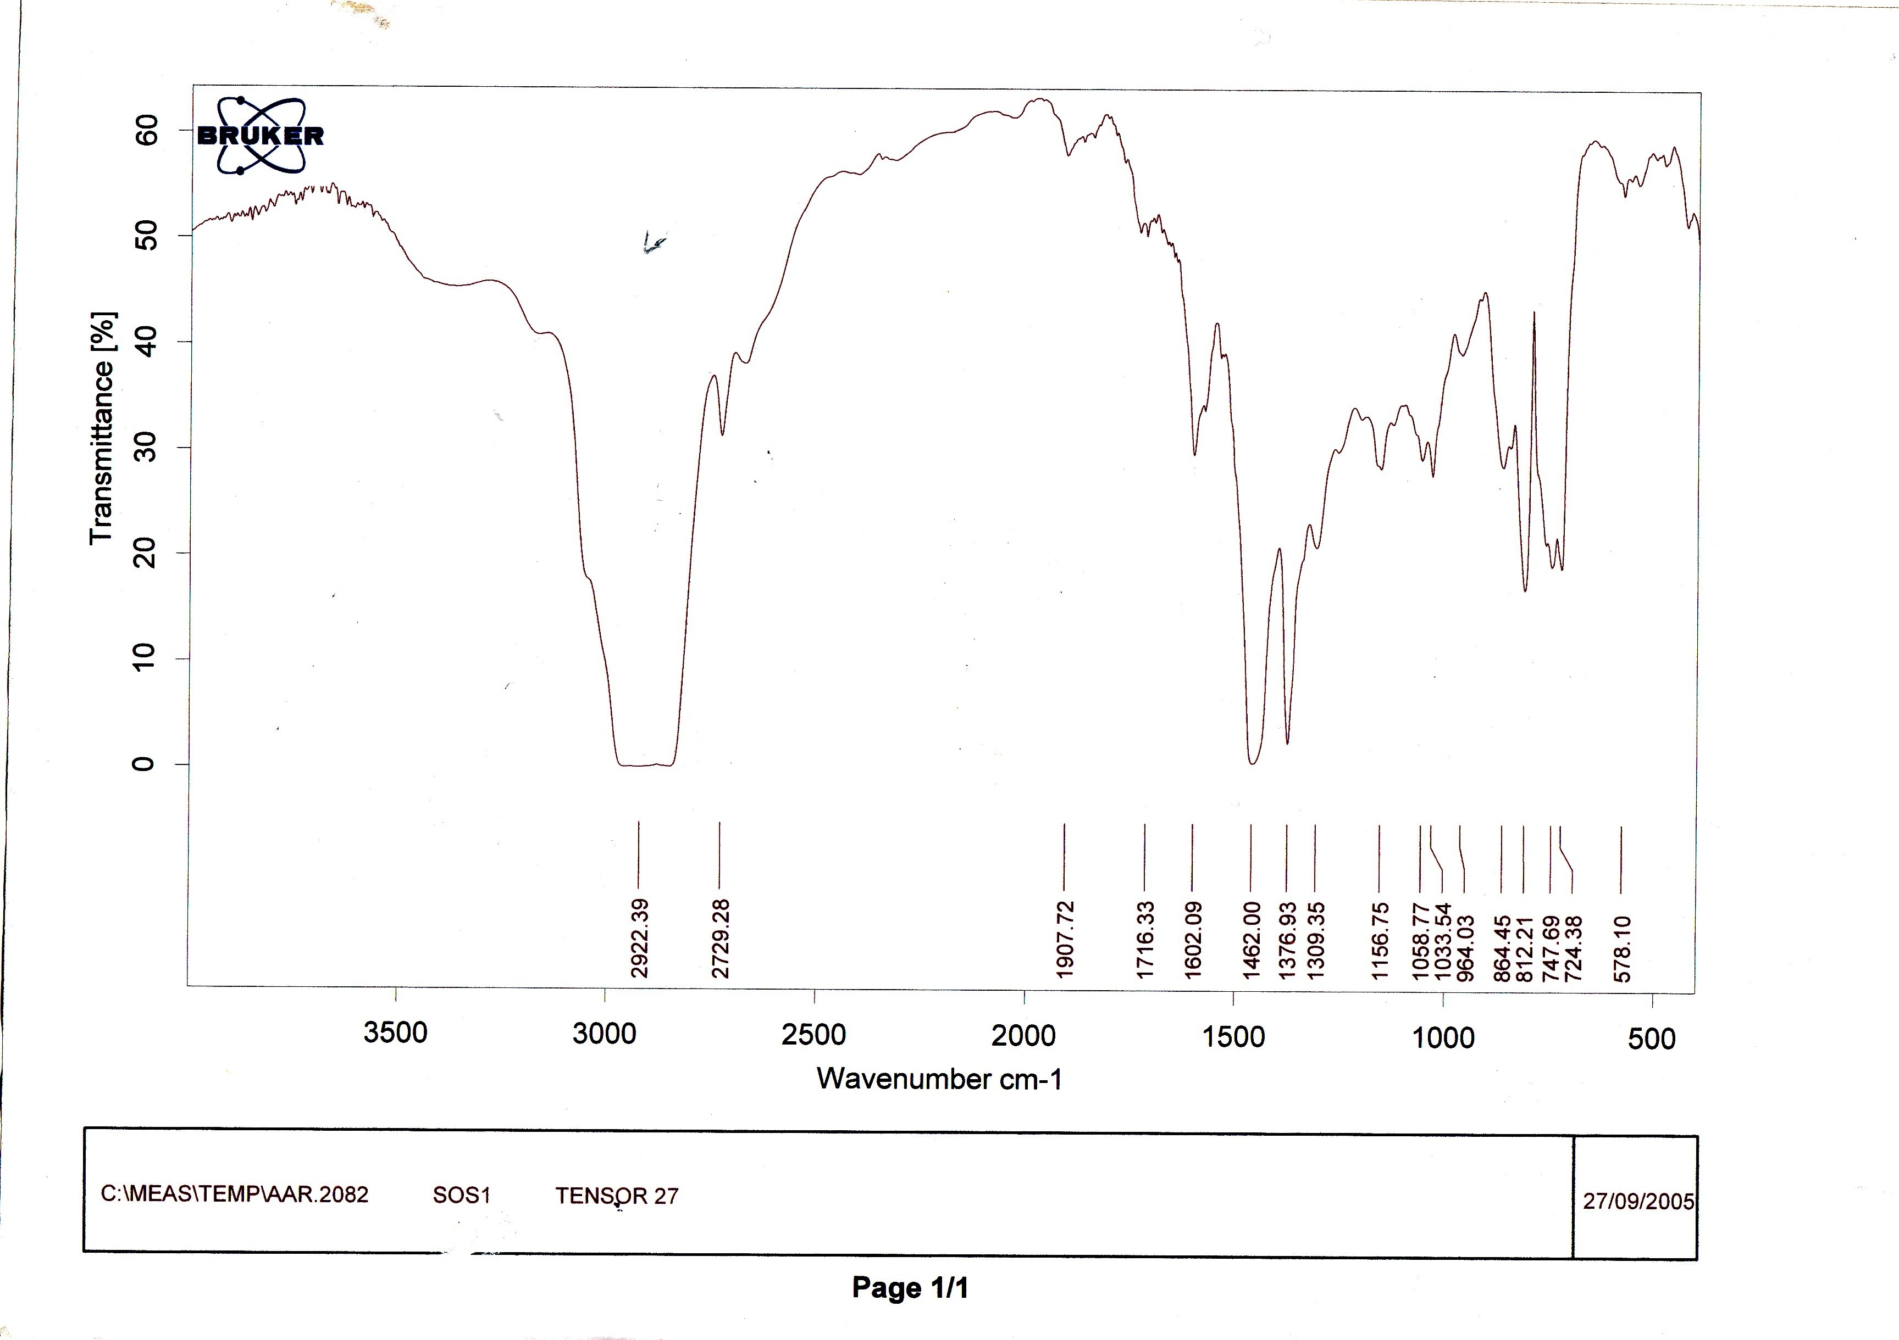

Fig(3) Infrared spectra of the fraction eluted by n-hexane using silica sample

11
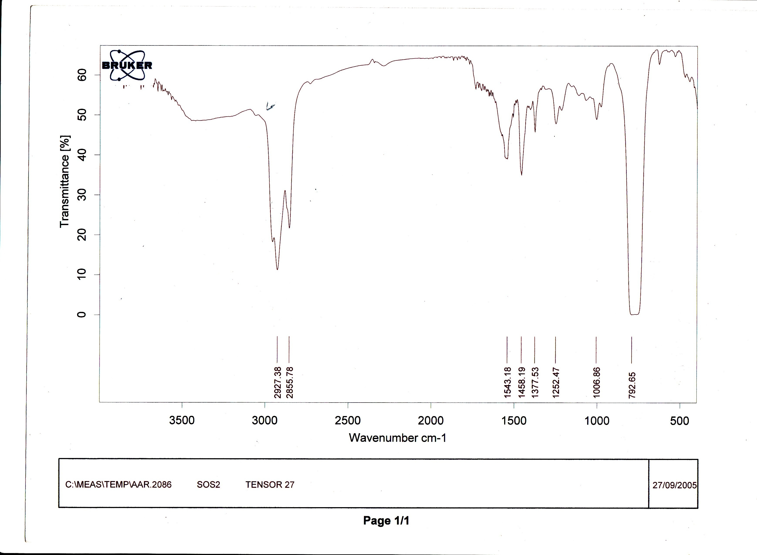
12

Fig(4) Infrared spectra of the fraction eluted by toluene using silica sample

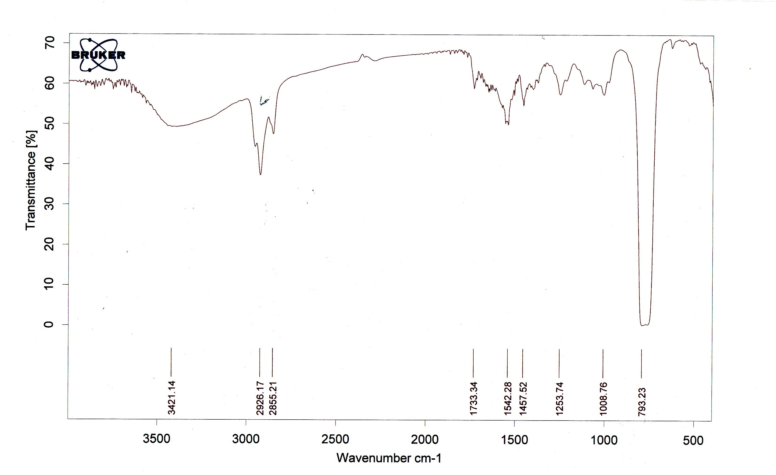
13

Fig(5) Infrared spectra of the fraction eluted by dichloromethane using silica sample

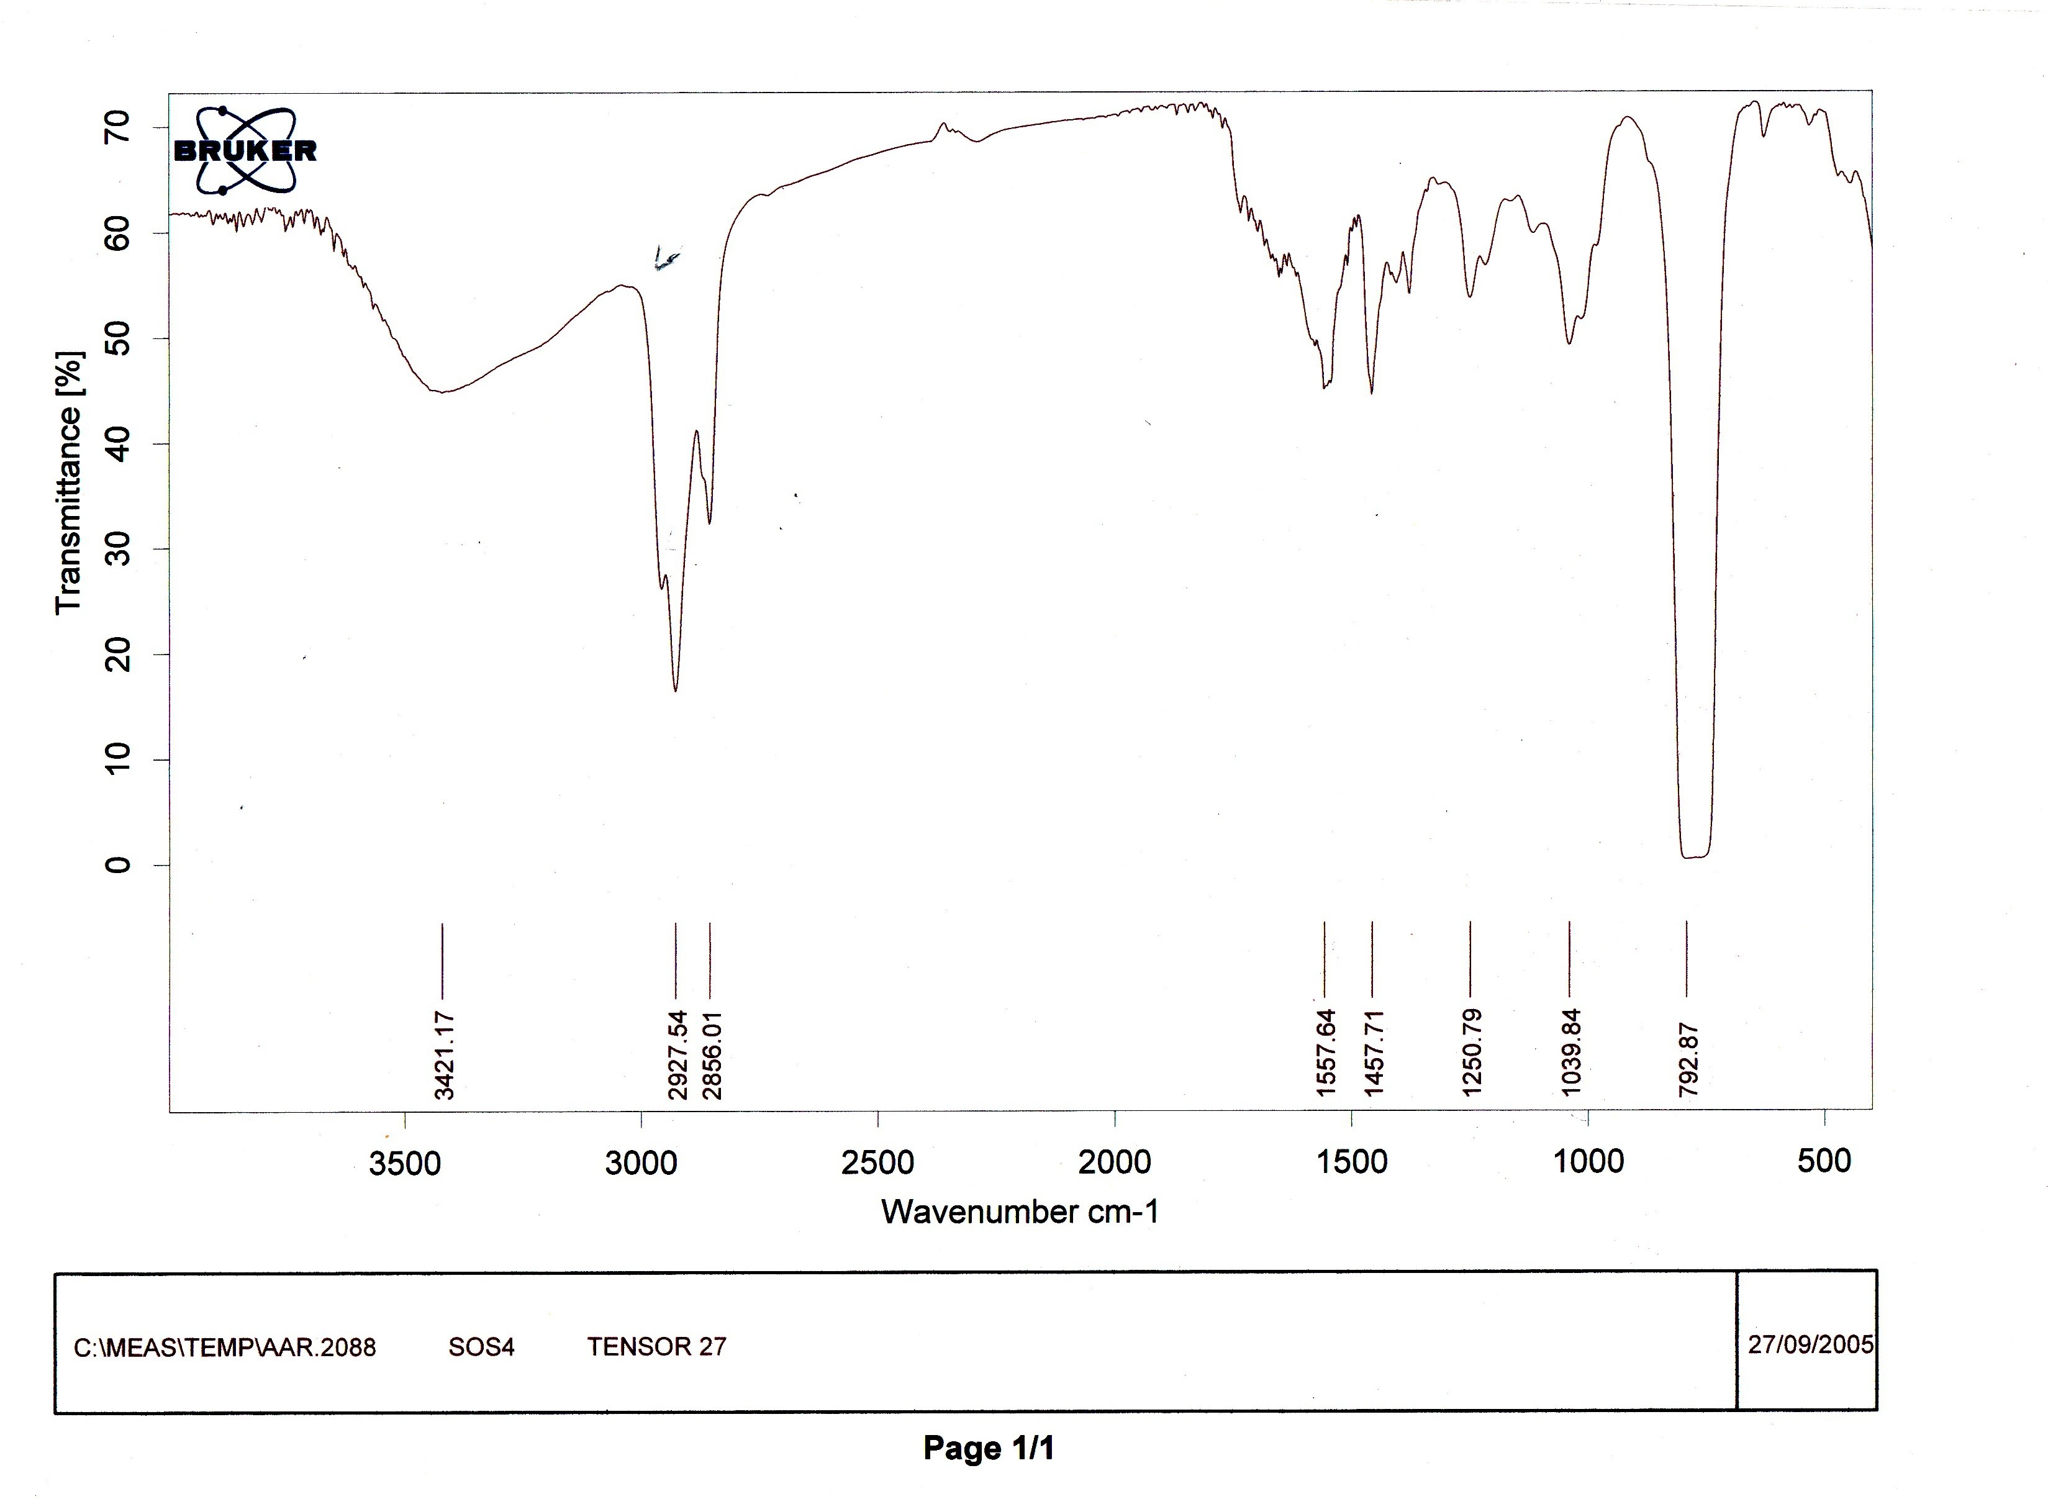

Fig(6) Infrared spectra of the fraction eluted by ethanol using silica sample

References
- R. A. Chalmers, "Laboratory Handbook of chromatographic Methods", Buttler and Tanner Ltd., London, 1970.
- A. Yamada, Y. Ezaki, and A. Nomura, J. chromatog., 1995, 705(2), 345.
- R. A. Buker and N. H. Taher, Dirasat, 2006, 33B(2), 158.
- O. Mikes, "chromatographic and Allied Methods", John Wielly and Sons, New York, 1979.
- R. A. Buker and N. H. Taher, Dirasat, 2000, 27B(2), 244.
- R. A. Buker, National J. chem., 2004, 12, 9.
- R. A. Buker, and A. S. Al-Botani, to be published in J. Rafidaine Sci., 2008.
- S. Z. Jassim ans S. Q. Al-Naqib, J. Iraqi Geol. Soc., 1989, 22, 112.
- K. J. Aswad, M. A. Amine, and S. Q. Al-Naqib, Dirasat, 1995, 22B, 1541.
- R. A. Buker and A. S. Al-Botani, to be published in J. Edu. Sci., 2008.
- R. A. Buker, J. Edu. Sci., 2003, 10(1), 1.
- M. McDaniel, J. polym. Chem. Ed., 1981, 19(8), 1967.
- A. I. Vogel, "Text Book of Qusntitative Inorganic Analysis", 4th ed., Longmans, Ltd., 1981.
- R. N. Clark, "Spectroscopy of Rocks and Minerals, and principles of Spectroscopy", John Wiley and Sons, Inc, New York, 1999.
- O. M. ramadhan and R. Y. Ghazal, National J. Chem., 2004, 16, 30.
- R. Silverstein, G. C. Bassler, and T. C. Morrill, "Spectroscopic Indentification of Organic Compounds" 5th. Ed., John Willey and Sons., New York, 2007.
14

