Thermodynamic Study on tautomerism reactions of some benzoin compounds by halogen titration method

A.S.P. Azzouz, M.A. Hussin and M.G. Al-Dabbagh
Chemistry Depatrtment, College of Education, Mosul University, Iraq
Keywords: benzoin, tautomerism, enediol, keto, halogen titration and thermodynamic

(NJC)

(Recevied on 12/4/2009) (Accepted for publication 20/4/2010)

Abstract
The study is started with the synthesis of benzoin, 4-methoxybenzoin and 4-nitrobenzoin by well known method. Their structures are confirmed by physical methods such as m.p., UV and IR spectra. The study deals with the tautomerism reactions of type enediol keto form by simple halogen titration method. The results show that the keto forms in compounds stated are predominant in benzoin and 4-methoxybenzoin shows a similar result at only 298K, and reverse results at other higher temperatures. Finally, the calculated thermodynamic parameters were estimated, namely ΔGْ, ΔHْ and ΔSْ support, the tautomerism reactions stated.
الخلاصة
ابتدأت الدراسة بتحضير مركبات بنزوين، 4-ميثوكسي بنزوين و4-نتروبنزوين وبطريقة معروفة. تم تثبيت الهيئات التركيبية للمركبات تحت الدراسة بالطرائق الفيزياوية مثل درجات الانصهار واطياف U.V و I.R. يشتمل البحث على دراسة تفاعلات التوتوميرية من نوع enediol keto
بطريقة التسحيح الهالوجيني والبسيطة. ذللت النتائج على ان اشكال هيئات الكيتو في المركبات تحت الدراسة هي السائدة في مركبي بنزوين و4-ميثوكسي بنزوين وفي مديات درجات الحرارة المحصورة بين 298-328K. اما مركب 4-نيتروينزوين فقد اظهر نتائج متشابهة فقط بدرجة حرارة 289K ونتائج معاكسة بدرجات الحرارة الاعلى واخيراً فقد تم حساب المتغيرات الثرموداينميكية والمشتملة على حساب ْΔG ، ْΔH و ْ ΔSوالتي ادعمت تفاعلات التوتوميرية المذكورة في اعلاه.

Introduction
The enolization⁽¹⁾ reactions in a simple carbonyl compounds having alpha hydrogen are the most discussed examples of prototropic tautomerism⁽²⁾ reactions. These tautomerism reactions affect the physical properties of keto and enol forms, such as solubility, melting point or boiling point, vapour pressure and the different forms of spectra. Enolization⁽¹⁾ generally is a slow process, but it is catalysed by acids and bases.
The concept of tautomerism of carbonyl^{(1, 3)}, analide⁽³⁾ and Schiff⁽⁴⁻⁶⁾ bases had been extensively studied. The methods⁽⁷⁾ were used for the determination of keto-enol equilibrium constants can be classified as chemical methods and physical, particularly spectroscopical, methods. The extent of enol-keto tautomerism study in phenol⁽⁸⁾ or phenolic Schiff bases^{(4, 6, 9)} had received a great deal of attention by many workers. NMR⁽¹⁰⁾ and UV^{(6, 11-12)} spectroscopical methods had been used for the evaluation of tautomerism equilibrium constants in these phenolic compounds. Infrared spectroscopic measurements had been used to study enolization of simple ketones⁽¹³⁻¹⁴⁾. The tautomerism of deoxybenzoin and some related compounds in the gaseous state had been measured by the integrated ion current curve by mass⁽⁷⁾ spectroscopy. The final method was also used for tautomerism⁽¹⁵⁾ reaction of benzylidene o-hydroxyaniline in the gaseous state. A direct and indirect halogen titration method⁽¹⁾ had been applied for the determination of enol contents in carbonyl compounds containing alpha hydrogen atom. As a continuation of tautomerism reactions were studied^{(6-7, 11-12, 15)} in our laboratory. This work describes the influence of temperature on equilibrium constants of tautomerism reactions of some benzoin compounds, by using the indirect halogen titration method. The influence of nitro or methoxy substituent group in benzoin on equilibrium constant values of tautomerised reactions, beside their thermodynamic parameters are considered.
Experimental
Materials and Methods
The following chemicals are used as supplied without any further purification. They are, benzoin, methanol, bromine, 4-methoxy-benzaldehyde,4-nitrobenzaldehyde, potassium cyanide, formic acid and sodium thiosulphate penta hydrate. Benzaldehyde was purified by normal distillation. Pure sample has a B.P. of ºC.
Synthesis of 4-methoxybenzoin
This compound was prepared by a similar method⁽¹⁶⁾. Transfer 1.25g of KCN dissolved in about 10ml of water into 100ml round bottom flask. To the last solution, add 6.8g of 4-methoxybenzaldehyde, 5.3g of pure distilled benzaldehyde and 18ml of ethanol. The mixture was refluxed for 1.5 hour. Steam was then passed through the solution until all ethanol and nearly all unchanged aldehydes were removed. Cooling and filtration of the mixture. Dry sample has a m.p. of 106ºC.
Synthesis of 4-nitrobenzoin
A similar⁽¹⁶⁾ procedure was followed to 4-methoxybenzaldehyde by replacement of 4-methoxybezaldehyde by 4-nitrobenzaldehyde. Pure sample has a m.p. about 300ºC.
Tautomerism study⁽¹⁾ on benzoin and 4-methoxybenzoin
- 10ml of 0.025N of each compound was placed in 50ml conical flask. The last was immersed in a water bath until equilibrium is attained at 25ºC.
- Add 2ml of 5% v/v bromine solution in methanol, which is previously thermostated at 25ºC. the mixture is left 30 minutes for completion of reaction of bromine with enol contents in the sample.
- Add a few milliter of 5% v/v aqueous formic acid solution to the final mixture, until the red colour of bromine is completely disappeared, followed by addition of 10ml of 10% w/v aqueous potassium iodide.
- The last mixture is left for about 30 minutes and titrated with 10⁻³N Na₂S₂O₃.5H₂O. Record the volume of titrant.
- Calculate the % of enol content in any sample from the neutralization equation: meq of enol = meq of I₂ = 2 meq of titrant
- Repeat steps (1-5) at other temperatures 35, 45 and 55ºC and evaluate the thermodynamic parameters of tautomerism in benzoin compounds.
Instrumentation
- The desired temperatures under study were fixed by using a water Julabo thermostat model SW 23.
- The IR spectra of solid benzoin compounds are measured by KBr disk method and by using a computerized Bruker Tensor-27.
- The UV spectra of 10⁻⁵M ethanolic solutions of benzoin compounds were measured by a double beam computerized UV 1601 Shimadzu spectrophotometer and by using a matched 1×1×3cm³ silica cells.

Table (1): Melting points, IR and UV spectral data for benzoin, 4-mehoxybenzoin and 4-nitrobenzoin

Symbol | Structure | m.p. °C | IR spectra cm⁻¹ |  |  |  |  | UV spectra λ_{nm} (ε_{max})  in ethanol
Symbol | Structure | m.p. °C | OH⁻ | C=O | Arom. | -OCH₃ | NO₂ | UV spectra λ_{nm} (ε_{max})  in ethanol
I | C  O  H  H  C  O  P  h | 133-135 | 3416.08 (m) | 11680.16 (s) | 1598.08 (s) |  |  | 206(16600), 248(13900), 290(900)
II | C  O  H  H  C  O  P  h  C  H  3  O | 95-97 | 3478.81 (m) | 1665.36 (s) | 1600.03 (s) | 1175.08 (s) |  | 211(580), 252(6100), 281(5900)
III | C  O  H  H  C  O  P  h  O  2  N | 300 | 3374.99 (m) | 1725.05 (s) | 1606.25 (s) |  | 1572.72 (s) | 221(28300), 270(7300), 341(1800)

m = medium
s = strong

Results and Discussion
A direct and indirect halogen titration methods⁽¹⁾ had been used for the determination of enol and content in carbonyl compounds, containing alpha hydrogen atom. In the indirect method, a solution of the substance to be investigated is titrated with a standard solution of bromine. The enol present reacts rapidly with bromine, yielding a bromo ketone, whereas the direct bromination of keto form is very slow. The problem of such method might result in too high enolic values and rather unsharp and point. This was avoided in a modification often referred to as indirect method, which was applied to our benzoin compounds under investigation. Actually, before studying the tautomerism of benzoin,
p-methoxybenzoin and p-nitrobenzoin, by the indirect halogen titration, it was decided to study their chemical structures by physical method. The last includes melting points, IR and UV spectra of benzoins mentioned as an available facilities in our laboratory, as shown in Table 1. The melting points of benzoin compounds are increased in the following order:
p-nitrobenzoin>benzoin > p-methoxybenzoin
The increases in melting point of p-nitrobenzoin as compared with others can be explained by two fold reasons:
- The relative increase in molecular weight of p-nitrobenzoin as compared⁽¹⁷⁾ with benzoin or p-methoxybenzoin. This is in a good agreement with other studies observed previously.
- The greater extents of p-nitrobenzoin to polymerize, possibly by intermolecular⁽¹⁸⁾ hydrogen bondings. This produces a long chain of molecules of relatively high molecular weights, and agrees well with the previous paragraph. The reverse electronic behaviours of p-methoxy group as compared with nitro group results in a minimum melting points value 95-97ºC. The IR spectra for all benzoin compounds observed in Table 1, shows the following wave numbers:
1. The sticking frequencies for all OH groups of benzoin compounds have a medium absorption range between (3375-3479)cm⁻¹.
2. Similarly, the carbonyl and aromaticity stretching frequencies for all benzoins have a ranged of values between (1665-1725)cm⁻¹ and (1598-1600)cm⁻¹.
3. Additional strong absorption frequencies are observed for p-methoxy and p-nitro groups in p-methoxybenzoin and p-nitrobenzoin at a wave numbers 1176.0cm⁻¹ and 1572cm⁻¹ respectively.
The UV absorption spectra for a benzoin compounds are seen in Fig. 2 and is summarized in Table (1). This shows three absorption bands at wavelengths λ(nm) and molar extencition coefficient values of Σ_{max} (Liter.mole⁻¹.cm⁻¹). Benzoin shows a longer absorption band at 290.0nm with Σ_{max} value of 900 for n→π* transition⁽¹⁹⁾. The other two absorptions at wavelengths of 248nm and 206nm with Σ_{max} values of 13900 and 11500 respectively for π→π* transition⁽¹⁹⁾. p-Methoxybenzoin and p-nitrobenzoin show a similar absorption transition bands for benzoin. All UV and IR absorptions confirm the chemical structures of benzoin compounds under study and are agreed with other compounds in literature⁽²⁰⁾. This encourage the workers to deal with the influence of temperatures on the equilibrium constants values of types enediol keto tautomerised reactions in benzoin compounds, beside their thermodynamic parameters, surely, the temperature as known has a great influence on many chemical reactions, as tautomerism of deoxybenzoin⁽⁷⁾ and some related compounds in the gas phase, phenolic Schiff base⁽²¹⁾ in solution and gaseous states, some aromatic mono and bi Schiff bases⁽²²⁾, formation of hydrogen bonds⁽²³⁾, pK_{a} of benzaldoxime⁽²⁴⁾ and other⁽²⁵⁾.
The equilibrium constants for tautomerism reactions of benzoin under study of type enediol keto, shown in Table 2, have estimated between temperatures 298-328K. A maximum value of 80.53 is observed for benzoin at 298K. Increasing the temperature to a higher values are accompined by decreasing the values estimated. This means that the relationship between the equilibrium constant values and the temperatures are inversely proportional. Introduction of electron donating group as methoxy or an electron accepting group as nitro as in 4-methoxy benzoin or 4-nitrobenzoin respectively is resulted to the relative decrease in equilibrium constant value as compared to benzoin.
The equilibrium constant values seen in Table 2, have a ranged of values between 80.53-0.07, depending on the chemical structure of benzoin or its 4-methoxy or 4-nitro derivatives and the ambient temperature. Those values of greater than unity as observed for benzoin and 4-methoxybenzoin at all temperatures , these mean that the keto forms are predominant or they are more stable. 4-Nitrobenzoin shows a similar result only at 298K. At other higher temperatures, the equilibrium constant have a values lower than unity or the favoured tautomer and the more stable one is the enediol.
The thermodynamic of tautomerism in compounds under study represent the various forms of energies associated with enediol keto reversible reactions. These are included ΔGْ, ΔHْ and ΔSْ thermodynamic parameters estimated from equations 1-3 of the forms:
ΔGْ = -R T lnK … (1)
ΔHْ
RT

lnK = constant – … (2)

ΔGْ = ΔHْ – T ΔSْ … (3)
The signs of ΔGْ are negative for benzoin, 4-methoxybenzoin at all temperature. This means that their tautomerism reactions are spontaneous. Similar sign is observed for 4-nitrobenzoin at 298K. At other higher temperatures, their ΔGْ signs are changes to a positive, due to the smaller equation values of lower than unity. The heats of tautomerism reactions ΔHْ in benzoin and its
4-methoxy or 4-nitro derivatives are evaluated by plotting a graph between lnK versus the inverse of absolute temperature using Excel program as in Fig. 3. The plots show a straight lines R² range values 0.9678-0.9971. They have a negative signs values, which means that heat of tautomerism is exothermic. In addition to that, the ΔHْ values are comparable with literature^{(1, 10)}. The ΔSْ values of entropies of tautomerism in benzoins are depend on their chemical structures. Their signs are positive in benzoin and 4-methoxybenzoin. This means that their tautomerism reactions are directed toward the more random. This can be expected if intermolecular hydrogen bonding for the double hydroxyl groups in enediol tautomer is greater than its keto tautomer. Conversely, the ΔSْ signs for the
4-nitrobenzoin are negative or they have an opposite interpreted to those just mentioned before. Those tautomerisms under study are in a good agreement with other tautomerism studies as deoxybenzoin⁽⁷⁾, phenolic Schiff bases⁽²¹⁾ and aromatic mono and bi Schiff bases⁽²²⁾.

Table (2): Equilibrium constants of tautomerism of benzoin compounds at various temperatures and their thermodynamic parameters.
Compound | Temp. (T) K | ml of Na₂S₂O₃  10⁻³ M | Enol  mqeq/10 ml | Keto  mqeq/10 ml | ln K | ΔGْ  kJ.mole⁻¹ | ΔHْ  kJ.mole⁻¹ | ΔSْ  kJ.mole⁻¹
Benzoin | 298 | 6.2 | 0.00065 | 0.05235 | 4.39 | -10.88 | -6.57 | +14.46
Benzoin | 308 | 7.3 | 0.00077 | 0.05223 | 4.22 | -10.81 | -6.35 | +14.48
Benzoin | 318 | 7.7 | 0.00082 | 0.05218 | 4.15 | -10.97 | -6.37 | +14.47
Benzoin | 328 | 8.3 | 0.00088 | 0.05212 | 4.08 | -11.13 | -6.38 | +14.48
4-methoxy benzoin | 298 | 10.7 | 0.00129 | 0.05921 | 3.83 | -9.49 | -2.45 | +23.62
4-methoxy benzoin | 308 | 11.2 | 0.00136 | 0.05914 | 3.77 | -9.65 | -2.38 | +23.60
4-methoxy benzoin | 318 | 11.5 | 0.00139 | 0.05911 | 3.75 | -9.91 | -2.41 | +23.58
4-methoxy benzoin | 328 | 12.0 | 0.00145 | 0.05905 | 3.71 | -10.12 | -2.37 | +23.63
4-nitro benzoin | 298 | 1.0 | 0.00013 | 0.00018 | 0.32 | -0.79 | -59.39 | -196.64
4-nitro benzoin | 308 | 1.8 | 0.00023 | 0.00008 | -1.05 | +2.69 | -57.87 | -196.62
4-nitro benzoin | 318 | 2.0 | 0.00025 | 0.00006 | -1.43 | +3.78 | -58.75 | -196.64
4-nitro benzoin | 328 | 2.3 | 0.00029 | 0.00002 | -2.66 | +7.25 | -57.24 | -196.62

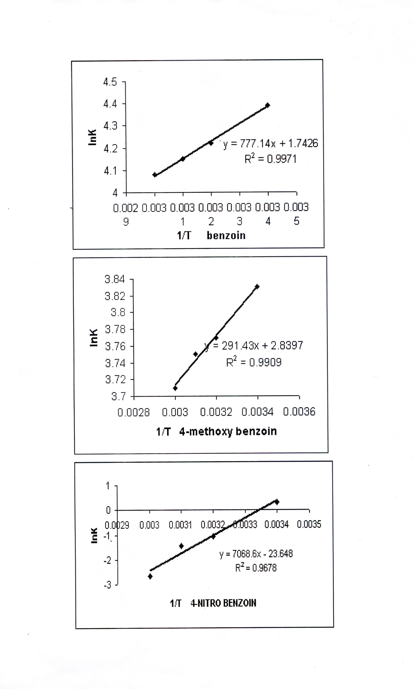
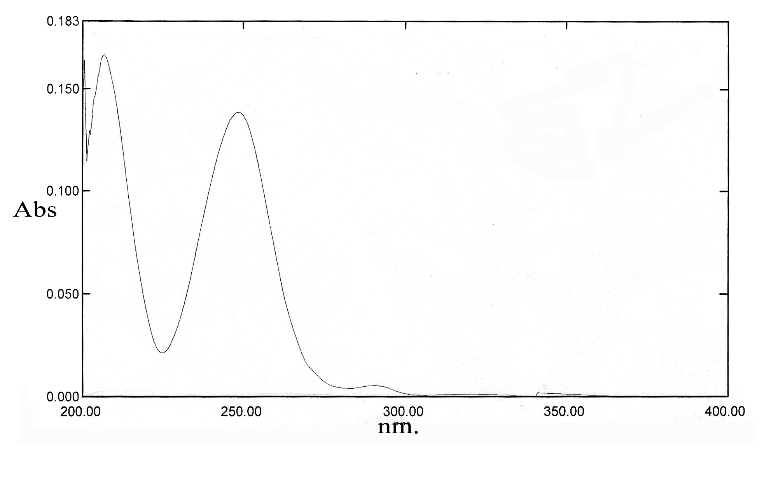
Benzoin

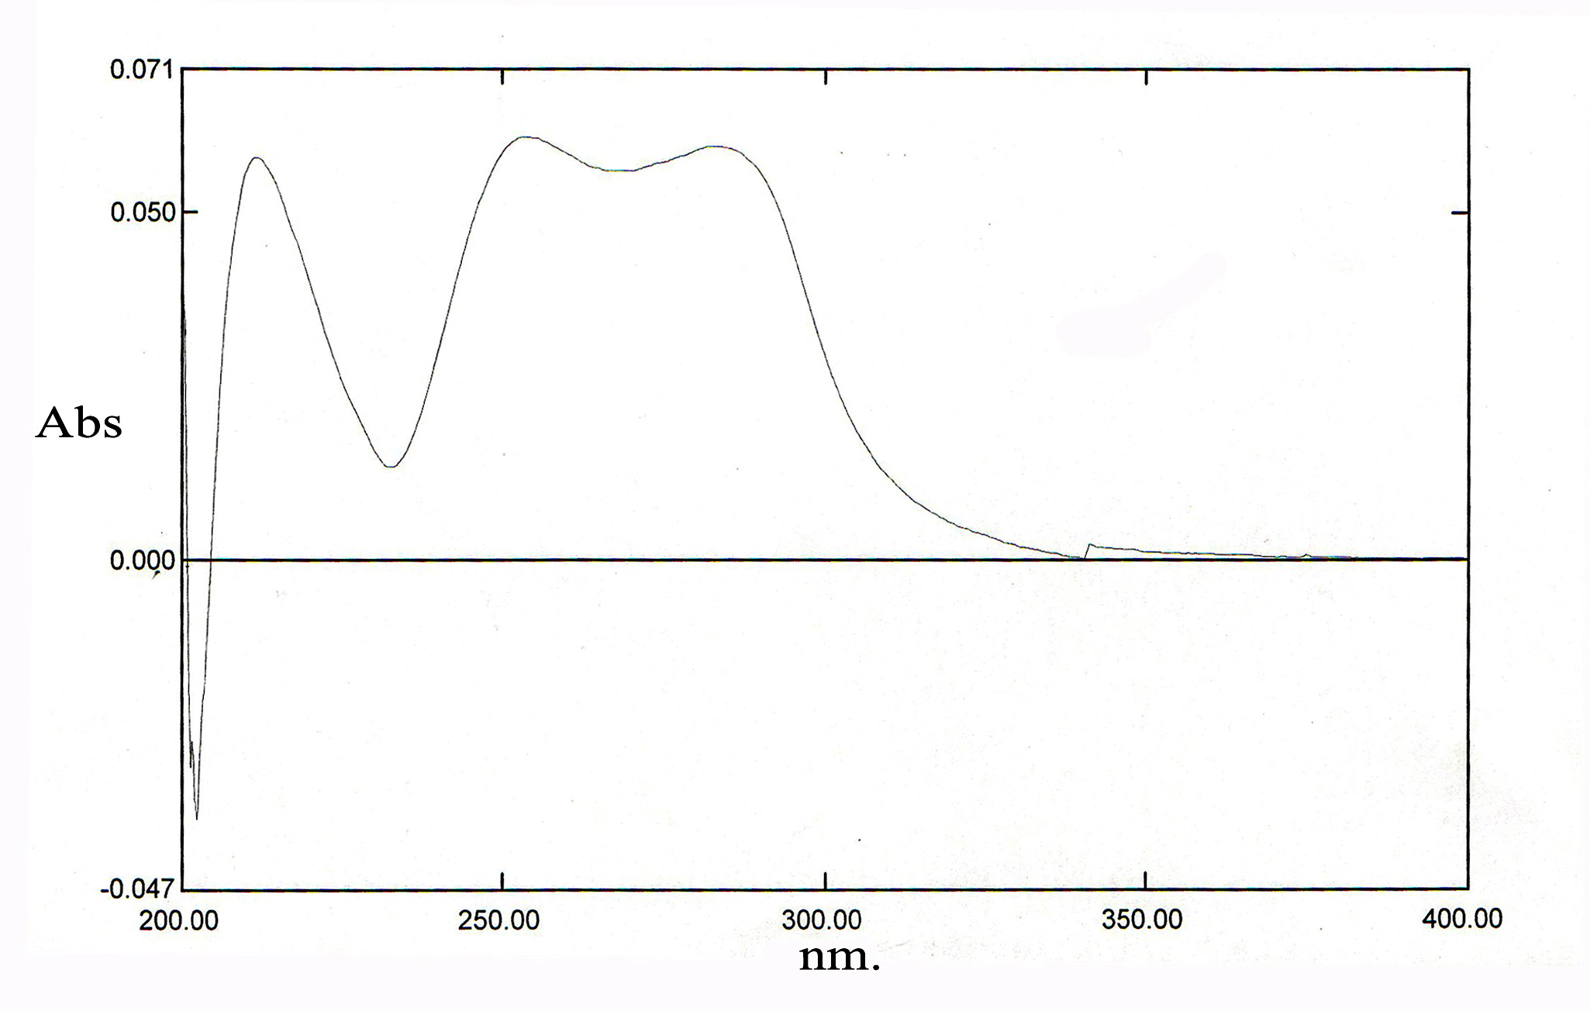
4-Methoxy benzoin

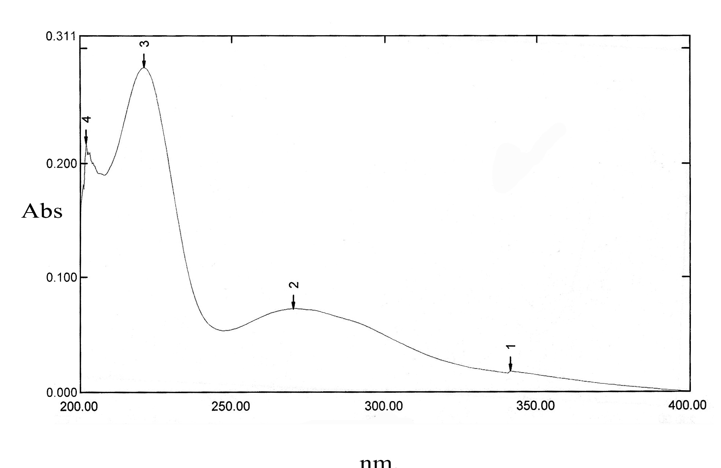
4-Nitrobenzoin

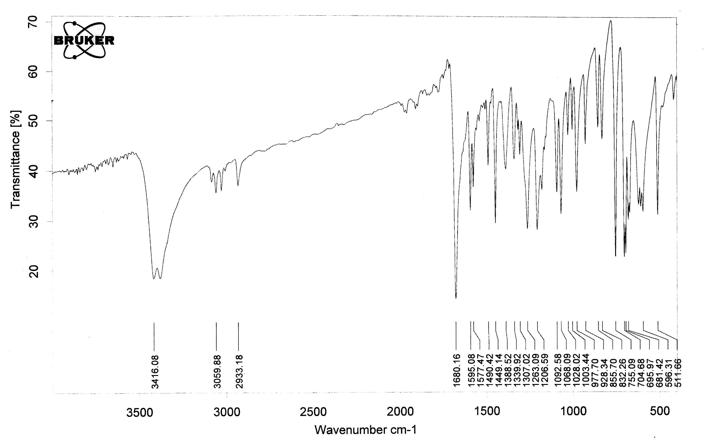
Benzoin

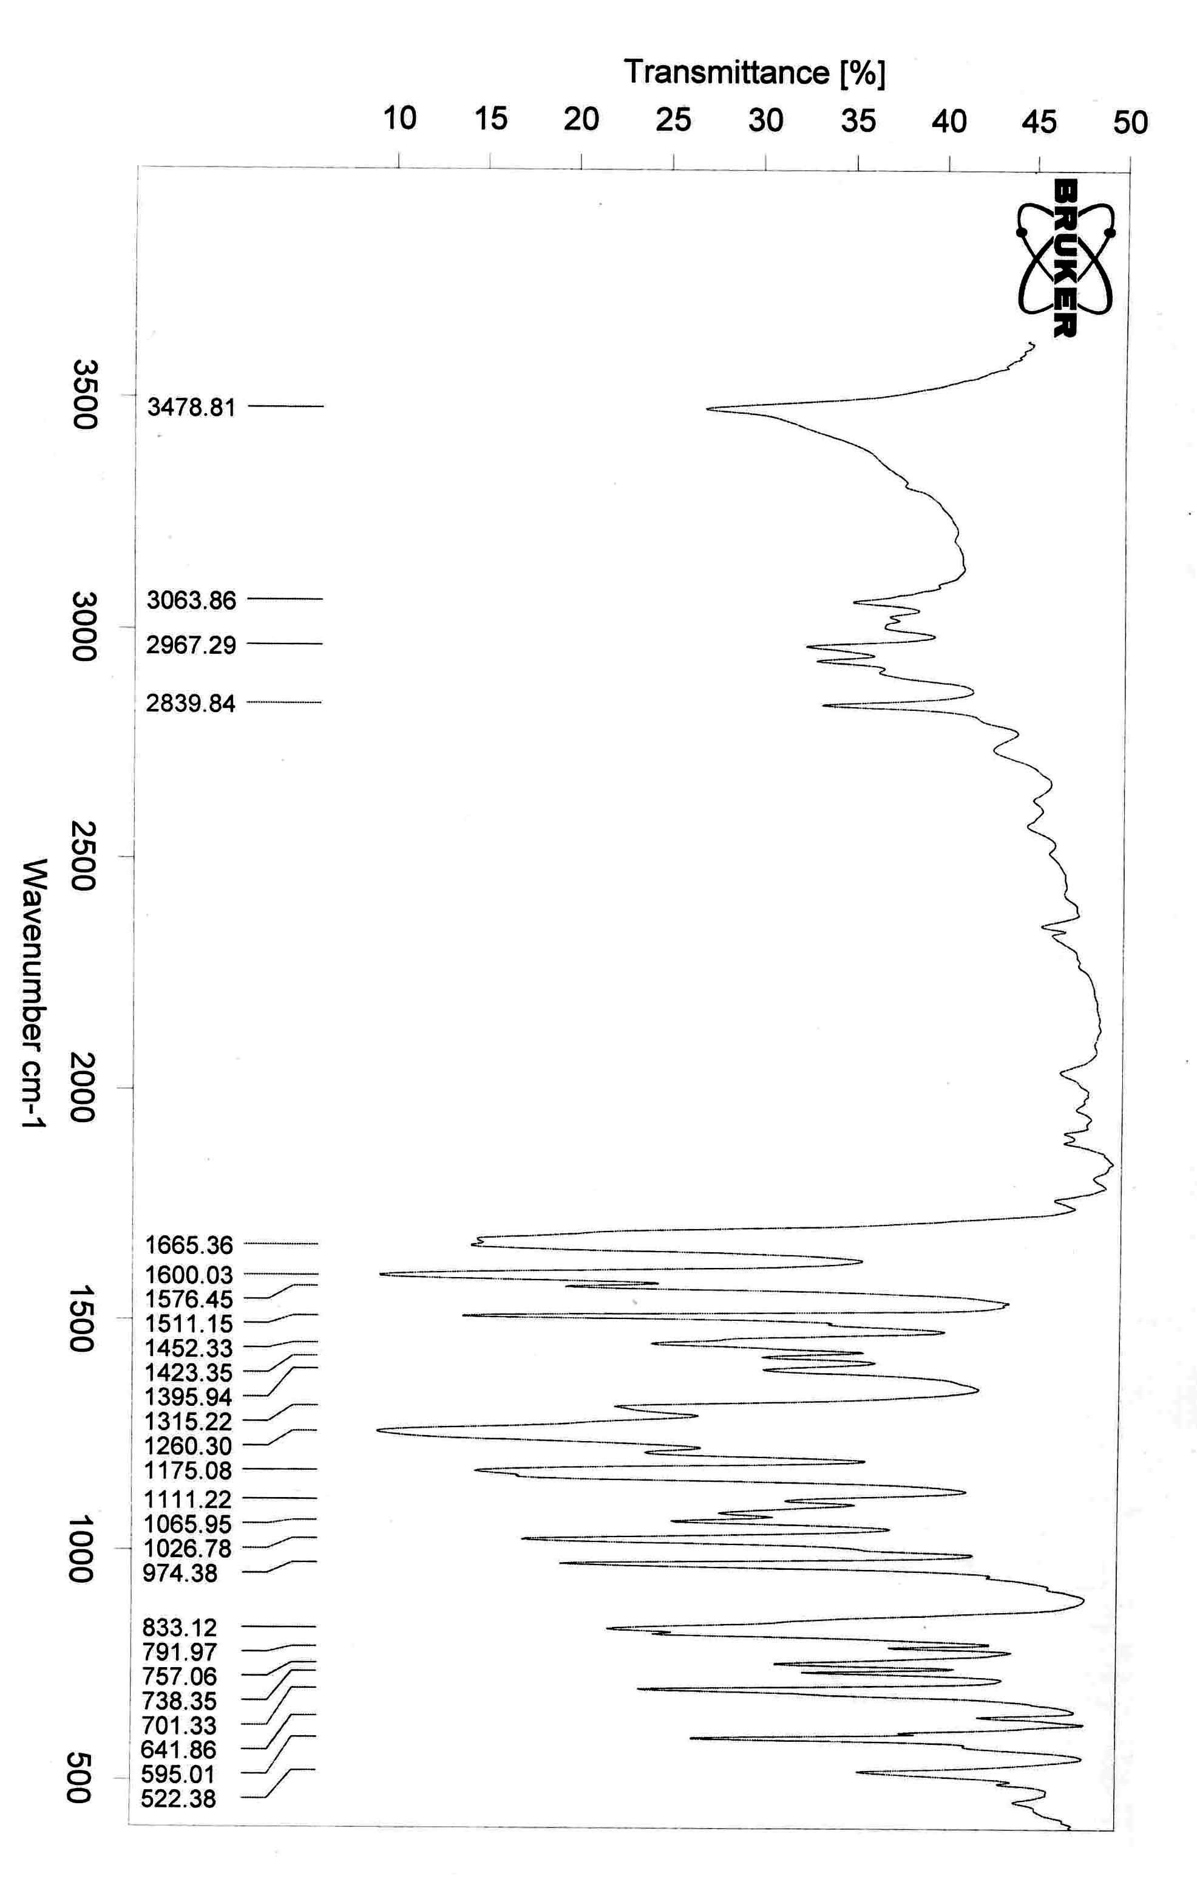
4-methoxy benzoin

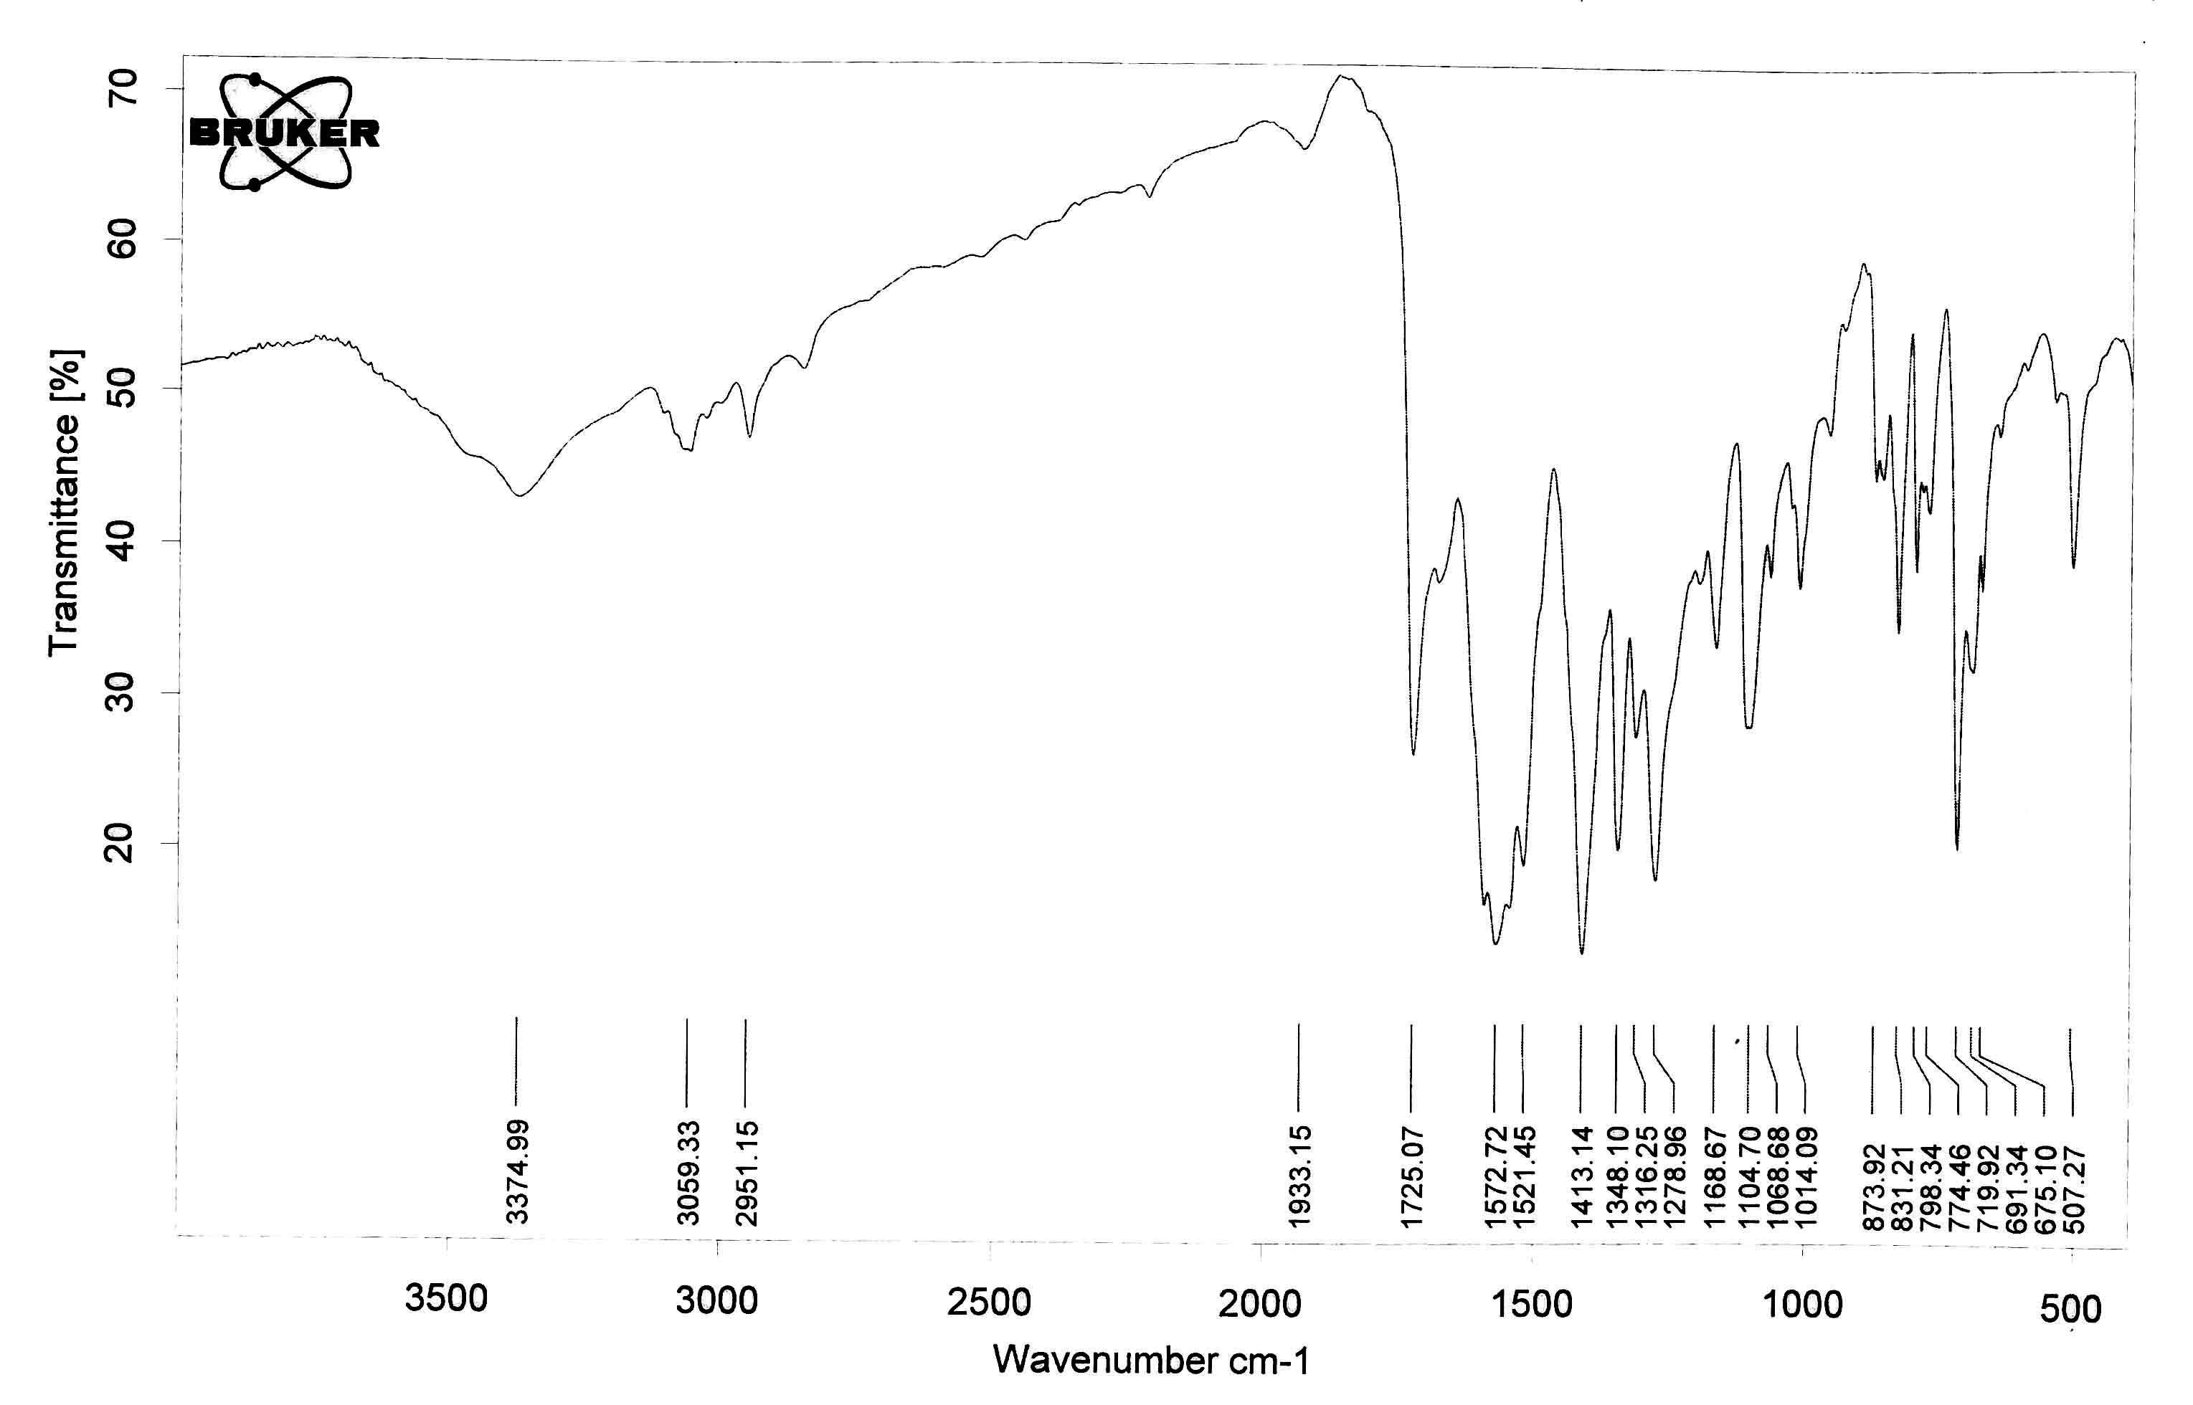
4-Nitrobenzoin

References
- Ed.Z. Zabicky, The chemistry of carbonyl Group, 1970, 2, Interscience, London, 157-240.
- C.K. Ingold, Structures and Mechanism in Organic Chemistry 1953, G. Bell, London, p. 529.
- G. Allen and R. A. Dwek, J. Chem. Soc., 1966,161.
- G.O. Dudek and E. P. Dudek, J. Amer. Chem. Soc., 1964, 86, 2483.
- A.S.P. Azzouz, National J. Chem., 2005, 22, 214.
- A.S.P. Azzouz and A. B. N. AL-Dabagh, National J. Chem., 2007, 26, 295.
- A.S.P. Azzouz, Mutah J. Res and Stud., 1993, 8, 93.
- S.H. Pine, J. B. Hendrickson, D. J. Cram and G. S. Hammond, Organic Chemistry, 4th ed., 1981, McGraw Hill, London, p. 183.
- M.D. Cohen, T. Hirshberg and G. M. J. Schmidt, J. Chem. Soc., 1964, 2060.
- G.O. Dudek and E. P. Dudek, J. Amer. Chem. Soc., 1966, 88, 2407.
- A.S.P. Azzouz, A.A. Rahman and A.G. Taki, National J. Chem. 2005, 20, 568.
- A.S.P. Azzouz, A.A. Rahman and A.G. Taki, National J. Chem, 2007, 26, 217.
- A.C. Cope and B.D. Tiffany, J. Amer. Chem. Soc., 1951, 73, 4158.
- N.A. Abood and A.F. Ajam, J. Chem. Soc., Pakistan, 1985, 7, 1.
- A.S.P. Azzouz and I.Z. Sulyman, J. Edu. Sci., 2004, 16, 125.
- W.S. Ide and J.S. Buck, Organic reactions, 1948, 4, 269-81.
- G.C. Pimental and A.L. Mecellellan, The hydrogen bond, Freeman, NewYork, 1960.
- A.S.P. Azzouz and M.M.H. AL-Niemi, Z. Phys. Chem., 2005, 219, 1591.
- A.S.P. Azzouz, A.A. Rahman and A.G. Taki, J. Edu. Sci., 2003, 15, 1.
- R.M. Silverstein and G.C. Bassler, Spectrophotometric Identifica-tion of organic compounds, 2nd ed., John Wiley, NewYork.
- A.S.P. Azzouz, Nat. J. Chem., 2006, 22, 214.
- A.S.P. Azzouz and A.B.N. AL-Dabagh, Nat. J. Chem., 2007, 26, 295.
- S.K. Al-Dilami and A.S.P. Azzouz, J. Edu. Sci., 1990, 10, 45.
- A. S. P. Azzouz and N.A. AL-Azzawi, J. Edu. Sci., 2002, 1, 20.
- A.S.P. Azzouz and N.A. Al-Azzawi, 2002, 14, 20.

