Synthesis ,characterization and kinetic studies of the formation of a new chromium( III) complex of mixed ligands L-cysteine and picolinic acid.

M.A.Abdullah* and Diary I. Tofiq†
Department of Chemistry, College of Science, University of Sulaimany
Kurdistan –Iraq.
Email:* Hamaaliabdullah@yahoo.com., † zand_71@yahoo.com

(NJC)

(Recevied on 23/6/2008) (Accepted for publication 20/4/2010)

Abstract
A new Cr(III) complex of mixed ligands of picolinic acid (Hpic) and L-cysteine has been synthesized from acid catalyzed hydrolysis of the blue colored solution of sodium salt of bis L-cysteinato(N,O,S) chromate^{III} complex with solution of Hpic restrictive acidic media of pH=3-4 with gentle heating. The red-brown color product complex of sodium bis L- cysteinato(N,O) monohydroxy picolinato(N)chromate^{III} have been characterized by element analysis ,electronic and i.r spectroscopy comparison to the properties of some well known related Cr(III) complexes leads to the conclusion that Hpic binds to Cr(III) center via its nitrogen donor atom.
The kinetics and mechanism of the formation of this complex, from the acid catalyzed cleavage of Cr—S bond and subsequent Hpic substitution, have been studied spectrophotometrically in a limited pH 3-4.5 range, which was adjusted by HClO₄ (μ =0.2M).The rate of the production shows two reaction paths ;one for mono protic thiol,[ Cr(III) (L-cysH)(L-cysN,O,S) (H₂O)] and other for diprotic both thiol, [Cr (L-CysH)₂ (H₂O)₂]⁺²,with Hpic ligand substitution on Cr(III) through N atom.The speices of monoprotic reacts faster with an acid dependent than the diprotic species reaction .The pseudo first order rate constant equation is of the form; k = k₁K_{a2} [H⁺]⁻¹ + k₂ (where k₁ represents the rate constant for first step, k₂ for second step reactions and K_{a2} is acid dissociation constant for diprotic species) was obtained with ΔH# and ΔS# for both paths are 67.195 kJ mol⁻¹,- 25.41JK⁻¹mol⁻¹ and 68.96 kJ mol⁻¹,-93.64 JK⁻¹ mol⁻¹ respectively.
Key words ;Chromium, Mixed ligand complex of L-cysteine and picolinic acid, Kinetic study.
الخلاصة
تم تحضير و تكوين معقد جديد ال Na[Cr(L-CysH)₂(Hpic)(H₂O)] للكروم (III) مع الليكندات المختلطة لحامض البيكولينيك (Hpic) مع سيستين من عملية التحلل المائى التحفيزى الحامضى للمعقد الازرق اللون: {Na [Cr (L-cys) ₂]. 2H₂O} مع محلول الليكاندات (Hipc) فى وسط حامضى (pH =3 - 4.5) مع التسخين الهادىء .
المعقد الناتج القهوائى المحمر اللون (Na[Cr(L-CysH)₂(Hpic)(H₂O)]) تم تشخيصها بالتحليل الدقيق للعناصر والاطياف الالكترونية وتحت الحمراء وكروموتوغرافيا التبادل الايونى وبواسطة مقارنة صفاتهم مع معقدات كروم (III) المعروفة. تبين من تشخيص ناتج التفاعل ان حامض البيكولينيك مرتبطة باصرة تناسقية مع الكروم فى المركز من خلال النايتروجين الواهب للالكترونات .
ان ميكانيكية وحركية تكوين المعقد من التفكك الحامضى للاصرة (Cr-S) والحامض بيكولينيك المرتبط, قد تم دراستها فى وسط الحامضى =pH 3-4.5 التي تم ضبطه بالحامض HClO₄ وكذلك الشدة الايونية (µ=0.2M NaClO₄) .
تم ايجاد ثابت سرعة التفاعل من الدرجة الاولى الكاذبة وفق المعادلة: k = k₁K_{a2}[H⁺]⁻¹+ k₂
حيث k₁ يمثل ثابت سرعة التفاعل للخطوة الاولى و k₂ يمثل ثابت سرعة التفاعل للخطوة الثانية ، اما K_{a2} يمثل ثابت تحلل الحامض البيكولينك .H₂pic باراميترات المنشطة المحصل عليها كانت لتكوين المعقد في الخطوتين كالاتى :
( , ( ∆H*=68.96 kJ mol⁻¹ ( 93.64JK⁻¹mol⁻¹ (∆S*=- و) (∆H*=67kJ mol ⁻¹ و (∆S*=-25.41JK⁻¹mol^{-1 .}

Introduction
Some important studies⁽¹⁻³⁾ have been reported on the interaction of thiol containing amino acids with Cr(III) to illustrate the role of loosely Cr—S bond in
Biological processes of Cr(III) cofactor (GTF) that rapidly responds to maintain proper carbohydrate and lipid metabolism ^{(4-6).}In the biological system. The main problem of Cr—S bond is its susceptibility to hydrolysis in both acidic and basic media⁽¹⁻³⁾ The well characterized crystal complexes of sodium and potassium of bis-L-cyseinato (N,O,S) chromate(III) have been synthesized⁽⁷⁾ and showed that the thiol binds Cr(III) at very narrow range of pH=7-8 {near physiological pH} and in media more or less than this range Cr—S bond cleavage occurs rapidly^{(2,3)}.
In the moderately acidic media (pH≈ 5.5) this complex gives two different protic species, mono protic(CH) and diprotic(CH₂⁺),as it was shown by the equilibrium distributions curve of O’Brien and his coworkers ⁽²⁾. According to this distribution curve the predominant species at pH < 4 is diprotic species. The kinetics and mechanism of this Cr—S bond cleavage have also been studied at pH=5.5-7.0 and showed that Cr—S bond is labile and readily hydrolyzed with the low activation energies⁽²⁾ and with acid independent rate constant. The labiality and easy cleavage of this Cr—S bond provides the reactive site for preparation of mixed ligands of L-cysteine and picolinic acid or nicotinic acid. Therefore, the mixed ligand of [Cr (L-cysSH)( Hpic)(H₂O)]⁺ have been synthesized in acidic media pH= 3.0-4.5 and the kinetics and mechanism of the product formation from protic species of acidic solution( pH 3.0- 4.5) of bis L-cysteinato Cr(III)complex have been studied in this paper.
Experimental
Material:
L-cysteine and piolinic acid were obtained from BDH, chromium (III ) nitrate nanohydrate and sodium perchlorate (stream chemical) were used with out purification. All other reagents were employed BDH analar, sephadex Sp-25(H⁺) and sephadex Sp(Cl ⁻) were used for column chromatography.

Equipments and analytical methods:
Electronic spectra of complexes were obtained and recorded on (HEλI0Sα - UV-Visible spectrophotometer V4.60); IR spectra were recorded as KBr disc on Beijing WQF-300 FTIR spectrophotometer. The thermostat and spectrophotometer of type TU-1800 UV-VIS used for kinetic studies pH meter of type OAKTON was used for hydrogen ion measurements in the solution. The micro analysis for C, H,N and S were obtained from Jordan laboratory using Perkin Elemer -2400 CHNS/O Analyser. The analysis for Cr^{III} was performed using 1,5 diphenyl hexano hydrazid by spectroscopic following method in reference⁽⁸⁾.
Preparation:
The blue crystals of potassium bis L-cysteinato(N,O,S) chromate salt were prepared according to method De Meester et.al.⁽⁷⁾.The solid blue crystal (1x10⁻³ mol) was dissolved in water and the pH decreased by adding HClO₄ until red–violet color was formed at pH 2-3 which indicates the hydrolysis of the linkage Cr—S that gives protic species (CH)and(CH₂⁺) then (2x10⁻³ mol) of picolinic acid(pKa =1.01 for COOH) was added with gentle heating and continuous stirring the color changed to red- brown. The red- brown solid was obtained by evaporation and finally washed with ethanol and ether(Mw.= 472) .
Kinetic:
A number of solution mixtures of the blue sodium salt bis-L-cysteinato (N,O,S) chromate(III) (5x10⁻³ mol) and Hpic (5x10⁻²mol) were prepared and thermostated at desired temperature (20 -50 ⁰C) after adjusting pHs to required values by( HClO₄ and NaOH) the ionic strength of each solution was kept constant at μ = 0.2 by NaClO₄ , then the changes of the absorbance of mixtures were measured with time(20,30,40,50) at λ =525 nm.
Results
The element analysis shows that resulted complex Cr:L-cys: Hpic is in the ratio 1:2:1
sodium monoaquo bis L-cysteinato(N,O) picolinato(N) chromate(III) monohydrate complex with the chemical formula; [Cr^{III}(C₃H₆NO₂S)₂(C₆H₅O₂N)(H₂O)]⁻ (table-1-).
The ion exchanger chromatographic on sephadex SP C-25 cation and anion exchanger indicates that the complex is anionic similar to the well known starting [Cr^{III} (L-CysN.O.S)₂]⁻ complex.

Table-1- Physical properties and Elemental analysis data for the prepared complexes .
Complexes | Color  (m.p.) | C% | H% | N% | Cr%
Complexes | Color  (m.p.) | Found(calcd)% | Found(calcd)% | Found(calcd)% | Found(calcd)%
Na[Cr(L-cys)₂]. 2H₂O | Blue  (198ºC) | 20.24(20.63) | 3.67(4.01) | 8.11(8.02) | 13.97(14.89)
Na[Cr(cys)₂(Hpic)(H₂O)].H₂O | Red-brown (217 ºC) | 30.52(30.51) | 3.52(4.02) | 8.84(8.89) | 10.90(11.76)

In the acidic media the starting complex, after both protonation and subsequent cleavage of the loosely Cr—S bond, gives two hydrothiol species CH and CH₂⁺as mentioned previously .On the basis of Paul and et.al^{.(2)} distribution curve of species the CH₂⁺ is mainly present in fairly acidic media range of pH =3.0- 4.5.This is because the weak Cr—S bond is sensitive to pH and that resists bond cleavage only at narrow range of pH= 7.0-8.0. This bond breaks rapidly and easily below that pH compare to Cr—N and Cr—O bonds^{(2,3).}Therefore, the remarkable change of blue color to red violet of CH₂⁺ ions was observed as expected for two N and four O donors chromophore similar to that of red violet of diaquo diglycenato Cr^{III} complex ⁽⁹⁾. This change is confirmed by remarkable shifts in their spectra (see fig.-1) that shows the two unsymmetrical splitting bands at 550 nm,610 nm and 410 nm,450 nm of [Cr^{III} (L-cysN.O.S)₂]⁻ disappear and instead of nearly two symmetrical bands appear at 400 nm(⁴T2g←⁴A_{2g}) and 539nm(⁴T_{1g←}⁴A_{2g}) .

The gentle heating of the mixture of acid catalyzed hydrolysis of bis- L-cysteinato(N.O.S) Cr(III) complex {species of mono protic thiol (CH) and diprotic thiol(CH₂⁺)} and picH solution in restrictive range of pH= 3.0- 4.5 gives a compound of red- brown Cr(III) .The spectra of this product shows one band of d-d transition at 525nm and the second band is obscured completely by very strong charge transfer band (CT) due to the linkages of Hpic (Hpic ligand can acts as a bidentate and a mono dentate ligand) through pyridine nitrogen donor to Cr(III). The similar mode of nitrogen ligation that gives very strong CT band that obscures d-d transition were reported for a series of well studied by x-ray crystallography of divalent Co(II),Mn(II),, Ni(II), and Cr(II) with nicotinic acid complexes⁽¹⁰⁾.All exhibit strong CT band at about 280 nm except Cr(II) at 340nm⁽¹⁰⁾.

Scheme -1 : Acid catalysis Cr-S bond cleavage of [Cr^{III}(L-Cyst N,O,S)₂] –in
aqueous solution. {log₁₀K_{a1}=-5.39 ,log₁₀ K_{a2} =-4.46 at 0 ºC from reference ⁽²⁾}

Although, the shifts of the bands in visible spectrum is in agreement with change environment of Cr(III) to one in which three N and three O donors bind Cr(III) center(CrN₃O₃) as compared to that of the red tris glycenato(N,O) Cr(III) complex that possesses absorption at 535nm and 398nm ⁽⁹⁾ and tris picolinato(N,O) Cr(III) at 520 nm and 402 nm (reflected spectra at 529 nm and 412 nm) ^{(11,12)} or tris quniolinato Cr(III) at 519 nm and 391 nm⁽¹³⁾ in HClO₄ solution but with one significant difference
that the highest energy of d-d transition is obscured by CT band in brown–red Cr(III) complex. Another indication of nitrogen binding of picH was obtained from the spectrum of UV region of position Cr—S band at 262nm that initially exists and disappears with slight shift to 268 nm that possibly results from п→п* transition of pyridine ring of Hpic.
The bidentate Hpic (pyridine-2-crboxylic acid) ligand binds preferable through N and leaves protonated other group (as C—OH) in this restrictive acidic media because of the position of carboxyl group influences the pyridine ring in which п –pair electrons delocalizes round the ring and creates resonances that blockades the lone pair electron of nitrogen to involve in pyridine ring and make them more available for coordination to metal in this acidic medium(see the resonance structures in scheme-2- below).This is in contrast to the nicotinic acid(pyridine 3-carboxylic acid) resonances in which the resonance causes the lone pair electron on nitrogen to involve within the ring and makes them less available to coordination with metal and binds preferably through COO⁻ .A strong evidence is the crystal structure studies of Cr(III)- nicotinic acid by Gonzalen-Vergara et.al. ⁽¹⁴⁾ they showed that each nicotinic acid bridges two Cr(III) centre through carboxyl oxygen in the complex [Cr₃ (nic-O)₆(H₂O)₃]⁺⁷.Also the reaction of nicotinic acid with acid hydrolyzed of bis- L-cysteinato(N.O.S) Cr(III) complex were tested a blue-gray precipitate was obtained which later changes to pink color complex that is differ from that of picolinic acid reaction .The bidentate picH coordinates through N and O to Cr(III), and gives isomers of CrN₃O₃ complexe: red meridonial and pink color facile precipitate of Cr(Hpic)₃ at higher temperature and fairly acidic solution of pH<2^{(11,12)}.

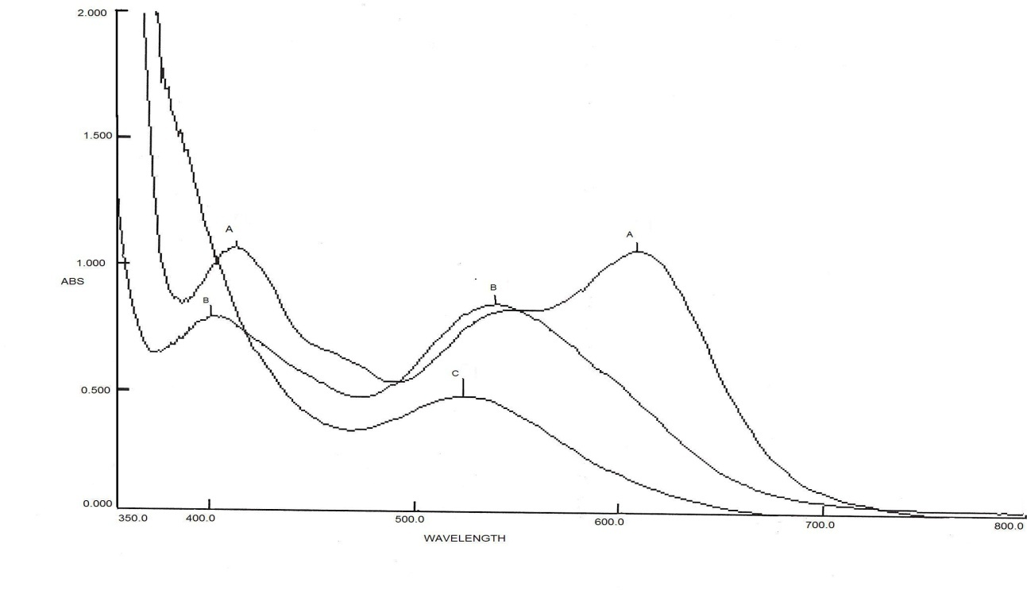
Fig-1 . Electronic absorption spectra of [Cr^{III}(L-Cyst N,O,S)₂] [A], [Cr^{III}(L-
cysH)₂(H₂O)₂] ⁺ (B)and[Cr ^{III} (L-cysH)₂(Hpic)(H₂O)]⁺ (C) in aqueous media.

The IR data of both ligands L-cysteine ,picolinic acid and that for complexes [Cr ^{III} (L-cysH)( Hpic)(H₂O)]⁺,[Cr^{III} (L-Cys N,O.S)₂]⁻ are tabulated in table-2. The band correspond to Cr-O and Cr-N at 352 and 317cm⁻¹ in the spectra of [Cr(L-cysH)(Hpic)(H₂O)]⁺ indicates that both L-cysteine still remain in the complex and coordinate throgh N andO with free non bonding thiol. The IR spectrum of Hpic exhibits two broad bands one with maximum at 2500 cm⁻¹releated to O-H str. and the other with maximum at 1443 cm⁻¹ related to δ (OH)carb., the latter band remains in the spectrum of product wich indicates the coordination of Hpic via nitrogen atom with free carboxyl group .This is more confirmed by significant changes of the quartet of peaks between 800 cm⁻¹ and 650 cm⁻¹ in the spectra of Hpic. The similar changes were reported for nitrogen coordination in Cr(II) –dinicotinate complex ⁽¹⁰⁾.
Therefore , on basis of the above mentioned results ,the red–brown product [Cr^{III}( L-cysN,O)₂(Hpic)(H₂O)]⁻ was assigned as structure (fig.6. I or II) formed from readily Cr—S bond cleavages and substitution by gentle heating of the solution mixture of the [Cr^{III} (L-Cys N,O,S)₂]⁻ with Hpic in the restrictive pH= 3.0-4.5 according to the following reactions:

[Cr^{III}(L-Cyst N,O,S)₂] ⁻ [Cr^{III} (L-cysN,O,S)( L-cysH)( H₂O) ]
blue color (C⁻)
(CH)
…….. (1)

[Cr^{III} (L-cysH)₂(H₂O)₂] ⁺
red –violet (CH₂⁺)

(CH) + Hpic [ CH , Hpic] [Cr ^{III}( L-cysN,O)₂(Hpic)(H₂O)]⁻ + H⁺
outer sphere complex brown-red (P) …….. (2)

(CH₂⁺) +Hpic [CH₂⁺ Hpic ] [Cr ^{III}( L-cysN,O)₂(Hpic)(H₂O)]⁻ +2H⁺
outer sphere complex brown-red (P) …...(3)

Scheme (2): Resonance structures of picolinic acid (Hpic) in acidic medium pH 3-4{the ligand picH presents in two protic forms; H₂pic⁺ and Hpic with pK_{a1}=1.01 for carboxyl and pK_{a2} = 5.39 for pyridine nitrogen.

Table-2- Characteristic absorption bands in IR spectra of L- cysteine ,picolinic acid , bis L- cysteinato(N,O,S) chromate(III) and [Cr(III) (L-cysH)₂(Hpic)(H₂O)]. H₂O
 | (L-cysteine)* | Hpic)** | Na[Cr(L-cys)₂]⁻. 2H₂O* | [Cr(L-cysH)₂(Hpic)(H₂O)]⁺
υ_{NH2} | 3050 m | 3429 | 3111 | 3029-3050 b
υ _{OH)water} | 3400-3500 b | 3464 w |  | 3550 m
υ_{(OH)carb.} |  | 2500 b |  | 3413 m
₍υ_{C=O)carbo} | 1740 s | 1719 s | 1640,1610 s | 1638 s
δ _{(OH)} |  | 1443b |  | 1443 m
υ_{(C-O)carb.} | 1230,1210 v.s | 1347 s | 1260 | 1350 m
υ_{Cr-S} |  |  | 690 m
υ_{Cr-O} |  |  |  | 560, 352
υ_{Cr-N} |  |  | 473 | 290-310
υ_{S-H} | 2565 m |  |  | 1900-200b
Note: S=strong m=medium w=weak b= broad

* J.inorg.nucl.Chem.Vol,43,No.12,pp,3398-3399,1981 **Z.Anorg.Allg,Chem.2003,626,1085-1090

Kinetic study
A typical diagram of the kinetic results of the formation of mixed ligands [Cr(L-cysH)( Hpic)(H₂O)]⁺ is shown in fig(2). Where absorbance of reaction mixture at λ =525 nm were plotted with time at constant temperature , pH and ionic strength. The figure shows that absorbance of the final product increase with time until reaches plateau. The plots of ln (A∞ –A_{t}) versus time are found not be straight line, typical diagram shown in fig-3.These plots show that the reaction involves two competitive parallel reactions with two different rates and two different pseudo first order rate constants; k _{obs1} and k _{obs2.} as shown in table -3.
Table(3) shows the values of k _{obs1} and k _{obs2} for different temperatures and pHs also shows that k _{obs1} is acid dependent and greater than acid independent k _{obs2.} This may result from that one reactant of equilibrium mixture of the protic species is more reactive than the other. The presence of two protic species, as shown in the reactions- 1 above, CH and CH₂⁺ with different charges and activities in equilibrium may complicated the subsequent Hpic substitution reaction .Therefore ,two kinetically control paths for reactions of product formation with two different rate constants k₁ and k₂ were suggested (see the scheme above). On basis of the saturated outer sphere complex of Egin-Wilkinson mechanism⁽¹⁵⁾ the rate of the reaction is derived as following :

d[P]/dt = k₁ [CH] + k₂ [CH₂⁺ ] ……..4

[C⁻] [H⁺] [CH] [H⁺]
K_{a1} = --------------- , K_{a2} = ------------- ………5
[CH] [CH₂⁺]

K_{a1} K_{a2} [CH₂⁺] K_{a2} [CH₂⁺]
[C] = -------------------, [CH] = -------------- ..……6
[H⁺] ² [H⁺]

C_{o} = [C⁻] + [CH] + [CH₂⁺] ……7

C_{o} is the initial total concentration of the reactant complex sodium bis L-cysteinato (N,O,S) Cr(III) complex, by substitution and rearrangement the values of[C⁻] and [CH] in the equation 7(with neglected K_{a1} K_{a2} and K_{a2} [H⁺]⁺]‹‹[H⁺]² in the dominator) gives the value of [CH₂⁺] as in equation 8:

K_{a1} K_{a2} [CH₂⁺] K_{a2} [CH₂⁺]
C_{o} = [CH₂⁺] + -------------------- + -------------
[H⁺] ² [H⁺]
C_{o} [H⁺] ²
[CH₂⁺] = ---------------------------------------- C_{o} …….8
[H⁺]² +K_{a1} K_{a2}+K_{a2} [H⁺]

Also the value of [CH] was obtained as a function of C_{o} then the rate equating becomes as shown below:

d[P]/dt = k₁ K_{a2} C_{o} [H⁺]⁻¹ + k₂ C_{o} …….…9

As proposed before, the reaction composed of two different rate paths with two rate constants
k _{obs1}and k _{obs2}, by comparison to equation 9, the acid dependent rate constant k_{obs1} = k₁ K_{a2}[H⁺]⁻¹ and acid independent rate constant k _{obs2} = k₂ both are pseudo first order on Cr(III) concentration at constant pHs. The plots of log₁₀ (k _{obs1} and k _{obs2} ) versus pH at different temperatures give straight lines with higher slops for k _{obs1}and little or no pH dependence for k_{obs2} , a typical plot for acid dependent rate constant(k _{obs1}) and acid independent rate constant (k _{obs2})versus[H⁺]⁻¹ is shown in fig(4) below .
The intercept of the lines of log₁₀ k_{obs1} versus pH gives value of log₁₀ k₁ K_{a2}(see table -3 ).Then from the value of log₁₀ K_{a2} at 0ºC in the literature⁽²⁾ the corrected values of log₁₀ K_{a2} at temperatures used in this study were calculated to found the values of k₁ at different temperatures .The calculated values of k₁ and average values k₂ at different temperatures are tabulated in table -3.

Fig-2- A typical diagram of the changes of absorbance(A_{t}) verses time for the
reactions of bis L-cysteinato chromate(III) ion with Hpic at different temperatures 20 ºC(♦),30 ºC (■) 40 ºC(►) and 50 ºC (*) and constant pH= 3.6

Fig.3- A typical diagram for ln (A∞ –At) versus time for reaction of bis L-cysteinato chromate(III) ion with HL at different temperatures and constant pH= 3.6 .

Table-3- Kinetic data for first path and second path rate constants for Hpic substitution reactions of CH and CH₂⁺at temperatures and pHs.

pH  TºC | 20ºC | 30ºC | 40ºC | 50ºC | 20ºC | 30ºC | 40ºC | 50ºC
pH  TºC | k_{obs1}/10⁻⁴ S⁻¹ | k_{obs1}/10⁻⁴ S⁻¹ | k_{obs1}/10⁻⁴ S⁻¹ | k_{obs1}/10⁻⁴ S⁻¹ | k_{obs1}/10⁻⁴ S⁻¹ | k_{obs1}/10⁻⁴ S⁻¹ | k_{obs1}/10⁻⁴ S⁻¹ | k_{obs1}/10⁻⁴ S⁻¹
3.2 | 2 | 6 | 13 | 20 | 0.06 | 0.2 | 1 | 4
3.6 | 5 | 8 | 13 | 25 | 0.4 | 1 | 3 | 5
4.0 | 5 | 11 | 16 | 28 | 0.2 | 2 | 3 | 4
4.2 | 6 | 14 | 19 | 30 | 0.4 | 2 | 3 | 6
4.6 | 7 | 15 | 24 | 34 | 0.5 | 1 | 3 | 6
(T) K | (1/T) K | intercept of  log₁₀k_{obs1}  versus pH | k₁ calc. | lnk₁ |  | Average value of k_{obs2} | lnk₂
293 | 0.00341 | -4.7061 | 0.28177 | -1.2666 | E_{a1}=69.861 | 0.0000312 | -10.375 | Ea2=71.517
303 | 0.0033 | -4.1815 | 0.69183 | -0.3684 | lnA=27.47 | 0.000124 | -8.9952 | lnA=19.206
313 | 0.00319 | -3.5686 | 2.09604 | 0.7400 | ΔH#=67.195 kJ mol⁻¹ | 0.00026 | -8.2548 | ΔH#=68.96 kJ mol⁻¹
323 | 0.0031 | -3.1956 | 3.75319 | 1.3226 | ΔS#=-25.41 JK⁻¹mol⁻¹ | 0.00050 | -7.6009 | ΔS#=-93.64 JK⁻¹mol⁻¹

Also activation energies, enthalpies of activation and entropies of activation were calculated using Arrhenious and Eyring equations(see fig.5) and showed in table -3.

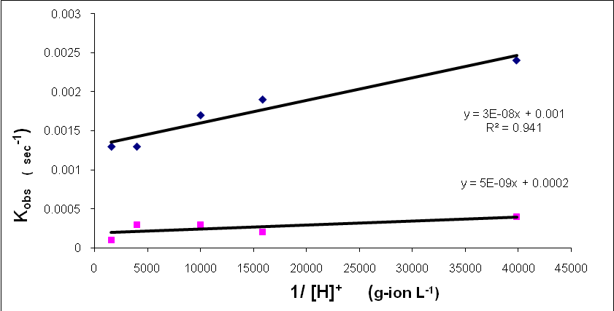
Sec⁻¹

Fig.4- Typical diagram for dependence of observed rate constants for first
path, k _{obs1} (♦)and second path ,k _{obs2} (■) versus [H⁺]⁻¹ dm³mol⁻¹ .

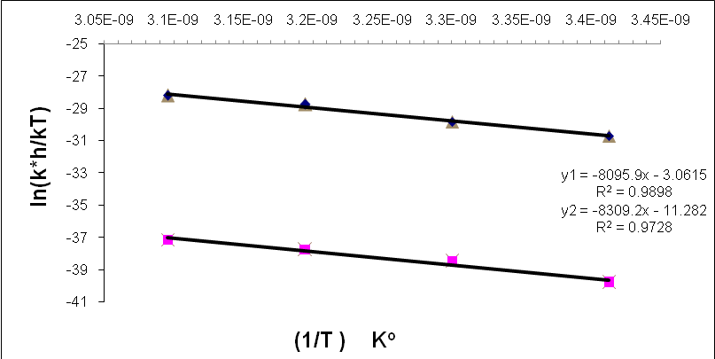

Fig.5- Eyring plots for the rate constants for first path, k₁ (♦) and second path,
k₂ (■) versus [T]⁻¹ K⁻¹.

The comparison of activation parameters of both rates, acid dependent and acid independent paths ,indicate that the same product forms through both paths (2and 3) in which the extent of participation depend on the presence and activity of different species CH and CH₂⁺ .The CH species possesses one loosely Cr—S bond, protonated thiol in this bond assists and facilitates cleavage and replacement by picH on Cr(III) with low activation energy and higher rates comparison to water exchange in the inert hexaaquo Cr^{III}(d³) ion(16){ΔH# is 109 kJ mol⁻¹} .

The low activation parameters have been reported for deprotonated thiol replaces water molecule in the ring closure studies of trans diaquo bisL-cysteinato(N,O)Cr(III) in the moderately acidic media pH 6-7 and showed that the rate of ring closure through water replacement is composed of acid dependent and acid independent processes⁽²⁾.This result is in favor of that in this study; two rates acid dependent and acid independent ,were suggested to give the product according to the saturated outer sphere mechanism.
The low activation energies and negative value of ΔS# of the first path (see tabl-2) re consistent with that proton involves in the reaction of rapid Cr-S bond cleavage and subsequent picH replacement in its places of mono protic species(CH).Therefore, the loosely Cr-S bond of coordinated L-cysteinato provides the labilization of Cr(III) to substitution and protonated thiol group activates it more .While the second species (CH₂⁺) which have no loosely Cr-S bond and in stead of that two water molecules (or hydroxyl) replaced and by the fact that free thiol of coordinated L-cysteine can form connection with vicinity intra-hydrogen bonding with water molecules and gives hydrothiol and OH group on Cr^{III} .The elimination and replacement by picH ligand occurs also with low energy of activation very near to that of the first path. Both activation parameters are very similar to that of acid catalyzed aquation via slow ring cleavage of Cr-N bond in the tris 3-hydroxy picolinate Cr^{III} { ΔH# =83.2 kJ mol^{-1,} ΔS# =-24.4 JK⁻¹mol⁻¹ } and for reversible acid dependent process of nitrogen ligation{ ΔH# 70.4kJ mol⁻¹ , ΔS# =-73.4 JK⁻¹mol⁻¹} ⁽¹³⁾ and also to the first aqation stage of tris quinolinato Cr^{III} in HClO₄ media{ΔH# =56.4 kJ mol⁻¹ , ΔS# = -94.5 JK⁻¹mol⁻¹ and the reversible process{ ΔH# =70.9 , ΔS# =-56.3 JK⁻¹mol⁻¹}(17).All activation parameters are similar to the values of the ligands substitution of pentaaquo monohydroxy Cr(III) ⁽¹⁸⁾ where hydroxyl on Cr(III) have been shown to have also labilizing effect . However, the value of ΔS# becomes more –ve as more intra hydrogen bonding formed in the inner sphere activated complex of charged CH₂⁺ compare to that of CH .The -ve values ΔS# of both paths indicate an interchange association nature (I_{a}) of substitution reactions as that reported for the majority of substitution on Cr(III) in the literature ^{(3,18- 20)}.
Conclusion:
The loosely Cr-S bond of anion bis L-cysteinato chromate^{III} undergoes readily cleavage in acidic media and gives two protic species with the active site of Cr^{III} that provides an easy way to readily substitute with another ligand such as picolinic acid(pyridine-2-crboxylic acid) that binds Cr^{III} with nitrogen atom in the restrictive acidic media of pH 3-4.5.The Cr-N bond replaces one axial Cr-S and the other by water molecule in the mixed product complex(I).However, by a connection hydrogen bonding of thiol ion of coordinated L-cysteinato with adjacent water molecule facilitates readily hydrolysis of H₂O and gives hydroxyl species complex(II).This complex , if heated and leaved for along period of time or at fairly acidic solution(pH < 2.5) gives insoluble red solid precipitate of Cr(III)(pic)₃.
The prepared complex(I) is soluble in water at different pHs particularly at physiological pH and temperature it exists as ionic form that transports easily by blood and it possesses Cr-N bond of pyridine ring as glucose tolerance factor (GTF).So it seems that it is more available source for biochroium ^{III} effect.

Fig-6- Suggested structures for [Cr^{III}(L-cys N,O)₂(Hpic)(H₂O)]⁻ (I) and
[Cr^{III}(L-cys N,O) (L-cysH N,O) (Hpic)(OH)]⁻ (II) complexes.

References
- Adzamli,K.,Deutsch, E. , Inorg.Chem., 1985, 24, 4086.
- Pou;l O,Brien , Inorg.Chim.Acta., 1987, 131, 5.
- Abdullah M.A.and Abdullah B.H., Iraqi . J. Chem., 1999, 24(2), 232.
- (a) Mertz ,W. , Bolio.Trace Element.Res., 1992, 32, 3.
(b)Anderson R.A., Mertz,W. ”Trace element in human and animal nutrition”: Vol.
ed.(1987) academic press Newyork.
(c) Schwarz. K. and Mertz, Arch. Biochm.Biophys. 1951, 85, 2927.
- Barret ,J. and O,Brien and Dejesus P. , Polyhydron ,1985, 4(1), 1.
- John B. Vincent “Recent advances in the nutrition biochemistry of tri valence chromium"; Proceedings of nutrition Society, 2004., 63, 41.
- DEMeester P.,Hodgson ,D.J.,Freeman H.C. and Moore, Inorg.Chem. (1997) 16, 1494.
- Allen T,L. ;Anal. Chem., 1958, 30, 447.
- (a) Jan A.Cooper,Black well,L.F.,Buckley P.O., inorg. Chim.Acta ,1984, 92, 23.
(b)Banerjia D. and Chandhuri D.;J. Inorg.Nucl.Chem., 1968, 30, 87.
- Cooper J.A.,Anderson B.,Buckley p. D. and Blackwell L.F, Inorganic Chimica Acta.,1984, 91,1,
- Dian M.S. and William H.A., Inorg. Chem, 1992, 31,5171-5184.
- Nicole E.C.,Rachel A.C. and Vencent J.B., polyhydron , 1999, 18, 2891.
- Ewa Kita and Karin G., Transition Metal Chemistry , 2007, 32,56.
- Gonzalez-Vergara.Hegenaner,J.,Saltman P.,Sabat M. and Ibers J.A., Inorganic Chim.Acta , 1982, 66,115.
- Shriver D.F. ,Atkins P.W., Inorganic Chemistry, Lang ford C.H. ;Oxford univ. press. (1970) ch.15,pag.466
- Plane R. andTube H., J. Phys. Chem., 1952, 63,33.
- Malgorzata S. and Ewa Keta, Transition Metal Chemistry ,2004, 29 ,762.
- Thusis D.; Inorg. Chem.,1971,10 (5),1106.
- Langford C.H.andGrayH."Lingd substitution process" W.A.Benjamin, New York (1965) Ch.1 -3.
- Banerjea D.and Chaudhuri S.D.; J.Inorg. Nucl.Chem., 1969, 31, 3845. Ibid (1970) 32, 1717.

