Synthesis and Spectral Studies of Some Transition Metal Complexes with New Thiazolylazo Ligand

Khalid. Jawad Al-adely
Department of Chemistry, College of Science, University of Al-Qadisiya
Abid Allah Mohamad Ali
Department of Chemistry, College of Education for Women, University of Kufa.
Rahim. Taher Mehdi
Department of Chemistry, College of Science, AL-Mustansiria University.

(NJC)

(Recevied on 2/2/2009) (Accepted for publication 20/4/2010)

Abstract
A new heterocyclic azo ligand 2-[(6-Methoxy-2-benzothiazolyl) azo] hydroquinone (6-MBTAHQ= H₂L) was prepared by the reaction between 6-methoxy-2-benzothiazodiazonium chloride with hydroquinone in alkaline alcoholic solution. Six new chelate complexes of Co (III), Ni (II), Cu (II), Zn (II), Cd (II) and Hg (II) have been prepared and characterized by elemental analysis, magnetic susceptibility, molar conductivity, infrared spectra and electronic spectra. The stability constants of complexes follows the sequence; Cu (II) > Zn (II) > Hg (II) > Co (III) > Ni (II) > Cd ((II). The isolated solid complexes have proposed the general formula [M(LH)₂].XH₂O, where X=1, M= Cu(II), Zn(II), Hg(II) and X=0 for M=Ni(II) Cd(II). When M= Co (III) the formula is [M (LH)₂]Cl. H₂O. The different measurements revealed that the metal ion in these complexes has hexa-coordination number with octahedral structure..The analytical data show that the metal to ligand ratio (M : L) in all complexes is (1 : 2) .
الخلاصة
تضمن البحـث تحضيـر ليكاند جديد لثيازوليـل أزو غيـر متجانسة الحلقـة 2-](6-ميثوكسي –2 – بنـزوثيازوليل )آزو[ هايـدرو كـوينون (6-MBTAHQ=H₂L) وذلــك من مفاعـلة كلوريــد (6- ميثوكسي -2- بنزوثيازوليل الديازوينوم) مع الهايـدرو كـوينون في محيط قاعدي كحولي . تم تحضير ستة معقدات لكل من الكوبلت (III) و النيكـل (II) والنحاس (II) والخارصين(II) والكادميوم (II) والزئبـق (II) مع الليكانـد المحضرة في هذا البحث وقـد تم تشخيـص الليكـــانـد و معقداته بوساطة التحليل الدقيق للعناصر ودراسة الخواص المغناطيسية والتوصيلية المولارية وأطياف الأشعة تحت الحمراء والاطياف الالكترونية . كما تضمن البحث تعيين ثوابت استقرار المعقدات المتكونة وقد اتخذت الترتيب التالي النحاس(II) < الخارصين (II) < الزئبق (II) < الكوبلت (III) < النيكل (II) < الكادميوم (II). وإستنادا" الى النتائج التحليلية تم إقتراح الصيغ التركيبية للمعقدات الصلبة وكانت [M(LH)₂].XH₂O حيث إن X=1 لكل من النحاس (II) والخارصين (II)والزئبق(II) فيما كانت X=0 لكل من النيكل (II) والكادميوم(II) . أما معقد الكوبلت (III) فقد أتخذ الصيغة التركيبية [Co(LH)₂]Cl. H₂O واشارت القياسات المختلفة ايضا" الى كون المعقدات سداسية التناسق ذات بنيه ثماني السطوح. وقد بـينت النتـائـــج إن نسبة ( الليكاند : الفلز) هي (1:2) لجميع المعقدات .
Keywords: Synthesis, Spectral studies, new thiozolyl azo ligand, metal complexes and characterization.

Introduction
A very large number of thiazolylazo ligands and their derivatives had prepared and this kind of ligands used as dyes. In analytical chemistry they are used as acid-base and redoxmetalochromic indicators, in addition to their use as ligands to prepare some chelate complexes ⁽¹⁻³⁾. Thiazolylazo compounds are widely used in the dye-stuffes industry ⁽⁴⁾ and also more recently in the field of non-liner optic⁽⁵⁾. Thiazolylazo dyes have great important applications as a spectrophotometric reagents ⁽⁶⁾.π-acidic azo imine group (─ N═N─C═N─), for this reason a number of these ligands were prepared as chelating agent ⁽⁷⁻¹⁰⁾. In this paper we describe the preparation and characterization of new thiazolylazo ligand (6- MBTAHQ=HL₂) and some of their transition metal complexes.
Experimental
Materials and physical measurements
All chemicals used were of highest purity (BDH, Fluka or Aldrich) and used with out further purification except of 2-amino-6-methoxybenzothiazole, this was prepared as described in the literature⁽¹¹⁾.
Elemental analysis was carried out by means of micro analytical unit of 1108 C.H.N element analyzer .Electronic spectra were recorded using Shimadzu UV-Vis 1650 spectrophotometer, for solution of the complexes in aqueous ethanol at room temperature. Using 1cm quartz cell. IR spectra were recorded with FT-IR-8000 Shimadzu, in the range of (4000-400) cm⁻¹ using CsI disc. The magnetic susceptibilities of the complexes were measured on powered samples using the faraday method, for this purpose balance magnetic MSB-MKI was employed .Electrical conductivity measured by conductivity bridge model 31Awith solute concentration of 10⁻³M in DMF at room temperature. pH measurements were carried out using pH meter model HI 9321. Mass spectrum of ligand was obtained using GC-mass-QP1000 A Gas-Mass spectrophotometer, the metal percentages were determined using atomic absorption technique by Shimadzu -AA-160.
Synthesis and characterization of azo ligand (6-MBTAHQ)
The ligand prepared by dissolving (1.80 gm, 0.01 mol) of 2-amino-6-methoxy benzothiazole in 30 ml of distilled water and 5ml of concentrated hydrochloric acid, then the filtratrerd solution was cooled below 5 °C. To this mixture a solution of (0.75gm, 6.01 mol) of sodium nitrate in 20 ml of distilled water was added drop wise at 0-5 °C and the mixture was stirred for 25 min. This diazonium solution was added drop wise to a 500 ml beaker containing (1.1, gm 0.01 mol) of hydroquinone dissolved in 150 ml of alkaline ethanol. The mixture was stirred for additional 2 hrs in an ice-bath allowed to stand over night and acidified with dilute hydrochloric acid to pH = 6.0. The crude dyes were collected by filtration and recystallized twice from hot methanol ⁽¹²⁾ and then dried in the oven at 60 °C for several hrs. The structural formula of our ligand is shown in figure.1.

_
Figure(1):- Structure of the ligand[ 2- (6-Methoxy-2-benzothiazolyl)] azo hydroquinone (6-MBTAHQ= H₂L)

Synthesis of complexes
The chelat complexes have been synthesized by at optimal pH vakues dissolved (0.603gm, 0.002 mol) of ligand (6-MBTAHQ) in 30 ml hot ethanol and then (0.01 mol) of metal chloride, M= Co(II), Ni(II), Cu(II), Zn((II), Cd(II) or Hg(II) dissolved in 20 ml hot distilled water is added drop wise with vigorous stirring to the ligand solution. The reaction mixture was heated to 50 °C for 30 min and left over night then the complexes are filtered off washed with distilled water, then with ethanol and dried in desiccators over anhydrous CaCl₂. Table.1 collects the physical properties and analytical data for those complexes are shown in table 1.

Table(1):- Physical properties and analytical data of the ligand (H₂L) and its complexes.
No. | Compound | Color | m.p  C° | Yield  % | Molecular formula  (Mot.Wt) | Found (Calc.)%
 |  |  |  |  |  | C | H | N | M
1 | H₂L | Dark  brown | 132 | 73 | C₁₄H₁₁N₃SO₃  (301.32) | 55.90  (55.81) | 3.57  (3.68) | 14.09  (13.95) | __
2 | [Co(LH)₂]Cl. H₂O | Dark  Purple | 227d | 52 | C₂₈H₂₂N₆S₂O₇ClCo  (713.02) | 47.29  (47.17) | 3.02  (3.11) | 11.67  (11.79) | 8.51  (8.27)
3 | [Ni(LH)₂] | Purple | 176 | 69 | C₂₈H₂₀N₆S₂O₆Ni  (659.31) | 50.92  (51.01) | 2.94  (3.06) | 12.92  (12.75) | 9.14  (8.90)
4 | [Cu(LH)₂]. H₂O | Dark  green | 191 | 81 | C₂₈H₂₂N₆S₂O₇Cu  (682.18) | 49.43  (49.30) | 3.32  (3.25) | 12.15  (12.32) | 9.10  (9.31)
5 | [Zn(LH)₂]. H₂O | Dark  Purple | 183 | 76 | C₂₈H₂₂N₆S₂O₇Zn  (684.02) | 49.06  (49.17) | 3.16  (3.24) | 12.44  (12.29) | 9.75  (9.56)
6 | [Cd(LH)₂] | Purple | 209 | 65 | C₂₈H₂₀N₆S₂O₆Cd  (713.03) | 47.03  (47.17) | 2.91  (2.83) | 11.63  (11.79) | 15.54  (15.77)
7 | [Hg(LH)₂]. H₂O | Purple | 217d | 57 | C₂₈H₂₂N₆S₂O₇Hg  (819.23) | 40.91  (41.05) | 2.79  (2.71) | 10.41  (10.26) | ____
H₂L =Ligand (6-MBTAHQ), d = decomposition.

Results and discussion
Mass spectrum of ligand (6-MBTAHQ)
Mass spectrometer data are supporting the proposed structure. The ligand was run using the direct insertion when the temperature was 178 °C the base peak had a measured mass of (301) corresponding to a molecular formula of C₁₄H₁₁N₃O₃SO₃ , the calculated formula weight is (301) . A fragment at (Z/e =165 and 110) due to 6-methoxy benzothiazole and hydroquinone respectively ⁽¹⁴⁾. The successive fragmentation peaks are shown in figure.2.

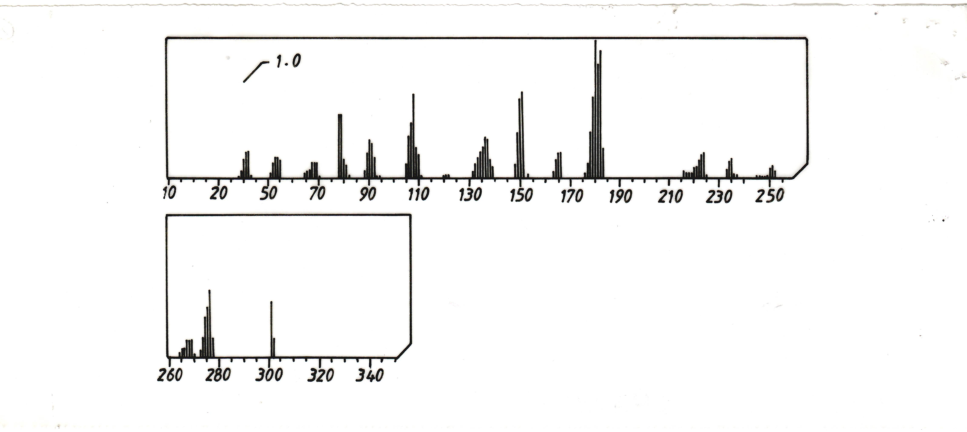

_
Figure (2):- Mass spectrum of ligand 2-[(6-Methoxy-2-benzothiazolyl) azo] hydroquinone (6-MBTAHQ)

Absorption spectra
The absorption spectra of ligand (6-MBTAHQ) and its complexes in aqueous 50% (V/V) ethanolic solution were studied and shown in figures3 and 4. The wavelength for the maximum absorption ($λ$_{max}) of the ligand was found at 418nm. The spectra of metal complexes were recorded within wavelength range (516 - 676) nm. The absorption maxima ($λ$_{max}) of each complex also shown in Table.2.

R
Co(III)
Ni(II)
Cu(II)

_

Figure(3):- Absorbance spectra of 6-MBTAHQ -metal chelats (1.25-1.75) x 10⁻⁴ M; In aqueous ethanolic solution 50% (V/V)

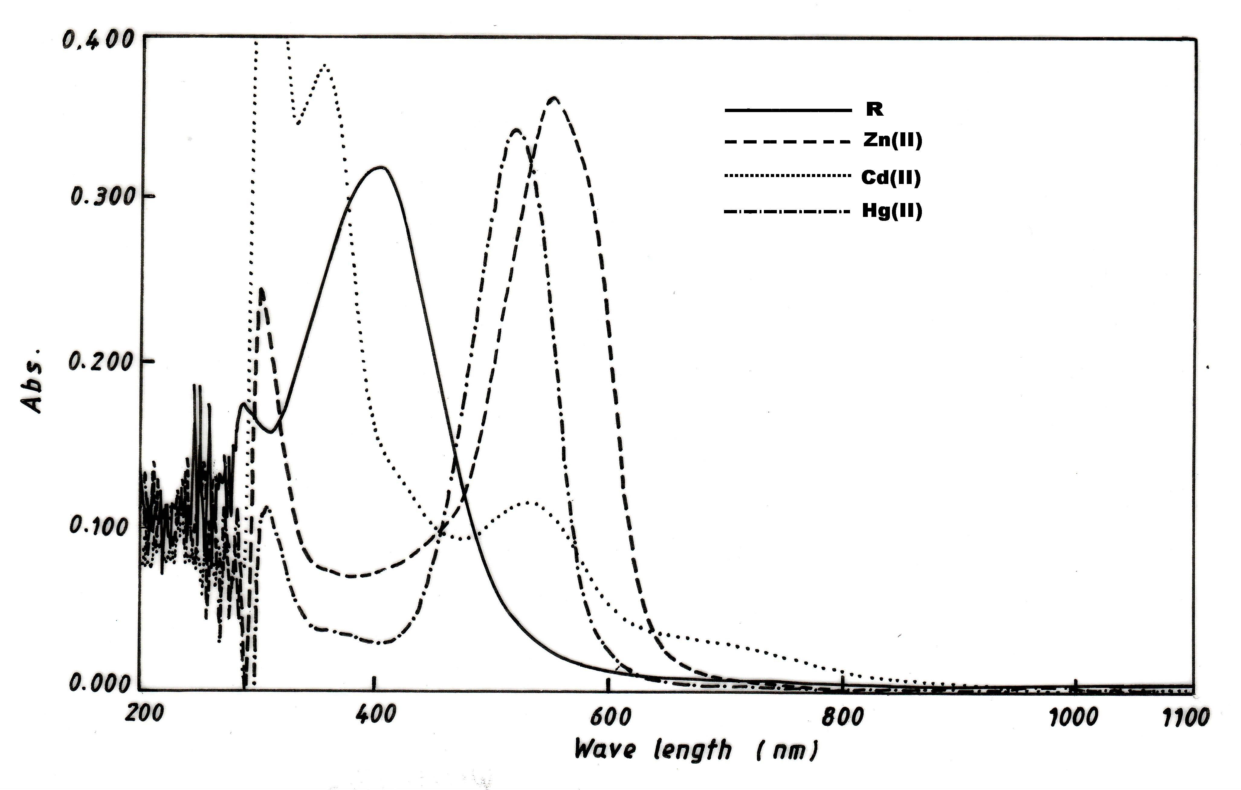

Figure(4):- Absorbance spectra of 6-MBTAHQ -metal chelats (1.50-2.00) x 10-4 M; In aqueous ethanolic solution 50% (V/V)

Table(2):- The optimal pH values, optimal molar concentration and wavelength ($λ$_{max}) with molar absorpitivity (Є) of metal ions in aqueous ethanolic solution 50% (V/V)

Ligand | Metal  Ions | Optimal pH | Optimal molar conc. X 10⁻⁴ mol | Molar absorpitivity(Є) x 10³ l.mol⁻¹.cm⁻¹ | Optimal wave length ($λ$_{max} )nm | Δ$λ$ª_{max}  nm
6-MBTAHQ  λ_{max}= 418 nm Є=4.88 x 10³ l.mol⁻¹.cm⁻¹ | Co(II) | 7.5 | 1.75 | 2.21 | 557 | 139
6-MBTAHQ  λ_{max}= 418 nm Є=4.88 x 10³ l.mol⁻¹.cm⁻¹ | Ni(II) | 7.0 | 1.25 | 2.39 | 516 | 98
6-MBTAHQ  λ_{max}= 418 nm Є=4.88 x 10³ l.mol⁻¹.cm⁻¹ | Cu(II) | 7.5 | 1.75 | 0.89 | 676 | 258
6-MBTAHQ  λ_{max}= 418 nm Є=4.88 x 10³ l.mol⁻¹.cm⁻¹ | Zn(II) | 8.0 | 1.50 | 1.91 | 548 | 130
6-MBTAHQ  λ_{max}= 418 nm Є=4.88 x 10³ l.mol⁻¹.cm⁻¹ | Cd(II) | 7.5 | 2.00 | 0.88 | 531 | 113
6-MBTAHQ  λ_{max}= 418 nm Є=4.88 x 10³ l.mol⁻¹.cm⁻¹ | Hg(II) | 8.5 | 1.75 | 1.76 | 527 | 109
Δ$λ$ª _{max} = $λ$_{max} Complex - $λ$_{max} ligand

Infrared spectra
The infrared spectra of the free ligand (6-MBTAHQ) and its complexes with Co (II), Ni (II) Cu (II) Zn ((II), Cd (II) and Hg (II) are given in Table.3. These spectra are complicated owing to the extensive overlap of number of bands arising from υ(O─H), υ(C═N), υ(N═N) and other bands due to the phenyl and thiazole rings which appeared in the region below 1595 cm⁻¹. The comparison between the IR spectral data of the free ligand with that of its complexes are discussed as follow:-
- The spectrum of azo ligand (6-MBTAHQ) show a very broad and weak absorption band around 3420 cm⁻¹due to the υ(O─H)groups. This suggests a strong intermolecular hydrogen bonding ^{(15,16)}. The band around (3480-3550) cm⁻¹ in each of Co (III) Cu (II), and Zn (II) and Hg (II) complexes indicates the presence of water ⁽¹⁷⁾. But this band is disappeared in the complexes spectra for both Ni(II) and Cd(II).
- The weak bands which observed at 3113 cm⁻¹ and 2490 cm⁻¹ in the ligand spectrum are due to υ(C─H) aromatic and aliphatic respectively. These bands are stable in position in both ligand and metal complexes ^{(18,19)}.
- The spectrum of ligand shows absorption band at 1595 cm⁻¹ due to υ(C═N) of thiazole ring^{(10,20)}.This band is observed with a little change in shape and shifted to lower frequencies (1575 – 1590) cm⁻¹ in complexes. These differences may suggest the linkage of metal ions with nitrogen of hetrocyclic thiazole ring^{(16,21)}.
- The azo group (N═N) appears at 1520 cm⁻¹ in the free ligand spectrum. This band has been shifted to a lower frequencies (1480-1505) cm⁻¹ and also reduced in intensity in complexes spectra; this means that some linkage of metal ions with nitrogen atom of azo group which is the farthest of thiazol ring takes place^{(10,21,22)}.
- The band at 1248 cm⁻¹ has also been appeared in the ligand spectrum which is due to υ(C─S) of thiazole ring⁽²³⁾.The fixed postion of this band in all chelate complexes means that the sulfur atom of heterocyclic ring does not participate in coordination ^{(16,21)}.
- Finally a new weak bands appears at (520-560)and (410-435) cm⁻¹in the complexes spectra which may suggest the linkage of metal ions with both oxygen and nitrogen atoms^{(24,25)}respectively. The IR spectra indicate that azo ligand (6-MBTAHQ) behaves as a tridentate chelating agent coordinated through phenolic oxygen, nitrogen of azo group and thiazole ring nitrogen. Figs. 5, 6 and 7 show the spectra of ligand (6-MBTAHQ), [Ni(LH)₂] and [Hg(LH)₂].H₂O.

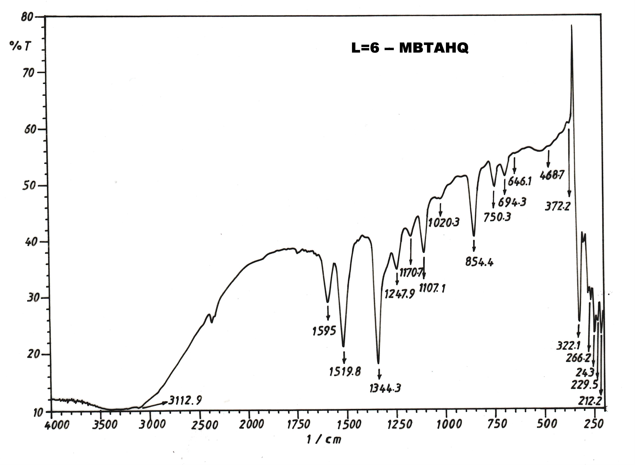

Figure(5):- IR spectrum of the ligand (6-MBTAHQ= H₂L)

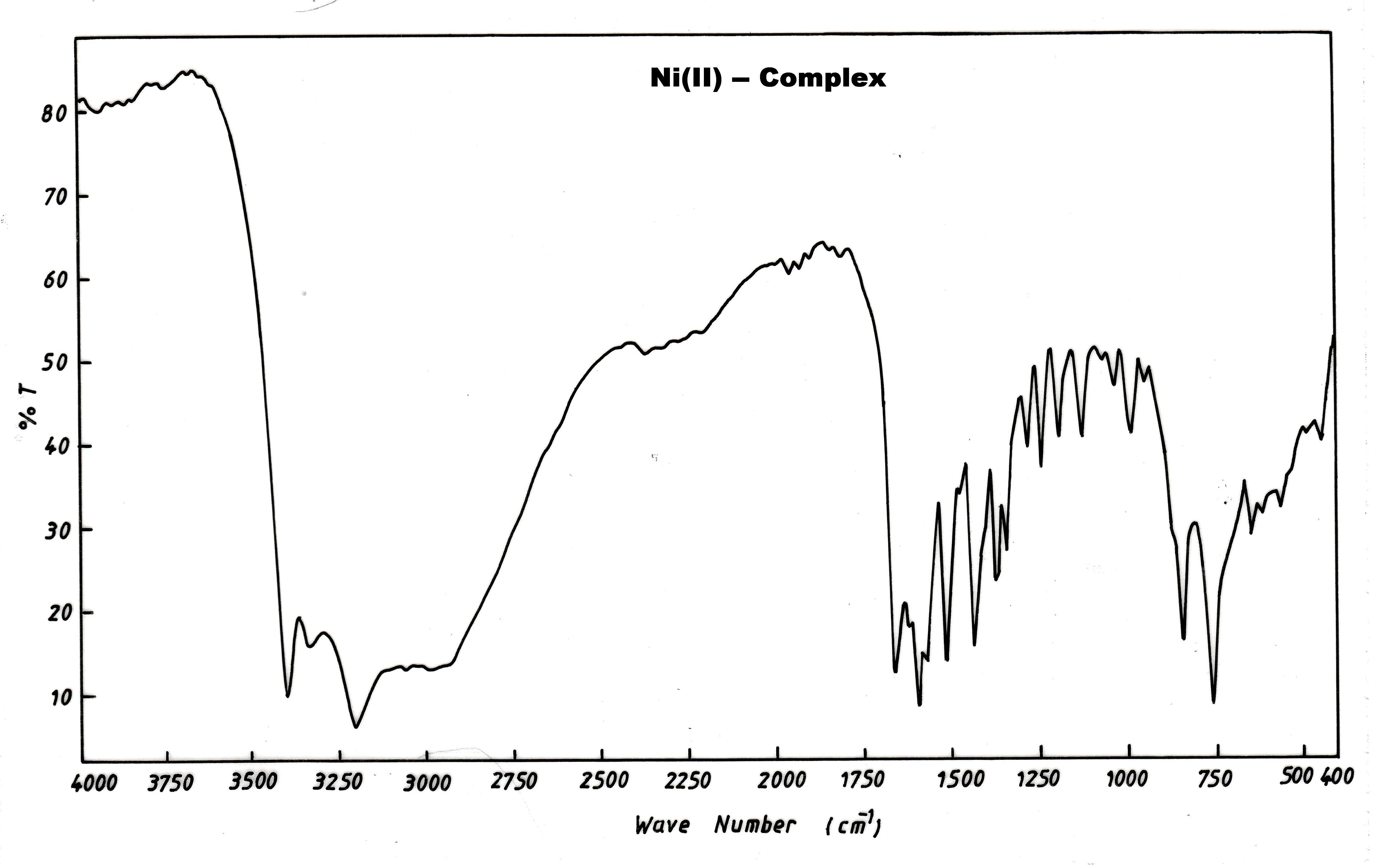

Figure(6): IR spectrum of the complex [Ni(LH)₂]

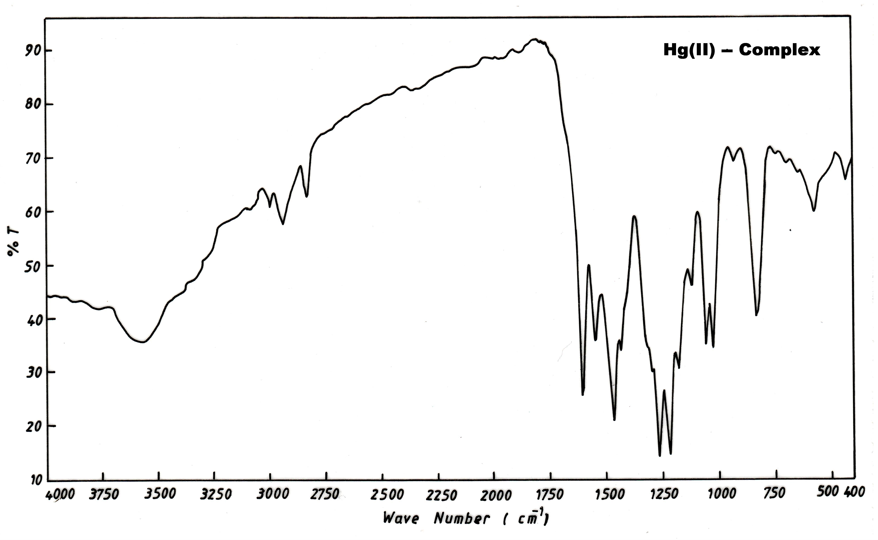

Figure(7):- IR spectrum of the complex [Hg(LH)₂]. H₂O

Table(3):- Characteristic IR absorption bands of the ligand (6-MBTAHQ) and its complexes in cm⁻¹ units.
No. | Compound | υ(O─H) | υ(C═N) | υ(N═N) | υ(C─S) | υ(M─O) | υ(M─N)
1 | LH₂ | 3420 w.br. | 1595 m. | 1520 m.  1344 s. | 1248w.  854m. | ─ | ─
2 | [Co(LH)₂]Cl.H₂O | 3480  w.br. | 1575m. | 1495m.  1330m. | 1255w.  850m. | 540w. | 435w.
3 | [Ni(LH)₂] | - | 1585m. | 1505s.  1335m. | 1250m.  855m. | 540w. | 425w.
4 | [Cu(LH)₂] .H₂O | 3520  w.br. | 1580s. | 1490s.  1310m. | 1250w.  855m. | 520w. | 430w.
5 | [Zn(LH)₂] .H₂O | 3510  w.br. | 1590m. | 1495m.  1320m. | 1245w.  855m. | 545w. | 420w.
6 | [Cd(LH)₂] | - | 1575m. | 1480m.  1325m. | 1250m.  850w. | 530w. | 410w.
7 | [Hg(LH)₂] .H₂O | 3550  w.br. | 1590 s. | 1485s.  1315m. | 1250m.  855s. | 560w. | 430w.

H₂ L= 6-MBTAHQ , w=weak , s=strange ,m= medium , br=broad .

Magnetic susceptibility and electronic spectra measurements
The magnetic momentum and electronic spectra studies have been used to confirm geometry of the complexes .These data are listed in Table.4.
Cobalt (III) complex
The magnetic momentum of the Co (III) complexes has been found to be diamagnetic and the low spin behavior of this complex indicates that Co (II) is oxidized to Co (III) during complexation. The change of the oxidation state agrees with earlier observation that the aqueous solution of Co(п) salts are spontaneously oxidized to Co(III) in the presence of strong ligand such as thiazolylazo compounds^{(26,27)}. The electronic spectrum of Co (III) complex show two absorption bands at 557 nm (17953 cm⁻¹) and 442 nm (22624 cm⁻¹) characteristic of octahedral stero chemistry⁽²⁸⁾. They were assigned to the transitions ¹A₁g → ¹T₁g and ¹A₁g → ¹T₂g respectively.

Nickel (II) complex
The value of magnetic moment of Ni (II) was found to be 3.09 B.M which can be a normal value for octahedral Ni (II) complex^{(29,30)} . The absorption spectrum of this complex shows three absorption bands at 982 nm (10183 cm⁻¹ ), 516 nm (19380 cm⁻¹ ) and 317 nm (31546 cm⁻¹), which suggests the existence of ³A₂g → ³T₂g(F), ³A₂g → ³T₁g(F) and ³A₂g → ³T₁g(p) transitions respectively with an octahedral spatial configuration⁽³¹⁾.
Copper (II) complex
The magnetic moment value of this complex was found to be 1.76 B.M suggest the presence of one unpaired electron in this complex. The electronic spectrum of this complex show abroad absorption band around 676 nm (14793 cm⁻¹). This band assigned to the transitions ²Eg → ²T₂g. It is reasonable to assign distorted octahedral structure^{(30,32)}.
Zinc (II), Cadmium (II) and Mercury (II) complexes
The magnetic susceptibity show that all complexes have diamagnetic moment, and the electronic spectra of these complexes do not show any d-d transition band .Three absorption bands were appear at the free ligand (6-MBTAHQ) spectrum. The bands at 263 nm (38023cm⁻¹) and 287nm (34843cm⁻¹) referring to the π→π* transitions while the band at 418 nm (23923cm⁻¹) is due to the charge transfer characters^{(33).} The electronic spectra of Co (III), Ni (II), Cu (II), and Zn (II), Cd (II) and Hg (II) chelate complexes and free ligand (6-MBTHQ) in ethanol solution are given in Figs.3 and 4.
Conductivity measurements
All complexes except of Co (III) complex show the conductivity measurement values ranging between (5.39 – 8.76) S.cm². mol⁻¹, these values indicating nonionic structure of these complexes⁽³⁴⁾.The lower conductivity value of the Co(III)complex is 78.54 S.cm².mol⁻¹ this indicates that the complex is(1:1)electrolyte.The conductivity values are listed in table 4.
Calculation of the metal complexes stability constant (β)
Stability constant of prepared complexes are obtained spectrophotometrically by measuring the absorbance of ligand solutions and metal ion mixture at fixed wavelength (λ_{max),} and pH. The degree of formation of the complexes (β) are obtained from the relationship⁽³⁶⁾ of β= (1- α)/ 4 α³C² and α= (A_{m} – A_{s})/ A_{m}, where α=degree of dissociation , A_{s} and A_{m} are the absorbance of the partially and fully formed complex respectively. The calculated β and log β values are listed in Table.4.The values of stability constant indicated high stability complexes .

Effect of pH
Suitable pH values for metal complex solutions were found to be in the range of (4.5 – 9.0). To evaluate the optimal pH values of metal complex solutions .The effect of pH on the absorbance were studied, and the results are shown in Figs. 8 and 9. which indicate that absorption spectra did not change over the whole range indicated high stability complexes

Figure(8):-The effect of pH on the absorbance Of metal complexes ligand conc. = (1.50-2.0) x 10⁻⁴ M metal ions conc. =1.75x 10⁻⁴ M

Figure(9):-The effect of pH on the absorbance of 6-MBTAHQ -metal complexes Ligand conc. = 2.25x 10⁻⁴ M ions conc. = (1.25-1.75) x 10⁻⁴ M

Effect of time
It was found that the absorbance of the metal complexes chromogenic system reaches a maximum value in 10 min. at room temperature then it remains stable for 24 hrs. indicated high statbility complexes ,the results are shown in Figs. 10 and 11.

Figure(10):-Effect of time on the absorbance of metal Complexes; M= Co (III), Ni (II) and Cu (II)

F igure(11):- Effect of time on the absorbance of metal complexes; M= Zn (II), Cd (II) and Hg (II)

Table(4):- Electronic Spectra, Conductivity measurements, Magnetic moment and stability constant values (β) of complexes
Complex | Absorption bands (cm⁻¹) | Transition | Conductivity  S.cm².mol⁻¹ | µ_{eff} B.M | β  L². mol⁻² | Logβ
[Co(LH)₂]Cl. H₂O | 17953 | ¹A₁g → ¹T₁g  ¹A₁g → ¹T₂g | 78.54 | dia | 6.48 x 10⁹ | 9.81
[Co(LH)₂]Cl. H₂O | 22624
[Ni(LH)₂] | 10183 | ³A₂g → ³T₂g(F)  ³A₂g → ³T₁g(F)  ³A₂g → ³T₁g(p) | 6.93 | 3.09 | 6.01 x 10⁹ | 9.78
[Ni(LH)₂] | 19380
[Ni(LH)₂] | 31546
[Cu(LH)₂]. H₂O | 14793 | ²Eg → ²T₂g | 7.34 | 1.76 | 5.20 x10¹¹ | 11.72
[Zn(LH)₂]. H₂O | ——— | ─── | 6.21 | dia | 3.53 x10¹⁰ | 10.55
[Cd(LH)₂] | ——— | ─── | 5.39 | dia | 1.58 x10⁹ | 9.20
[Hg(LH)₂]. H₂O | ——— | ─── | 8.76 | dia | 8.14 x10⁹ | 9.91

Metal: ligand ratios
The metal : ligand ratio (M:L)of complexes were determined by the molar ratio method at the wavelength of maximum absorption (λ_{max)} and fixed pH .The ligand (6-MBTAHQ) was found to form chelates with all metal ions mentio as shown in Figs. 12 and 13. The results are in agreement with the values reported for some thiazolyazo phenol complexes^{(16,35,37)}.

Figure(12):- Mole ratio (M: L) of (6-MBTAHQ)-metal Chelats

Figure (13):- Mole ratio (M: L) of (6-MBTAHQ)-metal chelats

According to the results the coordination number of all metal ions is found to be six with bonding through the phenolate O,azo N and with thiazol N atom.The structural formula of prepared complexes is most probably octahydral shown in fig.14.

M=Co(III);n=1;m=1
M= Cu (II), Zn (II), Hg (II) n=0, m=1
M= Ni (II), Cd (II), n=0, m=0

Figure(14):- The proposed structural formula of Co ((III), Ni (II), Cu (II), Zn (II), Cd (II) and Hg (II)

Acknowledgment
We thankful for Prof. Dr. Ayad.H.Jasim for great help to complete this work.

References
- Wonlee, Si-Eunlee; Mi-Kyoungkim; Chang-Heonlee; Young-Sangkim Bull. Korean Chem., 2002, 23(8), 1067-1072.
- Oszwaldowski, S; Jarosz, M. J. Chem. Anal (Warsaw).1997, 42, 740-746.
- Khlool, M, K; Kadhim, H; AL-Sharify,A,N., Nat. J of Chem.2005, 20, 493-501.
- Wang, , Funabiki,; Matsui ,M; Dyes and Pigments., 2003 ,57, 77-82.
- Matsui ,M; .Marui ,J,Kushida; Funabiki, K and Tai, K. Dyes and pigments, 1998, 38, 57-63.
- Teixeira ,L, S, G; Costa ,A. C. S; Freitas, M, L,.J. Braz. Chem. Soc., 1999, 10(6), 519-522.
- Rauth ,G; Sinha ,C; Transition Met .Chem, 2002, 27, 756-601.
- Abid Allah, M, Ali; Sic, J. Babylon University, 2004, 9(3), 841-852.
- Ghattopadhyay S, Pal,D, ; Sinha ,C; polyhydron ,2000, 19, 1263-1667.
- Masoud ,M.,S, Mohamed ; Abdul-Razek ,Y, H, J. Korean.Chem Soc, 2002, 46(2), 99-116.
- Brewster, R; Dans, F,B; J.Am.Chem.Soc., 1936, 58, 1364-1336.
- H. Langora, M. Sommer ; Talanta, 1969, 16, 680-687.
- Abid Allah, M, Ali; synthesis of some transition metal complexes with new thiazolyl azo and imidazole azo compounds and their spectral and thermal studies; Ph.D.Thesis ; University of Baghdad , 1999.
- Khalid, Jawad Al-adely; synthesis and spectroscopeic study of group (II)B and (III)B ion complexes with new azo compounds and with 1-[(2-pyridylazo)-2-napthol]; Ph.D.Thesis ;University of Baghdad , 2000.
- Snavely ,F, A;Yodeer ,C, H ; J .Org. Chem ; 1968, 33 ,513-519.
- Mehdi ,R, T;Ali, A. M. ; Ibn Al-Haitham . J. for pure and appl.Sci, 2005, 18(3), 50-58.
- Bervra ,H.,Sola ,J;Vinas , Vinas J.M.;Trans.Met.Chem., 1985, 10, 233-237.
- Crews ,P, Rodriguez; Jaspars ; Organic structure Analysis , Oxford University press New York , 1998.
- Maradiye ,H, R;Patel ,V,S, ; J. Braz.Chem .Soc ; 2001, 12, 710-714.
- Mangsup,L, Siripaisarnpipat S;Chaichit, N, J. Anal. Sci; 2003, 19, 1345-1351.
- Gusev, SI, Zhvakin, M,V;Kozhevnikov ,I. A.; Zh. Analitkhim, 1917, 26, 859-864.
- Denning R,C;Thatcter ,J; J.Amer.Chem.Soc ; 1986, 90, 5917-5921.
- Colthup ,N. B., Daly ,L. H;Wiberley ,S. E. ; " Introduction to infrared and Ramon spectroscopy ", 2nd Ed .Academic press .Inc.J.R.Dyer;Dyer; 1975.
- Singh, B; Sing ,R, N;Aggarywal, Polyhydrone R. C. ; 1985, 4, 401-416.
- Atio,Y, Schlapfer ,C,W, Cordes, M.;Nakamoto ,K. ; Applied spectra ; 1973, 27, 213-219.
- Schetty ,G.Helv.Chem. Acta ; 1968, 51(3), 505-510.
- Mochizuki,K;Fujimoto M. ; Chem. Lettors ; 1980, 1541-1546.
- Bailer ,J,C, Emeleus ,H;Nypholm ,R. ; Comprehensive Inorganic Chemistry , pergamon press, 1973.
- Dawood ,Z ,F;Sheet ,A, Z, M. ; J. Sci.Tekreet Univ, 2001, 7(3), 37-43.
- Rao ,S;Hussain Reddy ,K; Indian . J. Chem, 1996, 32A, 681-686.
- Manch ,W;Femetins ,W. C. ; J. Chem. Educ. 1961, 38, 192.
- Sacconi ,L;Champolini M.; J. Chem. Soc, 1964, 276-281.
- Ahmed ,Z,A, Atta ,F, M.;Abd Alla ,M. A.; J. Spectro Chem. Acta, 1989,45(A), 699-703.
- Geary ,W, J.; J. Coord .Chem. Rev , 1971, 7,81.
- Mehdi ,R, T;Ali ,A, M, ; Nat. J of Chem, 2005, 20, 540-546.
- Skoog ,D, A; Fundamental of Analytical chemistry , 5th Ed ., New York , 1988.
- Senchez ,N, G,, Santana ,B, Gonzalez ,V;Motelongo ,F,G.; Polyhedron , 1990, 9, 501-508.

