Study on Synthesis and Antibacterial Activity of Co(II) and Ni (II) Complexes Including Isopropylacetone Thiosemicarbozone
and Cresol

Amira J. Al–Shaheen
Chemistry Department/ Education College, Mosul University

(NJC)

(Recevied on 12/4/2009) (Accepted for publication 12/1/2010)

Abstract
Complexes containing mixed ligands of cobalt (II) and nickel (II) have been synthesized by the reaction of cobalt chloride or nickel chloride with isopropylacetonethiosemicarbazone (LH) and substituted cresols (3–Methyl–2 nitrophenol (L₁H) or 3–Methyl–2–aminophenol (L₂H) or 2–Methyl–3–nitrophenol (L₃H) or 3–Methyl–4–nitrophenol (L₄H) in mole ratio 1:2:1 metal: isopropylacetonethiosemicarbazone: cresol, respectively and characterized phyico–chemically.
They have been found to have the general formulas
[M(LH)₂(L¯H)]CL₂ or[M(LH]₂(L¯nH)Cl]Cl and K[M(L)₂L¯] or M(L)₂(L¯n)(H₂O)] in neutral and basic medium, respectively where M = Co(II) or Ni(II); LH = isopropylacetonethiosemicarbazone; L¯H = L₁H or L₂H; L_{n}¯H= L₃H or L₄H; L¯= deprotonated L₁H or L₂H; L_{n}¯₌ deprotonated L₃H or L₄H, respectively.
Furthermore, the complexes have been found to be biologically active as demonstrated by antibacterial screening against seven human pathogenic bacterial strains. It has been found that the complexes were more effective agent than the ligand.
Keywords: isopropylacetonethiosemicarbazone, antibacterial agent, cresol complexes, cobalt complexes, nickel complexes.
الخلاصة
حضرت معقدات للكوبلت (II) والنيكل (II) مع مزيج من ليكاند آيزوبروبيل اسيتون ثايوسيميكاربازون (LH) وبعض الكريسولات المعوضة (3-مثيل-2-نتروفينول (L₁H) أو 3-مثيل-2-امينوفينول (L₂H) او 2-مثيل-3-نتروفينول (L₃H) أو 3-مثيل-4-نتروفينول (L₄H) بنسب مولالية : 1:2:1 فلتر : ليكاند : كريسول معوض . شخصت المعقدات المحضرة بطرق فيزيائية – كيميائية . ووجد ان لها الصيغ البنائية العامة [M(LH)₂(L¯H)]CL₂ أو [M(LH]₂(L_{n}¯H)Cl]Cl أو K[M(L)₂L¯] أو K[M(L)₂(L_{n}¯)(H₂O)] على التوالي في كل من الوسطين المتعادل والقاعدي حيث أن LH = آيزوبروبيل اسيتون ثايوسيميكاربازون ، L¯H = L₁H أو L₂H ؛ L₃H = L_{n}¯H أو L₄H ؛ L₁=L¯ أو L₂ (بدون بروتون) ؛ L₃=L_{n}¯ أو L₄ (بدون بروتون) ؛ Co(II)= M أو Ni(II) على التوالي . كما شخصت الفعالية البكتيرية للمعقدات على سبعة جراثيم مرضية كمضادات للبكتيريا الموجبة والسالبة لصبغة كرام والمعزولة من حالات مرضية وقد أثبتت المعقدات أن لها فعالية كمضادات للبكتيريا أكثر من الليكاند .

Introduction
Thiosemicarbazone complexes of transition metals have attracted special attention due to their activity against virus, protozoa and certain kinds of tumor and also antitubercular activity⁽¹⁻³⁾. Recent years witness a growing interest in the chemistry of thiosemicarbazone owing to their ligational properties achieved through several available coordination sites⁽⁴⁻⁷⁾.
In view of this, since mixed ligand complexes with isopropylacetone thiosemicarbazones , substituted cresols with Co(II) and Ni (II) have not yet been reported. It is matter of interest to determine the extent to which the biological properties of these ligands would be affected by incorporating metal (II) ion⁽⁸⁻¹⁰⁾.
In the present work, cobalt (II) and nickel (II) complexes with mixed ligand (Figure 1) have been prepared and characterized physico -chemically besides, the study of antibacterial activity of these complexes against seven human pathogenic bacterial strains.
Experimental
a. Chemicals:
All chemicals used throughout these investigation avialble from Merck, B.D.H., Aldrich or Fluka.
B. Synthetic Methods:
Isopropylacetonethiosemicarbazone has been prepared according to literature method⁽¹¹⁾.
A general procedure has been adopted for the preparation of complexes in neutral and basic medium. In neutral medium, a solution of 0.01 mole (2.38g or 2.36g) of cobalt chloride or nickel chloride in 10ml of distilled water has been added to the solution of isopropylacetonethiosemicarbazone (0.02 mole (3.46g) and one of the substituted cresols (L₁H or L₂H or L₃H or L₄H 0.01 mole (1.53g, 1.53g, 1.53g and 1.53g) in 15 ml of hot ethanol, respectively. The mixtures have been refluxed for 3hrs. followed by evaporation of half then cooled. The products are isolated by filtration, washed with petroleum ether and dried. In basic medium, complexes have been prepared by applying the same amount used in neutral medium, and after mixing the metal chlorides with the ligands and heating on a water bath, potassium hydroxide solution (1M) has been added until pH of the solution have been (8–9). The mixtures have been heated on a water bath for half hr. Then allowed to cooled. The products have been filtered off, washed with petroleum ether and dried over CaCl₂.
C. Analytical and Physical Measurements:
Metal and chloride contents have been determined by applying precipitation methods⁽¹²⁾ decomposition of the complexes with concentrated nitric acid. Nitrogen content has been determined by Kjlediahl method. Conductivity measurements of the complexes have been measured using 10^{–3}M dimethylformamide solution at 25°C by using LF–42 conductivity meter. The infrared spectra has been recorded on Pye–Unicam Sp–1100 spectrometer as KBr discs at 4000 – 400 cm^{–1}. Electronic spectra have been recorded on a Shimadzu UV–160 spectrophotometer for 10 M^{–3} solution of the compounds on DMF at room temperature using at 1cm quartz cell. Magnetic susceptibility measurements have been determined by Bruker B.M6 of the complexes. Molecular weights of the complexes have been determined cryoscopically⁽¹³⁾.
D. Antimicrobial Assay of the Complexes:
Seven pathogenic microorganisms have been selected to study the antibacterial activity of the complexes in this work. The gram positive bacteria were staphylococcus aureus, streptococcus pyogenes, Bacillus subtillis and gram negative Eschcterichia coli, Pseudomonas aeruginosa, Proteus Vulgaris and Salmonilla typhi. In this method nutrient agar Petri dishes 6cm diameter have been seeded with 0.1ml of the broth culture of the tested microorganism containing (10)⁸ cell/(ml). Filter paper discs of 6mm diameter have been impregnated with the tested materials have been placed on the surface of seeded nutrient agar dishes, then these dishes have been incubated at 37°C for 24hrs. The zone of inhibition have
Been^{(14,15)} measured using a special calibrated lences.

+
-H₂O
KOH
LH
L

3–Methyl–2–nitrophenol
2–Nitro–m–cresol
2–Amino–3–methylphenol
2–Amino–m–cresol
2–Methyl–3–nitrophenol
3–Nitro–o–cresol

L₄H

3–Methyl–4–nitrophenol
4–Nitro–m–cresol

Figure 1: Model structures of the ligands

E. Determination of Minimum Inhibitory Concentration (MIC):
Different concentrations of the tested compounds in dimethylsulphoxide solutions (7.600, 15.375, 31.250, 62.500, 125 and 500μg/ml) have been used for the determination of minimum inhibitory concentration (MIC)⁽¹⁶⁾. The lowest dilution which inhibits the growth have been recorded, each experiment has been carried out in triplicates for each concentration of the complexes as well as for the microorganisms alone as positive controls for the growth The antibiotic chloramphenicol and ciprofloxacin have been used as acontrol .

Results and Discussion
The reaction of CoCl₂.6H₂O or NiCl₂.6H₂O with isopropylacetone thiosemicarbazone and substituted cresols in 1:2:1 molar ratio in both neutral and basic medium can be represented by the following reactions:
MCl₂.6H₂O + 2LH + L¯H → [M(LH)₂(L¯H)]Cl₂ + 6H₂O … (1)
MCl₂.6H₂O + 2LH + L¯_{n}H → [M(LH)₂(L¯_{n}H)Cl]Cl + 6H₂O … (2)
MCl₂.6H₂O + 2LH +L¯H+ 3KOH → K[M(L)₂(L)] + 2KCL + 9H₂O ... (3)
MCl₂.6H₂O + 2LH + L_{n}H + 3KOH →K [M(L)₂(L_{n})(H₂O)] + 2KCL+8H₂O…(4)
where M = Co(II) or Ni(II), LH = isopropylacetone thiosemicarbazone
L¯H = L₁H or L₂H; L¯_{n}H = L₃H or L₄H; L¯ and L¯_{n} deprotonated L₁H or L₂H and L₃H or L₄H respectively.
The solid complexes are coloured, slightly soluble in water, moderately soluble in ethanol and soluble in dimethylformamide. The values of molar conductivities (Table1) approach those expected for 1:2 and 1:1 for complexes prepared in neutral and 1:1 for complexes prepared n basic medium⁽¹⁷⁾. Molecular weight measurements suggest that all the complexes are monomers. The room temperature magnetic moments of Co(II) complexes are in the range 3.75–4.25B.M (Table 1) suggesting the presence of unpaired electrons, and hence the complexes are spin free with octahedral stereochemistry⁽¹⁸⁾. The magnetic moments of Ni(II) complexes calculated also from the corrected magnetic susceptibilities are in the range 2.75–2.79B.M as shown in (Table 1), indicating octahedral geometry around the nickel ion⁽¹⁹⁾.
The coordination sites of the ligands have been indicated by infrared spectroscopy, which is considered a useful technique for probing the structure of complexes. The infrared data of the main absorption bands of the ligands and the complexes are given in (Table 2).
A strong band at about 1560cm^{–1} which has been attributed to stretching frequency of azomethine groups (C=N) shifted towards a lower frequency of the order 10–30 cm^{–1} on coordination due to the decrease of the bond order as a result of metal nitrogen bond formation⁽²⁰⁾. The next band at 1420cm^{–1} and 1340 cm^{–1} have been attributed to the stretching and bending frequencies of thiosulfur group (C=S). The first value shifted towards a lower frequency on coordination in neutral medium, indicating the formation of chelation between the sulfur at the C=S group and the metal ion⁽²¹⁾. Meanwhile, in basic medium, this band has been absent and a new band has been observed at 700–750cm^{–1} due to the stretching vibration of C–S group (because of the conversion of the ligand to the thiolic form and the deprotoration of the ligand has been took place in basic medium. The region of 3200–3300cm^{–1} of the ligand spectra has been due to a broad band of stretching frequency of NH group as a result of consequence of hydrogen phenomenon has been more complicated due to different factor⁽²²⁾. Such effect of hydrogen bonding and the effect of coordination and also the presence of other groups (NH₂, OH and H₂O) appeared in the same position. This band, however, has been remained unaltered in the complexes prepared in neutral medium, indicating that there is no coordination through the NH group. Meanwhile in basic medium, because of the presence of hydrogen bonding it has been more difficult to notice the absence of NH group, but it has been well known that this band has been disappeared in basic medium⁽²²⁾ due to the thiolic form. The other strong bands at 3130–3420 and 1480cm^{–1} have been due to υ_{NH2}⁽²³⁾. These bands remained unaltered on complexation indicated that there is no coordination through this group and metal ion.
The infrared spectra of substituted cresols ligands (L₁H, L₂H, L₃H and L₄H) showed a wide bands in the region 3300–3600cm^{–1} and 3420cm^{–1} due to the stretching vibration of phenolic OH and NH₂ in L₂H, respectively. The wide range has been due to the hydrogen bonding. In the spectra of the complexes it has been more difficult to observe the coordination due to the presence of different groups and hydrogen bonding. Whatever, in the complexes have been prepared in neutral medium this wide band has been shifted to higher frequency, whereas for complexes have been prepared in basic medium it has been very difficult to observe. The disappearance of this band, but it has been well known that this band has been disappeared due to the deprotoration of cresol and the formation of ionic form⁽²⁴⁾. As a matter of the fact the band at about 1230cm^{–1} which is attributed to C–O group shifts towards higher frequency on complexation in all complexes demonstrates an evidence of coordinating through phenolic oxygen to the metal ion⁽²⁵⁾. The spectra of L₂H shows a band at 3300–3460cm^{–1}, this band has been shifted towards a lower frequency indicating the formation of chelation between the nitrogen of NH₂ group and the metal ion⁽²⁵⁾. The ligand L₁H, L₃H and L₄H show a band at 1525 and 1355cm^{–1} due to the nitro group⁽²⁵⁾. This band is shifted towards lower frequencies on coordination in the spectra of L₁H complexes indicating the formation of chelation between the oxygen of nitro group and the metal ion. While this band has been remained unaltered in the spectra of L₃H and L₄H complexes indicating the absence of coordination through this group. In addition for chloride complexes show a band at 590-610cm^{–1} which is observed in their infrared spectra has been attributed to ionic chloride⁽²⁵⁾. This is not observed in the spectra of the complexes prepared in basic medium indicating the absence of this ion. For all complexes spectra new bands have been observed around 530–610cm^{–1}, 420–520cm^{–1}, and 620–680cm^{–1} which attributed to the stretching modes of M–S, M–N and M–O, respectively⁽²⁶⁾. The presence of these bands support the formation of the complexes under investigation figures.
The aqua complexes gave one broad band in the region 3260–3320cm^{–1} due to stretching vibration OH of water⁽²⁷⁾. The loss of water molecules at a relatively high temperature suggest that these are coordinated and not lattice held⁽²⁸⁾.
The coordination of Chloride could not be inferred form the infrared spectra of the complexes because the band due to these group occurred beyond the range of our infrared spectrophotometer.
The electronic spectral bands of complexes in DMF solution have been recorded giving d–d spectra and charge transfer spectra. The spectra of cobalt(II) complexes exhibit three bands due to the spin–allowed transitions at 9495–9555cm^{–1}, 15800–16404cm^{–1} and 18350–19000^{–1}cm due to the transitions ⁴T_{1g(F)} → ⁴T_{2g(F)}(υ₁), ⁴T_{1g(F)} → ⁴A_{2g(F)}(υ₂) and ⁴T_{1g(F)} → ⁴T_{1g(p)}(υ₃) respectively expected for d⁷ system in octahedral field. The three bands in the spectra of nickel(II) complexes at 10084–10541cm^{–1}, 14365 – 15750 cm⁻¹ and 19127–20500cm^{–1} due to the transitions ³A_{2g(F)} → ³T_{2g(F)}(υ ₁), ³A_{2g(F)} → ³T_{1g(F)}(υ₂) and ³A_{2g(F)} → ³T_{1g(p)}(υ₃), respectively. The number and positions of these bands corresponding to octahedral structure for both cobalt and nickel complexes.
The ligand field parameter B and the ligand field splitting energy (10D_{q} ) have been calculated⁽²⁹⁾. The free ion value of B have been 372–440 and 221–314cm^{–1} compared to the reported value of B (1120 and 1080cm^{–1}) for Co(II) and Ni(II) complexes, respectively. The 10D_{q} values of the complexes indicated that the ligands have been produced a weak field energy calculations pointed out to the high spin nature of the complexes. The values of β of the complexes are between 0.21–0.45cm^{–1} clearly indicated the covalent character of the bond concerned. However, the electronic spectral data of complexes (Table 3) showed that the values of D_{q} /(B, υ₃/υ₁ and υ₃/υ₁) confirmed the octahedral geometry for all the complexes⁽²⁹⁾.
The antibacterial agents were known to attack the bacterial cell in a variety of ways such as killing or inhibiting the growth of bacteria by affecting special target sites like the synthesis of cell wall, protein and nucleic acid through their effects on the synthesis of ribonucleic acid which could be resulted from the inhibition action of bacterial DNA enzyme which caused the separation of supercoiling or decantenation or unknotting of the DNA⁽³⁰⁾. Numerous experiments have been done to determine the antibacterial influence of the complexes (Table 4).
The chemical complexes had a good ability to attack the cell wall of the bacteria through the heavy metal ions which preferentially bind to SH (sulfhydryl group) of the cell enzyme more strongly, it is logical to assume that the complexes screened were involved in a competitive equilibria involving the SH group of the cell enzyme. Therefore, we concluded the most of the complexes acquire a good antibacterial activity, this may be due to interaction of the metal ion more strongly than the donor atoms in the ligands and should have lower MIC these observations have been consistent with that observed by many authors^{(30, 31)} as shown in (Table 4 and5) and (Figure 4).

Table 1: Analytical data and physical properties of the complexes
No. | Complexes | m.p or d | Color | Λ_{M} | Relative M.Wt. calc. (obser.) | μ_{eff.} | % Analysis Calc. (Observ.)
 |  |  |  |  |  |  | M | N | Cl
1. | [Co(LH)₂(L₁H)]Cl₂ | 119 | Brown | 158 | 629 (637) | 3.75 | 9.37 (91.7) | 15.58 (15.63) | 11.28 (11.52)
2. | [Ni(LH)₂(L₁H]Cl₂ | 135(d) | Green | 137 | 628.7 (640) | 2.75 | 9.33 (9.24) | 15.58 (15.71) | 11.29 (11.98)
3. | [Co(LH)₂(L₂H]Cl₂ | 111 | Brown | 162 | 599 (611) | 3.85 | 9.84 (9.68) | 16.63 (16.20) | 11.85 (12.00)
4. | [Ni(LH)₂(L₂H)]Cl₂ | 104 | Green | 130 | 598.7 (600) | 2.75 | 9.80 (10.00) | 16.36 (16.47) | 11.85 (11.98)
5. | [Co(LH)₂(L₃H)Cl]Cl | 115 | Brown | 80 | 629 (624) | 4.25 | 9.37 (9.31) | 15.58 (15.36) | 5.64 (5.37)
6. | [Ni(LH)₂(L₃H)Cl]Cl | 137 | Green | 65 | 6287 (653) | 2.76 | 9.33 (8.91) | 15.58 (15.21) | 5.64 (5.70)
7. | [Co(LH)₂(L₄H)Cl]Cl | 124 | Brown | 73 | 629 (647) | 3.95 | 9.33 (8.91) | 15.58 (15.36) | 5.64 (5.70)
8. | [Ni(LH)₂(L₄H)Cl]Cl | 113 | Green | 67 | 628.7 (650) | 2.76 | 9.33 (8.59) | 15.58 (15.30) | 5.64 (5.82)
9. | K[Co(L)₂ (L₁)] | 125(d) | Brown | 65 | 549 (562) | 4.10 | 9.93 (10.01) | 16.49 (16.32) | -
10. | K[Ni(L)₂(L₁)] | 121 | Green | 82 | 593.7 (610) | 2.79 | 9.88 (10.00) | 16.50 (16.79) | -
11. | K[Co(L)₂(L₂)] | 107 | Brown | 79 | 564 (578) | 4.00 | 10.46 (10.21) | 17.37 (17.48) | -
12. | K[Ni(L)₂(L₂)] | 131 | Green | 65 | 5637 (574) | 2.75 | 10.41 (10.17) | 17.38 (17.17) | -
13. | K[Co(L)₂(L₃)(H₂O)] | 117 | Brown | 87 | 612 (634) | 3.99 | 9.46 (9.87) | 16.01 (16.23) | -
14. | K[Ni(L)₂(L₃)(H₂O)] | 161 | Green | 69 | 611.7 (588.5) | 2.79 | 9.59 (9.82) | 16.02 (15.82) | -
15. | K[Co(L)₂(L₄)(H₂O)] | 110 | Brown | 77 | 612 (591) | 3.75 | 9.46 (9.47) | 16.01 (16.20) | -
16. | K[Ni(L)₂(L₄)(H₂O)] | 139 | Green | 85 | 611.7 (637) | 2.78 | 9.59 (9.43) | 16.02 (15.98) | -

d= decomposition point
Λ_{M}= molar conductivities in Ω⁻¹ cm² mol^{–1}
Table 2: Selected I.R. bands of the ligands and their complexes (in cm^{–1})
Comp. | υ _{NH} , υ _{OH (ph.)} | υ_{C=N} _{thiosemi} | υ_{C=S} _{thiosemi} | δ_{C= S} | υ_{NH2} _{thiosemi} | υ_{M–S} | υ_{M–N} | υ_{M–O} | υ_{C–O}
LH | 3200– 3300 | 1560 | 1420 | 1340 | 3130–3420,1480 | - | - | - | -
1 | 3200– 3300 | 1530 | 1400 | 1220 | 3130–3420,1480 | 540 | 450 | 620 | 1230
1 | 3500– 3600
2 | 3200– 3300 | 1540 | 1400 | 1230 | 3130–3420,1480 | 550 | 450 | 660 | 1230
2 | 3500– 3600
3 | 3200– 3300 | 1550 | 1400 | 1220 | 3130–3420,1480 | 600 | 460 | 640 | 1230
3 | 3500– 3600
4 | 3200– 3300 | 1545 | 1400 | 1230 | 3130–3420,1480 | 600 | 450 | 650 | 1230
4 | 3500– 3600
5 | 3200– 3300 | 1550 | 1400 | 1220 | 3130–3420,1480 | 590 | 475 | 660 | 1230
5 | 3500– 3600
6 | 3200– 3300 | 1545 | 1400 | 1220 | 3130–3420,1480 | 610 | 460 | 680 | 1230
6 | 3500– 3600
7 | 3200– 3300 | 1540 | 1410 | 1230 | 3130–3420,1480 | 600 | 500 | 670 | 1230
7 | 3500– 3600
8 | 3200– 3300 | 1550 | 1410 | 1220 | 3130–3420,1480 | 570 | 490 | 620 | 1230
8 | 3500– 3600
9 | 3200– 3300 | 1540 | - | - | 3130–3420,1480 | 610 | 420 | 680 | 1230
10 | 3200– 3300 | 1540 | - | - | 3130–3420,1480 | 580 | 490 | 650 | 1230
11 | 3200– 3300 | 1540 | - | - | 3130–3420,1480 | 560 | 495 | 650 | 1230
12 | 3200– 3300 | 1545 | - | - | 3130–3420,1480 | 575 | 500 | 670 | 1230
13 | 3200– 3300 | 1550 | - | - | 3130–3420,1480 | 590 | 485 | 660 | 1230
14 | 3200– 3300 | 1540 | - | - | 3130–3420,1480 | 600 | 500 | 675 | 1230
15 | 3200– 3300 | 1530 | - | - | 3130–3420,1480 | 600 | 470 | 680 | 1230
16 | 3200– 3300 | 1540 | - | - | 3130–3420,1480 | 550 | 440 | 660 | 1230

Table 3: Electronic spectral data of Co(II) and Ni(II) complexes
No | υ₁ | υ₂ | υ₃ | C.T | B | 10D_{q} | D_{q}/B | β | υ_{3/}υ₂ | υ₃/υ₁ | C.F.S.E.
1. | 9555 | 15800 | 18865 | 23750 | 400 | 9130 | 2.32 | 0.41 | 1.19 | 1.97 | 7448.0
2. | 10529 | 14593 | 20500 | 28800 | 233 | 10524 | 4.51 | 0.22 | 1.40 | 1.94 | 12634.8
3. | 9535 | 16403 | 18816 | 25770 | 440 | 9281 | 2.10 | 0.45 | 1.14 | 1.97 | 7424.8
4. | 10537 | 15058 | 19875 | 28615 | 221 | 10537 | 4.76 | 0.21 | 1.13 | 1.88 | 12644.4
5. | 9501 | 16161 | 18834 | 28125 | 432 | 4333 | 2.16 | 0.44 | 1.13 | 1.98 | 7466.4
6. | 10160 | 14365 | 20321 | 28200 | 280 | 10160 | 3.62 | 0.27 | 1.41 | 2.00 | 12192.0
7. | 9521 | 16111 | 19000 | 29560 | 436 | 4479 | 2.17 | 0.44 | 1.17 | 1.99 | 7583.2
8 | 10118 | 14694 | 19923 | 28900 | 284 | 10118 | 3.56 | 0.27 | 1.35 | 1.96 | 12141.6
9 | 9495 | 15922 | 18911 | 29100 | 427 | 9416 | 2.20 | 0.43 | 1.18 | 1.99 | 7532.8
10. | 10089 | 15750 | 19570 | 28700 | 270 | 10089 | 3.73 | 0.26 | 1.24 | 1.97 | 7424.8
11. | 9517 | 15873 | 18798 | 28910 | 408 | 9281 | 2.27 | 0.42 | 1.24 | 1.97 | 7424.8
12. | 10204 | 14897 | 19127 | 28500 | 227 | 10204 | 4.49 | 0.21 | 1.28 | 1.87 | 12244.8
13. | 9498 | 15899 | 18518 | 29400 | 394 | 9020 | 2.28 | 0.40 | 1.16 | 1.94 | 7216.0
14. | 10105 | 15623 | 19419 | 28500 | 314 | 10975 | 3.49 | 0.30 | 1.24 | 1.92 | 13170.0
15. | 9523 | 16007 | 18350 | 28000 | 372 | 8827 | 2.37 | 0.38 | 1.14 | 1.92 | 7061.16
16. | 10541 | 14999 | 19809 | 28500 | 269 | 10541 | 3.91 | 0.26 | 1.32 | 1.87 | 12649.2

Table 4: The antibacterial activities of some complexes against different bacteria
No. LH | S. aureus  R | S. pyogenes MS | B. subtillis  R | E. coli  MS | Ps. aruginosa  R | Pr. Vulgaris  S | S. typhi  MS
3 | S | R | S | R | S | MS | MS
5 | S | S | MS | S | S | S | S
7 | MS | S | S | MS | MS | S | R
9 | R | MS | R | S | S | MS | S
10 | MS | R | S | MS | MS | R | MS
12 | S | MS | S | R | R | S | S
14 | R | S | MS | S | S | MS | S
16 | S | S | R | MS | S | MS | S
S= sensitive, zone diameter nor more than 6mm less than control
MS= moderately sensitive, zone diameter of 6–12mm less than control
R= resistant, zone diameter of 12mm or less than control.

Table 5: Minimum inhibitory concentrations (μg/ml) of the complexes
No. | S. aureus | S. pyogenes | B. subtillis | E. coli | Ps. aruginosa | Pr. Vulgaris | S. typhi
3 | 62.50 | – | 62.50 | – | 62.50 | 500 | 6250
5 | 31.25 | 62.50 | 500 | 62.50 | 62.50 | 62.50 | 500
7 | 500 | 62.50 | 62.50 | 62.50 | 500 | 62.50 | –
9 | – | 500 | – | 62.50 | 62.50 | 500 | 31.25
10 | 500 | – | 62.50 | 500 | 500 | – | 500
12 | 62.50 | 500 | 31.25 | – | – | 62.50 | 62.50
14 | – | 62.50 | 500 | – | 31.25 | 500 | 62.50
16 | 31.25 | 62.50 | – | 500 | 62.50 | 500 | 62.50

+2
Figure (2) Structures of the complexes in neutral medium
M
+2
+
M
Cl
M= Co (II) or Ni(II)
M

K
K
Figure (3) Structures of the complexes in basic medium
M
M
M
K

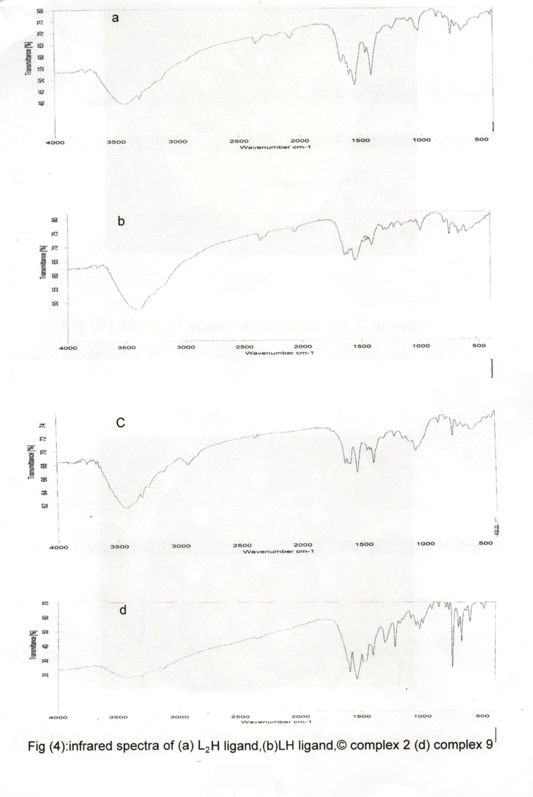

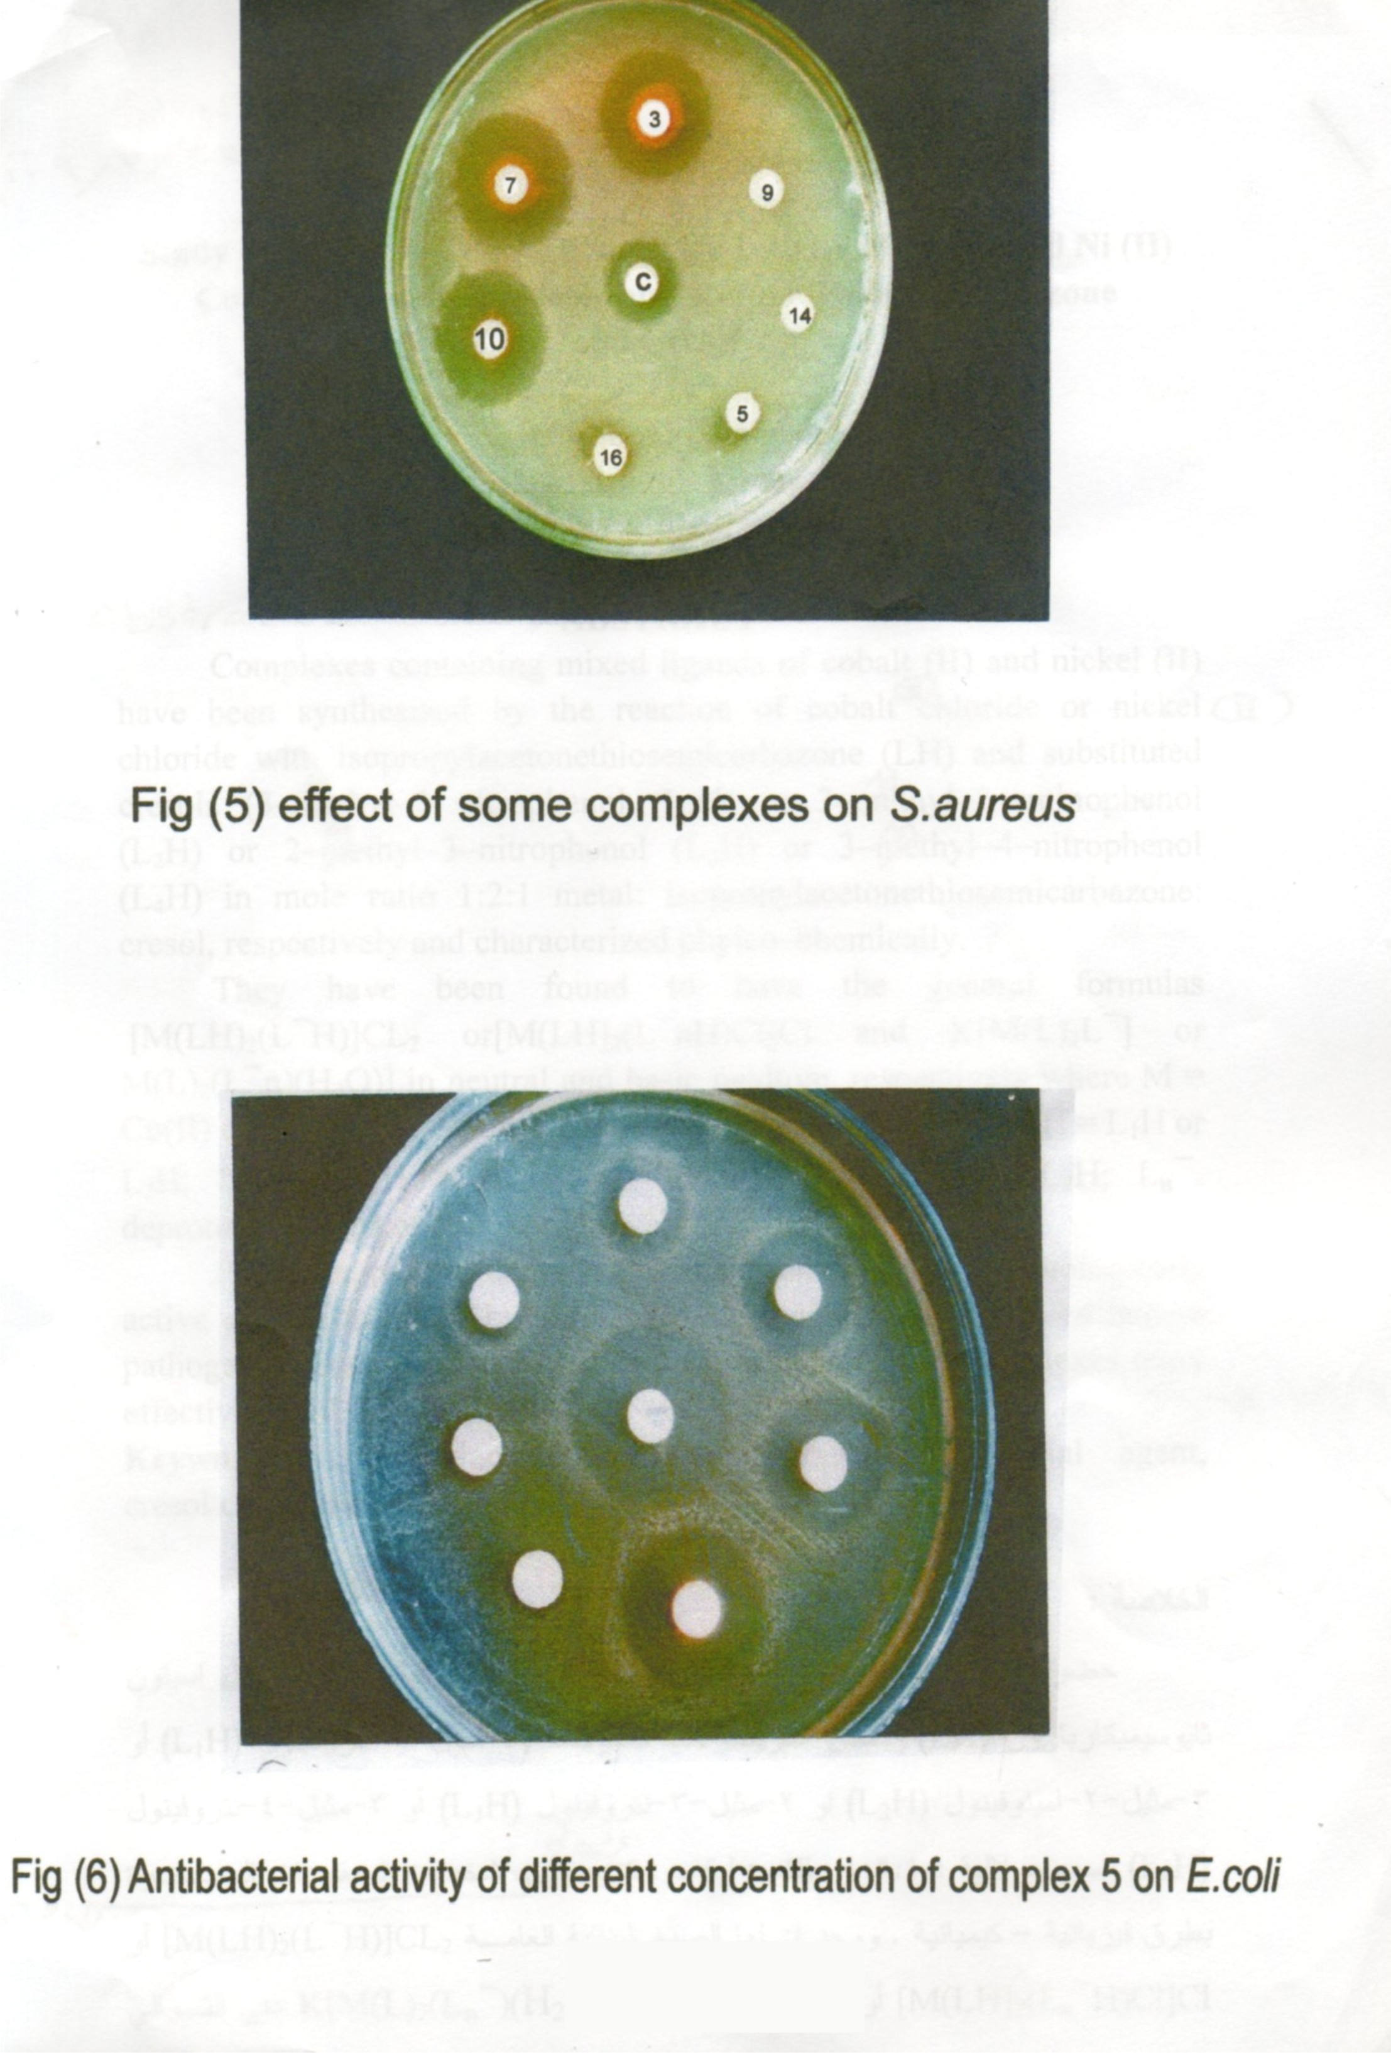

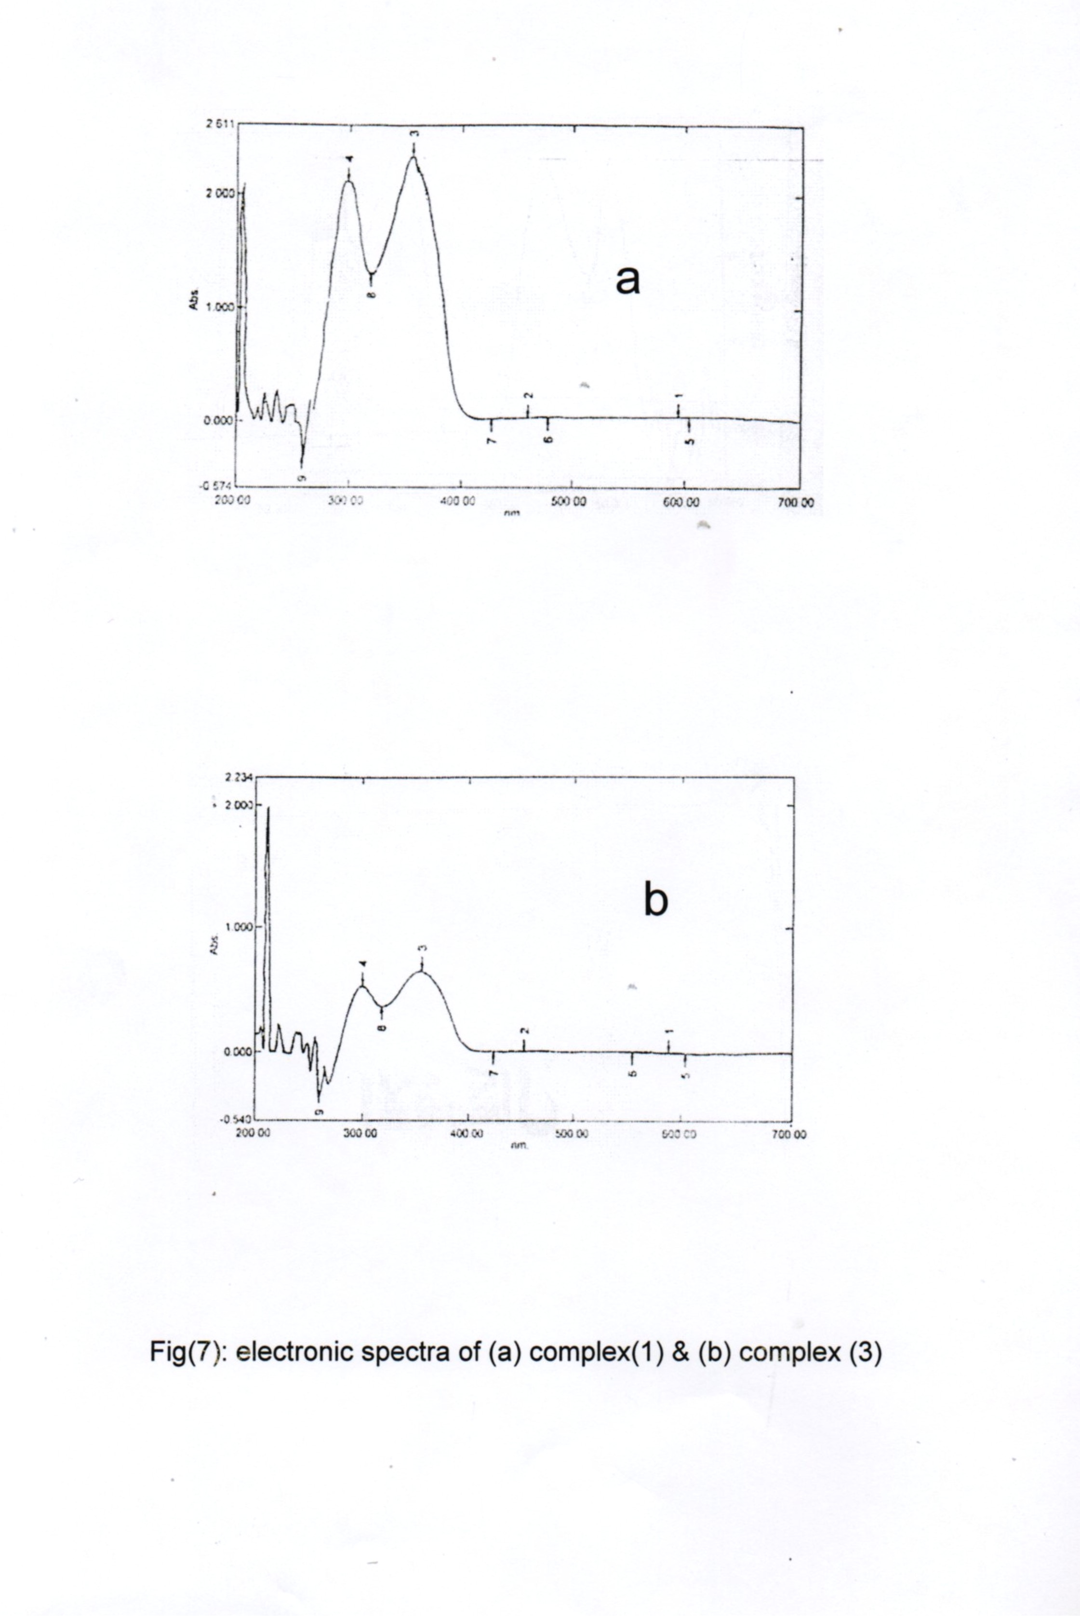

References
- F. Basuli, S.M. Peng and S. Bhattachary, Inorg. Chem. 1997, 36, 5645.
- B.Peng, H. Chao, B. Sun, H.Li, F.Gao and Liang-Nian Ji, J.Inorg. Biochem., 2006, 22, 171.
- F. Basuli, S.M. Peng and S. Bhattachary, Inrog. Chem., 2001, 39, 1120.
- I. PaI, F. Basuli, T.C.W. Mak and S. Bhattachary, Angew. Chem., Int. Ed. Engl., 2001, 40, 2923.
- Z. Afrasiabi, E. Sinn, J. Fok, K. Mehta, N. Rath, D. Deobagakar, Ch. A. Anson and A.K. Powell, Inrog. Chem., 2005, 44, 1154.
- N. Kanoongo, R.V. Singh and J.P. Tondon, Synth. React. Inrog. Met–Org. Chem., 1987, 17, 837.
- Y. Kuma and S.P. Tolani, Croat. Chem. Acta, 1989, 62, 73.
- M.M-Ajaily,A.A.Maihub,S.F.Ben-Gweirif,A.M.Belazi and R.S.El-Zweay, J.Chem.,2007,23,1
- Powers, L.J., J. Med. Chem., 1976, 19, 57.
- Kappe, C., Murphree, S. Padwaad, A., Tetrahedron, 1997, 53, 14179.
- A.I. Vogel, Textbook of Practical Organic Chemistry, Longmans Green, London, 3rd ed., 1964, 344.
- A.I. Vogel, Textbook of Quantitative Inorganic Analysis, Longman Inc., New York, 4th ed., 1982, 490–529.
- J.W. Danials, Experimental Physical Chemistry, McGraw–Hill,
6th ed., 1982, 81.
- A.W. Bauer, W.A.W. Kirbay, J.S. Sherris and M. Truk, Am. J. Clinc. Pathol., 1966, 45, 493.
- C.H. Collins, P.M. Lyne and J.M. Grange, Microbiological Methods, Butterworths, London, 6th ed., 1989.
- M.M. Dulta, B.N. Goswami and J.S. Kataky, J., Heterocyclic Chem., 1986, 23, 743.
- W.J. Geary, Coord., Chem. Rev., 1971, 7, 81.
- R.S. Nyholem, Quart. Rev., 1953, 7, 377.
- Wilkinson, R.D. Gillard and J.A. McCleverty, Comprehensive Coordination Chemistry, Pergamon Press, Oxford, England,
1st ed., 1987, vol. 1.
- Singh, P.K., Koacher, J.K. and Tandon, J.P., J. Inorg. Nuel. Chem., 1981, 43, 1755.
- Shrivastava, A.K. and Bana, V.B., J. Indian Chem. Soc., 1974, 36, 2118.
- Kanoongo, N., Singh, R. and Tandon, J. Transition Met. Chem., 1987, 12, 271.
- Petrovic, B.R. and D.M., J. Coord. Chem., 1982, 11, 239.
- I.J. Sallomi and A.J. Al–Shaheen, Polyhedron, 1988, 17, 1429.
- K. Nakamoto, Infrared and Raman Spectra of Inorganic and Coordination Compounds, Part B, John Wiley and Sons, Inc.,
5th ed., 1997.
- N. Ramen, S.J. Raja, J. Joseph and J.D. Raja, Russ. J. Coord. Chem., 2006, 33(1), 7.
- I. Gamo, Bull. Soc., 1961, 34, 760, 1430.
- T.A. Kabanos and J.M. Tsangaris, J. Coord. Chem., 1984, 13, 89.
- A.B.P. Lever, J. Chem. Edu., 1968, 45, 711.
- L.J.V. Piddock, R.N. Walters and J.M. Dwer, Antimicrob Agents and Chemother., 1990, 34, 233.
- W. Nadira and H.B. Singh, Inrog. Chim. Acta, 1988, 151, 387.

