Photolysis of Raxil DS2 in aqueous solution by sun light
through transition state computational study

Abbas .Abid Ali.Drea
Babylon University, Collage of Science, Chemistry Department

(NJC)

(Recevied on 1/9/2009) (Accepted for publication 12/1/2010)

Abstract
Transition state study have been carried out through computational methods to investigated photolysis of Raxil DS2 in aqueous solution by sun light . Quantum methods (semiemprical &Ab-initio included in packaged Hyper Chem 6.02 program) have been used to determine the chemical structures and physical properties of the pesticide molecule , intermediates ,and the all probable transition states structures involved in the first cleavage step reaction.
Energetic properties and chemical reactivity was calculated for every chemical moieties that’s participated in the photolysis reaction through surface potential energy calculations . Initiation steps of photolysis have been studied theoretically for the main bonds in pesticide molecules through surface potential stability calculation .
Several transition states are suggested for all probable main bounds that’s give-up the first cleavage step of photolysis ,they are examined by the calculations of surface potential energy, to estimate the heat of formation, energy barrier, and Zero point energy .calculations are carried out by study the structures of all suspected fragments that are produced from these transition states. Heat change for complete photolysis reaction has been estimated computationally to know heat formation for every chemical component participated in this reactions.
In the present work ,it has been found that Raxil DS2 pesticide have very reactive chemical bonds ,since it undergoes photolysis through C10-C12 bond by real transition state with energy barrier equal to 31.175 kCal mol ⁻¹ ,that’s equal to energy light of wave length of 916.440 nm .The first initiation step of photolysis reaction is endoenergetic with given up Two free radicals at 35.426 kCal mol⁻¹ . completely photolysis reactions of Raxil DS2 in aqueous media is exothermic reactions with -656.6945 kCal mol⁻¹ . Fifty six mole of water molecules are needed to Transform the pesticide molecule into sixteen mole of carbonic acids , hydrochloric acid , nitric acid , and hydrogen gas.

الخلاصة
تم دراسة الحالة الانتقالية من خلال الطرق الحسابية وذلك للتعرف على التحلل الضوئي لمبيد الراكسيل دي اس اثنان في المحلول المائي بوساطة ضوء الشمس. استخدمت الطرق الحسابية لميكانيك الكم (الشبة التجريبية والأولية الأساسية) المحملة ضمن البرنامج هايبركم 8.02 وذلك لاكتشاف التراكيب الكيميائية والمواصفات الفيزيائية لجزيئه المبيد,وكذلك المركبات الوسطية وكل الحالات الانتقالية المتوقع تكونها خلال خطوة التكسر الأولى للتفاعل.
تم احتساب الخواص الطاقية والفعالية الكيميائية لكل المكونات الكيميائية التي يتوقع إن تشارك في تفاعل التحلل الضوئي. تم دراسة خطوة البدء لتفاعل التحلل الضوئي بوساطة الحسابات الاستكشافية للأواصر الرئيسية في بنية جزيئه المبيد من خلال حسابات الاستقرار لسطح جهد طاقة الآصرة.
اقترحت بضعة حالات انتقالية للأواصر الرئيسة في جزيئه المبيد ذات الاحتمالية الكبرى في توليدها لخطوة الكسر الأولى في التحلل الضوئي. اختبرت هذه الحالات الانتقالية من خلال حسابات سطوح جهد الطاقة وذلك لبيان حرارة التكوين وحاجز الطاقة وطاقة نقطة الصفر لكل منها. تم إجراء هذه الحسابات بوساطة دراسة كل المكونات الكيميائية المتوقع تكونها من هذه الحالات الانتقالية. تم استبيان طبيعة التغيرات الحرارية لتفاعل التحلل الضوئي التام بوساطة حسابات حرارة التكوين لكل المكونات الكيميائية المشاركة في هذا التفاعل.
يتضح من هذا العمل
يمتلك مبيد الراكسيل دي اس اثنان أواصر فعالة جدا ,حيث إن التحلل الضوئي يتم من خلال الاصرهC10-C12 بوساطة حالة انتقالية حقيقية وبحاجز طاقة مقداره 31.175 كيلو سعره لكل مول واحد ,والذي يعادل طاقة إشعاع مرئي ذو طول موجة مقداره 916.440 نانوميتر . تكون خطوة الأولى لتفاعل التحلل الضوئي ماصة للحرارة وبطاقة مقدارها35.426 كيلو سعره لكل مول واحد لتوليد اثنان من الجذور الحرة. تكون تفاعلات التحلل الضوئي التام لمبيد الراكسيل دي اس اثنان باعثة للحرارة وبطاقة مقدارها -656.6945 كيلو سعره لكل مول واحد . تكمن الحاجة إلى ستة وخمسون مولا من جزيئات الماء لتحول جزيئه المبيد إلى ستة عشر مولا من حامض الكاربونيك وحامض الهيدروكلوريك وحامض النايتريك وغاز الهيدروجين.

Introduction
Since before 2500 BCE, humans have utilized pesticides to protect their crops. The first known pesticide was elemental sulfur dusting ,used in Sumeria about 4,500 years ago. By the 15th century, toxic chemicals such as arsenic, mercury and lead were being applied to crops to kill pests. In the 17th century, nicotine sulfate was extracted from tobacco leaves for use as an insecticide. The 19th century saw the introduction of two more natural pesticides, pyrethrum which is derived from chrysanthemums, and rotenone which is derived from the roots of tropical vegetables ⁽¹⁾ .
Some pesticides are considered too hazardous for sale to the general public and are designated as restricted use pesticides. Only certified applicators, who have passed an exam, may purchase or supervise the application of restricted use pesticides ⁽²⁾ . Pesticides are used to control organisms which are considered harmful,and they are using to reduced the economic losses in agricultures ⁽³⁾. mistake uses ,or over dosage causes high levels of concentrations in waters ,that’s produced an accumulation of toxic materials in the tissues of organisms ⁽⁴⁾ . Raxil DS2 is fungicide with a chemical formula of C₁₆H₂₃N₃OCl ,it is called according IUPAC as 1-(4-chloro-phenyl)-4,4-dimethyl-3[1,2,4]-triazol-l-yl methyl-pentan-3-ol .These pesticides are classified as triazoles that’s effected by inhibition the synthesis of sterols in fungus ,since fungicides are used for the control of fungi and omycetes⁽⁵⁾. Raxil DS2 are produced by Bayer CropScience company in German in 2002 year . Iraqi government have been imported 40000 Kg of Raxil DS2 at 2007s by ministry of agriculture to be used for cereal protection and another applications⁽⁶⁾ .
Computational methods are used to simulation all different kinds of chemical reactions with out directed treatment of these poisons chemical material in short time⁽⁷⁾ . Chemical reactivity and electronic density have been used in surface potential energy calculations to estimate the active sites of the reactions and the most probable transition state for the individual reactions⁽⁸⁾ . Calculation methods of Quantum mechanics are consisted of several factors that are controlling the accuracy of results and time of operation data out put, these are number of atoms per one molecule and the type of basis set for calculation process⁽⁹⁾.
Present work tends to use calculations methods of Quantum mechanics that’s included in packaged Hyper Chem 6.02 program to estimate the chemical reactivity of electronics density for Raxil DS2 .Transition states penetrated methods will be used to discover the responsible bond for the cleavage step of photolysis reaction in aqueous solution. different structures be studied to give up all the thermodynamic properties ,that’s produced a clearly view of this reaction.
Computational Details
Hyper Chem package program are used into XP Microsoft windows at 2008 vista setup . Geometry optimization calculations of Raxil DS2 molecule have been carried out through Ab-initio method at 6-311G**basis set using UHF &RHF with full Moller Plesset prturbation method of double precision ⁽¹⁰⁾ . Energetic properties according to configuration interaction through semiempirical calculations can be carried out by several methods like PM3, AM1, CNDO ,and MIND3 to estimate all values at these different method of calculations⁽¹¹⁾ . Also the same things been done to get up values of main bond length and estimate the most probable weak bond in pesticide molecule. Two dimensional view potential surface energy calculations are used to investigate the stability potential curve of main bonds, examined by semiempirical PM3 method at UHF calculation ⁽¹²⁾. Penetrate of proposed transition state for first cleavage step has been studied by semiempirical PM3 method at UHF and RHF calculation and also vibration spectrum to get out values of total energy ,heat of formation ,energy barrier, and zero point energy to put out properties of suggested transition states and their products moieties of cleaved reaction ⁽¹³⁾ . Heat of formation for full photolysis reaction calculated in Ab-initio and semiempirical calculations.
Results and Discussions
Substrate molecule of Raxil DS2 has been studied under different conditions to estimate the pathway of photolysis and their final products.
Chemical Optimized Structure of Raxil DS2
Surface potential energy calculations estimated a good geometry optimized structure of Raxil DS2 by -6768835.919 kCal mol ⁻¹ through Criterion of RMS gradient = 0.1000 kCal/(Aº mol). figure (1) show different methods of views for this molecule ,as symbol stick view, numbers of atoms stick view, ball &cylindrical view, electrostatic field in 2D, atomic charge, and basis set. This molecule has many active site towered the energy of the sun light, where electrostatic potential calculation tends to found two colors area, green area are positive side and red area are negative side⁽¹⁴⁾.From another side both of oxygen atom no16 have -0.306 atomic charge and nitrogen atom no17 have 0.270 atomic charge ,they have larger charge than the rest atoms in molecules. This phenomena means that’s both of O16 and N17 are good active sides in this molecule.

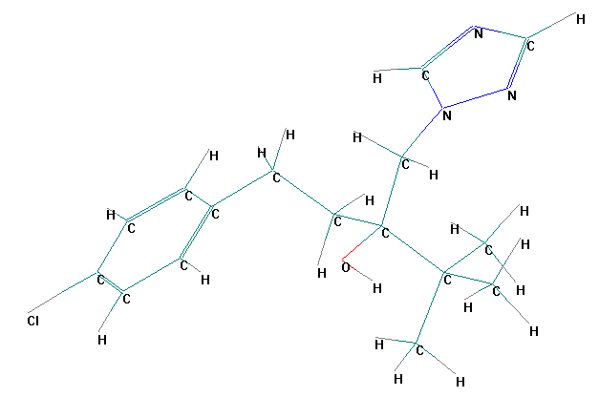 | 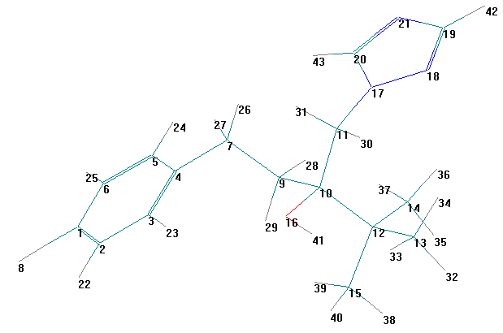
a-symbol stick view | b-numbers of atoms stick view.
Figure 1 Geometry optimized of Raxil DS2 structure calculated by Ab-initio at 6-311G**basis set using UHF &RHF calculation methods.

Calculated energetic properties are represented in Table 1. This calculation show Raxil DS2 molecule has different types of bonds with different lengths depending upon the attached groups. From table 2 it appears that bond of C1-Cl8 is the longest bond . Calculations of potential surface energy stability of these main bonds in figure 2 show, that’s C10-C12 bond is break don at 1.53Aº by -4200 kCal mol⁻¹ but the other bonds have longer distance and needed higher energy to break down into two free radicals.

Table1 Energetic properties of RaxilDS2 molecule in units of (kCal mol⁻¹ ) calculated by methods of semi-empirical estimation (UHF &RHF).

Method of calculations | Total Energy | Binding Energy | Isolated Atomic Energy | Electronic Energy | Heat of Formation
PM3 | -76835.919 | -4316.799 | -72519.119 | -600895.508 | -8.766
AM1 | -84510.498 | -4274.591 | -80235.906 | -614780.538 | 33.441
CNDO | -38517.877 | -24579.710 | -13938.166 | -76966.559 | -24379.830
MIND3 | -82743.362 | -4286.150 | -78457.211 | -588348.935 | 21.842

Table2 Semi-empirical estimation methods of main bonds length in Aº units in RaxilDS2 molecule.
Method of calculations | RC10-C12 | RC11-N17 | RC10-O16 | RC7-C9 | RC4-C7 | RC1-Cl8
PM3 | 1.582 | 1.473 | 1.425 | 1.535 | 1.494 | 1.686
AM1 | 1.556 | 1.443 | 1.430 | 1.518 | 1.488 | 1.700
Extended Hukel | 1.557 | 1.443 | 1.430 | 1.518 | 1.488 | 1.700
CNDO | 1.557 | 1.443 | 1.430 | 1.518 | 1.488 | 1.700
MIND3 | 1.635 | 1.445 | 1.376 | 1.521 | 1.512 | 1.765

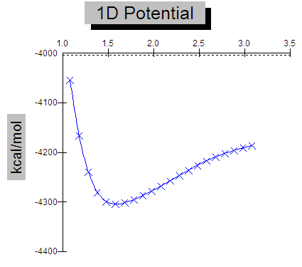 | 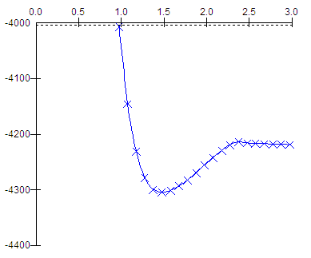
Potential energy of C10-C12 bond stability | Potential energy of C11-N17 bond stability
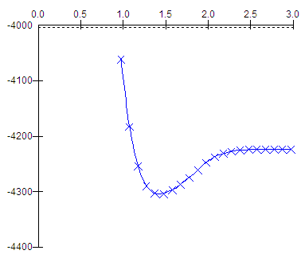 | 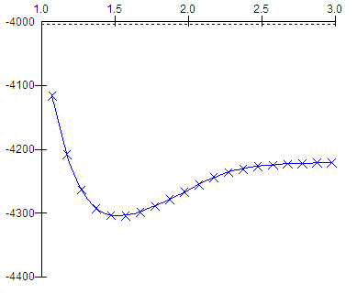
Potential energy of C10-O16 bond stability | Potential energy of C7-C9 bond stability
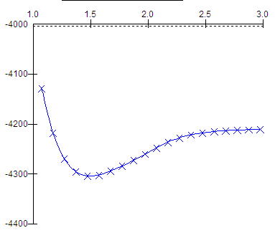 | 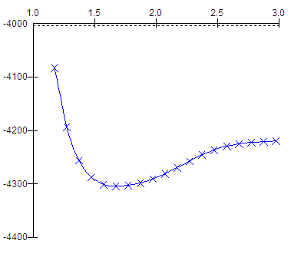
Potential energy of C4-C7 bond stability | Potential energy of C1-Cl8 bond stability

Figure2 Potential surface energy stability of main bonds in RaxilDS2 molecule calculated by PM3-semiemprical in two dimensions.

Initiation Step of Photolysis reaction
Any reaction mechanism must have initiation step then the reaction proceeds to give up final products. This step is passed through transition states ,therefore all these mean bounds must form a transition state to give up products of first initiation step. Figure3 represented the most probable of six transition state through the mean effective bonds in Raxil DS2,where each transition of these produced at last two free radical moiety . Figure 4 and Table 3 show the geometry optimized in stick view and energetic properties of the proposed chemical moiety that’s produced from these states respectively. our investigation of real transition states and their related calculations are represented in Table 4 included a coded transition states with their energetic calculated values. From the six proposed transition states, that’s only one of these give-up the real path for initiation step. The prediction are consisted from optimization the geometries and analysis of calculations for vibration stability. TS1 is the real path for initiation step since it has lowest value of potential energy surface equal to -76804.744 kCal mol ⁻¹ than other states that’s mean TS1is the most comfortable state⁽¹⁵⁾ . At the same the time heat of formation is the lowest 22.408 kCal mol ⁻¹ . Zero point Energy calculation estimate that’s TS1 has largest value than other states ,which equal to 226.30723 kCal mol⁻¹ ,that’s meaning TS1 needed lowest value of activation energy to give up products of reaction⁽¹⁶⁾ . The calculated values of reaction energy barrier for each transition state, investigated that’s lowest value of TS1 make their responsibility for the first cleavage step through C10-C12 bond by 31.175 kCal mol⁻¹ to produced two free radicals as in equation (1) of the most probable reaction.

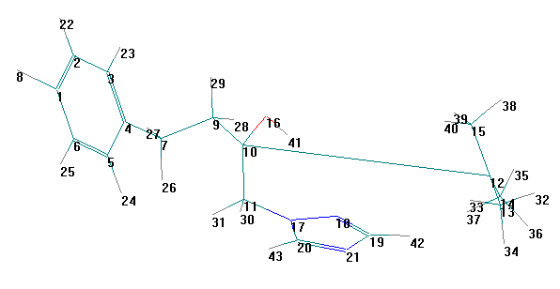 | 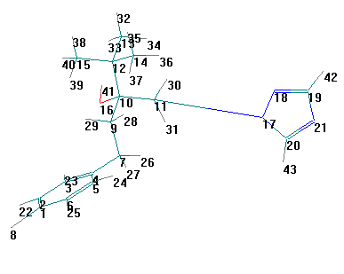
TS1 –through C10-C12 bond cleavage. | TS2- through C11-N17 bond cleavage.
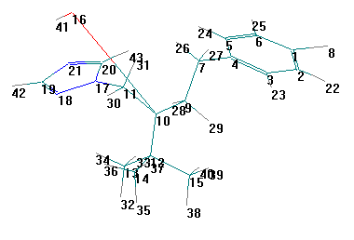 | 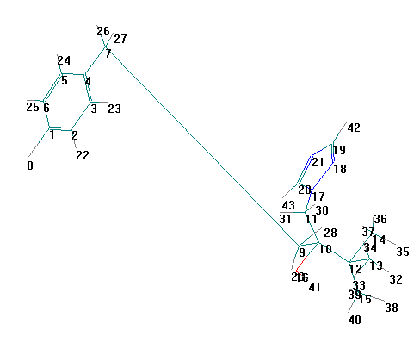
TS3- through C10-O16 bond cleavage. | TS4- through C7-C9 bond cleavage.
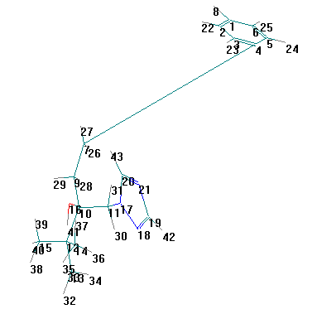 | 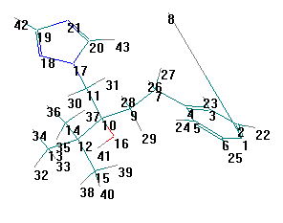
TS5- through C4-C7 bond cleavage. | TS6- through C1-Cl 8 bond cleavage.
Figure 3 penetrate of proposed transition state for first cleavage step through the main effective bonds in RaxilDS2 calculated by PM3 semi-empirical .

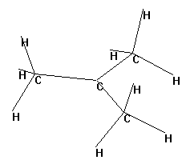 | 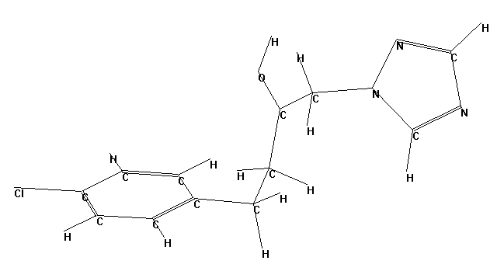
STR1- Tertiary butyl radical | STR2- 1-chloro phenyl,4-(1,2,4triazol),3-hydroxy-butane radical
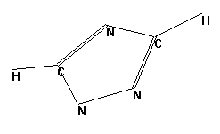 | 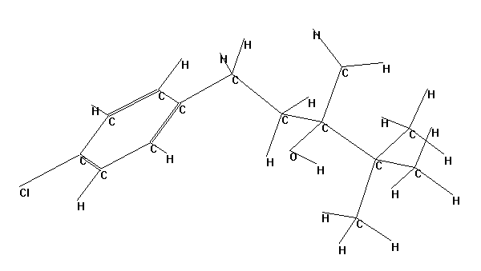
STR3- 1,2,4,triazol radical | STR4- 1-(4-chlorophenyl),4,4-dimethyl,3-methyl,3-hydroxyl pentan-1-radical.
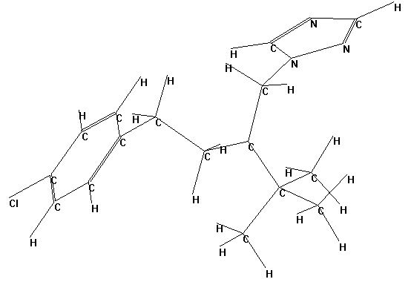 | 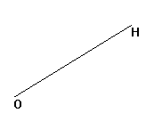
STR5- 1-(4-chloro-phenyl)-4,4-dimethyl-3[1,2,4]-triazol-l-yl methyl-pentan 3-radical. | STR6- hydroxyl radical
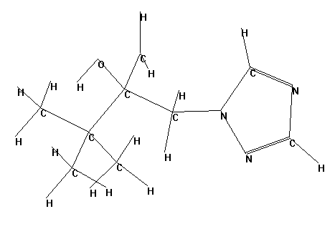 | 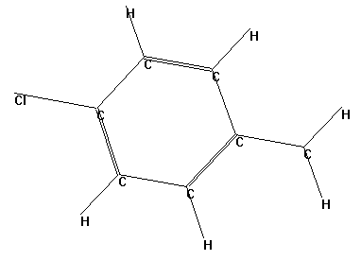
STR7- 4,4-dimethyl-3[1,2,4]-triazol-l-yl methyl-butane-3-ol 1-radical. | STR8- 4-chlorobenzyl radical .
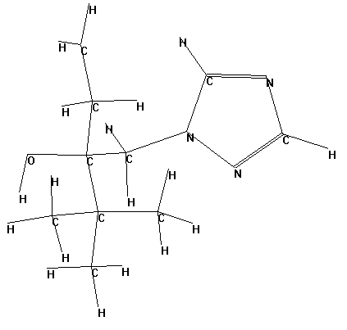 | 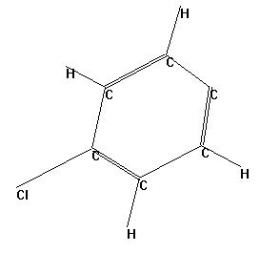
STR9- 4,4-dimethyl-3[1,2,4]-triazol-l-yl methyl-pentan-3-ol 1-radical | STR10- 4-chlorophenyl radical .
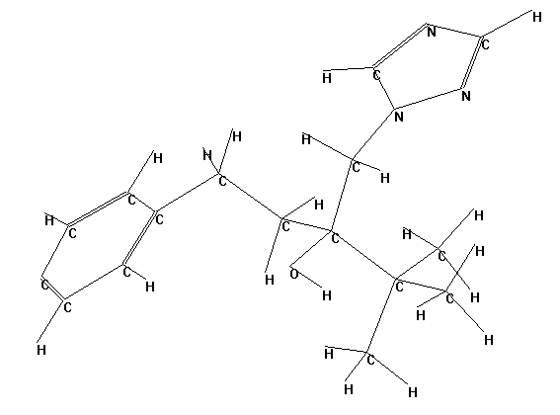 | 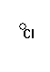
STR11- 1-(4-radical-phenyl)-4,4-dimethyl-3[1,2,4]-triazol-l-yl methyl-pentan-3-ol. | STR12- chloride radical.
Figure 4 Optimized geometries in stick view of suspected radical structures involved from the most probable transition states of first cleavage steps calculated by semi-empirical calculations PM3(UHF &RHF) method configuration interaction microstates (3X3).

Table 3 Energetic properties of coded structures of radicals that’s producing from suspected transition states calculated by semi-empirical calculations PM3 method .
Coded structures | Total energy  (kCal mol⁻¹) | Heat of formations  (kCal mol⁻¹) | Binding energy  (kCal mol⁻¹)
STR1 | -14132.617 | -6.551 | -1159.029
STR2 | -62667.874 | 33.211 | -3122.343
STR3 | -17330.755 | 91.540 | -693.443
STR4 | -59443.374 | -38.518 | -3561.567
STR5 | -69683.266 | 58.232 | -4138.139
STR6 | -7082.715 | 2.937 | -108.723
STR7 | -48246.291 | 9.932 | -2760.268
STR8 | -28539.614 | 31.313 | -1506.518
STR9 | -51693.646 | 5.699 | -3039.595
STR10 | -25067.547 | 60.258 | -1202.479
STR11 | -69477.988 | 51.461 | -4227.581
STR12 | -7268.710 | -7268.710 | 0.001

Table 4 Energetic properties of the suggested transition states calculated by semi-empirical calculations PM3 method .

Transition state NO | Surface potential energy  (kCal mol⁻¹) | Heat of formation  (kCal mol⁻¹) | Energy barrier  (kCal mol⁻¹) | Zero point energy  (kCal mol⁻¹)
TS1 | -76804.744 | 22.408 | 31.175 | 226.30723
TS2 | -76768.872 | 58.280 | 67.047 | 219.04558
TS3 | -76767.027 | 60.125 | 68.892 | 219.60405
TS4 | -68582.779 | 8244.372 | 8253.14 | -221.611
TS5 | -76657.282 | 169.869 | 178.637 | 214.55745
TS6 | -76741.011 | 86.140 | 94.908 | 221.88911

Free radical play an important role when its librated in the aqueous media of reaction to produced a serious steps of free radicals reactions⁽¹⁷⁻¹⁸⁾.previous calculations show ,that’s Energy barrier of initiation step needed 31.175 kCal mol⁻¹ equal to energy of light radiation with wave length of 916.440 nm . so that visible light energy is very effective to proceeds the initiation steps of photolysis .Estimation of Heat formation calculations ,reaction according equation (1) is endothermic reaction with 35.426 kCal mol⁻¹ .

C₁₆H₂₃N₃OCl +hν → C₁₂H₁₄ N₃OCl* +C₄H₉* … (1)

EB=31.175 kCal mol⁻¹ and ∆H_{rea} =35.426 kCal mol⁻¹
According the media of reaction is consisted from water molecules ,that’s reacted immediately with radicals to produces anther radicals until propagation steps are finished . At last simple chemical moieties are formed due the termination steps ,that’s Raxil DS2 transform into non toxic material ⁽¹⁹⁻²⁰⁾according equation 2 and 3. Calculations estimations that’s degradation reactions in equation 2 and 3 are exothermic reactions by -90.6085 kCal mol⁻¹ and -601.512 kCal mol⁻¹ respectively, therefore the total change in heat formation of exothermic photolysis reaction equal to -656.6945 kCal mol⁻¹ according equation 4 .

Photolysis reaction of Raxil DS2 achieved by Fifty six mole of water molecules to conformational into simple chemical moieties of sixteen mole of carbonic acids ,one mole of hydrochloric acid ,three mole of nitric acid , and 49.5mole of hydrogen gas.

C₁₆H₂₃N₃OCl +hν → C₁₂H₁₄ N₃OCl* +C₄H₉* ……… (1)

C₄H₉* + 12H₂O → 4H₂CO₃
+ 25/2 H₂ ….. (2)

∆H_{rea} = -90.6085 kCal mol⁻¹

C₁₂H₁₄ N₃OCl* + 44H₂O→ 12H₂CO₃ +HCl + 3HNO₃ +74/2 H₂ …. (3)

∆H_{rea} = -601.512 kCal mol⁻¹

C₁₆H₂₃N₃OCl + 56H₂O + hν→16H₂CO₃ +HCl + 3HNO₃ +99/2 H₂ ……. (4)

∆H_{rea} = -656.6945 kCal mol⁻¹

Conclusions
Photolysis of Raxil DS2 molecule is carried out by sun light through radiation wave length of (916.440 nm) through free radical mechanism reaction path way. Transition state proceeds in C10-C12 bond as a first initiation step of photolysis. Aqueous media is participate in free radical reaction by Fifty six mole of water molecules to give up simple molecular materials.

References
- G.T.Miller, (2002), “Living in the Environment “(12th Ed.). Belmont: Wadsworth/Thomson Learning. ISBN 0-534-37697-5 ,p443.
- H.D.Daly , and A.H.Purcell III (1998), “Introduction to insect biology and diversity”, 2nd ed. Oxford University Press. New York, New York. Chapter 14, Pp 279,300.
- S.Kuniuki , Japanese Journal of Crop Science , 2008, 70, Issue 4, 530-540.
- Kellogg RL, Nehring R, Grube A, Goss DW, and Plotkin S , (2007-10-03), “Environmental indicators of pesticide leaching and runoff from farm fields “. United States Department of Agriculture Natural Resources Conservation Service.
- AB Direktiflerine gore Güvenlik Bilgi Formu 940201/011.Ekim ,(2002), Raxil DS 2 05144922.
- Tables by ministry of agriculture -Iraqi government ,2007.envi4-tables.pdf.
- H. Dorsett , and A. White ,(2000) ,”Overview of molecular Modelling and Ab initio Molecular orbital Methods Suitable for use with energetic Material” ,Commonwealth of Australia .AR-011-578, p5.
- .J.A Foresman ,and C. Frisch ,(1996),” Exploring chemistry with electronic structure methods”,2nd ed .,Gaussian Inc., Pittsburgh ,PA ,p344.
- Y.Akutsu , and S.Y. Tahara , Journal of Energetic Materials, 1991, 9,161-172.
- B.M. Rice and , C.F.Chabalowski , J.Phys.Chem., 1997, 101 ,8720-8726.
- S.J.Stuart ,A.B.Tutein , and J.A.Harrison , J.Chem.Phys., 2000, 112 , 6472-6488.
- S. J.Weiner , (1984). J. Am. Chem. Soc.,1984, 106 , 765-782.
- J.Baker, J. Comp. Chem, 1986, 7(4), 385-395 .
- L.Salem , J. Am. Chem. Soc., 1968, 90 ,543-553.
- S.E.Gregory , R.C. Tessa ,and L.R. Elizabeth , (2007). in Nature., 2007, 446, 782-786 .
- J.H .Jensen , and M.S. Gordon , (1991). J. Am. Chem. Soc., 1991, 113, 7917-7924.
- A.A.Saaied , (2002) ,”Chemistry of free radical” ,1st ed .Dar Al-massira Publishing. Jordan ,p-13.
- E. Dvali, and G. Gruzinov , (2007). Physical Review Letters, 2007, 98: Art. No. 010402. doi:10.1103/PhysRevLett.98.010402.
- A.A.Drea (2007),Ph.D. Thesis .Babylon university- Iraq .
- A.A.Drea , National Journal ofChemistry, 2008, 29,109-130.

