Synthesis Of Some Modified Poly(vinyl chloride) Containing Cinnoline-deravitives

Olfa A.Naif and Radha I.AL-Bayati
Dept of chemistry ,College of Science , Al-Mustansiriya University. Baghdad,lraq

(NJC)

(Recevied on 21/10/2009) (Accepted for publication 25/2/2010)

Abstract

The present work consist of synthesis and characterization of three modified PVC polymers containing mercapto and hydrazino cinnoline-deravitives as pendent groups in the repeating units were synthesized in this work according to the following:
1:- Reaction of PVC with 4- hydrazine- 5- methoxy cinnoline in THF solvent afforded the following modified polymer (P1)
2:- Treatment of PVC with 4-mercapto 5- methoxy cinnoline in THF solvent furnishes the following modified polymer (P2)
3:- Reaction of PVC polymer with a mixture of equall amount of 4- hydrazino and
4-mercapto-5-methoxy cinnoline yields the following modified PVC polymer (P3)
Structures of all these modified polymers have been confirmed by spectral
(FT-IR and UV) analyses. The results indicated the presence of cinnoline-deravitives
rings in the polymeric chain.
الخلاصة
يتضمن البحث المقدم تحضير وتشخيص ثلاثة بوليمرات لبولي (كلوريد الفاينيل) المحتوي على مشتقات المركبتو والهيدرازينو سينولين تبعا" للخطوات التالية:-
اولاً:- تم تحضير بوليمر (P1) الناتج من مزج 4- هيدرازينو-5-ميثوكسي سينولين مع بولي (كلوريد الفاينيل).
ثانياً:- تم تحضير بوليمر (P2) الناتج من معاملة 4-مركبتو-5-ميثوكسي سينولين مع بولي (كلوريد الفاينيل).
ثالثاً:- تم تحضير بوليمر (P3) الناتج من تفاعل مزيج من كميات متساوية من4- هيدرازينو و4- مركبتو 5- ميثوكسي سينولين مع بولي (كلوريد الفاينيل).
تم تشخيص جميع صيغ البوليمرات المحضرة بمطيافية الأشعة تحت الحمراء (IR-FT) والأشعة فوق البنفسجية(UV) . تشير النتائج وجود حلقات مشتقات السينولين في السلسله البوليمرية.

Introduction
Vinyl chloride monomer and its polymers occupy a unique place in the history of plastics. Arriving early in technology of synthetic resins, they have not been displaced by new polymers. They have become increasingly important^{(1,2,3,4)}.
Poly(vinyl chloride), PVC, is a linear- chain polymer with bulky chloride side-groups which prevent crystalline regions occurring normally. PVC is hard and rigid material at room temperature^{(2,5,6 )}.Straight poly (vinyl chloride) is colorless rigid material. It has relatively high density and low softening point^{(7,8)}.The presence of the chlorine atom causes an increase in the inter chain attraction, hence an increase in the hardness and stiffness of the polymer is recognized. PVC is also a polar polymer because of C-Cl dipole. These properties make PVC polymers as good candidate in the application involving high frequencies because high dielectric constant and high power factor values higher than polyethylene owing to the polar carbon-chlorine bond⁽²⁾.
Poly (vinyl chloride) has very limited solubility. The most effective solvents are those which appear to be capable of some form of interaction with polymer. It has been suggested that poly (vinyl chloride) is a week proton donor and effective solvents are proton accepter^{(7,9)}. Thus the PVC polymer is soluble at room temperature in oxygen-containing solvents such as ethers e. g. dioxane, tetrahydrofuran; ketones e. g. cyclohexanone, and nitro compounds, e. g. nitrobenzene⁽¹⁰⁾.
Experimental
All chemical used were of reagent grade (supplied by either BDH or Fluka) and used as supplied. The FTIR spectra in the range (4000-400) cm⁻¹ cut were recorded as KBr disc on FT-IR,84005 Shimadzu Spectrophotometer. The UV-visible spectra were measured in THF using (Hitachi U-2000 ) ultra-violet spectrophotometer in the range (200-800) nm.

A-Purification of Poly(vinyl chloride)⁽¹¹⁾
Commercial poly(vinyl chloride) (PVC) supplied from Petkim company (Turkey) was purified from additives by re-precipitation three times from tetrahydrofuran (THF) solution in methanol. The purified polymer was dried under reduced pressure at room temperature for (24) hours before used.
B-Preparation of Cinnoline-deravitives;-
These compounds were prepared by as mentuntion the litruture ⁽¹²⁾

C-Preparation of modified polymers
Fixed polymer weight, was used because there was adifficult in obtain molecular weight.

1-Preparation of modified polymer (P1)
4- Hydrazino-5- methoxy cinnolin (0.0304 gm,0.0016 mole) was added to (0.125g) poly (vinyl chloride) and few drops of pyridine in (50mL) tetrahydrofuran (THF) .
A brown prcipitate was formed after refluxing the mixture for five hours .The modified polymer (P1) was filtered,washed with redistilled water,methanol,ether and dried under vaccum.

2-Preparation of modified polymer (P2)
4-Mercapto-5-methoxy cinnolinE (0.0307 gm,0.0016mole) was added to (0.125gm) poly(vinyl chloride) and few drops of pyridine in (50mL) tetrahydrofuran (THF) .
A yellow prcipitate was formed after refluxing the mixture for five hours, the modified polymer (P2) was filtered,washed with redistilled water,ethanol,ether and dried under vaccum

3- Preparation of modified polymer (P3)
A solution of mixture of ( 0.148 gm,0.00078 mole) 4- hydrazino -5- methoxy cinnoline and ( 0.0149 gm ,000078 mole) of 4-mercapto-5- methoxy cinnolin and drops of pyridine in (50 mL) tetrahydrofuran (THF) was added to (0.125gm) poly(vinyl chloride) .A brown prcipitat was formed after refluxing the mixture for five hours, the modified polymer (P3) was filtered, washed with redistilled water,methanol, ether and dried under vaccum.

Results and Discussion
In this research the synthesis of some new modified PVC containing cinnoline-deravitives(polymers prepared), with a view to finding out the effect of introducing these moieties on physical and chemical properties of PVC. Equations (1to 3) present the formation of polymers prepared.

Polymer(P1)

Polymer (P2)

Polymer (P3)

The reaction was initiated by the nucleophilic attack of (S,N) atoms on the carbon carrying chlorine atom in the polymeric chain followed by departure of chloride anion as a good leaving group.

The structure of the present polymers was confirmed by Infra-red spectroscopy. The most common bands are tabulated in Table (1-1 ) beside the typical IR absorption bands , each of the present polymers showed other band characteristic of its own structure, Figures (1-3) showed the following features , a medium to strong band at about (630) cm⁻¹ which could be attributed to (C-Cl) , the appearance of a medium band at about (1550) cm⁻¹ indicated that the end groups of these polymers are C=C double band , the bands at around (2900) cm⁻¹ which was assigned to the typical aliphatic (C-H) stretching vibration was also observed, moreover , these polymers exhibited significant bands in the region at (3050 for v(C-H aromatic) , 1635 for v(C=N) and at 750 for (C-H bending of O-disubstituted benzene) that clearly indicated the presence of nucleus cinnoline backbone of PVC chain.

Table (1) :The characteristic IR spectra of the prepared polymers

Polymers | v C-H aro. | V C –H aliph. | v C=C |  | v C=N | v C-CI | v others
P1 | 3070 | 2936 | 1569 |  | 1648 | 621 | 3379 N-H Stretching  1457 C-H bending of –CH₂-  737 C-H bending of ortho disubstituted benzene ring
P2 | 3025 | 2900 | 1582 |  | 1630 | 665 | 1444 C-H bending of –CH₂-  748 C-H bending of ortho disubstituted benzene ring
P3 | 3078 | 2896 | 1531 |  | 1616 | 651 | 3200 N-H stretching  744 C-H bending of ortho disubstituted benzene ring
PVC | - | 2970-2860 | - | - |  | 616 | 1429 C-H bending of –CH₂-

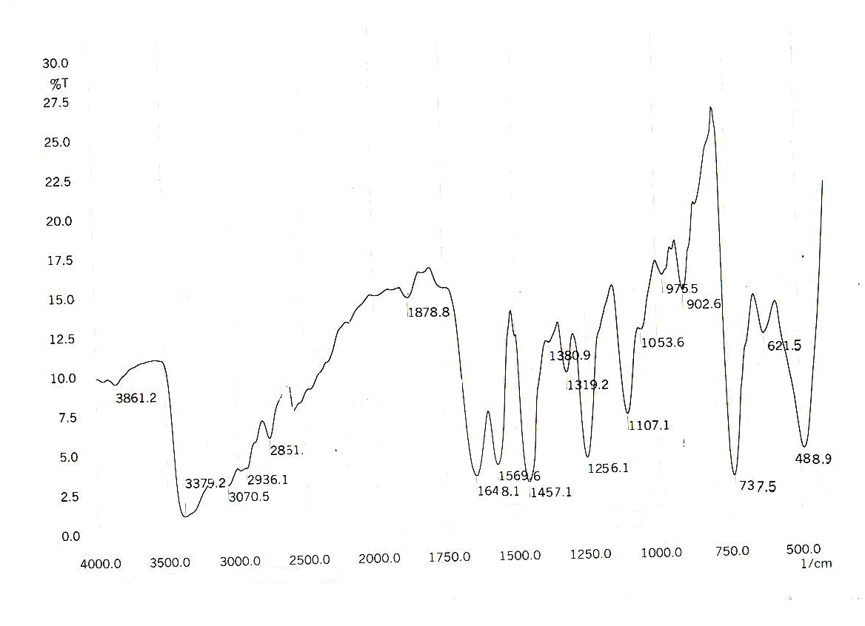
Figure (1) FTIR spectrum for P1

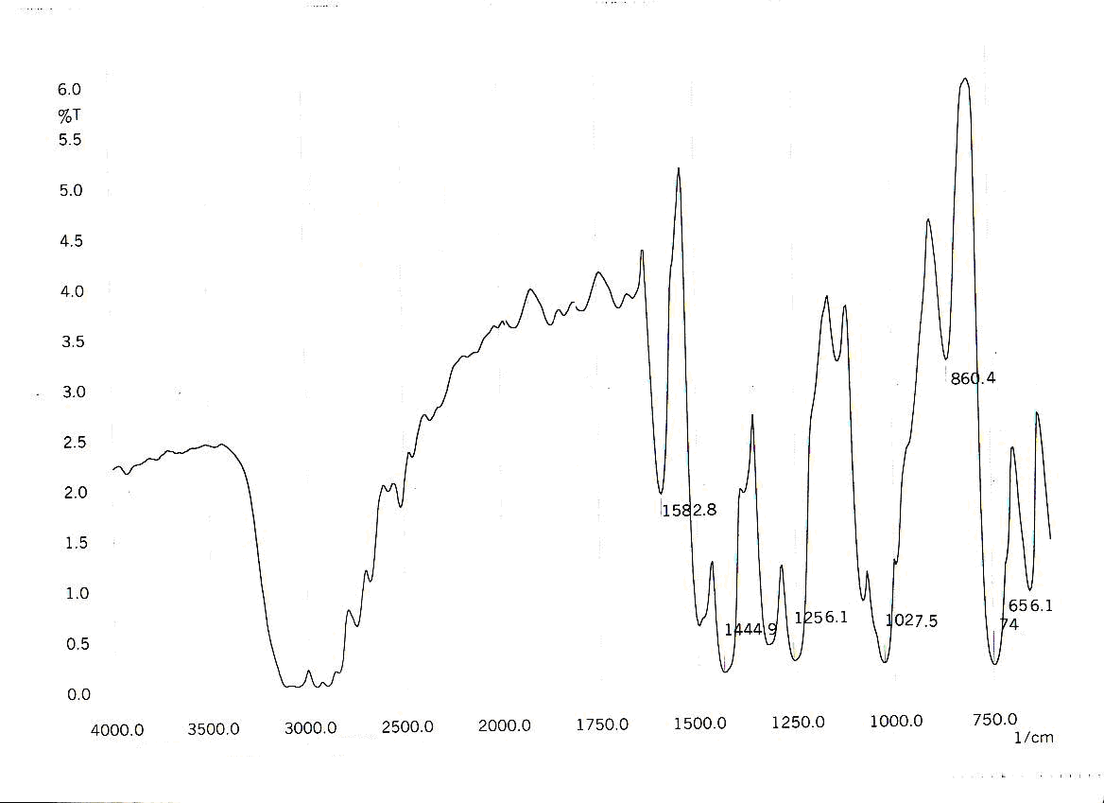

Figure (2) FTIR spectrum for P2

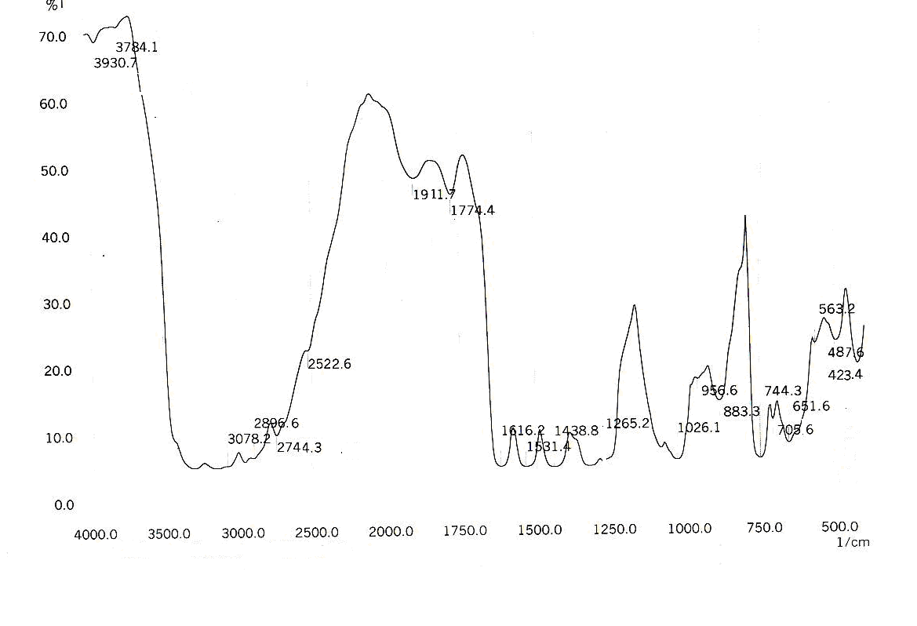

Figure (3) FTIR spectrum for P3

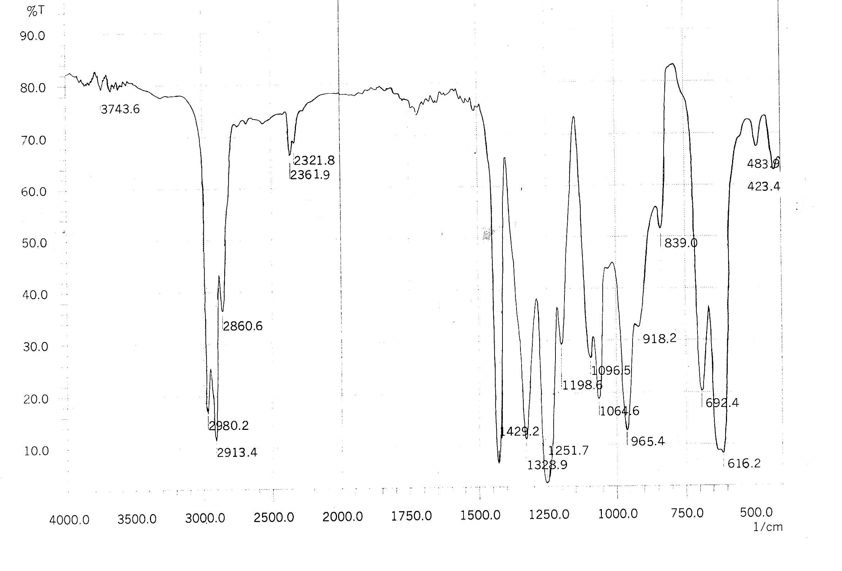

Figure (4) FTIR spectrum for Pvc

The ultraviolet-visible spectrophotometry technique is used to characterize the polymers in tetrahydrofuran (THF) as a solvent.The ultraviolet visible electronic spectra of the modified polymers, (Figures (5-8) showed an absorption bands could be attributed to the π → π* electronic transitions, These transitions are assigned in relevance to the structures of polymers . As shown in Table (2).The increase of the absorbance in the uv-vis range for samples containing modified PVC can be explaned by the formation of conjugation double bonds (band corresponding to the π → π* transition ) in these modified polymers resulting from introducing an aromatic cinnolin-deravitives rings. Thus, shifting the absorbance to longer wavelengths (i.e the bathochromic effect ) is good evidence that modification were formed in our PVC .moreover, the broading in the bands (fig (5-8) caused by the presence of other chromophores such as (C=N ,etc) which absorb in the above region and this overlapping bands make the interpretation of the results difficult.

Table (2) Electronic spectra of polymers in THF solvent.

Compound | Color | λ_{max} in THF
P1 | Brown | 225,272,281
P2 | Yellow | 223,326
P3 | Brown | 226,265
PVC | Colorless | 219,254

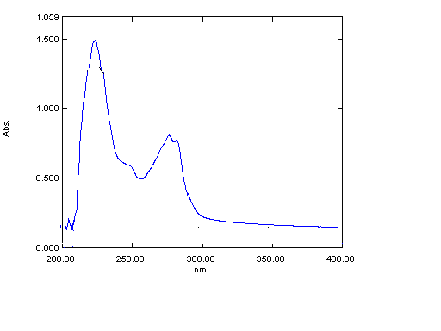
Figure (5): The ultraviolet visible spectrum for (P1) in THF solvent.
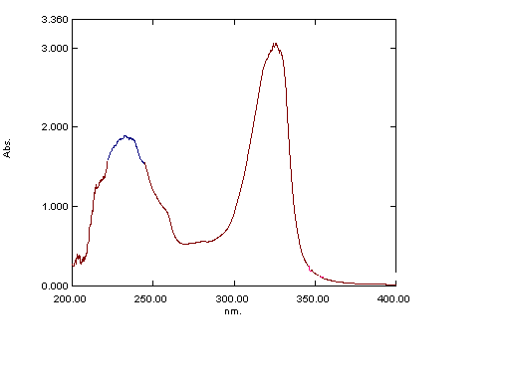

Figure (6): The ultraviolet visible spectrum for (P2) in THF solvent.

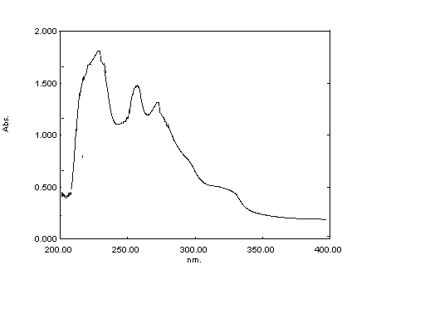
Figure (7): The ultraviolet visible spectrum for (P3) in THF solvent.

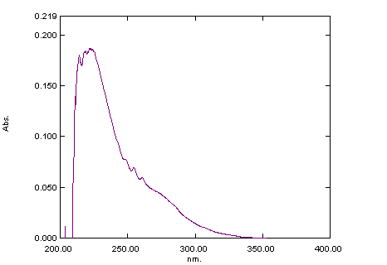

Figure (8): The ultraviolet visible spectrum for (PVC) in THF solvent.

References
1-C. Leonaed, “Vinyl and Diene Monomer”, New York (1971).
2-Robert, J. and Pierotti, J. ; ''Additives for plastics'' (Raymond B.S. ed),academic press New York, 1978, 2, 103.
3 -Kernsears and J. R. Darby, “The Technology of Plasticizers” New York (1982).
4- Purmova, J. Pauwels, K. F. D., Zoelen, W.N., Vorenkamp, E. J. and Schouten A. J.; New Insight into the formation of structural defects in poly(vinyl chloride), Macromolecules, 2005,38, 6352.
5-. V Koleste and L. H. Warimam, “Poly(Vinyl chloride)” London (1969).
6- Adriana de Campos and Franchetti, S. M.; Biotreatment effects in films and blends of PVC/ PCL previously treated with heat. Brazil. Archives. Biol. Technol., 2005,48, 235.
7- Rocha, A.P. Grandette , J.L., and Real ,L. P.; Artificial accelerated weathering of poly(vinyl chloride) for outdoor applications , Polym Degrad. Stab., 2003, 82, 235.
8- Real,P.L., Ferraria, A.M., and Bofelhodo, A.M. ; The influence of weathering conditions on the properties of poly(vinyl chloride) for outdoor applications, Polym. Testing, 2006, 26 , 77.
9- Fahmi,M.M. and Mohamed, N. A.; N-Substituted phenyl itaconimide-phenyl salicylate blends as organic stabilizers for plasticized poly(vinyl chloride) against photodegradation , Polym.Degrad.Stab, 2007, 92, 1003 .
10-Mogorkiswicz, “Engineering Properties of Thermoplastic” London (1970).
11 -B.B.Troiskii , L.S.Troitskaya ,V.N.Denisove , "Investigation of stabilizing effectiveness of alkyl(aryl) tin maleates and thioglycoates in thermal degradation of poly ( vinyl chloride ) .European Polymer Journal , 1977, 13, 1033.
12-Redha I.H,AI-Bayati andOlfa A.AI-Janaby 'synthesis of new cinnolines' AL-Mustansiriya J.Sci., 2002, 13, 4.

